1. Nodejs project started successfully

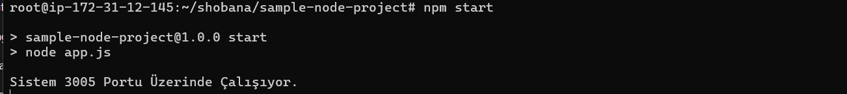

1. Docker compose build



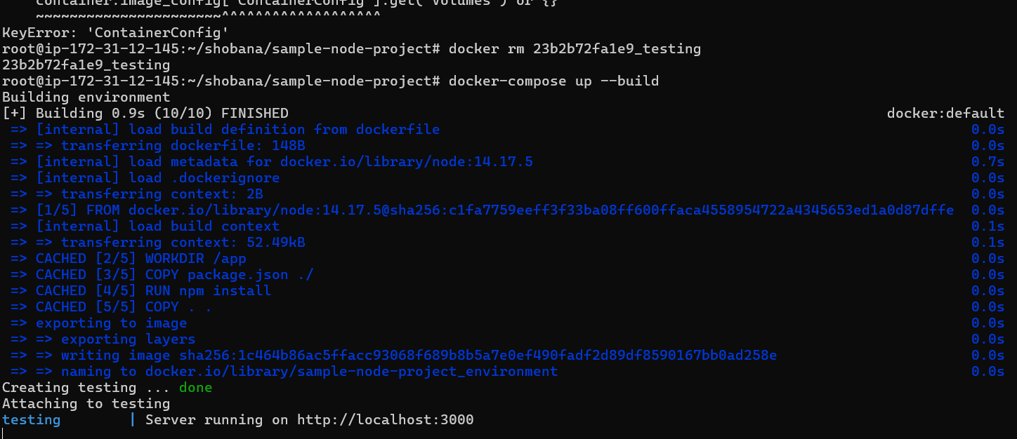

1. Basic Details – Output screenshot

