Script to check Http Headers using curl

#!/bin/bash

# Check if a URL is provided

if [ -z "$1" ]; then

echo "Usage: $0 <url>"

exit 1

fi

# Store the URL from the first argument

URL=$1

# Fetch the HTTP headers and store them in a variable

HEADERS=$(curl -I -s "$URL")

# Example: Extract the 'HTTP status code'

STATUS_CODE=$(echo "$HEADERS" | grep -oP '(?<=HTTP/2 )\d{3}')

# Check if the status code is 200

if [ "$STATUS_CODE" == "200" ]; then

echo "The server responded with a 200 OK status."

else

echo "The server did not respond with a 200 OK status."

Fi

**Command Run**

**./curl_call.sh** [**https://www.guvi.in**](https://www.guvi.in)

**./curl_call.sh** [**https://guvi.in**](https://guvi.in)

Output of the above script

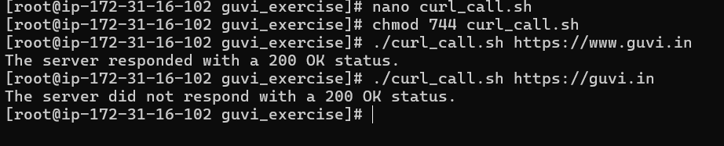

**Script to change**

#!/bin/bash

# Check if enough arguments are provided

if [ $# -ne 5 ]; then

echo "Usage: $0 <filename> <old_word> <new_word> <start_line> <end_line>"

exit 1

fi

# Assign variables to arguments

FILENAME=$1

OLD_WORD=$2

NEW_WORD=$3

START_LINE=$4

END_LINE=$5

# Check if the file exists

if [ ! -f "$FILENAME" ]; then

echo "File not found!"

exit 1

fi

# Replace the word in the file from start_line to end_line

sed -i "${START_LINE},${END_LINE}s/$OLD_WORD/$NEW_WORD/g" "$FILENAME"

**Commands Run:**

./curl_replace_text.sh replace_text.txt give learning 1 5

./curl_replace_text.sh replace_text.txt welcome learning 5 15

