TERRAFORM TASK

1. Terrform init

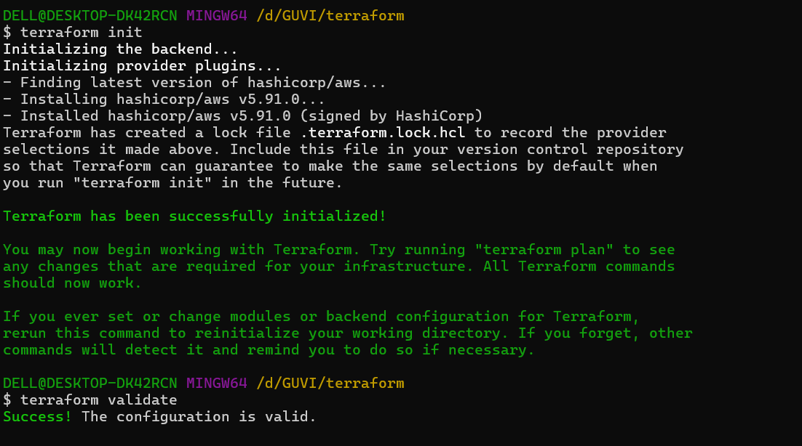

1. Terraform Validate

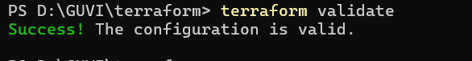

1. Terraform Plan

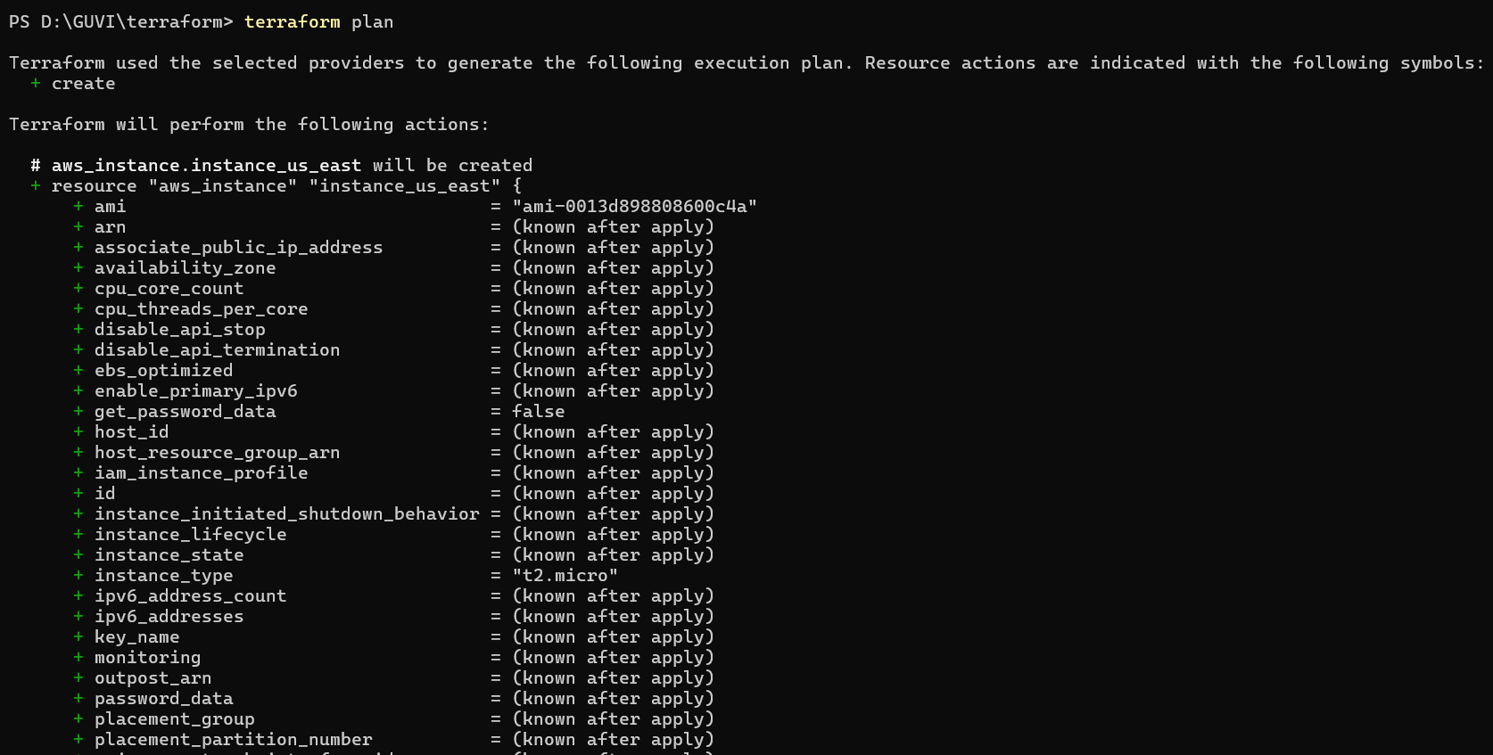

1. terraform apply -auto-approve

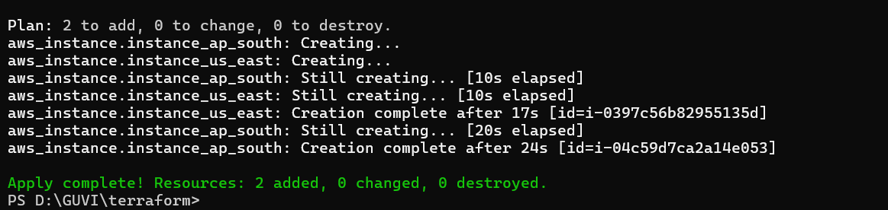

EC2 instances created

1. AWS Screenshot – Region 1 – us-east-1

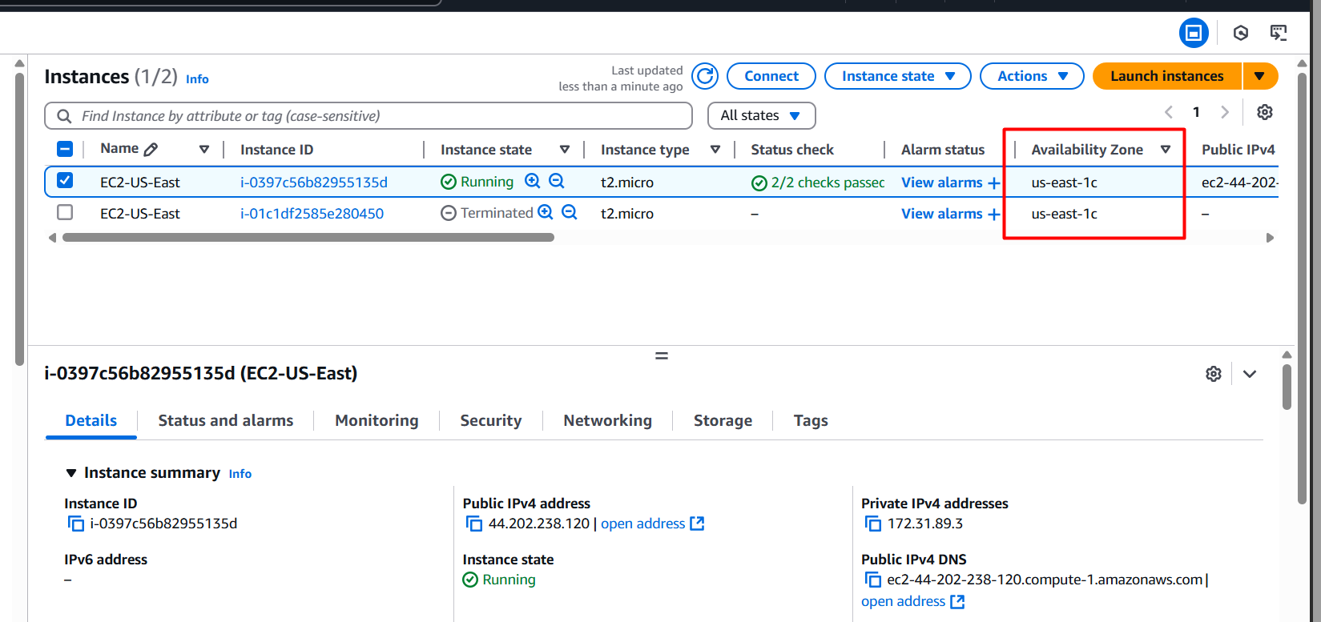

1. AWS Screenshot – Region 2 – ap-south-1

