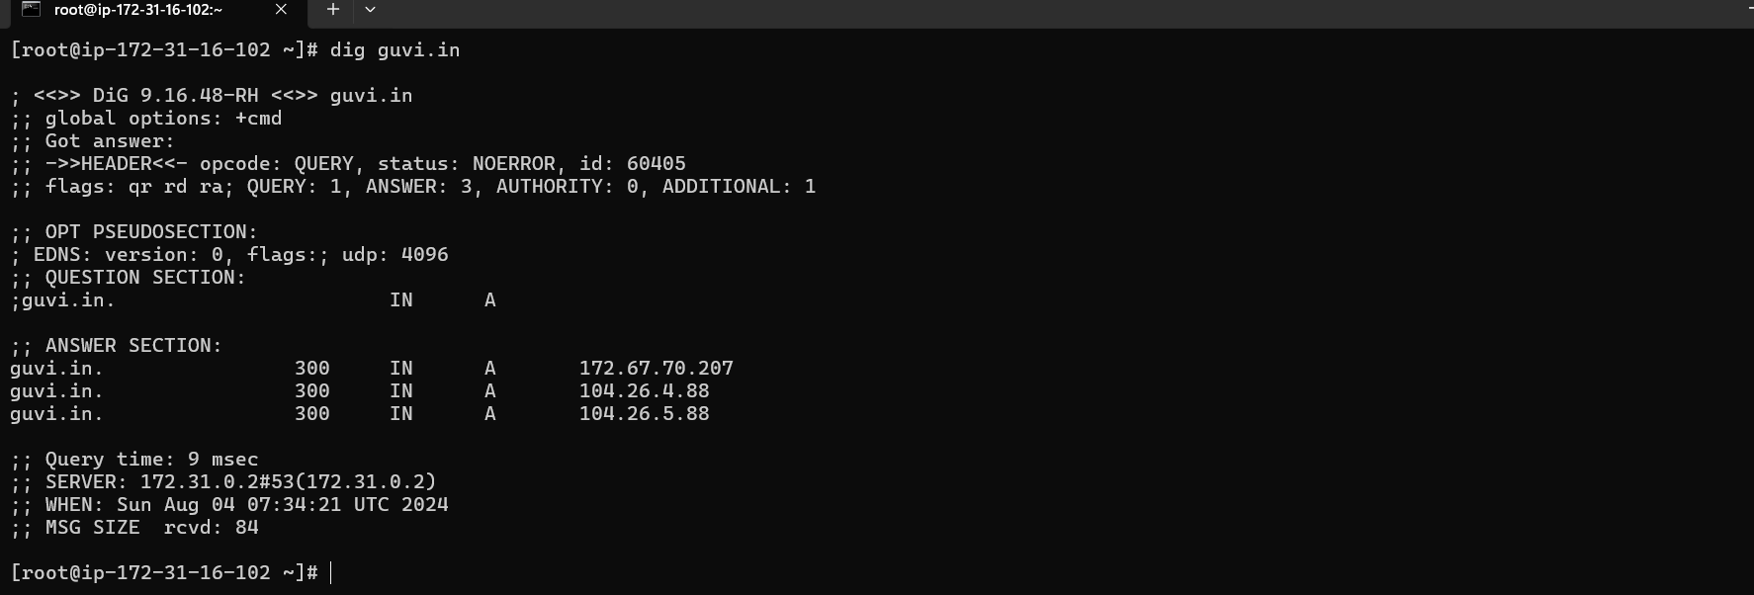

GUVI IP - 172.67.70.207

CPU /Memoray Usage - TOP

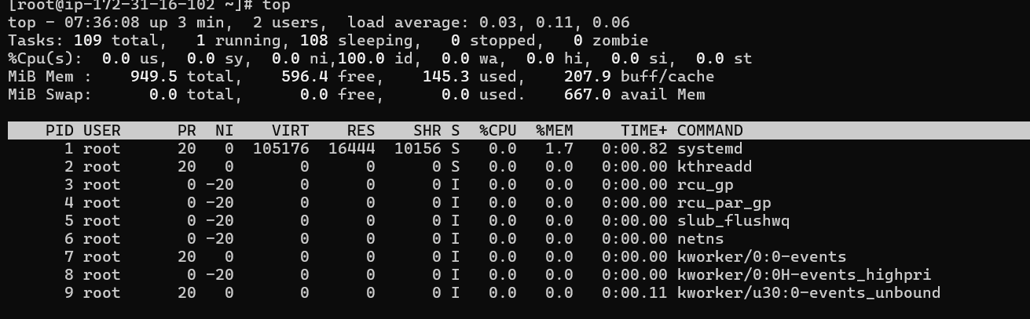

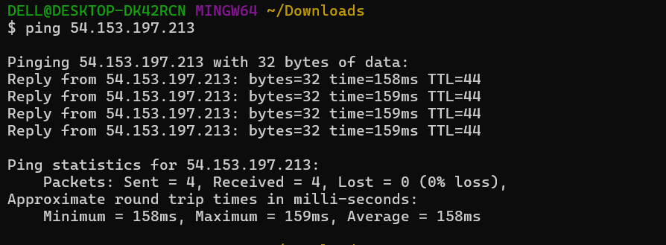

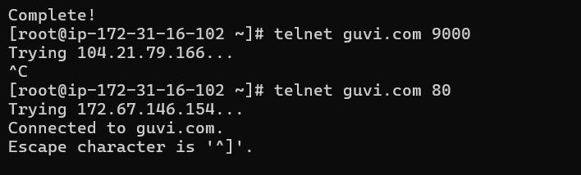

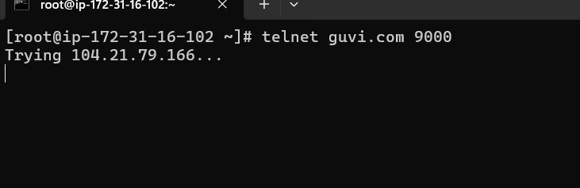

9000 port, the port is not open and unable to access. 80 – default port is open and which is able to access