Source Code Submission Document
Use of Blockchain and DAO in Patent Application System in India

Student Name: Shobit Garg
Team No: Team 5
Course: COOP-2
GitHub Repository: github.com/shobit000/Governance_tokens_contracts
Testnet Deployment Address: 0x84FBcb631232FDD3943101457E8E981125AB1DE5
Network: Ethereum Testnet (Sepolia)

Source Code Submission — Contents Overview
The complete project submission includes the following:
- MyGovernance.sol — Main Solidity smart contract
- compile.js — Contract compilation script using solc
- deploy.js — Deployment script using ethers.js v6
- contractRead.js — Script to read on-chain contract data
- contractWrite.js — Script to submit proposals and cast votes
- abi.js — Exported ABI for contract interaction
- package.json — Node.js dependencies and project config
- README.md — Setup and run instructions

1. Source_Code Complete project source code in proper folders.
  - MyGovernance.sol — Governor contract inheriting OpenZeppelin Governor, GovernorCountingSimple, GovernorVotes, GovernorVotesQuorumFraction, AccessControl
  - compile.js — Compiles contract using solc with optimizer (200 runs)
  - deploy.js — Deploys contract to testnet, logs deployed address and transaction hash
  - contractWrite.js — Creates proposals, polls state, casts votes end-to-end
  - contractRead.js — Reads contract name from on-chain instance
  - abi.js — Exports compiled ABI for use in frontend or scripts

2. README File A file named README.md containing:
  - Project title: Use of Blockchain and DAO in Patent Application System in India
  - Team member: Shobit Garg
  - Platform: Ethereum Testnet (Sepolia)
  - Programming languages: Solidity ^0.8.20, JavaScript (Node.js ES Modules)
  - Steps to run the code (see Section 5 below)
  - Required libraries and tools
  - Deployed contract address: 0x84FBcb631232FDD3943101457E8E981125AB1DE5
  - Token contract address passed at deployment: 0x315F6013042e2c11056AaF3a15f2D5a8740C5289

3. Requirements / Dependencies All required software, packages, libraries and versions:

Node.js v18+ (ES Module support required)
npm v8+
solc (Solidity compiler) — installed via npm
ethers.js v6 — installed via npm
dotenv — for loading environment variables
@openzeppelin/contracts v5 — Governor framework
Infura or Alchemy RPC endpoint (set in .env as API)
MetaMask wallet or private key with testnet ETH (set in .env as PRIVATE_KEY)

.env file format required:
API=https://sepolia.infura.io/v3/YOUR_PROJECT_ID
PRIVATE_KEY=your_wallet_private_key

4. Database / Dataset This project does not use a traditional database. On-chain state serves as the data layer:
  - All proposals, votes, and governance decisions are stored on-chain on the Ethereum testnet
  - Deployed contract address: 0x84FBcb631232FDD3943101457E8E981125AB1DE5
  - Transaction hash of deployment is logged by deploy.js on first run
  - No SQL or external database required

5. Run File / Execution Support Step-by-step instructions to run the project:

- Install dependencies:
npm install
- Set up environment variables: Create a .env file in the root folder with API and PRIVATE_KEY as shown in Section 3.
- Compile the contract:
node compile.js
- Deploy the contract:
node deploy.js
- Read contract data:
node contractRead.js
- Create a proposal and cast a vote:
node contractWrite.js

The project runs entirely from the command line. No frontend UI is required.

6. Output Proof
The following screenshots are included as proof of a working prototype deployed on the Ethereum Sepolia testnet.

Loom video (explaining the project) - Video

Screenshot 1 — GitHub Repository: MyGovernance.sol
The contract code hosted on GitHub showing the complete Solidity implementation including OpenZeppelin imports, 51% quorum configuration, voting period (50,400 blocks), and AccessControl setup.

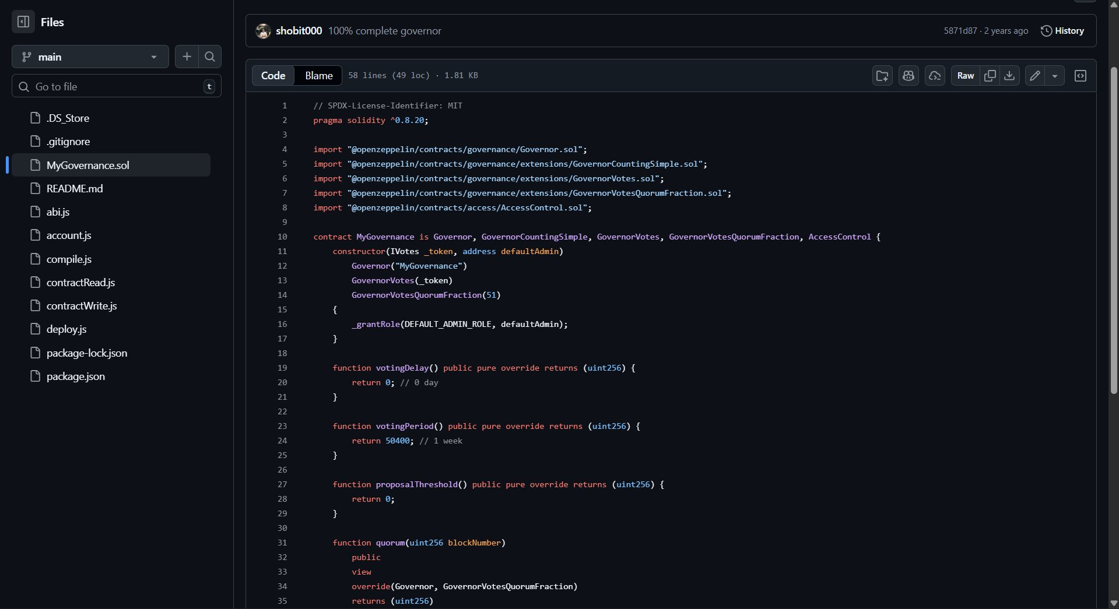
Figure 1: MyGovernance.sol — Governance contract on GitHub (shobit000/Governance_tokens_contracts)

Screenshot 2 — Etherscan Sepolia Testnet: Successful Deployment Transaction
Live transaction on Etherscan Sepolia testnet confirming the contract was successfully deployed. Status shows Success with 7 block confirmations, proving the governance contract is live on-chain.

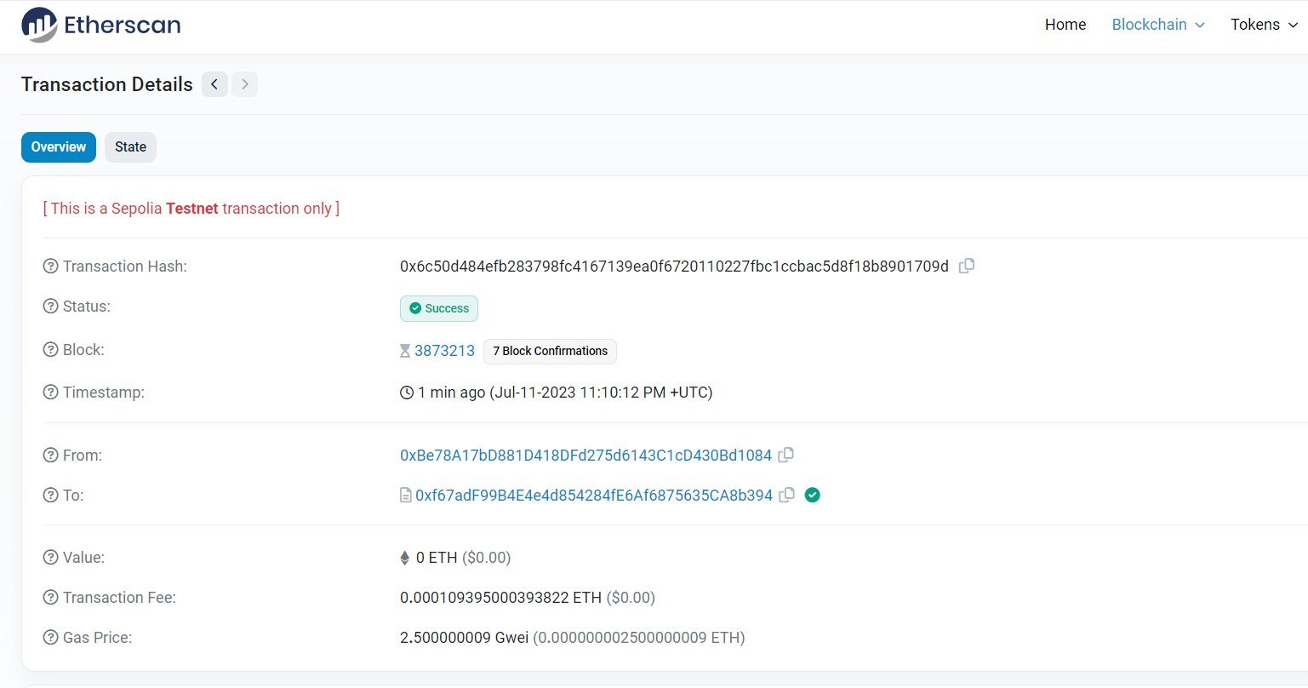
Figure 2: Etherscan Sepolia Testnet — Contract deployment transaction confirmed (Status: Success)

7. Project Report Final research paper in PDF format:
  - Title: Use of Blockchain and DAO in Patent Application System in India
  - Includes system architecture, smart contract workflow, KPI table, and 12-month implementation roadmap
  - Submitted separately as PatentChain_IN_Research_Paper.pdf

Important Notes

- Private Key: Do not commit your .env file or private key to GitHub. Add .env to .gitignore.
- Testnet ETH: Ensure wallet has sufficient Sepolia testnet ETH before running deploy.js.
- Contract Address: If redeploying, update the contractAddress variable in contractRead.js and contractWrite.js.

