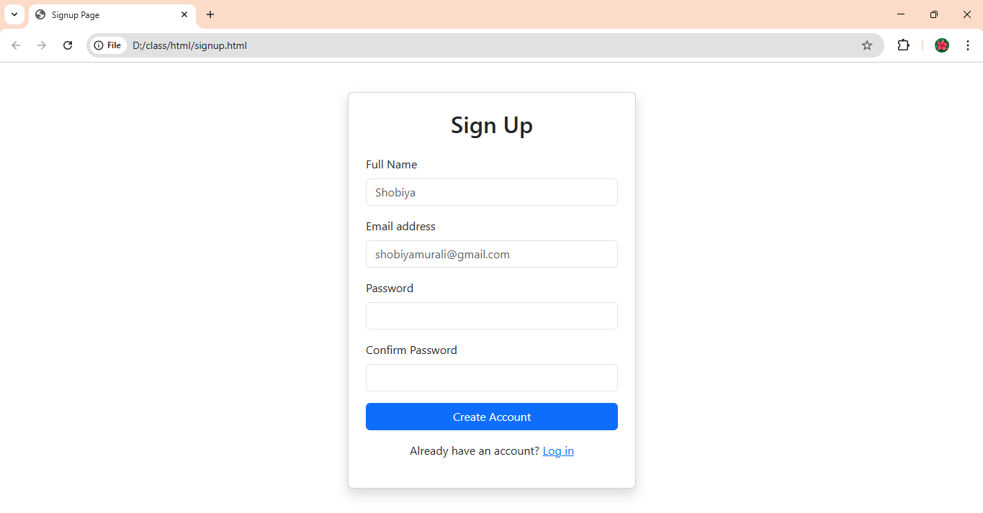

<!DOCTYPE html>

<html lang="en">

<head>

  <meta charset="UTF-8">

  <meta name="viewport" content="width=device-width, initial-scale=1">

  <title>Signup Page</title>

  <link href="https://cdn.jsdelivr.net/npm/bootstrap@5.3.3/dist/css/bootstrap.min.css" rel="stylesheet">

  <script src="https://cdn.jsdelivr.net/npm/bootstrap@5.3.3/dist/js/bootstrap.bundle.min.js"></script>

</head>

<body>

  <div class="container d-flex justify-content-center align-items-center min-vh-100">

    <div class="card p-4 shadow" style="width: 100%; max-width: 400px;">

      <h2 class="text-center mb-4">Sign Up</h2>

      <form>

        <div class="mb-3">

          <label for="name" class="form-label">Full Name</label>

          <input type="text" class="form-control" id="name" placeholder="Shobiya" required>

        </div>

        <div class="mb-3">

          <label for="email" class="form-label">Email address</label>

          <input type="email" class="form-control" id="email" placeholder="shobiyamurali@gmail.com" required>

        </div>

        <div class="mb-3">

          <label for="password" class="form-label">Password</label>

          <input type="password" class="form-control" id="password" required>

        </div>

        <div class="mb-3">

          <label for="confirm-password" class="form-label">Confirm Password</label>

          <input type="password" class="form-control" id="confirm-password" required>

        </div>

        <div class="d-grid">

          <button type="submit" class="btn btn-primary">Create Account</button>

        </div>

      </form>

      <p class="text-center mt-3">

        Already have an account? <a href="#">Log in</a>

      </p>

    </div>

  </div>

</body>

</html>