Salary Survey Data Cleaning Pipeline Report
Shoaib
2026-05-18
Table of contents

Config loaded successfully

1. Dataset Overview
Source: Ask A Manager Salary Survey 2021
Raw size: 28215 rows and 18 columns
Download date: April 2026
Variables: 18 variables covering salary, demographics, work experience and location
Pipeline outputs: Cleaned dataset exported in four formats — .sav, .dta, .xlsx, .rds
Assigned scope: All 18 variables in the dataset

2. Data Quality Diagnostics Before Cleaning

2.1 Missingness Overview Before and After Cleaning
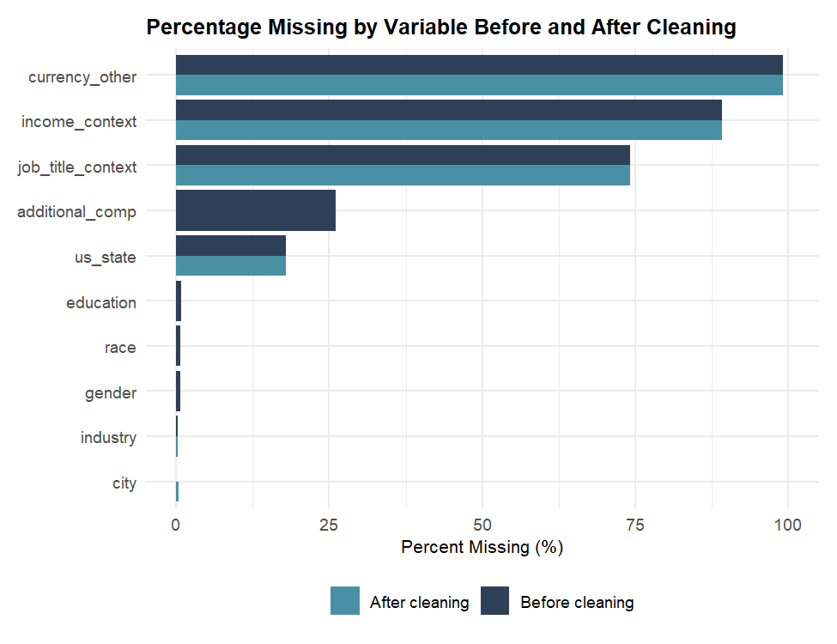

2.2 Key Issues Identified
- Country: 390 unique values found — USA alone had over 50 spelling variants
- Salary: Range 0 to 6,000,070,000 — 136 entries below 1,000, 34 zeros
- Additional compensation: 7,372 missing (26%) — survey wording suggests no bonus
- Experience logic: 265 entries where field experience exceeded overall experience
- City: 187 remote worker entries, 121 missing, 10 invalid entries
- Gender: Two near-identical categories merged into one standard category

3. Cleaning Decisions

3.1 Stage 1: Whitespace Removal
Leading and trailing whitespace stripped from all text columns. 1,708 country entries had invisible spaces causing duplicate values.

3.2 Stage 2: Timestamp Flagging
618 entries outside the 2021 survey period flagged but retained in the dataset.

3.3 Stage 3: Country Normalisation
All known country variants mapped to canonical names. 26 invalid entries flagged. USA variants reduced from over 50 to one standard value.

3.4 Stage 4: Salary Outlier Flagging
IQR method applied. 34 zero salaries, 102 below 1,000 and 1,218 above the upper fence of 192,750 flagged. No rows dropped.

3.5 Stage 5: Additional Compensation Flagging
7,372 missing and 2,045 above 500,000 flagged.

3.6 Stage 6: Industry Normalisation
96 lowercase entries corrected to title case. Library and Libraries merged into Library.

3.7 Stage 7: Job Title Flagging
1 missing and 2 invalid entries flagged.

3.8 Stage 8: Gender Standardisation
Prefer not to answer (1 entry) merged into Other or prefer not to answer (298 entries).

3.9 Stage 9: Experience Band Formatting
The band 5-7 years standardised to 5 - 7 years across both experience columns for consistency.

3.10 Stage 10: Experience Logic Checks
265 impossible field vs overall experience entries flagged. 12 impossible age vs experience combinations flagged.

3.11 Stage 11: City Flagging
121 missing, 187 remote entries and 10 invalid entries flagged.

3.12 Stage 12: Multi-State Entries
114 US state entries with multiple states reduced to first state listed.

3.13 Stage 13: Currency Other Standardisation
All values converted to uppercase. 8 numeric and 10 non-currency entries flagged.

3.14 Stage 14: Currency Country Cross Check
110 USD entries for clearly non-US countries flagged for transparency.

3.15 Stages 15 and 16: Missing Education and Race
240 missing education and 196 missing race entries flagged for imputation.

4. Imputation Applied
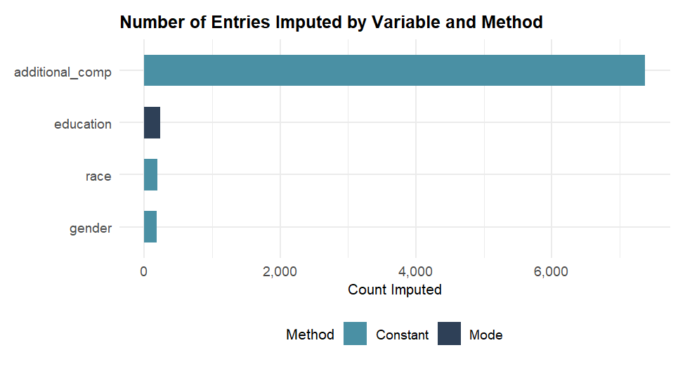
Variable | Method | Value Used | Count | Justification
Education | Mode | College degree | 240 | Dominant category at 48%
Gender | Constant | Other or prefer not to answer | 185 | Missingness is informative
Race | Constant | Prefer not to answer | 196 | Missingness is informative
Additional comp | Constant | 0 | 7,372 | Survey wording says if any

5. Post Cleaning Summary
Rows: 28215 — no rows were removed during cleaning
Columns: 18 original variables retained in the final export

5.1 Final Missingness After Cleaning and Imputation
Variables with remaining missing values after cleaning and imputation
Variable | Missing Count | Percent Missing
industry | 84 | 0.30
job_title | 1 | 0.00
job_title_context | 20933 | 74.19
currency_other | 27985 | 99.18
income_context | 25155 | 89.15
country | 1 | 0.00
us_state | 5070 | 17.97
city | 121 | 0.43

5.2 Annual Salary Distribution After Cleaning
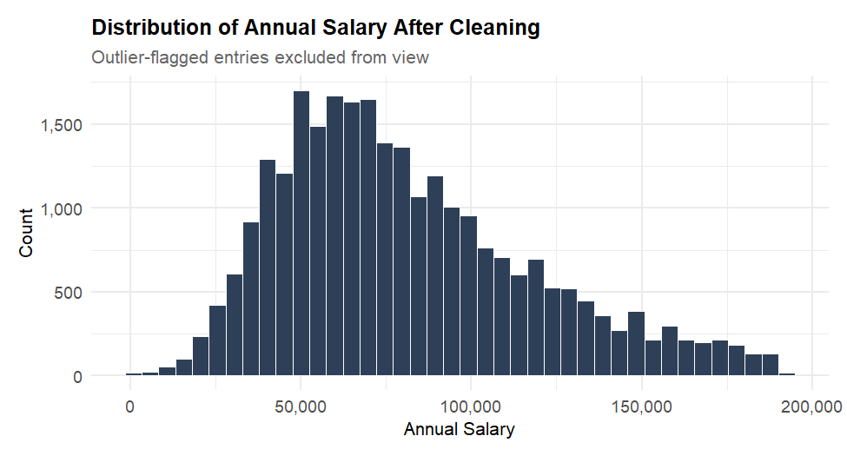

5.3 Additional Compensation Distribution After Cleaning
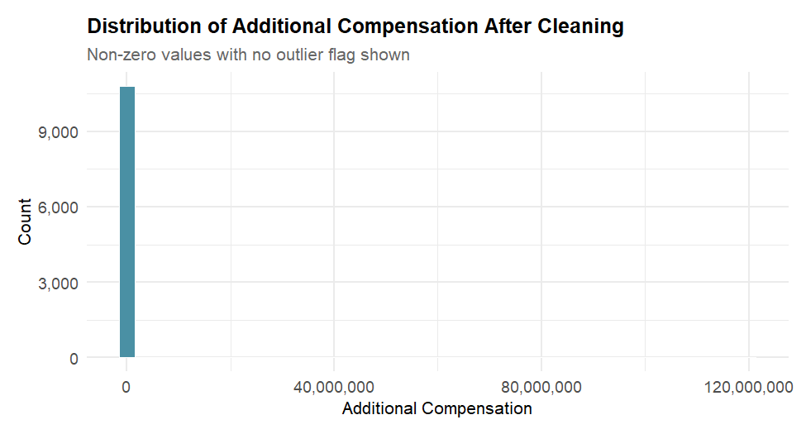

5.4 Observed vs Imputed Education
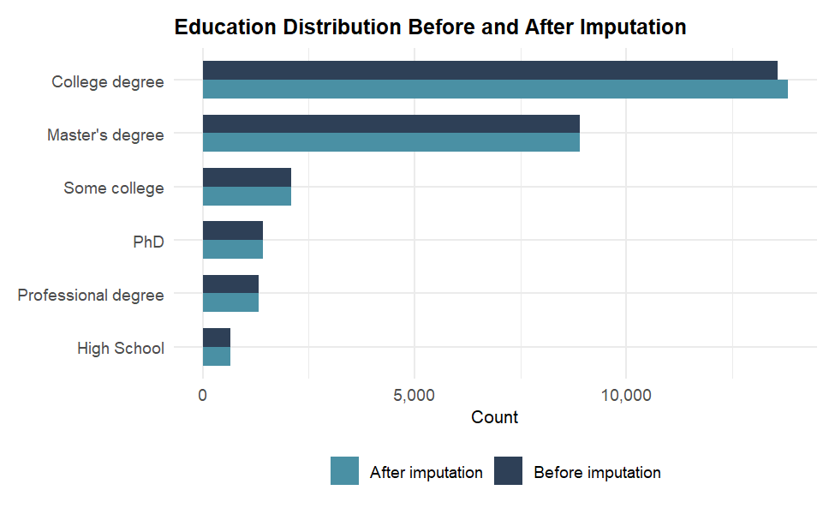

5.5 Median Salary by Education Level
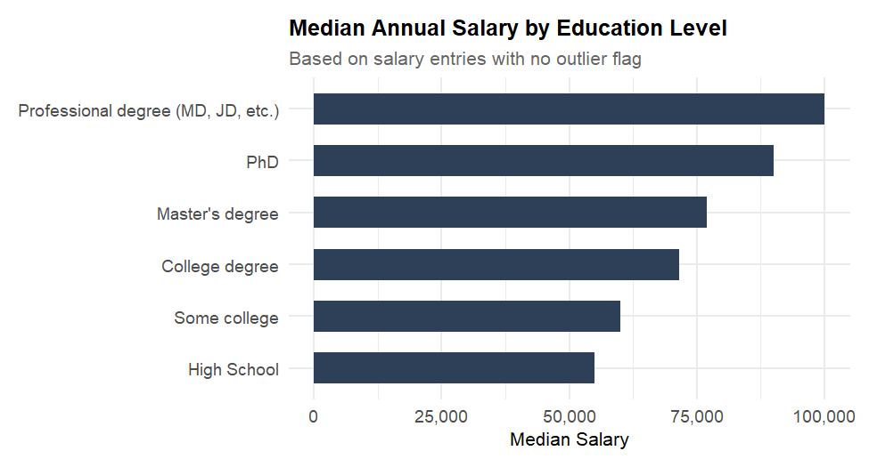

6. Limitations and Known Risks
- Country names were normalised using manual mapping. Some ambiguous entries may have been incorrectly mapped or flagged.
- Salary outliers were flagged using the IQR method but were not removed. Analyses using this dataset should filter flagged rows appropriately.
- Additional compensation missing values were imputed with zero based on survey wording. This assumption may not hold for all respondents.
- The dataset is self-reported with no verification of salary figures. Extreme values may reflect genuine high earners or data entry errors.
- Timestamps outside the 2021 survey period suggest the survey remained open beyond the intended collection window. These entries are retained but flagged.
- Industry is a freetext field with 1,089 unique values. Standardisation was limited to case correction and merging of obvious near-duplicates.
- 265 entries where field experience exceeded overall experience were flagged but not corrected as the true values are unknown.

