Pangasinan State University

Alaminos City Campus

Documentation of Final Project

Bani E-Market

In partial fulfillment

of the Requirements for the

Degree Bachelor of Science in

Information Technology

Submitted to:

Ma’am Ma. Joshua Caras.

Instructor

Submitted by:

Reyneil Puda.

Ranny T.Ortillo.

Ma. Angelika O.Santos.

Mae N.Laderas.

Sheilla O. Cabuburac

BSIT III-A

BS Information Technology

Table of Contents

Table of Contents. . . . . . . . . . . . . . . . . . . . . . . . . . 2

System Flow. . . . . . . . . . . . . . . . . . . . . . . . . . . . . 3

Entity Relationship Diagram. . . . . . . . . . . . . . . . . . . . . 4

Compilation of Screenshots of Pages. . . . . . . . . . . . . . . . . 5

Customer Home Page . . . . . . . . . . . . . . . . . . . . . . . . . 5

Order Page . . . . . . . . . . . . . . . . . . . . . . . . . . . . . 6

Product Detail . . . . . . . . . . . . . . . . . . . . . . . . . . . 7

Add Product/Create . . . . . . . . . . . . . . . . . . . . . . . . . 8

Product Availability. . . . . . . . . . . . . . . . . . . . . . . . 9

Order Detail Page. . . . . . . . . . . . . . . . . . . . . . . . . . 10

Customer Detail. . . . . . . . . . . . . . . . . . . . . . . . . . . 11

Admin Log-in Page. . . . . . . . . . . . . . . . . . . . . . . . . . 12

Dashboard. . . . . . . . . . . . . . . . . . . . . . . . . . . . . . 13

Check Sales Page . . . . . . . . . . . . . . . . . . . . . . . . . . 14

System Flow

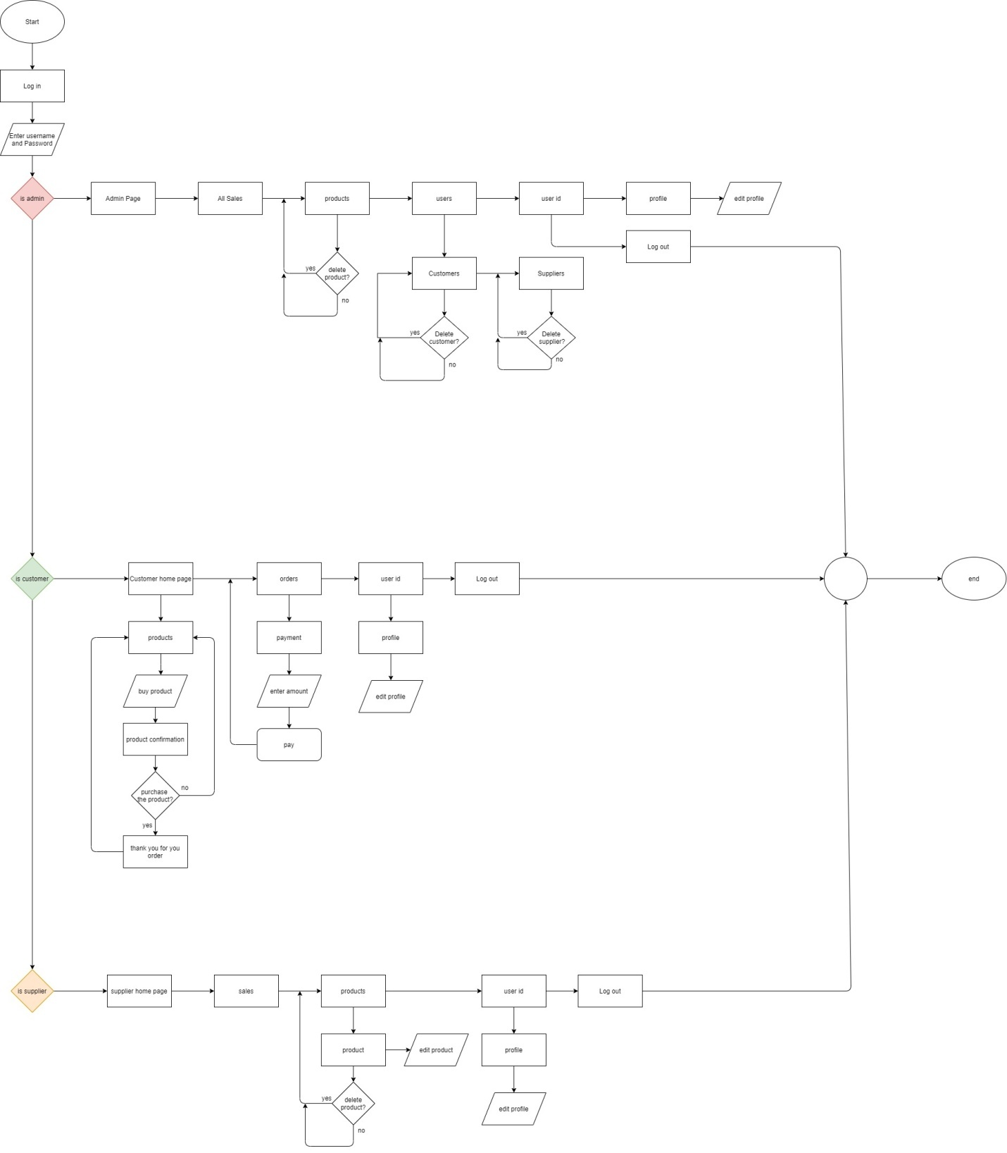

Entity Relationship Diagram (ERD)

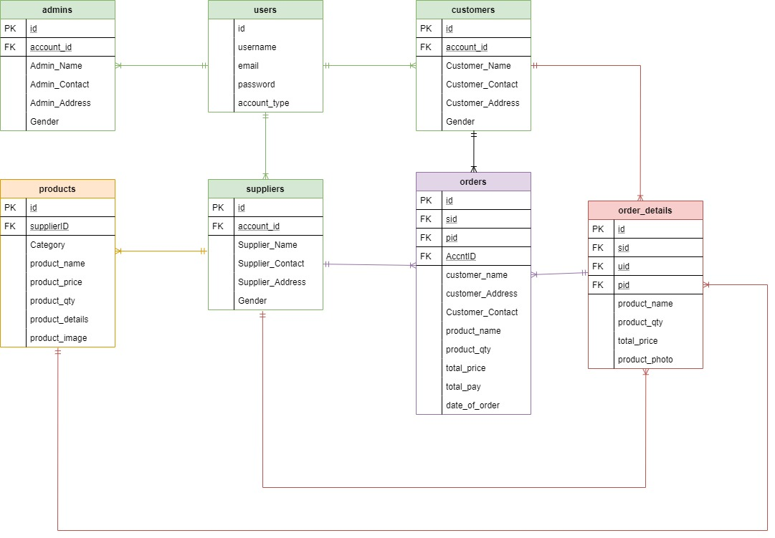

This shows the connection and attribute of entities in the system.

Compilation of Screenshots of pages

Customers Home Page

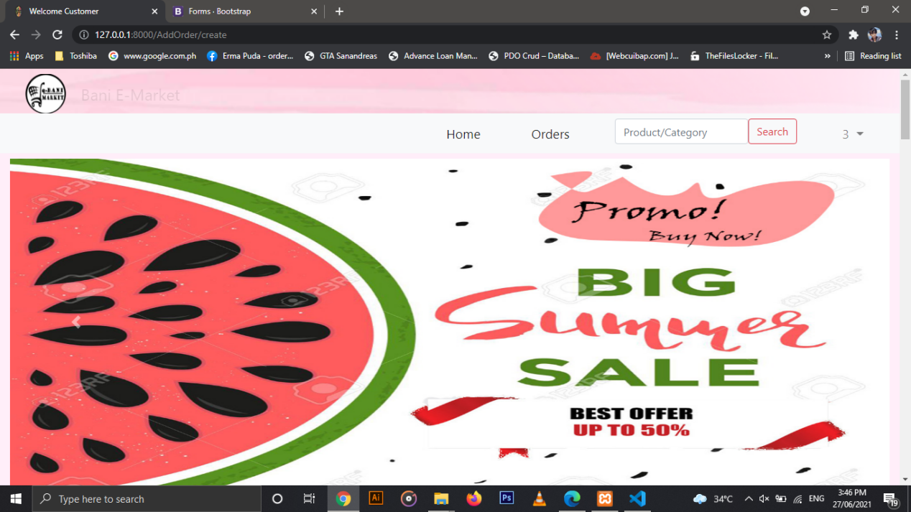

The home page contains an image that has a tagline and a buttons for Home, Orders, and the Search bar for the product and company and this buttons include some information that will lead you to buy products.

Add Order Page

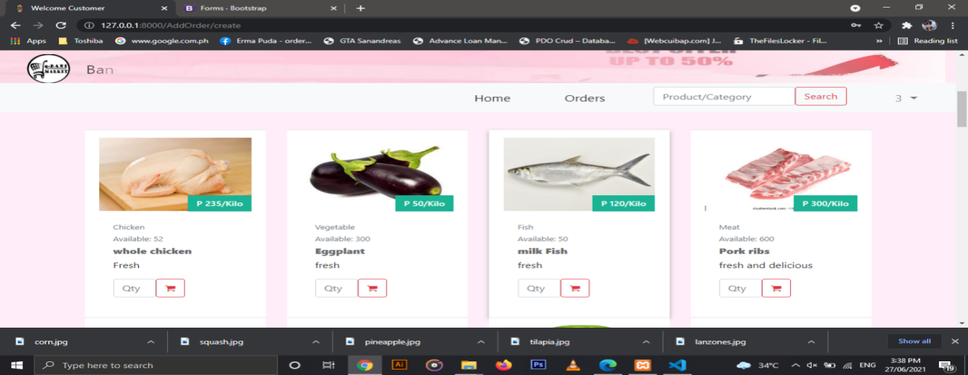

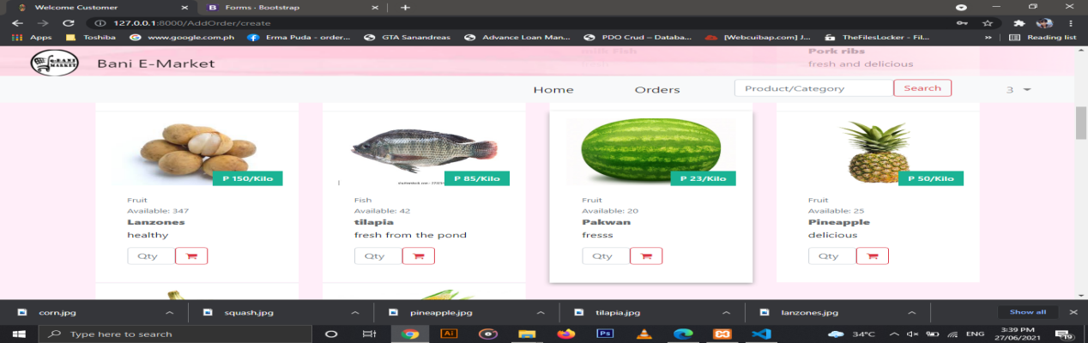

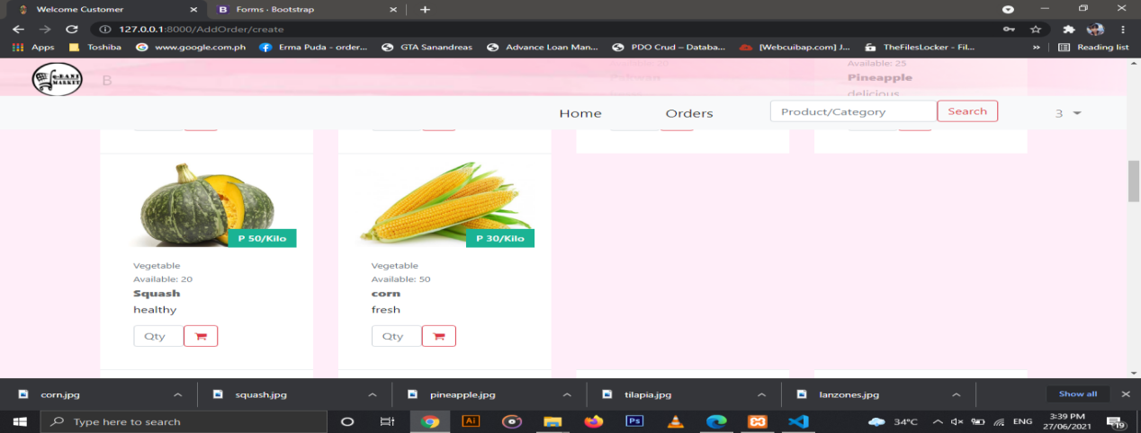

These three pages contain what products are available in our page that we can buy online. As you see, it contains the availability of the numbers of the product. It also includes the name, description of the product you want to buy and the category of product if where they belong. So in ordering a product, just click the “Qty” that is located at the button of the product that you want to buy.

Product Detail

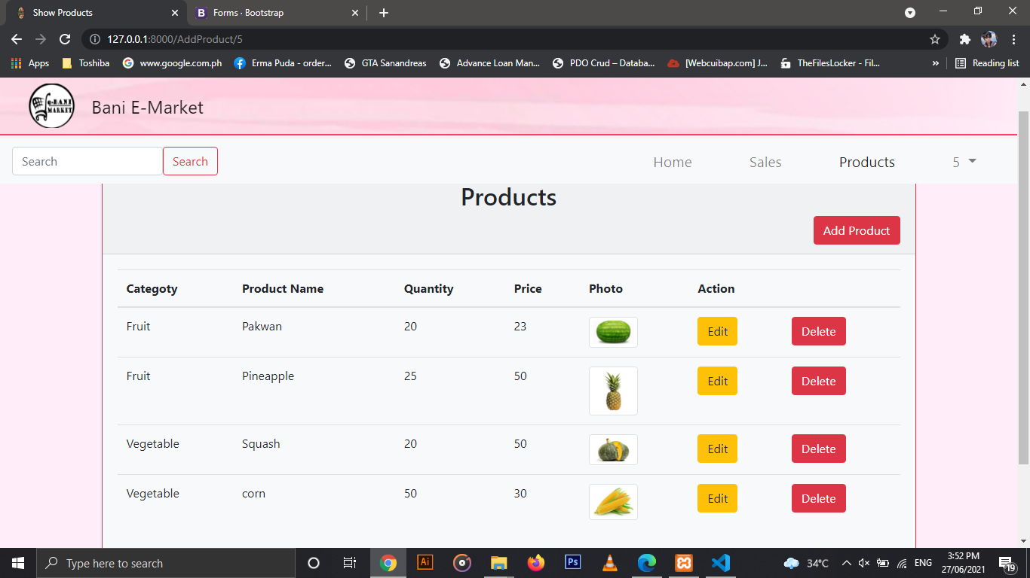

This page includes the details of the products such as the category, product name, quantity, price, photo and etc.

Add Product/Create

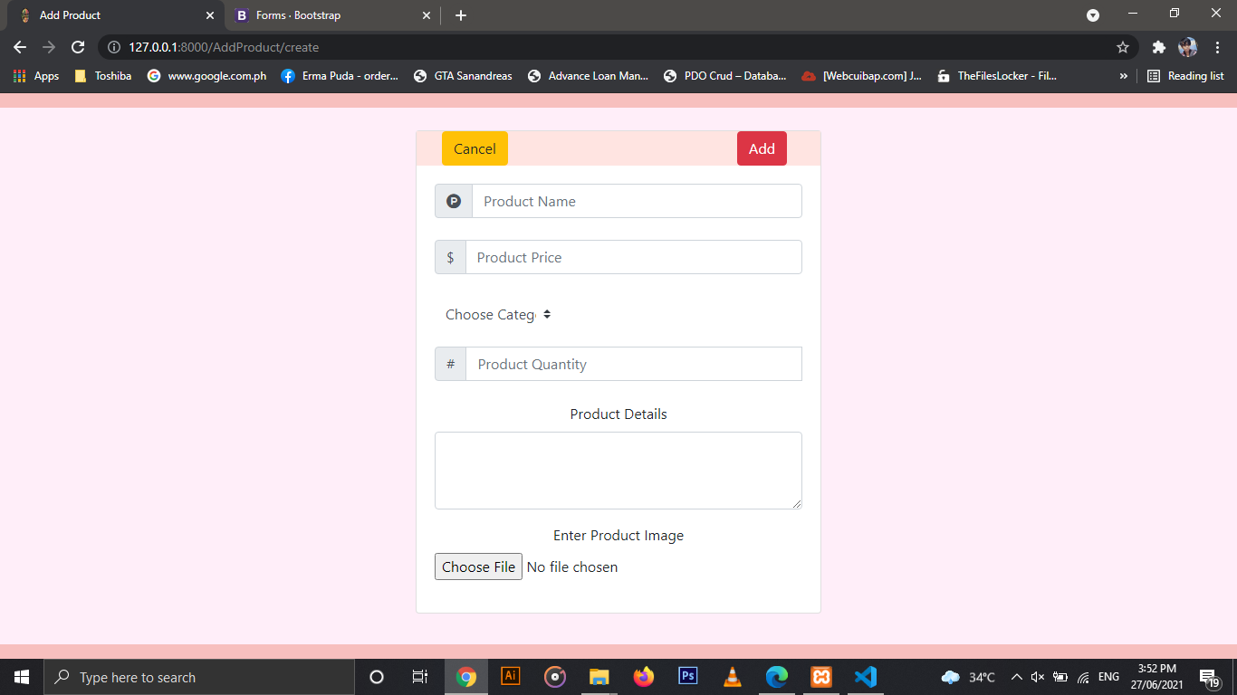

In adding a product, the user needs some information about the product such as the product name, product price, the category, the products quantity to be available, product details and the image of the product that you want to add.

Product Availability

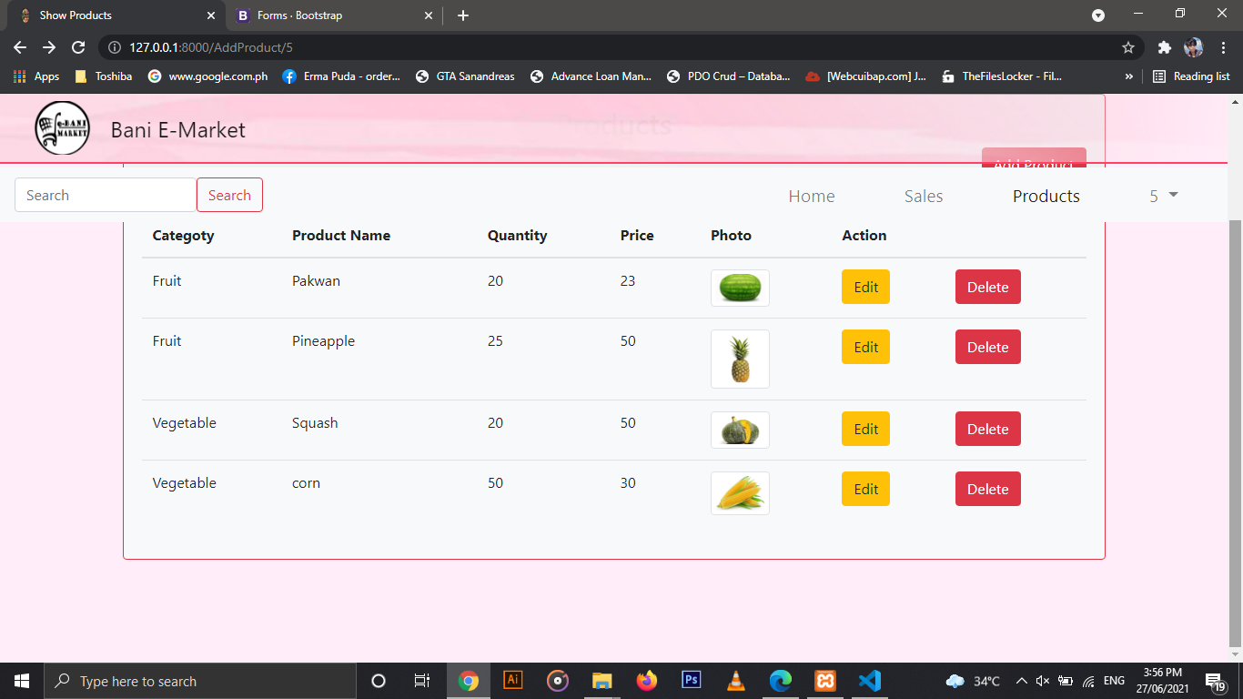

In this page, it shows the number of a product that is being available in the e-market.

Order Detail Page

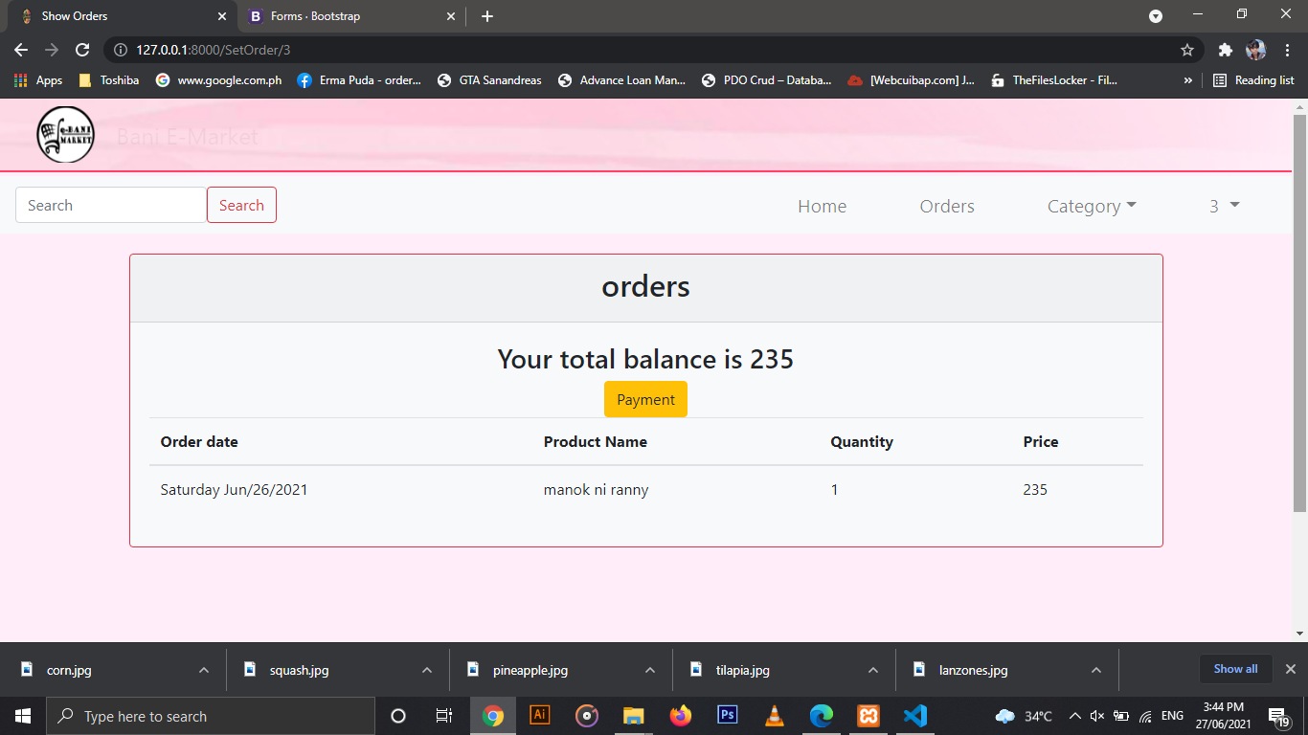

In this page, it shows the total balance of your payment and the information of product such as the order date, the product name, quantity and the price of the product that you buy.

Customer Detail

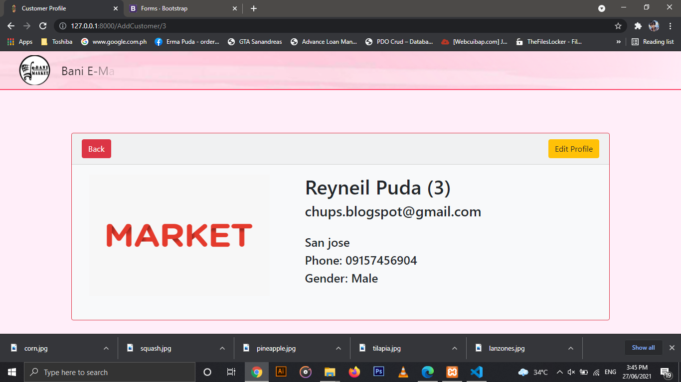

This page includes the personal information of the customer who wants to buy a product. It also includes the name, email, address, phone number and the number of the user.

Admin Log-in Page

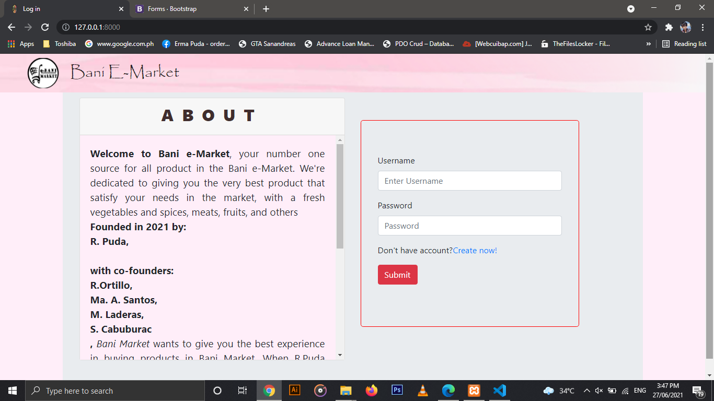

This page contains the log in page and the ‘About’ of our page. In the log in site, the user will enter his/her username and password and the about shows the information about the e-market. It also includes the names of the group who created it.

Dashboard Page

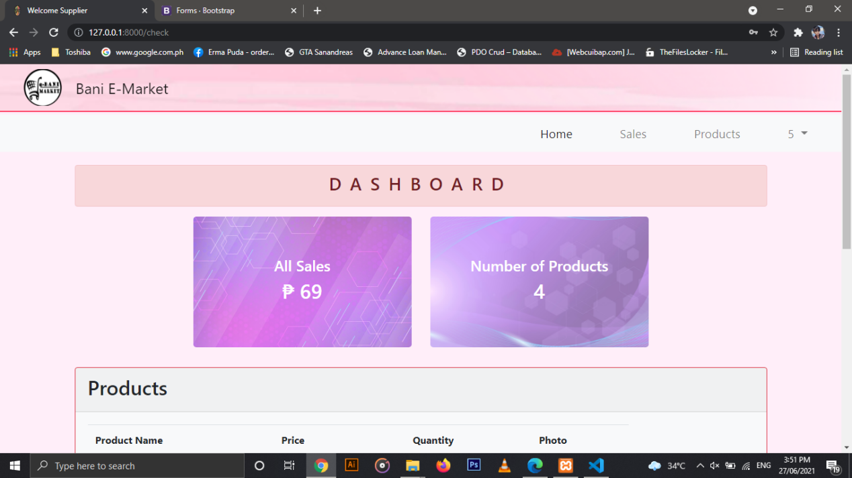

This page shows all sales and the number of products that is available. So as you can see, four fruits are being available in the dashboard. so if you want to see all products available you can click the “see all button” that is located at the bottom of dashboard.

Check Sales Page

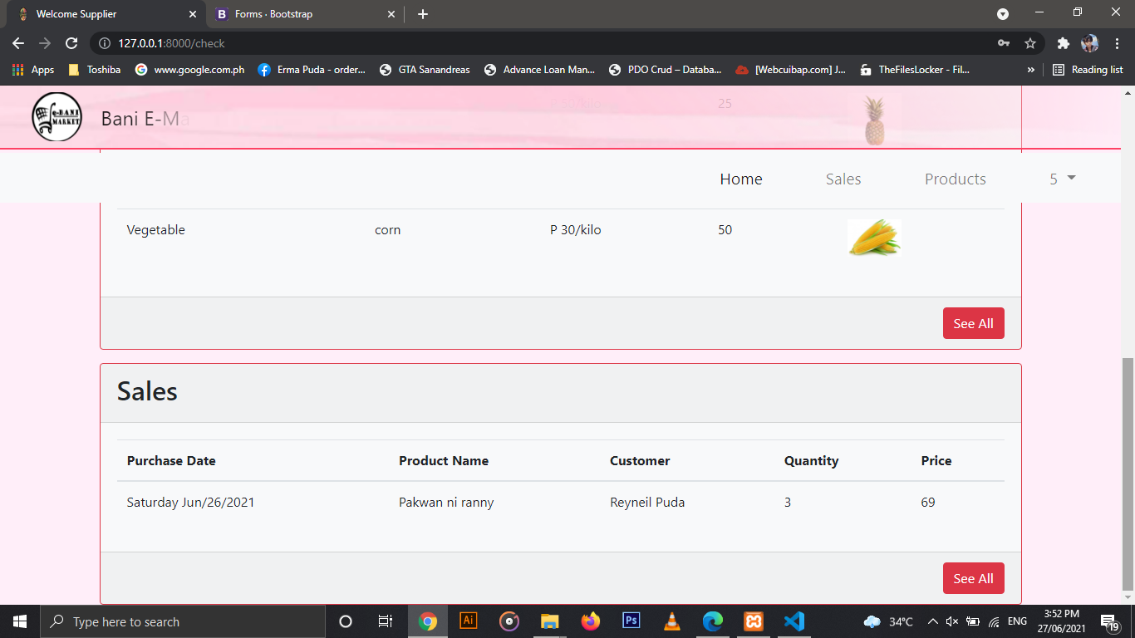

In this page, it shows the previous sale of the e-market it includes the date when they purchase, the name of the product, the customer’s name, the quantity of the product that is being sold and the price of it.

**Score:**

Reyneil Puda:

Ranny T Ortillo: 85

Ma. Angelika O.Santos: 83

Mae N.Laderas: 82

Sheilla O. Cabuburac: 82

END.