PROJECT REPORT
Submitted by
Team ID: PNT2022TMID07149
PRIYANKA C (130719104059)
SAVITHA V (130719104070)
SHANMUGA PRIYA S (130719104072)
YASMI DEVI R (130719104094)
In partial fulfilment for the award of the degree of
BACHELOR OF ENGINEERING
In
COMPUTER SCIENCE ENGINEERING


JERUSALEM COLLEGE OF ENGINEERING
(An Autonomous Institution, Affiliated to Anna University, Chennai)
NBA & NAAC (A GRADE) ACCREDITED INSTITUTION
Velachery main road, Narayanapuram, Pallikaranai,
Chennai - 600100.
- INTRODUCTION
The project aims to develop a system that converts the sign language into a human hearing voice in the desired language to convey a message to normal people, as well as convert speech into understandable sign language for the deaf and dumb.
  - PROJECT OVERVIEW:
In our society, we have people with disabilities. The technology is developing day by day but no significant developments are undertaken for the betterment of these people. Communications between deaf-mute and a normal person has always been a challenging task. It is very difficult for mute people to convey their message to normal people. Since normal people are not trained on hand sign language. In emergency times conveying their message is very difficult. The human hand has remained the preferred method of communication.
  - PURPOSE:
The project's purpose is to create a system that translates sign language into a human understandable language so that ordinary people may understand it.
- LITERATURE SURVEY:
  - EXISTING SYSTEM
Technology:
One of the easiest ways to communicate is through technology such as a smart phone or laptop. A deaf person can type out what they want to say and a person who is blind or has low vision can use a screen reader to read the text out loud. A blind person can also use voice recognition software to convert what they are saying in to text so that a person who is Deaf can then read it Interpreter:
If a sign language interpreter is available, this facilitates easy communication if the person who is deaf is fluent in sign language. The deaf person and person who is blind can communicate with each other via the interpreter. The deaf person can use sign language and the interpreter can speak what has been said to the person who is blind and then translate anything spoken by the blind person into sign language for the deaf person.
Just Speaking:
Depending on the deaf person's level of hearing loss, they may be able to communicate with a blind person who is using speech. For example, a deaf person may have enough residual hearing (with or without the use of an assistive hearing device such as a hearingaid) to be able to decipher the speech of the person who is blind or has low vision. However, this is often not the most effective form of communication, as it is very dependent on the individual circumstances of both people and their environment (for example, some places may have too much background noise).
  - REFERENCES:
[1] Verma, P., Shimi S. L. and Priyadarshani, R., "Design of Communication Interpreter for Deaf and Dumb Person", Vol.4, no.1, 2013
[2] Van Rossum, G., "Python Programming Languag", In Proceedings of USENIX Annual Technical Conference, Vol.41, No.36,2007.
[3] Banzi, M., and Shiloh, M.,“Getting Started with Arduino: The Open Source Electronics Prototyping Platform”, Maker Media, Inc., 2014.
[4] Desai, P., “Python Programming for Arduino”,Packt Publishing Ltd, 2015.
[5] D’Ausilio, A., “Arduino: A low-cost multipurpose lab equipment”, Behavior research methods, Vol. 44, No,.2, pp.305-313, 2012.

2.3PROBLEM STATEMENT DEFINITION:
Communication is the only medium by which we can share our thoughts or convey the message but for a person with disability (deaf and dumb) faces difficulty in communication with normal person. Because of this, a person who lacks in hearing and speaking ability is not able to stand in race with normal person

- IDEATION AND PROPOSED SOLUTION:
  - EMPATHY MAP:
An empathy map is a collaborative tool teams can use to gain a deeper insight into their customers.
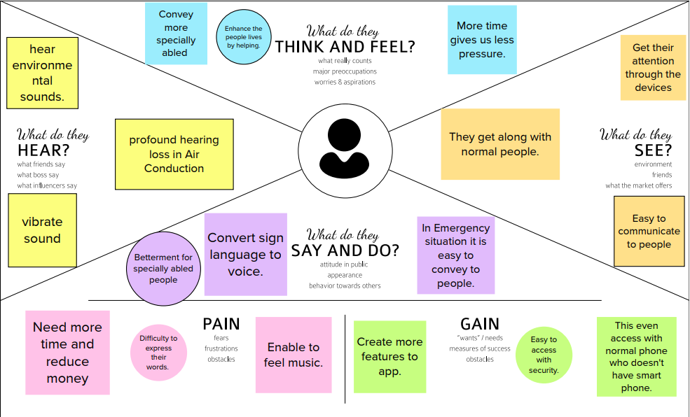

  - IDEATION AND BRAIN STORMING :

Ideation is the process of forming ideas from conception to implementation.

Brainstorming is a group problem-solving method that involves the spontaneous contribution of creative ideas and solution

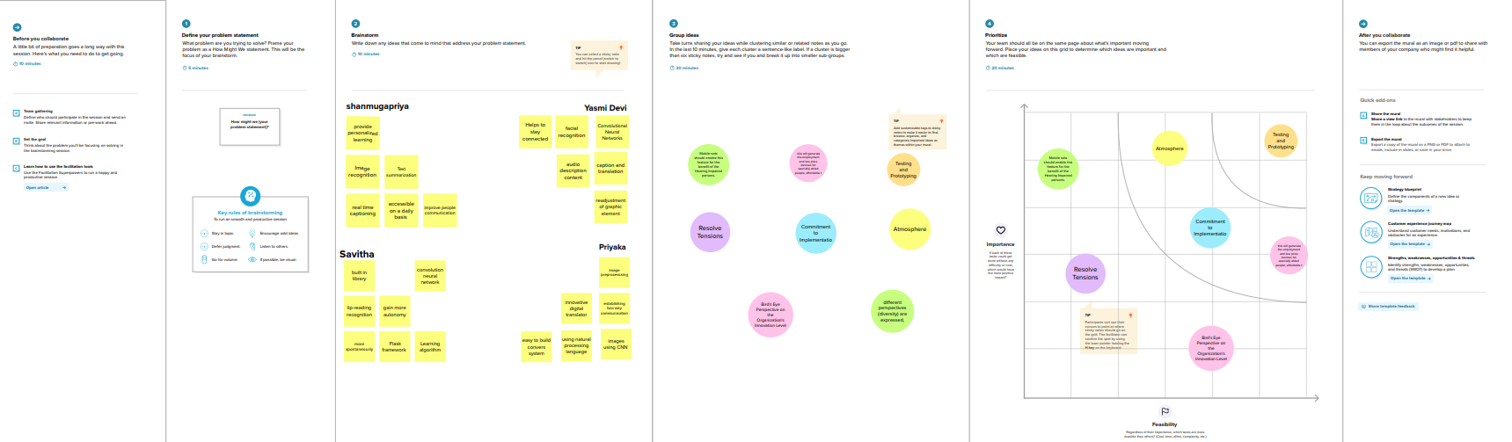

  - PROPOSED SOLUTION:

This project describes the system that overcomes the problem faced by the speech and hearing
impaired. The objectives of the research are as follow:
1. To design and develop a system which lowers the communication gap between speec hearing impaired and normal world.
2. To build a communication system that enables communications between deaf-dumb person and a normal person.
3. A convolution neural network is being used to develop a model that is trained on various hand movements. This model is used to create an app. This programme allows deaf and hard of hearing persons to communicate using signs that are then translated into human readable text

3.4 PROBLEM SOLUTION FIT:
Problem-Solution canvas is a tool for entrepreneurs, marketers and corporate innovators, which helps them identify solutions with higher chances for solution adoption, reduce time spent on solution testing and get a better overview of current situation.
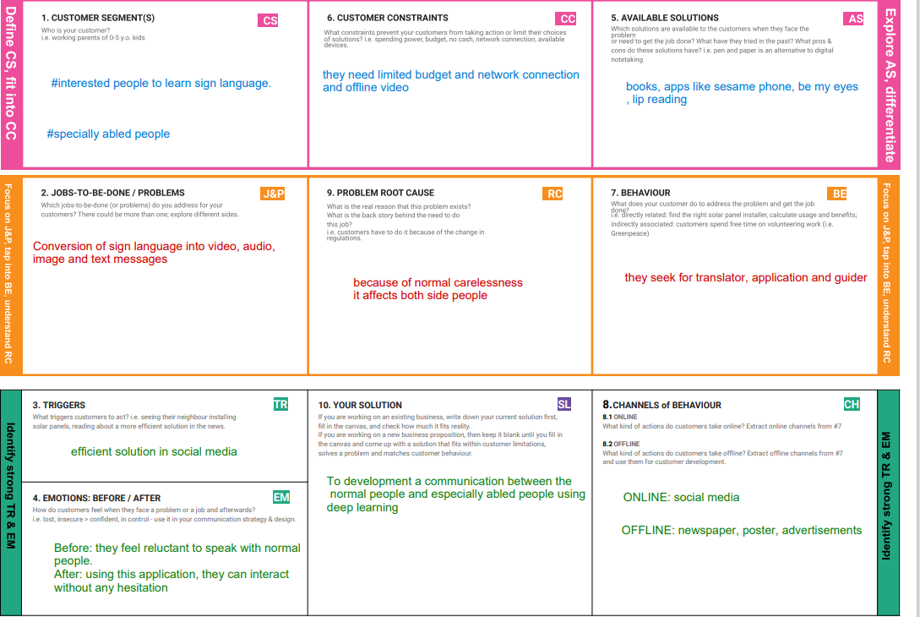

- REQUIREMENT ANALYSIS:

4.1 FUNCTIONAL REQUIREMENTS

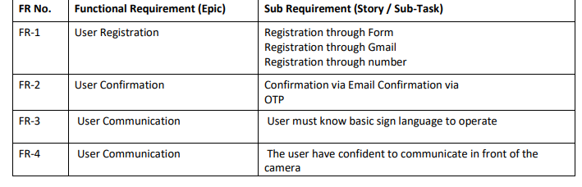
4.2 NON FUNCTIONAL REQUIREMENTS
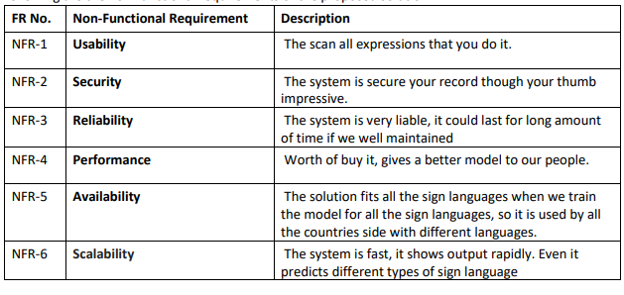

- PROJECT DESIGN:
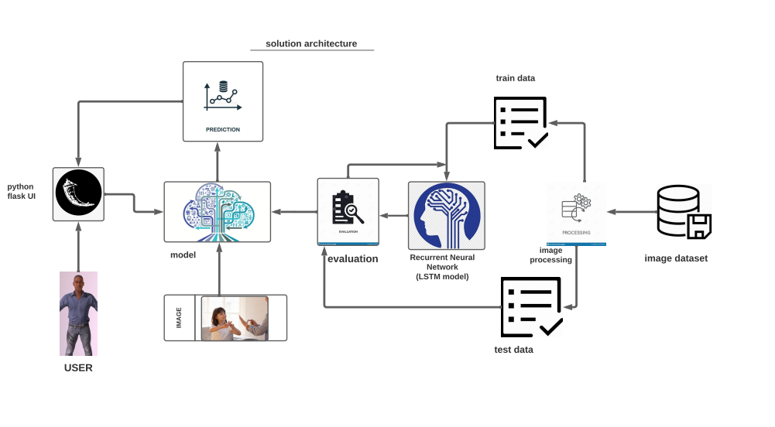
Project design is an early phase of the project lifecycle where ideas, processes, resources, and deliverables are planned out.

5.1 DATA FLOW DIAGRAMS:

A data flow diagram is a graphical or visual representation using a standardized set of symbols and notations to describe a business's operations through data movement.

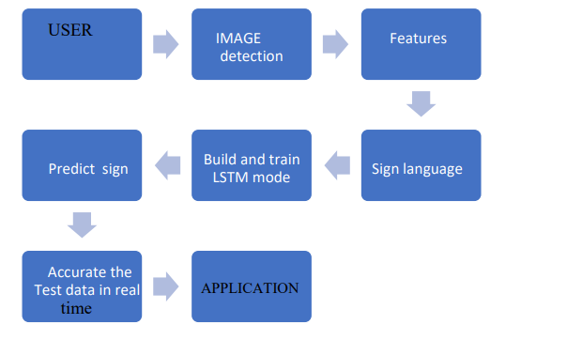
5.2. SOLUTION & TECHNICAL ARCHITECTURE:

Solution architecture is a description of a discrete and focused business operation or activity and how it supports that operation.

Technical Architecture is a form of IT architecture that is used to design computer systems.
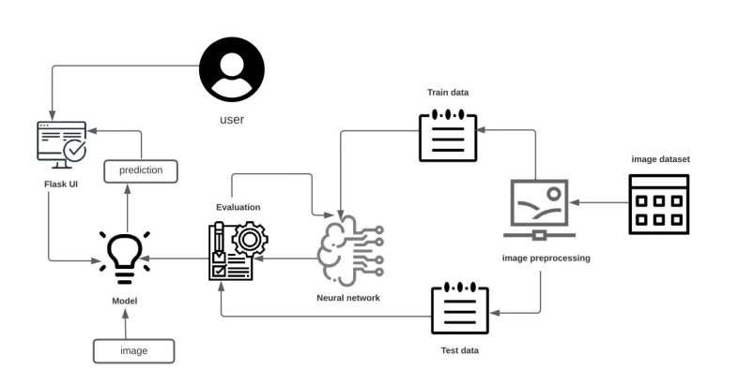

5.3 USER STORIES:
A user story is an informal, general explanation of a software feature written from the perspective of the end user or customer.

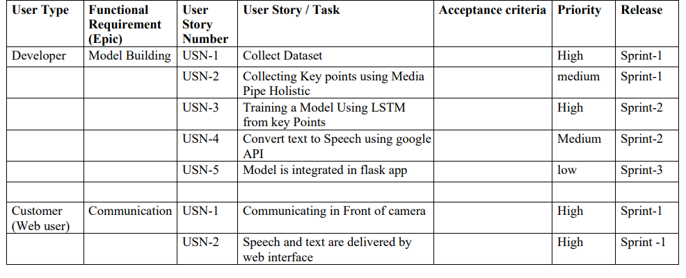

- PROJECT PLANNING AND SCHEDULING:

  - SPRINT PLANNING AND ESTIMATION:
The objective of the Estimation would be to consider the User Stories for the Sprint by Priority and by the Ability of the team to deliver during the Time Box of the Sprint.

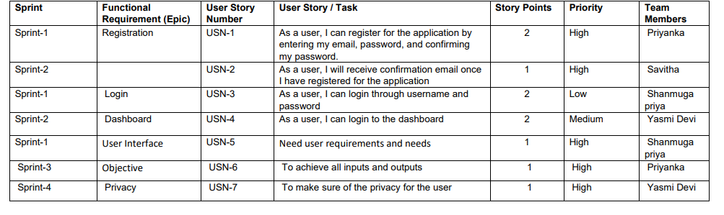
  - SPRINT DELIVERY SCHEDULE:
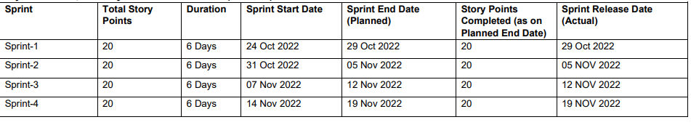
- CODING AND SOLUTIONING:
  - PYTHON CODE

main.py:
import cv2

video = cv2.VideoCapture(0)

while True:
ret, frame = video.read()
cv2.imshow("Frame", frame)
k = cv2.waitKey(1)
if k == ord('q'):
break

video.release()
cv2.destroyAllWindows()

Camera.py

import cv2
import numpy as np
from tensorflow.keras.models import load_model
from tensorflow.keras.preprocessing import image

class Video(object):
def _init_(self):
self.video = cv2.VideoCapture(0)
self.roi_start = (50, 150)
self.roi_end = (250, 350)
self.model = load_model('asl_model.h5') # Execute Local Trained Model
# self.model = load_model('IBM_Communication_Model.h5') # Execute IBM Trained Model
self.index=['A','B','C','D','E','F','G','H','I']
self.y = None
def _del_(self):
self.video.release()
def get_frame(self):
ret,frame = self.video.read()
frame = cv2.resize(frame, (640, 480))
copy = frame.copy()
copy = copy[150:150+200,50:50+200]
# Prediction Start
cv2.imwrite('image.jpg',copy)
copy_img = image.load_img('image.jpg', target_size=(64,64))
x = image.img_to_array(copy_img)
x = np.expand_dims(x, axis=0)
pred = np.argmax(self.model.predict(x), axis=1)
self.y = pred[0]
cv2.putText(frame,'The Predicted Alphabet is: '+str(self.index[self.y]),(100,50),cv2.FONT_HERSHEY_SIMPLEX,1,(0,0,0),3)
ret,jpg = cv2.imencode('.jpg', frame)
return jpg.tobytes

app.py
from flask import Flask, Response, render_template
from camera import Video

app = Flask(_name_)
@app.route('/')
def index():
return render_template('index.html')

def gen(camera):
while True:
frame = camera.get_frame()
yield(b'--frame\r\n'
b'Content-Type: image/jpeg\r\n\r\n' + frame +
b'\r\n\r\n')

@app.route('/video_feed')
def video_feed():
video = Video()
return Response(gen(video), mimetype='multipart/x-mixed-replace; boundary = frame')

if _name_ == '_main_':
app.run()

  - HTML CODE

<!DOCTYPE html>
<html lang="en">

<head>
<meta charset="utf-8">
<meta name="viewport" content="width=device-width, initial-scale=1.0, shrink-to-fit=no">
<title>SmartBridge_WebApp_VideoTemplate</title>
<link rel="stylesheet" href="https://cdn.jsdelivr.net/npm/bootstrap@5.1.3/dist/css/bootstrap.min.css">
<link rel="stylesheet" href="https://use.fontawesome.com/releases/v5.12.0/css/all.css">
<link rel="stylesheet" href="assets/css/Banner-Heading-Image.css">
<link rel="stylesheet" href="assets/css/Navbar-Centered-Brand.css">
<link rel="stylesheet" href="assets/css/styles.css">
</head>

<body style="background: rgb(39,43,48);">
<nav class="navbar navbar-light navbar-expand-md py-3" style="background: #212529;">
<div class="container">
<div></div><a class="navbar-brand d-flex align-items-center" href="#"><span
class="bs-icon-sm bs-icon-rounded bs-icon-primary d-flex justify-content-center align-items-center me-2 bs-icon"><i
class="fas fa-flask"></i></span><span style="color: rgb(255,255,255);">Real-Time Communication
System Powered By AI&nbsp;For Specially Abled</span></a>
<div></div>
</div>
</nav>
<section>
<div class="d-flex flex-column justify-content-center align-items-center">
<div class="d-flex flex-column justify-content-center align-items-center" id="div-video-feed"
style="width: 640px;height: 480px;margin: 10px;min-height: 480px;min-width: 640px;border-radius: 10px;border: 4px dashed rgb(255,255,255) ;">
<img src="{{ url_for('video_feed') }}" style="width: 100%;height: 100%;color: rgb(255,255,255);text-align: center;font-size: 20px;"
alt="Camera Access Not Provided!">
</div>
</div>
<div class="d-flex flex-column justify-content-center align-items-center" style="margin-bottom: 10px;"><button
class="btn btn-info" type="button" data-bs-target="#modal-1" data-bs-toggle="modal">Quick Reference
-<strong> ASL Alphabets</strong></button></div>
</section>
<section>
<div class="container">
<div class="accordion text-white" role="tablist" id="accordion-1">
<div class="accordion-item" style="background: rgb(33,37,41);">
<h2 class="accordion-header" role="tab"><button class="accordion-button" data-bs-toggle="collapse"
data-bs-target="#accordion-1 .item-1" aria-expanded="true"
aria-controls="accordion-1 .item-1"
style="background: rgb(39,43,48);color: rgb(255,255,255);">About The Project</button></h2>
<div class="accordion-collapse collapse show item-1" role="tabpanel" data-bs-parent="#accordion-1">
<div class="accordion-body">
<p class="mb-0">Artificial Intelligence has made it possible to handle our daily activities
in new and simpler ways. With the ability to automate tasks that normally require human
intelligence, such as speech and voice recognition, visual perception, predictive text
functionality, decision-making, and a variety of other tasks, AI can assist people with
disabilities by significantly improving their ability to get around and participate in
daily activities.<br><br>Currently, Sign Recognition is available <strong>only for
alphabets A-I</strong> and not for J-Z, since J-Z alphabets also require Gesture
Recognition for them to be able to be predicted correctly to a certain degree of
accuracy.</p>
</div>
</div>
</div>
<div class="accordion-item" style="background: rgb(33,37,41);">
<h2 class="accordion-header" role="tab"><button class="accordion-button collapsed"
data-bs-toggle="collapse" data-bs-target="#accordion-1 .item-2" aria-expanded="false"
aria-controls="accordion-1 .item-2"
style="background: rgb(39,43,48);color: rgb(231,241,255);">Developed By</button></h2>
<div class="accordion-collapse collapse item-2" role="tabpanel" data-bs-parent="#accordion-1">
<div class="accordion-body">
<p class="mb-0">Students at VIT-Bhopal University during SmartBridge AI Externship
Program.<br><br>1. <strong>Nirlov Deb</strong> 19BCG10067<br>2.
<strong>Kushagra</strong> 19BCG10025<br>3. <strong>Kartik Dhasmana</strong> 19BCG10002
</p>
</div>
</div>
</div>
</div>
</div>
</section>
<div class="modal fade" role="dialog" tabindex="-1" id="modal-1">
<div class="modal-dialog" role="document">
<div class="modal-content">
<div class="modal-header">
<h4 class="modal-title">American Sign Language - Alphabets</h4><button type="button"
class="btn-close" data-bs-dismiss="modal" aria-label="Close"></button>
</div>
<div class="modal-body"><img src="{{ url_for('static', filename='img/ASL_Alphabets.png') }}" width="100%"></div>
<div class="modal-footer"><button class="btn btn-secondary" type="button"
data-bs-dismiss="modal">Close</button></div>
</div>
</div>
</div>
<script src="https://cdn.jsdelivr.net/npm/bootstrap@5.1.3/dist/js/bootstrap.bundle.min.js"></script>
</body>

</html>

9.RESULT
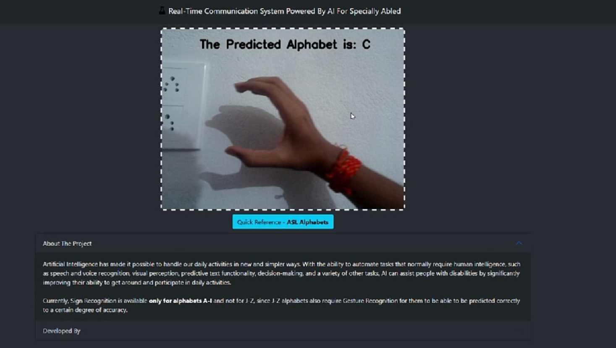
10. ADVANTAGES & DISADVANTAGES

ADVANTAGES
- It is possible to create a mobile applicationto bridge the communication gap between
deaf and dumb persons and the general public.
- As different sign language standards exist, their dataset can be added, and the user
can choose which sign language to read
DISADVANTAGES
- The current model only works from alphabets A to I.

- In absence of gesture recognition, alphabets from J cannot be identified as they require
some kind of gesture input from the user.

- As the quantity/quality of images in the dataset is low, the accuracy is not great, but that can easily be improved by change in dataset
11.CONCLUSION
Sign language is a useful tool for facilitating communication between deaf and hearing
People because it allows for two-way communication, the system aims to bridge
the communication gap between deaf people and the rest of society. The
Proposed methodology translates language into English alphabets that
are understandable to humans.
This system sends hand gestures to the model, who recognises them and displays the equivalent
Alphabet on the screen. Deaf-mute people can use their hands to perform sign language, which will then be converted into alphabets

12. FUTURE SCOPE
Having a technology that can translate hand sign language to its corresponding alphabet is a game changer in the field of communication and AI for the specially abled people such as deaf and dumb. With introduction of gesture recognition, the web app can easily be expanded to recognize letters beyond 'I', digits and other symbols plus gesture recognition can also allow controlling of software/hardware interfaces

13. APPENDIX

The Project deliverables are uploaded in Git repository and in the IBM dashboard.

GIT LINK
https://github.com/IBM-EPBL/IBM-Project-25736-1659971804

