The steepness of the characteristics of the electrovacuum diode
is determined only by the cathode temperature and at T = 750÷2000 K can be 150 - 400 mV. Shift characteristic a ₀ =- α ₁ lgI ₀ is also determined by the initial current of the diode, which depends on the design parameters of the lamp and can range from tens of microamperes to hundreds of milliamperes. Respectively
Rice. 3-5. Schemes of inclusion of electrovacuum logarithmic elements.
and ₀ =0.2÷1 B. Scatter of values a ₀ and a ₁ for lamps of the same series, it depends on the design and technological tolerances in their manufacture.
The upper limit of the logarithmic characteristic of the electrovacuum LE is defined as
where S is the area of the cathode; l is the distance between the anode and the cathode, and is 10 ⁻⁶ - 10 ⁻³ A. The lower limit is limited by parasitic currents and can reach up to 10 ⁻¹⁴ ... 10 ⁻¹³ A.
64
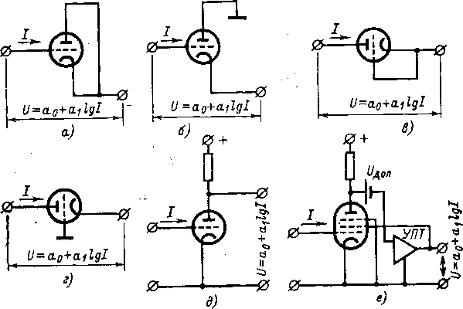
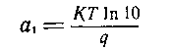
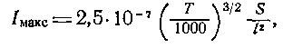

Inclusion schemes. The simplest version of an electrovacuum LE is a diode. Electrometric diodes are mass-produced abroad, for example, type 640 from the General Electric Company . In three-electrode electrometric lamps, the anode and cathode can be connected together (Fig. 3-5, a), but the best results are obtained by a three-clamp connection (Fig. 3-5, b ), when the grid-cathode section serves as a logarithm, and the anode potential is maintained close to the network potential: and, Non-linearity is less than with a two-clamp connection, and the capacitance of the element is also reduced by 3-4 times. For ceramic-metal lamps (nuvistors), for example 6S53-N, the anode is well isolated from the body and the Anode-cathode section can serve as a logarithm. In this case, two-clamp (Fig. (3-5, c) and three-clamp (Fig. 3-5, d) switching on of the lamp is possible. With a three-clamp diode lamp switching on (Fig. (3-5 , b and d) grounding the appropriate electrode reduces leakage between the high-resistance electrode and each, which improves the logarithmic response at low currents.
It is also possible to turn on triode electrovacuum LE, when the measured current is supplied to the control grid, and the output voltage is taken from the anode of the tamp (Fig. 3-5.5), which is both a logarithmic and amplifying element. In this case, the optimal characteristics are achieved [L. 3-20] when the lamp is operating in the constant anode current mode. The disadvantage of the triode circuit is the large input capacitance. In addition, the lamp as an amplifying element is not covered by feedback. If the LE serves as an electro -vacuum pentode, then the feedback signal can be applied to one of the grids of the lamp (Fig. 3-5, f).
Basic properties. The parameters of the logarithmic characteristic of electrovacuum LE depend on the type of the element, its switching circuit, operating mode, and external conditions (temperature). The scatter in the parameters of electrovacuum LEs of the same type is 10–20 % ( standard deviation) for the displacement and 2–5 % for the steepness. The filament voltage affects the slope, offset and nonlinearity of the logarithmic characteristic of the element, the temporal and temperature drift of its parameters. Incandescent reduction reduces non- linearity and time drift, but reduces transconductance 5-377 65
characteristics and increases the temperature error . The optimum is the heating voltage in the range of 0.3 - 0.5 nominal.
On fig. 3-6 shows the relative nonlinearities of the EM-4 electrometric lamp in a three-terminal diode connection at different filament voltages U _{n} Shift of the logarithmic characteristic at U _{a} =
\u003d 1.1 V is equal to α ₀ \u003d 0.4 V, the slope α ₁ \u003d 0.2 V. At U _{n} \ u003d \u003d 0.5 V, the offset increases to 1 V, and the slope decreases to 0.16 V. With a decrease heating, the logarithmic section of the lamp characteristic is shifted towards lower currents.
Rice. 3-7. Temporal drift characteristics of the lamp EM-4.
in the region of low currents;
______ in the area of high currents.
Stability. The drift of the parameters of the current-voltage characteristic of electrovacuum LE is caused by a change in the contact potential difference between the electrodes, the emissivity of the cathode , etc. % /h As the heat decreases, the error decreases. Temporal drift of the characteristics of the EM-4 triode in a three-terminal diode connection in the first 100 hours
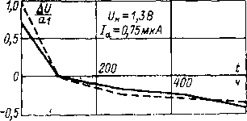
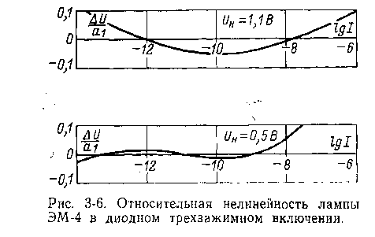

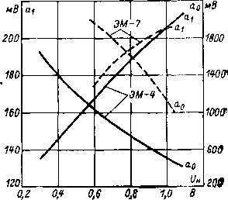
Рис. 3-8. Зависимость характеристик электровакуумных логарифмирующих элементов от напряжения накала.
is significant (Fig. 3-7), the lamp is being trained. Then it decreases. The drift is approximately the same at low and high currents, i.e., the steepness of the logarithmic characteristic changes little, and the offset is significant.
The effect of temperature. The temperature of the cathode of electrometric lamps is low, and the influence of the ambient temperature on the parameters of their logarithmic characteristics can be significant. For the EM-4 triode in a three- clamp diode connection , the current conversion error caused by a change in the ambient temperature reaches 1.5%/K; it decreases with increasing filament voltage.
Influence of filament voltage. On fig. Figures 3-8 show the dependences of the slope α ₁ and displacements α ₀ characteristics of EM-4 and EM-7 lamps in a three-terminal diode connection from the filament voltage, from which it is possible to determine the required stability of power supplies .
Influence of radioactive radiation. Under the action of radiation, the characteristics of electrovacuum LEs should change significantly, but there are no specific data on this issue in the literature.
own capacity. The capacitance of electrovacuum LEs is determined by their design and switching circuit and is several picofarads. With a three-terminal connection (see Fig. 3-5, e and f), the capacitance of the input installation is added to the capacitance of the LE itself . The smallest capacitance is achieved with a three-clamp diode connection (see Fig. 3-5, d), when the grounded grid plays the role of a screen, which sharply reduces the capacitance in the anode-cathode section.
Noises. The limiting possibilities of electrovacuum LE are determined by the time and temperature drift, therefore, LE noise is usually not considered.
where U is the voltage at the junction in the forward direction ; I is the current through the junction in the forward direction; I _{s} - saturation current through the transition in the opposite direction; T is the absolute transition temperature.
Equation (3-5) is valid for planar diodes and individual junctions of transistors, as well as for the transient response of a common base transistor. From a comparison of equations (3-4) and (3-5) it can be seen that the slope of the logarithmic characteristic of a semiconductor junction is significantly less than that of an electrovacuum diode, since the junction temperature is lower than the temperature of the hot cathode. At room temperature (T=293 K) for the p - n - junction we have α ₁ ≈60 mV. Since the saturation current I _{s} lies at the level of 10 ⁻¹⁰ A, the shift of the logarithmic characteristic of semiconductor devices is about 0.6 V.
The range of semiconductor LEs in the region of small currents is limited by leakage currents through the junction and insulation , and in the region of high currents, by the voltage drop across the internal resistance of the element. Nonlinearity can also be caused by the thermal resistance of the diodes and by surface and bulk junction defects . Specially designed semiconductor LE exist only for currents 10 ⁻⁵ - 10 ⁻² Ah, they are used in analog computers. In electrometry, ordinary elements from among the most suitable are used for these purposes.
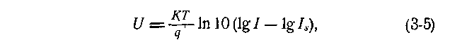
Inclusion schemes. A semiconductor diode is a two-clamp element, and the question of its inclusion as an LE is solved unambiguously. Good results are obtained by transistors in a three-terminal connection, when the emitter-collector section serves as a logarithm , and the base potential is maintained close to the emitter potential. The possibility of such inclusion is based on the proportionality of the input
в) Полупроводниковые логарифмирующие элементы
Параметры логарифмической характеристики. Вольт- амперная характеристика плоского p-n-перехода в прямом направлении при учете только диффузионной составляющей описывается уравнением
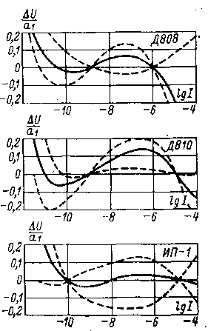
the bridge of a transistor with a grounded base to the base current [L. 3-22].
Рис. 3-9. Относительная нелинейность кремниевых p-n-переходов.
— усредненные характеристики; — границы макси
мального разброса.
Basic properties. The steepness of the logarithmic characteristic of a semiconductor junction, depending on the type of element , is 60-100 mV . Over a wider range, the offset of the characteristic and, especially, the non-linearity can change . On fig. Figures 3-9 show the characteristics of some silicon devices in a two- clamp connection, suitable for use as an LE. The steepness of the logarithmic characteristic is in the range of 70–90 mV , and the offset is at the level of 0.8–1 V. The standard deviation of the slope values for elements of the same type is about 10%, and the displacement is about 5%. The spread of nonlinearity values is also insignificant . The operating range of silicon p - n -junctions is about 10 ⁻¹¹ - 10 ⁻⁴ A, and the relative nonlinearity reaches 10–20% even for average characteristics . Logarithmic elements with silicon junctions can only be used in devices of low accuracy and at relatively high currents.
Planar transistors in a three-terminal connection, in which the distance between the collector and emitter is small, have the least nonlinearity, which ensures mutual compensation of the current components in the collector-base and emitter-base sections due to the main carriers. For silicon planar KT312A and diffusion KT301V and 2T301Zh transistors in a three-terminal connection (Fig. 3-10) , the slope is 50 - 60 mV, the bias is 0.75 - 0.85 V, and the operating range is 10 ⁻¹² -10 ⁻⁴ And with an error of about 5%. scatter
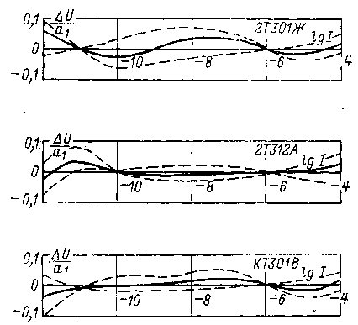
values of relative nonlinearity for devices of the same type do not exceed 2–3 % with an increase of up to 10% at the boundaries of the range , and the spread in the values of slope and displacement does not exceed 2–3 % .
Stability. The reason for the instability of the characteristics of semiconductor LEs can be irreversible changes in the structure of the element, which causes a change
Rice. 3-10. Relative non-linearity of transistors in a three-terminal connection.
- - average characteristics; — limits of maximum spread.
current I _{s} , and thus the characteristic shift. It can be assumed that semiconductor LEs are much more stable than electrovacuum ones. Exposure of silicon p - n -junctions under a relatively high current significantly changes its characteristics. Recovery of initial properties at lower currents may take several hours. For transistors in a three- terminal connection, the hysteresis phenomena are much smaller and lie in the range of 0.5-3 mV .
The effect of temperature. The temperature characteristics of semiconductor LE are determined from equation (3-5), in which the saturation current I _{s} also depends on temperature. The properties of semiconductor LEs depend more strongly on temperature than those of electrovacuum ones, since the transition temperature, in contrast to the temperature of the cathode 70
yes electrovacuum element, is entirely determined by the ambient temperature.
Influence of radioactive radiation. Under the influence of radiation, semiconductor LEs undergo reversible and irreversible changes in properties, but there are no quantitative data on this issue in the literature.
own capacity. The junction capacitance, depending on the type of element used, can range from units to hundreds of picofarads; it depends on the applied voltage and can vary by dozens of times. At low voltages, the capacitance is minimal; in the upper part of the logarithmic range, it is maximal. At currents of the order of 10 ⁻¹¹ And the resistance of the diode is large and its time constant can be 0.1 - 1 s, at high currents it is much less.
Noises. There are no data on the noise of semiconductor LEs, the capabilities of the elements are determined by the temperature and time drift of the characteristic, and not by noise.
d) Measurement of parameters of logarithmic elements
To study the current-voltage characteristics of LE at low currents, specialized equipment is required [L. 3-13] high accuracy and productivity. The method of functionally connected current and voltage sources [L. 3-7 - 3-9] allows you to directly measure the parameters of the logarithmic characteristic of a nonlinear element in the form given by equation (3-1). In this case, the LE characteristic is compared with a logarithmic dependence modeled using adjustable current and voltage sources . The investigated bipolar LE is included (Fig. 3-11, a) in the parallel OOS circuit of the EMU, the input of which is supplied with current from the source I. The output voltage of the EMU, equal to the voltage on the LE, is compared with the reference voltage U _{op} and their difference ΔU(I) is measured. Adjustment of sources I and U _{o p} is carried out discretely so that I _{R} =I ₀ G ^{m} and U _{op R} =U _{op0} + R _{m} , where G and m are banners
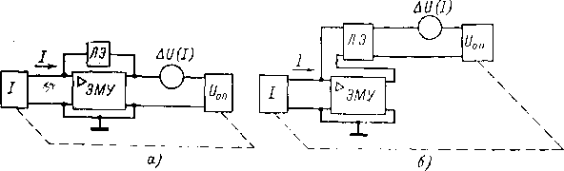
Rice. 3-11. Schematic diagrams for determining the characteristics of logarithmic elements: TWO-POLE (a) and multi-pole (b)
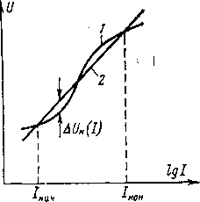

Рис. 3-12. Совмещение характеристик установки и исследуемого элемента в двух точках диапазона токов.
1-характеристика установки: 2-характеристика исследуемого элемента.
тель геометрической и разность арифметической прогрессий соответственно . При этом во всем диапазоне рабочих токов справедливо равенство
The dependence of the reference voltage on the input current is a logarithmic characteristic with an offset a ₀ and a steepness a _{1 , which can be changed by} adjusting U op0 etc. _
∆U(I) difference meter shows the deviation of the current-voltage characteristic of the LE from the logarithmic dependence, i.e., the nonlinearity voltage. Before measurement, the logarithmic dependence of the setting by adjusting the coefficients α ₀ and α ₁ is combined with the volt-ampere characteristic of the LE at two points spaced apart from each other in the range of currents I _{start} and I _{end} (Fig. 3-12). When measuring the characteristics of logarithmic multipoles (Fig. 3-11, b ) , the input terminals of the multipole are included in the OOS EMU circuit , and the reference voltage source with a voltage difference meter is connected to its output terminals. The method makes it possible to study the characteristics of LE of most known types in the range of 10 ⁻¹⁴ - 10 ⁻⁴ A with an error of 1%.
3-3. CAPACITORS WITH HIGH LEAKAGE RESISTANCE
- Dielectric Capacitors
General information. Capacitors used as passive electrometric transducers must have a self-discharge time constant of up ^{to} 104-105 ^{s} . Polystyrene and PTFE capacitors are the most suitable (Table 3-3).
The actual insulation resistance of capacitors usually exceeds the standard by 2-3 orders of magnitude. Methods for its measurement are regulated by GOST 6580-63 "Electric capacitors of constant capacity, Test methods ", 72
Table 3-3
Main technical characteristics of some commercially available high-resistance dielectric capacitors
Capacitor type | Characteristic
Capacitor type | Rating range _ | The smallest permissible deviations, % | TKE, 1/K | Insulation resistance or self-discharge time constant at 20 º C
 |  |  |  | between pins | on the body
MPGO | 0.1 - 10 uF | 0.1 | -1.5×10 ⁻⁴ | 5-10 ³ s | 10 ¹¹ ohm
MPG-P | 0.015-2uF | 0.1 | —2* 10 ⁻⁴ | 2.5*10 ¹⁰ ohm for C< 0.luF; 5-10 ³ s for C> 0.l uF | 10 ¹¹ Ohm
PM | 100pF - 0.01uF _ | 5 | —2*10 ⁻⁴ | 5- 10 ¹⁰ ohm | —
on | 51pF - 0.03uF _ | 5 | — | 10 ¹³ ...10 ¹⁴ Ohm | —
PSO | 470 pF—— 0.01mkΦ | 5 | — | 10 ¹⁰ ohm | —
FT | 560pF - 0.47uF _ | 5 | -2*10 ⁻⁴ | 5*10 ⁹ ohm | —

Absorption. Capacitors for electrometric circuits should have low absorption. Absorption is understood as the property of partially retaining the existing charge after a short-term short circuit. The ratio of the residual voltage on the capacitor to the original voltage is called the absorption coefficient . The absorption phenomenon can be displayed in a simplified (without taking into account other phenomena) capacitor equivalent circuit (Fig. 3-13) using a chain R _{a} C _{a connected} in parallel with the main capacitance C and having a large time constant. The resulting capacitance of the capacitor due to absorption depends on the time it is under constant voltage. Small absorption coefficients have polystyrene and fluoroplastic capacitors [L. 3-15]. For
polystyrene capacitors, the absorption coefficient is normalized to be 0.2 - 0.3%, in fact it is significantly less. For fluoroplastic capacitors, this coefficient is 0.05 - 0.1%. By special measures , the absorption coefficient can be reduced to very low values.
Rice. 3-13. Equivalent circuit of a capacitor with absorption.
Stability. The capacitance of capacitors with a dielectric changes little with time [L. 3-11]. For FT capacitors , during the first year from the date of manufacture, the capacitance changes within 0.1 - 0.3%, and in the future, less than 0.05% per year.
The effect of temperature. The temperature coefficient of capacitance (TKE) of capacitors with a dielectric usually does not exceed 0.02 %/K and can be reduced by the choice of rational technology . Training polystyrene capacitors with temperature cycles increases their thermal stability [L. 3-25]. There is information about capacitors with a very small TKE. For PTFE capacitors in the range from 20 to 50 º C , TKE is from -0.012 to -0.014 % / K, and at temperatures from 15 to 16 ⁰ C and from 18.5 to 20 º C , there are abrupt changes in capacitance at 0.07 - 0.1%, due to phase transitions in the dielectric.
The decrease in the insulation resistance of capacitors with a dielectric with increasing temperature is expressed by the empirical formula
where β for many dielectrics is in the range of 0.03 - 0.035, and for polyethylene - in the range of 0.04 - 0.045.
Influence of humidity. Water is a polar liquid with a high dielectric constant and high electrical conductivity. Moisture absorption leads to an increase in the capacitance of the capacitor and a sharp decrease in the insulation resistance. For capacitors used in electrometry, these phenomena are not very pronounced, since polystyrene and fluoroplast are not hygroscopic. Fully sealed capacitors
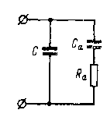
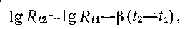

Humidity only affects leakage through insulators, and this effect is reversible.
Influence of voltage. The dependence of the capacitance of capacitors with a dielectric on the applied voltage does not exceed hundredths or thousandths of a percent and can usually be neglected.
Influence of radioactive radiation. Under the influence of radiation in capacitors with a dielectric, additional conductivity appears. This effect is reversible. Irreversible changes in capacitance and leakage resistance are also possible due to changes in the structure of the dielectric. The effect of radiation depends on the material of the dielectric, the design and technology of manufacturing the capacitor.
own interference. Self-interference of capacitors used in electrometric circuits is conveniently characterized by parasitic current. The causes and level of these interferences are poorly understood. The parasitic current of FT capacitors with a capacity of 0.037 - 0.1 μF under normal conditions can reach 10 ⁻¹⁴ -10 ⁻¹³ A and increases significantly with temperature changes.
- Air condensers
General information. With capacities less than 300 - 500 pF to ensure the self-discharge time constant 10 ⁵ - 10 ⁶ s it is necessary to have an insulation resistance of up to 10 ¹⁵ - 10 ^{l6} Ohm. Such parameters can be ensured only in specially made air condensers . To eliminate the influence of leaks in them, equipotential protection methods can be applied. The absorption of air condensers is negligible and the capacitance stability over time can be very high ; The TKE of air condensers is determined by design and materials and can be made small. Voltage does not affect their performance. The parasitic current of the air capacitor is determined by the quality of the insulator and can be reduced to (l÷2)10 ⁻¹⁷ BUT.
Execution examples. The easiest way is to make an air condenser with a capacity of up to 30 - 50 pF. With an increase in capacity, the gaps between the plates decrease, and the complexity of manufacturing increases. Air storage capacitors NK-1 and separating capacitors RK-1 are structurally similar, but the first ones are produced for a nominal value of 100 pF a the second - o t 10 to 30 pF. Condenser dimensions 32×26×26 mm, weight 14-16 g . Capacitors are designed for operating temperature range from -50 to +65 °С; TKE does not exceed

0.02% /K. The insulation is made of amber; insulation resistance not less than 10 ¹⁵ Ohm, parasitic current not more than 5∙10 ⁻¹⁷ BUT.
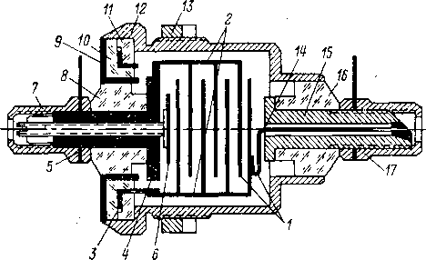
In a series of air condensers VNIIFTRI [L. 14-27] the design and technological solutions used in the capacitors NK-1 and RK-1 are taken as a basis, but they are made three- terminal (with equipotential protection against leakage currents) and adjustable. Capacitors have capacities from 1 to 400 pF. Capacitors of different capacities differ only in the number of plates.
Рис. 3-14. Конструкция воздушного электрометрическо
th capacitor.
The main assembly (fig. 3-14) is a block, which consists of two groups of polished plates that form the electrodes. Plates 1 _ fastened by spot welding to the posts 2, and those, in turn, are welded to the bushings 3 and 4. Sleeve 4 serves as one of the conclusions of the capacitor; it has a threaded hole through which the adjusting screw 5 passes with plate 6, serving to adjust the capacitance of the capacitor to the nominal value. Fixing the position of the screw is carried out by crimping the outer end of the screw 5 with the split end of the sleeve 4. The outlet of the adjusting screw is closed with a cap 7 screwed onto the sleeve 4. Sleeve 4 using epoxy glue attached to the insulator 8, and that one - to the guard ring 9. Sleeve 3 glued between insulators 10 and 11, and the latter are glued to the guard ring 9. Ring 9 serves for equipotential protection by separating insulators 7, 10 and 11 and connects to body 12 capacitor. Non-separable block of plates with bushings 3 and 4, insulators 7, 10 and 11 and a guard ring 9 is inserted into the body and rolled.
The second group of plates using a flexible conductor 14 connects with bushing 15, which is the second terminal of the capacitor. It is attached with an epoxy layer to the insulator 16, and the last - to the body. Conductor soldering point 14 and bushings 15 closed with a cap 17. A nut 13 is provided for fixing the capacitor . All insulators are made of amber, the surfaces of the insulators are carefully polished. Metal parts of capacitors (except for body, caps and sleeve 15) in order to reduce TKE, they are made of Invar.
76
Capacitors have an inaccuracy of capacitance adjustment of about 0.1%, TKE of about 0.01 -0.015% / K, leakage resistance between the plates is more than 10 ¹⁵ ohms. The dimensions of the capacitors are 32×32×50 mm for a 1 pF capacitor and 44×44×82 mm for a 400 pF capacitor.
3-4. SOURCES OF SMALL CURRENTS

a) Ionization sources
Ionization current sources (IIT) are an ionization chamber with a built-in radioactive emitter. The supply voltage is selected so that the camera operates in saturation mode. In IITs, α and β emitters are used, and the issues of radiation protection are solved more simply than with γ emitters. The high ionizing ability of α-particles makes IITs with α-emitters most suitable for currents of 10 ⁻⁸ -10 ⁻¹⁰ A. Comparatively strong electric fields are needed to obtain a saturation current in them. The charge created by one β-particle is 2-3 orders of magnitude less than for an α-particle, so β-emitters provide smaller statistical current fluctuations. Saturation is achieved in them at lower voltages than for α-emitters.
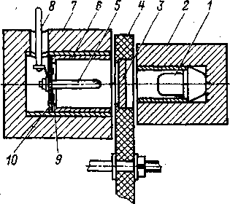
Ionization current sources can be performed for one value of the current at the output or adjustable. In the latter, the effective radiating surface is changed by moving the screen. Much work has been devoted to regulated and unregulated IITs . The instability of IIT is determined by the half-life of the radioactive drug and some other factors, and with the right choice of design and technology, it does not exceed 0.1 % per year [L. 3-30].
Рис. 3-15. Устройство ионизационного источника тока для тераомметра ТОМ-Тарту-63
On fig. 3-15 shows the IIT device with a β -emitter for the TOM-Tartu-63 teraohmmeter [L. 14-27], which uses an emitter

eleven
b) Capacitive sources
When a capacitor is connected to a sawtooth voltage generator (ΓΠH) , the current in the capacitor circuit is 78
tel 1 type BI-1, which is an isotope of strontium-90 in equilibrium with yttrium-90. The emitter has an activity of 0.5×3.7××10 ⁷ spread / s (0.5 mCi) and creates a current of 10 ⁻¹⁰ A. To attenuate the current by a factor of 1 : 10 : 100 : 1000 , metal filters 3 are provided, mounted on a rotating disc 4. Supply voltage +400 V is applied to cylindrical electrode 6. The current is taken from the central electrode 5 fixed on the fluoroplastic insulator 10 and having output 8. To reduce leakage insulator 10 surrounded by guard ring 9, the potential of which is maintained equal to the potential of electrode 5. Lead shields 2 and 7 are used to protect operating personnel from exposure to radiation and to suppress the effect of scattered secondary X-ray radiation . Since the source is not sealed, and the ionization current is proportional to the gas density in the chamber, then at when the temperature changes by 10° C or when the pressure changes by 400 N/m2 , the source current changes by 3-4 %.
The sealed IIT of the University of Tartu (Fig. 3-16) is a sealed ionization chamber 1 with a built-in radioactive emitter 2, filled with a mixture of gases: 98% argon and 2% helium . The emitter is connected through rod 3 with output terminal 4 and acts as the collecting electrode of the chamber. The output terminal is isolated from the chamber by a ceramic insulator 5 with electrode 6 for clamp equipotential protection. The main structural materials of IIT are steel and ceramics. The emitter base is made of Plexiglas and covered with a thin radioactive layer with carbon-14 isotope and then with a layer of gold. Details of IIT are connected vacuum-tight: seams of steel parts by argon-arc welding, ceramic-metal solder PSr-72. The half -life of the carbon- 14 isotope is 5600 years. The temporary instability of the IIT output current does not exceed 1% per year and is determined mainly by the change in the amount of free gas in the chamber. It can change due to microleaks in structural parts, as well as due to the absorption of gases during heating and cooling of IIT.
Ionization current sources have a long service life, small dimensions and weight, and are easy to operate . Victoreen (USA) produces unregulated IITs for currents from 10 ⁻⁸ up to 10 ⁻¹⁰ A [L. 3-26]. They use ²⁴¹ Am as a radioactive element . The supply voltage is from 25 to 500 V.

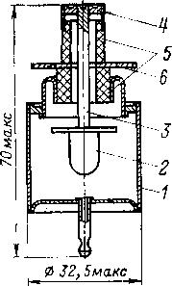

Rice. 3-16. The device of a sealed ionization current source.

proportional to its capacitance and the rate of change (steepness ) of the voltage
For C = const and dU∕dt = υ = const we have:
I(t) =C υ = const.
On this principle, it is possible to make sources for currents up to 10 ⁻¹⁵ A, for this you need C \u003d 10 pF and υ \u003d 0.1 mV / s. The leakage resistance of the differentiating capacitor must be very large, otherwise the leakage current will introduce an error.
potentiometers and electronic circuits are used as GPN . In the current source
Rice. 3-17. Schematic diagram of a current source with a multi- turn potentiometer.
Rice. 3-18. Schematic diagram of a current source with an electronic sawtooth voltage generator.
with a multi-turn potentiometer (fig. 3-17) the latter is rotated by a synchronous motor M, it should have good linearity. Irregular processes in the moving contact of the potentiometer can cause current fluctuations in the output.
In sources with electronic FPG (Fig. 3-18) , the latter is performed on . DC amplifier (UPT). With a large gain of the UPT, the voltage at the output of the GPN depends on the setting voltage U _{o} , resistance R at the input and capacitance C of the capacitor in the OOS circuit of the UPT as follows: U(t)=U ₀ t∕RC. The output current is I \ u003d U ₀ C _{D} / RC. Other systems can be used to obtain a linearly varying voltage , however, HPNs with UPTs provide a longer operating cycle and better linearity [L. 3-1, 3-3 - 3-5].
On fig. 3-19 shows a functional diagram of the VNIIFTRI source for currents of 10 ⁻ ⁸ -10 ⁻¹⁵ A. In the initial position, the relay contact P shunts the capacitor C ₁ , and the toggle switch B ₁ open. At
79
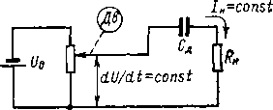
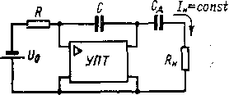
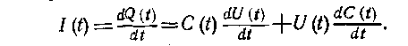

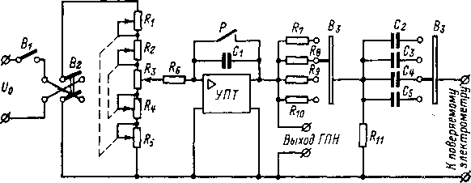
Рис. 3-19. Функциональная схема источника малых токов.
this sets the DTC to zero. Switch B ₂ selects the polarity of the voltage at the output of the GPN and, thus, the direction of the current at the output of the source, and switch B _{3 selects} the required range of currents. To start the working cycle, the relay contact P opens and the toggle switch B ₁ closes , as a result, the current flowing through the resistor R 6 _{charges} the capacitor C ₁ and the voltage at the output of the UPT increases linearly. Through the differentiating capacitor (one of C ₂ - C ₅ ) and the load connected to the source, current begins to flow. Its value is regulated by changing the slope of the voltage

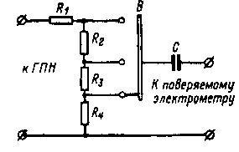
Рис. 3-20. Принципиальная схема выносной головки источника малых токов.
GPN. The latter is determined by the voltage taken from the three- decade divider R ₁ - R ₅ , the decades of which are simply depicted as potentiometers. The parameters of the integrating circuit (R ₆ \u003d 10 ⁸ Om, C ₁ \u003d 2 μF) are chosen so that when the voltage changes U ₀ at the input of the GPN from 20 to 2 V, the slope varies within 0.1 - 0.01 V / s. The discreteness of the current adjustment at the output with the help of a three-decade divider is not more than 1% .
To cover the current range of 10 ⁻⁸ -10 ⁻¹² A, differentiating capacitors with capacities of 100,000 - 10,000 - 1000-100 pF are used. 100 pF air capacitor with amber insulator, the rest are FT type . The actual values of capacitances differ from the nominal ones, therefore, capacitors with capacitances slightly exceeding the nominal values are used, and to obtain at the boundaries of the subranges (with a voltage slope of the GPN of 0.1 and 0.01 V / s) currents that are multiples of a negative degree of 10, by dividers are provided for the output of the GPN.
Currents 10 ⁻¹² - 10 ⁻¹⁵ A are obtained with the help of a remote head (Fig. 3-20) connected to the output of the HPN. The head uses a 10 pF three-clamp air capacitor C. The choice of subranges is carried out by switch B, which changes the transfer coefficient of the divider on resistors R ₁ —R4 . _ _ The smallest slope of the voltage at the output of the GPN is 100 μV/s (at a current of 10 ⁻¹⁵ A).
Current reproduction error at the output of such a source
80
is determined by the driving voltage source, input and output dividers, operational resistor, storage capacitor in the feedback circuit of the UPT, and differentiating capacitor. The parameters of all these elements are stable and little dependent on temperature. The stability of the current at the output is also affected by fluctuations in the gain of the DCET, zero drift and parasitic current of the DCET, as well as the leakage resistance of the storage and differentiating capacitors. However, even these influences can be reduced to sufficiently small ones. The reproducibility of the source lies at the level of 0.1–0.2%.
- Sources with variable capacity
time-varying capacitance C is included in the circuit of a constant voltage source U , then the current in the load will be equal to I(t) = dQ(t) ∣ dt=UdC(t)∕dt, i.e. for dC(t) ∣ dt = const we have I=const [L. 3-4]. The leakage resistance of the capacitor must be large enough , otherwise the leakage current through the insulation will be added to the current through the capacitance. Such sources are used only when measuring high resistances, when it is sufficient to know only the average value of the current over a certain time and there are no high requirements for the constancy of the current in time, and, consequently, for the nature of the capacitance change.
- Sources with direct charge transfer
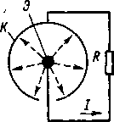
In current sources based on the principle of an atomic battery (Fig. 3-21), α- or β - particles emitted by the emitter E fly through the vacuum gap and are collected on the collector K. Through the load R current flows in the external circuit of the battery. The current-voltage characteristic of the sources (Fig. 3-22) is symmetrical [L. 3-3]. By changing the additional voltage source, it is possible to
Rice. 3-21. Nuclear power source.
ensure the saturation mode and thus high internal resistance of the source. The stability of such sources depends on the half-life of the emitter, the retention of vacuum, and the constancy of the secondary electron 6-377 81
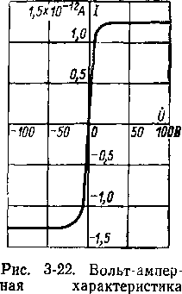
emissions from internal surfaces under the influence of radioactive radiation, etc. Vacuum radioactive current sources have a lower level of static current fluctuations than ionization ones, and are most promising for currents of 10 ⁻¹² A and below.
источника на атомной батарее.
- Sources on photocells
By changing the illumination of the photocell , one can smoothly adjust the current in its circuit over a wide range. The limiting possibilities are limited by the dark current of the photocell, which is 10 -10 -10 -14 A ^{, and} its temperature dependence, as well as the insulation resistance. “Fatigue” of the photocathode causes current instability during prolonged use of the photocell. An electrometric lamp can serve as a photocell [L. 3-27], the control grid of which is illuminated and, working as a photocathode, is a current source. All other lamp electrodes are connected together. The source is powered by a 15 V battery, the output currents are 10 ⁻¹⁴ - 10 ⁻⁹ d. As a light radiation converter, you can use [L. 3-27] and a planar p-n-p- transistor.
- Thermionic sources
In such sources [L. 3-29] the current is formed by the flow of electrons from the cathode to the anode. In an evacuated cylinder 1 a tungsten cathode in the form of a filament 2 (Fig. 3-23) is placed, the temperature of which, and hence the emission current, is regulated by a change in incandescence. The anode 3 is made in the form of a cylinder coaxial with the filament. Part of the electrons moving from the cathode to the anode flies through hole 4 in the anode and enters collector 5 , generating current in an external circuit. Collector terminal 5 protected from surface leakage currents by a guard ring. The ratio of the anode current to the current in the external circuit is determined by the ratio of the anode area to the hole area. Smooth adjustment of the output current 82
F , and on its sides 2 and 3 equal charges of opposite sign are formed. The amount of electricity on the surfaces of the plate is proportional to the force Q= aF, where a is a coefficient that takes into account the piezoelectric constant of quartz and the geometrical dimensions of the plate. With a uniformly varying force dF(t)∕dt =const , current I(t)= = dQ(t) ∣ dt = adF(t)/dt flows in the external circuit , which can be 10 ⁻¹⁵ -10 ⁻¹¹ A. At present, piezoelectric sources are not used, since it is difficult to obtain a linearly changing force.
in the range 10 ⁻¹⁴ -10 ⁻³ A is carried out by changing the filament voltage. At currents above 10 ⁻¹² A, current fluctuations did not exceed 2% for 100 hours.

g) Sources based on the piezoelectric effect
The main part of the piezoelectric source, created for the first time by the Curie brothers, is a quartz plate 1 (Figure 3-24). Force applied to the plate
h) Resistive sources
A simple current source can be made using a high-resistance resistor R and voltage source Uc∙ At R>R _{n} the current in the circuit is I=U ₀ ∕R. Advances in the production of precision high resistance resistors have made it possible to create high quality resistive sources. The Keitley firm (USA) produces a model 261 source, the resistors of which have resistances from 10 ⁵ to 10 ¹² ohms. The current setting error , depending on the range, is from 0.25 to 1.5% (instability for 3 months - 0.15%, temperature coefficient -
0.01 %/K on ranges 10 ⁻⁷ - 10 ⁻⁵ A and 0.1 % / K at lower currents.
6*
Rice. 3-24. Piezoelectric toyu source.
83
Rice. 3-23. Thermoelectronic current source.
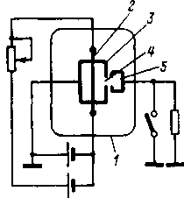
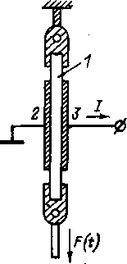

The internal resistance of a resistive source can be increased using an EMU (see Chap. 14).
i) Capacitive current dividers
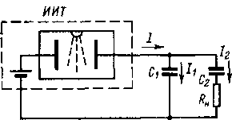
Many of the considered current sources are easiest to perform for one output current value. You can change the value of the current at the output of the source using capacitive dividers (Fig. 3-25). Capacitors C _{1 are switched} on at the output of de IIT and C ₂ , with C ₁ >C ₂ . From the relation It=UC, taking into account the equality of stresses on C ₁ and С ₂ , we get I ₁ ∣ I ₂ =C ₁ /C ₂ and we can have I ₂ < I ₁ . By changing C ₁ /C ₂ , you can change I ₂ . The steady value of the current in the load is reached exponentially with the time constant R _{n} C ₂ .
Рис. 3-25. Емкостной делитель тока.
If the current source is resistive, then I and , consequently , I ₂ will decrease from the initial value equal to E ∕R, to zero with time constant τ=R(C ₁ + C ₂ ), i.e., the time of using t _{max by} such a source must satisfy the condition t _{max} ≪τ , otherwise an additional error will occur.
Chapter Four

ELECTROMETRIC AMPLIFIERS
4-1. INPUT CONVERTERS OF ELECTROMETRIC VOLTAGE AMPLIFIERS
- General information
As shown in § 1-1, an indispensable element of all types of electrometric equipment is an electrometric voltage meter, which has a very large input resistance and a low level of intrinsic noise. At the first stages of the development of meters of this kind, this problem was solved using electrostatic electrometers. Over the past 20-30 years, various types of EMUs have been developed that provide amplification of the measured voltages and thereby

