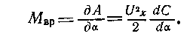
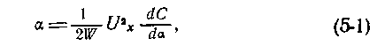
with time constant T = 2Q∕ω ₀ , where Q is the quality factor of the selective circuit; ω ₀ is the resonant frequency of the circuit . If the resonant frequency of the circuit and the frequency of the signal do not match, then the resonant amplifier is characterized by two time constants. The time constant of the phase sensitive rectifier is determined by a smoothing filter. Thus, an EMU with DC to AC conversion contains at least three or four inertial links, and the characteristic equation of such an EMU with a closed FOS will be, respectively, of the fourth or fifth order. To ensure stability in this case, corrective chains and other special measures are used.
Chapter Five

ELECTROSTATIC ELECTROMETERS AND AMPLIFIERS
5-1. ELECTROSTATIC VOLTAGE TO DISPLACEMENT CONVERTERS
- Voltmeters and electroscopes
In electrostatic measuring mechanisms, the measured voltage is converted into an angle of rotation or linear movement of the moving part. The torque is created by the forces of electrostatic interaction between the movable and fixed plates. If the capacitance between the plates is C and voltage U _{x is applied to them} , then the energy stored in the mechanism is A = CU ² _{x} ∕2 and torque is defined as the derivative of energy with respect to the rotation angle of the moving part, i.e.
This moment is balanced by a counteracting moment proportional to the displacement M _{pr} \u003d W _{α} , and at M _{vr} \ u003d M _{pr} the angle of rotation of the moving part, i.e., such devices have a quadratic scale.
106
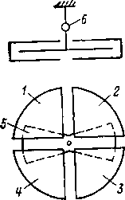
Рис. 5-1. Схематическое устройство квадрантного электрометра.
The input resistance of electrostatic voltmeters is determined by insulation leakage. Voltmeter sensitivity (dα ∣ dU _{x} ) is low, since the distance between the electrodes cannot be very small due to design considerations, and the capacitance change dC ∣ dα small. The most sensitive of the serial electrostatic devices, the C70 voltmeter has a measurement limit of 10 V.
Electroscopes have similar characteristics. Unlike voltmeters, they are designed specifically for the purpose of electrometry. In electroscopes, a microscope is provided to increase the resolution of reading the position of the movable electrode . There are many types of electroscopes [L. 5-16]; a description of an electroscope with golden petals can also be found in modern physics courses. At present, electroscopes are out of use, as they are inconvenient to use.
- The principle of operation of the electrometer
To increase the sensitivity in electrostatic electrometers (ESE), two fixed electrodes and one movable electrode are provided, which are under different potentials. For example, in the quadrant ESE of Dolezhalek (Fig. 5-D), the main parts are four quadrants 1 - 4 (fixed electrodes) in the form of extended quarters of a round box and a biscuit 5 (movable electrode), suspended on a thin conductive thread, on which a reference mirror 6 is fixed. Opposite quadrants are electrically connected. The theory of quadrant and other ESEs was developed by Maxwell and other researchers [L. 5-18] and briefly boils down to the following [L. 5-6].
Let U ₀ , U ₁ , U ₂ are the potentials of the moving and two pairs of fixed electrodes, respectively. Voltage across capacitance C ₁ , formed by a movable electrode and the first pair of fixed ones, is equal to U ₀ - U ₁ , and on the capacitance C ₂ formed by a movable electrode and a second pair of fixed
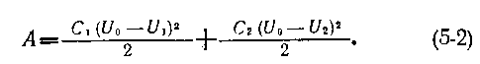
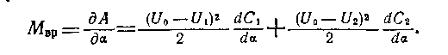
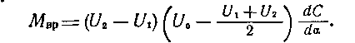
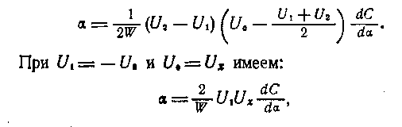
i.e. "unlike electrostatic voltmeters and electroscopes, ESE have a linear scale - the angle of rotation is directly proportional to the measured voltage , and its sign depends on the sign of the measured voltage. Due to the large auxiliary voltage U ₁ in the ESE, you can get a much greater sensitivity than in a voltmeter [L. 5-29].
U₀—U₂. Энергия, запасенная в измерительном механизме:
Вращающий момент определяется соотношением
В силу симметрии конструкции dC₁∕da= -dC₂∕da и поэтому
Если противодействующий момент M_{пр}=W_{α}, то угол поворота подвижной части
- Sensitivity
Equation (5-2) is approximate; its derivation does not take into account the charge induced on the movable electrode when moving in the field of stationary electrodes. The interaction of the electric field with this charge creates an additional torque. The general expression for the sensitivity of the ESE, taking into account this phenomenon, has [L. 5-20, 5-29] view:
where E is the field strength in which the movable electrode is located; his movement; C - capacity
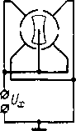
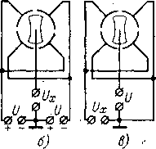
Рис. 5-2. Схемы включения элек-
подвижного электрода. Увеличением напряженности Е в любом ЭСЭ можно получить бесконечно высокую чувствительность, когда малейшему напряжению на входе ЭСЭ соответствует отклонение подвижной части на всю шкалу. Такой режим называется критическим или «опрокидыванием». Приблизиться к нему можно лишь при малых W. В противном случае чувствительность очень сильно зависит от Е и других параметров ЭСЭ и уберечься от перехода в критический режим невозможно.
- Switching schemes
An electrostatic electrometer allows various options for switching on the measured and auxiliary voltages (Fig. 5-2). When double enabled, the auxiliary voltage is not used, the ESE works like a voltmeter and its sensitivity is low. The highest sensitivity is provided with biscuit switching. With a quadrant inclusion , the sensitivity is 2 times lower than with a biscuit one [L. 5-1].
- ESE types
There are many different ESEs. We confine ourselves to a brief description of characteristic systems. The considered quadrant ESE is one of the most sensitive. With an auxiliary voltage of 100 V and a distance from the mirror to the reading scale of 1 m, the constant voltage is 200–300 μV/div, and in special designs it is 50–60 μV/div. The settling time is tens of seconds. In the binary ESE, the quadrants are replaced by a curved metal box cut into two parts, and the movable part also consists of two isolated halves (Fig. 5-3). The sensitivity of a binary electrometer is less than that of a quadrant one.
109
In a string ESE (Fig. 5–4) , a platinum filament 1–5 μm thick is stretched between the knives, to which a potential of the order of 100 V is equal in magnitude and opposite in sign. The forces of electrostatic interaction between the thread and the fixed electrodes are balanced by the elastic forces of the thread. The thread is observed using an eyepiece or projection device. Sensitivity, adjustable by changing the thread tension and the distance between the knives, is 10-20 times less than that of quadrant ESE. String ESEs have a small input capacitance and a short settling time of readings - hundredths of a second. When the knives of the string ESE are powered by alternating voltages with the frequency of natural vibrations of the string, the sensitivity can be increased in Q times, where Q is the quality factor of the thread [L. 5-11].
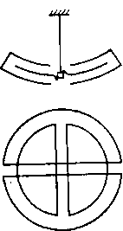
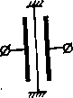
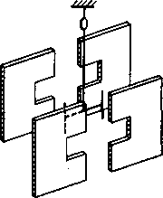
Рис. 5-3. Схематическое устройство бинантного электрометра.
Рис. 5-4. Схематическое устройство струнного электрометра.
Рис. 5-5. Схематическое устройство крутильного электрометра.
In a torsional ESE (Fig. 5-5), between four knives connected in pairs crosswise, a rocker is suspended on a conductive thread. The sensitivity of torsional ESEs is low, but the capacitance is small. Torsional electrometers SG-1M and SG-2M are widespread in our country [ L. 17-2]. The constant SG-1M is 20 mV/div, the capacitance is 2.5 pF. In the SG-2M electrometer, in contrast to Fig. 5-5, there are only two knives, its constant is 0.8 - 1 V / div, the capacitance is also 2.5 pF.
- Electrostatic amplifiers
Electrostatic electrometers have a number of disadvantages. Some of them can be eliminated by converting the angle of rotation into an electrical signal and covering the entire environmental protection system. The first devices of this kind [L. 5-19, 5-32] were a combination of a conventional ESE with an angle-to-angle converter
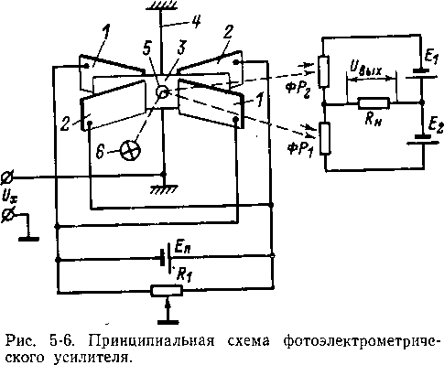

electrical signal. Subsequently, measuring mechanisms for them began to be developed taking into account all the requirements that arise in this case. A large amount of work on electrostatic amplifiers was carried out at the Kuibyshev Polytechnic Institute [L. 5-7].
In an electrostatic amplifier with a photoelectric converter of the angle of rotation into an electrical signal (Fig. 5-6) [L. 5-7] there are two pairs of fixed plates 1 and 2 and a light movable plate 3, reinforced with braces 4. A mirror 5 is installed on the movable plate, illuminated from the source 6. The fixed plates are connected in pairs, the same voltage is applied to them, but different in sign, from the source E _{p} . Resistor R ₁ you can change the ratio of stresses on the fixed plates. The movable plate is insulated and the measured voltage U _{x is applied to it} . At U _{x} = 0 , the movable plate is in the middle between the fixed ones, under the influence of U _{x} she turns. The beam of light from the mirror is redistributed between the photoresistors ΦP ₁ and FR ₂ , and a bridge formed by photoresistors and sources power E ₁ and E ₂ , unbalanced. At the load R _{n} voltage appears U _{o} , proportional U _{x} . Such an EST, like any other, may be covered by the CAB.
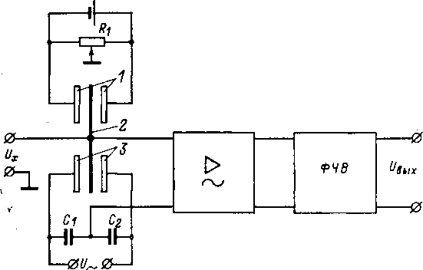
Rice. 5-7. Schematic diagram of an electrostatic amplifier with a capacitive transducer.

In an electrostatic amplifier with a capacitive displacement transducer [L. 5-7] there are (Fig. 5-7) two fixed plates 1 , to which potentials of opposite sign are applied, regulated by resistor R ₁ . Moving plate 2 isolated and suspended. In the presence of U _{x} it rotates and its lower part changes its position between the second pair of fixed plates 3. Bridge formed by containers between the movable plate and fixed and containers C ₁ and C ₂ and fed by the source U ~ , unbalanced. The alternating voltage at its output is proportional to U _{x} , it is amplified and converted into a constant by a phase-sensitive rectifier of the PFC . Other principles for constructing electrostatic amplifiers are also possible.
5-2. THRESHOLD OF SENSITIVE ELECTROSTATIC ELECTROMETERS AND AMPLIFIERS
- General remarks
The sensitivity of the ESE is determined by the design of the measuring mechanism, auxiliary voltages , etc. [L. 5-18, 5-25, 5-33]. The limiting capabilities of an ESE or an electrostatic amplifier are characterized by a sensitivity threshold determined by the level of self-interference.
- Brownian fluctuations
The moving part of the electrostatic measuring mechanism is constantly affected by fluctuations of air molecules. According to the views of statistical physics, the average thermal energy of the fluctuating exchange of a body with the environment is KT ∣ 2 for each degree of freedom, where K is the Boltzmann constant ; T is the absolute temperature. The movable part of the ESE has one degree of freedom—rotation of the movable part in systems with angular displacement or displacement of the movable part (string) in the observation plane in systems with linear displacement. Fluctuation energy of the moving part W , α ² ∕2, where W is the counteracting moment of the suspension system of the moving part; α is the angle of its rotation, is found from the equality Wα ² ∕2=KT /2. From here it is possible to determine the average square of fluctuations of the angle of rotation of the moving part α ² and the level of input voltages to which these fluctuations correspond.
The consideration carried out does not take into account the dependence of the nature of the movement of the moving part of the ESE in an unsteady mode on the moment of inertia of the moving part and the degree of its calming. Analysis with these parameters [L. 5-23] shows that the level of Brownian fluctuations depends on the design parameters of the measuring mechanism and the resistance of the signal source, which affects the damping mode of the moving part. In an evacuated ESE, the fluctuations of the moving part are significantly reduced [L. 5-22], since this excludes the movement of air masses near the moving part of the ESE due to the occurrence of temperature drops. However, 8-377 113
evacuation does not reduce Brownian fluctuations, the average energy of which remains equal to KT/2 as before. In other words, when eliminating Brownian fluctuations around the moving part, they are not eliminated inside the moving part itself. The essence of this phenomenon is that each additional fluctuating force informs the system of additional attenuation, which exactly compensates for the influence of this fluctuating force.
- Microseismic impacts
Highly sensitive ESEs are susceptible to external mechanical influences: shocks, vibrations, tilts, microseismic vibrations of the soil. Fluctuations caused by microseismic impacts depend on the mode of calming of the moving part and the spectrum of microseismic oscillations and can be significant [L. 5-24].
- Influence of contact potential difference
The contact potential difference between the ESE plates creates a parasitic moment and displaces the moving part. Drift and short term fluctuations of the contact potential difference are perceived as changes in the measured voltage. To reduce these influences, the plates of the measuring mechanism are made of the same material, polished, gilded, placed in an inert gas atmosphere or vacuum, etc.
- Other sources of interference
The sources of intrinsic interference of the ESE are also the parasitic current of insulators and radioactive contamination of materials. The latter create charges on the plates, which cause additional torques . Thermal air flows near the moving system, the presence and changes in the electrostatic fields of insulators inside the device case also affect [L. 5-27], thermo-emf. etc. To reduce fluctuations due to the movement of air flows, the measuring mechanism is surrounded by a thick copper screen , which ensures minimum thermal gradients. It is also useful to create a vacuum in the ESE of the order of 100-1000 Pa (several mm Hg).
- Limits
Ensuring a high threshold of sensitivity in the ESE requires great skill from the experimenter. It is relatively easy to achieve a sensitivity of about 10 div/mV in ESE; in some cases, sensitivity up to 50 div/mV can be realized. In electrostatic amplifiers, the presence of feedback makes it possible to solve many problems more satisfactorily, but so far such devices with extremely high sensitivity have not been made.
5-3. PERFORMANCE AND PROPERTIES OF ELECTROSTATIC ELECTROMETERS AND AMPLIFIERS
- ESE properties
The input resistance of electrostatic measuring mechanisms is determined by insulator leakage . In these devices, there are no strict restrictions on the choice of materials and design of insulators, thus facilitating the search for optimal solutions. Achieving a high sensitivity of the ESE is associated with the complication of the device and the careful setting of the experiment. The higher the sensitivity of the ESE, the more it reacts to tilts , shocks, vibrations, ambient temperature fluctuations , overloads, etc. Electrostatic electrometers do not have a standardized accuracy class and require periodic calibration. Most ESEs are characterized by the inconvenience of reading, some of the types are characterized by a long settling time and a large input capacitance. Currently, ESE of classical designs are rarely used. Attempts to bring the performance of the ESE closer to the generally accepted for laboratory electrical measuring instruments with direct reading did not give satisfactory results in terms of sensitivity [L. 5-21].
- ESE with a variable excitation field
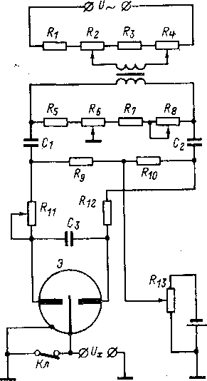
In an ESE with a variable excitation field, the disadvantages of classical designs are largely eliminated: high sensitivity is combined with resistance to mechanical stress and independence of indications from the slope [L. 5-4 - 5-6, 5-12, 8* 115
5-28]. The sensitive element is (Fig. 5-8) a gold-plated quartz thread with a diameter of about 4 microns and a length of 3.5 mm, it is cantilevered in a gap of 1.5 mm wide between two binants. An alternating voltage is applied to the binants, which creates an alternating electric field in this gap . If the voltages on the binants relative to the case are phase-shifted by 180° (this is provided by the resistor R ₁₁ ), then in the absence of a constant voltage on the thread, it is at rest. If voltage U _{x is applied} to the thread , then it oscillates with an amplitude proportional to U _{x} . The measured voltage is compensated by the reference voltage from the source on the resistor R ₁₃ . The image of the thread is projected onto a matte screen using an optical system consisting of two ellipsoidal mirrors and a microscope with a magnification of 12.5 times. The screen does not have a uniform scale with 100 divisions . When the thread vibrates, a light strip is observed on the screen, which contracts into a line when balance is reached. Sensitivity is regulated by resistors R ₂ and R ₄ , balance at U _{x} \u003d 0 - resistors R ₆ and R ₈ Sensitivity of such ESEs from Argonne National Laboratory (USA) reached 104 ^{cases} /V and ¹⁰¹⁶ cases / C [L. 5-12].
Рис. 5-8. Принципиальная схема электростатического электрометра с переменным возбуждающим полем.
c) Properties of electrostatic amplifiers
The presence of NFB in electrostatic amplifiers makes it possible to obtain a normalized accuracy class, which is convenient 116
counting, short time of indications establishment, resistance to mechanical influences. The properties of an electrostatic amplifier are determined mainly by the input electrometric transducer. The electrostatic measuring mechanism, in principle, makes it possible to obtain very high characteristics. For example, it does not contain sources of flicker noise inherent in some other electrometric voltage converters, it does not impose severe restrictions on the materials and designs of insulators, it is possible to use rational technology to reduce the drift of the contact potential difference, etc. However, they are not commercially available yet. are issued.

d) Execution example
In the photocompensation electrostatic electrometer FKE-ZP [L. 5-7] (Fig. 5-9) uses the converter already described (see Fig. 5-6). The fixed plates are powered through a rectifier (diode resistor and capacitor C ₁ ) from the network. Resistor R ₄ voltage is set on the plates. Resistors R ₁ -R ₃ (30, 500, 30 k) are used to set the ratio _{of} voltages on the plates (using resistor R 2 it is possible to set the movable plate to the zero position at U _{x} =0). The measured voltage is compensated by the counter voltage of the OOS, taken from the resistors R ₅ - R ₈ . Switch lem P selects the measurement limit. The current through these resistors is regulated by resistor R9 . Photoresistors FR type FSK-2 are powered by a rectifier (diodes D ₂ , D ₃ , capacitors C ₂ , C ₃ ). day off
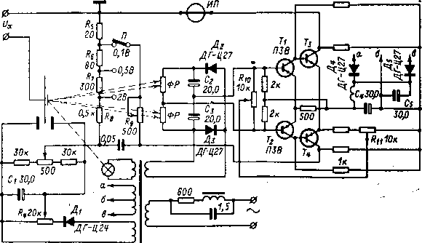
Rice. 5-9. Schematic diagram of the photocompensation electrometer FKE-ZP.
the voltage of the photoresistive bridge is applied to a two-stage balanced transistor amplifier ( T ₁ - T ₄ ), the initial collector currents of the transistors T ₃ and T ₄ are set by resistors R ₁₀ and R ₁₁ . The transistor amplifier is also powered by a rectifier (D ₄ , D ₅ , C ₄ , C ₅ , L ₁ ). The output signal is measured by IP microammeter.
The FKE-ZP device has measurement limits of 100 - 500 - 2000 mV, the input resistance is determined by insulation leakage. Output current 5 mA, external load resistance not less than 300 Ohm. Instrument accuracy class 1.0, indication settling time 0.3 s.
An electrometric recording device for studying static fields and measuring charges ERIS-66 on a capacitive transducer has [L. 5-7] measurement limits for voltage 20 and 200 mV and for charge 10 ⁻¹¹ and 10 ⁻⁹ C, error is not more than 2% and zero drift is 100 μV for 10 hours. The conversion frequency is 3 kHz, the load resistance is 420 Ohm, the bandwidth is 0.3 Hz.
Chapter Six

TUBE ELECTROMETRIC AMPLIFIERS
6-1. ELECTROMETRIC LAMPS
- General information
Electrometric amplifiers with an input stage based on an electrometric lamp (EML) are widely used , they are easy to manufacture and have a low cost. The sensitivity threshold of tube EMUs is determined by the EML characteristic. Conventional amplifying lamps have a grid current of 10 ⁻⁸ - 10 ⁻¹⁰ A, a The best modern EML (l÷3)10 ⁻¹⁵ A. The first attempt to create an EML dates back to 1922 , and already in 1930 an EML of the FP-54 type was developed with a grid current of less than 5∙10 ⁻¹⁵ A. Various types of EML are described in [L. 6-20, 6-28, 6-33, 6-39]. At present, various EMLs with a wide range of properties are commercially produced in different countries.
- Basic properties
When the voltage at the anode EML more than 8 V [L. 6-44] the grid current increases sharply (Fig. 6-1, a), so it is selected in the range of 4 - 12 V, most often about 6 V. Another feature of the EML is the low temperature of the cathode, since with a decrease in heat [L. 6-44] grid current decreases (Fig. 6-1.6). With such restrictions on the anode voltage and cathode temperature, in order to obtain any significant anode current 118
and, thus, sufficient steepness of the characteristic of the lamp, it is necessary to have a control grid with a large permeability. As a result, EML have, as a rule, a low gain. Only in electrometric
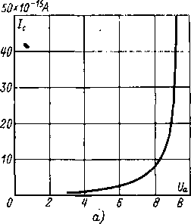
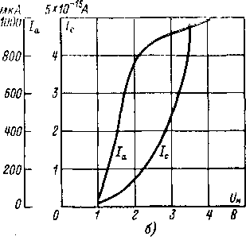
Рис. 6-1. Типичные лампы от анодного
зависимости сеточного тока электрометрической напряжения (а) и напряжения накала (б).

With pentodes, it is possible to obtain a gain of the order of hundreds. The steepness of the EML characteristic lies in the range of 20 - 100 μA / V.
- Types
Electrometric lamps are most often made as tetrodes. The presence of a cathode grid reduces the grid current. Triodes have a larger grid current. Small grid currents make it possible to obtain an inverted triode, the so-called plation . In it, the measured voltage is applied to the anode of the lamp, and the output signal is taken from the grid [L. 6-31]. In terms of steepness and gain, such EMLs are inferior to tetrodes. Electrometric pentodes provide a high amplification factor and, thus, facilitate the implementation of EMU as a whole, however, they are still inferior to tetrodes in terms of the grid current level. Quite often, EML is performed in pairs: in one cylinder there are two systems with a common cathode, and sometimes with a common cathode grid. On such EML it is convenient to build balanced cascades with a small zero drift.
- Characteristics of serial EML
In table. 6-1 shows the main technical characteristics of some EML domestic and foreign production (see also [L. 6-15, 6-49]).
Table 6-1
Main characteristics of electrometric lamps
Type of | Manufacturer | System | × | S, µA/V |  | I _{a} , µA | AT  a, | I _{n} , uA | AT  n
1E1P | USSR | tetrode | 70 | fifty | 1.3 | 100 | 6 | 46 | one
2E2P |  | double tetrode | 80 | 23 | 1.3 | 45 | 6 | 55 | 2
EM-4 |  | Triode | 80 | 80 | 2.2 | 130 | eight | 24 | 1.3
EM-5 |  | double tetrode | 5 | fifty | 1.1 | 85 | 5 | 115 | 3.15
EM-6 |  | Same | 5 | 45 | 1.1 | 75 | 5 | 75 | 4.5
EM-7 |  | Triode | fifty | 80 | 1.6 | 200 | 7 | eighteen | one
EM- 10 |  | Pentode | 9 | ten | 150 | 3 | 7 | 16 | 0.7
SK5886 | United States, Raytheon |  | 200 | 160 | 2 | 200 | 10.5 | ten | 1.25
SK5889 | Same |  | 3 | ten | 250 | four | 12 | 7.5 | 1.25
ME1400 | England, Mullard | » | 6000 | 240 | 1 200 | 80 | 45 | — | 4.5
ME1401 | Same | Triode | 100 | 80 | 2 | — | 9 | fifteen | 1.25
ME1402 | Same | tetrode | 5 | 100 | one | — | 4.5 | — | 1.25
DC760 | GDR, RFT | Inverted triode | one | fifty | 0.3 | 150 | four | 13 | 1.1
DC762 | Same | Same | 100 | 120 | one | 400 | 9 | 13 | 1.1
4066 | Holland, Philips | tetrode | 25 | 17 | one | twenty | 4.5 | 13 | 1.25
4068 | Same | Pentode | 3 | 10.5 | on | 5 | ten | 8.2 | 1.25
4069 | Same | Triode | 160 | 80 | 2 | 100 | 9 | fourteen | 1.25
2NE9 | Czechoslovakia cue, Tesla | tetrode | twenty | thirty | — | 150 | eight | thirty | 1.25

On fig. 6-2 shows the grid characteristics of some types of EML according to catalog data, as well as according to [L. 6-31, 6-38, 6-50]. For most EMLs, at a certain voltage on the grid, the grid current is maximum; at this point, the input dynamic resistance of the lamp is equal to infinity, i.e., the EML converter approaches the ideal in this parameter. However, more often they work at large negative biases on the grid, when the grid current depends little on the lamp mode, and the input resistance is still quite high.
- Using conventional lamps in electrometric mode
Some of the conventional electronic amplifying tubes are close in design parameters to EML and have good isolation of the control electrode.
Rice. 6-2 Grid currents of electrometric lamps.
By choosing an operating mode close to electrometric and making a selection of lamps, it is possible to reduce the grid currents to 10 ⁻¹² -10 ⁻¹³ A and less [L. 6-7, 6-22, 6-30]. At present, the use of conventional lamps in electrometric mode is rarely practiced. Sometimes non-electrometric lamps are used in reversed mode [L. 6-5, 6-40, 6-45].
where I _{e} is the cathode emission current; U _{c} is the grid potential; T _{k} is the temperature of the cathode; q is the electron charge; K is the Boltzmann constant; m is a coefficient depending on the size of the electrodes and the anode voltage.
To reduce the electronic current of the grid, the negative potential on the grid is increased to 2–3 V and
121
6-2. INDIRECT INTERFERENCE OF ELECTROMETRIC LAMPS a) Grid current
Grid current components. Various components of the grid current [L. 6-12, 6-22, 6-35, 6-36] create a negative or positive potential on the grid. The negative potential is created by the electron current of the grid; some of the electrons from the cathode have sufficient energy to overcome the negative potential of the grid. For a triode with U _{c} ≤0 this current [L. 6-22] is:
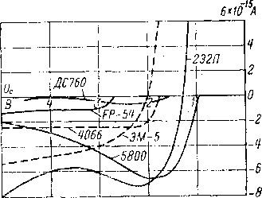
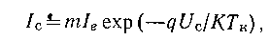

reduce the cathode temperature by using cathodes of tared tungsten (T _{κ} = 1700÷1800 K) or oxide cathodes (T _{κ} =800÷900 K). With an appropriate choice of these parameters, the electron current is close to zero (Fig. 6-3).
Insulation leakage currents create a positive potential on the grid, since all EML electrodes have
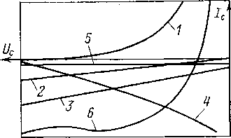
Rice. 6-3. Dependence of the grid current of an electrometric lamp and its components on the grid voltage.
1 - electronic current; 2 - leaks in the grid-cathode section;
3 - leaks in the grid - anode section; four — ionic, thermoelectronic and photoelectronic currents; 5 - residual current; 6 - full grid current.
positive potential relative to the control grid. The leakage currents are linearly dependent on the voltages in the respective sections. At U _{c} = 0 , the leakage current in the grid-cathode section is zero. To reduce leakage currents in the design of EML, high-quality insulators of the control grid inside the lamp and the grid output on the bulb are used, during manufacture, measures are taken to prevent internal contamination of the bulb, and, in addition, the bulb is covered with water-repellent layers of low intrinsic conductivity. When using EML, the methods of equipotential screening of the grid from other electrodes are used to reduce leakage. Before using the EML, it is recommended to wash it with alcohol, then with distilled water and dry thoroughly. Sometimes the lamp is boiled in distilled water. Parasitic currents of EML grid insulators become noticeable if the total grid current does not exceed 10 ⁻¹⁴ A [L. 6-36]. To reduce them, it is recommended to perform miniature EML.
Other components of the currents that create a positive grid potential can be divided into three groups : ion current, thermionic emission current, and photoelectron emission current. The ion current represents the flow of positively charged particles onto the grid and can be due to the following reasons:
- ionization of atoms and molecules of the residual gas when they collide with electrons flying from the cathode to the anode [this part of the ion current is proportional to the anode current of the lamp. To reduce it, it is necessary to increase the degree of vacuum in the flask and choose the anode voltage below the value of the ionization potentials of the residual gases in the lamp, which for the main components of the residual gases (H, H ₂ , N, N ₂ , O, O ₂ , CO ₂ .) lies in the range 12-16 V. In addition, active absorbers are used inside the flask];
- ions emitted from the cathode and thermal ions arising when residual gas molecules hit the cathode [this part of the ion current is eliminated by using a screen grid between the cathode and the control grid, which intercepts the ions moving from the cathode to the control grid];
- ions formed during the ionization of the residual gas by cosmic or radioactive radiation of the surrounding space [to reduce this component, the EML is placed in a metal screen].
Thermionic emission current from the grid surface arises due to heat transfer from the cathode to the grid. To reduce this current, the temperature of the cathode is reduced, the conditions for heat removal from the grid are improved, and materials with a high work function are used for the grid .
The photoelectron emission current from the grid surface is caused by light radiation from the cathode and extraneous sources, light quanta from excited residual gas molecules, and ultrasoft X-rays from the anode or screen grid. To decrease it , the cathode temperature is lowered, and the EML is placed in an opaque screen (even small holes in the screen cause an increase in the grid current by several orders of magnitude). Component of the photoelectronic beam caused by supersoft X-rays [L. 6-12, 6-36]:
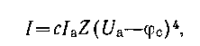

where I _{a} , U _{a} — anode current and voltage; φc _ is the work function of the grid; Z is the atomic number of the anode material; c is a coefficient depending on the design parameters . To reduce it, it is necessary to reduce the steepness
and the gain of the lamp and cover the anode with a material with a low atomic number [L. 6-36].
The sum of the ionic, thermionic, and photoelectronic currents depends in a complex way on the grid voltage, usually decreasing with increasing negative bias (see Figure 6-3).
In addition to these components of the grid current, there are a number of others. Each of them is relatively small and difficult to study. Their combination is called the residual current, which depends little on the voltage on the grid (Fig. 6-3). The dependence of the resulting grid current on its potential has a complex character and, with a change in the design parameters and the electrical regime of the lamp, can change quantitatively and qualitatively . In the region of high negative potentials on the working grid, the grid current is due to the ion current of the grid, and an increase in the grid current causes a positive potential on the grid. If the positive pole of the controlled voltage or current source is connected to the grid, then an increase in the grid current appears as an increase in the measured voltage or current.
Free grid mode. At some grid bias, the EML grid current is zero. If the grid of the lamp has no leakage resistance, then the grid current charges the input capacitance until the voltage on the grid is reached, at which it is equal to zero. In this state, the lamp will remain in the future. For triodes, the floating potential point lies in the range from -0.5 to -2 V and slightly depends on the anode voltage or cathode temperature. Reducing the temperature of the cathode or the anode voltage shifts it to zero bias. In electrometric tetrodes, the floating potential is usually greater than 2 V, since the energy of the cathode grid is transferred to the electron beam. The behavior of electrometric cascades in the free grid mode has been studied little [L. 6-17]. In practice, this mode is used only occasionally [L. 6-9, 6-42], and is not used at all in serial production devices . Working in free grid mode requires an individualized approach to each instance of the lamp. With fluctuations in operating conditions, the potential of the free grid may change, which cannot always be taken into account, and the lamp will go out of 124
mode. With large signals, the lamp also goes out of mode, as a result, significant grid currents can appear.
Measurement of grid currents. Like any small currents, EML grid currents can be measured either by the voltage drop across a high resistance resistor or by the capacitor charge rate. The easiest way to do this is to perform an EMU with an input stage on the lamp under study and include its parallel OOS resistor or capacitor in the circuit. With the resistor method, the difference between the output voltages of the EMU with a shorted and open resistor is equal to the voltage drop across the resistor due to parasitic current at the input of the EMU. In the capacitor method, the parasitic current is determined by the rate of change of the EMU output voltage. The capacitance of the capacitor must be small so that this speed is high and the effect of voltage drift can be neglected. The capacitor method allows for greater accuracy and sensitivity than the resistor method. It is also possible to measure the grid currents of the EML in the simplest cascade on the investigated EML [L. 6-24]. In this case, a resistor or capacitor is switched on at the lamp input. The voltage drop across a resistor or capacitor can be compensated for with an additional regulated source; then you do not need to know the transfer coefficient of the tube cascade.
- Noises
Noise components. Noise characteristics of tube electrometers began to be of interest soon after their development [L. 6-46, 6-51]. The main components of EML noise are flicker noise and shot noise of the grid and anode currents. The flicker effect is due to chaotic changes in the emissivity of individual sections of the cathode, which causes fluctuations in the anode current [L. 6-54]. The level of flicker noise and its frequency spectrum depend on the manufacturing technology and cathode type; The oxide cathodes have the highest flicker noise. It is different for different instances of lamps of the same type. Usually , the flicker noise spectral density is taken equal to A ∣ f ª , where A and a are constants, and α≈1; f is the frequency. As the frequency decreases, the flicker noise gradually transforms
into a drift of the lamp anode current. For α≥l , the specified dependence of the spectral density on frequency cannot be extended to arbitrarily low frequencies, otherwise it would be necessary to assume that the noise spectral density increases indefinitely, which cannot be. In the low frequency region, there should be a region in which a becomes less than unity; however, such a region has not yet been observed experimentally ; apparently, it begins below the frequency range in which measurements are currently being made.
The shot noise of the EML grid current obeys general laws (see § 1-3). In this case, the current producing shot noise should be understood as the sum of the absolute values of the electronic and ion components of the grid current.

Shot noise of the anode current is found taking into account the depression coefficient Γ≤l, which takes into account the decrease in the noise of the anode current due to the space charge near the lamp cathode, i.e.
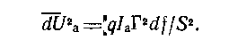
Имея в виду, что ΔI_{a}=SΔU_{c}, где S — крутизна анодно-сеточной характеристики лампы, приведенное ко входу шумовое напряжение, создаваемое дробовыми шумами анодного тока:
It does not depend on the resistance in the lamp grid circuit.
There are other causes of tube noise [L. 6-25], however, they appear to a lesser extent than those considered.
total noise. All EML noise can be divided into current noise and voltage noise. Current noise is represented only by the grid current noise of the lamp, all other components give voltage noise . Noise voltage includes flicker noise, and its density depends on frequency. The shot noise density of the grid current does not depend on the frequency. If other factors, such as fluctuations in the grid current, also affect the level of the noise current, then the spectral density of the noise current may depend on the frequency.
for this lamp is from -1.45 to +2.45 V) the minimum grid current is reached. The tubes that needed the most offset almost always had the most noise.
It is generally accepted that EML voltage noise can be described by the equivalent noise resistance , which depends on the frequency as follows:
works on the experimental study of EML noise [L. 6-13, 6-23, 6-54]. Measurement
spectral noise density of 19 5886 lamps in the range from 1 to 1000 Hz [L. 6-23] showed (Fig. 6-4) that for the best and worst it differs very much, especially at low frequencies . The noise level depended on the grid displacement at which (according to passport data, it
Rice. 6-4. Input-referred equivalent noise density for 5886 electrometric tubes.
where f ₀ means the frequency at which flicker noises (1/ f ) are equal to noises whose spectral density does not depend on frequency (thermal, etc.), and R _{equiv} is the noise resistance at f>> f ₀ . The higher f ₀ , the greater the contribution from flicker noise at low frequencies. For EML approximately R _{e kb} = 2∙10 ⁶ Ohm and f ₀ \u003d 500 Hz. At low frequencies, when flicker noise prevails and R ' _{equiv} = 10 ⁹ ∕f.
EML vibronoises are especially pronounced when the lamp operates under conditions of constant mechanical influences (shaking, vibrations, shocks), but they are also noticeable in laboratory conditions. The level of vibronoise is determined by the design of the lamp and the natural resonant frequencies of its electrodes.
Measurement methods. The upper limit of the frequency range in which it is necessary to know the EML noise does not exceed 100–1000 Hz (the bandwidth of high-speed electrometric current meters or
127
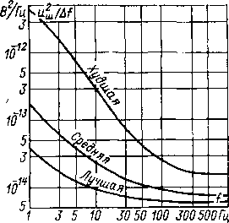
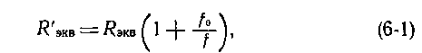

voltage usually does not go beyond this range ), and the lower one reaches 10 ⁻⁴ - 10 ⁻³ Hz. To measure noise in this range, [L. 6-10, 6-11] broadband low-noise amplifier, for example, on a 6Zh32P pentode in microcurrent mode [L. 6-1]. It is used to amplify EML noise to a level available for further processing.
When determining very low frequency noise , discrete processing methods are most suitable. With the help of a digital voltmeter, the noise level is determined at regular intervals, which makes it possible to find the desired noise characteristics, for example, the spectral density, on a computer later on.
In analog methods, noise is analyzed using low-pass bandpass filters with a tunable resonant frequency and low-frequency r.m.s. voltmeters. The main difficulties are associated with the construction of low-frequency filters and voltmeters. At frequencies of the order of 1 Hz and above, the problem is solved relatively simply [L. 6-1]. At lower frequencies, noise is written to a tape or other memory device at a slow tape speed and then read from it at a much faster speed. This makes it possible to transform the frequency spectrum of the studied noise without nonlinear distortions and to use standard high frequency equipment for analysis .
With all methods, the measuring device as a whole must be preliminarily or during the measurement process calibrated using infra-low-frequency noise generators [L. 6-10]. During measurements, it is necessary to separate EML noise by voltage and current. The first are determined when the lamp input is shorted, when current noise does not appear, the second - when a large resistance is connected to the input. It is necessary that the voltage on it, caused by current noise, significantly exceed the EML voltage noise.
- Zero drift
Own EML drift. Under favorable conditions , the EML zero drift does not exceed 0.1 mV/h. One of the reasons for the drift is a change in the contact potential difference between the grid and the cathode, in particular, under 128
the influence of changes in the current taken from the cathode. Typically, the drift speed is highest at the first moment after switching on and gradually decreases. The EML intrinsic drift can be reduced by preliminary training of the lamp at nominal anode and filament voltages for approximately 100 h.
To avoid increased EML drift, the anode circuit and the protective grid circuit should be powered only after the lamp has warmed up. Otherwise , the surface activation of the cathode may change and it will take a long time to restore the stable emission characteristics of the lamp [L. 6-29].
The reason for the increased EML drift may be electrical overloads on the control grid. Overloads up to hundreds of volts do not disable the EML, but increase the grid current of the lamp and its drift, and the lamp returns to its normal state slowly. To protect against overloads, a resistor with a resistance of several megohms is connected in series with the control grid. In the nominal mode, the voltage drop across the resistor from the grid current of the lamp is small, but during overload, when the grid current increases, most of the voltage is extinguished on the resistor.
The temperature drift of the EML zero can approximately be considered equal to 2.5 mV/K for a single lamp and 0.1-0.25 mV /K for a double triode in a balanced cascade. Sometimes compensation for temperature drift is provided.
The current drift of the EML zero is determined by the instability of the grid current of the lamp and its dependence on temperature. It is usually assumed that short-term changes in the grid current do not exceed 10% of its absolute value.
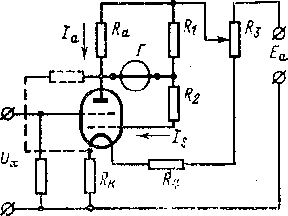
Anode and cathode drift. The drift caused by fluctuations in the supply voltages is divided into anodic, i.e., due to the power supplies of the anode circuit, and cathodic, due to the power supplies of the filament circuit. The anode drift of the amplifying stage brought to the input ΔU _{x} = ∆E _{a} ∕μ, where ∆E _{a} is the change in the supply voltage of the anode circuit; μ is the gain of the lamp. If E _{a} =10 V and stabilized to within 0.1%, and μ=l, then ΔE _{a} = 10 mV and anode drift ΔU _{x} =10 mV. The cathodic drift, reduced to the EML input, can be approximately considered equal to 10–30 mV per 1% of the measurement . ₁₂₉
heating current [L. 6-2, 6-5, 6-24, 6-25, 6-27]. There are many methods for compensating the anode and cathode drift; they require an individual approach to the choice of cascade parameters and are not used in commercial devices .
Рис. 6-5. Несимметричная балансная схема одноламповых электрометров по Дюбриджу и Брауну.
Balanced asymmetrical cascades. At the initial stage of the development of tube electrometers, much attention was paid to single stage systems without negative feedback, which are insensitive to supply voltage fluctuations. They can be divided into balanced asymmetrical and. balance symmetrical. Among balanced non- symmetric cascades , schemes are most widely used, one of which was proposed by Dubridge and Brown [L. 6-24] and the other by Bartom and Penik.
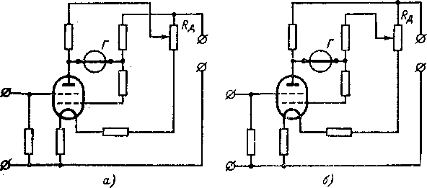
In the scheme of Dubridge and Brown (Fig. 6-5) by choosing R _{κ} , R _{a} , R ₁ , R ₂ and R ₃ , the cascade is configured so that the current through the output device G does not depend on changes (within a narrow range) of voltages E _{a} and nominal
Рис. 6-6. Варианты несимметричной балансной схемы одноламповых электрометров по Барту.
voltage at the electrodes of the lamp. The latter is not always possible, therefore, in the Barth scheme (Fig. 6-6) , it was required to introduce another degree of freedom when setting 130
to make this ratio the same as for the other lamp. When using electrometric triodes, this can be done by shunting the anode-cathode section of the lamp with active resistance, by including one of the additional resistance lamps in the anode circuit , or by selecting a bias on the control grid of one of the lamps. For multigrid EML, other ways of changing the ratio of the dynamic and static resistances of the lamp are also possible, for example, by selecting resistance in the cathode grid circuit.
Cathodic drift in a parallel-balanced cascade is eliminated under the condition [L. 6-15, 6-19]
and the supply voltages of the anode circuits and the cathode grid are not the same. Depending on which of them is larger (this is revealed during commissioning), the circuit takes on the form shown in Fig. 6-6, a or 6-6.6. In both versions, there is an additional divider Rd, which _{in} the first case sets the anode voltage lower than the voltage on the cathode grid, and vice versa in the second case.
Balanced symmetrical cascades. The most common parallel-balanced circuit is performed on two lamps or on one dual lamp. Compared to unbalanced and balanced unbalanced cascades, the noise in such devices is √2 times higher . The advantage of symmetrical cascades is a small drift. There is no anode drift if the condition R _{st2} / R _{i2} =R _{st1} ∣ R _{i1 is satisfied} , where R _{i} and R _{st} - dynamic and static resistance of the lamps. This condition is not exactly observed, but the anode drift is still 10–20 times smaller than in an asymmetric cascade. To completely eliminate the anode drift , it is necessary [L. 6-15] change the ratio R _{st} / R _{i} for one of the lamps so
Rice. 6-7. Scheme of a parallel-balanced cascade with cathode drift compensation.
In practice, it is not strictly observed, but the use of a symmetrical balanced cascade is essential .
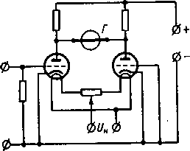


reduces cathodic drift. For c leading it to zero, change (Fig. 6-7) the ratio between the lamp filament currents [L. 6-26, 6-32]. There is an opinion [L. 6-4] that the intrinsic drift of the balance cascade on the EML is the smaller, the less sensitive the cascade is to fluctuations in supply voltages, however, there are no sufficient confirmations of this yet.
6-3. SCHEMES AND PROPERTIES OF TUBE EMUs
- Single stage electrometers
Single stage electrometers are simple and can often be made in-house. Sometimes an additional stage is used after the input to increase the signal to a convenient level. These circuits are similar in properties to single-stage electrometers.
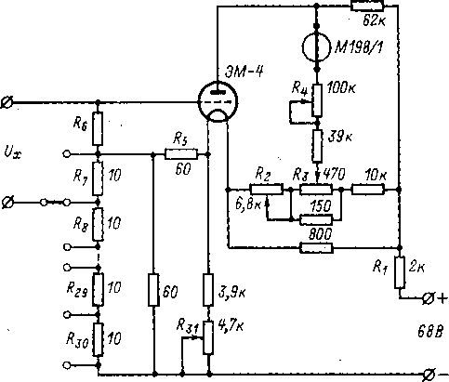
Rice. 6-8. Schematic diagram of a single-lamp electrometer EM-61.

Tube electrometers without environmental protection have an unstable transmission coefficient, an increased settling time, and are rarely used.
Single stage electrometric millivoltmeter EM-61 [L. 6-14] produced by VNIInauchpribor is powered by a network of variables o g o 132
t oκa through a stabilized rectifier on gas-discharge zener diodes SG1P and SG2S, the output voltage of which is 68 V (Fig. 6-8). Part of the voltage is quenched on the resistor R ₁ , the voltage on the lamp stage is 20 V. Zero is set by resistors R ₂ and R3 . _ Output microammeter M198/1 accuracy class 1.0 has a measurement limit of 1 μA. Sensitivity is regulated by resistor R ₄ , connected in series with the device. The initial bias on the grid is created by the current of the filament circuit on the resistor R ₅ . A high-resistance resistor R ₆ is included at the input . In the EM-61 millivoltmeter, most of the measured voltage is compensated by the voltage from a divider of 23 precision manganin resistors R ₇ -R ₃₀ . Operating current divider resistor R ₃₁ is set to 5 μA, the compensation voltage is changed in steps of 50 mV from 0 to 1.15 V. The uncompensated voltage is measured by an electrometric cascade with a measurement limit of 50 mV. The operating current of the divider and the sensitivity of the electrometric cascade are set according to the normal element. The error of the millivoltmeter does not exceed 0.05% of the measurement area (1.2 V). Zero drift does not exceed 2 mV/h. The power consumed from the network is 60 W, dimensions 315×255×205 mm, weight 9 kg.
- Lamp EMUs with environmental protection
In order to reduce drift, the cascades of such EMUs are usually performed symmetrically according to a parallel- balanced circuit on two EMLs or one dual one. Sometimes, for this purpose, the entire amplifier is made symmetrical. To reduce the influence of the drift of the secondary amplifier, electrometric pentodes with high gain are used in the input stage [L. 6-6, 6-21].
Rice. 6-9. Scheme of switching on an electrometric lamp together with a photogalvanometer .
amplifiers with direct connection of cascades were used as secondary ones . Electrometric amplifiers of this type were used in the EK6-7 teraohmmeter and the EMU-3 electrometer. In the last decade, the secondary amplifiers of tube
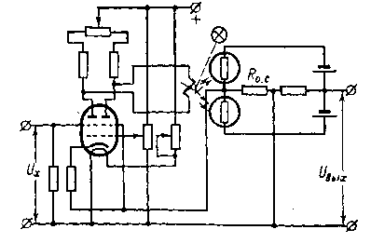
133
EMU is performed on transistors. Transistor cascades require a 20-30 V supply and are well combined with an EML cascade . Other types of secondary amplifiers are also used: on photogalvanometers F117 and F120 (Fig. 6-9), magnetic amplifiers, amplifiers on a vibration transducer, with a key modulator on transistors [L. 6-52], with a modulator on varicaps [L. 6-29]. However, these systems have not been widely used . In recent years, operational amplifiers on integrated circuits have been increasingly used as secondary ones, which, apparently, will supplant all other possible systems in the near future.
With a rational choice of the input stage and the secondary amplifier, the zero drift of tube EMUs can be reduced by OD mV / h, more often it is 0.5 - 1 mV / h and is normalized for serial devices equal to 1 - 4 mV / h. Usually the lower limit of measurement (full scale) is 100 mV , less often 30-50 mV , sometimes GO mV. On the side of large signals, the measurement range is limited by the amplitude range of the output stage, which depends on the supply voltage. Most often, the upper limit of measurement of lamp EMUs does not exceed 20 - 50 V. The use of complex cathode repeaters makes it possible to expand it to hundreds of volts [L. 6-8, 6-9].
EMUs is determined by the EML grid current (10 ⁻¹⁵ -10 ^{-14 A) and is 10 -13} -10 ⁻¹² A at best . by compensating the grid current or introducing a correction for it, are of little promise. For such measurements , it is more natural to use an EMU with a dynamic capacitor.
The amplification factor of tube EMUs can be brought to units - tens of thousands. Ensuring stable operation in the environmental protection mode usually does not require special measures. The frequency range is up to tens or hundreds of kilohertz, and tube EMUs are used in high-speed equipment. These advantages of tube EMUs have led to their widespread use.
- Practical schemes
In the tube EMU of the U 1-6 device, the first stage is made (Fig. 6-10) on a subminiature electrometric pentode EM- 10 according to a common cathode scheme. The initial offset on the control grid is set by the resistor R ₁ . Zero adjustment is carried out 134
by changing the potential of the screen grid: resistors R ₂ and R ₃ roughly and resistor R ₄ smoothly. The second stage is also made according to the scheme with a common cathode on a 1Zh18B lamp. The third amplification stage uses the MP 104 transistor in a common-emitter circuit. To increase the stability of the transmission coefficient, OOS is provided through the resistor R ₅ in the emitter circuit. The output stage is an emitter follower based on an MP104 transistor. The load of the EMU is the divider R ₆ -R ₁₀ for switching limits, counting
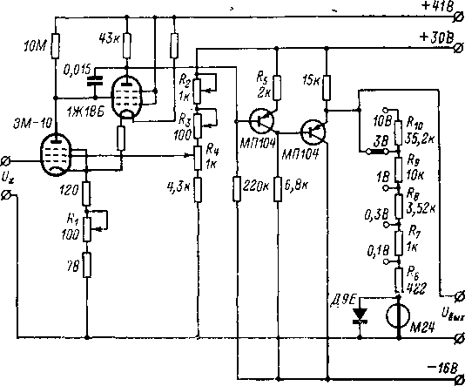
Rice. 6-10. Scheme of EMU type U 1-6.

the M24 device is protected from overloads by the D9E diode. The total gain of the EMU is 1000 - 1500, the distribution of gain over the stages is as follows: k ₁ = 50÷80, k ₂ =8, k ₃ =3, k ₄ =0.85. In the U1-6 device, this EMU is covered by a serial or parallel OOS, in fig. 6-10 it is not shown.
In the EMU in Fig. 6-11 , the transistor cascade after the EML operates in the current amplification mode, i.e., it is controlled by the current. This makes it possible to do without matching cascades, which are necessary if an amplifier based on transistors is used after EML, the first of which operates in the voltage amplification mode [L. 6-18]. The amplifier is assembled according to an unbalanced circuit, the second stage is made on a silicon p - n -p transistor OS201. A change in temperature by 1 °C changes the current at the input of this transistor by 10 ⁻⁹ A, with a steepness of the EML type ME1403 of about 100 μA / V, this is equivalent to a change in the input signal by 0.1 mV. The current gain of the first transistor stage is 20; this allows not to impose high requirements on the following cascades. The total gain of the EMU is 4000, with an output signal of 14 V, saturation of the output is achieved.
Table 6-2
Characteristics of serial tube electrometers
Type of | Manufacturer | Measurement limits (full scale)
Type of | Manufacturer | U
U1-6 | "Izmeritel", Leningrad | 0.1—10V;  2.5-4% | 10 ⁻¹³ - 2*10 ⁻⁸ BUT;  3-7%
U 1-7 | "Izmeritel", Leningrad | 0.1-10 V;  2.5% | 10 ⁻¹¹ - 10 ⁻⁷ A; 3-6%
EK6-7 | Punane Rat, Tallinn | 0.1-10 V;  2.5% | 10 ⁻¹³ -10 ⁻⁷ A; 4-6%
1230A | General Radio (USA) | 0.03-10 V;  2-4% | 3 * 10 ⁻¹³ - 10 ⁻³ A; 3— 10%
TR-85 | Takeda Ricken (Japan). | 0.03-10 V; 2% | 3*10 ⁻¹³ - 10 ⁻⁴ BUT;  3-8%
multi-dyne | Lemouzy (France) | 0.01-20 V; 1-2% | 10 ⁻¹² -10 ⁻⁶ A;  2-5%

cascade, the zero drift at a constant temperature is 0.25 mV/h, the temperature drift is 1 mV/K. The voltage sensitivity threshold is 0.2 - 0.5 mV. After the introduction of the OOS, which
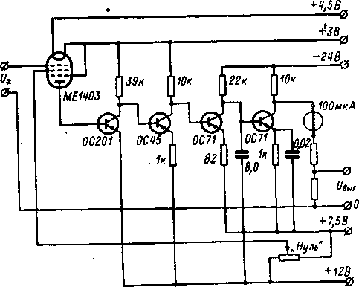
Rice. 6-11. Schematic diagram of an EMU with a secondary transistor amplifier. '

and error |  | Zero drift | Dimensions, mm | Weight, kg
 | R | Zero drift | Dimensions, mm | Weight, kg
 | — | 2 mV for 20 min | 240×190×120+70×130 | 5.1
 | — | 2 mV for 20 min | 240×190×120+70×130 | 5.1
 | 10 ⁸ -10 ¹⁶ Ohm;  4-10% | — | 324×250×212 | fifteen
 | 3*10 ¹² -3*10 ¹⁵ Ohm; 3-10% | 2 mV/h | — | —.
 | — | 0.4-2 mV/24 h | 170×250×240 | —
 | 10 ⁶ -10 ¹⁴ Ohm;  2-5% | — | 440×300×300 | 17

rice. 6-11 is not shown, the measurement limits (full scale) of a device with such an EMU are from 10 mV to 10 V.
- Tube EMUs with conversion
When using EML as a DC to AC converter (§ 4-1), the nonlinearity of the characteristics of the lamp and the presence of capacitive couplings between its electrodes make it difficult to separate the input circuits and control circuits and it is not possible to obtain small intrinsic noise. If very high sensitivity is not required, such circuits can be convenient.
In the diagram in fig. 6-12 , the input stage is made on a rod lamp with a separate anode output through the bulb dome. The lamp works in reversed mode. The modulating signal from the generator G is fed to the first grid , the modulated signal from the second and third grids is separated by a resonant circuit formed by the primary winding of the transformer Tr and capacitor C and tuned to the frequency of the generator. From the secondary winding Tr , the signal is fed to a three-stage AC amplifier U and is converted by the demodulator D into a DC voltage proportional to the input. The initial lamp mode is set by resistors R ₁ - R ₅ and zener diode St. The circuit is powered by a stabilized power supply source with an ungrounded output. A change in the input voltage leads to the same voltage change on all other electrodes and on the screen, which reduces the effect of the input
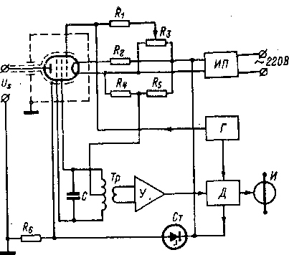
Rice. 6-12. Scheme of a tube EMU with modulation.

containers. Potential differences between the electrodes remain unchanged, which increases the stability of the device. The output signal of the demodulator is measured by an I instrument . Such an electrometric amplifier has a constant of 20 mV/div, an input resistance of 1014-1015 ^{Ω} , ^{an} input capacitance of 0.3-0.6 pF , and a bullet drift of a few millivolts per day.
- Serial devices
On the basis of lamp EMUs, usually inexpensive universal electrometric instruments of medium sensitivity are used to measure voltages, currents, charges and resistances (Table 6-2).
The measurement ranges and accuracy depend on the parameters of the EMU and passive electrometric transducers . The voltage measurement error is most often determined by the output device, and at sensitive measurement limits it is also determined by the zero level instability. When measuring currents, charges and resistances, the error of passive transducers is added.
Chapter Seven

ELECTROMETRIC AMPLIFIERS ON FIELD TRANSISTORS
7-1. FIELD TRANSISTORS
- General information
Field effect transistors are voltage controlled devices. They have a low level of their own interference. Particularly suitable for the construction of electrometric voltage converters are field -effect transistors with an insulated gate; their input impedance reaches ¹⁰⁻¹⁵ ohms, and the input current lies at the level of ¹⁰⁻¹⁵ A and below. The input current of field-effect transistors with a controlled semiconductor junction at the input is determined by the minority carriers in the gated junction and for silicon devices is 10 ⁻¹² - 10 ⁻¹⁰ A. They do not allow making an electrometric transducer with high current sensitivity, and the main attention will be given to insulated gate transistors. Field -effect transistors were proposed as early as 1939 [L. 7-14]. The first works on them were made after the war [L. 7-44], and the beginning of industrial implementation dates back to 1962-1964 . Since then , serial production of field-effect transistors and electrometric equipment based on them has been mastered, many works have been published [L. 7-10, 7-14, 7-16, 7-19, 7-43, 7-54].
- Operating principle
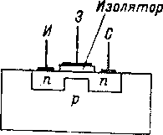
Field-effect transistors with an insulated gate [L. 7-6, 7-7, 7-14, 7-35, 7-52] are performed with a conductive channel or with an induced one. In the first (Fig. 7-1) , on a semiconductor wafer, for example, with hole conductivity, two heavily doped regions with electronic conductivity are created at a small distance from each other : source I and drain C. They are connected by a thin near- surface channel with the same
conduction type. The channel is covered with a thin layer of insulating material, covered with a metal film , which forms a control electrode, called gate 3.
Рис. 7-1. Структура полевого транзистора с проводящим каналом.
The electric field created by the gate voltage changes the concentration of charge carriers in the channel and, thus, the resistance of the source-drain section. If the channel is electronically conductive, a negative gate voltage increases its conductance and the current in the drain circuit. This mode is called the enrichment mode. With a positive voltage, the channel operates in the depletion mode, up to the blocking of the channel. If the channel is made with hole conduction , then a depletion mode occurs at a negative gate voltage, and an enrichment mode occurs at a positive voltage.
In transistors with an induced channel, conduction between the drain and source is formed only in the presence of a gate voltage due to the enrichment of the near electrode layer. A change in the gate potential changes the thickness of the inversion layer and the concentration of charge carriers in it, the channel conductivity and the current in the drain-source circuit change. Such transistors operate only in enrichment mode. When the gate voltage is less than a certain value, called . threshold, the channel current is zero.
- Varieties
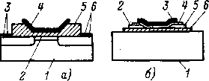
Insulated gate transistors are divided [L. 7-16] into two classes: with a metal-oxide-semiconductor structure (MOS transistors) and thin-film field-effect transistors (TFTs). MOSFETs (Fig. 7-2, a) have an annular or linear geometry. The process of their manufacture is based on the diffusion of n -type impurities into a lightly alloyed p - type material . In TFT (Fig. 7-2, b ) a semiconductor channel, usually from cadmium sulfide, is deposited from the vapor phase on a glass or ceramic
Рис. 7-2. Конструкции полевых транзисторов с МОП-структурой (а) и тонкопленочного (б). а: 1 — подложка (Si); 2 — канал;
3— сток; 4 — затвор (А1); 5 — изолятор (SiO₂); 6— исток; б: 1 — подложка (изолятор); 2 — сток; 3 — затвор; 4 — напыленный изолятор;
5 — исток; 6 — напыленный полупроводник.
film and are 10 ¹² -10 ¹⁵ ohms. For a transistor with a pn junction, they are determined by the resistance of the first junction and do not exceed 10 ⁹ ohms. The capacitances between the electrodes gate - drain C ₁ , gate - source C ₂ and drain - source C ₃ are similar in manifestations to the transmission, input and output capacitances of an electron tube. They lie within units of picofarads, and for transistors with a pn junction, they can reach tens of picofarads. The input capacitance depends on the gate voltage, the nature of this dependence is affected by the drain voltage [L. 7-6]. The current at the output of the transistor is characterized in the equivalent circuit by the generator SU _{x} , connected in parallel with the channel resistance R _{κ} , where S is the steepness of the drain-shutter characteristic. Other things being equal, it is proportional to the gate capacitance. The manufacturing technology of MOS transistors makes it possible to obtain gates with small dimensions, i.e., with a small
substrate. Then, drain and source metal electrodes, an insulating layer, and a metal contact for the gate are successively deposited onto the film forming the channel. Micropores in the insulating film do not make it possible to obtain the input impedance of the TFT above 10 ⁹ Ohm ; they are not used in the input electrometric voltage converters, i.e., in the first stage of the EMU.
d) Equivalent circuit
Contact resistance of electrodes of field effect transistors with semiconductor material R ₃ , R _{c} and R _{and} (Figure 7-3) lie at the level of hundreds of ohms. The greatest influence on the operation of the transistor is exerted by R _{and} , which creates a negative feedback in a cascade with a common source or a common drain (see § 7-3). The resistances Rz and Rc _{are} small compared to the external _{resistances} in the electrode circuits, and they can be ignored. Resistance between gate _{and} source Rc.i and between the gate and drain Rc _{of the MOS} transistor are represented by leakage through the insulating
141
Rice. 7-3. Field transistor equivalent circuit .
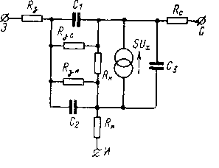

capacitance, and they have a higher ratio of transconductance to capacitance than pn - junction transistors.
- Volt-ampere characteristics
The output characteristics of the field effect transistor, which give the dependence of the drain current on the drain voltage at various gate voltages, are similar in appearance to the anode characteristics of an electrovacuum pentode. In a transistor with a conducting channel, when
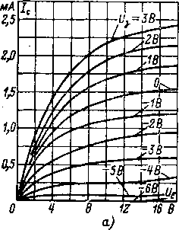
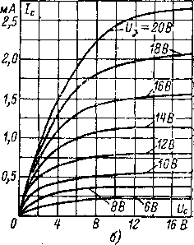
Рис. 7-4. Характеристики полевых транзисторов.
а — с проводящим каналом; б — с индуцированным каналом.

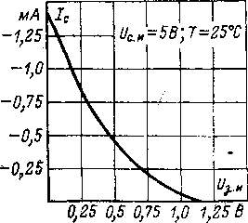
Рис. 7-5. Характеристика передачи транзистора с каналом р-типа. •
For a given gate voltage, the drain current initially grows in proportion to the drain voltage, i.e., the voltage on the channel (Fig. 7-4, a). Then the proportionality is violated due to the narrowing of the channel, and at a certain voltage, called the cutoff or saturation voltage, the current in the channel becomes independent of the voltage. The saturation current depends on the gate bias voltage. The output characteristics of transistors with an induced channel (Fig. 7-4.6) are similar, except that such transistors
can only work with a certain polarity of the control voltage, and transistors with a conducting channel with both [L. 7-10].
The transfer characteristic (Fig. 7-5), which is the dependence of the drain current on the gate-source voltage at a given drain voltage, in most cases can be described with a good approximation by the parabola equation [L. 7-16]. The greatest steepness of the characteristic S = dI _{c} ∣ dU _{c.i.} obtained at small _{displacements} U c.i. The maximum slope is inversely proportional to the channel resistance. Modern technology makes it possible to obtain a transconductance within 0.5–2 mA/V without significant deterioration of other transistor parameters. This is much greater than that of electrometric lamps (0.01-0.1 mA/V), and facilitates the design of subsequent amplification stages.
- Performance measurement
The output characteristics of field-effect transistors are determined experimentally by trivial methods [L. 7-11, 7-21, 7-24, 7-28]. To measure the input characteristics and low-frequency noise [L. 7-9] the same methods are suitable as for electrometric lamps (§6-2).
- Temperature effect
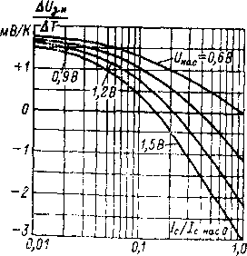
The temperature drift of the field -effect transistor brought to the input depends on [L. 7-16] on the drain saturation voltage U _{us} and the drain current (Figure 7-6). Under I _{s.nas0} is understood the current in the drain circuit of the transistor, connected according to the circuit with a common source, at the gate, short-circuited with the source . As can be seen from fig. 7-6, you can choose the operating mode of the transistor, in which the temperature drift is zero. Another way to reduce temperature drift is to use temperature compensation, for example,
Рис. 7-6. Температурный дрейф полевых транзисторов.
switching on at the output of the cascade of conventional transistors having a temperature coefficient of the opposite sign.
Changes in temperature change the mobility of the main carriers and, thus, the steepness of the characteristic of the field-effect transistor. This dependence is determined by the design of the transistor and the materials used; for silicon MOSFETs, it is insignificant [L. 7-14]. The gate current of a MOSFET is little dependent on temperature, and they can operate at high temperatures, as well as at low temperatures, down to helium [L. 7-30]. For pn junction transistors, the gate current doubles for every 8C increase in temperature.
h) Radiation properties
Radiation effects change the state of the surface and bulk properties of the semiconductor. Surface effects are due to the interaction of the ionized gas in the device case with residual impurities on the surface of the semiconductor. Volumetric changes are caused by the formation of electron-hole pairs and structural defects in the crystal lattice . Electron-hole pairs increase the conductivity of the material; this effect disappears with the cessation of irradiation. The lattice structure is disturbed even after the cessation of irradiation. Changes in the amplifying properties of field-effect transistors with a pn - junction under the influence of radioactive radiation are 100-1000 times less than in bipolar ones [L. 7-14].
7-2. INDIRECT INTERFERENCE FIELD TRANSISTORS
- Gate current
The gate insulator of a MOSFET is a thin film of SiO ₂ . The requirements for its execution are contradictory - with a decrease in the thickness of the insulator, the steepness of the characteristic increases, but the conductivity and capacitance increase, and at field strengths above 10 ⁶ V/cm, an intrinsic conduction occurs in the insulator. When considering the physical processes occurring in the insulator and determining the current and gate resistance, [L. 7-14] electronic conductivity, including the injection of charge carriers 144
where z, l and x are the width, length and thickness of the shutter; σ is the specific conductivity of the film material; I _ is the gate-source voltage; U _{us} is the gate saturation voltage.
With U _{z.i} = U _{us} /2, there must be a zero gate current. In serial MOS transistors, it is possible to reduce the gate current to 10 ⁻¹⁴ -10 ⁻¹⁵ A, in MOS transistors with equipotential gate protection [L. 7-36, 7-38] you can get smaller currents. However, EMUs based on MOS transistors are still less suitable for the construction of serial electrometric equipment with ultimate sensitivity than EMUs based on dynamic capacitors. Of course, it should be borne in mind that MOS transistors for electrometry are just beginning to develop, their properties are constantly improving, and it can be expected that over time, EMUs on MOS transistors will have a sensitivity close to that which is currently implemented using dynamic capacitors.
- Noises
of noise in MOSFETs : gate current shot noise, thermal noise from channel, gate, drain, and source resistances, and flicker noise caused by lasing-recombination effects. Shot noise determines the current noise, for MOS transistors it is small, and for transistors with a pn junction it can be significant.
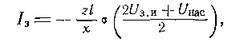
The thermal noise of the field effect transistor is small, the equivalent noise resistance for thermal noise in the channel is related to the steepness of the transistor characteristic by the dependence Rsh = ₂ ∕3S [L. 7-14]. The consequence of thermal noise in the channel is the so-called noise induced in the gate circuit. Fluctuations for 10—377 145
над потенциальным барьером, туннелирование, влияние пространственного заряда, дефекты изоляторов, ионная и поверхностная проводимости. Возможны гистерезисные эффекты, появление нелинейных зависимостей и пр. Для упрощенной модели изолятора, учитывающей только объемную проводимость изолятора и допускающей, что электрическое поле в окисном слое является однонаправленным, ток затвора равен:
rows in the channel cause equal, opposite in sign fluctuations of the charge on the gate, creating current fluctuations in the gate circuit. The level of these noises depends on the design parameters of the transistor and its mode [L. 7-14].
The most significant for MOS transistors are flicker noise, the spectral density of which depends on the frequency according to the law l∕f ^{α} , where α for serial transistors ranges from 1 to 1.4 depending on the gate voltage [L. 7-31]. Flicker noise is often referred to as 1/f noise . Flicker noise in field effect transistors is due to local changes in the electrical properties of the material, in particular, defects in the crystal lattice of the channel material. Especially often the noise of this nature is produced by surfaces, since they are strongly subject to various influences. Flicker noise can be caused by traps on the surface. According to the tunnel noise model in the MOSFET, the traps are evenly distributed in the oxide to a depth of about 0.005–0.01 µm from the boundary. The electrons tunnel from the channel to the traps and vice versa, creating noise. Flicker noise is highly dependent on the technology of transistor manufacturing. For the first MOS devices, they were significant [L. 7-47], the improvement of technology has made it possible to significantly reduce them.
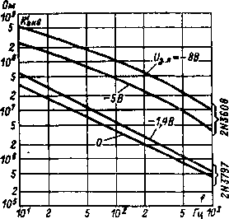
As for electrometric lamps (§ 6-2), the resulting noise resistance of MOSFETs can be represented as R' _{equiv} \ u003d R _{equiv} ( 1 + f ₀ /f), where approximately R _{equiv \} u003d 10 ³ Ohm and f ₀ \ u003d \ u003d 5 * 1 0 ⁵ Hz. For low frequencies, when we get R' _{equiv} =5∙10 ⁸ ∕f, i.e., practically the same values as for an electrometric lamp. The noise of transistors with a pn- junction is somewhat less . On fig. 7-7 are given . experimental dependences of the equivalent
Рис. 7-7. Зависимость эквивалентного шумового сопротивления полевых транзисторов с изолированным затвором от частоты.
noise resistance versus frequency for two MOSFETs: 2N3608 with p-channel and operating in enrichment mode and 2N3797 with n - channel and operating in depletion mode. The equivalent noise resistance of the 2N3797 is the same as the average above, while the 2N3608 is 10 times larger. Thus, the given values of R _{equiv} and f ₀ can only be used as indicative, and the exact values must be found experimentally for each transistor.
- Zero drift
The causes of EMU drift on MOSFETs are transistor aging, ultra-low frequency flicker noise, supply voltage fluctuations, and temperature changes. Aging manifests itself in a decrease in saturation current and an increase in gate current. Instability can also be caused by contamination of the gate oxide layer with positive ions. The inherent drift of MOSFETs is estimated to be about 0.1 mV / h, i.e. the same as for electrometric lamps.
The instability of the supply voltages manifests itself in EMUs on MOS transistors in the same way as in any other amplifiers with direct connections of stages. To reduce these influences, highly stable power supplies are used and circuit measures are resorted to, in particular, to the use of differential stages. The latter also reduces the temperature drift, especially if transistors paired in the same package are used. Coupled MOSFETs are already commercially available.
7-3. CIRCUITS AND PROPERTIES OF MOSFET EMU
- Input stages
The field effect transistor can be turned on [L. 7-10, 7-16] in common-source, common-drain, and common -gate circuits. In the common gate circuit, the input of the stage is low-resistance, and it is not used in electrometry. Electrometric amplifiers based on MOS transistors are made with direct connections of stages, the conversion of direct current into alternating current in the input stage of the EMU is not used, although in principle it is
possible [L. 7-23]. Widespread [L. 7-34, 7-49] field-effect transistor type converters , in which the control AC voltage is applied to the gate, usually have a low input resistance and therefore do not provide such a high current sensitivity as conventional MOS electrometric voltage converters. transistors .
A common-source circuit is characterized by high input and output resistances. The polarities of the input and output signals are opposite. This circuit is similar to a tube cascade from an anode to
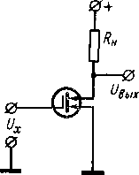
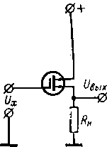
Рис. 7-8. Включение полевого транзистора по схеме с общим истоком.
Рис. 7-9. Включение полевого транзистора по схеме с общим стоком.

load, including the polarity of the supply voltages , if an n -channel transistor is used (Fig. 7-8). For a transistor with a p-channel, the polarities of the supply voltages are reversed. The voltage gain is equal to μR _{n} ∕(R _{i} + R _{n} ) , where Ri is the dynamic resistance of the channel; R _{n is the} load resistance ; μ = SR _{i} is the transistor gain . When a resistor is included in the source circuit to create automatic gate bias, FOS occurs and the gain decreases.
The common drain or source follower circuit (Figure 7-9) has high input impedances and low output impedances. The polarity of the output signal is the same as that of the input. This circuit is similar to a tube cathode follower, including the polarity of the supply voltages, if 148 is used.
/1-channel transistor. The transmission coefficient is equal to SR _{n} (1 + SR _{n} ) .
MOSFETs typically use bipolar transistors at the output. Rational joint inclusion makes it possible to obtain a series . There is [L. 7-4, 7-10, 7-45, 7-48] several options for combined input stages (Fig. 7-10). Each of them has its advantages and disadvantages, which can be found in more detail in the referenced literature.
b) Overload protection
MOSFETs are destroyed at gate voltages of the order of 30 V [L. 7-15]. To protect the input stages of EMU on MOS transistors, protective circuits on semiconductor diodes are provided [L. 7-27, 7-47], bipolar transistors [L. 7-32] or a neon lamp. Such circuits can withstand overloads up to 100 - 1000 V. In series with the EMU input, an additional resistance is switched on, and the EMU input is shunted, for example , by two silicon planar transistors of p-n-p and npn - type in anti-parallel connection (Fig. 7- eleven). In normal mode, the transistors are locked, when overloaded, one of them (depending on the polarity of the overload voltage) opens and the voltage is extinguished at the additional resistance. With the selected mode, the leakage current of protective transistors is approximately 100 times less than the initial collector current I _{k0} , the total leakage current is not
Rice. 7-10. Methods for direct connection of field and bipolar transistors.
149
Rice. 7-11. Overload protection with transistors.
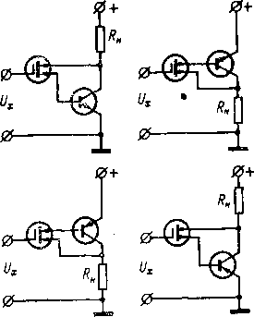
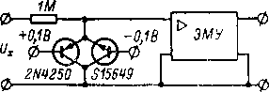

exceeded 10 ⁻¹⁴ A in the range from 20 to 70 º C. In addition to a low leakage current, the protective elements must provide high resistance in the off state, otherwise the thermal noise current will be large. There are reports of the release of specialized protective diodes.
It is possible that MOS transistors may be damaged before they are placed in the equipment, during transportation, storage, especially during installation. To avoid an electrostatic charge on the gate as a result of
Table 7-1
Characteristics of serial devices on MOSFETs
Type of | Manufacturer | Limits of measurement (full
Type of | Manufacturer | U | I
602 | Keithley Instruments (USA) | 1 mV - 10 V;  ¹ % | 10 ⁻¹⁴ - 0.3 A; 2-4%
610С | Keithley Instruments (USA) | 1 mV - 100 V;  one% | 10 ⁻¹⁴ - 0.3 A; 2-4%
TR-8641 | Takeda Ricken (Japan) | — | 10 ⁻¹² - 10 ⁻² A; 3%
TE-980 | Tek - Elec | 10 mV - 100 V | 10 ⁻¹² -10 ⁻⁶ A
GVM-30 | Radiometer (France) | 1 mV - 300 V | 3*10 ⁻¹¹ —3*10 ⁻⁴ a

Table 7-2
Characteristics of serial operating EMUs on a MOSFET
Type of | Manufacturer | Input impedance | Gain | Zero drift
311 | Analog Devices (USA) | 2*10 ¹⁴ Ohm | — | 10 μV/K; 10 ⁻¹⁵ A/C
300 | Keithley Instruments (USA) | 10 ¹⁴ Ohm, S _{in} = 10 pF | 20 000 | 10 ⁻¹⁵ A/24 h;  10 ⁻¹⁵ a / c;  0.5 mV/h;  0.5 mV/K
301 | Keithley Instruments (USA) | 5*10 ¹² Ohm, C _{in} = 10 pF | 50,000 | 10 ⁻¹⁵ A/24 h;  1 mV/week, 150 µV/K
302 | Keithley Instruments  (USA) | 10 ¹² Ohm, S _{in} = 5 pF | 12 000 | 10 ⁻¹⁵ A/24 h;  1 mV/week;  150 µV/K

friction of the leads on a plastic container during transportation and storage, the transistor leads are connected to each other, and the transistors are placed in a conductive container or wrapped in foil. The greatest danger of the transistor failure is during its installation. The human body has a capacitance of about 150 pF and can accumulate charges that create a potential of up to 300 V. If this charge enters the gate, the transistor will inevitably be broken. So when the transistor
scale) and error |  |  | Zero drift | Dimensions, mm | Weight, kg
 | Q | R | Zero drift | Dimensions, mm | Weight, kg
 | 10 ⁻¹² -10 ⁻⁶ C;  5% | 10 ² -10 ¹³ Ohm;  3-5% | 1 mV/24 h;  150 µV/K | 266×168×254 | 5.2
 | 10 ⁻¹³ -10 ⁻⁵ Cl: 5% | 10 ² —10 ¹⁴ Ohm; 3-5% | 1 mV/24 h;  150 µV/K | 266×168×254 | 4.8
 | — | — | 2%∕24 h; one% | 250×149×240 | 6.5
 | — | 10 ⁴ — 10 ¹⁰ Ohm | 0.2 mV/h | — | —
 | — | 10 ³ —3*10 ⁸ ohm | — | — | —

rax
 | Parasitic current, A | Noises | Bandwidth
 | 10-14 _ | 2∙10 ⁻¹⁶ A (effective value) at Δf=0÷2 Hz | —
 | 5* 10 ⁻¹⁴ | 5*10 ⁻¹⁵ a (double amplitude);  5 µV (rms) at ∆f = 0.1 ÷ 10 Hz | 150 Hz
 | 10-14 _ | 5 * 10 ⁻¹⁵ A (double amplitude);  10 µV (effective value) at ∆f = 0.l÷10 Hz | —
 |  | 5 * 10 ⁻¹⁵ A (double amplitude);  10 µV (rms) at ∆f = 0.1 ÷ 10 Hz | 150 kHz

taken by hand, its conclusions must be interconnected or grounded. All installation tools must be grounded. The soldering iron must be unplugged and grounded during soldering.
c) Practical schemes
MOSFETs have a large characteristic curve, and it is easy to make a single-stage electrometer based on them. More often use EMU on MOSFETs with OOS [L. 7-8, 7-13, 7-25, 7-33, 7-40, 7-50].
On fig. 7-12 shows a diagram of an EMU with a parallel OOS, the input stage of which is made on a dual MOS transistor of the type
(recorder)
Rice. 7-12. The scheme of the electrometer on a dual MOSFET.
F10049. The circuit uses six bipolar transistors, the modes of which are selected so as to obtain a small effect of temperature . The gain in the feedback loop is about 200. The input MOSFET is protected from overloads with a neon lamp. With a resistance in the CFO circuit equal to 10 ¹³ Ohm, the current noise level from peak to peak is 5∙10 ⁻¹⁶ A.
- Serial devices
Electrometric equipment based on MOS transistors , in particular universal (Table 7-1), is mass-produced abroad. It provides sufficiently high characteristics, permissible overvoltages range from 100 to 1000 V. MOSFETs turned out to be 152
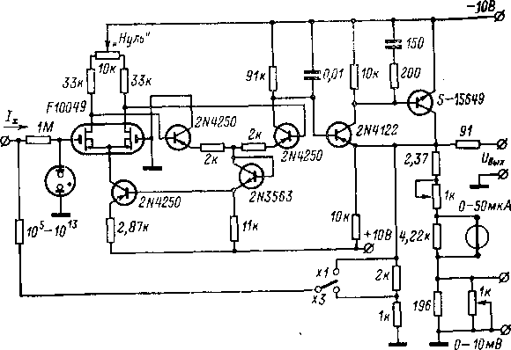

also convenient for building an EMU with a symmetrical input (Table 7-2). In general, EMUs on MOS transistors are close in properties to EMUs on electrometric lamps.
Such EMUs are mass-produced without environmental protection elements, which allows the consumer to perform a wide variety of electrometric meters with their help . Therefore, such EMUs are called operational .
Chapter Eight
ELECTROMETRIC AMPLIFIERS WITH SOLID STATE TRANSDUCERS-MODULATORS
8-1. ELECTROMETRIC AMPLIFIERS WITH VARICAPS a) MOS diodes
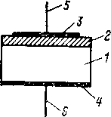
DC-to-AC converters based on controlled semiconductor capacitances (they are called varicaps, picodiodes, capacitive diodes, nonlinear semiconductor capacitors ) are widely used in DC amplifiers. The use of a semiconductor diode with a MOS structure (surface varicap) makes it possible to apply this principle to create an EMU. In a MOS diode [L. 8-1] semiconductor surface 1 (Fig. 8-1) is covered with a thin film of dielectric 2 silicon dioxide or titanium. A metal electrode 3 is applied to the film with output 5. On the opposite side of the semiconductor
Рис. 8-1. Схематическая конструкция МОП-диода.
ohmic contact is made 4 with output 6.
The input resistance of a MOS diode, as in MOS transistors, is determined by the insulating film and can be 10 ¹³ -10 ¹⁵ ohms. It depends little on temperature. The inherent noise of MOS diodes is of the same nature and level as that of MOS transistors. The capacitance of a MOS diode consists of the capacitance of the dielectric film and the surface capacitance of the semiconductor, connected
sequentially. The former does not depend on the voltage applied to the diode, while the latter depends due to the formation of an inversion layer on the semiconductor surface. As a result, the capacitance of the diode as a whole changes.
The MOS diode, when used in a DC-to-AC converter, is characterized by the slope of the capacitance-voltage characteristic S = dC / dU,
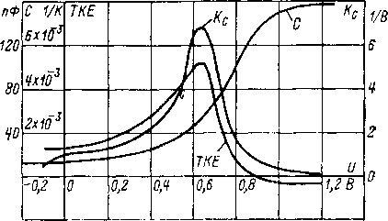
Rice. 8-2. Dependence of the parameters of the MOS diode on the bias voltage.

nonlinearity coefficient K _{c} =S∕C and temperature coefficient of capacitance. These parameters depend on the DC bias voltage. For a MOS diode with the structure Ag - SiO ₂ - Si and the thickness of the insulating film of SiO ₂ on the order of 0.02–0.025 µm , these dependences are shown in Figs. 8-2. The maximum coefficient of non-linearity is equal to 5 1/V, the overlap ratio is C _{max} / C _{min} =1 4. It is possible to work at bias voltages of any polarity. The disadvantages of the MOS diode include low quality factor, high TKE in the working area, instability of the capacitance-voltage characteristic due to charge instability in the MOS structure. They can be weakened by improving the manufacturing technology of the MOS structure.
Electrometric amplifiers based on MOS diodes are at the very initial stage of their development. Amplifiers based on varicaps with a locked pn junction are more widespread , but they do not allow obtaining high current sensitivity.
- Own interference
of a MOS diode is determined by its own parasitic current and shot noise and can be small. For varicaps with a locked pn junction, the junction current is determined by minority carriers and for silicon junctions it lies at the level of 10 ⁻¹⁰ A. Shot noise in this case is significant. The input current of such varicaps varies [L. 8-11] by one third for every lC.
Self-interference voltage varicap have [L. 8-9] two components: thermal noise of the series resistance (bulk resistance of the semiconductor, leads and contacts) and flicker noise associated with phenomena on the surface of the pn -junction and channel effects. The series resistance of a varicap does not exceed several tens of ohms, and its thermal noise is small. The level of flicker noise depends on the device and manufacturing technology of the varicap. For pn varicaps, the main component of the flicker noise, associated with the effect of capture and recombination of carriers , with an appropriate treatment of the surface of the pn junction is practically zero [L. 8-9]. The noise voltage of the varicap converter in the 1 Hz band may not exceed 0.01 - 0.02 μV [L. 8-11]. The main source of voltage interference is zero drift due to changes in the parameters of the pn -varicap (barrier capacitance, series and shunt junction resistances) with temperature. According to [L. 8-9] , the temperature drift of the zero of the transducer on one varicap is in the range of 0.5-3 mV / K , and with differential inclusion of varicaps, depending on the careful selection of pairs of varicaps, it decreases by 1-3 orders of magnitude. At best, it can be reduced to 60-160 µV / K [L. 8-11].
- Input Converters
The input electrometric voltage converters based on MOS diodes can be made according to the same circuits as converters based on conventional vari- arcs with a closed semiconductor junction for high-sensitivity UPTs.
155
156
Rice. 8-3. Bridge converter on varicaps.
balanced with respect to the control voltage U ~ and the variable signal U _{out} at its output is zero. Under the action of the measured voltage U _{x , the} capacitance of the varicaps changes and the equilibrium of the bridge is disturbed.
The alternating voltage Uout is _{proportional} to the measured one, and its phase is determined by the polarity of the input signal. The filter R _{f} S _{f} prevents the alternating voltage from entering the signal source, the separating capacitance C _{p} passes to the output only the variable component proportional to U _{x} .
If at U _{x} \u003d 0 the capacities of the varicaps are equal to C ₀ , and in the presence of a signal C ₁ \u003d C ₀ - ΔC (U _{x} ) and C ₂ \u003d C ₀ + ΔC (U _{x} ), then the conversion coefficient of such a system is U _{out} / U _{x} = U ~ K _{c} ∣ C. Voltage U ~ cannot be large, otherwise, due to the nonlinearity of the varicap , a rectification of the voltage U ~ on the varicap will occur. Therefore, the conversion coefficient is determined mainly by the coefficient K _{c} and, when using conventional varicaps, is 10–20 % . To raise it
Three types of varicap converters are known: 1) AM converters, in which the DC input signal controls the amplitude of the AC output signal;
- frequency modulation converters, in which the DC input signal controls the frequency of the AC output signal;
- self-oscillating converters, in which the varicap bridge is included in the positive feedback circuit of the alternating current amplifier and the input signal controls the amplitude of self-oscillations of such a generator.
Existing variants of bridge amplitude modulators [L. 8-2, 8-3, 8-10, 8-14, 8-16, 8-18, 8-23, 8-25, 8-28, 8-31, 8-32] differ in the number of controlled varicaps, scheme their inclusion , the type of elements,
forming the rest
bridge elements (resistors, capacitors), etc. In the absence of a measured signal , the bridge, for example, according to fig. 8-3, pre
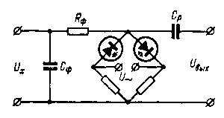

You can use resonant circuits [L. 8-2, 8-7, 8-10, 8-23].
Converters on controlled capacities with frequency modulation are made with LC- and R C-chains [3]. The former are most suitable for low conversion frequencies [L. 8-14], the second - at high [L. 8-21, 8-30]. In both cases, a frequency-to-voltage converter is required at the output , then the circuit as a whole can be covered by the OOS.
- Autogenerator EMU
The main differences between self-oscillating amplifiers [L. 8-9 - 8-11] from conventional DC amplifiers of the MDM type are as follows:
there is no excitation voltage generator;
there is no phase sensitive demodulator, which is replaced by an amplitude detector;
the output circuits of the AC amplifier are connected to the input circuits of the converting device, i.e. there is a common positive feedback on the alternating voltage.
The amplifier circuit as a whole is simple.
The main node of a self-oscillating EMU on a MOS diode [L. 8-5, 8-6] is a self-oscillating converter (AGP) (Fig. 8-4). The AGP AC amplifier is made on two P403 transistors according to the cascode circuit common emitter - common base with a parallel oscillatory circuit in the collector circuit. Such a circuit has large input and output impedances and a stable gain. Its use in the AGP amplifier ensures the stability of the conversion frequency, which is determined only by the natural frequency of the resonant circuit. Thus, high stability of the conversion factor of the entire EMU is achieved. The amplifier has a voltage gain of about 2500. The self-oscillating converter operates at a frequency of 465 kHz .
Two arms of the controlled capacitive bridge are represented by transformer windings, one arm is a MOS diode, and one arm is a capacitor with a capacitance of 30 pF equal to the capacitance of the MOS diode in the mode of optimal capacitance–voltage characteristic steepness. In the presence of a direct current signal, the bridge is unbalanced and the depth of the positive feedback of the AHD changes, which causes a change in the amplitude of oscillations of the AHD operating in the soft excitation mode. The amplitude of the AGP alternating signal is proportional to the measured voltage. The signal from the AGP is amplified by an AC amplifier based on two P403 transistors, which is similar to the AGP amplifier, and is rectified by a D223 diode, after which the UPT is turned on. The latter is assembled on MP105 transistors connected as a composite emitter follower. The OOS signal is removed from the load
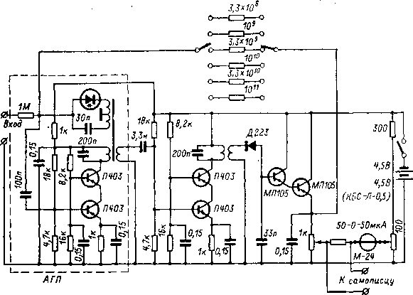
Rice. 8-4. Schematic diagram of an electrometer on surface varicaps.

emitter follower. Resistors with resistances from 3.3∙10 ⁸ up to 10 ¹¹ Ohm, with the help of which the measurement limits change from 3∙10 ⁻⁹ up to 10 ⁻¹² A. The current sensitivity threshold is 10 ⁻¹⁴ A, the zero drift at a temperature of 20 ± 5 º C is approximately 2.5∙10 ⁻¹⁴ And for 24 hours, the noise level at the output at the most sensitive limit is about 0.5%.
- Amplifiers on pn -varicaps
Such amplifiers are widely used and in some cases make it possible to obtain high sensitivity (Table 8-1), approaching the sensitivity of EMUs on electrometric lamps and MOS transistors. According to [L. 8-22] they are superior in sensitivity to amplifiers with DC-to-AC converters based on field-effect transistors, in which the control AC voltage is applied to the gate, or amplifiers based on dual bipolar transistors. In such UPTs, either special pn -varicaps or conventional diodes and silicon zener diodes are used, for example D814A-D814D [L. 8-9]. For the latter, the resistance of the barred junction is up to 10 ¹⁰ Ω, but it strongly depends on the temperature, decreasing 158
with its rise [L. 8-28]. The coefficient of nonlinearity of such varicaps is 0.06 - 0.1 % / mV [L. 8-10, 8-14], and TKE lies in the range of 0.008 - 0.1 1 / K [L. 8-14, 8-25].
Table 8-1
Characteristics of serial high-resistance devices with varicap converters
 | Manufacturer | Measurement limits
Type of | Manufacturer | U
301 | A,palog Devices (USA) | — | —
Multimeter 35 | AEG (Germany) | 10 mV - 100 V | —
900 | Perkin — Elmer |  | 5 ∙ 10 ⁻¹² - 5 ∙ 10 ⁻⁸ A
Amplifier for pH meters | Yokogawa (Japan) | — | —
302 | Analog Devices (USA) | — | —

Continuation of the table. 8-1
Type of | Noises | drift-zero | Input impedance
301 | 1 μV (p-p) at ∆f=l Hz; 10-14A _ _ | 30 µV/K;  6∙10 ⁻¹⁴ A/C | 10 ¹⁰ - 10 ¹² 0m
Multimeter 35 | — | 0.1 mV; 10-13 _ BUT;  30 µV/K;  10-14 _ A/C | 10 ¹¹ ohm
900 | — | — | ——-
Amplifier for pH meters | — | 40 µV/ K ; 2∙10 ⁻¹³ BUT | 10 ¹³ Ohm
302 | 2 μV at Δf= = 1 Hz; 6* 10 ⁻¹⁴ A | 50 µV/K; 5*10 ⁻¹⁴ A/C

8-2. ELECTROMETRIC AMPLIFIERS FERROELECTRIC
- Ferroelectric converters
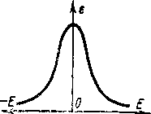
The dielectric constant of ferroelectrics depends on the strength of the electric field (Fig. 8-5). Controlled capacitances based on ferroelectrics can be used in the same schemes as MOS diodes and pn -varicaps. The input impedance of such a converter is determined by leakage and can be large. The capacitance of a ferroelectric can be changed not only by a longitudinal, but also by a transverse field, which makes it possible to separate the conversion and control circuits (Fig. 8-6, a) and make a dynamic capacitor on a solid body. In such a converter [L. 8-12] on ceramics VK-2 times
Рис. 8-5. Зависимость диэлектрической проницаемости сегнетоэлектриков от напряженности электрического поля.
measures 0.8 × 8 mm with four terminals in two mutually perpendicular directions, the multiplicity of capacitance change was 6 - 8, which gives a coefficient of conversion of direct voltage into an alternating voltage of the order of 0.7. The capacitance of the ferrocapacitor reaches the maximum and minimum values twice during the alternating current period, and the conversion occurs at the double frequency of the control voltage . The device had [L. 8-12] sensitivity threshold 10 ⁻¹² A, zero drift did not exceed 3∙10 ⁻¹¹ And for 12 hours, the input resistance was 6∙10 ¹² Ohm.
The polarization curve of a ferroelectric is an odd curve, symmetrical with respect to the origin of coordinates , and the current through a ferrocapacitor, which is under a sinusoidal voltage, contains only odd harmonics [L. 8-13]. Even harmonics will appear if a constant voltage is simultaneously applied to the ferrocapacitor. The amplitude of the second harmonic at a low DC voltage depends linearly on the voltage, and the phase changes by 180° when its polarity is reversed. A number of circuits for converters of constant signals into variables with an output on the second harmonic are possible [L. 8-13]. In the diagram in fig. 8-6.6 DC voltage is supplied to the ferrocapacitors in the opposite direction 160
polarity with respect to the phase of the alternating voltage and the second harmonics of the current through the capacitors are shifted by 180°. The current in the load is equal to the difference in currents through the capacitors, and the even harmonics are added in the load, while the odd ones are subtracted. The sensitivity threshold of such a circuit on VK2-0 variconds was 2 * 10 ⁻¹³ And with an input resistance of 10 ¹³ -10 ¹⁴ ohms.
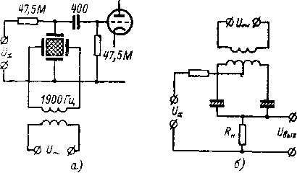
Rice. 8-6. Schemes of input electrometric transducers on variconds.

Ferroelectric converters can be made on a triglycine sulfate (TGS) crystal, for example, using the so-called tandela [L. 8-8]. It is a plate of a TGS single crystal with an area of 1 mm ² and a thickness of 0.1 mm; electrodes are deposited on the plate in a vacuum. At a certain ac supply voltage, the tandel enters the auto stabilization mode, when its parameters, including the nonlinearity of the dielectric characteristics, depend little on temperature. Nonlinear distortions arising in the tandele under the influence of the signal voltage are determined . The electrometric device on the tandele had measurement limits (full scale) for voltage from 0.1 to 1 V and for current from 10 ⁻¹¹ to 10 ⁻⁵ A. The input resistance exceeded 10 ¹² ohms, the input capacitance was 150 pF, and the zero drift was 100 mV/h.
- Own interference
One of the main sources of self-interference ferroelectric converter is [L. 8-15] asymmetry of its characteristics (maximum 11-377 161
new value of ε in Figs. 8-5 corresponds to E≠0). As a result, the second harmonic at the output of the converter takes place even in the absence of input voltage. The temporal and temperature drift of zero is the greater, the greater the shift itself. Individual crystals and even sections of one crystal are characterized by different displacements, which is apparently associated with the distribution of defects in the crystal. Other noise sources are ferroelectric noise, similar in nature to Barkhausen noise, and the so-called memory effect, due to which, when the input signal changes, the output reaches a steady level after some time. If the coercive force of the ferroelectric is large, then this can also lead to intrinsic interference, since a large excitation voltage is required and the fight against the second harmonic is difficult.
- EMU on a ferroelectric converter
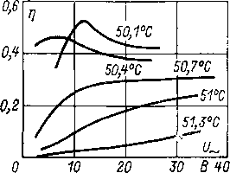
A radical way to reduce your own interference is [L. 8-15] in the use of a ferroelectric converter based on a TGS crystal operating at a temperature in the region of the Curie point. In this case, the TGS crystal has a bias of the order of millivolts and a small bias drift, low noise, and coercive force. The memory effect is reduced to zero. The transformation properties of the crystal also decrease, but remain at an acceptable level (Fig. 8-7).
Рис. 8-7. Зависимость коэффициента преобразования η от напряжения возбуждения и температуры.
In a practical converter [L. 8-15] gold electrodes were deposited onto a TGS single crystal 4 × 4 × 0.2 mm in size , to which the leads were attached with silver paste in compliance with measures preventing mechanical stresses in the leads. The crystal was mounted on a mica plate and placed in a vacuum cylinder to protect it from moisture (THS is soluble in water) and to prevent chemical processes that could lead to a change in characteristics.
The converter was made differential , two groups of electrodes were deposited on one crystal, which were switched on in opposite directions, so that their bias voltages were subtracted, and the second harmonic signals were added. A thermostat with a stabilization factor of 100 was used to thermostat the converter. The excitation circuit of the converter was fed from a built-in generator with a frequency of 50 kHz. A low-pass filter was provided at the generator output, which prevented the appearance of second harmonic excitation in the voltage. After the converter, a band-pass filter tuned to the second harmonic frequency was switched on, then an AC amplifier, and then a phase-sensitive detector with a smoothing filter. The control voltage to the phase sensitive detector was supplied from the generator through a buffer amplifier with adjustable amplitude and phase and a frequency doubler. The converter had an input resistance of 10 ¹³ Ω, its zero drift did not exceed 10 μV for 12 h and 10 μV/K. With an input resistance of 1 MΩ , the noise did not exceed 6 µV (double amplitude ) in the frequency band from 0 to 1 Hz. The voltage effect was 100 µV per 1% change in the excitation voltage.
The results obtained are very high, which allowed the authors of this work [L. 8-15] to compare an electrometer on a ferroelectric converter with an electrometer on a dynamic capacitor with electrostatic excitation model 640 from Keithley, which has the highest performance of all serial devices. However, it should be noted that the experience of constructing an EMU based on a ferroelectric is limited to only one publication, and there is no information about the introduction of this principle into mass production. Therefore, there are no sufficient grounds for categorical statements about the prospects of EMU with a ferroelectric converter.
eleven*
Chapter Nine

ELECTROMETRIC AMPLIFIERS WITH DYNAMIC CAPACITOR
9-1. DYNAMIC CAPACITOR TRANSDUCERS
a) Operating principle
An electrometric amplifier with a capacitive dynamic DC/AC converter provides the highest current sensitivity of all known EMU types. Such a transducer is called a dynamic capacitor (DC), sometimes a capacitive modulator, a capacitive transducer, a capacitive vibration transducer. The first fundamental works on EMU with DC belong to the postwar years [L. 9-42]. Industrial designs of such devices appeared in the early to mid-1950s.
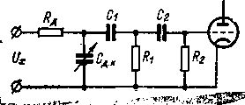
The main element of a capacitive dynamic DC /AC converter (Fig. 9-1) is a DC. It is an air condenser, the capacitance of which, with the help of the excitation system , periodically changes with a frequency of several
Рис. 9-1. Принципиальная схема преобразователя на динамическом конденсаторе.
tens, hundreds or even thousands of hertz. The most common are DCs with electromagnetic excitation, in which the movable plate is made of a ferromagnetic material and vibrates under the action of a force created by an electromagnet powered by alternating current. In the last decade, DCs with electrostatic excitation have been developed and started to be commercially produced , in which the forces of electrostatic attraction are used. It is also possible to perform a DC with an acoustic excitation system, purely mechanical, and on a piezoelectric quartz resonator [L. 9-7], but they did not find practical application. Not widely used and to DC with a rotating plate [L. 9-9], which are structurally cumbersome.
The dynamic capacitor has very good insulation between the moving and fixed plates . Additional resistance R _{D} is selected from the condition R _{D} S D.K >> 1/ ω , where ω is the vibration frequency of the movable plate. When the converter is connected to a source of controlled voltage U _{x} The DC is charged to this voltage with a time constant determined by the resistance R _{D} , source internal resistance U _{x} and capacitance C _{D.K} , as well as shunting C _{D.K} capacities. The charge accumulated on the DC, equal to U _{X} C _{D} . _{К} , during the period of vibration of the movable plate due to the inequality R _{D} C _{Д.К} >>1∕ω remains practically unchanged, even if the internal resistance of the source is small (namely, this case, the resistance R _{D is provided} ). Since Q _{D.K} =U _{D.K} C _{D.K} = = const, then a periodic change in C _{D.K} causes a periodic change in U _{D.K.} This variable component is proportional to U _{x} . Through the filter C ₁ R ₁ , C ₂ R ₂ (sometimes single-link filters are used), it is fed to the AC amplifier. The filter does not pass the DC component to the input of the amplifier and, in addition, must have a low transfer coefficient for slowly changing noise from the input of the amplifier to the DC, otherwise they will be simulated. and will be taken as a signal. After amplification, the AC signal is rectified by a phase-sensitive rectifier and the system as a whole is covered by the CNF.
b) Input impedance
In steady state, DC is charged up to voltage U _{x} and the input impedance of the converter is determined by the leakage through the insulators. It can be 10 ¹⁴ -10 ¹⁵ ohms. There is no power consumption from the signal source , all the energy at the output of the converter is obtained from the excitation source (see § 4-1). An alternating voltage on the DC is applied to a circuit of resistance R _{d} and resistance R _{i} signal source , and an alternating current flows in it. This may be important, for example, when working with biological objects, when alternating current causes distortions in the object under study, or when working with non-linear objects. AC power dissipated by R _{i} , taken from the excitation system, and not from
where C ₀ = εε ₀ S∕d ₀ — static capacity of DC; m ₌ ∆d ∣ d0 is the modulation factor. Sometimes [L. 9-14] under the modulation coefficient is understood the ratio of the effective
b)
Rice. 9-2. Experimental determination of the DC modulation coefficient.
Rice. 9-3. Frequency dependence of the modulation coefficient of the DK-64T capacitor.
the value of the alternating voltage on the capacitor to the measured direct current voltage, i.e. the value of Δd ∕ √ 2d ₀ ∙ The static capacitance of a DC with electromagnetic excitation is 20 - 50 pF, for special purposes a DC with a small capacity is developed [L. 9-3]. To determine t (Fig. 9-2, a), 166
signal source. This can be verified by conducting a thought experiment on measuring the voltage across a charged capacitor with an ideal DC converter. To do this, the DC converter is connected in parallel with the capacitor, after which the DC excitation is turned on. The average value of the charge on the controlled capacitor does not change during the measurement and remains at the same level as before the excitation was turned on.
c) Conversion factor
The distance between the DC plates usually changes according to the sinusoidal law d(t) = d ₀ + ∆d sin ωt, then the capacitance of the DC changes as follows:
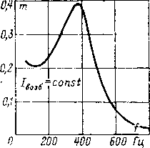
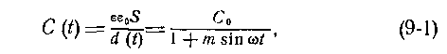
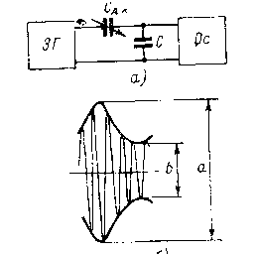

contour [L. 9-8] or synchronous switching in the converter load circuit [L. 9-6] have not received practical application.
The conversion factor of the input circuit with DC as a whole also depends on its parameters. The electrical state of the simplest circuit with DC (Fig. 9-4) is described by the equation
[L. 9-14, 9-22] sound generator ZG, the output frequency of which is much higher than the frequency of excitation DC, and the oscilloscope Os. If C>>C _{D.K} , then according to the picture on the oscilloscope screen (Fig. 9-2.6) we find m = (ab) ∕ (a + b).
The DC modulation coefficient at a constant excitation voltage is maximum (Fig. 9-3) when operating at the natural resonance frequency of the vibrating electrode [L. 9-22]. For a DC with electromagnetic excitation , usually m = 0.15 ÷ 0.2, by forcing the excitation it can be brought up to 0.4 - 0.5 [L. 9-10]. Possible ways to artificially increase the efficiency of a converter with a DC, for example, by turning the DC into resonance
or
where it is taken into account that the capacity C(t) is changed according to equation (9-1) and some transformations are performed. To find the current through the DC in order to then determine the voltage in the circuit, it is necessary to find a steady-state solution from this equation and differentiate it with respect to time. However, the integral of the form under consideration cannot be expressed in a simple way in terms of elementary functions. It is possible to significantly simplify the calculation only
167
Rice. 9-4. Simplified diagram of the converter.
where Q(t) is the instantaneous value of the charge on the DC. The general solution of this differential equation under zero initial conditions has the form:
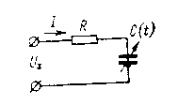
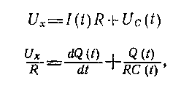
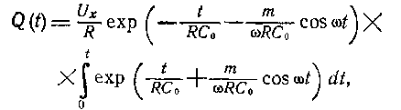

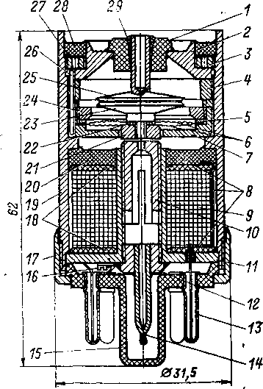
for m<<1, which is not the case in practice. The most suitable for these purposes is the method of complex calculus , which makes it possible to determine the conversion coefficient of any complexity of the converter circuit with DC [L. 9-4].
- DC with electromagnetic excitation
Dynamic capacitors with electromagnetic excitation can be divided into membrane and reed capacitors . In the first case, the movable electrode is an elastic membrane tightly fixed around the circumference [L. 9-2, 9-10, 9-12, 9-20, 9-24, 9-52], in the second - a cantilevered tongue plate [L. 9-3, 9-51, 9-52]. The reed system has a higher conversion factor, but does not have decisive advantages over the membrane system.
In a membrane DC type DC-64T [L. 9-22] the base part (Fig. 9-5) is the body 19, on which the main components are mounted: in the upper part, the capacitor itself, in the lower part, the excitation system. They are separated by a membrane box 7, on which, using a washer 5 and rings 24 two corrugated membranes 6 are fixed. This whole system with 4 distance ring, Nut 3 and cover 2 is closed with a cardboard washer 27 and is filled with compound 28 during final assembly . Pin 26 ensures the correct mutual orientation of parts 2, 4 and 7 during intermediate assembly. Input insulator 1 attached to cover 2 compound, a fixed plate DK 25 is fixed in the insulator with compound 29 , before pouring , a gap between the DK plates is set using a calibrated gasket. Moving plate 23
Rice. 9-5. The design of the membrane DC type DK-64T.
Table 9-1
Characteristics of serially produced DC
Characteristic | DK type
Characteristic | DK-64 | DRC-2 | DRK-Z | DRC-4  I class
Insulation resistance, Ohm | 1 0 ¹⁵ | 10 ¹⁴ | 10 ¹⁴ | 10 ¹⁵
Static capacitance, pF. | 35 | fifteen | fifteen | fifteen
modulation factor. . | - 0.25 | 0.2 | 0.2 | 0.2
Operating frequency, Hz ... . | 375-425, | 260-290 | 260-290 | 260-290
Insulator current, A | fifty | — | — | 10 ⁻¹⁷
Residual contact potential difference, mV. |  | — | .— | ——
Residual uncompensated e. d.s., µV .... |  | 100 | fifty | ten
Zero drift, μV/24 h. . . | 200 | 2000 | 250 | 100
Zero temperature drift, µV/10 K | 200 | — | 400 | —
Excitation coil power , VA | 0.31 | 0.05 | 0.05 | —
Dimensions, mm | 0 31.5×62 |  | — | —
Weight, g | 150 | 70 | 70 | —

Continuation of the table. 9-1
Characteristic | DK type
Characteristic | DRC-4 |  | DKV-65 | Vibrio "H" by Electrical  Instruments
Characteristic | II class | III class | DKV-65 | Vibrio "H" by Electrical  Instruments
Insulation resistance, Ohm | 10 ¹⁴ | 10 ¹⁴ | 5*10 ¹⁴ | 10 ¹⁶
Static capacitance, pF. | fifteen | fifteen | twenty | —
modulation factor. . | 0.2 | 0.2 | 0.1 | 0.3—0.45
Operating frequency, Hz ... . | 260- | -290 | 650 | 800
Insulator current, A  Residual contact difference | 10 ⁻¹⁶ | 10 ⁻¹⁵ | — | 10 ⁻¹⁶
potentials, mV. . Residual uncompensated | — | — | twenty | —
e. d.s., µV .... | 25 | fifty | —— | —
Zero drift, μV/24 h. . . zero temperature drift, µV/10 K ........  Excitation coil power | 250 | 600 | 100 | 100
 | — | — | — | —
, VA . . . |  | — | 0.5 | 0.75
Dimensions, mm |  | — | 0 32×78 | 48×120
 | — | — | 120 | 400

13 DK. Isolator 3 mounted on a pillar 8 sealing ring 5, nut 1 and puck 2. The stand is attached to the powder base 9 with screws 11 and sealing gasket 10. On the base, the conclusions of electromagnets 6 and 7 and the casing of the DC (not shown in the figure) are reinforced. Condenser DRK-2 is designed for operation at temperatures from -40 to +50 º C and relative air humidity up to 98%. On its basis, more advanced (see Table 9-1) designs of DRC-3 and DRC-4 have been developed [L. 2-61. Capacitor DRK-4 has a built-in separating R C-chain for connecting the converter with an AC amplifier.
using washer 22 and anchors 21 articulated with membranes 6. Details of the magnetic circuit of the excitation system: armature 21, building 19, base 11 , adjustable core 10 and membrane box 7 are made of mild electrical steel.
Field winding 9 sealed with compound 20, it has 1400 turns of PEV-1 wire with a diameter of 0.21 mm. Cheeks 18 the windings are made of foil- coated getinaks and, together with the foil surrounding the winding, form an electrostatic screen 8 attached to pin 13 octal plinth 15. The terminals of the winding and the DC housing are also connected to the pins of the base, the latter through screw 16. The base is attached to the body with a clamping ring 17. From below, the DC is closed with a stopper 12, which is screwed and glued. Stengel 14 serves to connect the DC to the compressor when checking the tightness with a halogen leak detector, after which the DC is filled with air. Capacitor DK-64T is designed for operation at temperatures from 5 to 60 °C, its characteristics are given in Table. 9-1.
In the reed DC [L. 2-6] of type DRK-2, the base part is (Fig. 9-6) rack 8, on which all the elements of the capacitor are attached. Two oscillating plates 12 made of permalloy are tightly clamped at the base of the rack. At the top of rack 8, opposite the plates, there are two electromagnets 6 for excitation of the plates. At the base of the rack, opposite one of the plates, an electromagnet 7 is installed to create a feedback of the exciting generator. Between the oscillatory plates there is a fixed plate 4, tightly fixed in the insulator 3 and related to input
170
Rice. 9-6. The design of the reed DK type DRK-2.
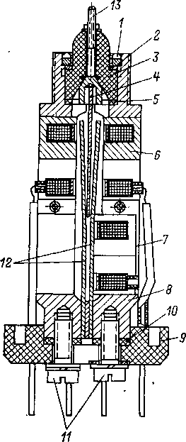

- DC with electrostatic excitation
Philips has developed a DC with electrostatic excitation [L. 9-39, 9-41], the Keithley company has mastered the mass production of electrometric equipment with such DCs. Systems with electrostatic excitation [L. 9-13] have a number of advantages over systems with electromagnetic excitation. First, it is possible to increase the excitation frequency to several kilohertz, as a result of which all the resistances of the transducer can be chosen to be small and the noise is sharply reduced. The equivalent noise resistance of a converter with an electrostatic DC is only 10 ⁸ ohms.
The high conversion frequency makes it easier to filter the rectified signal at the output of the AC amplifier . Secondly, the construction of a DC with electrostatic excitation allows annealing for the purpose of degassing materials and evacuation , which predetermines a small drift of the contact potential difference. Thirdly, in such DCs , the fight against pickups from the excitation system is facilitated, since the voltage frequency at the output of the excitation generator and the excitation frequency are greatly separated.
The cross section of a DC with electrostatic excitation is shown in fig. 9-7 [L. 9-41]. A round glass membrane M is clamped around the circumference between glass insulators I ₁ and I ₃ . Both sides of the membrane and the middle parts of the insulators are covered with metal and provided with leads. Electrodes E ₃ and E` _{m} included in the generator circuit and form an excitation system, the membrane oscillates at its own resonance frequency (about 6 kHz). E``m electrodes _ and E1 _ form the DC itself, its capacitance changes with the frequency of membrane oscillations. Electrodes E' ₁ and E2 _ on fixed insulators they form a separating capacitor between the DC and the AC amplifier. To lengthen the creepage distances, the electrodes of the fixed insulators are surrounded by cylindrical grooves, the insulation resistance exceeds 10 ¹⁴ ohms. Diameter of insulators and membrane 18 mm,
171
Rice. 9-7. DK device with electrostatic excitation.
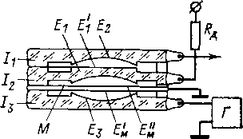

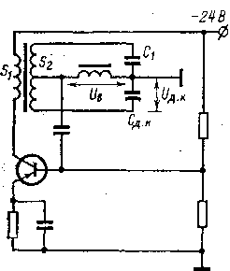
Рис. 9-8. Схема генератора для ДК с электростатическим возбуждением.
the thickness of each insulator is 3 mm, the thickness of the membrane is 0.13 mm. Deviation from plane-parallelism is not more than 2 µm. The radius of curvature of the central shaped part of the insulators is 1.5 m. The electrodes on the insulators and the membrane are made of tantalum by the cathode sputtering method . Tantalum layers are oxidized in an ozone atmosphere, which creates a thin oxide film with high chemical and mechanical stability. The dynamic capacitor is placed in an evacuated glass container to protect it from dust, moisture, and other influences. All the materials used can withstand high temperatures, and when pumping out the DC, it is calcined in order to degas the elements. This ensures a small drift of the contact potential difference.
The excitation generator - (Fig. 9-8) is tuned to a frequency of approximately 1 MHz and is in the generation mode if the feedback voltage between the base and emitter of the transistor has the correct amplitude and phase. This voltage is supplied from the collector circuit of the transistor to the bridge circuit containing the winding S ₂ with central tap and tank C ₁ and S _{d} . _{to} . Generator excitation conditions depend on the ratio C ₁ and C _{d.k.} Since during the operation of the DC, the capacitance C _{d} . _{k} continuously changes with the natural frequency of the membrane, then the excitation conditions periodically arise and disappear. As a result, the generator produces oscillations with a frequency of 1 MHz, modulated at the frequency of the membrane. Such a system makes it possible to get rid of pickups at the conversion frequency from the excitation system to the measuring channel by simple means.
9-2. INDIRECT INTERFERENCES OF CONVERTERS WITH DYNAMIC CAPACITOR
a) Parasitic current
The input electrometric voltage converter with DC makes it possible to obtain lower constants 172
current self-interference components than in other types of converters. Parasitic DC currents are caused only by insulators, the materials and design of which are not subject to strict restrictions, as well as by radioactive contamination of materials. To reduce ionization currents, the DC can be made evacuated. Unlike an electrometric lamp or a MOS transistor, there are no such sources of current interference in DC, the elimination of which is associated with the deterioration of other properties of the converter . These features of the DC transducer make them indispensable for measurements with extreme current sensitivity. K.S. Shuklin in the BEM-1 converter [L. 2-6] it was possible to reduce the parasitic current to 2∙10 ⁻¹⁸ And, for serial EMUs with a DC, the parasitic current at best is (l÷2) 10 ⁻¹⁷ BUT.

b) Noises
Sources of noise converter with DC [L. 9-16, 9-39, 9-42, 9-45] are (Fig. 9-9) an additional resistor R d _{and} an AC amplifier. Noises DC,
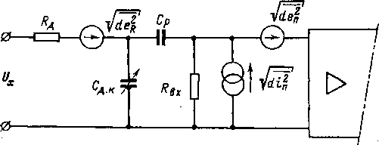
Rice. 9-9. Sources of noise in a DC converter.

for example, due to fast fluctuations of the contact potential difference, apparently, it can be neglected, and the isolation capacitor can be considered non-noisy.
Noise source √ de ² _{R} connected in series with signal U _{x} and is brought to the EMU input with a coefficient of 1. Sources √ di ² _{П} (this source also takes into account noise R _{in} ) and √ de ² _{П} create two types of noise (Fig. 9-10):
- direct noise, the frequency spectrum of which coincides with the bandwidth f _{m} of the selective
173
Rice. 9-10. Frequency spectrum of noise of the converter with DC.
EMU amplifier; this noise is directly transmitted to the EMU output and detected;
2) indirect noise, the frequency spectrum of which lies below the modulation frequency of the converter f _{m} ; this noise is modulated by a DC, transmitted to the output of the EMU, and the output device marks that part of it, the frequency spectrum
which lies within the passband of the EMU as a whole.
The effect of direct noise sources √ de ² _{P.N.} and √ di ² _{P.N} , appearing at the modulation frequency ω _{m} , is equivalent to the action of the source √ de ² _{C n} , connected in series with the capacitance C _{d} . _{to} and equal
where
The source √ de ² _{C n} gives the noise component at the same frequency ω _{M} as the sources √ de ² _{P.N.} and √ di ² _{P.N} . To bring the source √ de ² _{C n} to the EMU input and replace it with the component √ de ² _{n} at the frequencies of the signal ω, we assume that the action of the signal U _{x} at the frequency ω at the EMU input can be replaced with some approximation by the action of the signal mU _{x} , where m is the modulation coefficient acting at the frequency ω _{M} and connected in series with the static capacitance DC. Then the direct noises reduced to the EMU input:
174
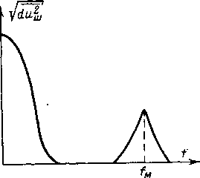
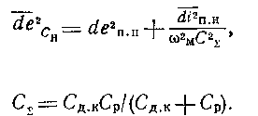
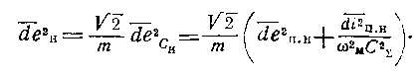

175
The presence of the coefficient √ 2 is due to the fact that the bandwidth at the frequency ωm is two _{times} different from the bandwidth at the low frequency ω.
Source √ de ² _{P} does not create voltage on the capacitance Sd.k and, therefore, does not cause indirect noise. Source √ di ² _{P.K} creates on capacity C _{d} . _{to} voltage
In order to determine them in full, it is necessary to substitute the expressions for de ² _{P.N} , di ² _{P.N} and di ² _{P.K.} and integrate the resulting equation in the EMU passband as a whole. The latter is determined from below by the longest measurement time, and from above by the filter time constant of the synchronous detector. Expressions for noises de ² _{П} and di ² _{P} determined by the type and properties of the AC amplifier. When finding de ² _{П H} in the expression for the equivalent noise resistance, which has the form (6-1) for an amplifier on a lamp or a transistor , it is necessary to substitute not the signal frequency ω, but the modulation frequency ω _{M.}
It follows from equation (9-2) that the EMU noise with DC is represented only by voltage noise, there is no current noise. To reduce the noise of an EMU with DC, it is necessary to reduce the resistance Rd (to do this , it is necessary to increase the modulation frequency), reduce the noise of the AC amplifier, increase the conversion factor m and increase the conversion frequency . The latter is realized in a DC with electrostatic excitation
which is then modulated by the converter in the same way as the signal U _{x} , i.e., the source √ de ² _{κ} , and is the noise brought to the EMU input caused by indirect noises √ di ² _{P.K.}
The total noise of the EMU with DC, reduced to its input:
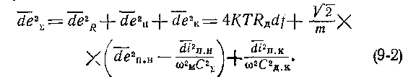


The indirect noise of the grid current and the input impedance of the AC amplifier can be completely eliminated with the help of the so-called double DC [L. 9-34, 9-45]. In this case (Fig. 9-11) there are two DCs, the capacitances of which change in antiphase, i.e.
Rice. 9-11. Schematic diagram of a double DC converter.
Rice. 9-12. Schematic diagram of a converter with a balanced DC.
and two fixed plates with a measurement time of 2.5 s had a sensitivity threshold of 3.5∙10 ⁻¹⁷ Cl.
In the diagram in fig. 9-11 due to the presence of the capacitance of the signal source, the equality of capacitances C _{d.k1} and C _{d.k2} required to eliminate noise is violated . This phenomenon is absent in the double DC in Fig. 9-12 [L. 9-30], in which the central plate is stationary, and the extreme ones oscillate in antiphase, the total capacitance at the input of the differential amplifier is constant. Compared
with conventional DCs in such a converter, in addition to noise reduction, a number of other advantages are realized, in particular, decoupling from the controlled circuit with the help of additional resistance is not required, the DC is connected to the amplifier input without separating capacitance, with the same relative change in capacitance, the conversion coefficient is doubled .
Rice. 9-13. Schematic diagram of a converter with a differential DC.
176
and the total capacitance at point B remains unchanged
Therefore, the noise at this point is not modulated and is not present at the output of the EMU. Experimental model of EMU with double DC [L. 9-45] with one movable
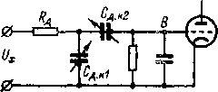
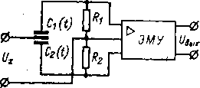
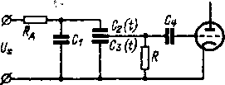

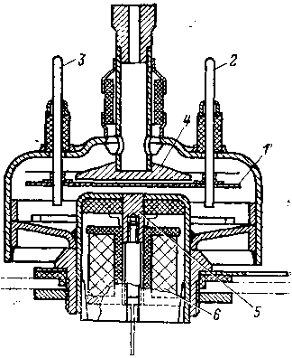
In a double DC converter from Siemens [L. 9-54] there are (Fig. 9-13) additional resistor R _{D} , capacitor C ₁ , closing the alternating current external electrodes DC, DC with two fixed electrodes and one movable (medium), resistance R , with which the constant potential of the movable electrode is maintained at zero level , and a separating capacitor C ₄ . Tanks C ₂ and C ₃ change in opposite phase. If voltage U _{x is applied} to DC , then the movable electrode takes the potential of the corresponding point in the space between the stationary electrodes, i.e. the voltage across it is proportional to U _{x} and changes with the modulation frequency. The voltage applied to the DC from the output side, for example, the noise voltage is modulated with a double modulation frequency, since the capacitance of the moving electrode relative to the fixed electrodes takes on the minimum and maximum values 2 times during the modulation period . This component is filtered out by a synchronous detector at the EMU output. The use of such a converter makes it possible, in particular, to drastically reduce the requirements for the first stage of the AC amplifier.
The design of a double DC from Siemens , type F102 , is shown in fig. 9-14. The movable electrode is represented by membrane 1 with you waters 2 and 3, one fixed 4 has output on the same side as membrane 1, and the second 5 connected with the electromagnetic excitation system 6. Excitation is carried out at the frequencies of the membrane, for which an additional feedback winding is provided . The dynamic condenser is filled with hydrogen after pumping . The contact potential difference between the electrodes is small, its fluctuations during a month do not exceed 1 mV, and no constant change in one direction is observed.
Rice. 9-14. Double DC design.
The source of intrinsic noise in DC converters can also be pickups from the excitation system due to parasitic coupling capacitances in the DC itself. To avoid this, the excitation system must be carefully shielded from the conversion channel. Good results are obtained if the excitation frequency and the conversion frequency are different, as, for example , in a DC with electromagnetic excitation without a permanent polarizing magnet, in which the movable plate oscillates at twice the frequency of the excitation current. In this case, pickups with the excitation frequency are filtered out by a phase sensitive rectifier. Similar advantages are provided by the system adopted in a DC with electrostatic excitation, when the generator frequency is 1 MHz and the modulation frequency is 6 kHz.
c) Zero drift
The main reason for the zero drift of converters on DC is a change in the contact potential difference between the working surfaces of its plates, for example, due to diffusion of the base metal into the coating, absorption of gases, deposition of moisture, pollution, chemical reactions, changes in the structure of the material due to aging, etc. n. [L. 9-10, 9-12, 9-16, 9-42, 9-47, 9-51]. To obtain the maximum identity of the DK plates, they are made from the same piece of material, for example, stainless steel, which is little affected by external influences . The plates are polished to a mirror shine, scratches and other surface damage are not allowed, they can serve as a source of contamination and inhomogeneities. After polishing, the plates are thoroughly cleaned of polishing mixtures, water or oxides that have had time to form on the surfaces, and washed with the highest purity alcohol. Then both plates are simultaneously coated with a thin (about 10 µm) layer of a chemically inactive material, most often gold (rhodium is recommended in some works). Before this, the plates are mechanically adjusted so that after gilding, assembly can be started immediately. Gilding is usually done by cathode sputtering in a vacuum, to maintain maximum purity, the gold is pre-calcined 178
and the plates are subjected to ion bombardment in an electrostatic field. Assembly of DC is carried out in a dust-free room or even under a stream of nitrogen to remove dust. After assembly, the DK chamber is evacuated and filled with argon or clean air; sometimes, for better washing of the chamber, the operation is repeated twice. Then the chamber is sealed [L. 9-1].
The zero drift of the finished DC is usually proportional to the level of the contact potential difference. At the first moment after manufacture, this level can be significant and varies greatly with time. Therefore, all finished DCs undergo temporary or artificial aging, for example, by temperature cycles from -40 to + 50 º C. Usually, after aging , a contact potential difference of less than 10 mV is considered satisfactory. In the case of the best samples, the zero drift does not exceed 100-200 μV in 24 h. In converters with a DC, the contact potential difference is compensated by a regulated voltage source connected in series with the DC. However, it is not possible to compensate it completely; the so-called residual uncompensated e remains. d.s., it lies at the level of 10 - 100 μV. The reasons for its existence have not been sufficiently studied; it is known that it depends on the nonparallelism of the DC plates.
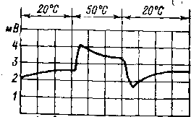
The described technology with certain variations is generally accepted for DC with electromagnetic excitation; it is used, in particular, in the manufacture of DC-64T capacitors. In the manufacture of capacitors of the DRK type, gilding of the plates is not used [L. 9-43]. The plate material in this case is 79NM permalloy, which has good magnetic properties and low chemical activity. The plates are subjected to heat treatment, which reduces the residual contact potential difference by a factor of 3–5 and reduces the necessary natural aging time of the capacitors after assembly by a factor of 3 . In the best samples of DRC capacitors, the zero drift does not exceed 100 μV in 24 h, i.e., lies
Рис. 9-15. Влияние температуры на дрейф нуля ДК типа ДРК.
at the same level as in the best specimens of gold-plated DC . The technology used in this case is simpler, and, consequently, the cost of DC is reduced.
The drift of the contact potential difference strongly depends on temperature fluctuations, which affect the contact difference not directly, but through other factors, for example, absorbed gases, moisture, or the rate of chemical reactions, which cause a change in the electron work function. The most significant zero drift takes place [L. 9-16] immediately after the temperature change (Fig. 9-15). With slow temperature changes, the temperature drift of the EMU with DC lies at the level of 20-50 μV /K.
9-3. SCHEMES AND PROPERTIES OF ELECTROMETRIC AMPLIFIERS WITH A DYNAMIC CAPACITOR a) Circuits
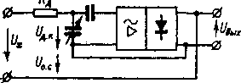
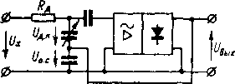
Mandatory components of an EMU with DC are an input converter, an AC amplifier, a phase sensitive rectifier, and a smoothing filter. Sometimes UPT is used after the filter. In a DC with electromagnetic excitation, due to the high inductance of the excitation coil , the current in it lags behind the voltage by 70-80°, which must be taken into account when designing a phase -sensitive rectifier.
Рис. 9-16. Схемы включения преобразователя с ДК в цепь усилителя с последовательной ООС.
There are two options for including a converter with a DC in an EMU circuit with an OOS. They are shown in fig. 9-16 for the case of sequential FOS. Both options provide the same input impedance, the same time constant , etc., but the second option has a number of advantages, namely: the common point of the amplifier is grounded, which facilitates the fight against interference; provides a convenient transition from serial OOS to parallel; the issue of zero adjustment is simply solved (by switching on the regulated voltage in the OOS wire).
The literature describes a number of schemes for EMU with DC and separate nodes for them. [L. 9-5, 9-49, 9-50, 9-51, 9-57]. In the VK2-16 electrometer (Fig. 9-17), the converter is made on the DRK-3 capacitor, operating at the frequency of its own resonance. A dynamic capacitor is included in the generator circuit (the generator circuit is not shown in Fig. 9-17 ). The alternating current preamplifier consists of an amplification stage on an EM-8 electrometric lamp, a composite emitter follower on two MP106 transistors, and one amplification stage on MP 106 transistors . . Its gain is about 100.
The main amplifier is assembled on MP 106 transistors and includes an emitter follower, one amplification stage, a phase shifter for correcting the phase characteristic of the amplifier, and one more amplification stage; then follows a phase-inverted stage on the P306 transistor for switching to a push-pull circuit and a push-pull power amplifier based on two P306 transistors. The gain of the main amplifier is about 1000.
The phase-sensitive rectifier is assembled according to the ring demodulator circuit on four P308 transistors. The control voltage is obtained from the generator supplying the DC excitation. An OOS divider is connected to the rectifier output, to which a divider is connected at the output of the preamplifier. When switching the measurement limits, the gain in the CNF loop is maintained constant and equals 1000 at all measurement limits, except for the limit of 3 mV, where it is equal to 300, and 1 mV, where it is equal to 100. An M1792 indicating device with additional resistances is connected to the detector output. , protected from overload by a D814V zener diode.
b) Basic properties
In table. 9-2 shows the main technical characteristics of some of the commercially available electrometers with DC. The model 640 electrometer based on a DC with electrostatic excitation has better properties in terms of basic indicators than other devices. The best electrometers based on a DC with electromagnetic excitation have a zero drift of less than 100 µV per day and fluctuations of 10-20 µV . This allows you to have the most sensitive voltage limit of 1 mV. The upper limit is 10 - 30 V, for measuring high voltages (up to 1 kV), dividers are used, as, for example , in the M141 electrometer. The input impedance of electrometers with DC is 10 ¹³ -10 ¹⁶ ohm.
The highest resistance of the measuring resistors is 10 ¹¹ -10 ¹² ohms and the most sensitive current limit is 10 ⁻¹⁵ -10 ⁻¹⁴ A. Increasing the resistance to 10 ¹³ ohms or lowering the voltage measurement limit below 1 mV (as in an electrometer
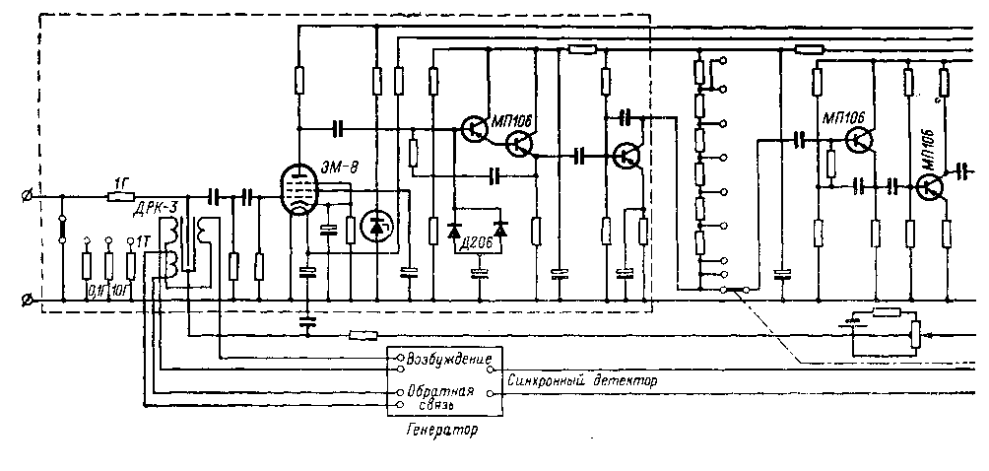
Rice. 9-17. Schematic diagram of the VK2-16 electrometer.
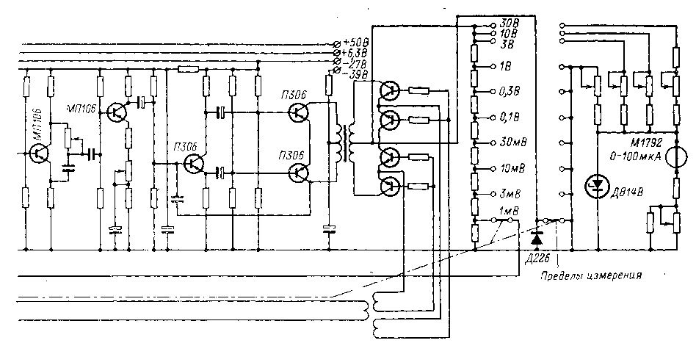

Table 9-2
Characteristics of commercially available electrometers with DC
Type of | Manufacturer | Limits of measurement, error
Type of | Manufacturer | U | I
ED-05M | Instrumentation plant, Tallinn | 10 mV - 60 V, 1 . 5% | 10 ⁻¹³ —10 ⁻⁹ A , 10%
VK2-16 | Minsk Instrument Building Plant | 1 mV - 30 V, 4 - 2.5% | 10 ⁻¹⁵ - 3*10 ⁻⁷ A, 10%
BMI-65 | Dzerzhinsky branch of OKBA | 1 mV - 3 V,  1 . 5% | 10 ⁻¹⁴ -3 * 10 ⁻⁷ A, 2.5%
640 | Keitħley (USA) | 30 μV - 3 0 V, 5 - 1% | 10 ⁻¹⁵ -3 * 10 ⁻⁵ A, 4-3%
3710 | Applied  Pħysics Corporation (USA) | — | —
33B _ | Electrical Instruments (England) | 10 mV - 1 V, 2-1% | 10 ⁻¹³ -10 ⁻⁹ A
62A | Electrical Instruments (England) | 1 mV - 10 V, 1% | —
TR 84-B | Takeda Ricken (Japan) | 1 mV - 30 V | 10 ⁻¹⁵ -3 * 10 ⁻⁷ A, 5 - 3%
VA-J-52 | VEB Vakutronik (GDR) | 1 mV - 10 V | —
M141 | Weyne Kerr (England) | 1 mV - 10 V, 1% | 10-15—10-7 A
FH-56 | Frieseke und Hoepfner (Germany) | 10 mV - 1 V, 1.5% | From 10 ⁻¹⁵ BUT
MMA11-17 | Kawaguci Electric Worke (Japan) | 1 mV - 10 V, 1% | 10 ⁻¹⁵ -10 ⁻⁵ A, 2.5%

Noises | Zero drift | Input resistance , Ohm | Weight, kg | Note
— | — | 10 ¹⁴ | 28 | P=80 VA
5∙10 ⁻¹⁷ BUT | 0.2 mV/24 h | 10 ¹⁶ | fourteen | P=45 VA
— | — | — | — | P=15 W;  cable up to 500 m
2 µV (p-p);  2∙10 ⁻¹⁷ double amplitude);  1.5∙ 10 ⁻¹⁶ C (double amplitude) | 20 µV/24 h, 20 µV/K, 5∙10 ⁻¹⁷ A/24h | 10 ¹⁶ | 9 | τ=l.5 s at R= = 10 ¹² Ohm; $ 1995
10-17A _ _ | 20 µV/20 min, 100 µV/24 h |  | 1.1 | P=1W; dimensions 100×150×40 mm;  f=5 kHz
— | 0.1 mV/12 h, 0.3 mV/week | 10 ¹³ | — | f =50 Hz
— | 0.1 mV/12 h | 10 ¹⁶ | — | P=25 VA; cable up to 90 m
20 µV, 10 ⁻¹⁵ A; 6* 10 ⁻¹⁶ C | — | — | — | τ=2 s at R= =10 ¹² Ohm; $ 1490
50 µV, 2∙10 ⁻¹⁷ BUT | — | 10 ¹⁵ | — | —
10 uV | 0.1 mV/24 h | 10 ¹⁶ | 16 | C _{b x} \u003d 3 - 30 pF;  f =1 kHz;  R=85 W
— | 1 mV/24 h | 10 ¹⁵ |  | f=l kHz
150 µV;  5* 10 ⁻¹⁷ A | 0.5 mV/24 h | 10 ¹⁵ |  | t =1; 5; 60 s

640) does not increase the current sensitivity threshold, which is limited by parasitic current and is equal to (2÷3)10 ^{-17 at best} A. Sometimes electrometers with DC provide for the measurement of small charges. With a measuring capacitance of 100 pF and a voltage measurement limit of 1 mV, the charge measurement limit is 10 ⁻¹³ C. When measuring the current by the charge accumulation method for an accumulation time of 100 s, the measurement limit is 10 ⁻¹⁵ A. The increase in sensitivity in this case is also limited by parasitic current. Sometimes attachments for measuring resistances are attached to electrometers on a recreation center. They contain a DC power supply and a camera for connecting an object . With the most sensitive current measurement limit of 10 ⁻¹⁵ And you can measure the resistance of 10 ¹⁵ ohms (full scale) at a voltage of 1 V, 10 ¹⁶ Ohm - at 10 V and 10 ¹⁷ Ohm - at 100 V.
Electrometers with DC at the most sensitive limits have a time constant of unity - tens of seconds, which makes it possible to increase their sensitivity. EMUs with DCs are usually not used in high-speed meters; at best, their settling time is 1 s.
of electrometers with DC is usually 10–20 kg. In recent years, such electrometers have been used in space exploration systems [L. 9-53]. The serial electrometer 3710 has a mass of 1.1 kg and dimensions of 100×150××40 mm. At the same time, the same characteristics are provided as on the best conventional electrometers .
Chapter Ten
HIGH SENSITIVITY AMPLIFIERS
DC _
10-1. AMPLIFIERS WITH VIBRATION CONVERTERS
- Input Converters
Mechanical converters of direct voltages into variables , called vibration transducers (VP), make it possible to perform UPTs with a voltage sensitivity threshold at the level of nanovolts at an input resistance of one to tens of ohms with sensitivity .

