The internal resistance of a resistive source can be increased using an EMU (see Chap. 14).
i) Capacitive current dividers
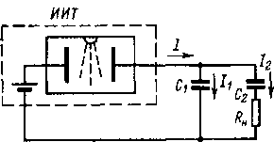
Rice. 3-25. Capacitive current divider.
Many of the considered current sources are easiest to
perform for one output current value. You can change the
value of the current at the output of the source from to -
the power of capacitive dividers (
Fig. 3-25). At the exit -
de IIT included con -
densators C ₁ and C ₂ , with
C ₁ >C ₂ . From the relation
It=UC, given the equality of
stresses on C ₁ and
С ₂ , we get I ₁ ∣ I ₂ =C ₁ /C ₂
and we can have I ₂ < I ₁ .
By changing C ₁ /C ₂ , one can
change I ₂ . The steady value of the current in the load is reached exponentially with the time constant R _{n} C ₂ .
If the current source is resistive, then I and , consequently , I ₂ will decrease from the initial value equal to E ∕R, to zero with time constant τ=R(C ₁ + C ₂ ), i.e., the time of using t _{max by} such a source must satisfy the condition t _{max} ≪τ , otherwise an additional error will occur.
Chapter Four

ELECTROMETRIC AMPLIFIERS
4-1. INPUT CONVERTERS OF ELECTROMETRIC VOLTAGE AMPLIFIERS
- General information
As shown in § 1-1, an indispensable element of all types of electrometric equipment is an electrometric voltage meter, which has a very large input resistance and a low level of intrinsic noise. At the first stages of the development of meters of this kind, this problem was solved using electrostatic electrometers. Over the past 20-30 years, various types of EMUs have been developed that provide amplification of the measured voltages and thereby

make it possible to use the principles of negative feedback (NFB), which implements a number of positive properties.
The most important element of the EMU is its input voltage converter, the purpose of which is to create a signal at the output that is proportional to the measured voltage and has a sufficient level and power for further amplification . In the EMU input converter, there is necessarily a signal (voltage) amplification in terms of power, and in some types of converters, in terms of amplitude.
Since when measuring in the electrometric range with extremely high sensitivity , it is required to have the input impedance of the transducer tending to infinity, then an ideal electrometric transducer should be understood as such [L. 4-3], which in the steady state (at a constant input voltage) in principle does not consume energy from a controlled source. Energy consumption takes place only in the transient mode, when the measured voltage changes, when the input capacitance is charged. Real voltage converters, of course, do not have infinite input resistance due to insulation leakage. Energy consumption from the controlled object, however, is not a necessary condition for the operation of the converter, and it can be reduced without violating the very principle of conversion.
Another important requirement that the input voltage converter for EMU must satisfy is a low level of self-interference in voltage and current. The quality of real transducers can be assessed by the degree of approximation of their characteristics, including noise, to the characteristics of an ideal model.
- Construction principles
Let's try to find out in what ways, in principle, input electrometric voltage converters with a very high input resistance and a low noise level can be implemented [L. 4-3].
Based on the type of output value of the converter, we can distinguish between converters with electrical

output signal and non-electrical. Let's take a look at the second one first. Electrometric converters of voltage into a mechanical quantity, namely, into displacement or angle of rotation, exist: firstly, these are electrostatic electrometers that use Coulomb's law; secondly, piezoelectric bimorph transducers, which use the inverse piezoelectric effect [L. 4-1, 4-2]. The latter do not yet have the sensitivity required for electrometry. The output can also be an optical quantity, namely, the plane of polarization in transducers based on the electrooptical effect. However, they also do not provide high sensitivity . Electrometric transducers with other non-electrical output quantities (magnetic, thermal, acoustic, etc.) cannot be created , since there are no effects relating these quantities to the strength of a constant electric field. Thus, transducers with non-electrical output provide only one solution that can be of practical importance, and that is an electrostatic electrometer.
Let us turn to converters with electrical output. Since an electrometric transducer should not consume power from the signal source in steady state, and its output power must be significant, any transducer of this type must have an auxiliary power source from which power is transferred to the output . Thus, the input electrometric voltage transducer can only be an amplifying type transducer.
The output signal of the input amplifying converter must be directly proportional to the input voltage, and the output signal power must be taken from an auxiliary source. Let us show more specifically how the energy is transferred from the auxiliary source to the converter output . Let us assume (this corresponds to reality ) that the output signal of the electrometric transducer is voltage (the input signal is also voltage). This limits the ways of transferring energy from the auxiliary source to the output to the following options:
86

Let's consider the first option first. In principle, the parameters of the electrical circuit, which can be controlled by the voltage U _{x} , can be resistance, capacitance and inductance. Since there are no physical effects that would make it possible to control the inductance with the help of an electric field, only resistance and capacitance are suitable for practical use.
Electric lamps and MOSFETs are used as resistances controlled by an electric field . Self-interference in them can also be small. Regardless of the type of controlled resistance, I _{aux} can be both constant and variable, respectively, we obtain a constant or alternating output voltage of the converter. In both cases it is proportional to U _{x} and I _ Systems with a variable auxiliary signal are relatively uncommon, since they have an increased level of intrinsic noise due to capacitive coupling between the circuits U _{x} and Isp and non-linearity of the characteristics, leading to the effects of rectification .
Three types of capacitances controlled by an electric field are known: varicaps with a semiconductor junction , MOS diodes, and ferroelectrics. Varicaps do not provide the required input impedance and are of limited use in electrometry. MOS diodes and ferroelectrics are more promising, but converters based on these elements have not yet left the stage of experimental research. When using controlled capacitances, the current I _{aux} can only be variable, and hence the output
87
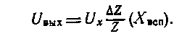
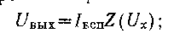
- the auxiliary energy source has an output _{value} of the current Iaux and voltage U _{x} controls any parameter of the electric circuit Z(U _{x} ). Then
- auxiliary energy source X _{aux} has an output value of a change in some parameter of the electric circuit ΔZ/Z (X _{rev} ), how the transfer coefficient changes from input to output. Then

Amplifiers based on this principle are usually called parametric. Their feature is the presence of a reactive element (capacitance or inductance), which periodically changes its main parameter in time. This element is connected between the input and output of the converter. The output power comes from an auxiliary power source. In electrometry , converters with a periodically changing capacitance can be used; their input resistance can be close to infinity. Energy ratios for converters with a reactive controlled element were obtained by Manley and Rowe [L. 10-8]. If the conversion frequency f ₁ significantly exceeds the signal frequency f ₂ , the power transmitted by the low frequency source f ₂ to the components of the output signal does not exceed P _{m} f ₂ /(f ₁ + f ₂ ) , where P _{m} is the power of the modulated oscillations. At f ₂ =0 (DC signal is converted), no power is taken from the signal source. The output of the converter receives power from a source of electrical or mechanical energy, which periodically changes the reactivity of the element .
Note that the name "parametric" does not very clearly set off the features of such converters, since 88
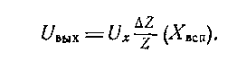
voltage must be variable. A necessary condition for the correct operation of such devices is I _{aux} Z _{c} ≪U _{x} , otherwise the auxiliary signal will have its effect on Z _{c} , which will distort the operation of the converter .
In the converters considered, the voltage Ux _{directly} controls the circuit parameter: resistance or capacitance. It is also possible to control with intermediate converter. For example, U _{x} can first be converted using an electrostatic system into displacement, and then the latter into a circuit parameter: resistance, capacitance, inductance , mutual inductance. This principle is used in electrostatic amplifiers.
Let us turn to the second variant of energy transfer from the auxiliary source to the output of the converter, in which the equation is realized

as in the converters of the first type, there is a change in any circuit parameter ( R or C). The only difference is that in one case the circuit parameter changes periodically with time, and in the other under the influence of a signal. However, in view of the widespread use of the term “parametric”, we will use it in the generally accepted sense.
In electrometry, parametric converters use controlled capacitances of the electromechanical type (dynamic capacitors) and on ferroelectrics . They can also be performed on MOS diodes, however, in this case, the control and conversion circuits are not separated, therefore, acceptable solutions are obtained only if the output signal has a frequency twice that of the excitation signal (converters with a second harmonic output) .
Parametric transducers always output an AC signal; if they do not use a resonant circuit, then they do not allow, unlike nonparametric ones, to obtain signal amplification in terms of level, but only in terms of power.
The considered principles exhaust the available possibilities for constructing input electrometric voltage transducers. In ch. 5-10 main ones will be discussed in detail.
- Classification
Depending on the classification feature, various classifications of input electrometric voltage transducers can be proposed. In the review, we divided them, as is usually done, according to the type of the input element. This division allows one to judge the main features of various converters, since these features are largely determined by the principle of operation of the input element. We also divided transducers into parametric and nonparametric ones; in this case, the classification feature is the method of converting the input voltage into an output signal. Such a subdivision carries useful information, since non-parametric converters, in principle, make it possible to obtain signal amplification in terms of level, and parametric
89

metric - only due to the introduction of a resonant circuit.
Taking as a basis the design of the input electrometric voltage converters, they can be divided into electromechanical and electronic ones. The first include electrostatic pre-
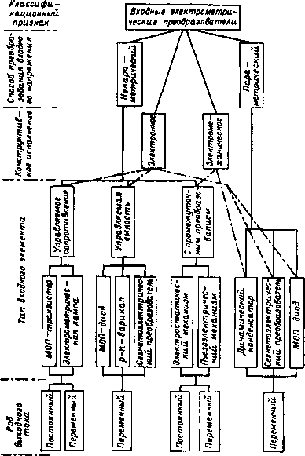
Rice. 4-1. Classification of input electrometric transducers.
generator and dynamic capacitor, to the second - all the rest. At the present stage of development of technology, electromechanical transducers, especially a dynamic capacitor, make it possible to obtain a more satisfactory set of electrometric characteristics than electronic ones. This is due to the fact that 90

unlike electronic transducers no unwanted restrictions. As a result, it is possible to provide the maximum possible input impedance , as well as to get rid of some sources of noise; in particular, there are no flicker noises in electromechanical converters , which are one of the main sources of intrinsic noise in electronic converters.
Finally, taking the type of current at the output of the input converter as a classification feature, they can be divided into converters with direct and alternating current output. The latter are preferable because they lighten the requirements for further amplification stages. However, in general, such systems are more cumbersome.
The resulting classification of input electrometric transducers is shown in Figs. 4-1.
- Non-electrometric high sensitivity transducers
All electrometric transducers have a voltage input signal. Transducers with a current input signal do not allow obtaining the maximum current sensitivity, however, they are sometimes used in electrometry. An example is vibration transducers, which are controlled active resistance [L. 10 - 13], included in the circuit of the controlled signal. With open contacts of the converter, the resistance is equal to infinity, with closed contacts - zero. Such a converter can only work by consuming energy from the signal source.
According to the principle of operation, photoresistive modulators, which are controlled by a light beam, are close to vibration transducers. In this case, the controlled resistance is not equal to infinity in the "open whip" state and zero in the "closed" state, i.e., the modulation coefficient of the controlled resistance is less than that of vibration transducers . Amplifiers based on bipolar transistors have also received some use in electrometry, the input signal of which is also current and which sometimes provide a relatively high current sensitivity.
4-2. GENERAL INFORMATION ABOUT ELECTROMETRIC AMPLIFIERS
- Construction principles
A DC amplifier with an input electrometric voltage converter, which has a large signal amplification in terms of level and allows the use of feedback, is called an electrometric
91

amplifier (EMU). The input signal of the EMU is DC voltage, and the output signal is also voltage.
Like conventional amplifiers, EMUs can be made with an unbalanced input, when one of the input terminals is high-resistance, and the other is connected to the common point of the EMU, and with balanced, when there are two high-resistance input terminals and one common. The EMU with balanced input uses two identical input voltage converters. Such EMUs are less susceptible to the influence of external interference and are more suitable for constructing various circuits, in particular differential meters, than EMUs with asymmetric input, however, due to their greater complexity , they are still of limited use. Therefore, in the future, we will restrict ourselves mainly to consideration of EMU with an asymmetric input.
- Types of environmental protection
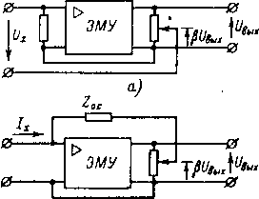
b)
Rice. 4-2. Types of environmental protection in EMU.
and serial in voltage;
b - parallel in voltage.
Electrometric amplifiers are usually covered by
OOS voltage [L. 4-5]: serial or
parallel (Fig. 4-2); OOS for current in electrometric equipment has not received application .
With serial
OOS, a part of the output voltage βU out is
subtracted from the input
U x ₍
switched on in series ), an
insignificant part of U _{x} is applied
to the EMU input
. With parallel FOS, part of
the
output voltage
βU _{out} is applied to the
feedback element
Z _{о .c} , represented by
one of the types
passive electrometric transducers. The current arising in this case, approximately equal to βU out ∕ Z _{oc} , is fed to the EMU input parallel to the input current I _{x,} and the difference of these currents flows in the EMU input circuit. Electrometric amplifiers with OOS and single-ended input have one common terminal between input and output, one high-resistance input and one low-resistance
92

day off. In both cases, one terminal of the signal source is connected to the high-resistance input of the EMU, and the second one is connected either to the common point of the EMU (for parallel OOS) or to the output terminal of the EMU (for serial ). This allows you to switch from one type of OOS to another using a switch in low-resistance circuits of devices.
- Typical schemes for using EMU
On fig. 4-3 shows typical diagrams of electrometric meters for voltages, currents, charges and resistances; for simplicity, the OOS is shown as 100% . To measure voltages, EMUs with sequential OOS are used (Fig. 4-3, a). For measuring currents
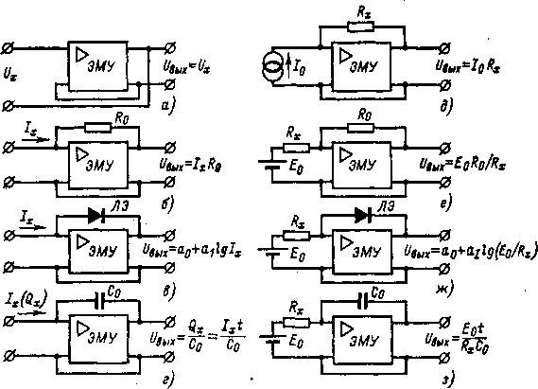
Rice. 4-3. Typical schemes of electrometric meters with OOS.
current-to-voltage converter is included in the parallel OOS circuit of the EMU : a high-resistance resistor R ₀ (Fig. 4-3, b) , a logarithmic element (Fig. 4-3, c) or a capacitor (Fig. 4-3, d), the latter the circuit is also used to measure charges. When measuring resistances , the current source is the measured resistance R _{x} , powered by a source of known voltage U ₀ (Fig. 4-3, f-h). It is possible to use a calibrated current source I ₀ and voltage meter on R _{x}
93

with the help of EMU (Fig. 4-3, e). Bridge circuits are also used. A more detailed consideration of various options for circuits of electrometric equipment will be given later.
- The main properties of EMU with sequential feedback
The equivalent circuit of such an EMU is shown in fig. 4-4, where Z ₂ is the resistance of the signal source; Z ₁ and R _{out} - input and output resistance of the EMU; k is the EMU gain; β is the transfer coefficient of the OOS link; R _{n} - load resistance. Usually
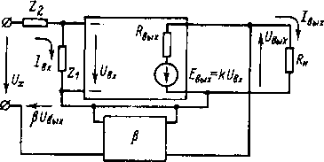
Rice. 4-4. EMU equivalent circuit with serial OOS.
in EMU, either 100% OOS (β=l) or a resistive divider (β<l) is used. In general, the quantities Z ₁ , Z ₂ , k and β are complex. Taking into account the indicated in Fig. 4-4 polarities of voltages and currents we get the equations
94
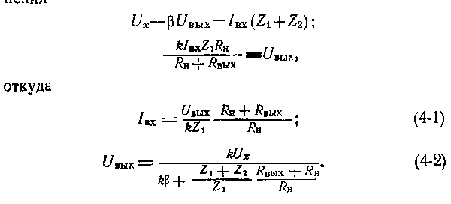
At idle, i.e. at R _{n →} ∞, we get:
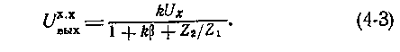

We find the input resistance from equations (4-1) and
(4-3) as
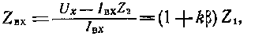
i.e., serial OOS increases the input impedance
by a factor of (l+kβ) , increasing the input impedance and
decreasing the input capacitance. By increasing the input resistance
, the power consumed from the controlled source
can be brought to very small values ,
however, the EMU sensitivity threshold is determined by the
level of its interference and the use of environmental protection cannot be
increased.
The transfer coefficient of the EMU with serial OOS
depends (4-3) on the parameters k and β and resistance ratios Z
₂ and Z ₁ ; at Z ₂ →∞ , the OOS, which closes
through the signal source, breaks. Usually Z ₂ ∕Z ₁ ≤kβ,
and the influence of this term is neglected. Then
i.e., the OOS reduces the gain of the amplifier by a factor of 1 + kβ and reduces the influence of the instability of the EMU gain on it. When kβ>>l , the output voltage _{Uout} =U x ∕ β and the transfer coefficient does not depend on the EMU gain, but is determined only by the OOS circuit. In the particular case β=l, for kβ>>l we have U _{out} =U _{x} ∙
The output impedance of the EMU in the presence of NFB is equal to the ratio of the no-load voltage, which is given by equation (4-3), to the short-circuit current at the output of the EMU, which is found as
95
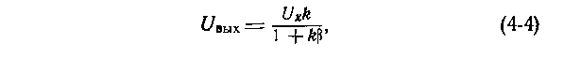
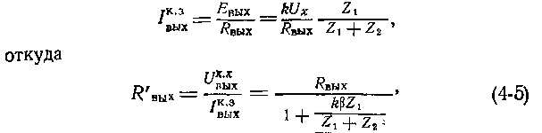
i.e., the introduction of the OOS reduces the output impedance of the EMU. Since usually kβZ ₁ /(Z ₁ + Z ₂ )>>1, the output
resistance is small and its influence is neglected, using equation (4-3) for the output voltage.

e) Main properties of EMU with parallel OOS
The equivalent circuit of such an EMU is shown in fig. 4-5, where Z ₂ is the impedance of a passive electrometric transducer (resistive or
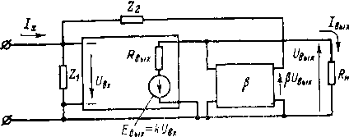
Rice. 4-5. EMU equivalent circuit with parallel OOS.
capacitive) in OOS chains, other designations are the same
as in the previous case. Expression for output
voltage
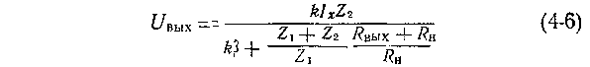
completely coincides with equation (4-2) for EMU with sequential feedback ,
except that instead of
U _{x} it is necessary to substitute ∕ _{x} Z ₂ . The main conclusions for
consistent FOS hold true here as well. The output
impedance is given by Equation (4-5) and its influence can be
neglected. Then the output voltage
i.e. , the transmission coefficient U _{out} ∕I _{x} is determined by the total resistance Z ₂ , the parameters k and β , and the ratio Z ₂ ∕ Z ₁ . When Z ₁ → 0, the FOS breaks. In correctly executed practical devices Z ₂ ≪ Z ₁ and the influence of Z ₂ /Z ₁ can be neglected. Then
The input impedance of the EMU with parallel CNF will be found taking into account (4-7) as
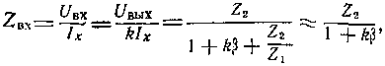
96
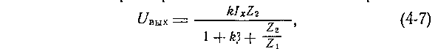

. i.e. input impedance decreases: input resistance decreases, input capacitance decreases. Reducing the power consumption when maintaining a parallel FOS does not increase the sensitivity threshold , which is determined by the level of EMU interference. Note that often for EMU with parallel) OS, the input resistance is indicated equal to the resistance in the OOS circuit. This is not true.
e) Own interference. equivalent circuit
The input electrometric voltage converter is characterized by the total input impedance (generally parallel connection R _{in} C _{in} ) and the level of self-interference. Electrometric voltage converters or EMUs are
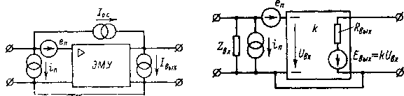
Rice. 4-6. Interference sources 4-7. EMU replacement circuit. )MU.
to the category of active non-autonomous quadripoles with a common point between the input and output. In general, their own noise must be characterized by four statistically independent sources of noise, for example, voltage sources e _{p} and current I _{p} at the input, a current source in the feedback circuit and a current source at the output i _{o} (Fig. 4-6). Since the output impedance of the EMU is small, the influence of the _{source} i _{out} and the voltage drop i o.s R _{out} can be neglected. Then the source i _{o. c} can be considered connected in parallel i _{p} and merge them into one. Thus, it suffices to characterize real EMUs by interference sources e _{p} and i _{p} (Fig. 4-7). EMU equivalent circuit parameters Z _{bx} , e _{p} , i _{p} , k are generally complex.
The total level of intrinsic noise of the EMU in terms of voltage , reduced to the input, is greater than the noise of the input converter due to the noise of subsequent stages. Current EMU interference is determined only by its input 97

converter. In case of unsuccessful installation, currents flow through the common wire between the input and output of the EMU, creating a voltage drop across it. In principle, this source of self-interference can be eliminated and is usually not considered, but in practical devices it is a source of trouble. Self-interference in voltage and current is divided into three components:
high-frequency fluctuations caused by thermal, shot and other noises of the electrometric transducer and subsequent stages;
slow changes due to aging of elements, temperature changes, etc., called zero drift;
zero offsets.
The periodic component of the drift can be considered as very low frequency noise.
- Manifestation of EMU interference in the presence of environmental protection
In the absence of a useful signal (short-circuited terminals U _{x} in fig. 4-4 and open terminals I _{x} in fig. 4-5) EMU schemes with serial and parallel OOS are the same. The difference is only in the resistances Z ₁ and Z ₂ , the values and nature of which (resistive , capacitive) depending on the scheme of use
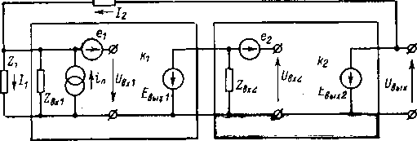
Rice. 4-8. On the calculation of noise in a generalized circuit of an electrometric meter.
may be different (see Figure 4-3). The manifestation of EMU fur can be considered in general terms for both types of environmental protection (Fig. 4-8). It is assumed that the input electrometric transducer has a voltage transfer coefficient kι=E _{out1} ∣ U _{in1} and own noise e ₁ and i _{p} , and the secondary amplifier is characterized by voltage noise e ₂ (noise according to 98

current are not considered, since the circuits are low-resistance) and the transfer coefficient k ₂ \u003d E _{out2} / U _{in2} In the general case , the equivalent circuit parameters Z and k are complex quantities. Resistors Z ₁ and Zbx _ are connected in parallel and, for simplicity, only Z _{1 can be considered} . Solving the system of initial equations describing the scheme under consideration, we obtain:
where k = k ₁ k ₂ is the resulting voltage gain ;
e _{p} \u003d e ₁ +e ₂ ∕k ₁ is the voltage noise level
reduced to the input . From this it follows that the intrinsic
noise of the second (the conclusion is also valid for a
larger number of stages) amplification stage, reduced to the
EMU input through the complex gain
of the first stage, manifests itself as interference that
occurs in the input circuit.
The voltage at the output of the EMU, caused by its own interference ,
Therefore, to ensure a low level of EMU noise with OOS, it is not enough to have insignificant intrinsic EMU voltage noise e _{p} , it is also important to provide a large EMU input resistance Z ₁ . In wideband electrometric equipment, the capacitive component Z ₁ can dramatically increase the high-frequency noise of the EMU. The interference component due to the parasitic current of the EMU is determined by the resistance Z ₂
⁷ * 99
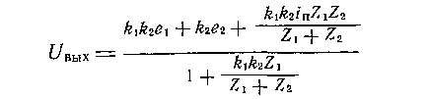
We can designate:
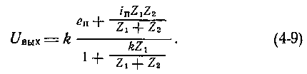
In most cases, Z ₁ ≥Z ₂ , then kZ ₁ /(Z ₁ + Z ₂ )>> 1 and
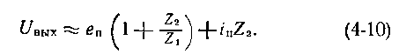

- Zero setting
Zero offset in voltage and current can be compensated. By repeating this operation periodically, it is possible to reduce the influence of the drift components of self noise. To do this, devices always provide devices for zeroing in voltage , and sometimes in current. The intrinsic voltage and current interference of the EMU manifest itself in different ways, it is most correct to use a separate zero setting for voltage and current. Zero voltage should be set at Z ₂ =0, when the parasitic current source is short-circuited. After that, you can perform zero current setting at Z ₂ ≠0. The voltage zero offset is adjusted in the input converter or subsequent stages. The applied methods depend on the specific EM scheme. When the current is set to zero, the parasitic current of the EMU is compensated ; To do this, a current is supplied to the input through a high-resistance resistor from a source of voltage regulated in terms of level and sign.
- Equipotential protection
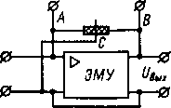
Rice. 4-9. Equipotential protection _
in the EMU.
Regardless of the type of OOS, the voltage between the
input and output terminals that are not connected to the common
point of the EMU can be significant. With serial OOS, the voltage of the signal source and the insulation resistance between the terminals are applied
to
them
connected in parallel with the input resistance of the
EMU. With parallel FOS, voltage is applied to them in
the
FOS circuit and the
insulation resistance shunts the FOS element.
These undesirable influences are
eliminated by means of equipotential
protection (Fig. 4-9). The insulation resistance between points
A and B is
separated by a metal screen and
connect the screen (point C) to the common point of the EMU. The AC isolation drain is connected in parallel to the EMU input and does not have a significant effect on its operation, since it is under voltage close to zero, and the VS section is connected in parallel with the EMU output.
100

With serial FOS, in this way it is possible to exclude the influence of the resistance of the contact of the key that closes the input of the EMU, or of the cable connecting the measured object with the EMU. With parallel FOS , the equipotential protection eliminates the influence of the insulation resistance of the contact of the key that closes the FOS circuit, or the insulation resistance of the passive electrometric transducer. The area to be protected (cable, air capacitor, contact, etc.) must be made with a three-terminal section. It is often sufficient to apply only surface leakage protection by means of a protective metal ring on the surface of the insulator.
- EMU properties with and without transformation
Depending on the principle of operation of the input electrometric voltage converter, further amplification in the EMU is performed on direct or alternating current. The first case is typical for converters based on electrometric lamps and field-effect transistors, while the second is typical for converters based on dynamic capacitors, varicaps, and ferroelectrics . Electrometric amplifiers with DC-to-AC signal conversion are very different in their main features and functional blocks from EMUs, in which the conversion is not used.
The main advantage of EMU without conversion is their simplicity. To obtain the required signal amplification in terms of level and power, several amplifying stages are sufficient. The frequency range is up to tens - hundreds of kilohertz. The main disadvantage of EMU without conversion is a large zero drift due to temperature effects, fluctuations in supply voltages, aging of elements, etc. Attempts to reduce it usually lead to loss of simplicity of EMU circuit solutions as a whole.
Converted electrometric amplifiers are often more complex than non-converted EMUs. The input electrometric transducers used in them usually have a conversion coefficient in signal amplitude less than unity, therefore, in subsequent amplifying
101

cascades require a lot of gain. After the AC amplifier , a
synchronous rectifier and
a smoothing filter are needed, which also complicates the circuit. At
a low conversion frequency, such EMUs have a narrow
bandwidth. It is more difficult to provide stability to self -
excitation in them. All these shortcomings are
usually paid off by a small drift of the EMU zero with the conversion
. Amplification is carried out on alternating current, and changes in
the modes of amplifying stages under the influence
of temperatures, aging of elements, etc. do not lead
to zero drift, which is almost entirely determined by the
input electrometric transducer.
k) Joint use of EST without conversion
and with conversion
Simultaneous use of both types of EMU
can combine a wide bandwidth of one
with a small drift of the other
[L. 4-16]. To do this, a wide -
band EMU with a symmetrical input
and a
gain k ₁ and low -
drift EMU with gain k ₂ are
connected in parallel to the signal source, and the low -
drift EMU output is connected to
the second input of the
broadband EMU (Fig.
4-10). If drift zero EMU
is equal to e ₁ and e ₂ , then the output voltage
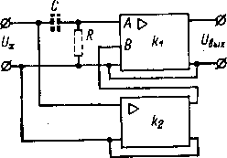
Rice. 4-10. Schematic
diagram of an EMU with continuous serial -
parallel
correction.
i.e. taking into account the fact that k ₂ >>1, the ratio of interference to the useful
signal
Effect of drift e ₁ broadband EMU decreases in k ₂ times, and only the drift e _{2 of} the low-drifting EMU appears. The bandwidth is determined by the wideband EMU and can be large. for that 102
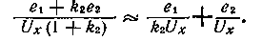
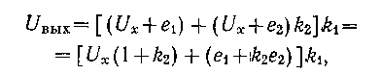

To eliminate the influence of the parasitic current of the broadband EMU
, which in this circuit passes through the resistance of the signal source, a blocking capacitance
C and
a leakage resistor R are switched
on at the input of the broadband EMU . Parasitic current, closing on the resistance
R , manifests itself as zero drift in the voltage of the broadband EMU and is corrected by a low drifting amplifier .
In this case, the AC signals go directly to the
wideband EMU,
while the DC signals come only through the
low-drift EMU.
The considered method of continuous correction of drift -
zero by the method of switching on the EMU is called series
-parallel. A parallel system is also possible ,
when both EMUs are connected in parallel,
and
their output signals are summed up by a DC amplifier , which is also a power
amplifier [L. 4-5]. Such systems are not yet used in electrometry
.
m) EMU with periodic zero correction
Sometimes used in EMU [L. 4-7 - 4-10] periodic zero drift correction .
The correction relay (Fig.
4-11) periodically operates, and its contacts P _{a} and
R _{b} switch from position
1 to position 2. In position 2 _
EMU with gain k
covered by
100% OOS,
and the storage capacitor C is connected
in parallel with the
EMU input. In the presence of a
zero shift e _{p} the condenser is
charged up to
stress e _{p} k∕ (1+k ). When switching contacts to position
1 EMU is connected to the signal source U _{x} and on his
the input, in addition to the signal, receives the difference between the zero shift e _{p}
and the voltage on the storage capacitor, i.e.
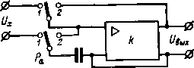
Rice. 4-11. Principal diagram of
EMU with periodic correction (
according to Prince).
The zero shift decreases by (1+ k ) times. When used as a memory element reochord driven by a reversible engine [L. 4-6, 4-13] the storage period of the obtained storage element
103


information is not limited. In general, the use of periodic zero
correction in EMU does not justify itself.
The circuit becomes much more complicated, periodic switching at the
EMU input causes long transient
processes, disrupts the continuity of measurements, and increases the
noise level at the input.
m) Stability of EST with environmental protection
In equations (4-2) and (4-7) for the transmission coefficients of the EMU
with serial and parallel OOS
, the parameters k, β, Z ₁ and Z2 _ are complex. In
practice, most often the OOS link is represented by a resistive divider
and β does not depend on frequency, and Z ₁ and Z ₂
are generally represented by a parallel connection of
resistance and capacitance, i.e.
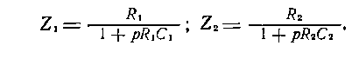
If the EMU itself can be considered as an inertial link
of the first order with a time constant T _{k} ,
i.e., describe it by the transfer function
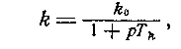
where k ₀ is the gain factor of the EMA at ω = 0, then the characteristic equation of expressions for the transfer coefficients of the EMA with serial or parallel OOS, which determines the stability of the system as a whole, has the form:
and the system is unconditionally stable.
If the EMU has two inertial links and its transfer characteristic is described by the equation
a
whole has the form:
where α ₀ , α ₁ , α ₂ , α ₃ are constant coefficients depending on the parameters of the system. According to the Routh-Hurwitz criterion, this system is stable if condition (α ₁ α ₂ -α ₃ α ₀ )>0. Analysis obtained by this criterion
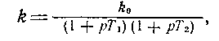
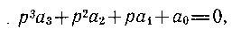

The general stability conditions are difficult , since, depending on the scheme used, the _{parameters k} , β , R1 , R2 , C1 , _{C2} , T1 , and _{Т2} can take on a wide range _{of values} . For each specific scheme, this is easier to do. In any case, stability can be ensured if the transfer coefficient inside the FOS loop (k ₀ β) does not exceed a certain value. The problem of stability in practice is reduced to obtaining such a large k ₀ β that it can be considered satisfactory from the point of view of the input resistance of the EMU, the influence of external factors on the operation of the EMU, etc.
The transfer function of the EMU can also be described by the equation of the oscillatory link
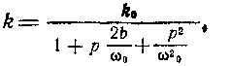
where k0 _ is the EMU gain at ω = 0; b is the degree of calm; ω ₀ is the angular frequency of natural oscillations. Such a case occurs if a combination of an electrometric lamp with a photogalvanometer is used as an EMU [L. 4-4].
It is especially difficult to solve the problem of stability in EMU with the conversion of direct current into alternating current . In such EMUs, the number of inertial links is large. The input voltage of the electrometric modulator is a constant or slowly changing voltage, the output voltage is an alternating voltage that changes with the modulation frequency. The transient characteristics of the modulator are determined by the relationship between the time dependences of the input voltage and the envelope of the output voltage. If the modulation frequency is much higher than the frequency of the converted signal, then the very fact of modulation does not affect the transient response of the system, i.e., the ideal modulator is inertialess. In real converters, the input time constant is significant and determines the time constant of the modulator, which can be considered as a first order inertial link.
The transfer characteristic of the selective amplifier , which gives the connection between the envelopes of the output and input modulated signals, corresponds to the characteristic of the inertial link of the first order
105

with time constant T = 2Q∕ω ₀ , where Q is the quality factor of the selective circuit; ω ₀ is the resonant frequency of the circuit . If the resonant frequency of the circuit and the frequency of the signal do not match, then the resonant amplifier is characterized by two time constants. The time constant of the phase sensitive rectifier is determined by a smoothing filter. Thus, an EMA with DC to AC conversion contains at least three or four inertial links, and the characteristic equation of such an EMA with a closed FOS will be, respectively, of the fourth or fifth order. To ensure stability in this case, corrective chains and other special measures are used.
Chapter Five

ELECTROSTATIC ELECTROMETERS AND AMPLIFIERS
5-1. ELECTROSTATIC VOLTAGE TO DISPLACEMENT CONVERTERS
- Voltmeters and electroscopes
In electrostatic measuring mechanisms, the measured voltage is converted into an angle of rotation or linear movement of the moving part. The torque is created by the forces of electrostatic interaction between the movable and fixed plates. If the capacitance between the plates is C and voltage U _{x is applied to them} , then the energy stored in the mechanism is A = CU ² _{x} ∕2 and torque is defined as the derivative of energy with respect to the rotation angle of the moving part, i.e.
This moment is balanced by a counteracting moment proportional to the displacement M _{pr} \u003d W _{α} , and at M _{vr} \ u003d M _{pr} angle of rotation of the movable part
i.e., such devices have a quadratic scale.
106
