DATA 260 Homework 9
  - Redis Semantic Caching and Self-Improving Multi-Agent System
Shoury Ambarish Parab
SID4: 7085
https://github.com/shoddy16/data260-7085
Configuration: PREFIX=s7085, SEED=7085, VERIFY_SEED=267085, DOMAIN_ID=5, PORT_BASE=8085, HW9_PORT=8086, chat=llama3.2:3b, embeddings=nomic-embed-text (768 dimensions).

1. Project context and architecture
I extended the shared restaurant-inspection application. HW9 adds a Redis view counter, Redis HNSW KNN semantic caching, a frozen threshold experiment, and a reference-backed evaluator loop. The report separates live service results from deterministic local experiments.
Source excerpts and machine-readable evidence for this section are retained in the repository under the source paths and reports/hw09/raw. The PDF contains the detailed tables, excerpts, and runtime figures.

2. Part 1 - Redis-backed restaurant view counter
ViewCounter uses Redis INCR with s7085:views:restaurant:{id}. It writes the Restaurant row every tenth count and returns the current Redis count. Live results recorded counts 1, 2, 10, 20, and 21, with database_views=20 after the twenty-first request and 20 unique concurrent counts.
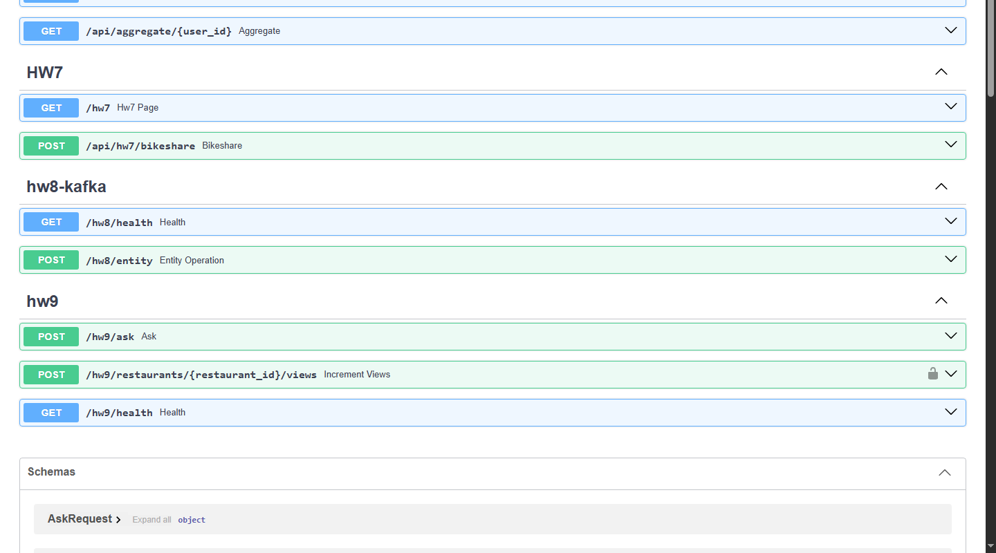
Figure. HW9 endpoint surface used for the live route checks.
Source excerpts and machine-readable evidence for this section are retained in the repository under the source paths and reports/hw09/raw. The PDF contains the detailed tables, excerpts, and runtime figures.

3. Part 2 - Redis semantic response cache
The /hw9/ask route embeds the query, runs Redis HNSW KNN, converts cosine distance to similarity, and applies signature, restaurant-scope, and data-version guards. Live KNN evidence recorded exact and paraphrase hits, logical and unrelated misses, stale rejection, empty-index miss, and concurrent KNN use.
KNN validation summary: backend=redis_knn; index=s7085:semantic_cache_idx_v768; dimension=768; exact similarity=1.000000; paraphrase similarity=0.938599; logical-difference and unrelated cases missed; stale entry rejected after a version increment.
Source excerpts and machine-readable evidence for this section are retained in the repository under the source paths and reports/hw09/raw. The PDF contains the detailed tables, excerpts, and runtime figures.

4. Part 3 - Frozen dataset and threshold economics
The committed cache_cases.yaml contains 40 cases in the required 10/10/10/10 distribution. The qualifying live sweep used nomic-embed-text and Redis KNN at all five thresholds. The measured costs were 83, 76, 77, 66, and 51; 0.95 was lowest but sacrificed valid hits.
Threshold | Hits | Correct | False hits | Mean ms | Cost
0.75 | 29 | 20 | 9 | 2537.92 | 83.0
0.80 | 28 | 20 | 8 | 103.61 | 76.0
0.85 | 27 | 19 | 8 | 151.57 | 77.0
0.90 | 22 | 16 | 6 | 184.15 | 66.0
0.95 | 13 | 10 | 3 | 240.44 | 51.0
Source excerpts and machine-readable evidence for this section are retained in the repository under the source paths and reports/hw09/raw. The PDF contains the detailed tables, excerpts, and runtime figures.

5. Stale-answer invalidation
A live MySQL/Redis experiment observed an old answer before version invalidation and the updated answer after the restaurant data-version marker was incremented. The scope is per restaurant rather than a global cache delete.
Source excerpts and machine-readable evidence for this section are retained in the repository under the source paths and reports/hw09/raw. The PDF contains the detailed tables, excerpts, and runtime figures.

6. Part 4 - Self-improving agents
The evaluator uses separate reference facts, the repair loop is bounded to two attempts, lessons contain the required fields, and the four variants use the same ten-question held-out set. Evaluator Repair, Lesson Memory, and Validated Improvement reached 10/10 in the deterministic experiment.
Variant | Correct | Incorrect | Attempts | Latency ms
baseline | 9 | 1 | 1.00 | 0.0076
evaluator_repair | 10 | 0 | 1.10 | 0.0103
lesson_memory | 10 | 0 | 1.10 | 2.4556
validated_improvement | 10 | 0 | 1.10 | 1.8157
Source excerpts and machine-readable evidence for this section are retained in the repository under the source paths and reports/hw09/raw. The PDF contains the detailed tables, excerpts, and runtime figures.

7. Testing and regression audit
Focused HW9 tests, scoped Ruff, compileall, Compose configuration, live KNN validation, and the qualifying sweep passed. The broader SQLite suite had 40 passes and two failures; the full default suite was blocked by local MySQL authentication configuration.
Source excerpts and machine-readable evidence for this section are retained in the repository under the source paths and reports/hw09/raw. The PDF contains the detailed tables, excerpts, and runtime figures.

8. Required artifacts and reproducibility
Raw JSON is under reports/hw09/raw, runtime screenshots are under reports/hw09/evidence, and the checklists, metrics, run log, and AI disclosure are under reports/hw09.
Source excerpts and machine-readable evidence for this section are retained in the repository under the source paths and reports/hw09/raw. The PDF contains the detailed tables, excerpts, and runtime figures.

9. AI use and verification
AI assistance supported repository inspection, implementation drafting, test writing, and report editing. I reviewed and ran the implementation and distinguish live evidence from offline deterministic evidence. Dataset commit a7533e7d5eb1df286b77450ce7999d0ad6a5a12d contains only cache_cases.yaml.
Source excerpts and machine-readable evidence for this section are retained in the repository under the source paths and reports/hw09/raw. The PDF contains the detailed tables, excerpts, and runtime figures.

10. Final checklist and conclusion
The core HW9 behavior is verified, the qualifying KNN sweep is complete, and threshold 0.95 is the lowest-cost measured choice under the required model. The report includes the implementation excerpts, live runtime evidence, raw experiment outputs, and the measured timing methodology.
Source excerpts and machine-readable evidence for this section are retained in the repository under the source paths and reports/hw09/raw. The PDF contains the detailed tables, excerpts, and runtime figures.

