
PROJECT REPORT ON

EFFECT OF CERIUM REINFORCEMENT AND HOT-ROLLING ON MICROSTRUCTURE AND
MECHANICAL PROPERTIES OF HIGH MANGANESE STEEL

Submitted in partial fulfillment of the requirements of the degree of

BACHELOR OF TECHNOLOGY IN METALLURGICAL AND MATERIALS ENGINEERING

Supervised by:  Dr. Swati Sharma (Assistant Professor) |  | Submitted By: Aditya Raj (2022UMT1429) Harsh Kumar(2022UMT1180)  Rohan Meena(2022UMT1402)

DEPARTMENT OF METALLURGICAL AND MATERIALS ENGINEERING MALAVIYA NATIONAL INSTITUTE OF TECHNOLOGY, JAIPUR

Dec-2025


DEPARTMENT OF METALLURGICAL AND MATERIALS ENGINEERING, MALAVIYA NATIONAL INSTITUTE OF TECHNOLOGY JAIPUR

CERTIFICATE
This is to certify that the Project Report entitled “EFFECT OF CERIUM REINFORCEMENT AND HOT-ROLLING ON MICROSTRUCTURE AND MECHANICAL PROPERTIES OF HIGH
MANGANESE STEEL”, submitted by B.Tech. (Metallurgical & Materials Engineering) VIII semester students, Aditya Raj, Harsh Kumar and Rohan Meena towards the partial fulfilment of the requirements of the degree of Bachelor of Technology(B.Tech) in the field of Metallurgical and Materials Engineering of Malaviya National Institute of Technology, Jaipur is a record of the confide work carried out by them under my supervision. The work submitted, in my opinion, has reached to a level required for being accepted for the examination.

The matter embodied in the seminar work, to the best of my knowledge, has not been submitted to any other university or institute for the award of any degree or diploma.

.
Dr. Swati Sharma
(Assistant Professor) Department of Metallurgical & Materials Engineering Malaviya National Institute of Technology, Jaipur

DECLARATION

We, Mr. Aditya Raj (ID - 2022UMT1429), Mr. Harsh Kumar (ID - 2022UMT1180), and Mr. Rohan Meena (ID - 2022UMT1402), hereby declare that the project report entitled “EFFECT OF CERIUM REINFORCEMENT AND HOT-ROLLING ON MICROSTRUCTURE AND MECHANICAL PROPERTIES OF
HIGH MANGANESE STEEL” being submitted towards partial fulfillment of the degree of BTech in Metallurgical and Materials Engineering, is a bonafide research work carried out by us under the supervision of Dr. Swati Sharma, and this has not been submitted anywhere else for the award of any other degree.

Aditya Raj | Harsh Kumar |  | Rohan Meena
2022UMT1429 | 2022UMT1180 | ` | 2022UMT1402

Metallurgical and Materials Engineering MNIT JAIPUR



ACKNOWLEDGMENT

We are extremely grateful and indebted to Dr. Swati Sharma, Assistant Professor, Department of Metallurgical and Materials Engineering, MNIT Jaipur, for providing us with our final year B.Tech project under her guidance. We are also very thankful to her for her demand for perfection that has encouraged us to put in so much effort into this project. Her useful guidance, suggestions, discussions and calm demeanour at each step of our work helped us a lot to complete this project.

We would also like to take this opportunity to thank Dr. Ranveer Singh for guiding us through the project process and providing us the necessary guidance.

We express our profound sense of gratitude to Dr. Rajendra Kumar Goyal, Professor and Head of the Department, Metallurgical & Materials Engineering Department for his encouragement and necessary permission to carry out the work.

We express our gratitude to all those who are directly or indirectly involved in this work including all the support staff in the departmental laboratories and office.

(Aditya Raj) (Harsh Kumar) (Rohan Meena)

Table of Contents
Contents Page
No.
Certificate i
Acknowledgement ii
Table of Contents iii
Abstract iv
- Introduction 1-3
  - Background
  - Why Cerium and Hot Rolling
  - Applications of Ce Reinforced Steels
  - Motivation
- Literature Survey 4-5
  - Effect of alloying elements on High-Mn Austenitic Steel
    - Effect of Cr
    - Effect of Al
  - Specific Role of Ce
  - Effect of Hot Rolling -1200deg C

- Experimental Procedure 6-9
  - High Level Flow Chart
  - Microstructural Characterization
  - Mechanical Characterization
  - Grain Size Measurement
  - Hardness Measurement
  - Twin Density Measurement
- Results and Discussion 10-12
  - Chemical Composition of as received sample
  - Phase Analysis using X-Ray Diffraction
  - Hardness and Grain Size Correlation
  - Hardness, Grain Size and Twin Density Correlation
- Conclusions 13
- Scope of Future Work 14
- References 15

ABSTRACT
The global imperative for sustainable energy has accelerated the demand for Liquefied Natural Gas (LNG), necessitating advanced structural materials capable of withstanding cryogenic temperatures. While conventional 9% Nickel steels and austenitic stainless steels provide necessary toughness, they are constrained by high costs and supply volatility. High Manganese Steels (HMS) offer a cost-effective alternative due to their austenitic stability and high work-hardening rates; however, their industrial application is often hindered by casting defects such as coarse dendritic structures and microsegregation.
This project investigates the efficacy of "Oxide Metallurgy" via Rare Earth Cerium (Ce) reinforcement and thermomechanical processing (hot-rolling) to ameliorate these microstructural deficiencies. Three specimens of HMS were synthesized with varying Cerium concentrations: 0 wt.%, 0.04 wt.%, and 0.06 wt.%. The investigation focused on the correlation between Ce content, microstructural evolution, and mechanical hardness.
Experimental characterization was conducted using X-Ray Diffraction (XRD), Optical Microscopy, and Vickers microhardness testing. XRD analysis confirmed that all specimens retained a stable single-phase face-centered cubic (FCC) austenitic structure, demonstrating that Ce addition up to 0.06 wt.% does not induce the formation of deleterious secondary phases like BCC ferrite. Microstructural analysis revealed a distinct inverse correlation between Cerium content and grain size. This refinement is attributed to the solute drag effect and Zener pinning mechanisms exerted by Ce-based inclusions, which effectively restricted grain growth. Furthermore, the study observed a monotonic increase in annealing twin density from 145.71~mm^{-1} to 187.36~mm^{-1} with increasing Ce content. Consequently, the mechanical performance improved substantially, with Vickers microhardness rising from 368 Hv to 552 Hv. These results validate the Hall-Petch relationship and the Dynamic Hall-Petch effect, suggesting that Cerium reinforcement combined with hot-rolling is a viable pathway for developing high-strength, cryogenically stable High Manganese Steels.

Introduction 1

Background
The global imperative for sustainable energy solutions has catalyzed a significant expansion in the liquefied Natural Gas (LNG) sector, requiring the development of advanced cryogenic materials capable of withstanding extreme service environments. LNG is typically stored and transported at temperatures approximating -163°C (110 K), a thermal point where conventional structural steels undergo a ductile-to-brittle transition (DBTT), rendering them prone to catastrophic fracture. Historically, the cryogenic infrastructure has relied heavily on 9% Nickel steels and austenitic stainless steels (such as the AISI 304 and 316 series). While these materials offer the required toughness and phase stability, they are burdened by high alloying costs, susceptibility to unstable pricing of nickel, and complex fabrication requirements.

In this context, High Manganese Steels (HMS), typically defined by a manganese content exceeding 10 wt.% and often ranging up to 30 wt.%, have emerged as a technically more suitable and economically viable alternative. The high manganese content stabilizes the face-centered cubic (FCC) austenite (gamma-Fe) phase down to cryogenic temperatures, preventing the formation of the brittle body-centered cubic (BCC) ferrite or martensite phases. This austenitic stability endows HMS with an exceptional combination of high ultimate tensile strength, superior ductility, and impressive impact toughness at sub-zero temperatures. Furthermore, the low stacking fault energy (SFE) inherent to these alloys promotes deformation mechanisms such as Twinning Induced Plasticity (TWIP) and Transformation Induced Plasticity (TRIP), which are instrumental in achieving high work-hardening rates.

However, solute redistribution can easily occur in high-Mn austenitic steel weld metal during solidification due to the high alloying degree. The element microsegregation is most severe in nature in the liquid phase at the front of the solidification interface. Coupled with the small volume of the welding pool, fast cooling speed and high welding heat input, this will form a coarse dendritic structure and an uneven solidification structure .

Why Cerium and Hot Rolling?
To address the microstructural deficiencies of as-cast HMS, this project explores the suitable application of "Oxide Metallurgy" via Rare Earth (RE) microalloying and thermomechanical processing (hot rolling).

Cerium (Ce), the most abundant rare earth element, exhibits a profound chemical affinity for oxygen and sulfur, surpassing that of conventional deoxidizers like aluminum or silicon. The introduction of Ce into the molten steel thermodynamics fundamentally alters the deoxidation and desulfurization reactions. These Ce-based inclusions possess high melting points, ensuring they precipitate early in the solidification sequence. Furthermore, the Ce element has low solubility in the austenite phase, which is enriched at the front of the solidification interface and reduce the degree of undercooling. These factors can refine the solidification and improve microsegregation.

Beyond inclusion modification, Ce plays a pivotal role in grain refinement through two primary mechanisms:

Heterogeneous Nucleation: Specific Ce-bearing inclusions possess a crystal lattice structure that is coherent or semi-coherent with the primary austenite phase. This low lattice disregistry reduces the nucleation energy barrier, facilitating the formation of fine equiaxed grains directly on the inclusion surface, thereby suppressing the growth of coarse columnar dendrites
.
Solute Drag and Zener Pinning: The large atomic radius of Ce (0.182 nm) compared to Iron (0.124 nm) results in limited solubility in the austenite matrix. Consequently, Ce atoms tend to segregate to the solid-liquid interface during solidification and to grain boundaries in the solid state. This segregation exerts a solute drag effect that retards grain boundary migration. Additionally, fine precipitates of Ce-oxides pinned at grain boundaries exert a Zener pinning pressure, inhibiting grain coarsening during high-temperature processing.

While Ce modification improves the as-cast state, thermomechanical processing is essential to homogenize the structure and close casting defects. Hot rolling involves the deformation of the steel at temperatures above its recrystallization temperature. This process serves multiple functions:
Dynamic Recrystallization (DRX): The high strain energy introduced during rolling drives the nucleation of new, strain-free grains, significantly refining the microstructure beyond what is achievable by casting alone.
Inclusion Redistribution: The massive plastic deformation breaks up inclusion clusters and redistributes them more uniformly throughout the matrix.
Defect Healing: High compressive stresses close internal porosities and voids inherent to the casting process.

The combination of Ce reinforcement and hot rolling is expected to produce a High Manganese Steel with a refined, equiaxed grain structure, a high density of annealing twins, and a purified matrix with harmless inclusions, leading to superior mechanical properties.

Applications of Ce Reinforced Steels
The enhanced property profile of Ce-reinforced steels opens a broad spectrum of industrial applications:
Cryogenic Storage: Inner shells of LNG storage tanks and piping systems where high toughness at -163°C is non-negotiable.
Marine and Offshore Structures: High-strength plates for ship hulls and offshore platforms that require resistance to brittle fracture in arctic environments and improved corrosion resistance against chloride attack.
Automotive Safety Components: Structural parts requiring high energy absorption during crash events, leveraging the TWIP effect.

Motivation
The motivation for this research stems from the pressing need to optimize High Manganese Steels for next-generation energy infrastructure. While the benefits of HMS are known, the variability in their mechanical performance due to casting defects and inclusion morphology remains a barrier to widespread adoption. Furthermore, while the effect of Ce has been studied

in bearing steels and ferritic grades, its systematic influence on the twin-density and recrystallization behavior of high-carbon, high-manganese austenitic systems remains under-explored. Addressing this gap offers the potential to develop a low-cost, high-performance material that can replace expensive high-nickel alloys, contributing to economic efficiency in the energy sector.

Literature Survey

Effect of Different Alloying Elements
The mechanical and chemical behavior of steel is intricately dictated by its alloy chemistry. In the context of High Manganese Steels, several elements play critical roles:
Carbon (C): An essential austenite stabilizer and solid solution strengthener. In HMS, carbon expands the austenite phase field and lowers the Martensite Start (Ms) temperature, ensuring the stability of the FCC structure. However, excessive carbon can lead to the precipitation of grain boundary carbides (cementite), which embrittle the material.
Silicon (Si): Acts as a solid solution strengthener and a deoxidizer. Silicon significantly influences the Stacking Fault Energy (SFE). While it strengthens the ferrite in dual-phase steels, in austenitic HMS, it can lower the SFE(Stacking Fault Energy)
Manganese (Mn): The defining element of this class of steels. Mn is a substitutional austenite stabilizer. It lowers the SFE, promoting TWIP/TRIP mechanisms. High levels of Mn are required to suppress the kinetics of ferritic transformation upon cooling, ensuring a fully austenitic structure at room temperature.

Recent literature has systematically explored various microalloying additions to further enhance HMS performance.

Effect of Chromium (Cr)

Chromium is often added to HMS to improve corrosion resistance and hardness. Studies indicate that Cr additions contribute to solid solution strengthening and can form M23C6 carbides, which enhance wear resistance. Furthermore, Cr facilitates the formation of a passive oxide film, mitigating the poor corrosion resistance typically associated with plain Fe-Mn-C alloys.

Effect of Nickel (Ni)

Nickel is a critical element in this case. It is an austenite stabilizer.

2.3 The Specific Role of Cerium (Ce)
While the elements above are standard, the role of Rare Earth elements, specifically Cerium, holds importance in HMS research. Literature on Cr4Mo4V bearing steels and High-Mn weld metals provides a theoretical foundation for this study.

Research by Liu et al. on Cr4Mo4V steel demonstrates that Ce addition (0.056 wt.%) transforms network-like primary carbides and irregular inclusions into dispersed, fine particles. Ce reacts with Oxygen and Sulfur to form Ce_2O_3, Ce_2O_2, and Ce. The standard Gibbs free energy of formation for these compounds is significantly more negative than for Al_2O_3 or MnS, meaning Ce will scavenge O and S from the melt effectively.

The efficacy of an inclusion as a nucleus is governed by the planar lattice disregistry (delta)

between the inclusion and the solidifying matrix (gamma-Fe).
Studies on High-Mn weld metals have confirmed that steels containing Ce-based inclusions exhibit significantly finer dendrite arm spacing compared to those dominated by alumina, attributed directly to this low-misfit heterogeneous nucleation.

Experimental Procedure

High Level Flowchart
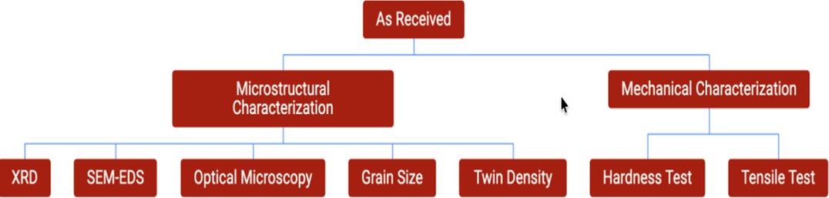

Fig. 3. Schematic representation of the experimental procedure

Microstructural Characterization

3.3.1 Sample Preparation :

Specimens of certain dimensions were cut from the as received samples using Hand Cutter. Constant water was sprinkled on the sample so as to prevent microstructural changes due to high temperatures generated while cutting.
Surfaces of samples were made flat using Belt Grinder. A systematic grinding process was employed using Emery papers of increasing fineness: 220, 400, 600, 800, 1000, 1200, 1500, and 2000 grit. Emery papers were fixed on Disc polisher and samples we held against the rotating emery papers supported by water sprinkling.Alumina was used after emery papers for further smoothening of the surface. Final polishing was conducted on a rotating cloth wheel supported by water sprinkling to achieve a mirror-like finish free of scratches.
To reveal the microstructure, the polished surfaces were chemically etched using a 5% Nital solution (5 ml HCL+ 95 ml Ethanol) for approximately 10-30 seconds. This etchant preferentially attacks grain boundaries and twin boundaries, rendering them visible under reflected light.

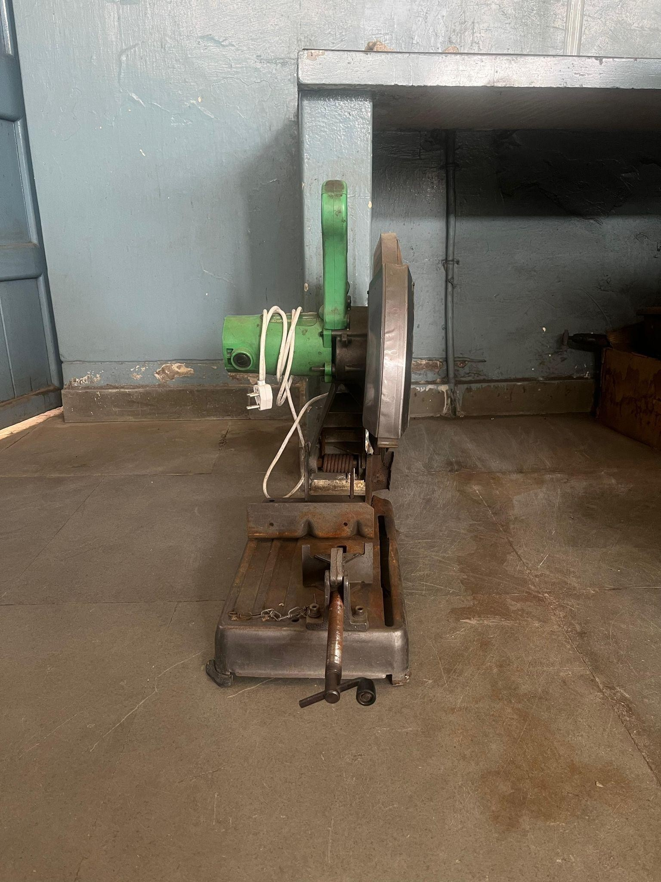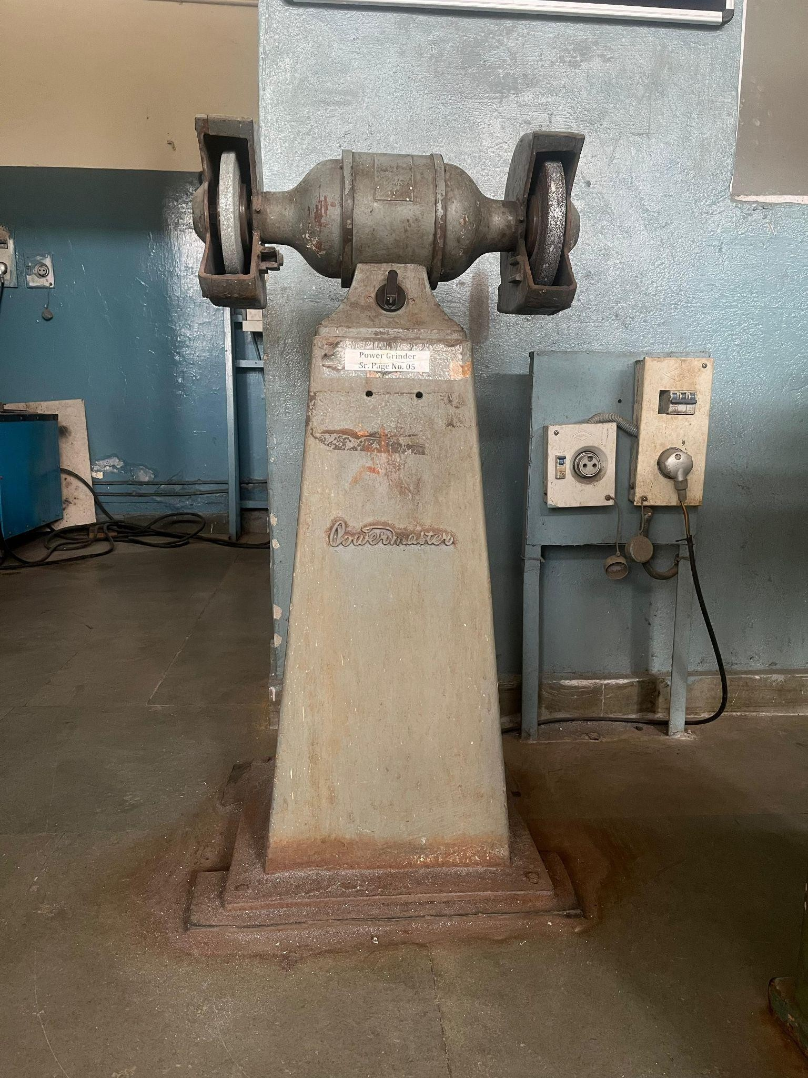
Fig - Metal Chop Saw Fig - Grinder
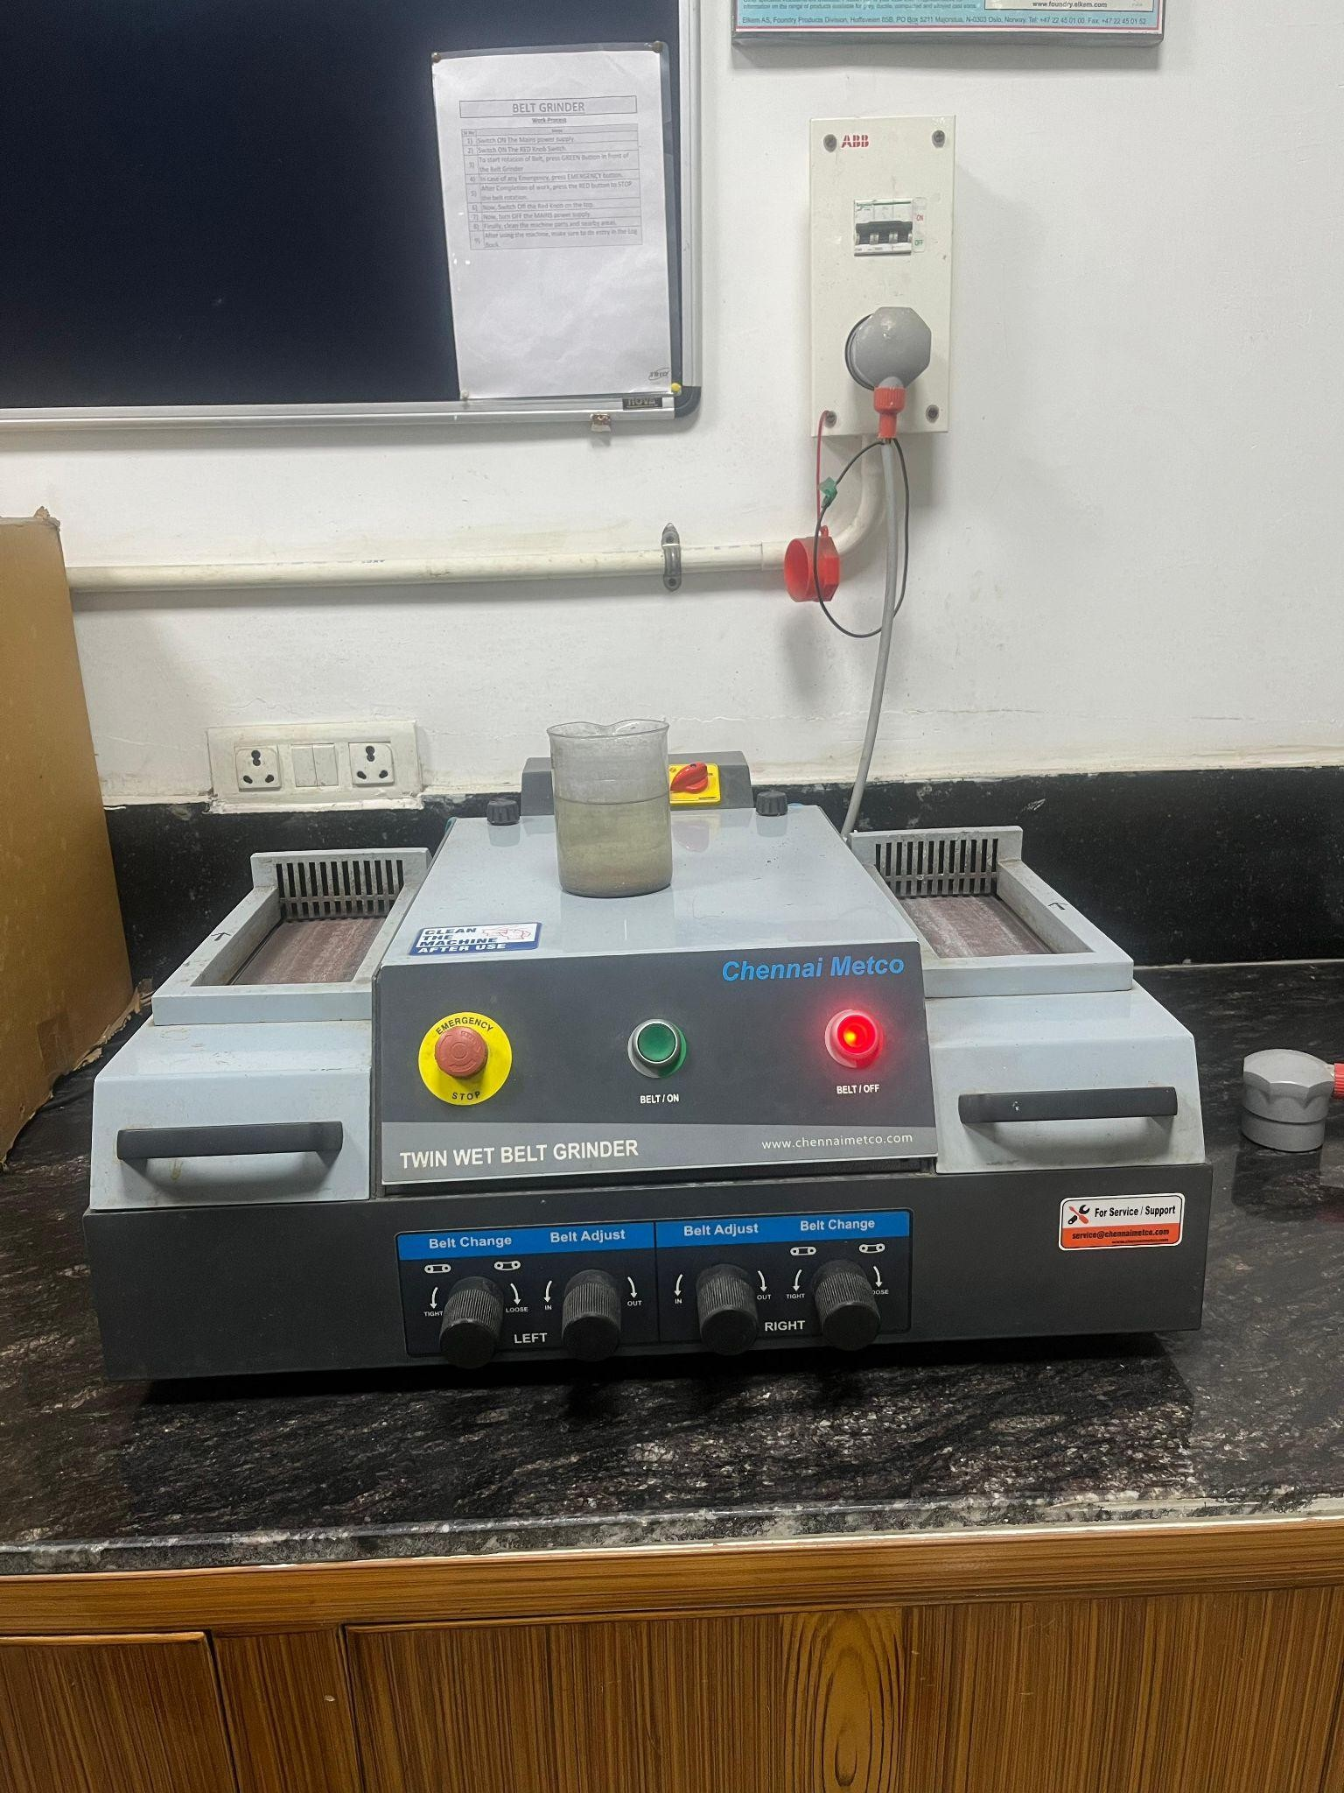

Fig - Belt Grinder Fig - Hand Cutter
Materials used in preparing samples. For cutting we used Chop saw and Hand Cutter, and for grinding and surface flattening, we used Belt Grinder.

We used Disc Polisher for material polishing with cloth and Alumina, used optical microscope for microstructure images.

Mechanical Characterization :
The polished and etched specimens, prepared earlier, were subjected to Vickers hardness testing to evaluate the mechanical hardness.

Grain Size Measurement Procedure :
Grain size of the sample was measured using the point intercept method with ImageJ software.
First, images of the sample were captured under a microscope and then imported into ImageJ for analysis. A grid of points was applied over each image, and the points that fell on the grain boundaries were carefully counted. By comparing the number of points on the boundaries with the total number of points, the average size of the grains in the sample was calculated. This method is useful because it provides a reliable estimate of grain size and allows for accurate measurement of the microstructure using digital image analysis. In addition to this, grain size can also be measured using the linear intercept method, where the average distance across the grains is measured directly. This distance is then converted into a standard grain size number using a simple formula, which helps in comparing the grain structure of different samples. Using these methods together ensures that the grain size is determined accurately and consistently, providing valuable information about the material’s properties and its microstructural features, which are important for understanding its mechanical behavior and performance in practical applications.

Hardness Measurement Procedure:
Hardness of the sample was measured using a Vickers hardness tester, which applies a controlled force to a diamond-shaped indenter pressed onto the surface of the material. The sample was first cleaned and polished to ensure a smooth surface for accurate measurement. The indenter was then pressed into the material under a specific load for a fixed time, creating a small indentation. The diagonals of the indentation were measured using a microscope attached to the tester, and the Vickers hardness number (VHN) was calculated based on the applied load and the average diagonal length. This method allows precise determination of hardness, even for small or thin samples, and provides a reliable indication of the material’s resistance to deformation. Vickers hardness testing is widely used because it can be applied to a variety of metals and alloys, and the results can be used to compare the mechanical properties of different samples or to assess the effects of treatments such as heat treatment, alloying, or rolling on material strength. The test is straightforward, repeatable, and provides detailed insight into the surface hardness and overall mechanical behavior of the material.

Twin Density Measurement Procedure:
Twin density is quantified as the number of twin boundaries per unit length or area, often reported as the mean twin spacing or the number of twins per grain, measured along defined linear traverses perpendicular to the twinning plane.Twin density of the sample was measured using the line intercept method with ImageJ software, providing a quantitative evaluation of the twinning in the microstructure. First, high-quality microstructural images of the sample were captured under an optical microscope and then imported into ImageJ for analysis. In the software, straight lines were drawn across the images at different orientations to ensure representative sampling of the microstructure. The number of twin boundaries intersecting each line was carefully counted, and the total line length and the number of intersections were used to calculate the twin density, which is expressed as the number of twins per unit length. This method is highly effective because it allows for precise, repeatable measurement of twin structures, minimizing human error through digital analysis. Twin density is an important parameter for understanding the deformation behavior and mechanical properties of metals, as the presence and distribution of twins can significantly influence strength, ductility, and work-hardening characteristics. Measuring twin density also provides insight into the effects of various processing methods, such as hot rolling, annealing, or alloying, on the microstructure.

By analyzing twin density alongside other microstructural features like grain size and phase distribution, researchers can better understand the relationship between processing, microstructure, and material performance, which is crucial for optimizing mechanical properties and designing materials for specific engineering applications. Overall, the line intercept method with ImageJ offers a reliable and efficient approach to quantify twinning,
contributing to a deeper understanding of material behavior at the microscopic level.

Results and Discussion :

Chemical Composition of as received sample
We had samples of three types consisting of 0%,0.04% and 0.06% Ce Reinforcement in High Mn Steels.

Specimen | C | Mn | Cr | Mo | Ni | Si | P | Ce | Fe
Ce-0 | 0.707 | 12.5 | 0.76 | 0.44 | 0.304 | 0.76 | 0.023 | 0 | Bal.
Ce-0.04 | 0.703 | 12.5 | 0.75 | 0.42 | 0.305 | 0.74 | 0.024 | 0.04 | Bal.
Ce-0.06 | 0.705 | 12.3 | 0.73 | 0.46 | 0.307 | 0.78 | 0.025 | 0.06 | Bal.

Phase Analysis using XRD :
Phase analysis using X-Ray Diffraction (XRD) is the process of identifying and quantifying the crystalline phases (compounds or minerals) present in a material. It works on the principle that every crystalline substance has a unique atomic structure, which produces a unique diffraction pattern—effectively a "fingerprint."

The X-ray diffraction patterns obtained for the Ce-0, Ce-0.04, and Ce-0.06 specimens are presented in the project data. All three patterns exhibit a similar profile, showing same diffraction peaks at 2(((theta)) angles corresponding to the (111), (200), (220), (311), and (222) crystallographic planes.
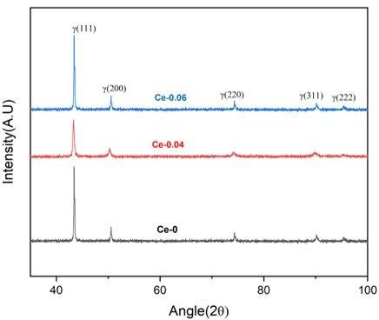

11
Austenite Stability: Indexing of these peaks confirms that the matrix is fully Austenitic. There are no detectable peaks associated with BCC ferrite. This indicates that the addition of Cerium up to 0.06 wt.% does not destabilize the austenite phase.

Hardness and Grain Size Correlation
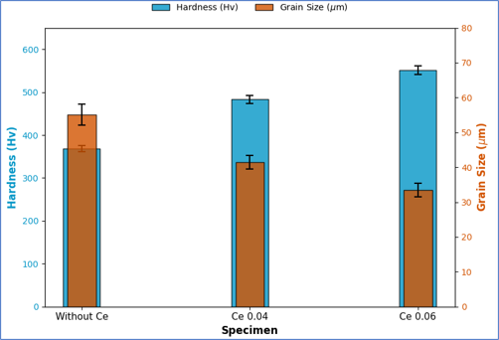
Fig : Average hardness value and average grain size of Ce-0,Ce-0.04 and Ce-0.06 specimens.

Above Figure illustrates the simultaneous variation of Vickers microhardness and average grain size for the high manganese steel specimens with varying Cerium content. A distinct inverse correlation is observed between the two parameters.
The addition of Cerium appears to promote grain boundary pinning, leading to a more uniform and slightly finer grain size distribution compared to the base alloy.

Hardness, Grain Size and Twin Density Correlation

S.No. | Specimen | Avg. Grain Size(μm) | Avg. Hardness(Hv) | Avg.Twin Density(mm-1)
1 | Ce | 55.05 + 3 | 368 + 7 | 145.71
2 | Ce-0.04 | 41.45 + 2 | 483 + 9 | 168.73
3 | Ce-0.06 | 33.43 + 2 | 552 + 10 | 187.36
Table 2 - Summary of average grain size, twin density, and Vickers microhardness for the investigated high manganese steel specimen

12
The quantitative data presented in Table 2. indicates a distinct inverse relationship between the average grain size and the mechanical microhardness. With the addition of Cerium (0 to 0.06 wt.%), the average grain size decreased significantly from 55.05 ± 3 µm to 33.43 ± 2 µm. Concurrently, the twin density exhibited a monotonic increase from 145.71 mm⁻¹ to
187.36 mm⁻¹.
The substantial increase in hardness from 368 ± 7 Hv (Ce-0) to 552 ± 10 Hv (Ce-0.06) is primarily governed by grain boundary strengthening, adhering to the classical Hall-Petch relationship:
σ_{y} = σ₀ + k.d^{(-½)}
where is the yield stress, is the friction stress, d is grain diameter and k is strengthening coefficient.

Conclusions
The following conclusions has been drawn from the above work :
- The X-ray diffraction (XRD) analysis revealed that all the developed high manganese steel specimens exhibited a stable single-phase face-centered cubic (FCC) austenitic structure. It was observed that the addition of Cerium (up to 0.06 wt.%) did not induce the formation of any deleterious secondary phases, thereby preserving the phase stability essential for cryogenic applications.
- The microstructural examination demonstrated that the reinforcement of Cerium resulted in a significant refinement of the prior-austenite grains. This refinement was attributed to the solute drag effect and the pinning of grain boundaries by Cerium-based inclusions, which
effectively restricted grain growth.
- The specimens exhibited a distinct presence of twins, wherein the twin density increased with increasing Cerium content. The extensive formation of these twins was attributed to the low Stacking Fault Energy (SFE) of the high manganese steel matrix, which energetically favors the formation of twin boundaries during the thermal processing.
- The average Vickers microhardness values increased significantly with Cerium addition. This enhancement in hardness was correlated with the Hall-Petch relationship, where the refined grain structure and the increased density of twin boundaries (Dynamic Hall-Petch effect) acted as effective barriers to dislocation motion, thereby requiring higher stress for deformation.

Future Scope :
The provided document outlines two specific areas for future research, though it does not elaborate on the specific methodologies to be used for them within this text:
- Corrosion Study: Investigation into the chemical resistance of the material.
- Tribological Study (Wear Study): Investigation into the interaction of the material surfaces in motion, specifically focusing on wear and friction.
The addition of Cerium and controlled hot-rolling can be further explored to enhance not only the mechanical properties but also the corrosion and wear resistance of high-manganese steels. Future studies may investigate the effect of varying Ce content on corrosion behavior in different environments and examine the relationship between microstructure refinement and corrosion performance. Tribological studies can evaluate how Ce-modified inclusions and hot-rolled microstructures influence wear mechanisms and friction behavior under various loads and conditions. Combining corrosion and tribology research could lead to the development of high-Mn steels with superior tribocorrosion resistance for industrial applications. Additionally, optimization of Ce content and processing parameters can help design steels with an ideal balance of strength, toughness, corrosion resistance, and wear resistance for demanding service conditions.

References :
- J. Qiu, C. Wei, N. Lv, X. Zhu, and S. Cui, "Effects of Cerium on Microstructure and Corrosion Resistance of High Manganese Steel for Liquefied Natural Gas Tank," Protection of Metals and Physical Chemistry of Surfaces, vol. 60, pp. 949–958, Oct. 2024. https://link.springer.com/article/10.1134/S2070205124702265

- M. Z. Jiang, Y. C. Yu, H. Li, X. Ren, and S. B. Wang, "Effect of Rare Earth Cerium Addition on Microstructures and Mechanical Properties of Low Carbon High Manganese Steels," High Temperature Materials and Processes, vol. 36, no. 2, pp. 145–153, 2017. https://www.researchgate.net/publication/303291261_Effect_of_Rare_Earth_Cerium_Addition
_on_Microstructures_and_Mechanical_Properties_of_Low_Carbon_High_Manganese_Steels

- J. Zhang, G. Li, H. Wang, X. Wan, M. Hu, and Y. Cao, "Effect of cerium on microstructure and microsegregation behavior of novel cryogenic high-Mn austenitic steel weld metal," Journal of Materials Research and Technology, vol. 9, no. 6, pp. 13667–13678, 2020.
https://www.sciencedirect.com/science/article/pii/S1044580322007094

- U. Gürol and S. C. Kurnaz, "Effect of Carbon and Manganese Content on the Microstructure and Mechanical Properties of High Manganese Austenitic Steel," Journal of Mining and Metallurgy, Section B: Metallurgy, vol. 56, no. 1, pp. 1–10, 2020. https://jmmab.com/wp-content/uploads/2020/08/1450-53392000009G-018.pdf

- R. Singh, S. Sharma, and S. K. Vajpai, "Effect of Reversible Cyclic Plastic Deformation and Thermal Treatment on the Microstructure and Mechanical Properties of SS304L Steel," Transactions of the Indian Institute of Metals, vol. 73, pp. 1603–1614, 2020. https://doi.org/10.1007/s12666-020-01971-3

- J. Yang, B. Xie, and M. Sun, "Cerium Addition Enhances Impact Energy Stability in S355NL Steel by Tailoring Microstructure and Inclusions," Metals, vol. 15, no. 7, p. 802, Jul. 2025. https://doi.org/10.3390/met15070802

- V. Alcántara Alza, "TWIP Steels: Mechanical and Metallurgical Properties - A Review," Journal of Multidisciplinary Engineering Science and Technology (JMEST), vol. 8, no. 1, pp. 13333–13339, Jan. 2021.
https://www.researchgate.net/publication/348945378_TWIP_Steels_Mechanical_and_Metallur gical_Properties_-A_Review

- Shri Vaibhav Metacast Pvt. Ltd. (2025). Spectrolab chemical composition analysis results [unpublished raw data], Jaipur, Rajasthan, India.

