Lesson 2 – Importing Data into Power BI

Topic: Importing Data into Power BI
Prerequisites: Download Sales_Data.csv

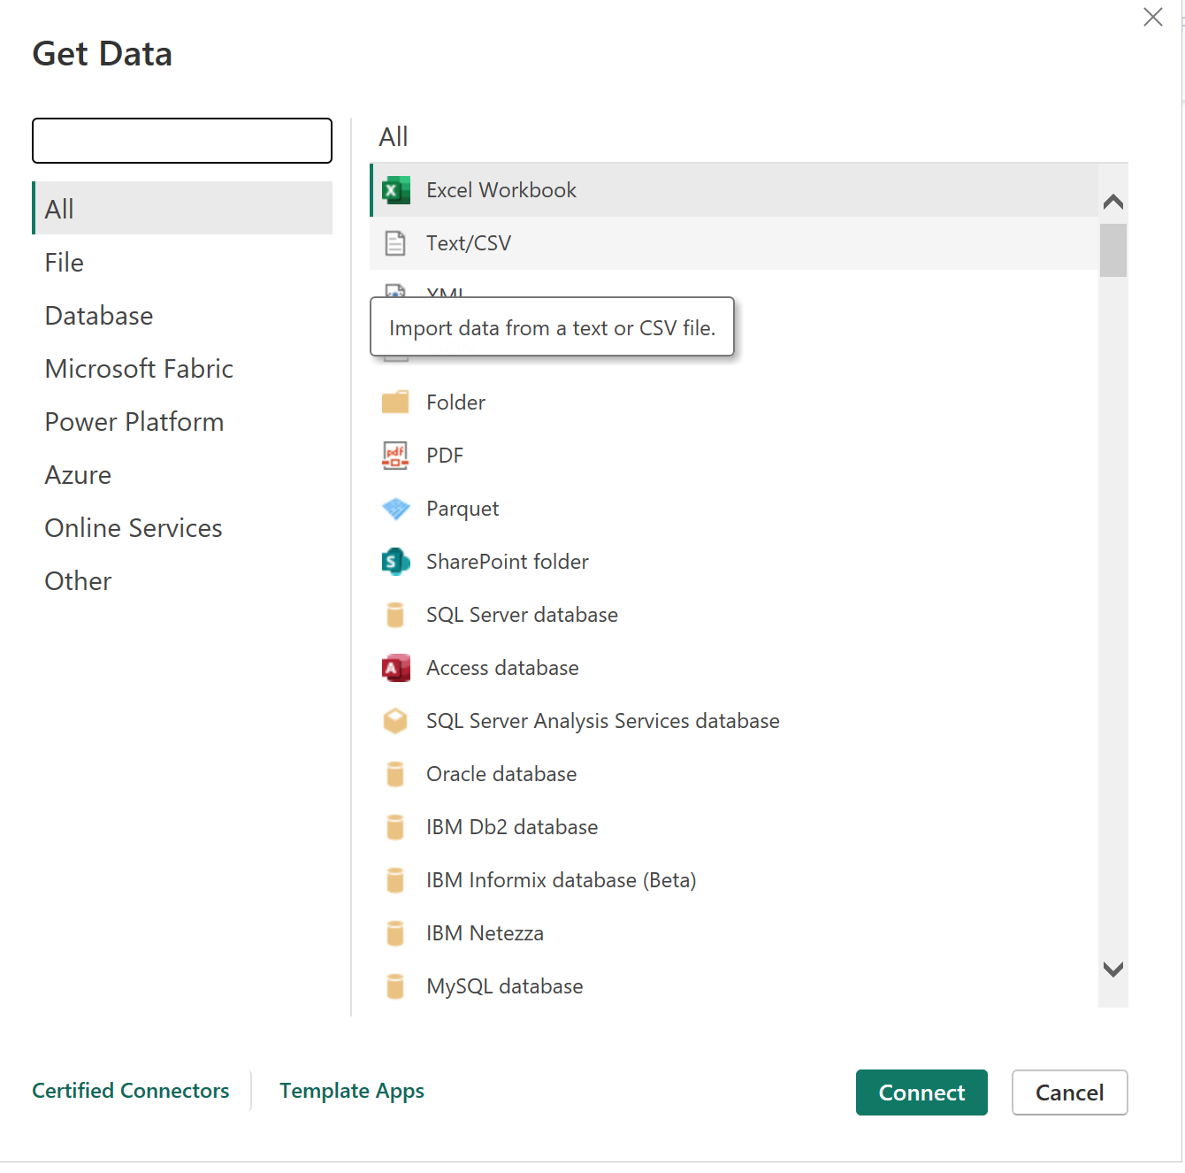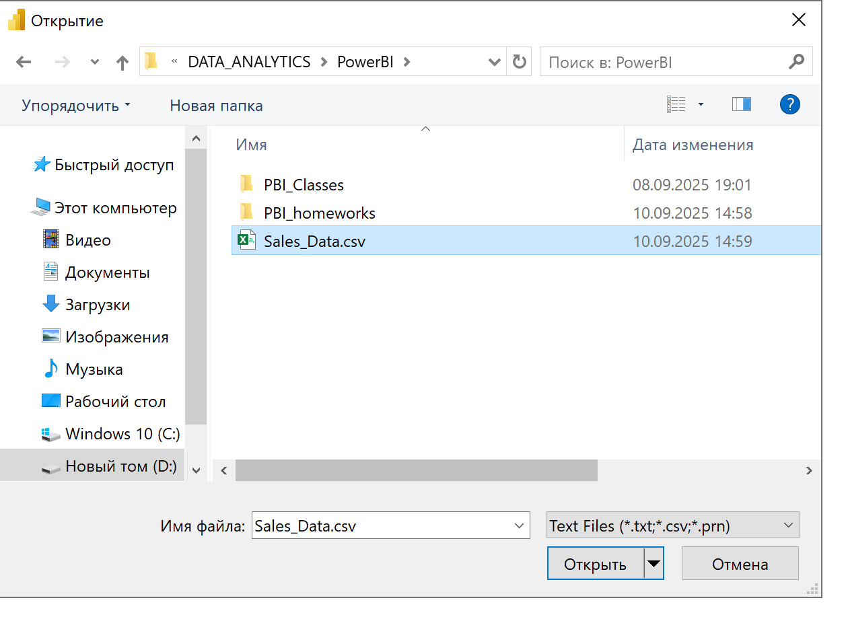

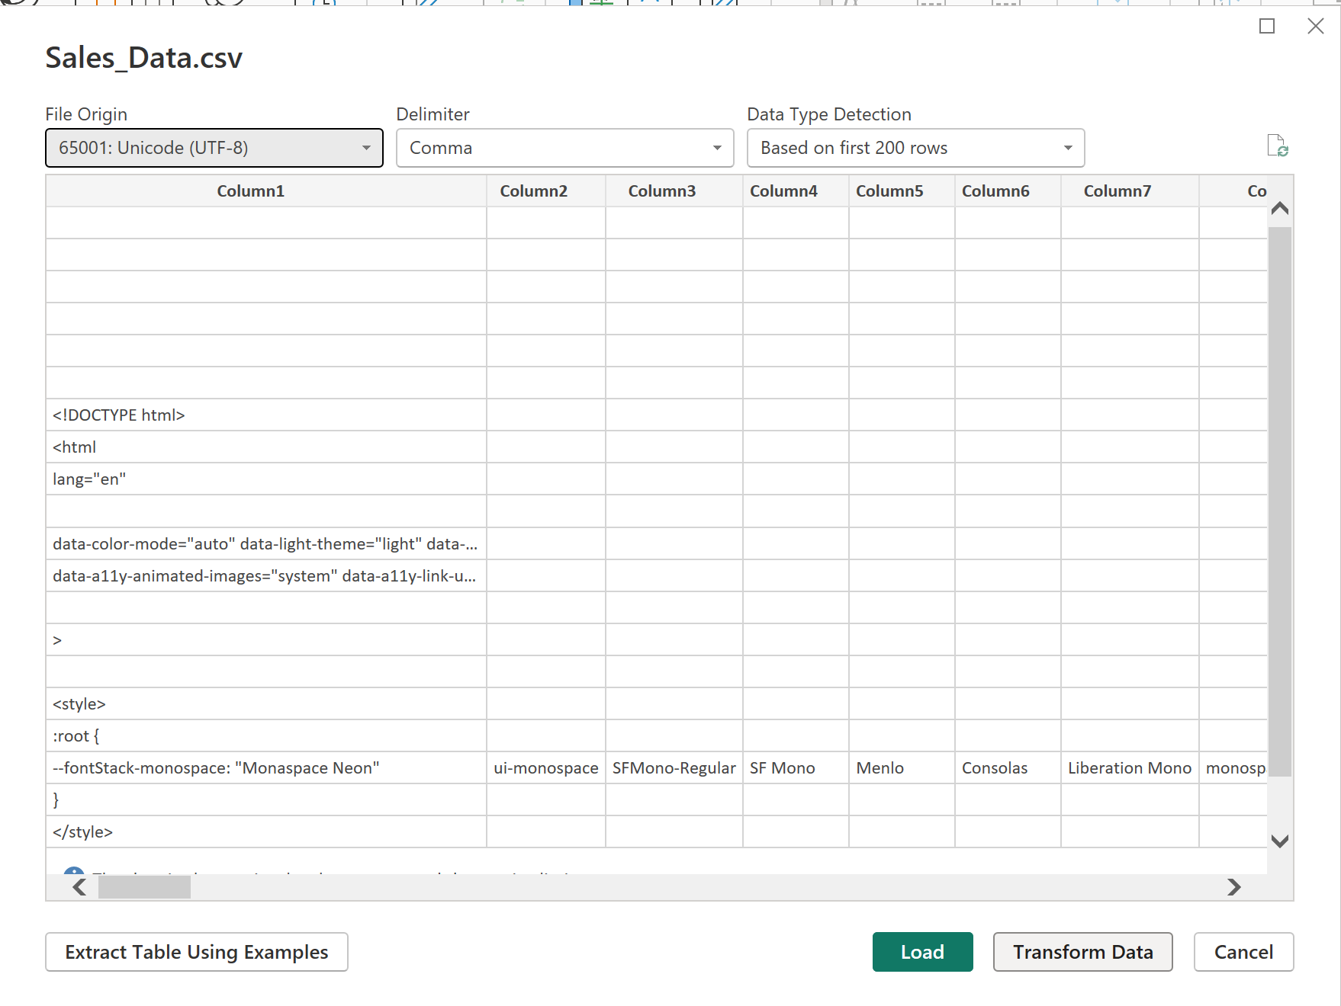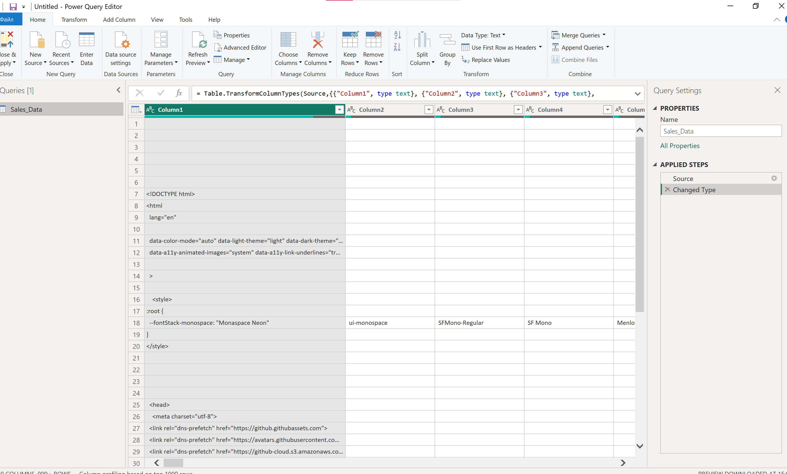

1. List three data sources Power BI can connect to.
- Excel
- SQL Server
- Web (API / website)
(Other examples: SharePoint, Oracle, JSON, CSV, Azure, etc.)

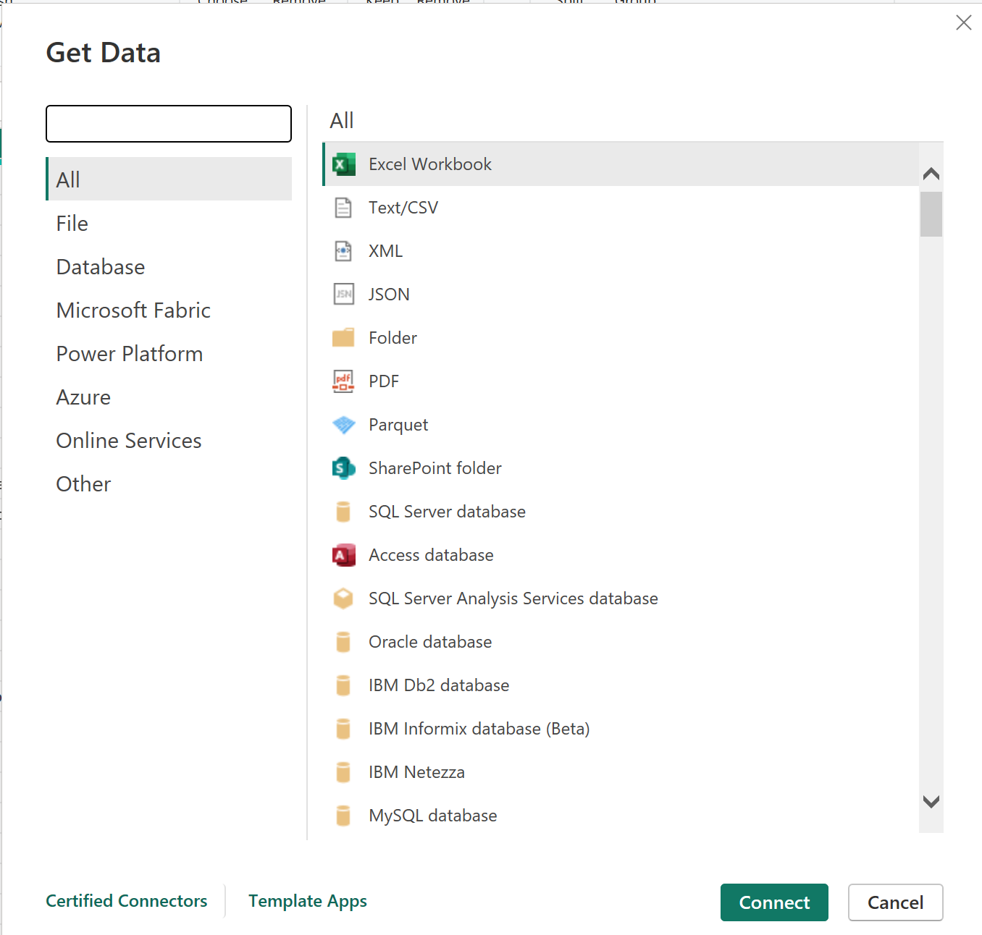

2. What is the first step to import data into Power BI Desktop?
Open Power BI → Home → Get Data → select a data source.

3. How do you refresh imported data in Power BI?
On the ribbon → Home → Refresh (or press Ctrl+R).

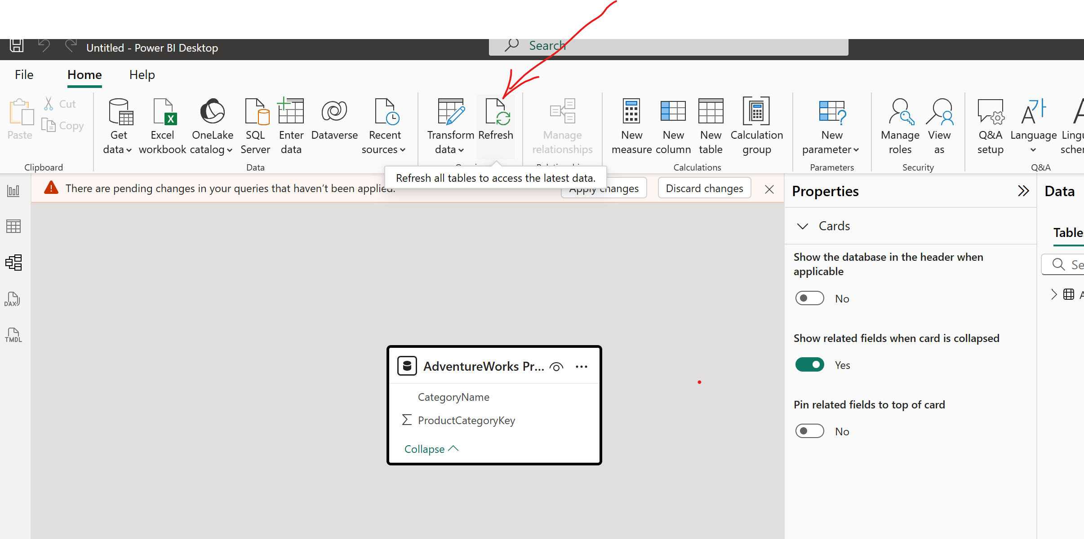

4. What file formats can Power BI import directly? (Name two.)
- .csv
- .xlsx
(Also JSON, XML, txt, etc.)

5. What does the "Navigator" window show after selecting a data source?
It displays a list of tables/sheets/objects available for loading.

6. Import Sales_Data.csv and load only the "Product" and "Price" columns.
In Power Query Editor → select the required columns → Remove Other Columns → Close & Load.

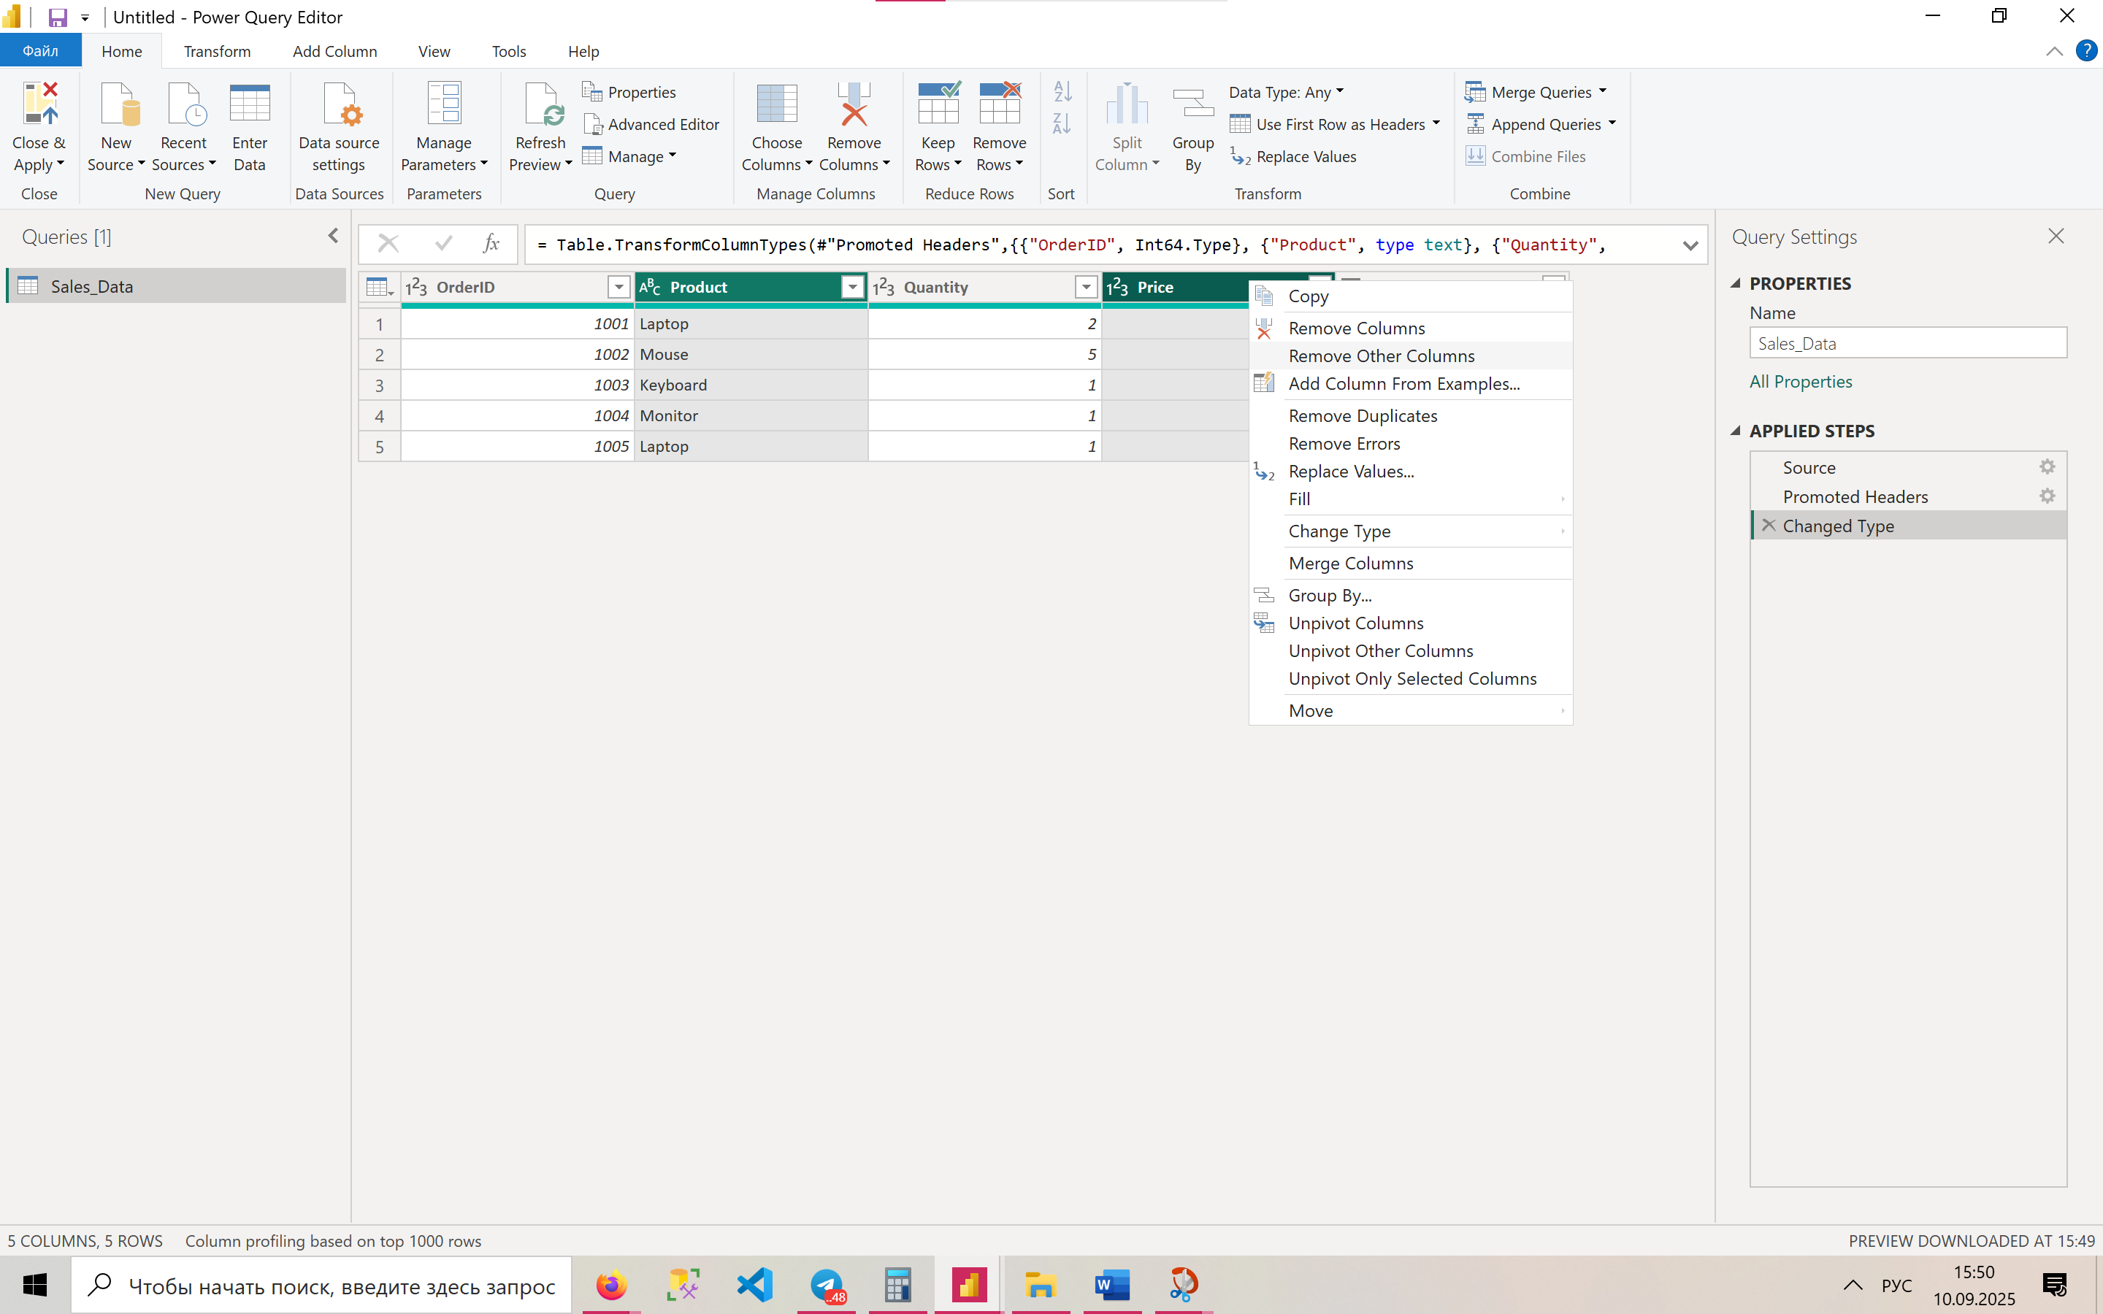

7. How would you change OrderDate to a date format during import?
In Power Query Editor:
- Select the OrderDate column
- In the Data Type menu choose Date

8. What is the difference between "Load" and "Transform Data" in the import dialog?
- Load – immediately loads the data into the model without changes.
- Transform Data – opens Power Query Editor to clean and prepare data.

9. Why might you see an error when connecting to a SQL database? (Name one reason.)
- Incorrect login/password
- No access rights to the server
- Firewall blocking the connection

10. How do you replace a data source after importing it?
Go to Power Query Editor → Home → Data source settings → Change Source.

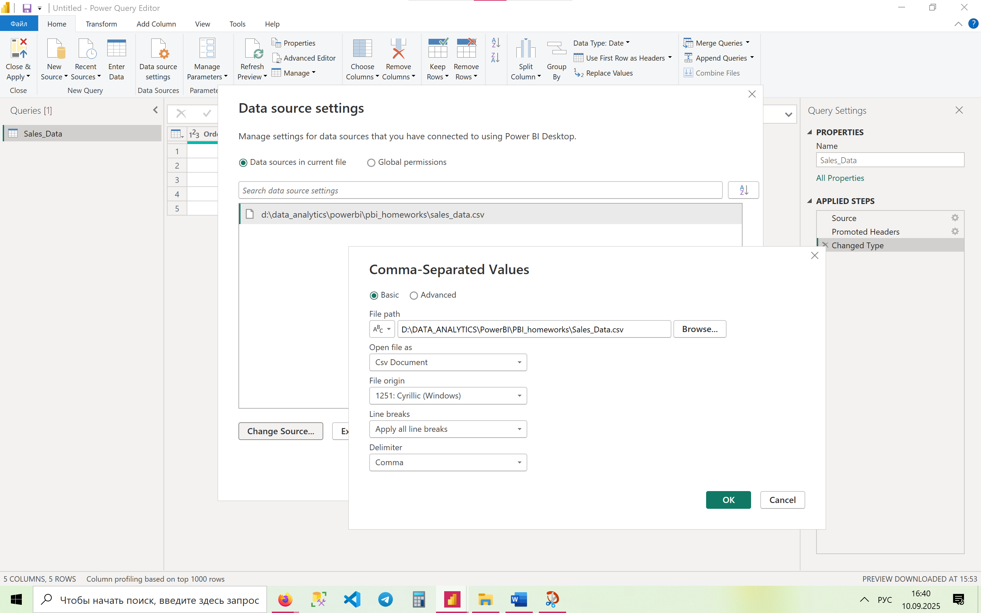

11. Write the M-code to import only rows where Quantity > 1.

let
Source = Csv.Document(File.Contents("C:\Sales_Data.csv"), [Delimiter=",", Columns=5, Encoding=65001, QuoteStyle=QuoteStyle.None]),
PromotedHeaders = Table.PromoteHeaders(Source, [PromoteAllScalars=true]),
ChangedType = Table.TransformColumnTypes(PromotedHeaders, {{"OrderID", Int64.Type}, {"Product", type text}, {"Quantity", Int64.Type}, {"Price", Int64.Type}, {"OrderDate", type date}}),
FilteredRows = Table.SelectRows(ChangedType, each [Quantity] > 1)
In FilteredRows

12. How would you change the data source if Sales_Data.csv changed?
Through Data source settings → Change Source and point to the new file path.

13. Troubleshoot: Your CSV import fails due to a "mixed data type" error—how do you fix it?
- In Power Query → select the column → Change Type to the correct type (e.g., Text or Number).
- If values are inconsistent → replace or remove invalid rows.

14. Connect to a live SQL database with parameters (e.g., filter by year).
In Power Query you can define a parameter:
let
YearParam = 2023,
Source = Sql.Database("ServerName", "DatabaseName"),
SalesTable = Source{[Schema="dbo",Item="Sales"]}[Data],
FilteredRows = Table.SelectRows(SalesTable, each Date.Year([OrderDate]) = YearParam)
in
FilteredRows

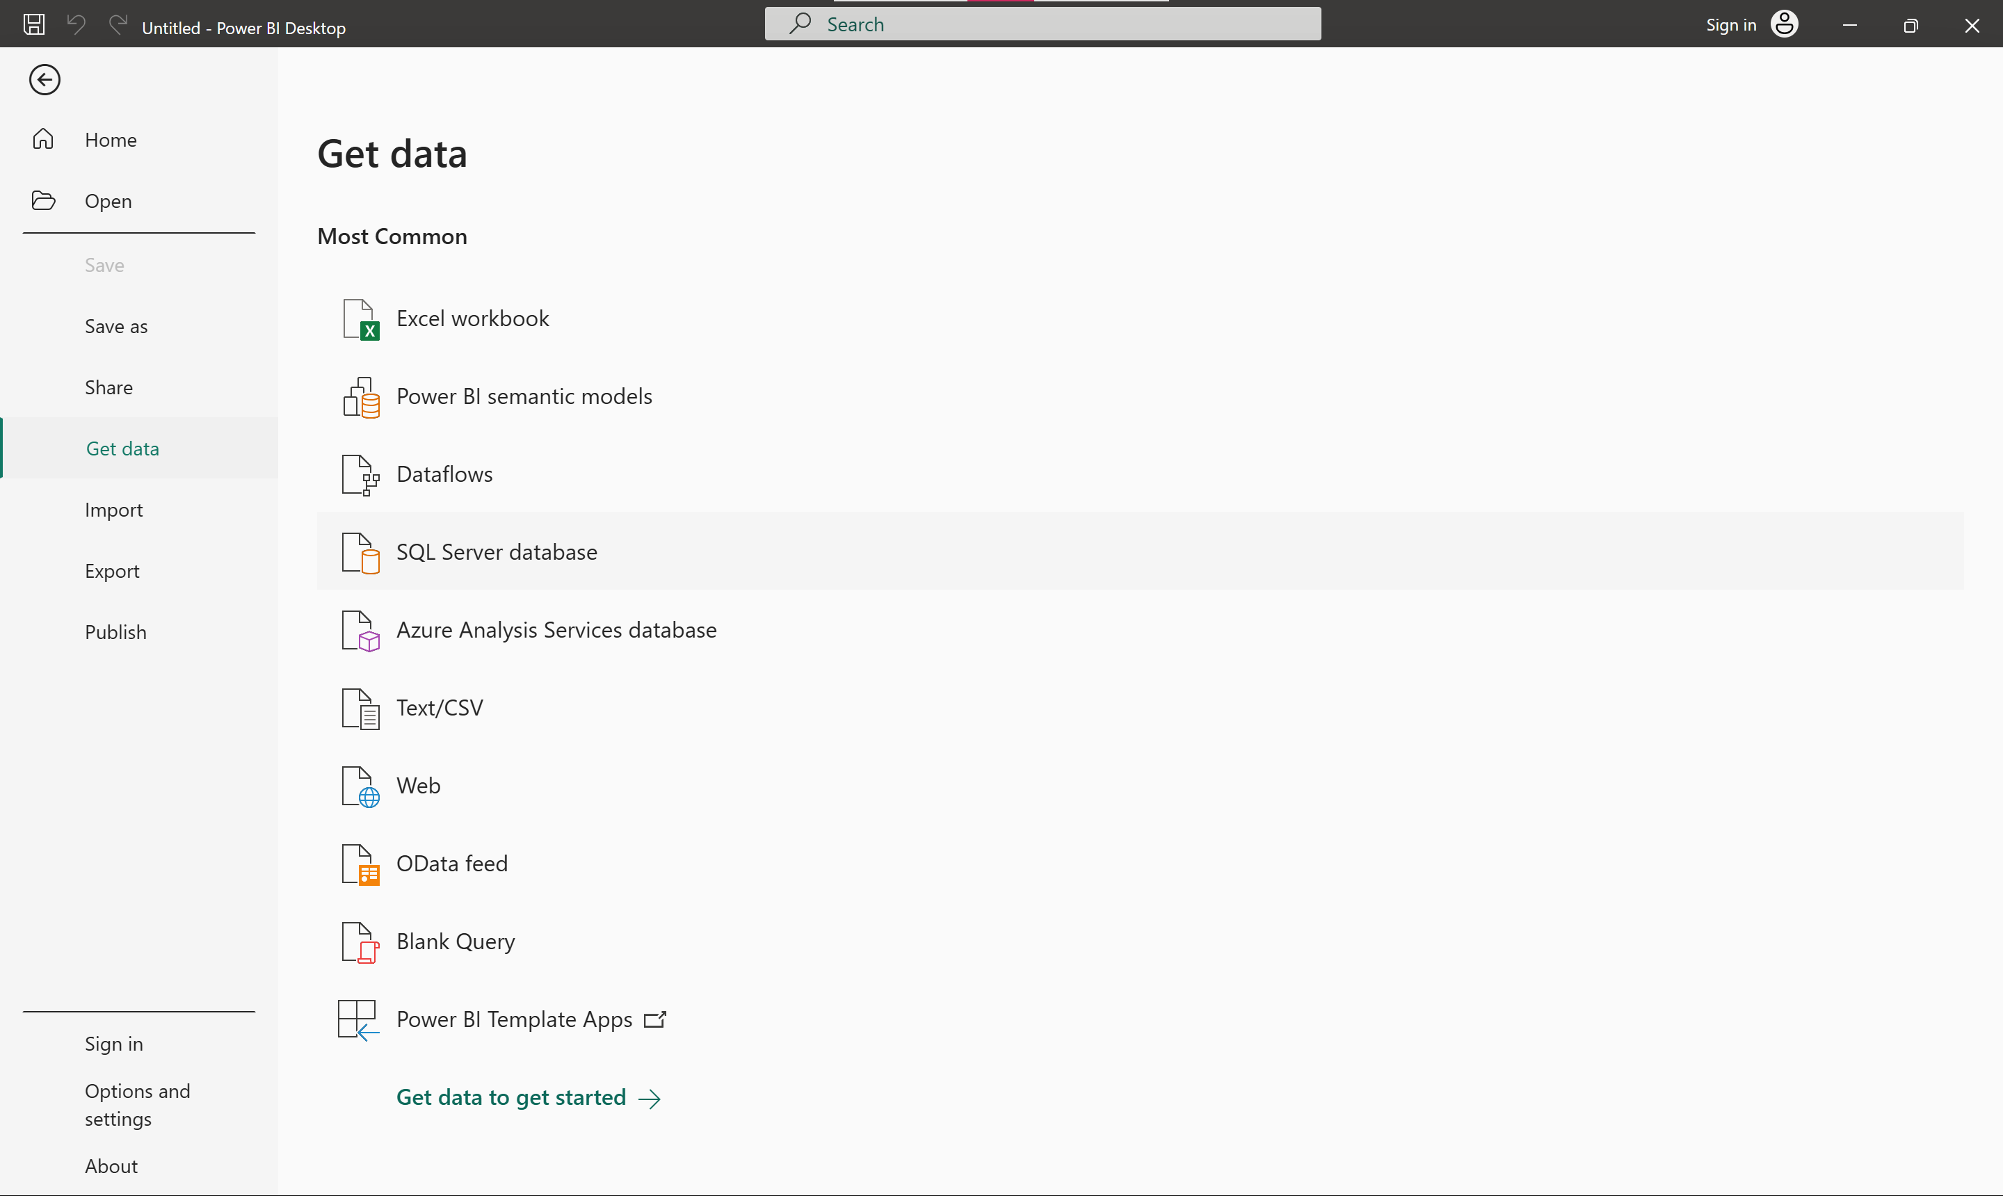

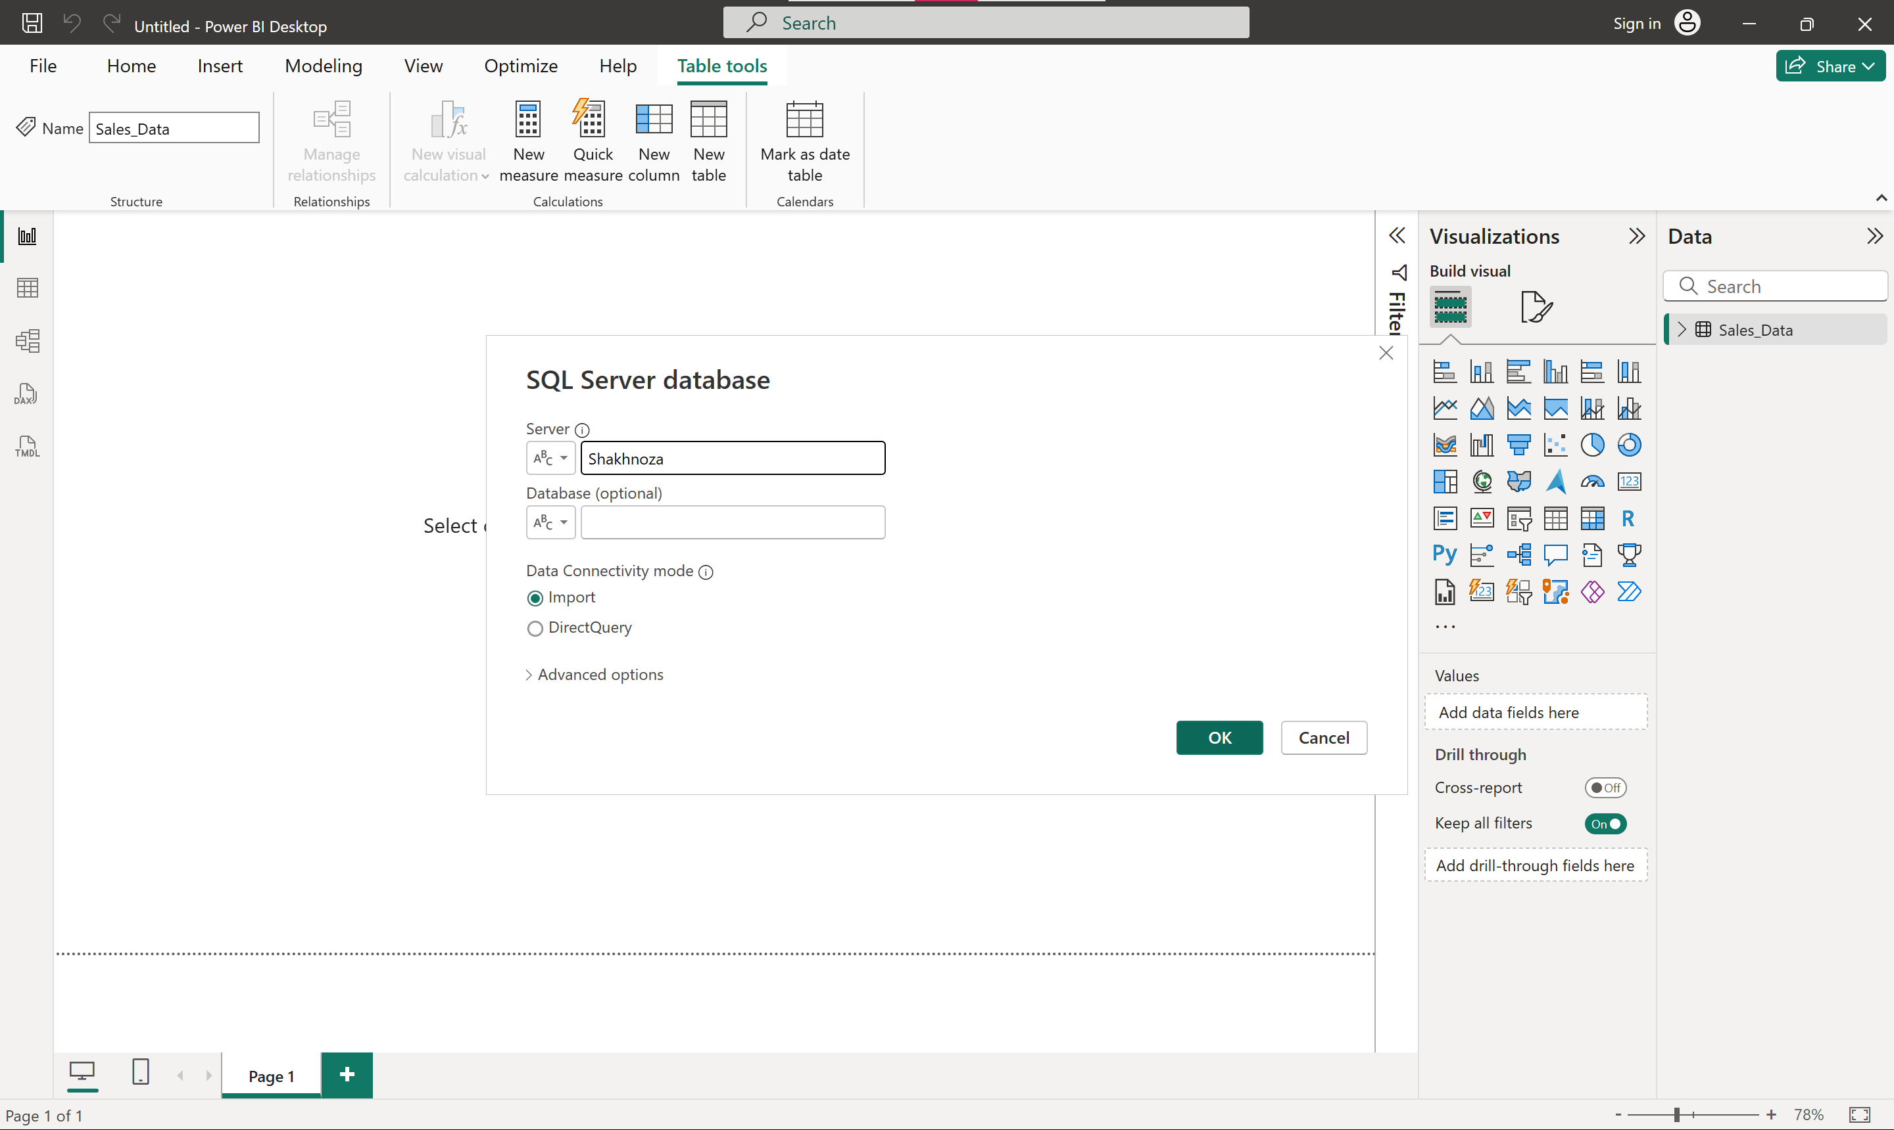

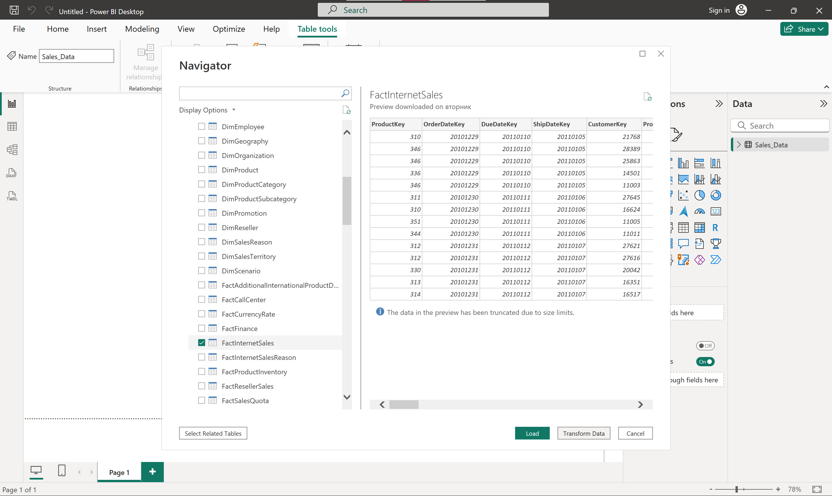

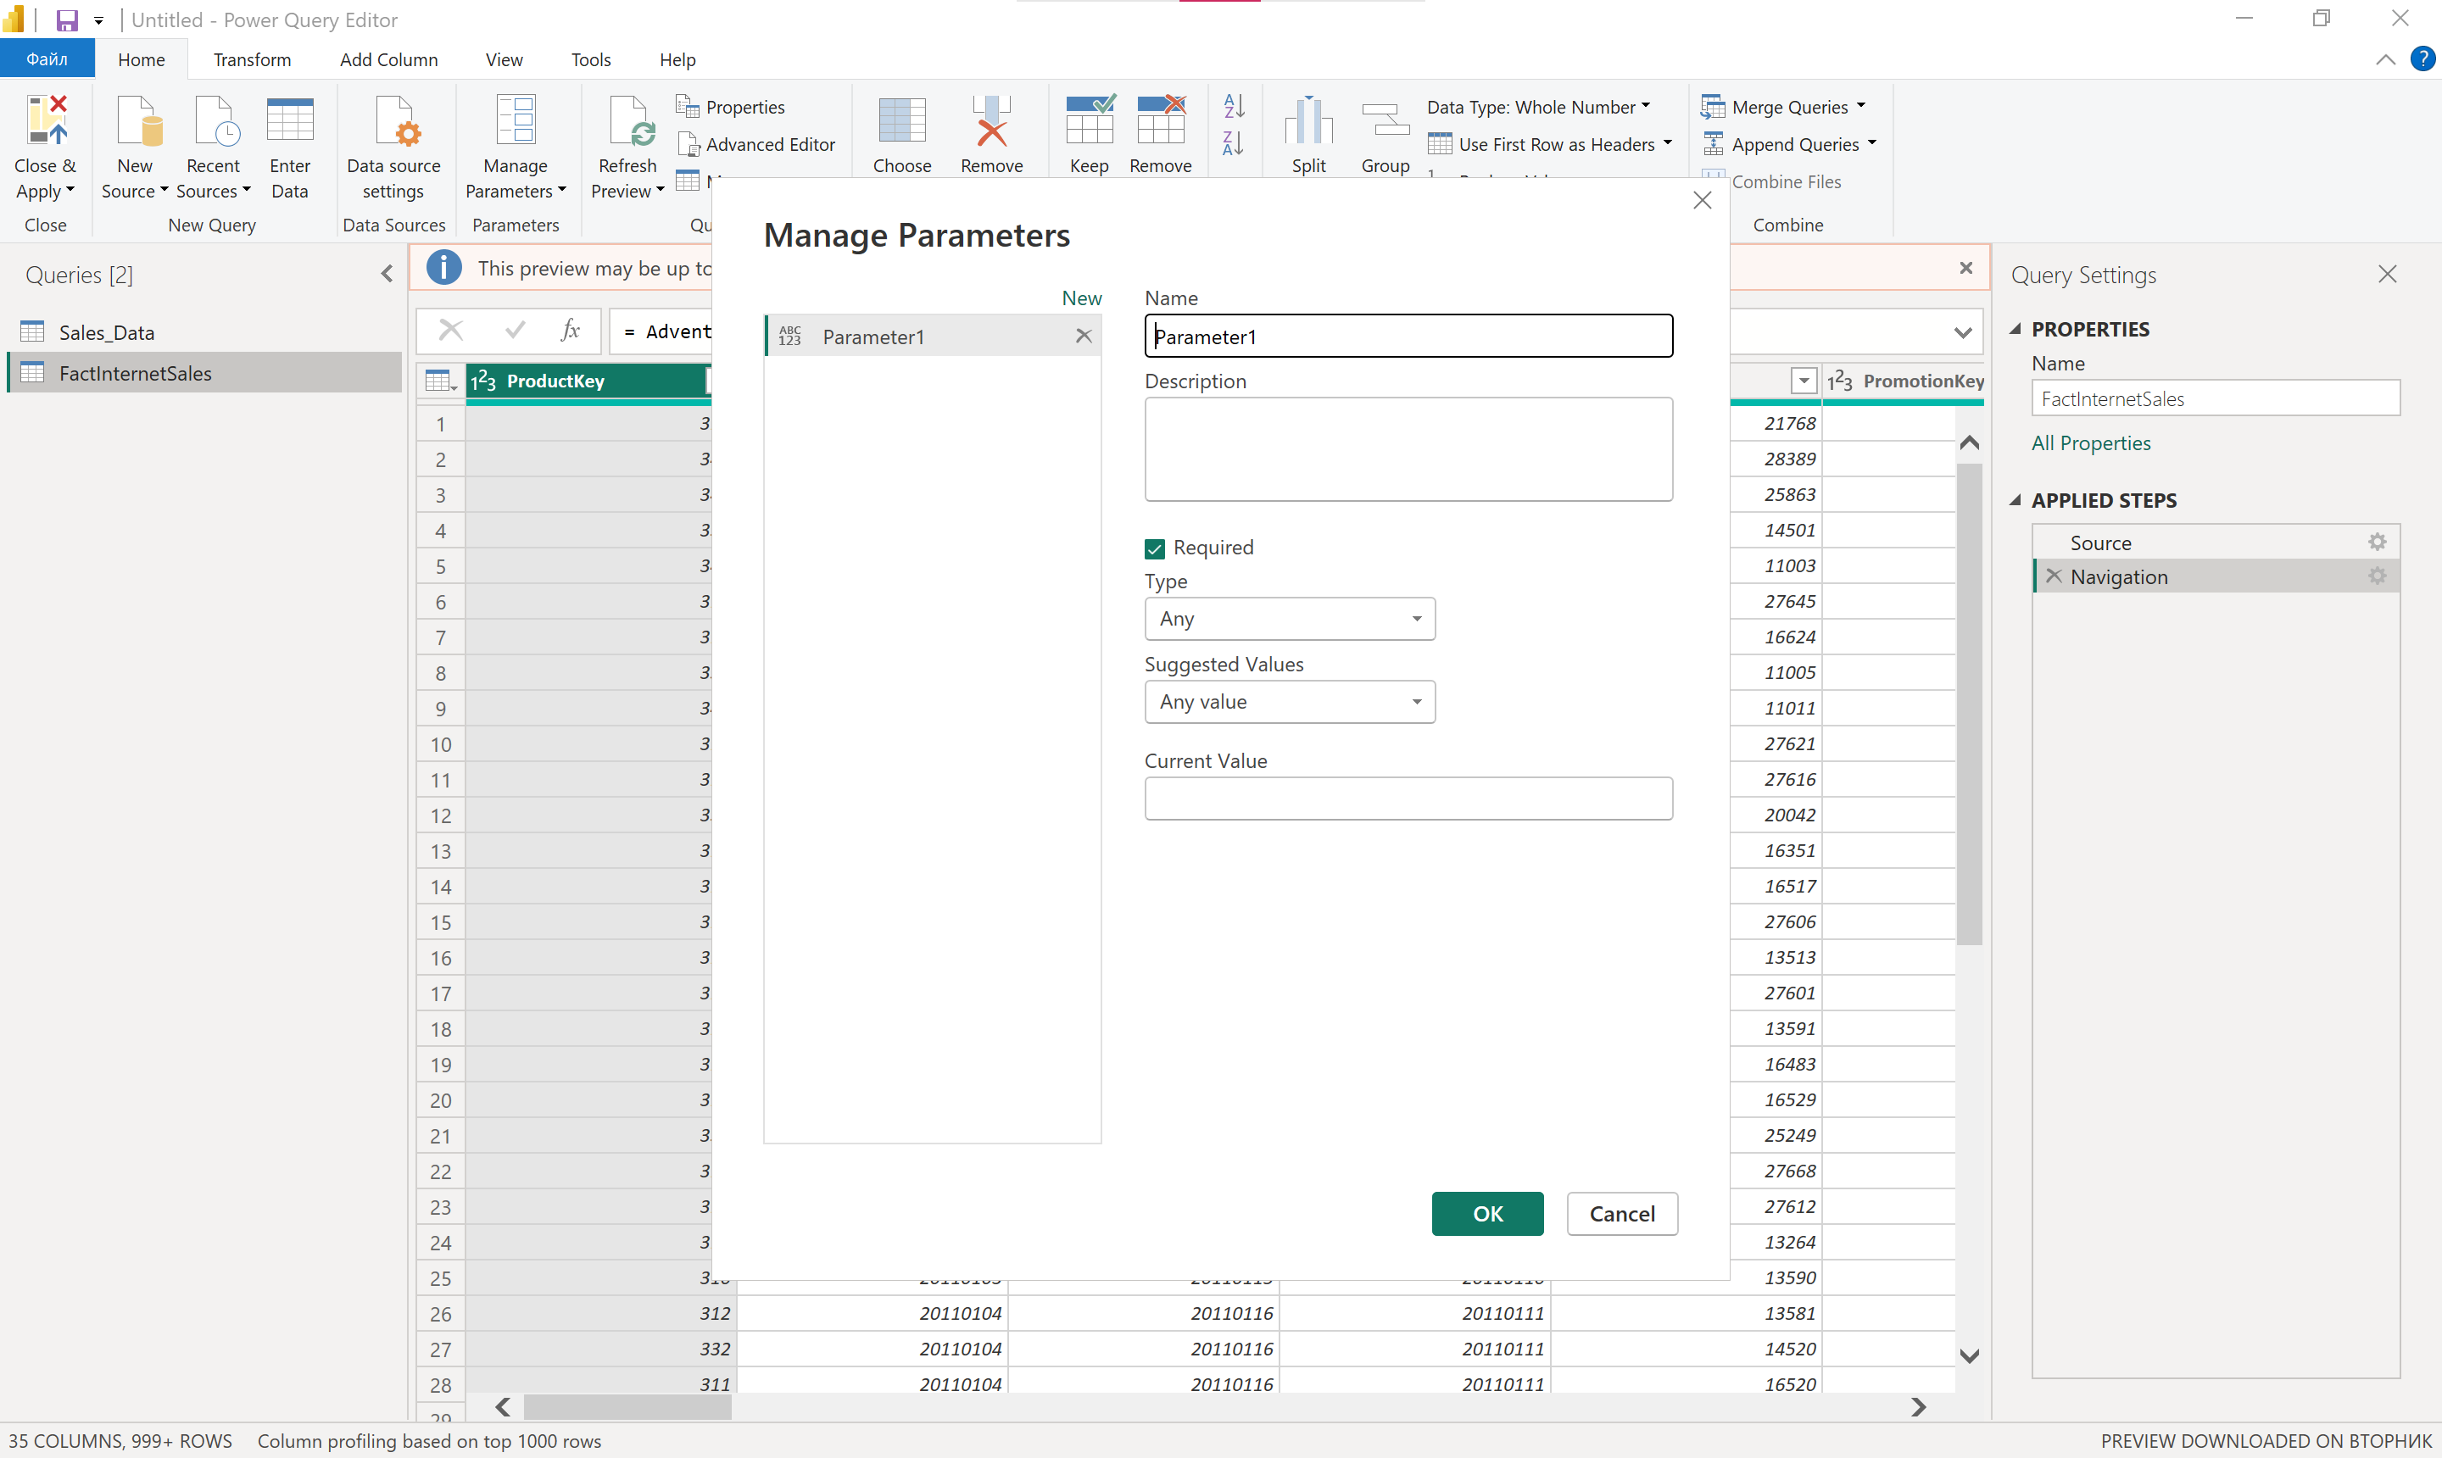
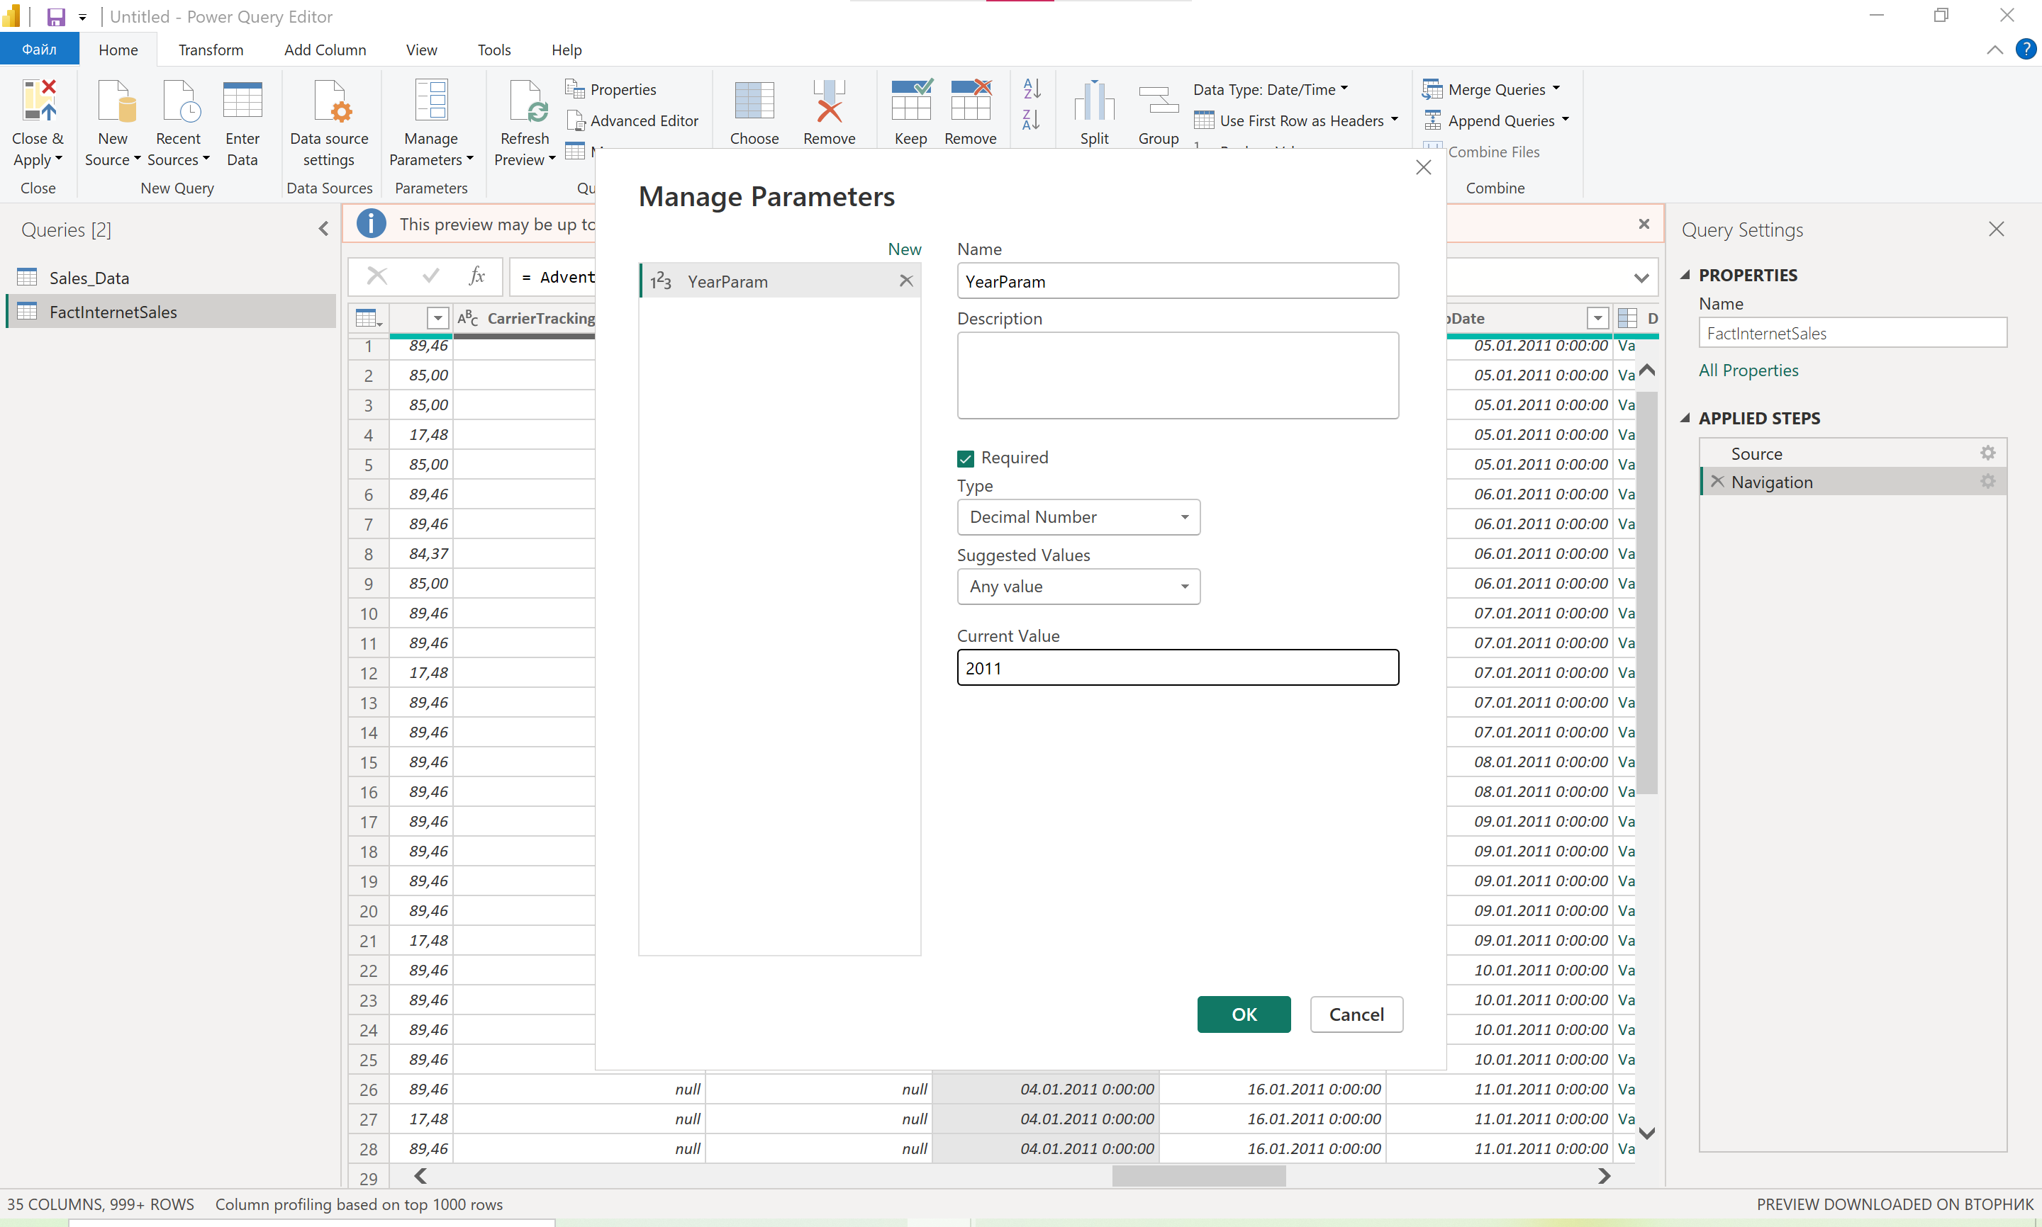

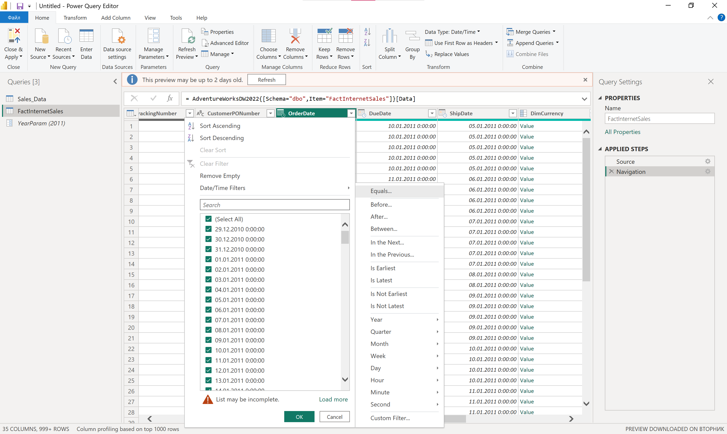

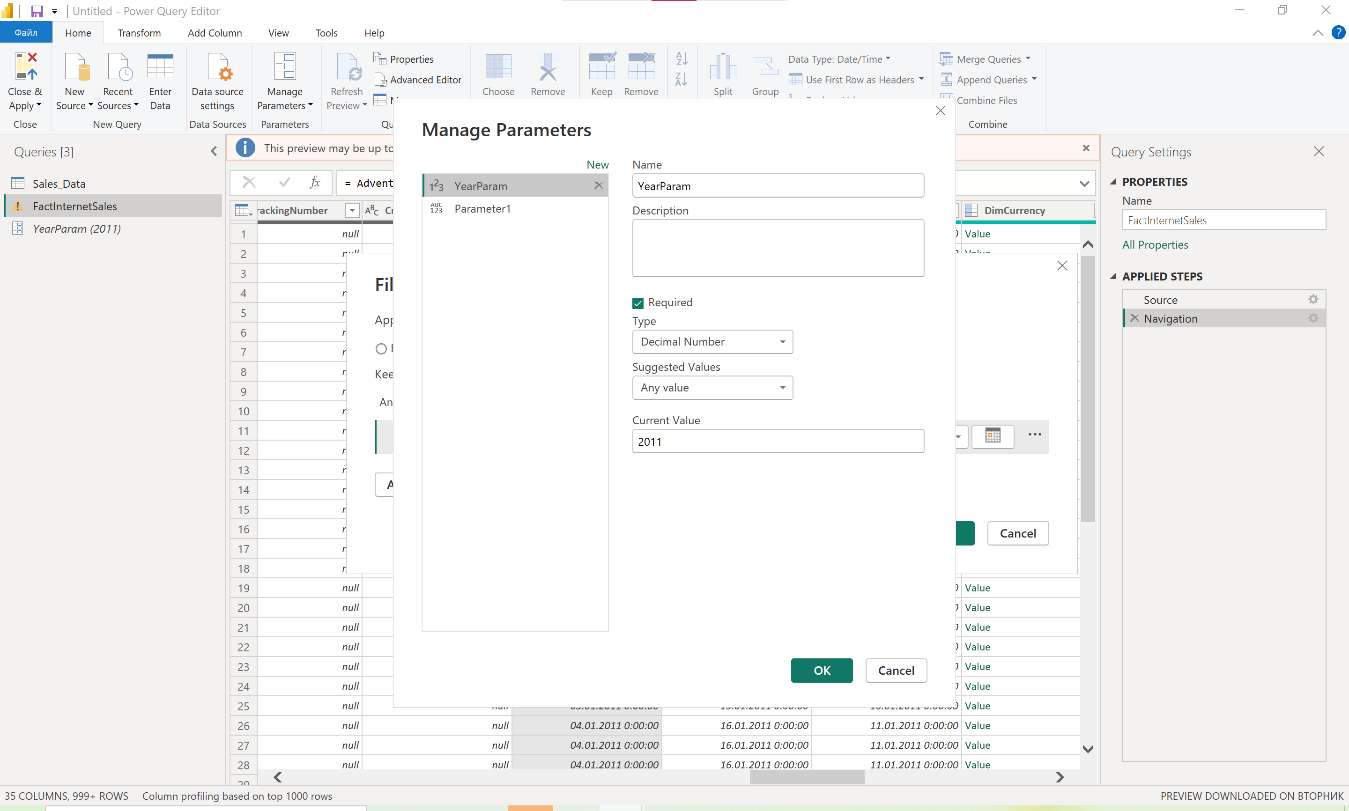

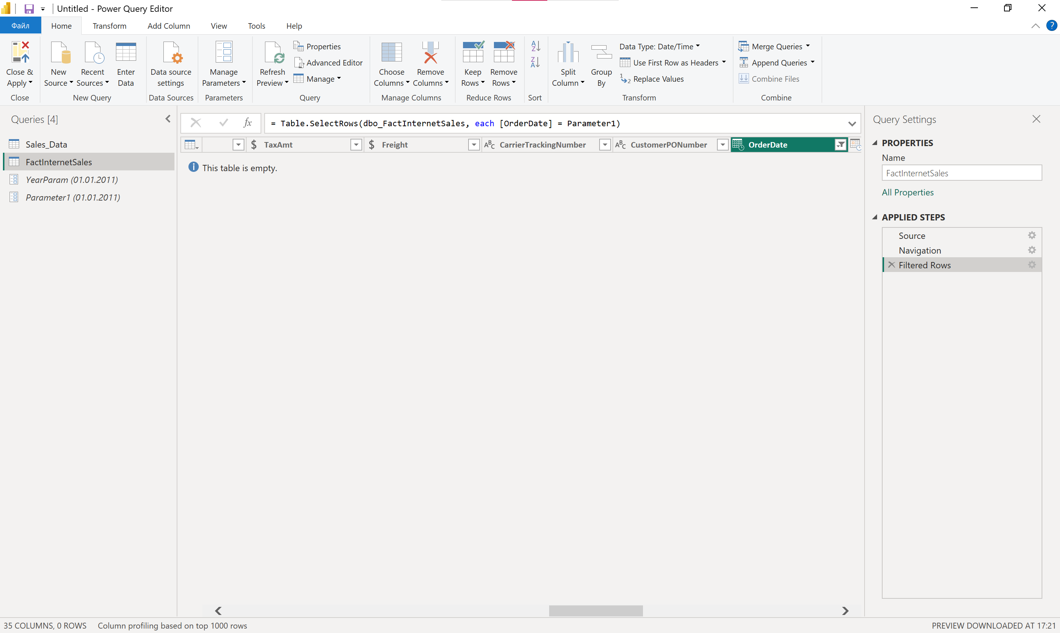

15. How would you automate data imports using Power BI and Power Automate?
- Publish the report to Power BI Service.
- In Power Automate create a Flow that triggers a Dataset Refresh on a schedule or event.

