Lesson 3

Topic: Data Transformation with Power Query (Part 1)
Prerequisites: Download Customer_Orders.txt, Orders.txt

Theory Questions

- What is the purpose of the "Applied Steps" pane in Power Query?
It records every transformation you apply (remove columns, filter, split, etc.). It works like a history list of steps, which you can edit, reorder, or delete.

- How do you remove duplicate rows in Power Query?
  - Select the column(s) you want to check for duplicates.
  - Go to Home → Remove Rows → Remove Duplicates.

- What does the "Filter" icon do in Power Query?
It allows you to filter rows based on values (text, number ranges, dates, etc.), just like filtering in Excel.
- How would you rename a column from "CustID" to "CustomerID"?
  - Right-click the column header → Rename → type CustomerID.
  - Or use Transform → Rename.
- What happens if you click "Close & Apply" in Power Query?
→ All transformations are saved and loaded into Power BI’s Data Model.

- Remove all rows where Quantity is less than 2.
📂 File: Orders.txt (column Quantity)
- Select Quantity → Filter → Number Filters → Greater Than or Equal To 2.
M-code:
Table.SelectRows(Orders, each [Quantity] >= 2)

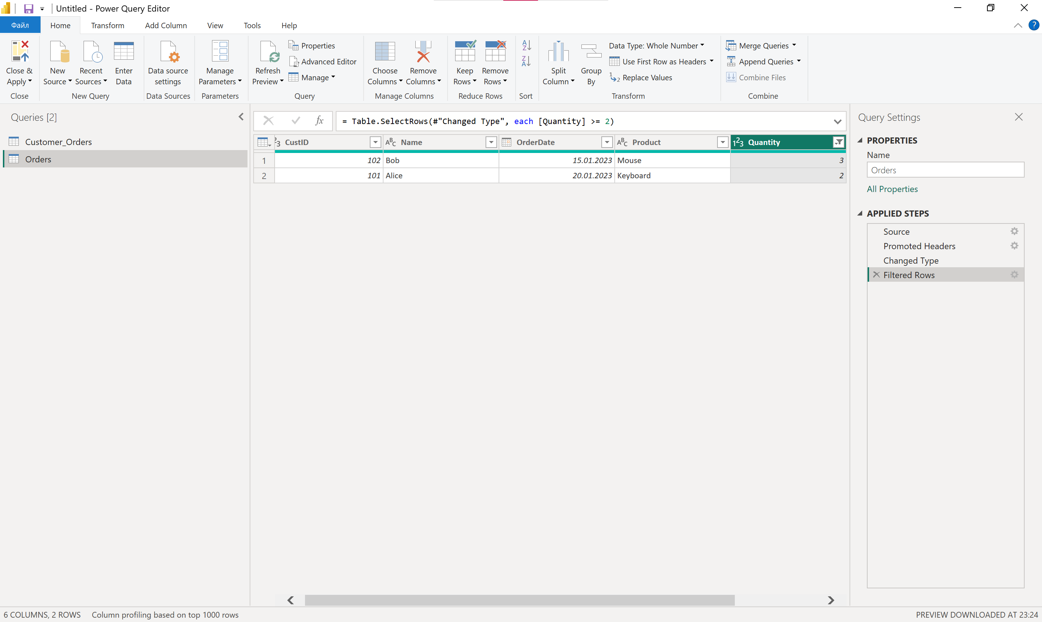

7. Split the OrderDate column into "Year," "Month," and "Day".
📂 File: Orders.txt (есть колонка OrderDate)
- Select OrderDate → Add Column → Date → Year / Month / Day.
M-code:

= Table.AddColumn(
Table.AddColumn(
Table.AddColumn(Orders, "Year", each Date.Year([OrderDate]), Int64.Type),
"Month", each Date.Month([OrderDate]), Int64.Type
),
"Day", each Date.Day([OrderDate]), Int64.Type
)

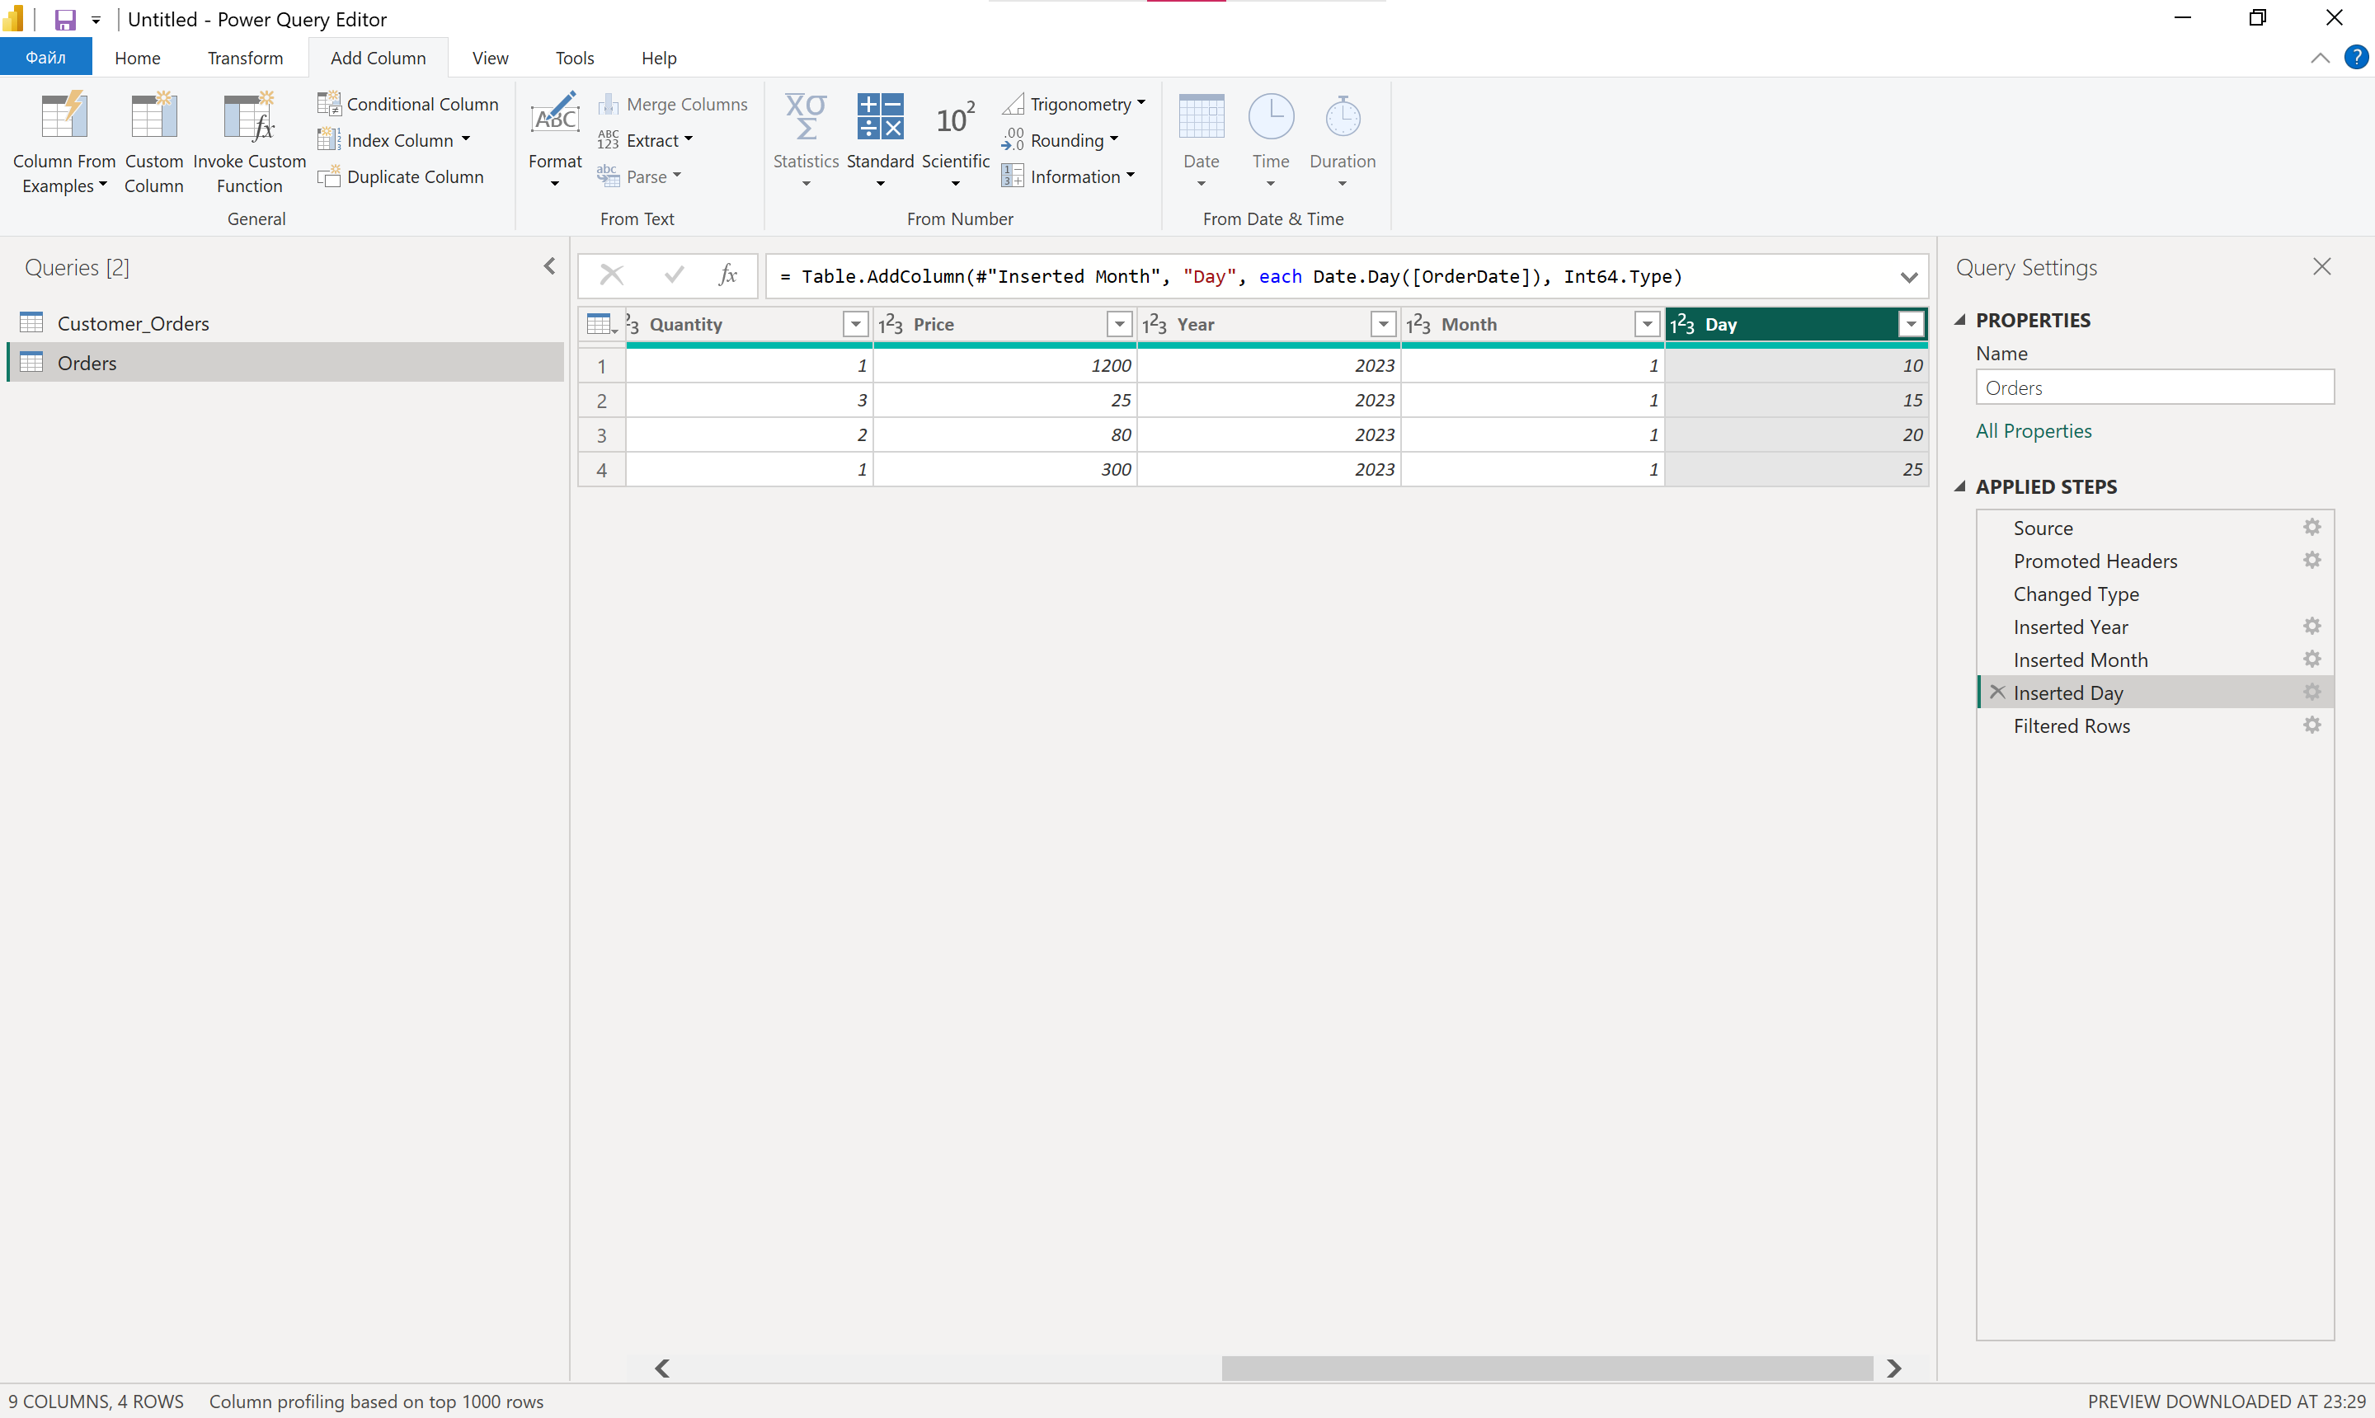

8. Replace all "Mouse" entries in the Product column with "Computer Mouse".
📂 File: Orders.txt (есть колонка Product)
- Select Product → Transform → Replace Values.
M-code:
Table.ReplaceValue(Orders, "Mouse", "Computer Mouse", Replacer.ReplaceText, {"Product"})
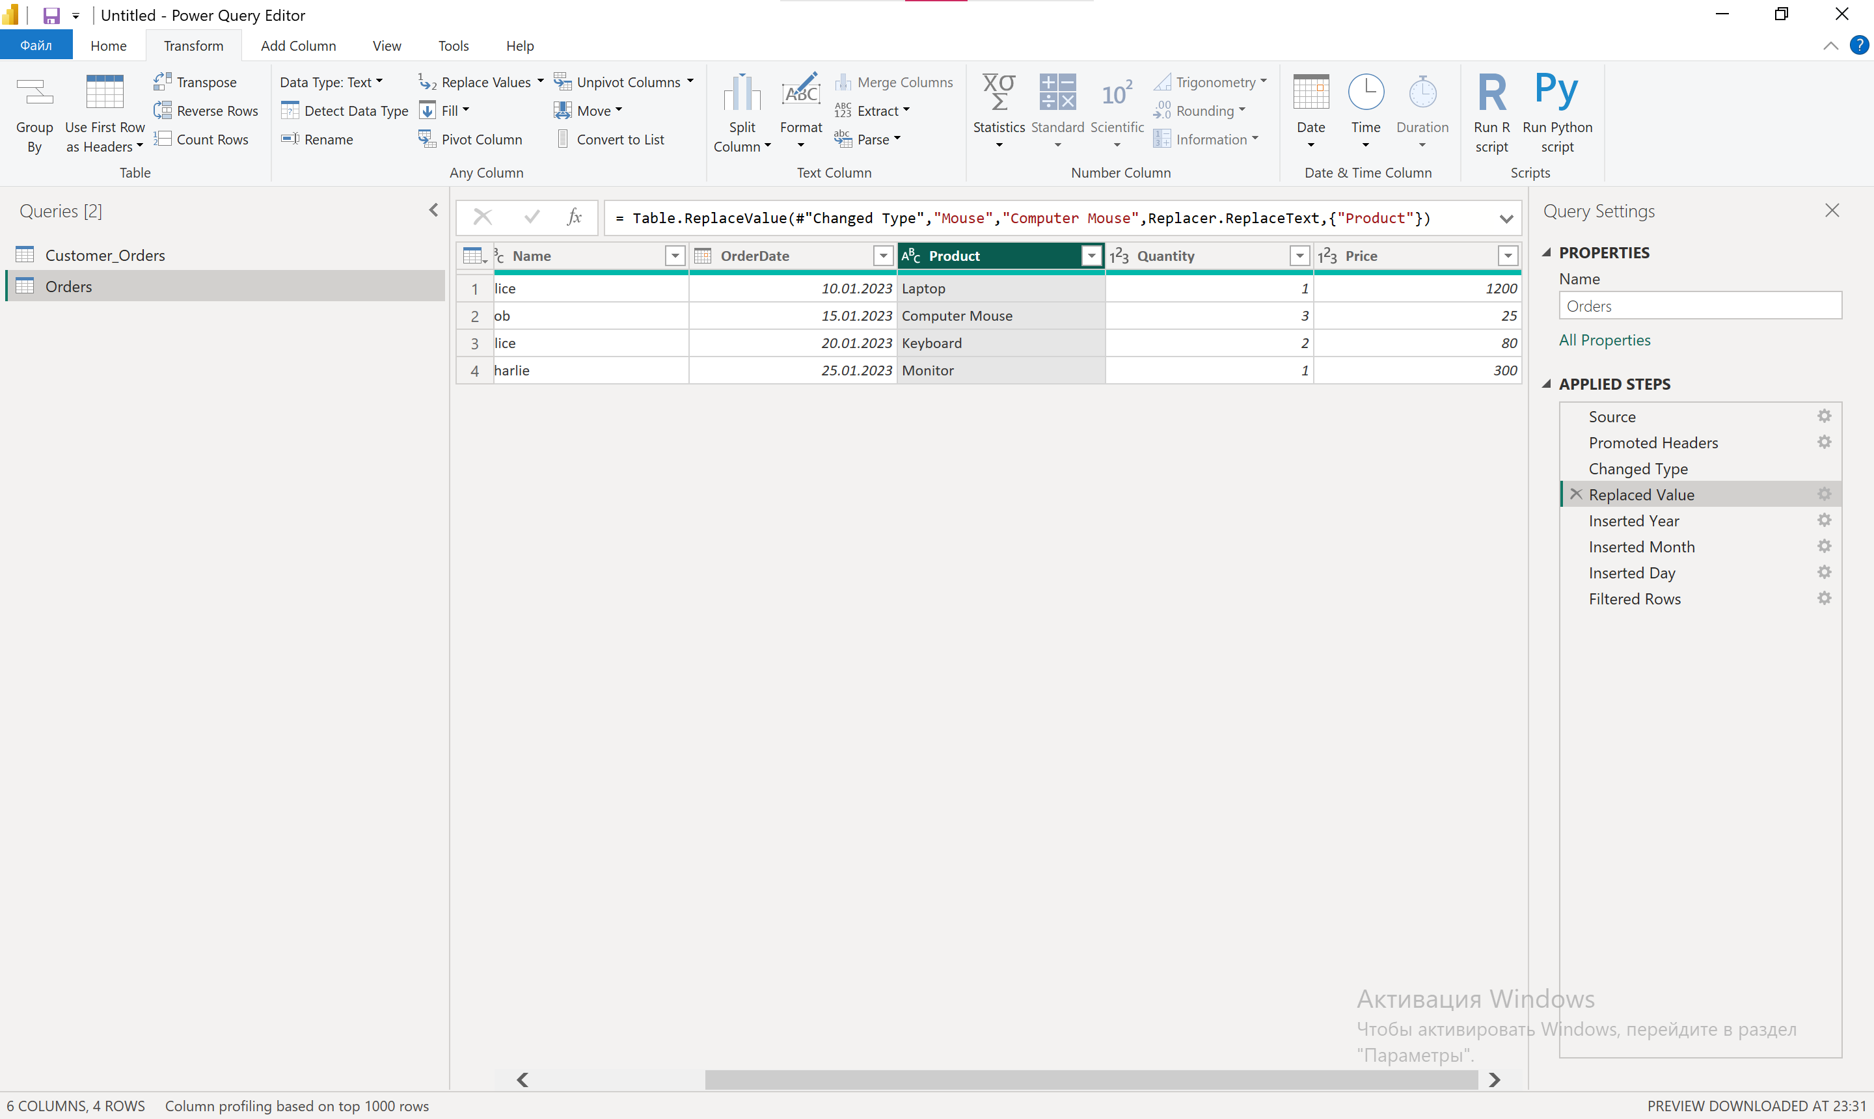

9. Sort the table by OrderDate (newest first).
📂 File: Orders.txt
- Select OrderDate → Sort Descending.
M-code:
Table.Sort(Orders, {{"OrderDate", Order.Descending}})
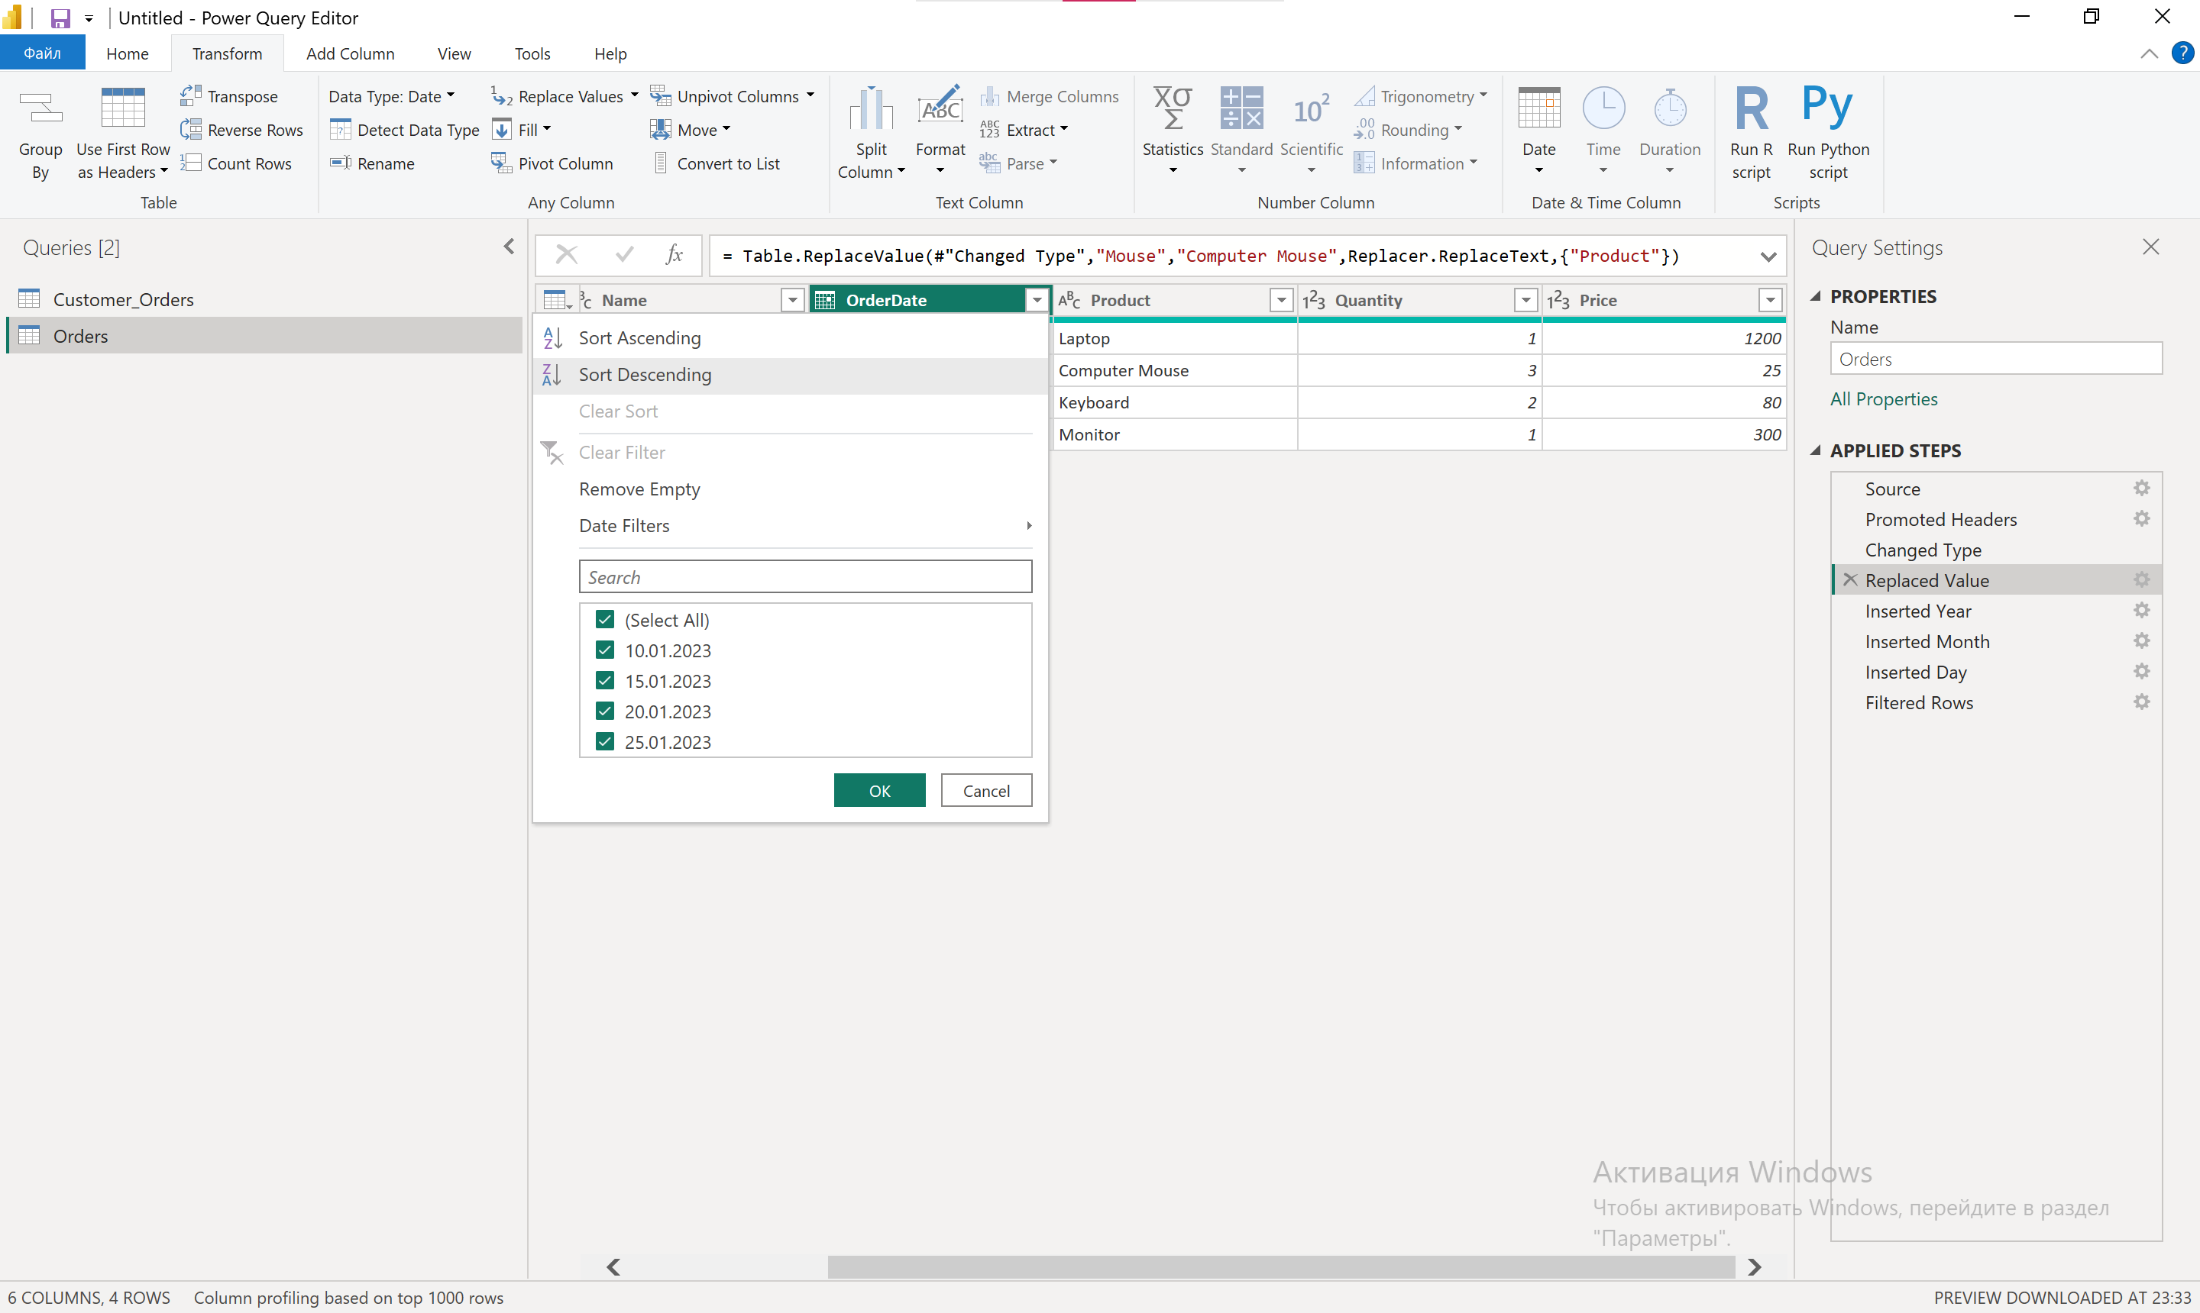
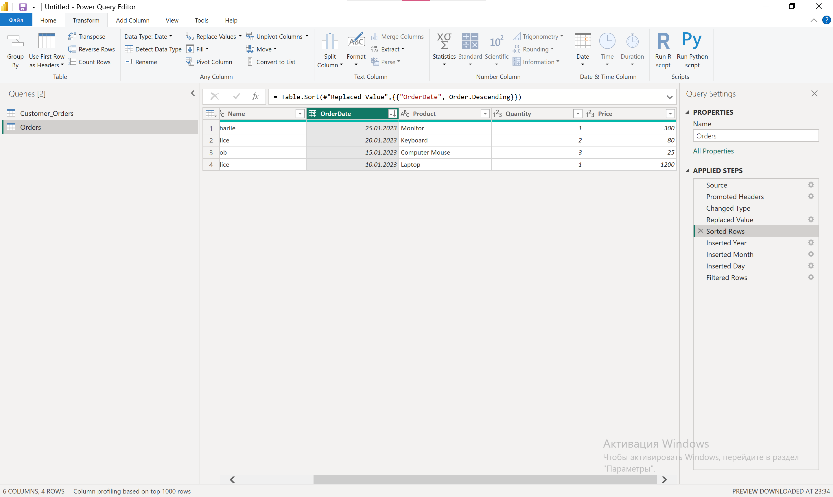

10. How would you handle null values in the Price column?
📂 File: Orders.txt (есть колонка Price)
- Replace nulls with 0 → Transform → Replace Values → null → 0.
- Or remove null rows → Remove Rows → Remove Blank Rows.
- Or fill down/up.

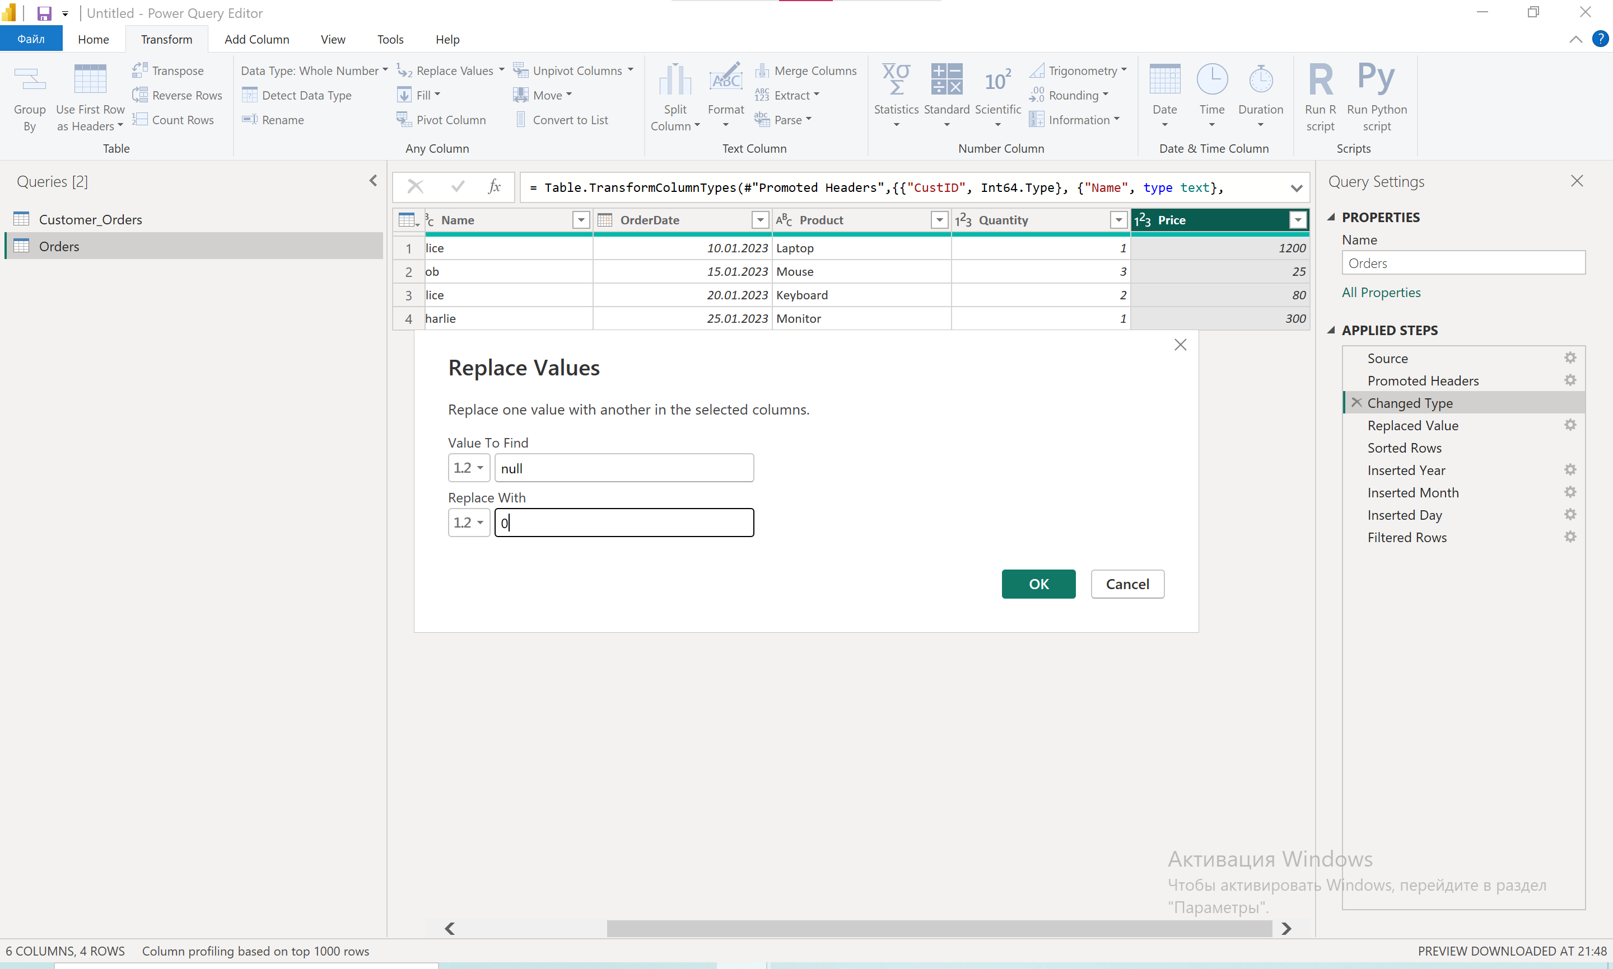

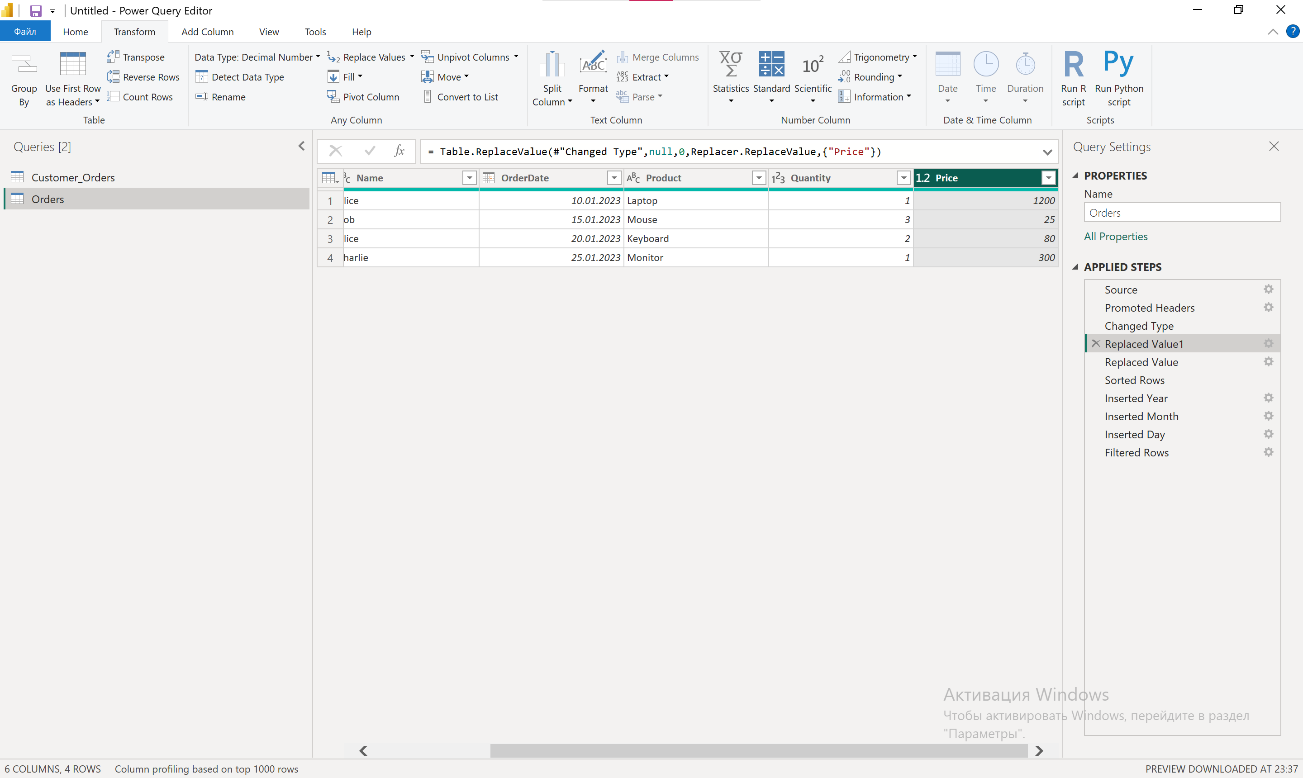

11. Write custom M-code to add a column calculating TotalSpent = Quantity * Price.
📂 File: Orders.txt
- Add Column → Custom Column.
M-code:
Table.AddColumn(Orders, "TotalSpent", each [Quantity] * [Price], type number)

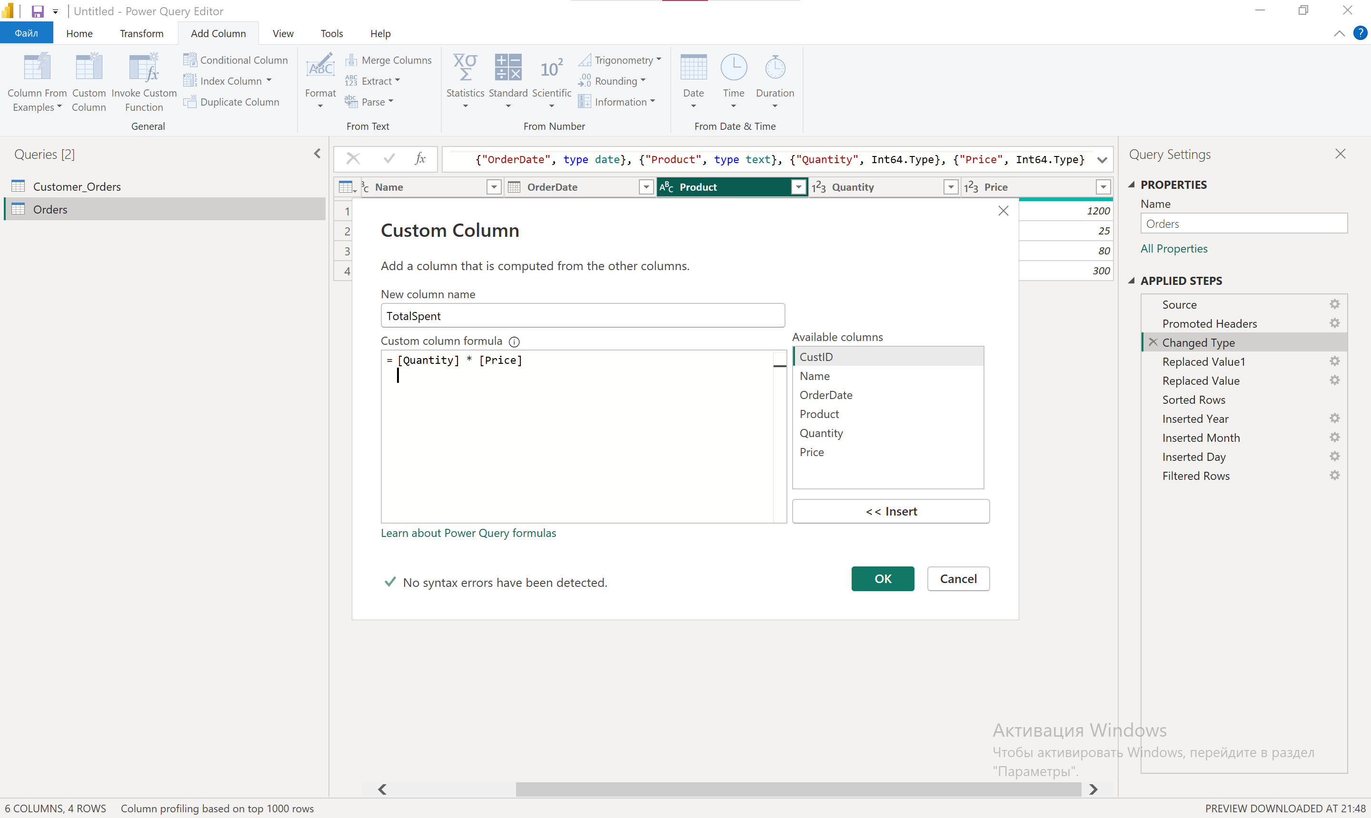

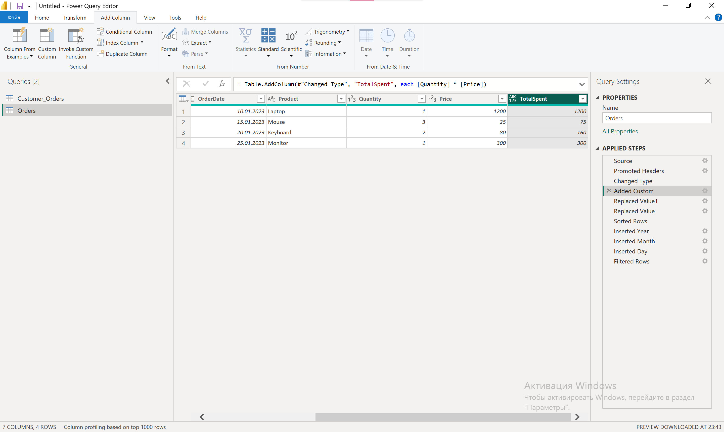
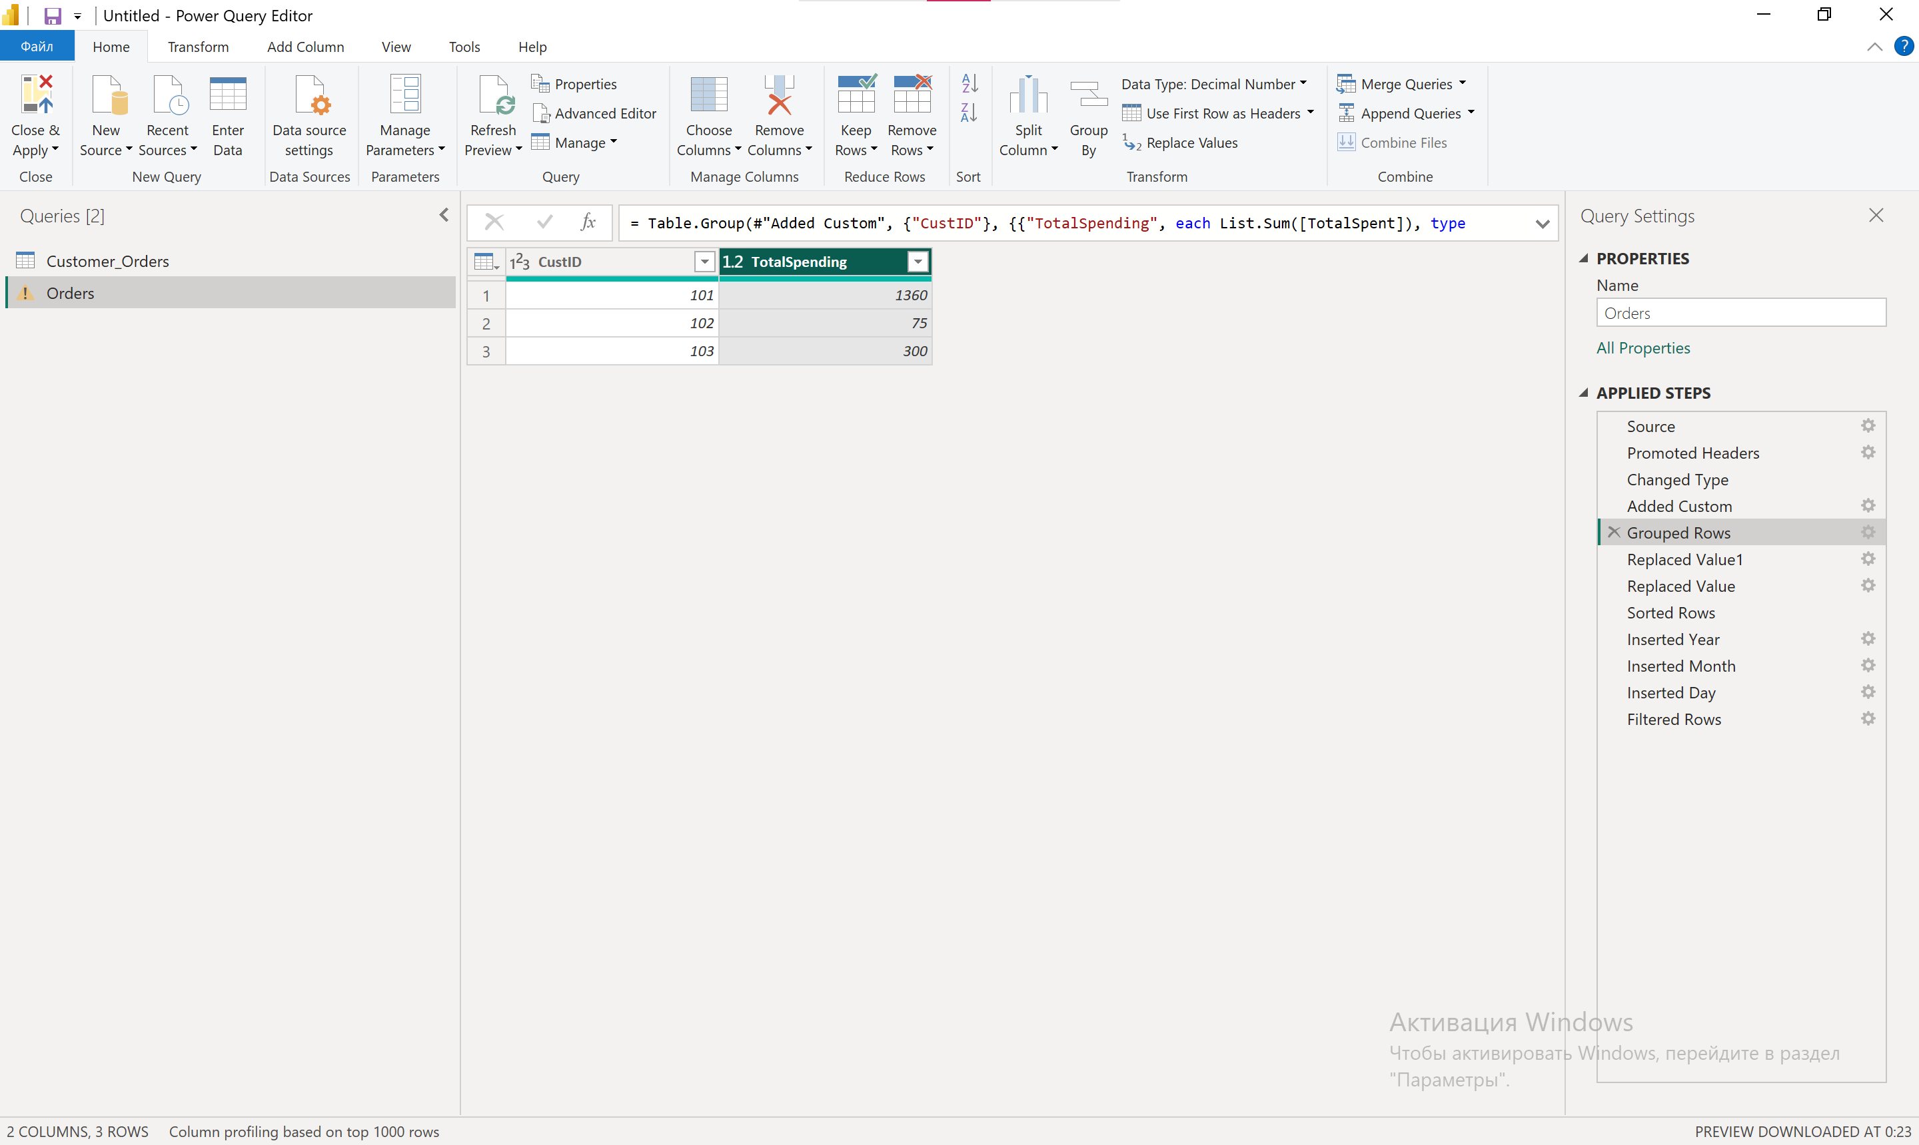

12. Group the table by CustID to show total spending per customer.
📂 File: Customer_Orders.txt (там есть CustID → связь с Orders)
- Merge Orders + Customer_Orders (если нужно).
- Select CustID → Home → Group By → Sum on TotalSpent.
M-code:
Table.Group(Customer_Orders, {"CustID"}, {{"TotalSpending", each List.Sum([TotalSpent]), type number}})

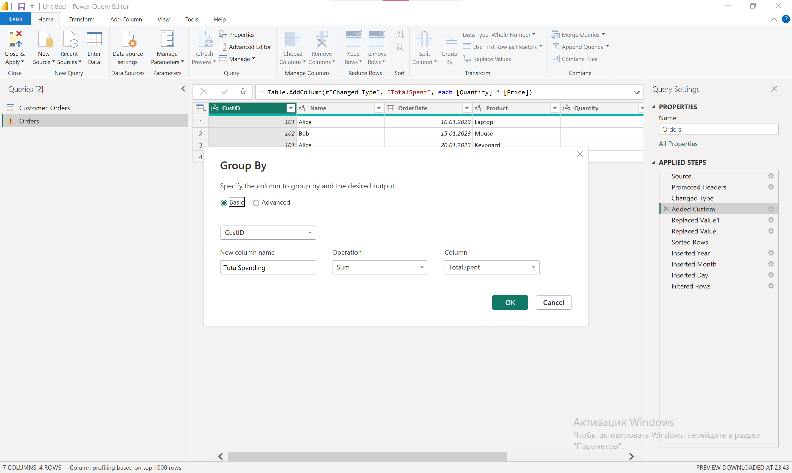

13. Fix inconsistent date formats in OrderDate.
📂File: Orders.txt
- Select OrderDate → Change Type → Date.
- If needed → Change Type → Using Locale.
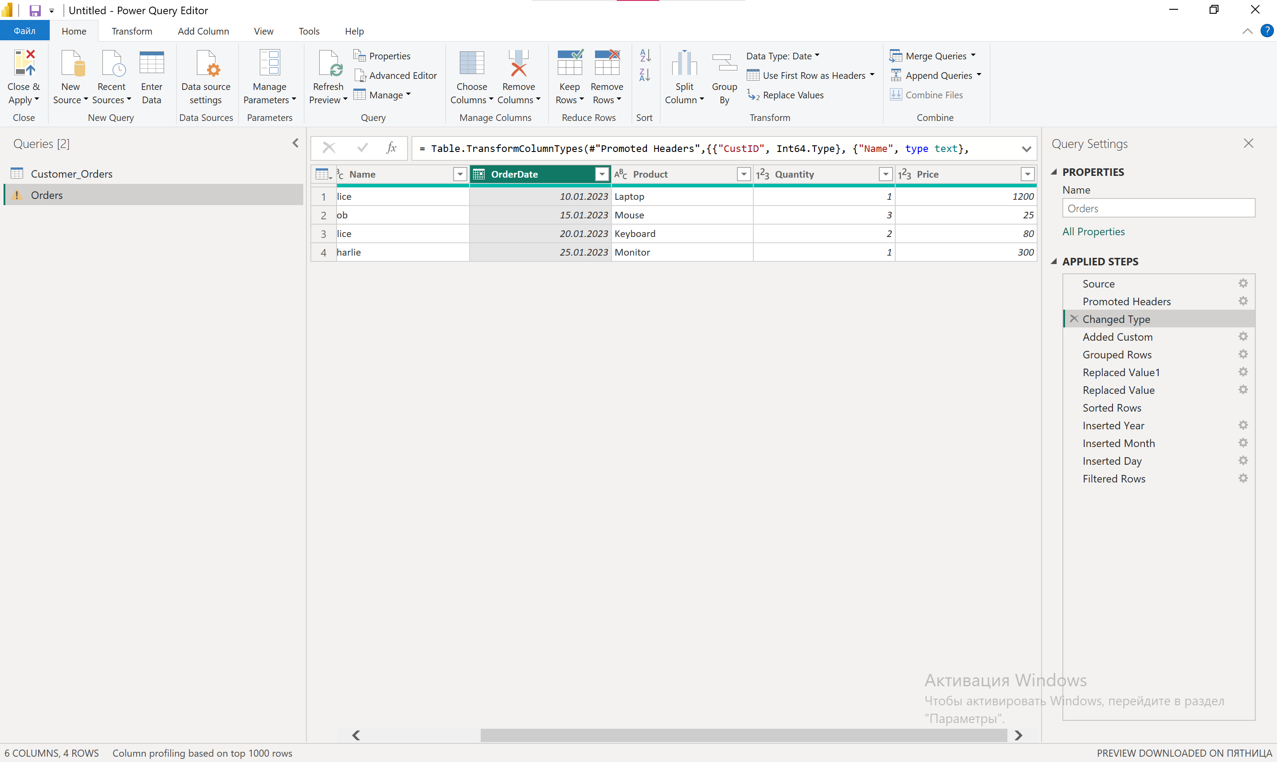

14. Create a conditional column: Label orders as "High Value" if Price > 100.
📂 File: Orders.txt
- Add Column → Conditional Column.
M-code:
Table.AddColumn(Orders, "OrderValueLabel", each if [Price] > 100 then "High Value" else "Normal")
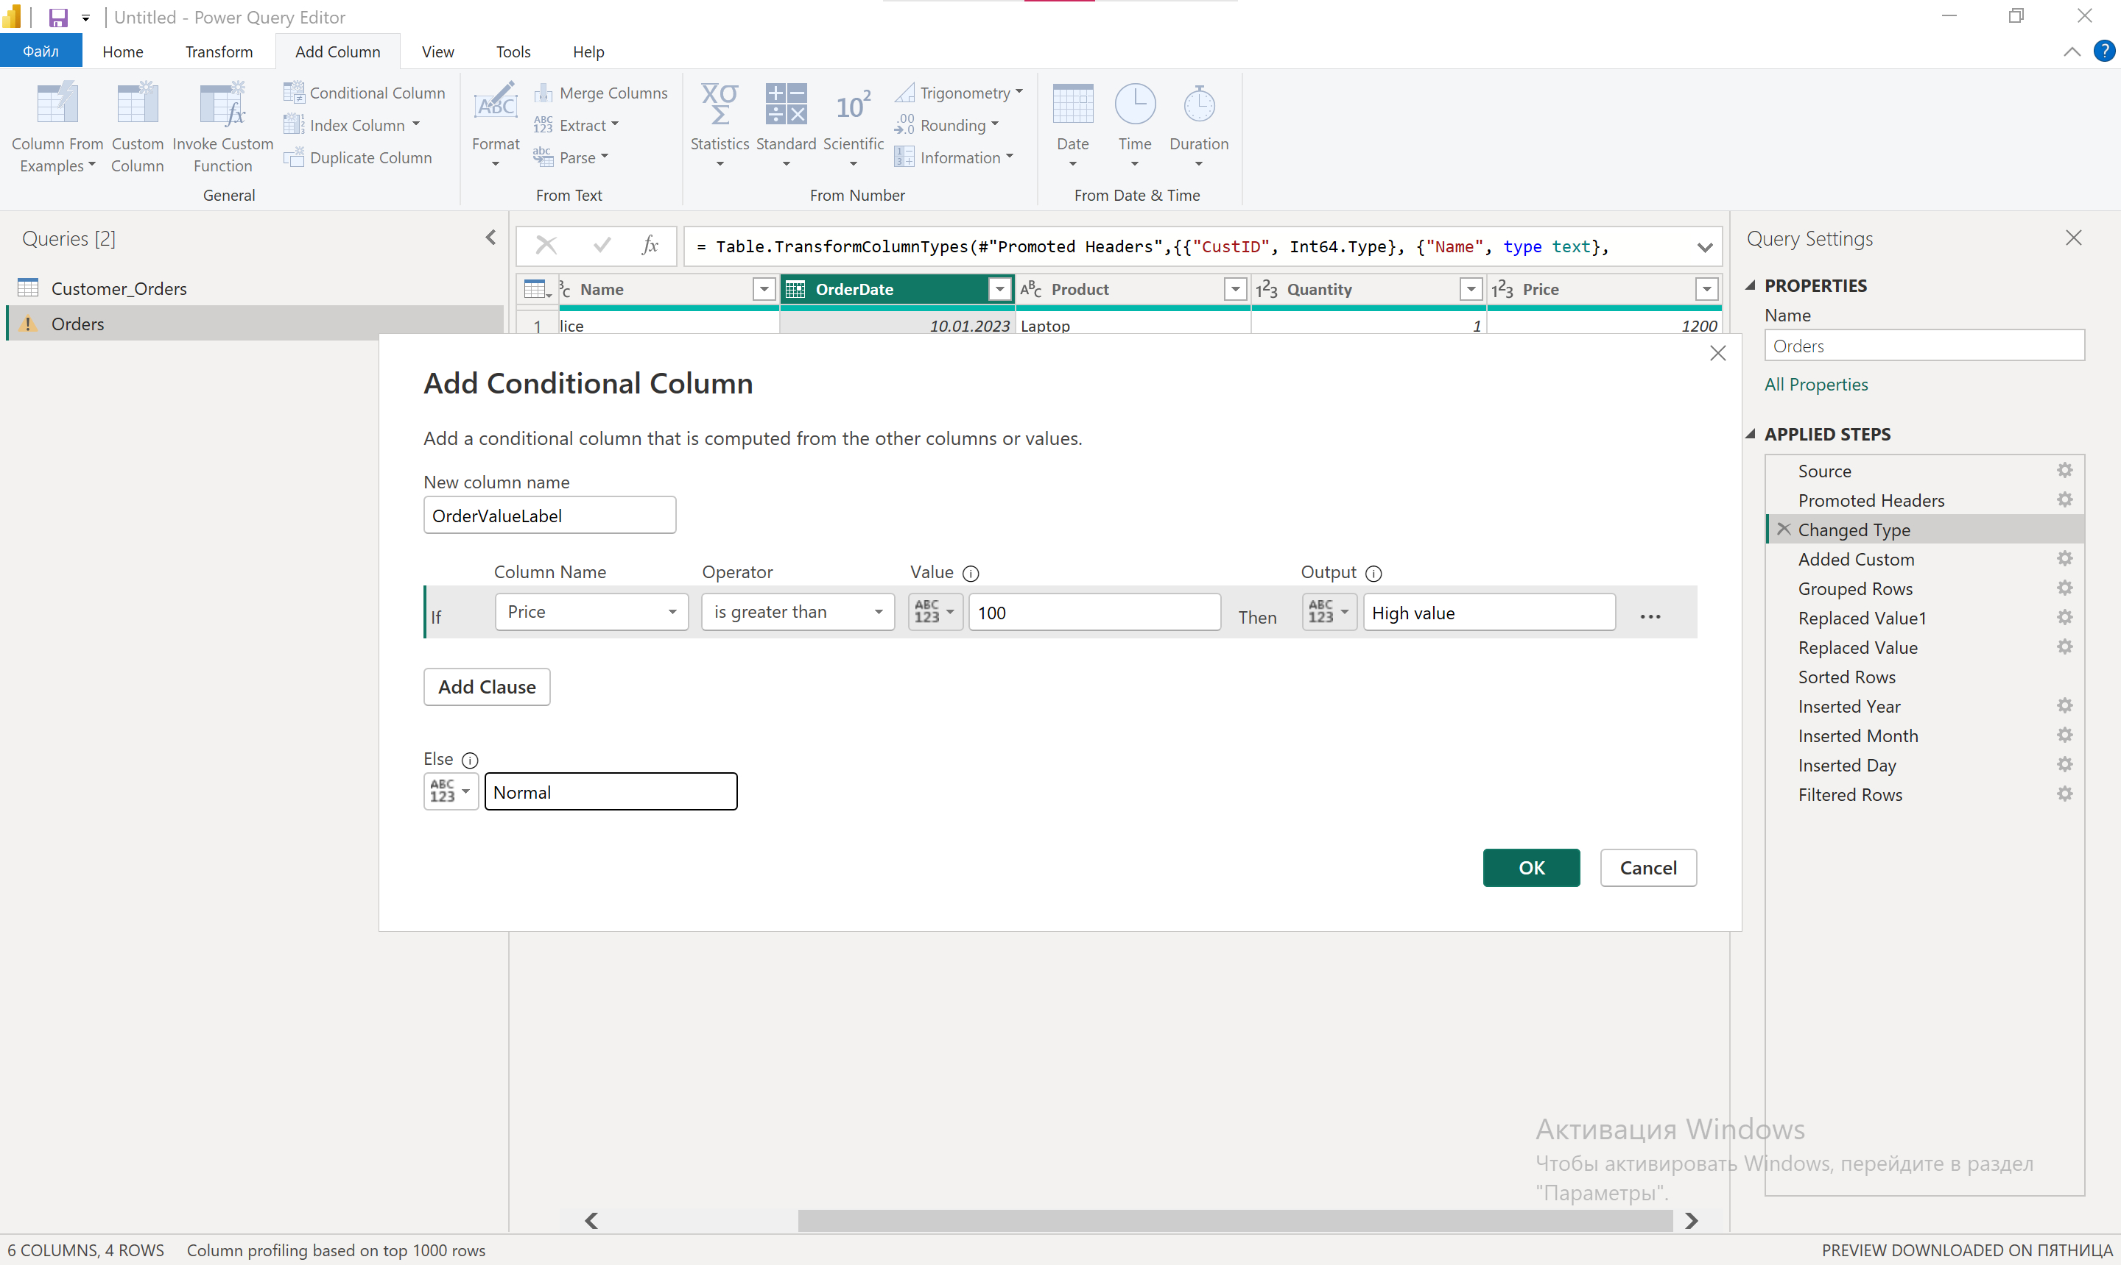

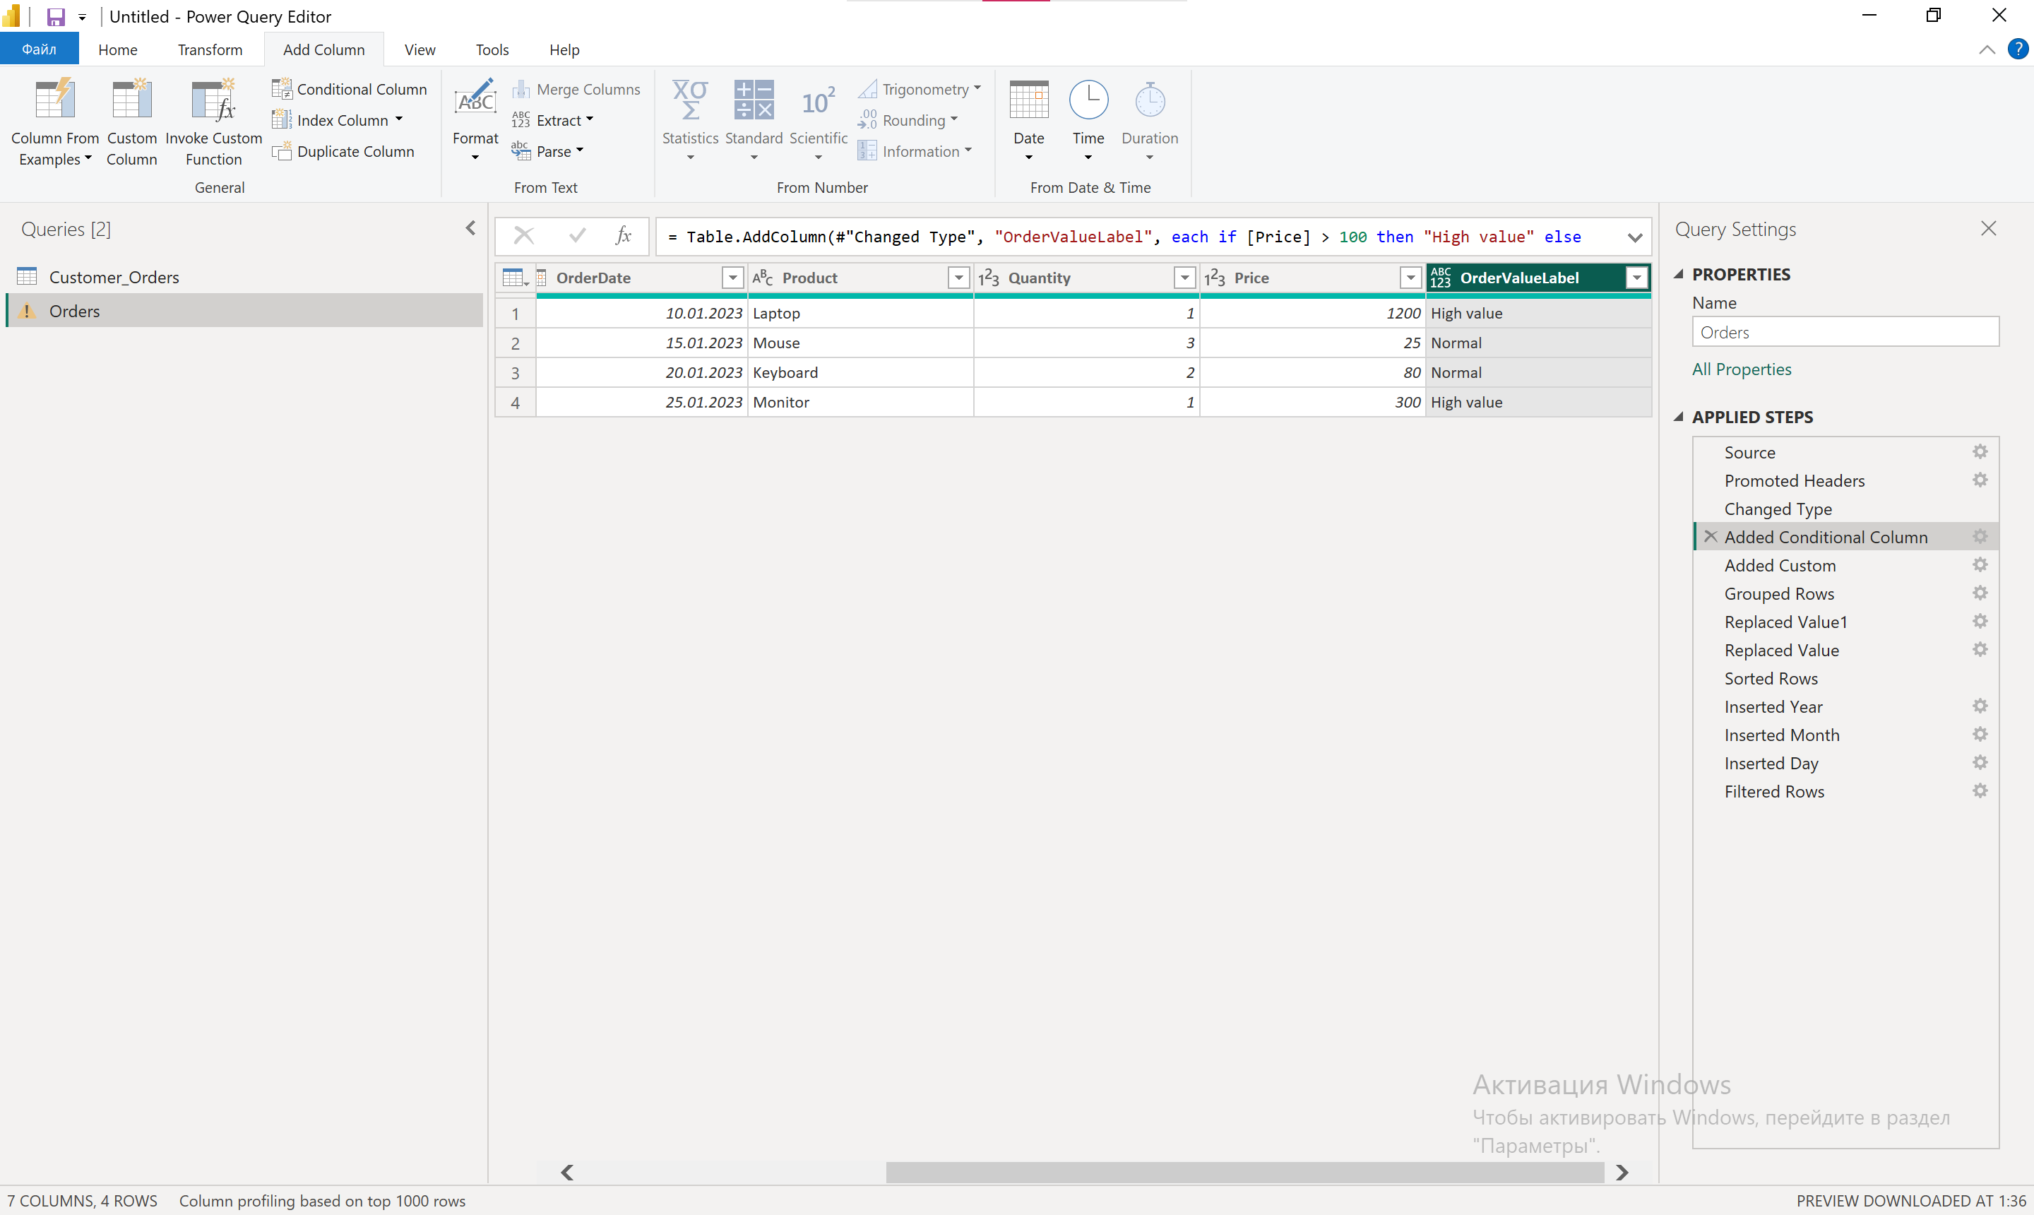

15. Optimize the query to reduce refresh time.
📂 work with 2 files: Orders.txt и Customer_Orders.txt
- Remove unused columns early.
- Filter before merging.
- Avoid multiple data type changes.
- Disable load for intermediate queries.

