Coloring Remainders Exploration Questions

Pascal's Triangle is very interesting from a number pattern point of view. We've already seen the interesting 2-color patterns from coloring multiples of numbers. Now we are going to look at remainders.

1. Find the quotients and remainders when each number in row 4 of Pascal's triangle is divided by 2, 3, 4, 5, 6, and 7, filling in the table below:

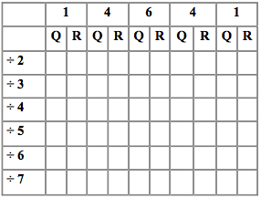

What happens when we divide by numbers larger than the largest number in the row in general?

2. Now try coloring Pascal's Triangle on paper, using 3 as the divisor. Color all remainders 0 one color, remainders 1 another color, and remainders 2 a third color.

3. Use the Coloring Remainders Activity to explore other patterns. Try at least three different numbers. Do you see a general pattern? Can you describe how each number you try relates to the pattern for that number?

4. How do these patterns compare to the ones you found with the Coloring Multiples Activity?

