Factorize Exploration Questions

1. For each of the numbers below use the Factorize activity to develop all the factorizations. Write out all the factorizations for the numbers below:

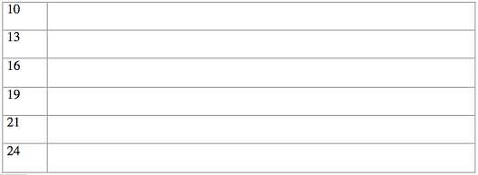

2. Which of those numbers in the table have only one set of factorizations?

3. Try to name all the numbers between 1 and 50 that only have one set of factorizations.

4. Which number(s) between 1 and 50 has the greatest number of factorizations? How many?

