Flake Maker Exploration Questions

This activity is designed to allow the user to generate interesting, irregular fractals.

1. Use the Flake Maker Activity to build fractals from the following three generators:

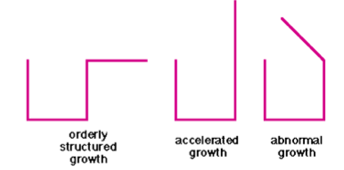

Look at these three generators. How are they different? How are they the same? Do you expect a large difference in the fractals they generate? What do you observe?

2. Now change to a triangular grid and try the following generator:



Do you recognize this fractal? Compare it to The Koch Snowflake.

3. Now that you have experimented with the software, try to build a "custom" figure, your version of the "prettiest picture."

