Koch’s Snowflake
Exploration Questions

The Koch Curve is the most recognized "line bender" fractal.

Directions: Draw several iterations of the Koch Curve, filling in the table below.

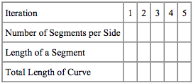

Answer the following questions:

• What would the total length of the N-th iteration be? Look at the patterns made by the numbers both before and after simplifying.

• What do you expect the Koch Curve to look like? In other words, what would you expect to happen if you repeated this infinitely many times?

• What is the length of the Koch Curve?

• Can you estimate the area at each stage? What is the area of the final snowflake?

