Perimeter
Exploration Questions

1. Complete the following table:

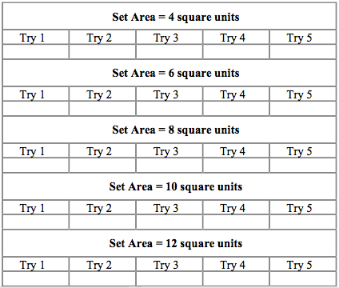

2. How many different values did you get for each set area?

3. What conclusion can be drawn from your data?

