Sierpinski’s Triangle
Exploration Questions

Run several stages of the Sierpinski's Triangle Activity, and answer the following questions:

• Fill in the table:
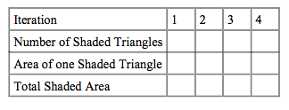
• What patterns do you see in the numbers for the number of shaded triangles? Can you build a formula for the number of shaded triangles at the n-th stage?

• What patterns do you see in the numbers for the area of one shaded triangle? Can you build a formula for the area of one shaded triangle at the n-th stage?

• What patterns do you see in the numbers for the total shaded area? Can you build a formula for the total area at the n-th stage?

• What do you think happens to these numbers as the number of stages approaches infinity?

• Compare these results to those for the Sierpinski's Carpet. Does the "three-ness" of a triangle and the "four-ness" of a square seem to play a role in these numbers?

