Connect the Dots

1. Design a tessellation using the Tessellation Activity.

2. Screen capture it.

3. Paste it into a drawing program.

4. Choose a point on one of the polygons and draw a dot on it.

5. Draw dots on all of the corresponding points on the polygons that are
adjacent to the first polygon.

6. Draw lines connecting all the dots except the first one.

7. Record observations.

8. Repeat steps 1 - 7 until making enough observations to form a theory. Share theories with classmates.

9. To do this activity by hand, print out the sample tessellations below and use them in place of steps 1 - 3.

Hexagon sample

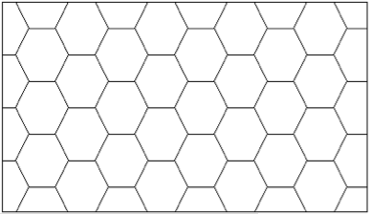

Rectangle sample

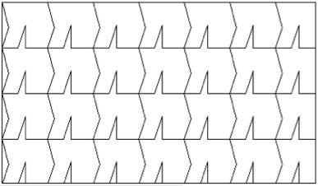

Triangle sample

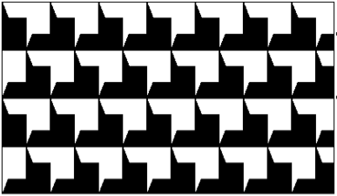

Hexagon sample

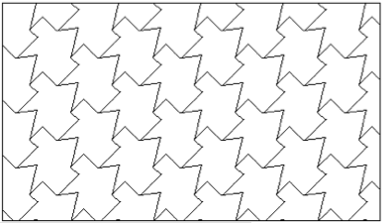

Challenge: Use a paint program to design your own tessellations and perform this experiment!

