Sample Problems on Bar Graph Class Intervals

General Suggestions:

You can change the class interval sizes (horizontal scale on the bar graph) by counting several class intervals together (e.g., counting by three months instead of one month). Experiment with different class sizes until you find the best presentation from the point of view indicated in each problem.

1. Stock Market

A stockbroker claims that the product he is selling stock for yields relatively stable returns, and is therefore a good investment. Using the following data illustrating the money earned from this product for each month in the past year, how should the stockbroker create the horizontal scale of a graph to emphasize product stability? How should the stockbroker for another product create the horizontal scale of the graph to illustrate that this product is relatively unstable, and is therefore a poor investment?

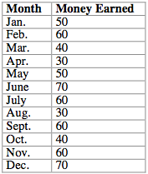

2. Basketball Scores

The coach of a local basketball team is trying to prove that his team is the most stable in the league. Using data illustrating the total number of points scored in each month for the last year, create a graph for the coach. Create the horizontal scale such that emphasis is placed upon stability.

Is this an accurate representation of the team's scores? Is it possible to create a graph such that relative instability is emphasized? How would you create a graph that is an accurate representation?

Use the following table in creating your graphs.

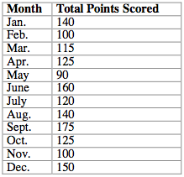

3. Car Accidents

The following table illustrates the number of car accidents that have occurred on Dangerous Street for each of the past 15 years.

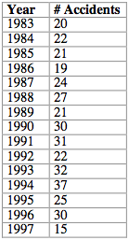

How can this data be manipulated to suggest that the number of accidents that occur on Dangerous Street has increased since 1983? Create a graph that depicts such an increase. Next, alter the horizontal scale of this graph to create an illustration that suggests that the number of accidents that occur has decreased since 1983 (or remained relatively constant). As a driver who frequently travels on Dangerous Street, how do you think the data should be represented such that you see an accurate portrayal of the number of accidents that have occurred?

