Sample Problems on Comparing Histograms and Bar Graphs

1. In the past year, you have recorded the number of tickets that a movie theater has sold during each month. To represent this data set graphically, would you construct a bar graph or a histogram? Why is this choice better than the other? Using the following data, construct the graph that you choose.

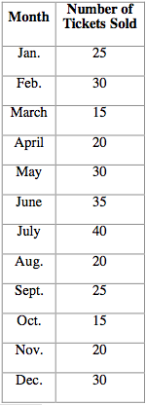

2. Over the past several years, you have recorded the number of automobiles that a used car dealer in your town has sold in different price ranges. First, decide whether a histogram or a bar graph is most appropriate for this situation.

Next, using the given data, construct several graphs of this situation using different intervals for the price ranges (vary the increment size--$2,000 or $5,000, for example). If you were the car dealer, what increment size would you choose to advertise car sales?

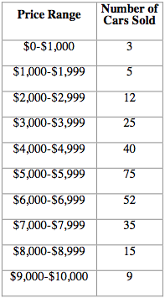

3. For a recent science project, you collected data regarding the distribution of fish and aquatic life in a nearby pond. Your data consists of the number of living creatures found in each 1 meter depth increment in the pond. Construct a bar graph and several histograms (vary the depth increment size) for the following data. In which case(s) is the histogram the same as the bar graph? How do the other histograms vary from the bar graph?

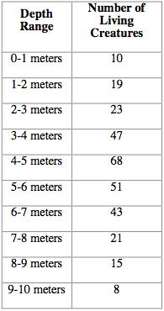

4. You play on a local soccer team and, over the past three years, have recorded the number of goals scored by each of the 12 players on your team. Is it more appropriate to create a bar graph or a histogram for this situation? Using the following data, construct the appropriate graph.

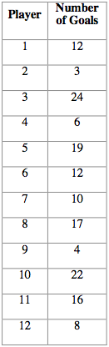

5. A shoe store in your local mall has recorded the number of each type of shoes that it has sold in the past month. Is it more appropriate to create a bar graph or a histogram to represent this situation? Using the following data, construct the appropriate graph.

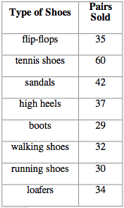

6. You own a local computer store and have kept a record of the number of computers sold each month for the past year. See the following data:

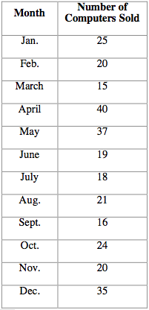

These data can be represented graphically using several different time increments (number of computers sold per month, number of computers sold per two months, etc.). Construct several histograms using different time increments. As the owner, would you use a bar graph or a histogram to illustrate an increase in computer sales from your shop? If you choose a histogram, what would be the time increment?

