Sample Problems on Histogram Scales and Impressions

Data Set 1. Monthly report of sales for Fast Growing, Inc. for the year 2001.

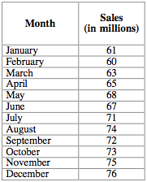

Represent this data using histograms. For Histogram 1, use a vertical scale of 5 million per unit, starting from 0. For Histogram 2, use a vertical scale of 1 million per unit, starting from 60 million. Which histogram would you use if you were the manager of Fast Growing, Inc. who wants to convince people that the company grows fast? Which would you use if you were a manager of Stable Income, Inc. (the main competitor of Fast Growing) who wants to diminish the success of the competing company? How would you present the data if you were an independent observer who wants to present the information in the most accurate manner?

Data Set 2. Monthly report of crime rates in Gotam town for the year 1984.

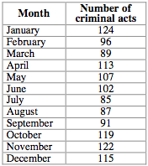

Suppose you are a journalist who is convinced that the crime rate goes down only when the police perform crime-fighting campaigns. You believe there were two campaigns during 1984. Choose a scale for your histogram to better represent your opinion.

Now suppose you are the chief of police, who wants to show that the crime rates are more or less stable year round, due to constant police efforts. Choose a scale for your histogram to match this opinion.

How would you represent the data to be the most accurate?

