**Blue Waters Petascale Semester Curriculum v1.0**

**Unit 2: Parallel Computing Concepts**

**Lesson 2: Parallel Programming Patterns**

**Instructor Guide**

*Developed by Nitin Sukhija for the Shodor Education Foundation, Inc.*



*Except where otherwise noted, this work by The Shodor Education Foundation, Inc. is licensed under CC BY-NC 4.0. To view a copy of this license, visit*[*https://creativecommons.org/licenses/by-nc/4.0*](https://creativecommons.org/licenses/by-nc/4.0)

*Browse and search the full curriculum at*[*http://shodor.org/petascale/materials/semester-curriculum*](http://shodor.org/petascale/materials/semester-curriculum)

*We welcome your improvements! You can submit your proposed changes to this material and the rest of the curriculum in our GitHub repository at*[*https://github.com/shodor-education/petascale-semester-curriculum*](https://github.com/shodor-education/petascale-semester-curriculum)

*We want to hear from you! Please let us know your experiences using this material by sending email to* [*petascale@shodor.org*](mailto:petascale@shodor.org)

Patterns

a “vocabulary” for designing algorithms

Parallel Patterns

A recurring combination of distribution of tasks and access of data pertaining to a specific problem in design of parallel algorithm.

aid in achieving scalability and convenience for developing parallel applications .

facilitates comparison between parallel and serial performance.

Universal in nature as patterns can be utilized any parallel programming models.

Bag of Tasks

Data Parallel

Task Parallel

Pipelining

Divide and Conquer

Bag of Tasks (BoT)

Also called Embarrassingly Parallel or loosely coupled applications

Component tasks of application are independent

Tasks don't communicate with each other

Tasks can be executed in any order

Minimal parallel overhead

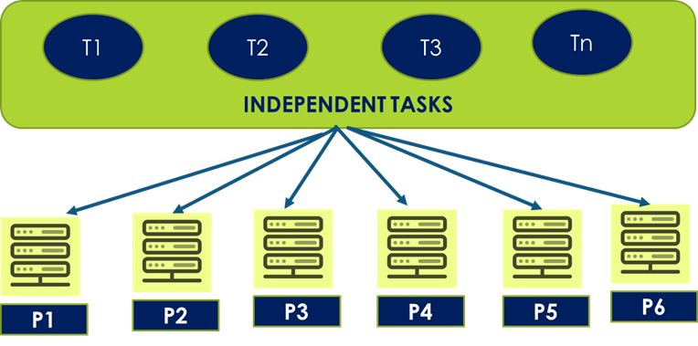

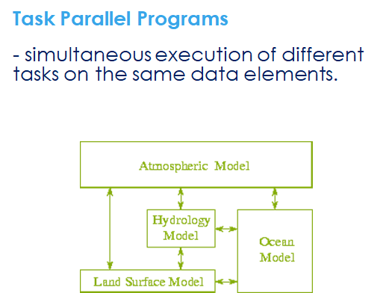

Data Parallel

Most parallel work in these applications is focused on performing tasks on a data set.

a subset/partition of the dataset is given to each process.

each process performs the same tasks on the different subsets/partition of data.

Example: each task (T1) adds 3 to each data element.

Task Parallel

a subset of the tasks is allocated to each process

each process performs a different subset of tasks on the same data.

at the end of the tasks, all of processes have to share the results of the tasks executed, (global reduction).

Pipelining

A stream of data is passed through a succession of processes, each of which perform some task on it.

A pipeline is composed of several computations called stages.

Computation stages performed on data are ordered but independent.

Computation stages run independently for each item.

Each output of computation becomes input to the following computation.

Enable modular design

Conceptually simple

Serial computation still a bottleneck

Divide and Conquer

Concurrency is obtained by:

Splitting the problem into subproblems

concurrently solving the subproblems

merging the solved subproblems solutions into a solution for the whole problem

**Common Pitfalls for Students and Instructors**

1. Lack of knowledge of Computer Organization and Architecture
2. Lack of knowledge of Supercomputing as a domain.