**Blue Waters Petascale Semester Curriculum v1.0**

**Unit 3: Using a Cluster**

**Lesson 8: Scaling on a Cluster 3**

**Instructor Guide**

*Developed by Michael N. Groves for the Shodor Education Foundation, Inc.*

1. Slides are written for both SLURM and Torque/Maui scheduler systems. Just select the appropriate part of the slide package.
2. The Makefile for the code should be applicable for multiple systems by commenting/uncommenting the appropriate system/compiler you want to use
3. The result of the student activity should look like this: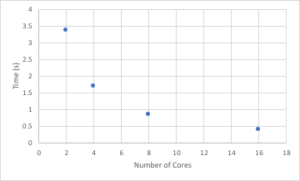

which is the same figure used in the slides. The goal is for students to see that the time does not continue to drop but instead it hits an asymptote as the number of cores increases.

1. The result from the wallclock activity should be a horizontal line. Wallclock time should not significantly affect the time to complete the job.

**Common Pitfalls for Students:**

-Not knowing how to navigate Unix command line environments and their text editors



*Except where otherwise noted, this work by The Shodor Education Foundation, Inc. is licensed under CC BY-NC 4.0. To view a copy of this license, visit*[*https://creativecommons.org/licenses/by-nc/4.0*](https://creativecommons.org/licenses/by-nc/4.0)

*Browse and search the full curriculum at*[*http://shodor.org/petascale/materials/semester-curriculum*](http://shodor.org/petascale/materials/semester-curriculum)

*We welcome your improvements! You can submit your proposed changes to this material and the rest of the curriculum in our GitHub repository at*[*https://github.com/shodor-education/petascale-semester-curriculum*](https://github.com/shodor-education/petascale-semester-curriculum)

*We want to hear from you! Please let us know your experiences using this material by sending email to* [*petascale@shodor.org*](mailto:petascale@shodor.org)