1. Exercise 1: Review the given source code for parallel reduction using sum operator for 2^20 elements

To run the program:

nvcc <filename>

a //(in windows)

or ./a //(in linux)

1. Exercise 2: Write a kernel that performs reduction as shown in figure using shared memory for 2^20 elements.

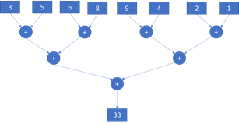

Here is how it can be designed

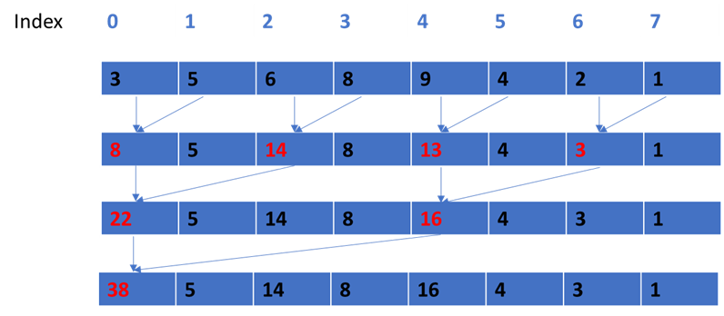

Elements in red represent the reduced values.

Note: Since each block will compute a single result, you will need to add all the block results at the end to get the final reduced result.

1. Exercise 3: Write a program for parallel reduction using max operation to find the max value among 2^20 elements
   1. First define host variables and a serial method to find max
   2. Define device variables and initialize them
   3. Create a kernel to find max similar to exercise 1 using global memory
   4. Create a kernel to find max similar to exercise 1 using shared memory