**Blue Waters Petascale Semester Curriculum v1.0**

**Unit 9: Optimization**

**Lesson 1: Cache Efficient Matrix Multiplication**

**Sample Assessment**

*Developed by* *Paul F. Hemler for the Shodor Education Foundation, Inc.*



*Except where otherwise noted, this work by The Shodor Education Foundation, Inc. is licensed under CC BY-SA 4.0. To view a copy of this license, visit*[*https://creativecommons.org/licenses/by-sa/4.0*](https://creativecommons.org/licenses/by-sa/4.0)

*Browse and search the full curriculum at*[*http://shodor.org/petascale/materials/semester-curriculum*](http://shodor.org/petascale/materials/semester-curriculum)

*We welcome your improvements! You can submit your proposed changes to this material and the rest of the curriculum in our GitHub repository at*[*https://github.com/shodor-education/petascale-semester-curriculum*](https://github.com/shodor-education/petascale-semester-curriculum)

*We want to hear from you! Please let us know your experiences using this material by sending email to* [*petascale@shodor.org*](mailto:petascale@shodor.org)

Given the following two matrices,

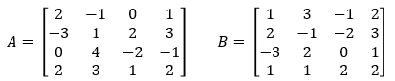

1. What is the product C = AB?

Hint:

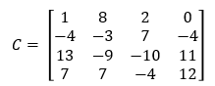

1. Transpose B and find the product by multiplying the rows of A with the rows of B. Did you get the same result as in question 1?
2. Perform block matrix multiply using 2 X 2 blocks. DId you get the same result as in question 1 and 2?