DATABASE MANAGEMENT SYSTEM

**Student Performance Monitoring System (SPMS)**

horizontal line

**FINAL REPORT**

GROUP 02

Shoeb Uddin Ahmed 1920038

Istiak Ahammad Limon 1930038

Tahsin Bin Khaled 1830422

**CHAPTER 1: INTRODUCTION**

**BACKGROUND OF THE PROJECT**

**OBJECTIVE OF THE PROJECT**

**SCOPE OF THE PROJECT**

**CHAPTER 2: REQUIREMENT ANALYSIS**

**RICH PICTURE (AS-IS)**

**SIX ELEMENTS (AS-IS)**

**PROCESS DIAGRAM (AS-IS)**

**PROBLEM ANALYSIS**

**RICH PICTURE (TO-BE)**

**SIX ELEMENTS (TO-BE)**

**PROCESS DIAGRAM (TO-BE)**

**CHAPTER 3: LOGICAL SYSTEM DESIGN**

**BUSINESS RULE**

**ENTITY-RELATIONSHIP DIAGRAM**

**ENTITY-RELATIONSHIP DIAGRAM TO RELATIONAL SCHEMA**

**NORMALIZATION**

**DATA DICTIONARY**

**CHAPTER 4: PHYSICAL SYSTEM DESIGN**

**INPUT FORMS**

**OUTPUT FORMS**

**CHAPTER 5: CONCLUSION**

**PROBLEM AND SOLUTION**

**ADDITIONAL FEATURES AND FUTURE DEVELOPMENT**

**CONCLUSION AND RECOMMENDATIONS**

**CHAPTER 1**

**INTRODUCTION**

● BACKGROUND OF THE PROJECT

● OBJECTIVE OF THE PROJECT

● SCOPE OF THE PROJECT

**A. BACKGROUND OF THE ORGANIZATION:**

Independent University, Bangladesh (IUB) was established in 1993. It is one of the oldest Private Universities in Bangladesh, currently has more than an estimated 7,048 undergraduate and graduate students and over 10,455 alumni. This student population is predicted to grow at about 10% annually. Since its inception, IUB has shown remarkable outcomes in producing graduates with marketable skills by being sincere, staying disciplined, and up to date with the ongoing curriculum and progress system.

IUB has five main school distinctions under its name and they are as follows:

1. Business & Entrepreneurship
2. Engineering, Technology & Sciences
3. Environment and Life Sciences
4. Liberal Arts & Social Sciences
5. Pharmacy and Public Health.

IUB also provides massive percentage-based tuition fee waivers and scholarships for a huge proportion of these students, more than most private universities of the country. This greatly helps the financial guarantors of the students to keep up with the expenses of studies.

Furthermore, IUB is also constantly developing and improving its lab facilities and flourishing on its curriculum according to current corporate world demands, greatly diminishing the outraging gap between academic curriculum and the professional job market.

**B. BACKGROUND OF THE PROJECT:**

Currently, the student marking monitoring system of IUB students is done completely manually through the means of excel files and previously determined PLOs and COs from the IEB, UGC, and mapped by the respective department of each major. The stakeholders, department, or any higher authorities do not have an automated system through which they can visualize the performance data of the students throughout the semesters. So we have to change that to an automated process for everybody’s convenience.

**C. OBJECTIVE OF THE PROJECT:**

The Student Performance Monitoring System (SPMS) that we are going to build will get all student performance data from the respective faculties and departments and vividly summarize and present all the performance data including various sorts of graphs to make it crystal clear for the Stakeholders and all the higher authorities to understand without much effort. The faculties no longer have to create vast excel sheets representing all the marks and CO/PLO achievements of each student manually, instead, the faculty will just have input the marks of each student onto the SPMS and it will automatically do all the work for the faculty, making it tons easier, faster and less hectic for the individuals. As it is all done by computer systems, the process will be instantaneous, unlike a very lengthy process from before, and all the stakeholders that have access to the system will be able to see the data right away without any issues.

**D. SCOPE OF THE PROJECT:**

As we have done a thorough analysis of the existing marking and evaluation system and found out that there are several issues within the entire process that can lead to serious amounts of waste in time and resources. Our proposed Web Application system known as the Student Performance Monitoring System (SPMS) will eradicate all these unnecessary consumption of resources and throw them to be done automatically at the system backend. The system will include a Relational Database Management System (RDBMS) server to store and edit/update all the performance information of the student in the enrolled courses. The Web Application will have seamless and intuitive User Panels or Graphical User Interfaces (GUIs) to make it easily operable for every stakeholder involved. Each individual user type will be able to observe and download all the student data in a way that is visualized extremely vividly and also that fits most suitable for them to understand. Moreover, all the data will be stored on the server protected by high-tier cyber security means, and each user type will have access to the specific data that is relevant to only them in order to maintain the best quality privacy for every user or stakeholder.

**CHAPTER 2**

**REQUIREMENT ANALYSIS**

● RICH PICTURE AS-IS

● SIX ELEMENTS AS IS

● PROCESS DIAGRAM AS-IS

● PROBLEM ANALYSIS

● RICH PICTURE TO-BE

● SIX ELEMENTS TO-BE

● PROCESS DIAGRAM TO BE

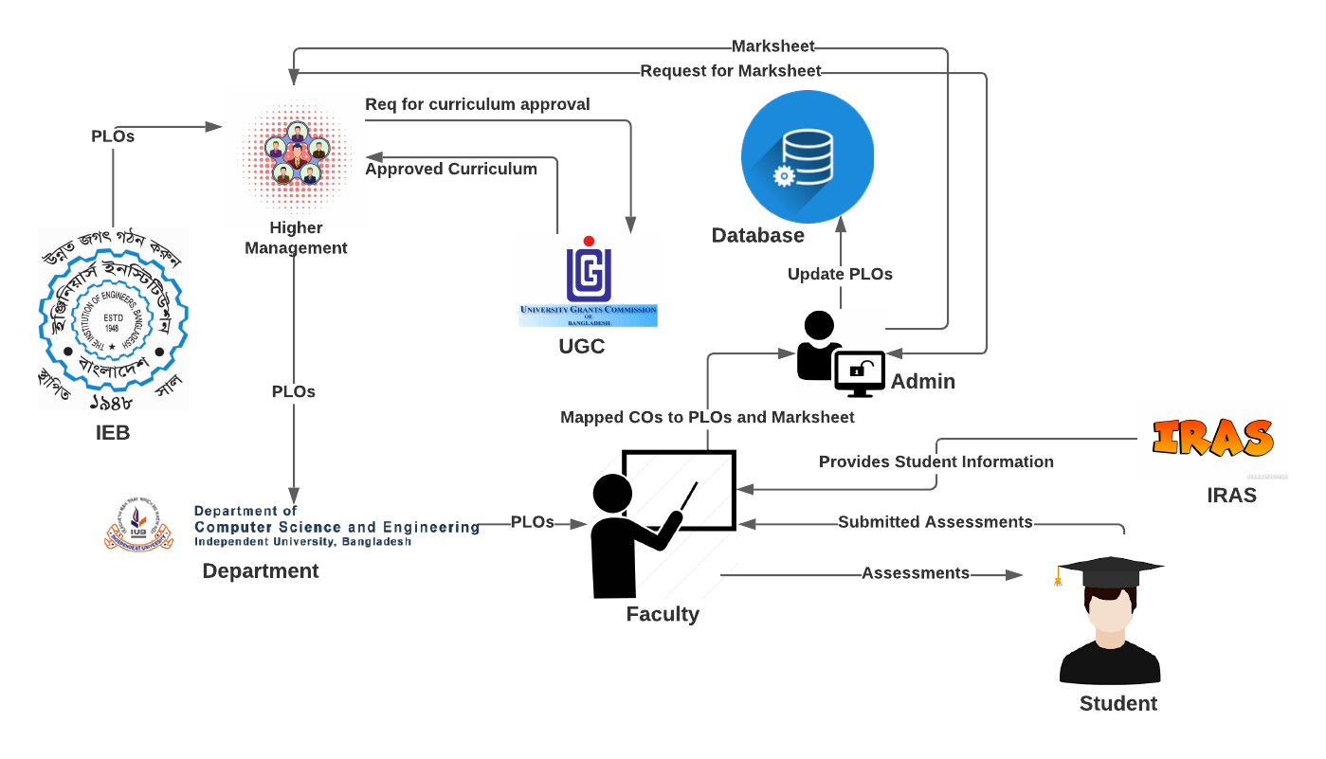

**A. Existing Business System:**

**B. Six Element Analysis of Existing Business:**

|  |  |  |  |  |  |  |
| --- | --- | --- | --- | --- | --- | --- |
| **process** | **Human** | **Non-computing Hardware** | **Computing**  **Hardware** | **Software** | **Database** | **Communication**  **& Network** |
| STUDENT’S ASSESSMENT | **1.Faculty :**  **a)**Create Question Paper.  a) Takes exam of  students in the  form of quizzes,  midterm and final  term by providing  questions.  b) Create  assessment report.  c) Send the  assessment report  to admin  **2. Student:**  a) Answers the questions  provided by  Faculty.  b) submit the answer paper to the faculty.  **3.Admin:**  a) Receives and  stores  assessment report  of students  provided by  Faculty.  b) Store the marks of the student in the Database. | **Paper:**  a) Used to  prepare hardcopy  of question  papers that are  used to assess  students in  exams.  b) Used to  prepare hardcopy  assessment  report.  c) Used to  provide hardcopy  of answer script  to the faculty.  **2.Stationery:**  a) Used to check  hardcopy of  answer script  provided by  students.  b) Used to fill  answer scripts  that are to be  provided to  faculty.  **3.Store Room:**  a) Used to store  all hardcopy of  questions, answer scripts  and assessment  reports. | **1.Computer:**  a) Used to  prepare softcopy  of question  papers that are  used to assess  students in  exams.  b) Used to  prepare softcopy  assessment  report.  c) Used to  prepare softcopy  of answer script  to the faculty.  d) Used to store  all softcopy of  questions,  answer scripts  and assessment  reports.  **2.Printer:**  a) Used to print  the questions on  to paper.  b) Used to print  the assessment  report.  c) Used to print  the answer script. | **1.Microsoft Word:**  a) Used to prepare  softcopy of question  papers that are used  to assess students in  exams.  b) Used to prepare  softcopy of answer  script to faculty.  **2.Microsoft Excel** :  a) Used to prepare  softcopy assessment  report.  **3.Gmail :**  a) Used to send  softcopy of  questions, answer  scripts and  assessment reports  to designated  personnel. | **1.Google Drive:**  a) Used to store and  backup all softcopy  of questions,  answer scripts and  assessment reports  on the internet. | **1.ISP:**  a) Provides  Internet service so  that the use of  Gmail, Google  Drive and Dropbox  is possible. |

|  |  |  |  |  |  |  |
| --- | --- | --- | --- | --- | --- | --- |
| **Process** | **Human** | **Non-computing Hardware** | **Computing Hardware** | **software** | **Database** | **Communication & Network** |
| Curriculum Approval by UGC | **1.Higher**  **Management:**  a) Forms a  committee of  faculty to prepare  a curriculum in  accordance to the  guideline provided  by UGC.  b) Receives  proposed  curriculum  provided by the  designated faculty  committee.  c) Requests UGC  for approval of  curriculum.  d. Receives  approval or  necessary  correction details  from UGC.  e) Sends  confirmation of  approved/correcte  d curriculum to  admin for storing.  **2.UGC:**  a)Receives  request from  higher  management for  approval of  curriculum.  b) Sends approval  or necessary  correction details  of curriculum to  higher  management.  c) Provides  guidelines to  higher  management for  preparing the  curriculum. | **1.Paper:**  a) Used to  prepare hardcopy  of faculty  committee  details, UGC guidelines,  proposed/  corrected curriculum,  approved  curriculum.  **2.Stationery:**  a) Used for  handwritten  mind mapping in  regards to faculty  committee  details,  proposed/correct  ed curriculum,  approved  curriculum.  **3.Store Room:**  a) Used to store  hardcopy of  approved  curriculum. | **1.Computer:**  a)Used to  receive, store and  analyze UGC  guidelines.  b) Used to  prepare and  store softcopy of  faculty  committee  details,  proposed/  corrected curriculum,  and approved  curriculum.  **2.Printer:**  a) Used to print  hardcopy of  faculty  committee  details, UGC  guidelines,  proposed/  corrected curriculum,  approved  curriculum. | **1.PDF Reader:**  a) Used to view and  store the softcopy of  received guidelines  from UGC, faculty  committee details,  proposed/corrected  curriculum and  approved curriculum  in PDF format.  **2.Microsoft Word:**  a) Used to prepare,  view and store  softcopy of faculty  committee details,  proposed/corrected  curriculum and  approved curriculum  in word format.  **2.Microsoft Excel:**  a) Used to prepare  softcopy for the  mapping of CO to PO  while creating  courses for the  curriculum.  **3.Gmail :**  a)Used to send  softcopy of faculty  committee details,  UGC guidelines,  proposed/corrected  curriculum,  approved curriculum  to designated  personnel. | **1.Google Drive:**  a) Used to store and  backup all softcopy  of faculty  committee details,  UGC guidelines,  proposed/corrected  curriculum,  approved  curriculum on the  internet. | **1.ISP:**  a) Provides  Internet service so  that the use of  Gmail, Google  Drive and Dropbox  is possible. |

|  |  |  |  |  |  |  |
| --- | --- | --- | --- | --- | --- | --- |
| **Process** | **Human** | **Non-computing Hardware** | **Computing Hardware** | **software** | **Database** | **Communication & Network** |
| Collecting  PLOs from IEB | **1. IEB:**  a) Send PLOs to higher  management.  **2.Higher**  **Management:**  a) Receives PLOs from IEB  b) Send PLOs to the department.  **3.Department:**  a)Send the PLOs to the Faculty  **4.Faculty:**  a) Receives  PLOs from the Department. | **1.Paper:**  a) Used to  prepare hardcopy  Of the PLOs  **2.Stationery:**  a) Used for  handwritten  assessment to  create PLO  report.  **3.Store room:**  a) Used to store  hardcopy of PLO  report. | **1.Computer:**  a) Used to  prepare and  store softcopy of  PLO report.  **2.Printer:**  a) Used to print  hardcopy of PLO report | **1.PDF Reader:**  a) Used to view and  store the softcopy of  PLO report  **2. Microsoft Excel:**  a) Used to prepare,  view and store  softcopy of PLO  report in Excel Shit.  **3.Gmail:**  a. Used to  send/receive  softcopy of  PLOs from IEB to Higher management to faculty to Admin personnel. | **1.Google Drive:**  a) Used to store and  backup all softcopy  of PLO Report on the  internet. | **1.ISP:**  a) Provides  Internet service so  that the use of  Gmail, Google  Drive and Dropbox  is possible. |

|  |  |  |  |  |  |  |
| --- | --- | --- | --- | --- | --- | --- |
| **Process** | **Human** | **Non-computing Hardware** | **Computing Hardware** | **software** | **Database** | **Communication & Network** |
| Mapping of  COs to  PLOs | **1. Faculty**  **Member**  a) Maps the  COs from  PLOs based on  the syllabus  covered in the  course.  b) Sends the  mapped COs  to the admin  through email.  **2. Admin**  a) Receives the  mapped COs  from the  faculty  member.  b) Updates it  in the excel file. | **Paper**  a) Used if the  faculty member  or the admin  wishes to print  out the mapped  COs. | 1. **Computer**   a) Used to edit  the COs' Excel  file.  **2. Printer**  a) Used to  print out the  COs for  hardcopy  storage  backup in case  something  happens to  the digital  version. | 1. **Microsoft**   **Excel:**  a) Used to  store the  mapped COs.  **2. Web Browser:**  a) To send and  receive the COs  through email. | **1.Google Drive:**  a) Contains  the mapped  COs.  **2. Hard Copy**  **storage:**  a) Contains  the  hardcopy  version of  the COs'  Excel file for  backup. | 1. **ISP:**   a)Provides  Internet service so  that the use of  Gmail, Google  Drive and Dropbox  is possible. |

**C. Process Diagram (AS-IS):**

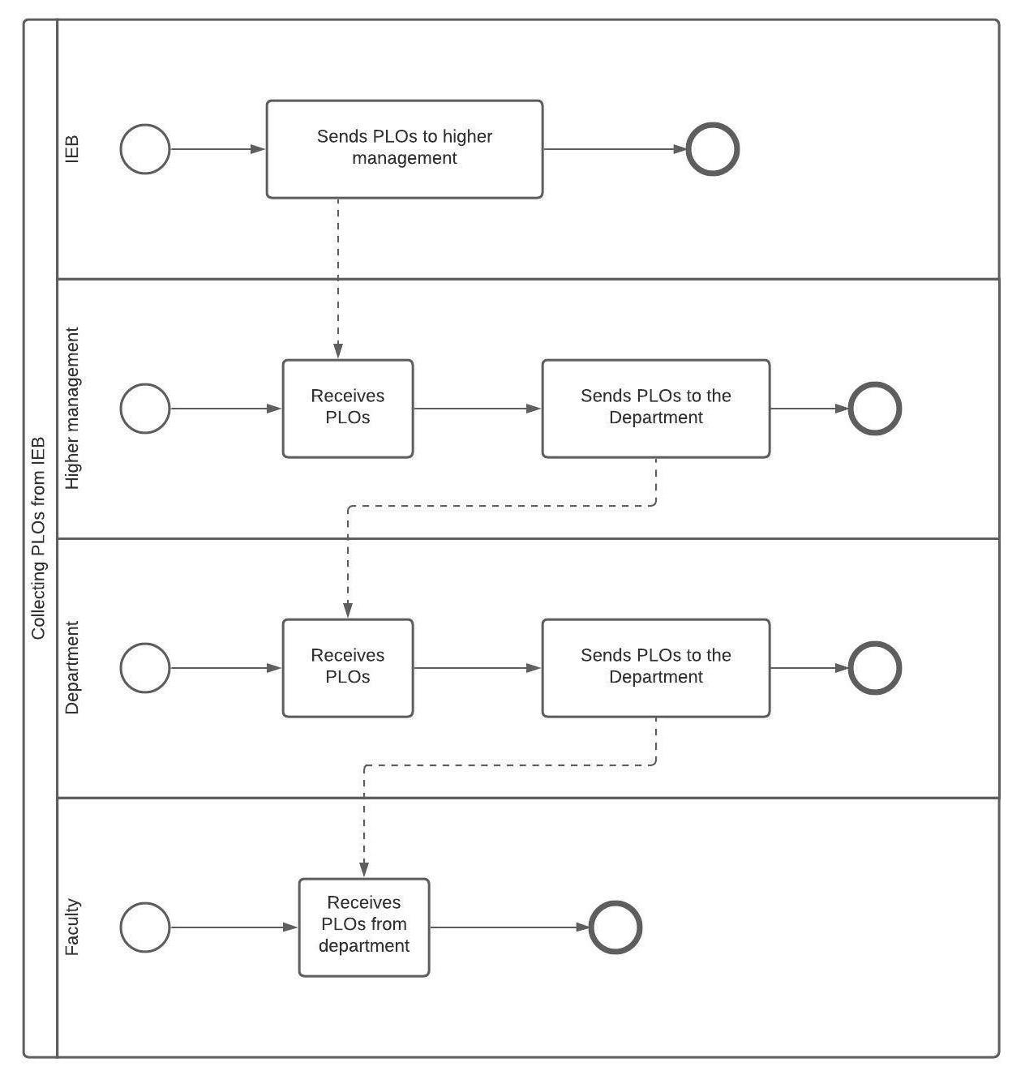

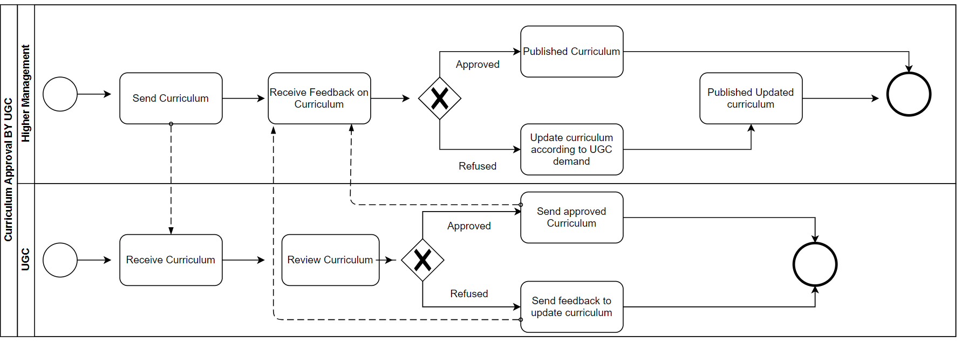

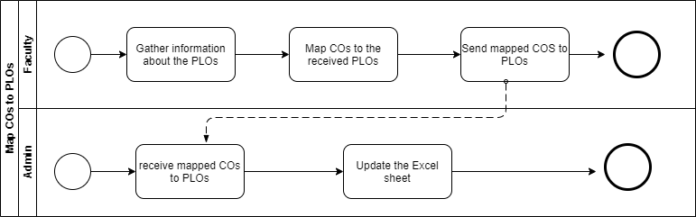

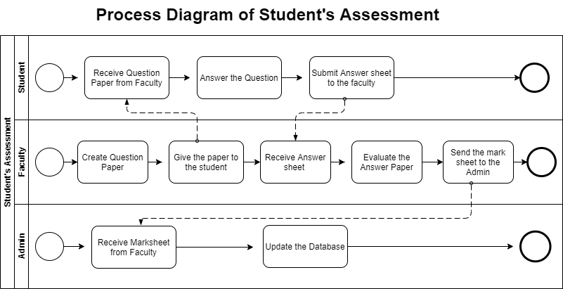

**Problem analysis Of the Existing System:**

|  |  |  |  |  |
| --- | --- | --- | --- | --- |
| **Process Name** | **Stakeholders** | **Concerns**  **(Problems)** | **Analysis (Reason of**  **the Problem)** | **Proposed Solution** |
| STUDENT’S ASSESSMENT | **1.Faculty**  **2.Admin** | The Faculty members  have to provide the mark sheet  to Admin and then  the Admin enters the  mark sheet into the  Database. This  process becomes too  time-consuming and  uses up a lot of extra  resources. | Since the faculty has to send the mark sheet all the way to the admin before getting uploaded to the database, it takes up much of the time and also uses unnecessary resources. | Our software allows the faculty to directly update the marks to the database. Hence, the use or participation of the admin is not required. |
| PLO/CO Achievement Analysis | **1. Faculty** | The CO, PLO achievement analysis has to be done by the faculty by manually entering marks of each student to finalize whether they pass or fail. The analysis has to be sent to the admin to be uploaded to the database. | The entire CO, PLO achievement analysis table, and the passing of the data is extremely time-consuming. | Our software is designed to do the entire CO, PLO achievement analysis by itself. All the faculty has to do is enter the marks in the desired field. |

**E. Rich Picture of Proposed System:**

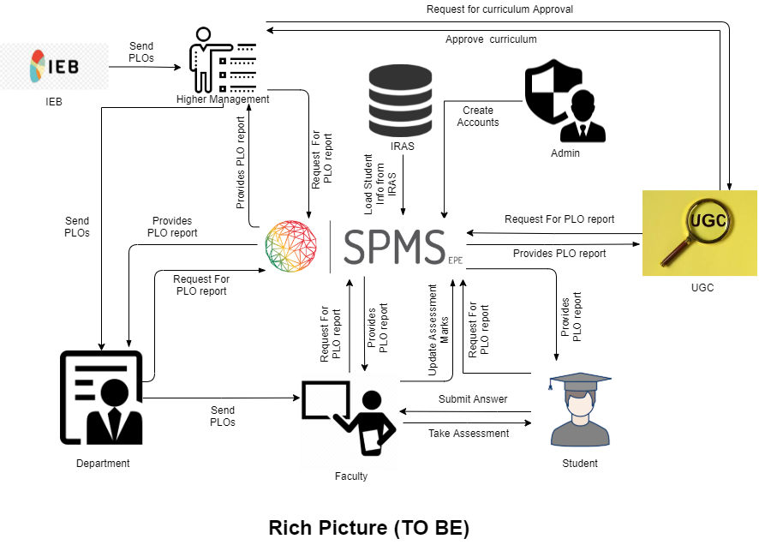

**F. Six Element Analysis of Proposed System:**

|  |  |  |  |  |  |  |
| --- | --- | --- | --- | --- | --- | --- |
| Process | System Roles | | | | | |
| Human | Non-Comp  Hardware | Computing  Hardware | Software | Database | Network &  Communication |
| STUDENT’S ASSESSMENT | **1.Faculty :**  a)Create Question Paper.  b) Takes exam of  students in the  form of quizzes,  midterm and final  term by providing  questions.  c) Create  assessment report.  d) Updates assessment marks directly to SPMS  **2.Student:**  a) Answers the questions  provided by  Faculty.  b) submit the answer paper to the faculty. | **1.Paper:**  a) Used to  prepare hardcopy  of question  papers that are  used to assess  students in  exams.  b) Used to  prepare hardcopy  assessment  report.  c) Used to  provide hardcopy  of answer script  to the faculty.  **2.Stationery:**  a) Used to check  hardcopy of  answer script  provided by  students.  b) Used to fill  answer scripts  that are to be  provided to  faculty.  **3.Store Room:**  a) Used to store  all hardcopy of  questions, answer scripts  and assessment  reports. | **1.Computer:**  a) Used to  prepare softcopy  of question  papers that are  used to assess  students in  exams.  b) Used to  prepare softcopy  assessment  report.  c) Used to  prepare softcopy  of answer script  to the faculty.  d) Used to store  all softcopy of  questions,  answer scripts  and assessment  reports.  **2.Printer:**  a) Used to print  the questions on  to paper.  b) Used to print  the assessment  report.  c) Used to print  the answer script. | **1.Microsoft Word:**  a) Used to prepare  softcopy of question  papers that are used  to assess students in  exams.  b) Used to prepare  softcopy of answer  script to faculty.  **2.Microsoft** Excel :  a) Used to prepare  softcopy assessment  report.  **3.Gmail :**  a) Used to send  softcopy of  questions, answer  scripts and  assessment reports  to designated  personnel. | **1.Google Drive:**  a) Used to store and  backup all softcopy  of questions,  answer scripts and  assessment reports  on the internet.  2. **SPMS** - Updates and stores mark sheet in MySQL | **1.ISP:**  a) Provides  Internet service so  that the use of  Gmail, Google  Drive and SPMS  is possible. |
| Curriculum Approval by UGC | **1.Higher**  **Management:**  a) Forms a  committee of  faculty to prepare  a curriculum in  accordance to the  guideline provided  by UGC.  b) Receives  proposed  curriculum  provided by the  designated faculty  committee.  c) Requests UGC  for approval of  curriculum.  d. Receives  approval or  necessary  correction details  from UGC.  e) Sends  confirmation of  approved/corrected curriculum to  admin for storing.  **2.UGC:**  a)Receives  request from  higher  management for  approval of  curriculum.  b) Sends approval  or necessary  correction details  of curriculum to  higher  management.  c) Provides  guidelines to  higher  management for  preparing the  curriculum. | **1.Paper:**  a) Used to  prepare hardcopy  of faculty  committee  details, UGC guidelines,  proposed/  corrected curriculum,  approved  curriculum.  **2.Stationery:**  a) Used for  handwritten  mind mapping in  regards to faculty  committee  details,  proposed/corrected curriculum,  approved  curriculum.  **3.Store Room:**  a) Used to store  hardcopy of  approved  curriculum. | **1.Computer:**  a)Used to  receive, store and  analyze UGC  guidelines.  b) Used to  prepare and  store softcopy of  faculty  committee  details,  proposed/  corrected curriculum,  and approved  curriculum.  **2.Printer:**  a) Used to print  hardcopy of  faculty  committee  details, UGC  guidelines,  proposed/  corrected curriculum,  approved  curriculum. | **1.PDF Reader:**  a) Used to view and  store the softcopy of  received guidelines  from UGC, faculty  committee details,  proposed/corrected  curriculum and  approved curriculum  in PDF format.  **2.Microsoft Word:**  a) Used to prepare,  view and store  softcopy of faculty  committee details,  proposed/corrected  curriculum and  approved curriculum  in word format.  **2.Microsoft Excel:**  a) Used to prepare  softcopy for the  mapping of CO to PO  while creating  courses for the  curriculum.  **3.Gmail :**  a)Used to send  softcopy of faculty  committee details,  UGC guidelines,  proposed/corrected  curriculum,  approved curriculum  to designated  personnel. | **1.Google Drive:**  a) Used to store and  backup all softcopy  of faculty  committee details,  UGC guidelines,  proposed/corrected  curriculum,  approved  curriculum on the  internet. | **1.ISP:**  a) Provides  Internet service so  that the use of  Gmail, Google  Drive  is possible. |
| Collecting  PLOs from IEB | **1. IEB:**  a) Send PLOs to higher  management.  **2.Higher**  **Management:**  a) Receives PLOs from IEB  b) Send PLOs to the department.  **3.Department:**  a)Send the PLOs to the Faculty  **4.Faculty:**  a) Receives  PLOs from the Department. | **1.Paper:**  a) Used to  prepare hardcopy  Of the PLOs  **2.Stationery:**  a) Used for  handwritten  assessment to  create PLO  report.  **3.Store room:**  a) Used to store  hardcopy of PLO  report. | **1.Computer:**  a) Used to  prepare and  store softcopy of  PLO report.  **2.Printer:**  a) Used to print  hardcopy of PLO report | **1.PDF Reader:**  a) Used to view and  store the softcopy of  PLO report  **2. Microsoft Excel:**  a) Used to prepare,  view and store  softcopy of PLO  report in Excel Shit.  **3.Gmail:**  a. Used to  send/receive  softcopy of  PLOs from IEB to Higher management to faculty to Admin personnel. | **1.Google Drive:**  a) Used to store and  backup all softcopy  of PLO Report on the  internet. | **1.ISP:**  a) Provides  Internet service so  that the use of  Gmail, Google  Drive  is possible. |
| Getting student information for courses enrolled |  |  | **Server Computer –** SPMS sends requests to IRAS for student information on courses enrolled each semester through API. | **1.SPMS:**  a) Sends requests to IRAS for Student information on courses enrolled each semester through API.  **2. IRAS:**  a) Sends requested information to SPMS. | **1.MySQL :**  Stores Student information on courses enrolled each semester | **1.ISP:**  SPMS and IRAS require internet which is provided by ISP. |
| Viewing the required PLO Report | 1.**UGC**  a) Request for information on PLO report  b) Get the information from the system.  2.**Higher Management**  a) Request for information on PLO report  b) Get the information from the system.  3.**Department**  a) Request for information on PLO report  b) Get the information from the system.  4.**Faculty**  a) Request for information on PLO report  b) Get the information from the system.  5.**Student**  a) Request for information on PLO report  b) Get the information from the system. |  | 1.**Computer**:  Used to browse PLO reports from SPMS.  2.**Phone**:  Use to browse PLO report from SPMS | 1.**SPMS**: Prepare the required PLO report for stakeholders  2. **Web Browser**:  Access the SPMS website | 1. **MY SQL**: Store the necessary data which are used to make the POL report. | 1. **ISP**: Provides Internet service to the Stakeholders so that they can access the information. |

**G. Process Diagram (TO-BE):**

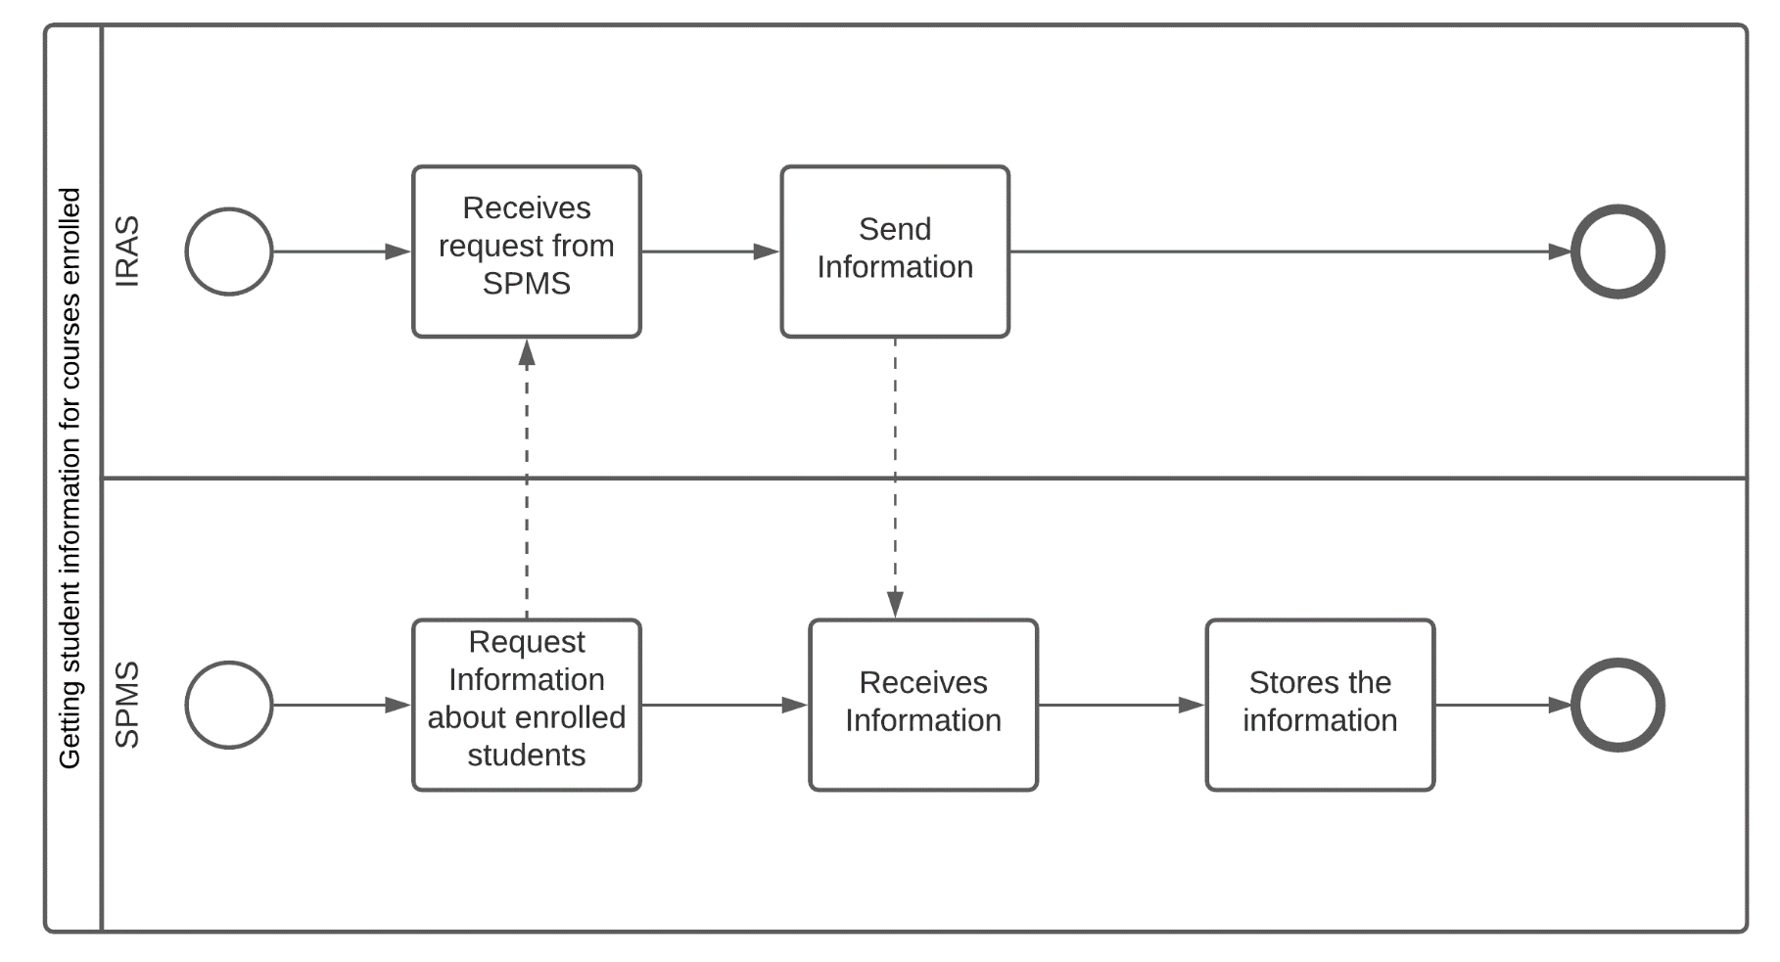

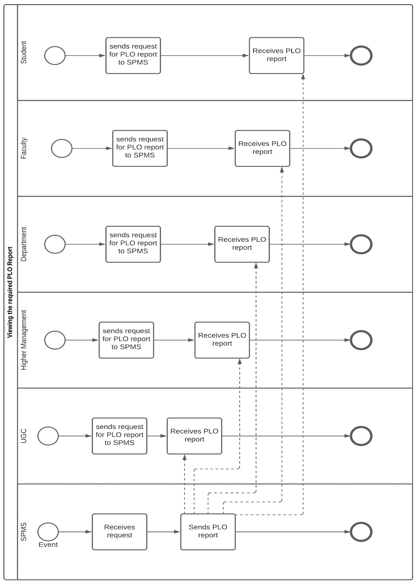

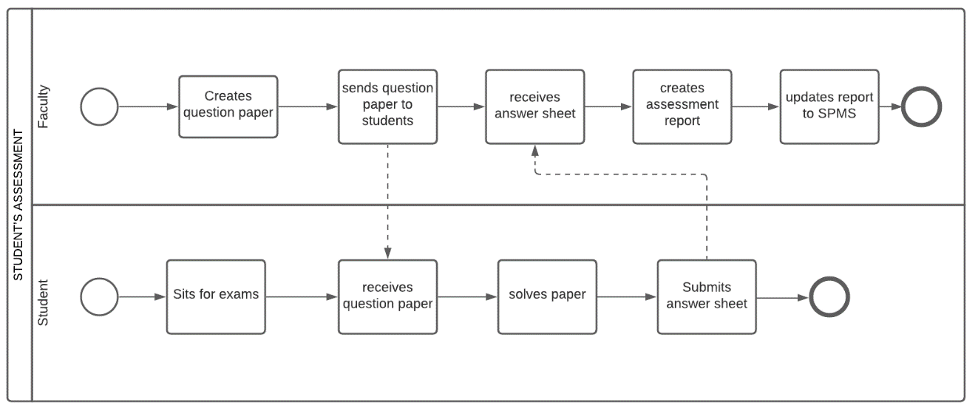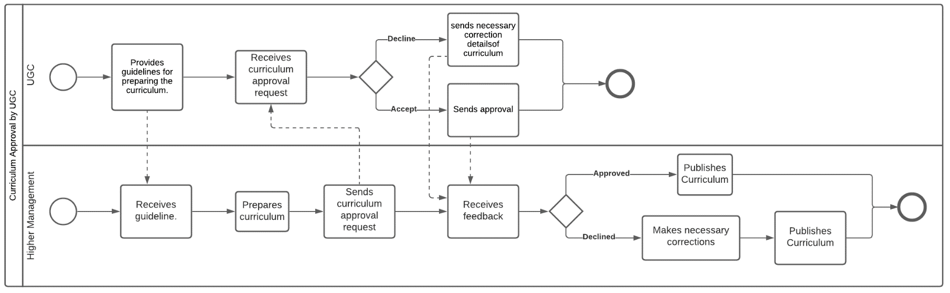

**CHAPTER 3**

**LOGICAL SYSTEM DESIGN**

● BUSINESS RULE

● ENTITY-RELATIONSHIP DIAGRAM

● ENTITY RELATIONSHIP DIAGRAM TO RELATIONAL SCHEMA

● NORMALIZATION

● DATA DICTIONARY

BUSINESS RULE

The goal of the software is to increase efficiency in monitoring the students' performance. The SPM system is where all the PLO(Program Learning Outcome) and CO(Course Outcome) is stored. The CO needs to be updated by the faculty for each course and before the semester starts to map the COs to the PLOs so that they can check if each student has achieved the required PLOs.

In the system, IEB has no authorization to update the PLOs, so it has to send it to the Admin and then the Admin updates the PLO for the faculties to map. The faculties can update the COs based on the given PLOs. The students can view their achieved PLOs for a particular course they've taken and see the required PLOs for the program in the system UGC has no authorization in monitoring the student’s performance so they have to request it through admin in order to view it.

ENTITY-RELATIONSHIP DIAGRAM

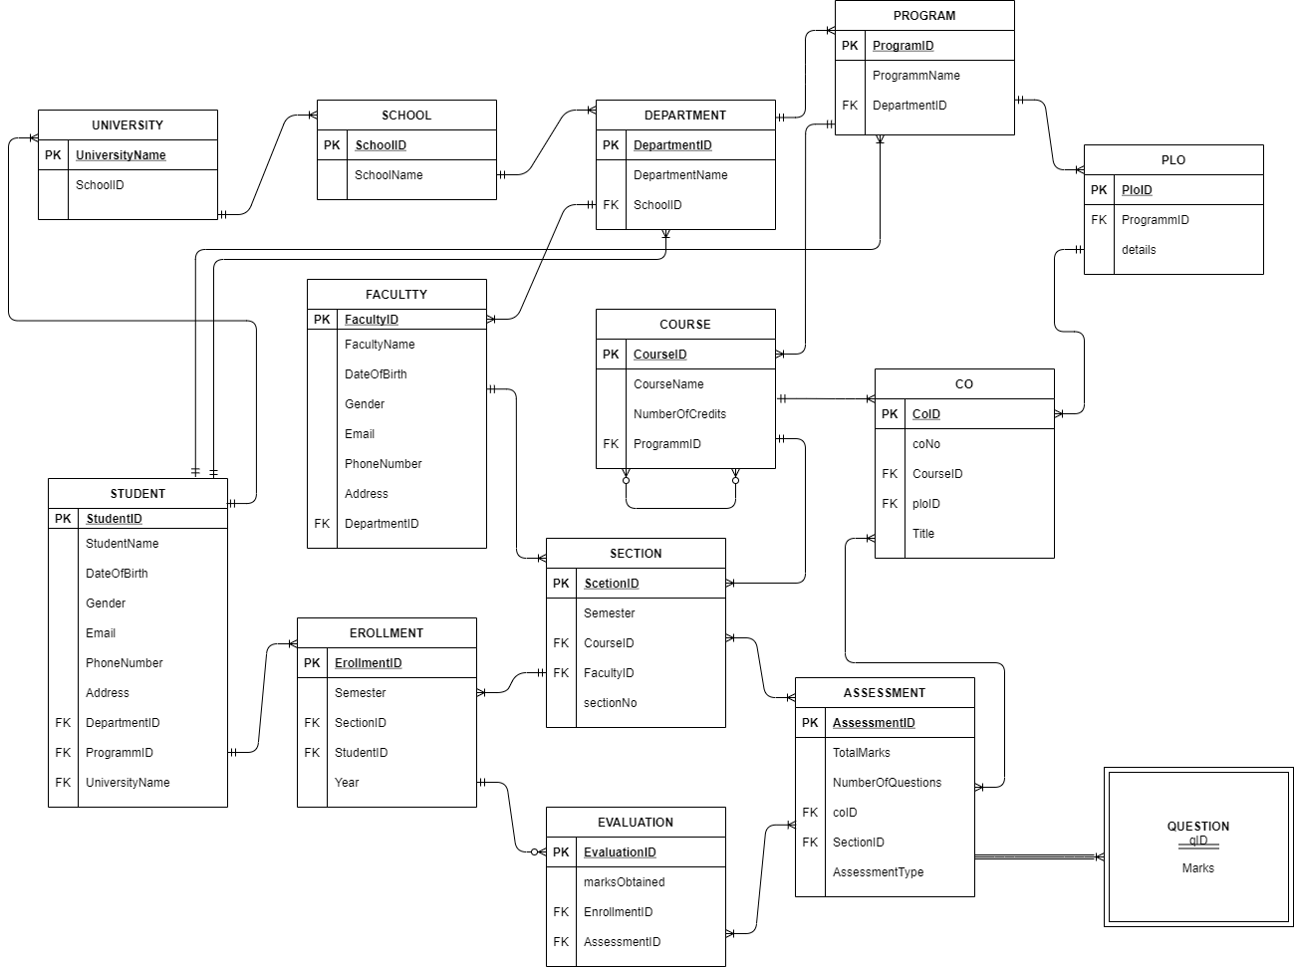

**Entity Relationship Diagram of SPMS**

ENTITY RELATIONSHIP DIAGRAM TO RELATIONAL SCHEMA

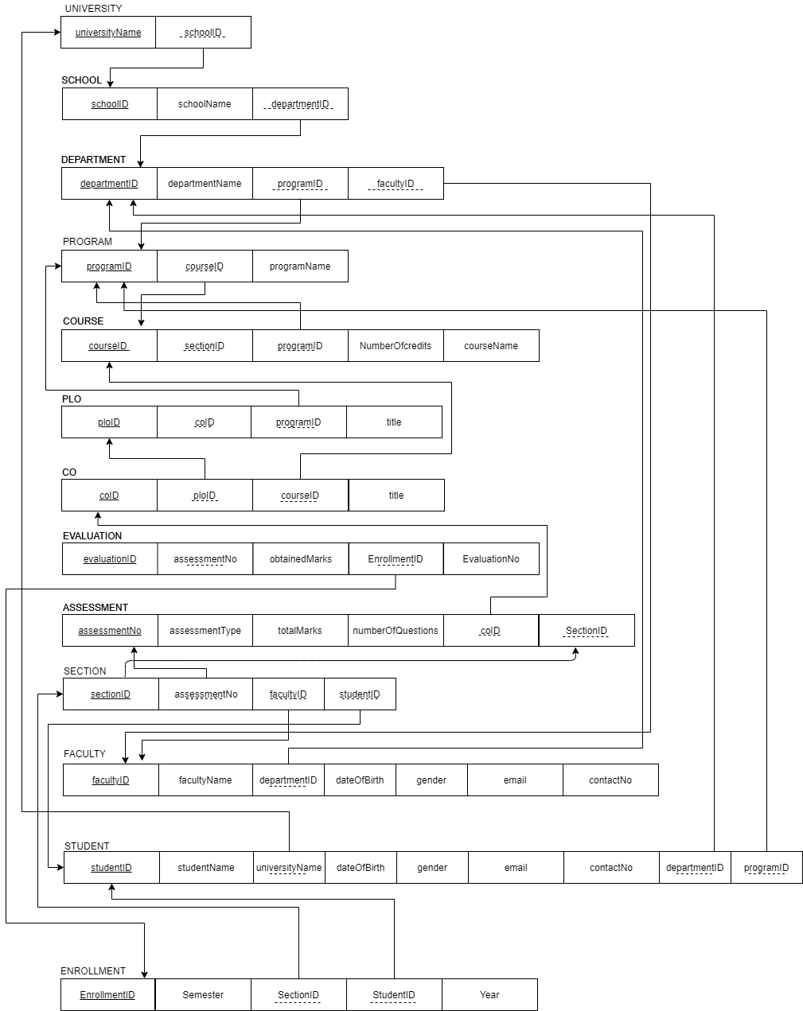

NORMALIZATION

|  |  |  |  |  |  |
| --- | --- | --- | --- | --- | --- |
| Enrollment | EnrollmentID | e1 | Evaluation | EvaluationID | v1 |
| semester | e2 | evaluationNo | v2 |
| year | e3 | obtainedMarks | v3 |
| StudentID | t1 | assessmentNo | a1 |
| SectionID | q1 | EnrollmentID | e1 |
| Section | SectionID | q1 | Student | StudentID | t1 |
| sectionNo | q2 | studentName  UniversityName | t2  u1 |
| semester | q3 |
| CourseID | o1 | dateOfBirth | t4 |
| FacultyID | f1 | gender | t5 |
| Course | CourseID | o1 | email | t6 |
| courseName | o2 | phone | t7 |
| noOfCredits | o3 | address | t8 |
| courseType | o4 | DepartmentID | d1 |
| ProgramID | r1 | ProgramID | r1 |
| Program | ProgramID | r1 | Faculty | FacultyID | f1 |
| programName | r2 | facultyName | f2 |
| DepartmentID | d1 |
| Course | CourseID | o1 | gender | f4 |
| courseName | o2 | dateOfBirth | f5 |
| noOfCredits | o3 | email | f6 |
| courseType | o4 | phone | f7 |
| ProgramID | r1 | address | f8 |
| School | SchoolID | s1 | DepartmentID | d1 |
| SchoolName | s2 | Assessment | assessmentNo | a1 |
| CO | coID | c1 | marksObtained | a2 |
| coNo | c2 | coID | c1 |
| ploID | p1 | SectionID | q1 |
| title | z1 | NumberOfQuestions | x1 |
| CourseID | o1 | PLO | ploID | p1 |
| Department | DepartmentID | d1 | ploNo | p2 |
| DepartmentName | d2 | details | p3 |
| SchoolID | s1 | ProgramID | r1 |
| University | universityName | u1 |  |  |  |
| schoolID | s1 |  |  |  |

|  |  |
| --- | --- |
| u1➔ | s1 |
| s1➔ | s2 |
| d1➔ | d2, s1 |
| r1➔ | r2, d1 |
| f1➔ | f3, f4, f5, f6, f7, f8, d1 |
| t1➔ | t2, t4, t5, t6, t7, t8, r1, d1,u1 |
| o1➔ | o2, o3, o4, r1 |
| p1➔ | p2, p3, r1 |
| c1➔ | c2, p1, o1,z1 |
| q1➔ | q2, q3, o1, f1 |
| e1➔ | e2, e3, q1, t1 |
| a1➔ | a2, c1, q1,x1 |
| **v1**➔ | v2, v3, a1, e1 |

|  |  |
| --- | --- |
| universityName➔ | schoolID |
| SchoolID➔ | SchoolName |
| DepartmentID➔ | DepartmentName, SchoolID |
| ProgramID➔ | programName, DepartmentID |
| FacultyID➔ | facultyName, gender, dateOfBirth, email, phone, address, DepartmentID |
| StudentID➔ | studentName, dateOfBirth, gender, email, phone, address,DepartmentID,ProgramID,universityName |
| CourseID➔ | courseName, noOfCredits, courseType, ProgramID |
| ploID➔ | ploNo, details, ProgramID |
| coID➔ | coNo, ploID, CourseID, title |
| SectionID➔ | sectionNo, semester, CourseID, FacultyID |
| EnrollmentID➔ | semester, year, SectionID, StudentID |
| assessmentNo➔ | ocID, SectionID,assessmentType, NumberOfQuestions |
| EvaluationID➔ | evaluationNo, obtainedMarks, assesmentNo, EnrollmentID |

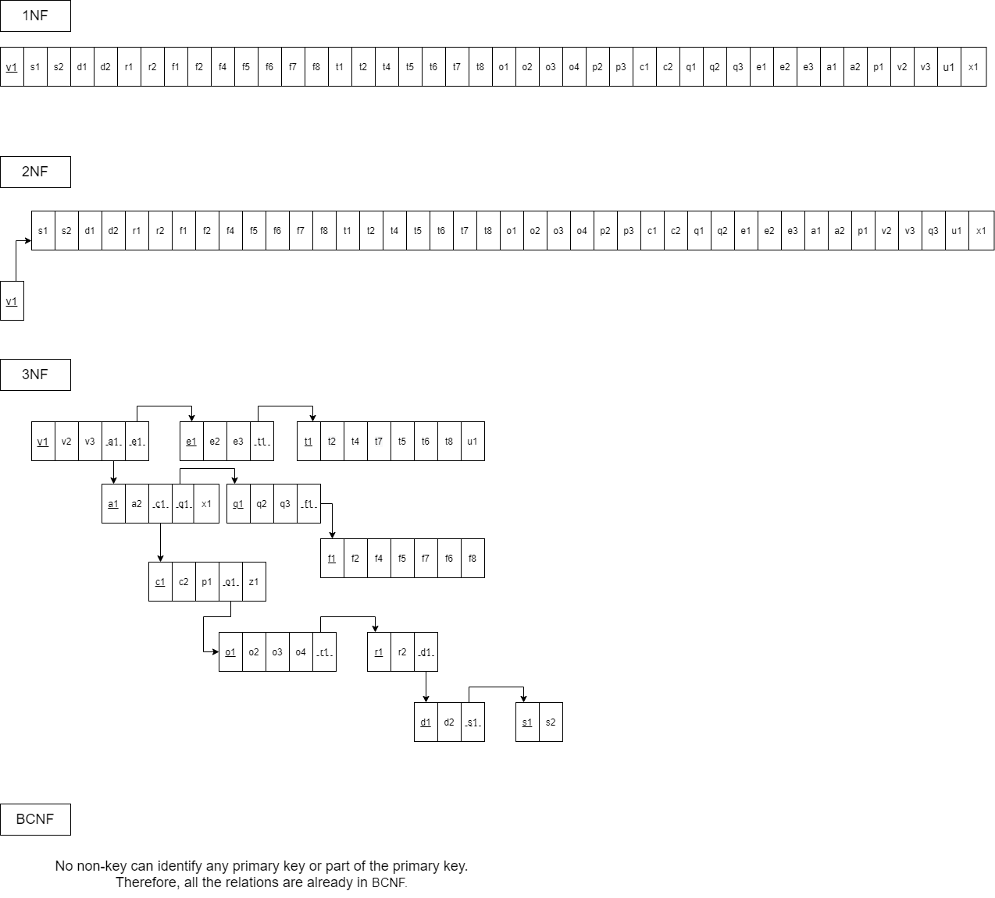

DATA DICTIONARY:

university_T

|  |  |  |  |
| --- | --- | --- | --- |
| **Name** | **Data Type** | **Size** | **Remark** |
| UniversityName | VARCHAR | 15 | This is the Primary Key of the Department. Example: ”IUB” |
| SchoolID | VARCHAR | 10 | This is the Foreign Key of the table School. Example: “SETS” |

Department_T

|  |  |  |  |
| --- | --- | --- | --- |
| **Name** | **Data Type** | **Size** | **Remark** |
| DepartmentID | VARCHAR | 10 | This is the Primary Key of the Department. Example: “CSE” |
| DepartmentName | VARCHAR | 30 | This is the name of the Department.  Example: “Computer Science and Engineering” |
| school_id | VARCHAR | 5 | This is the Foreign Key of the table School. Example: “SETS” |

School_T

|  |  |  |  |
| --- | --- | --- | --- |
| **Name** | **Data Type** | **Size** | **Remark** |
| SchoolID | VARCHAR | 10 | This is the Primary Key of School  Example: “SETS” |
| SchoolName | VARCHAR | 30 | This is the name of the School.  Example: “School of Engineering, Technology and Science” |

**Program_T**

|  |  |  |  |
| --- | --- | --- | --- |
| **Name** | **Data Type** | **Size** | **Remark** |
| ProgramID | VARCHAR | 10 | This is the Primary Key for a Program  Example: ”B.Sc”. |
| ProgramName | VARCHAR | 30 | This is the name of the Degree Program. Example: “Bachelor of Science” |
| department_id | VARCHAR | 10 | This is the Foreign Key from the Department table.  Example: “CSE” |

**Student_T**

|  |  |  |  |
| --- | --- | --- | --- |
| **Name** | **Data Type** | **Size** | **Remark** |
| StudentID | VARCHAR | 10 | This is the Primary Key for the Student. Example: “1930038” |
| StudentName | VARCHAR | 30 | This is the first name of the Student.  Example: “Istiak Ahammad” |
| DateOfBirth | DATE | DD-MM-YY | This is the Date of Birth of the Student.  Example: “08-11-2000” |
| Gender | VARCHAR | 3 | This is the gender of the Student.  Example: “M” |
| Email | VARCHAR | 30 | This is the email address of the Student. Example: “1930038@iub.edu.bd” |
| Address | VARCHAR | 35 | This is the address of the Student.  Example: “House 1, Road 1, Sector 1, Uttara, Dhaka, Bangladesh” |
| department_id | VARCHAR | 10 | This is the Foreign Key from the Department table.  Example: “CSE” |
| programm_id | VARCHAR | 10 | This is the Foreign Key from the Program table Example: ”B.Sc”. |
| university_name | VARCHAR | 15 | Foreign Key from the university table Example: ”IUB”. |

**CO_T**

|  |  |  |  |
| --- | --- | --- | --- |
| **Name** | **Data Type** | **Size** | **Remark** |
| CoID | VARCHAR | 10 | This is the Primary Key for Course Outcome. Example: |
| CoNo | VARCHAR | 10 | This is the number of the Course Outcome. Example: ”1” |
| course_id | VARCHAR | 10 | This is the Foreign Key from the Course table. Example: “CSE101” |
| plo_id | VARCHAR | 10 | This is the foreign key from the Program Learning Outcome table.  Example: “PLO1” |
| Title | VARCHAR | 50 | This is the title of the Course Outcome. Example: ”Deep Thinking” |

**PLO_T**

|  |  |  |  |
| --- | --- | --- | --- |
| **Name** | **Data Type** | **Size** | **Remark** |
| PloNo | VARCHAR | 10 | This is the primary key for Program Learning Outcome.  Example: “PLO1” |
| program_id | VARCHAR | 10 | This is the foreign key from the Program table Example: ”B.Sc”. |
| details | VARCHAR | 50 | This is the details of the Program Learning Outcome.  Example: “An ability to select and apply the knowledge, techniques, skills, and modern tools of the computer science and  engineering discipline” |

**Faculty_T**

|  |  |  |  |
| --- | --- | --- | --- |
| **Name** | **Data Type** | **Size** | **Remark** |
| FacultyID | VARCHAR | 10 | This is the Primary Key for Faculty.  Example: “1801” |
| FacultyName | VARCHAR | 30 | This is the name of the Faculty. Example: “Abu sayed” |
| DateOfBirth | DATE | DD-MM-YY | This is the Date of Birth of the Faculty. Example: “11-05-1989” |
| Gender | VARCHAR | 3 | This is the gender of the Faculty.  Example: “M” |
| Email | VARCHAR | 30 | This is the email address of the Faculty. Example: “abusayed@iub.edu.bd” |
| PhoneNumber | VARCHAR | 20 | This is the phone number of the Faculty. Example: “145687015” |
| department_id |  | 10 | This is the Foreign Key from the Department table.  Example: “CSE” |

**Course_T**

|  |  |  |  |
| --- | --- | --- | --- |
| **Name** | **Data Type** | **Size** | **Remark** |
| CourseID | VARCHAR | 10 | This is the Primary Key for the Course. Example: “CSE203” |
| CourseName | VARCHAR | 30 | This is the name of the Course.  Example: ”Data Structure” |
| NumberOfCredits | VARCHAR | 3 | This is the credit for the Course.  Example: ”3” |
| program_id | VARCHAR | 10 | This is the Foreign Key from the Program table Example: ”B.Sc”. |

**Section_T**

|  |  |  |  |
| --- | --- | --- | --- |
| **Name** | **Data Type** | **Size** | **Remark** |
| SectionID | VARCHAR | 10 | This is the Primary Key for Section |
| Semester | VARCHAR | 15 | This is the semester name: “Autumn” |
| course_id | VARCHAR | 10 | This is the foreign key from the Course table.  Example: “CSE101” |
| faculty_id | VARCHAR | 10 | This is the foreign key from Faculty table Example: “1801” |
| SectionNo | VARCHAR | 5 | This is the section number.  Example: “1” |

**Enrollment_T**

|  |  |  |  |
| --- | --- | --- | --- |
| **Name** | **Data Type** | **Size** | **Remark** |
| EnrollmentID | VARCHAR | 10 | This is the Primary Key for Enrollment |
| Semester | VARCHAR | 15 | This is the semester of Enrollment Example: “Summer” |
| section_id | VARCHAR | 10 | This is the Foreign Key from the Section table |
| student_id | VARCHAR | 10 | This is the Foreign key from the Student Table.  Example: “1930038” |
| Year | VARCHAR | 5 | This is the year of Enrollment  Example: “2019” |

**Assessment_T**

|  |  |  |  |
| --- | --- | --- | --- |
| **Name** | **Data Type** | **Size** | **Remark** |
| AssessmentNo | VARCHAR | 10 | This is the Primary Key for Enrollment |
| marksObtained | VARCHAR | 5 | This is the marks of the assessment Example: “30” |
| numberOfQuestion | VARCHAR | 5 | This is the number of questions in the assessment Example: “10” |
| co_id | VARCHAR | 10 | This is the Foreign Key from the Course |
| sectoion_id | VARCHAR | 10 | This is the Foreign Key from Section table |
| AssessmentType | VARCHAR | 15 | This is the type of assessment: “Mid Term” |

**Evaluation_T**

|  |  |  |  |
| --- | --- | --- | --- |
| **Name** | **Data Type** | **Size** | **Remark** |
| EvaluationID | VARCHAR | 10 | This is the Primary Key for Evaluation |
| marksObtained | VARCHAR | 5 | These is the marks obtained by the Student Example: “29.5” |
| enrollment_id | VARCHAR | 10 | This is the Foreign Key from the Enrollment table |
| assessment_no | VARCHAR | 15 | This is the Foreign Key from the Assessment table |

**CHAPTER 4**

**PHYSICAL SYSTEM DESIGN**

**● INPUT FORMS**

**● OUTPUT VIEWS**

**Input form: Assessment Details**

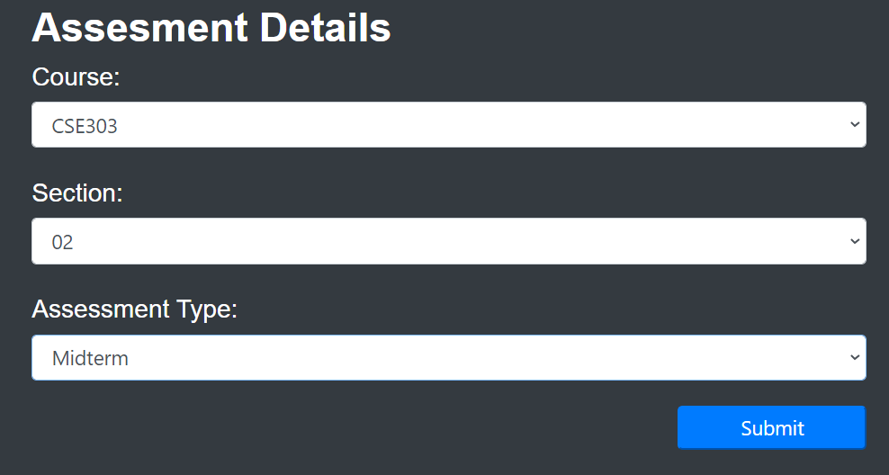

This is a faculty only screen. It allows the faculty to choose the following course and section along with determining the type of assessment. For ex. Final, Midterm or Quiz.

**Input form: PLO-CO mapping for the assessment**

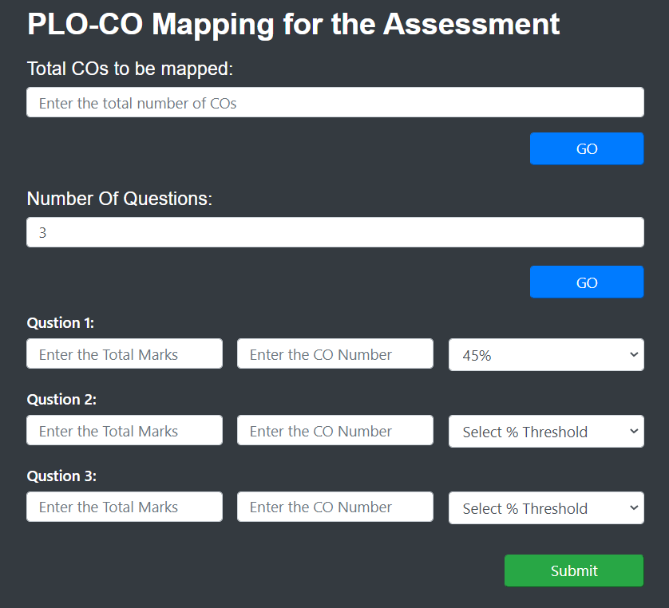

Here the faculty gets to enter the total number of CO’s along with the total number questions which will then generate a form for the faculty to input total marks for each question, associated CO number for each question and the percentage threshold.

**Input form: Assessment performance of each student**

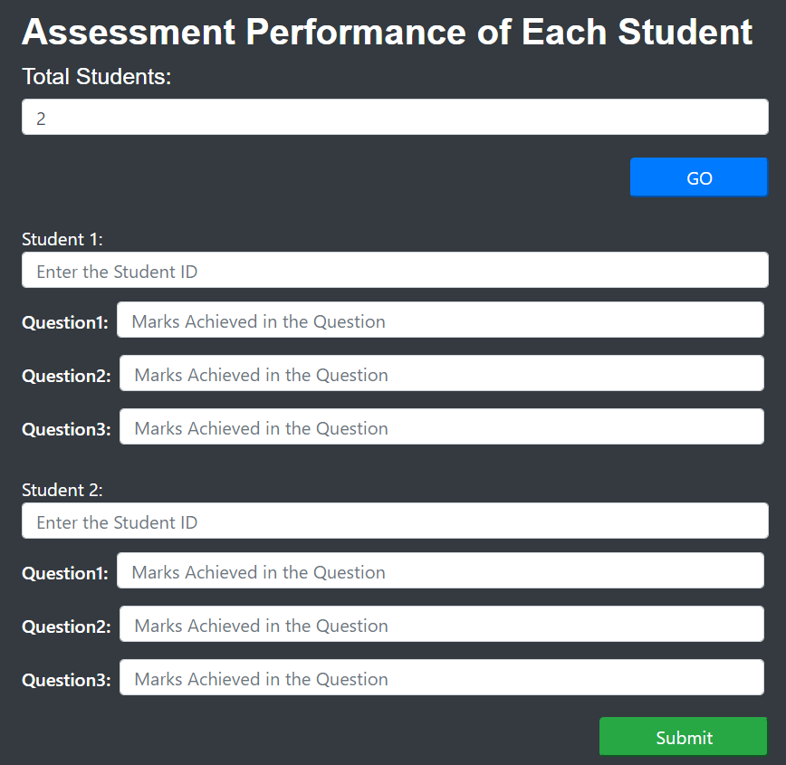

Here the faculty inputs the number of total students to be assessed. After selecting “go” , inputs for all the students gets generated automatically.

**OUTPUT VIEWS**

**Student Wise PLO ANALYSIS:**

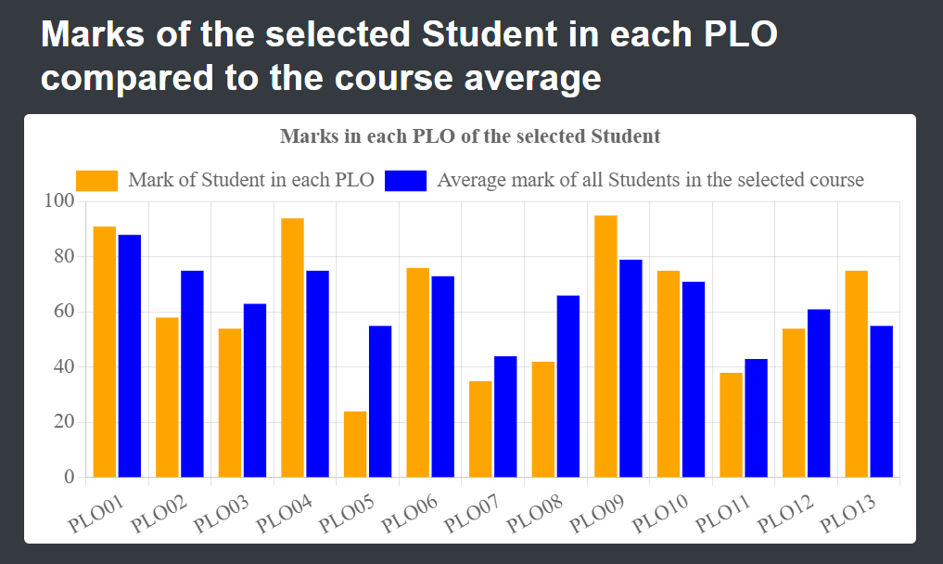

**SELECT AVG(TotalPlo.PLOpercentage) AS ActualPlo**

**FROM (**

**SELECT (PLO / TotalComark * 100) AS PLOpercentage**

**FROM (**

**SELECT SUM(DISTINCT e.obtainedMarks) AS PLO, SUM(DISTINCT a.marks) AS TotalCoMark**

**FROM performance_monitor_enrollment_t en,**

**performance_monitor_evaluation_t e,**

**performance_monitor_assessment_t a,**

**performance_monitor_co_t c,**

**performance_monitor_plo_t p**

**WHERE en.student_id = '{}'**

**AND en.enrollmentID = e.enrollment_id**

**AND e.assessment_id = a.assessmentNo**

**AND a.co_id = c.coID**

**AND c.plo_id = '{}'**

**GROUP BY en.section_id**

**) ploPer**

**) TotalPlo;**

**University Wise PLO ANALYSIS:**

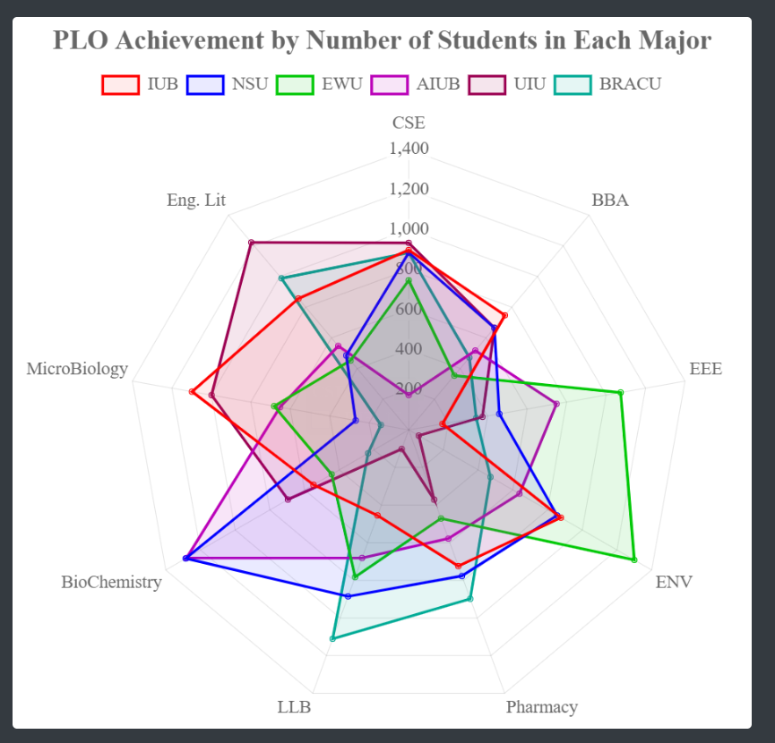

**SELECT AVG(TotalPlo.PLOpercentage) AS ActualPlo**

**FROM (**

**SELECT (PLO / TotalComark * 100) AS PLOpercentage**

**FROM (**

**SELECT SUM(e.obtainedMarks) AS PLO, SUM(a.marks) AS TotalCoMark**

**FROM performance_monitor_enrollment_t en,**

**performance_monitor_evaluation_t e,**

**performance_monitor_assessment_t a,**

**performance_monitor_co_t c,**

**performance_monitor_plo_t p,**

**performance_monitor_student_t st**

**WHERE st.department_id = '{}'**

**AND st.studentID = en.student_id**

**AND en.enrollmentID = e.enrollment-id**

**AND e.assessmentID = a.assessmentNo**

**AND a.coID = c.coID**

**AND c.ploID = '{}'**

**GROUP BY en.sectionID**

**) ploPer**

**) TotalPlo;**

**PLO attempted VS Achieved By Students:**

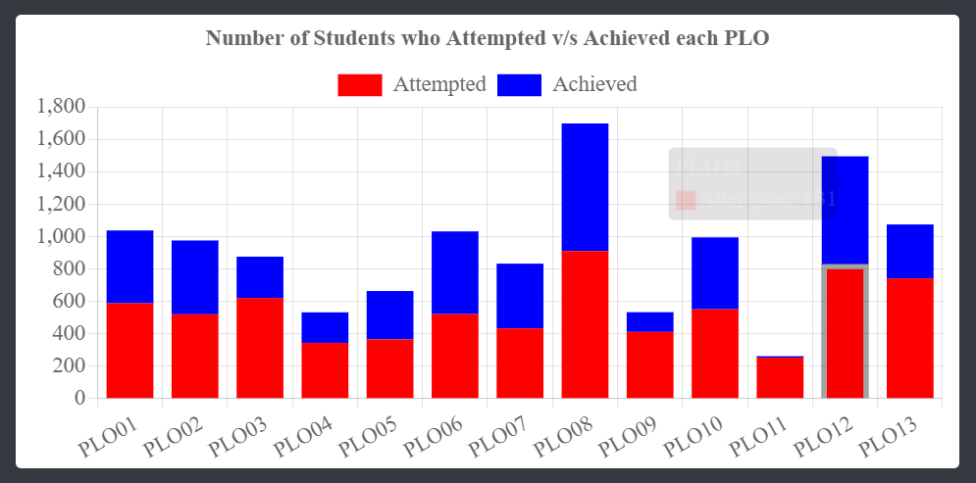

**SELECT COUNT(TotalPlo.PLOpercentage) AS Acheive**

**FROM (**

**SELECT studentID,(PLO / TotalComark * 100) AS PLOpercentage**

**FROM performance_monitor_plo_t p,**

**performance_monitor_co_t c,**

**(**

**SELECT en.studentID,c.plo_id,SUM(DISTINCT e.obtainedMarks) AS PLO,SUM(DISTINCT a.marks)AS TotalCoMark**

**FROM performance_monitor_enrollment_t en,**

**performance_monitor_evaluation_t e,**

**performance_monitor_assessment_t a,**

**performance_monitor_co_t c,**

**performance_monitor_plo_t p,**

**performance_monitor_section_t s**

**WHERE en.studentID = '{}'**

**AND en.enrollmentID = e.enrollment_id**

**AND e.assessmentID = a.assessmentNo**

**AND a.coID = c.co_id**

**AND c.ploID = p.ploNo**

**GROUP BY studentID,p.ploNo**

**) ploPer**

**WHERE p.ploNo = ploPer.ploID**

**GROUP BY studentID,ploNo**

**HAVING PLOpercentage >=40**

**) TotalPlo**

**GROUP BY studentID**

**SELECT COUNT(TotalPlo.PLOpercentage) AS Acheive**

**FROM (**

**SELECT studentID,(PLO / TotalComark * 100) AS PLOpercentage**

**FROM performance_monitor_plo_t p,**

**performance_monitor_co_t c,**

**(**

**SELECT en.studentID,c.plo_id,SUM(DISTINCT e.obtainedMarks) AS PLO,SUM(DISTINCT a.marks)AS TotalCoMark**

**FROM performance_monitor_enrollment_t en,**

**performance_monitor_evaluation_t e,**

**performance_monitor_assessment_t a,**

**performance_monitor_co_t c,**

**performance_monitor_plo_t p,**

**performance_monitor_section_t s**

**WHERE en.student_id = '{}'**

**AND en.enrollmentID = e.enrollment_id**

**AND e.assessmentID = a.assessmentNo**

**AND a.coID = c.coID**

**AND c.ploID = p.ploNo**

**GROUP BY studentID,p.ploNo**

**) ploPer**

**WHERE p.ploNo = ploPer.ploID**

**GROUP BY studentID,ploNo**

**) TotalPlo**

**COURSE WISE PLO ANALYSIS:**

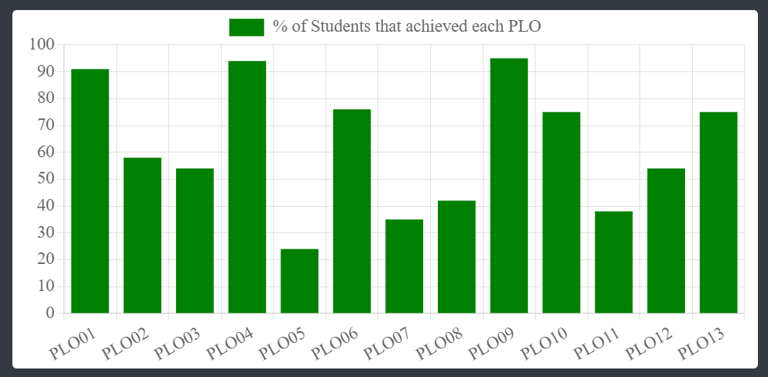

**SELECT DISTINCT co.course_id, co.coNo, p.ploNo, (PLO / TotalComark * 100) AS**

**PLOpercentage**

**FROM Performance_monitor_plo_t p, mainapp_co_t co, (**

**SELECT DISTINCT c.course_id,c.coNo, c.plo_id, SUM(DISTINCT**

**e.obtainedMarks) AS PLO, SUM(DISTINCT a.marks) AS TotalCoMark**

**FROM Performance_monitor_enrollment_t en,**

**Performance_monitor_evaluation_t e,**

**Performance_monitor_assessment_t a,**

**Performance_monitor_co_t c,**

**Performance_monitor_plo_t p**

**GROUP BY en.section_id,c.plo_id**

**ORDER BY c.plo_id**

**) ploPer**

**WHERE co.coNo = ploPer.coNo**

**AND p.ploNo = ploPer.plo_id**

**AND co.course_id = ploPer.course_id;**

**CHAPTER 5**

**CONCLUSION**

**● PROBLEM AND SOLUTION**

**● ADDITIONAL FEATURES &**

**FUTURE DEVELOPMENT**

**● CONCLUSION & RECOMMENDATIONS**

**PROBLEM AND SOLUTION**

* The limited amount of mark sheets and information provided on students and faculties, we had to limit a lot of our calculations and work. If provided with more resources and data to work with, we believe we could have achieved a much reliable and accurate result, representation and prediction.
* The bounded timeframe of the semester has stalled our ability to achieve the full potential of this software. We believe we have created the best possible software from the limited resources and time provided, and hope to come up with improvements with better analysis when allowed more time.

**ADDITIONAL FEATURES AND FUTURE DEVELOPMENT:**

* The addition of an assessment page where faculties will be able to add marks for a specific assessment and fix the threshold for each question of a student throughout the term.
* Users will be expanded to also include advisors, where advisors will get relevant information about the students they're advising for improved and more beneficial interactions between students and advisors.
* The addition of Curriculum Page in the SPM where members of the Higher Management team can add and edit any changes to curriculum. Moreover, faculty members and students can check these updates to stay informed about the latest changes.

**CONCLUSION AND RECOMMENDATIONS:**

We believe that we have designed, built and implemented the best possible version of the idea we had for our SPM software. Through the proper usage of this software, we are hopeful to achieve a drastically improved quality of education that universities provide. This software is serviceable to students who want to improve themselves as better and more competent scholars, for faculties to keep better track of their students and improve their teaching methods accordingly, and for the members of the institution to better regulate their resources.