**Project_2 Report**

Group 18 E24076849 翁麒庭

E24076239 彭恩宇

E24072073 王俊傑

XX1092023 梁師睿

**Create a Chat Room in Linux system**

Part A: Code section

Server code:

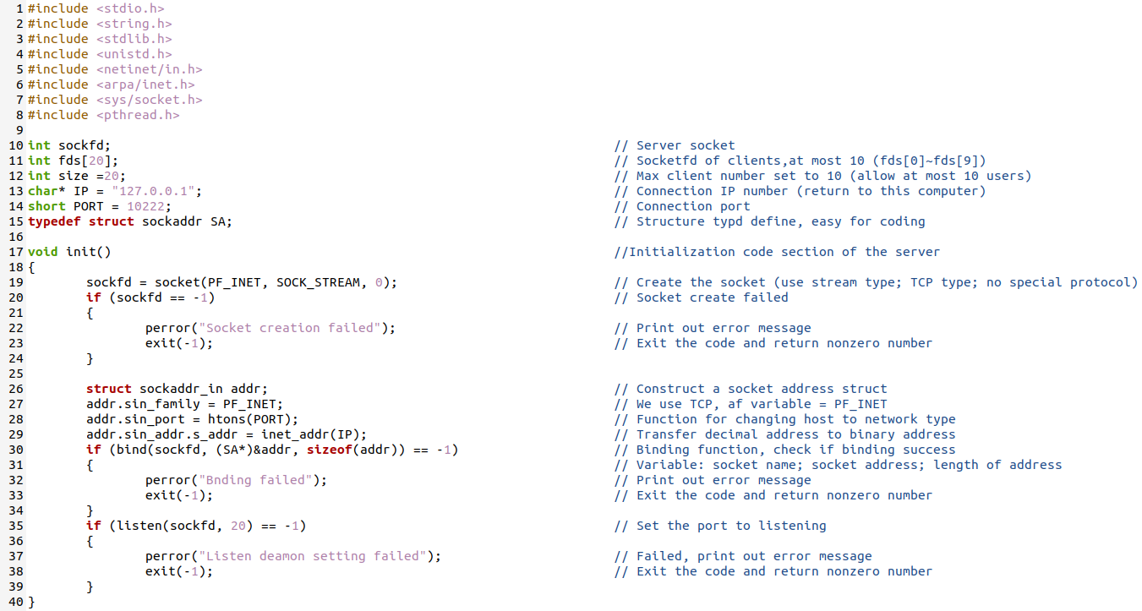

Figure 1. Server code and comment (initialization)

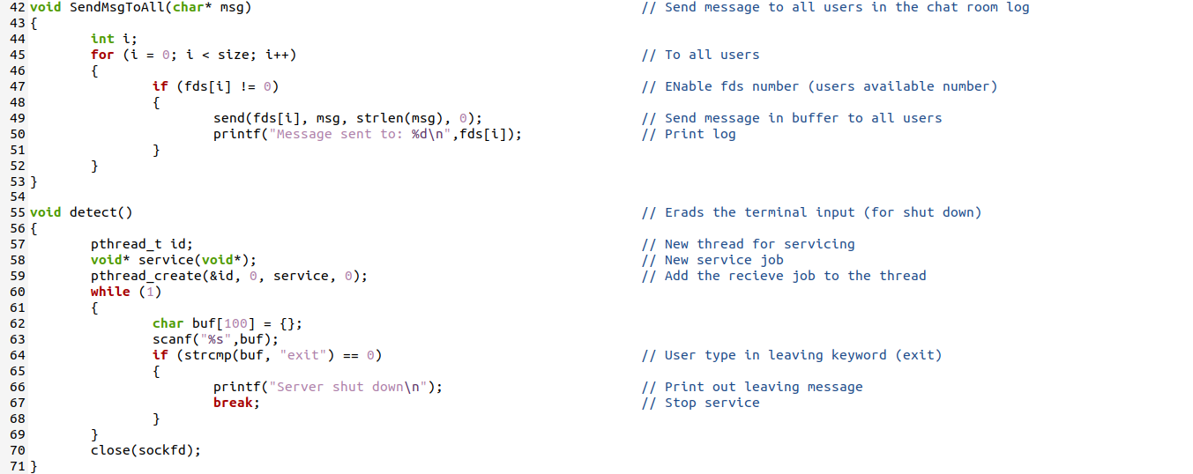

Figure 2. Server code and comment (message send and detect)

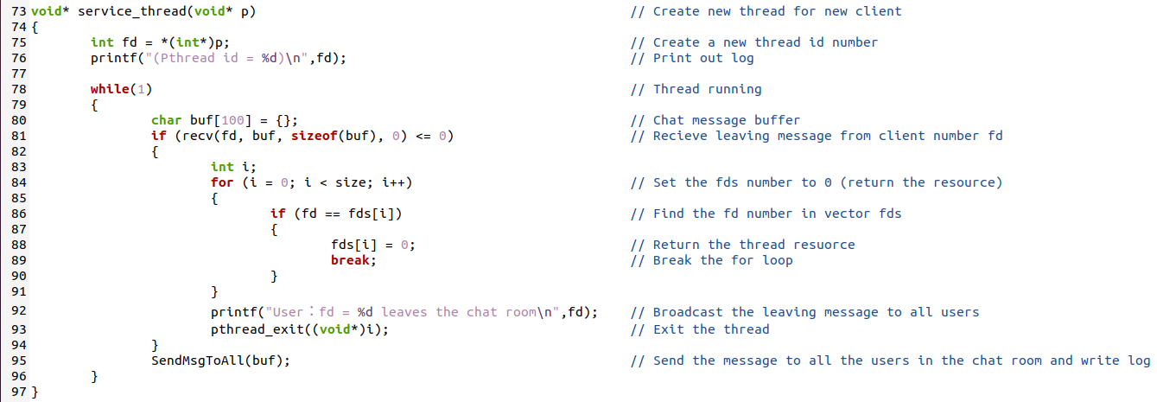

Figure 3. Server code and comment (service thread)

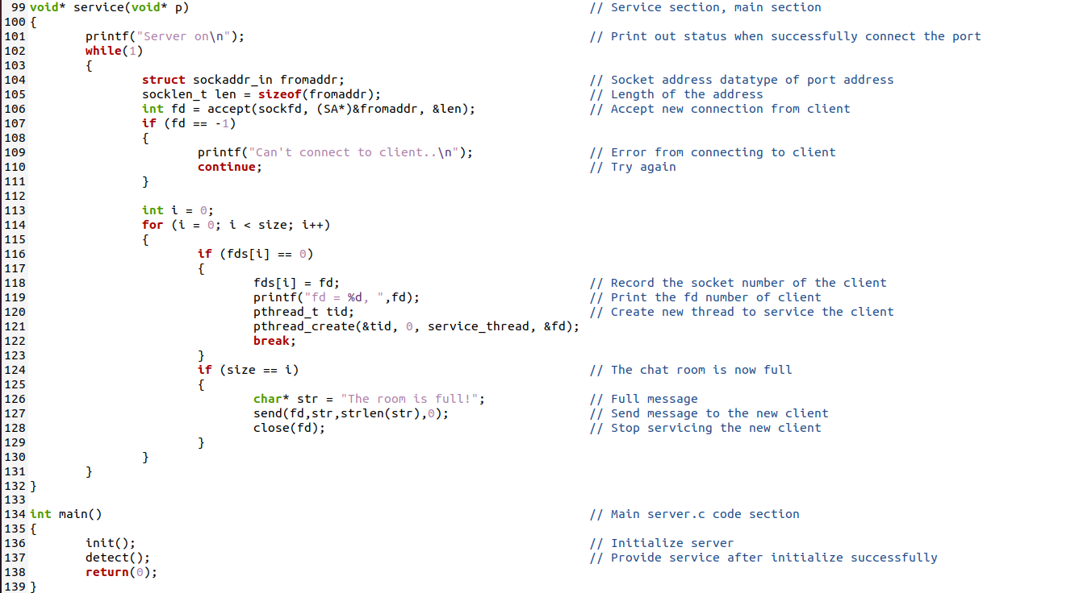

Figure 4. Server code and comment (service and main section)

Client code：

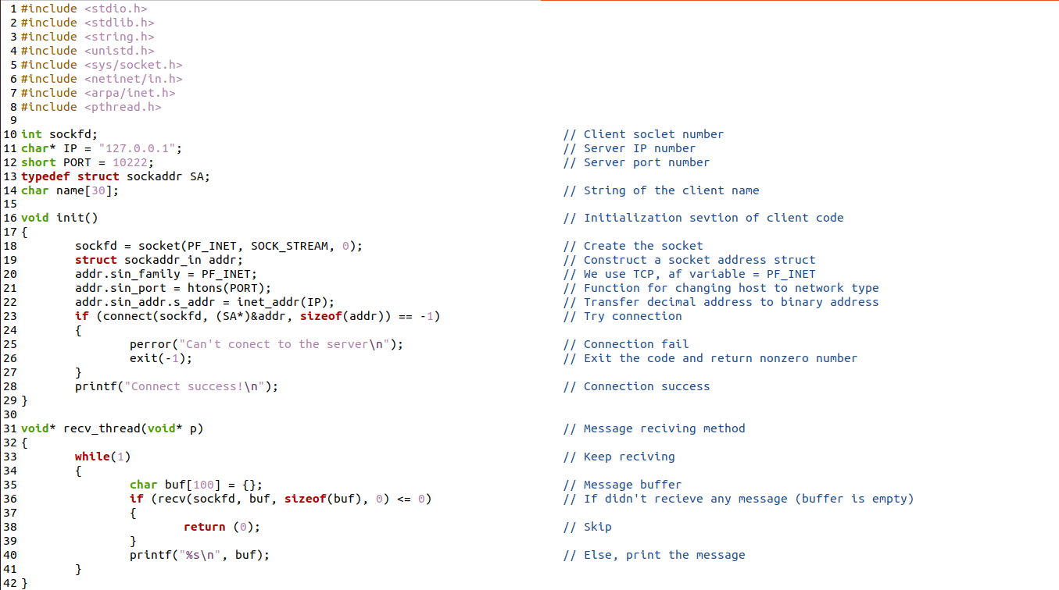

Figure 5. Client code and comment (initialization and receive message thread)

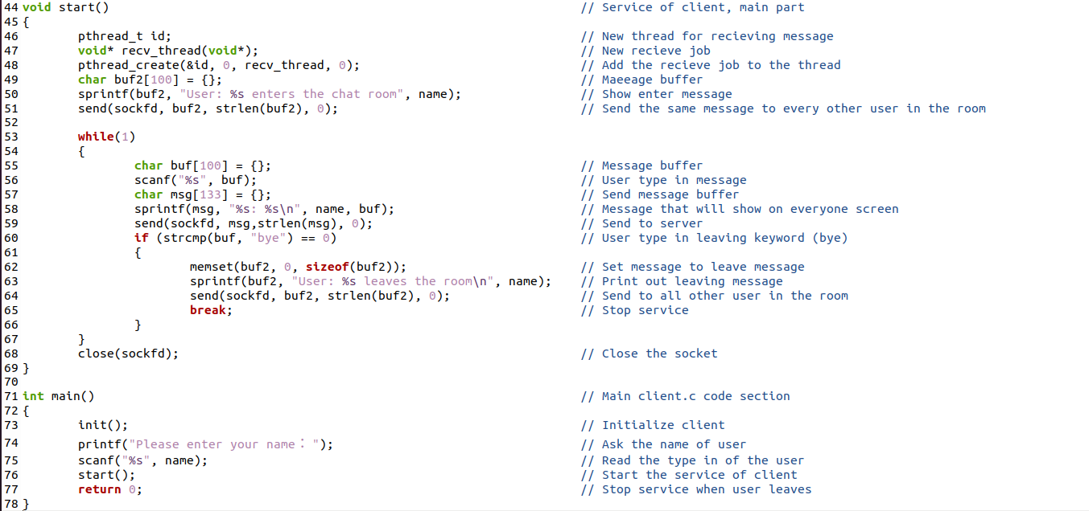

Figure 6. Client code and comment (main section)

Part B: Result

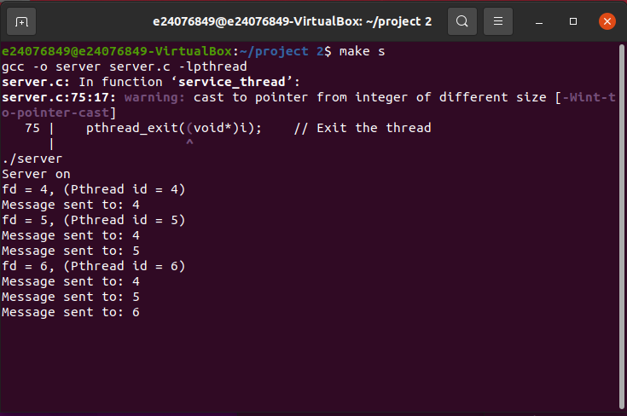

Figure 7. Server running screenshot

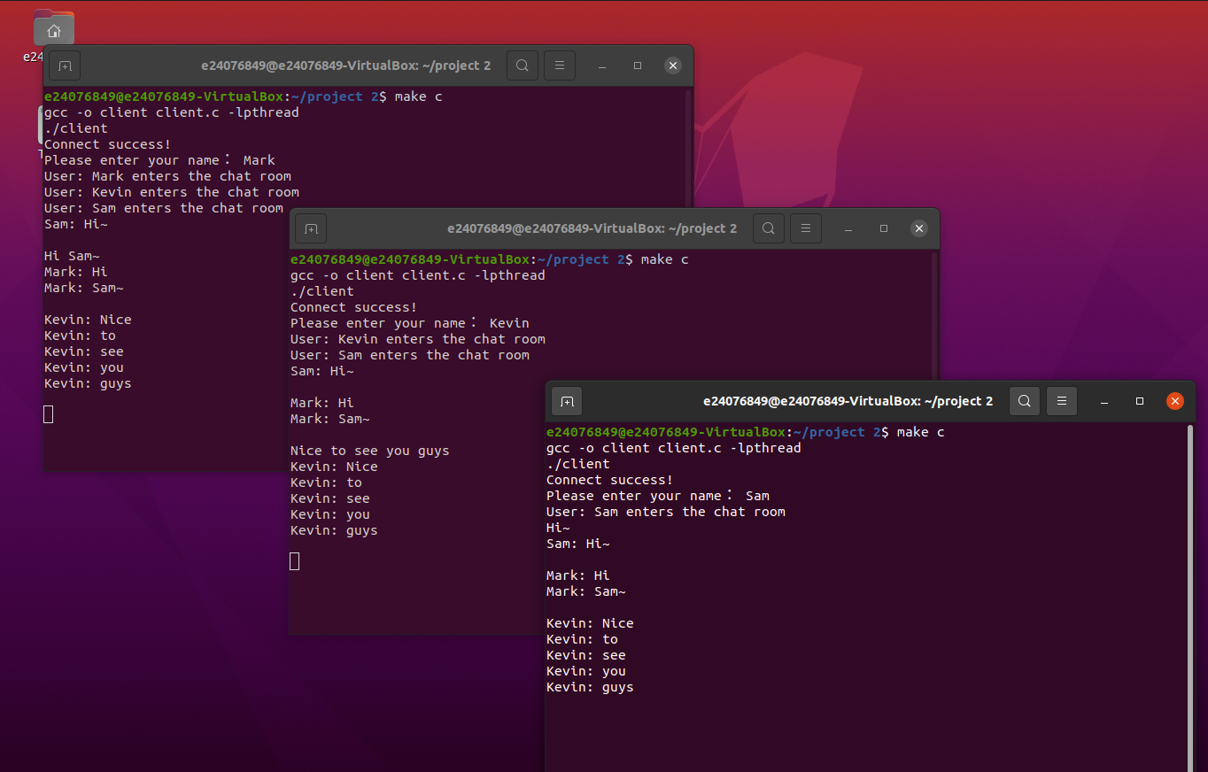

Figure 8. Three users chatting screenshot

Part C: Explanation of code

Connection:

We create sockets to link server and clients. IP number is set to 127.0.0.1 to connect back to our computer, port number is set to 10222 a random number larger than 1024.

Send and receive:

In both server and client, we create threads to send and receive messages.

On server side, server will receive message from every client, and broadcast

(send) to all the clients (include the message sender).

On client side, when user types message, client will send a message to the server. When the client receives the broadcast from server, it will show up on the screen.

Part D: READ ME file

We provide a makefile to easily execute the code correctly

Command: *make s* 🡪 compile server code and run.

*make c* 🡪 compile client code and run.

When the server is on, it will keep write log on the terminal, include new client connected (created a new thread to handle the client message sending) and message send to clients.

Type in *exit* can shut down the server.

When a client is created, it will automatically try to connect to the server if there exists one. If connected successfully, system will ask user to type in a name to recognize in chatting.

After enter the chat room, the user can type in every message freely. But the system distinguishes messages by the space, thus on sentence will be separated to words and show on the terminal.

If the user wishes to leave the chatroom, just type in command *bye.*