Contribution technique

- If we want to find the sum over many ways/possibilities, we should consider every element (maybe a number, or a pair or an edge) and count how many times it will be added to the answer.

- Found the contribution of every element/pair/edge… to the answer, then add it to the result.

- The number of subarrays {j, (j+1, ….., i, …..,k-1), k} that index i contributes to it is (i - j) * (k - i) including itself.

Introduction

- We have n objects:

The no. of ways to choose all the n objects (order mater) is n * (n - 1) * … * 1 = n!

The no. of ways to choose all the m (m < n) objects
(order mater) is
n * (n - 1) * … * (n – m + 1) = n! / (n - m)! = nPm

(order doesn’t matter ) is
n! / ((n - m)! * (m)!) = nCm
(We divide by factorial of their number (m!) because order of the m objects doesn’t matter!)

nCr, nPr

- nCr (Combination): The number of ways to choose r objects from n objects without considering the order. (mostly used)
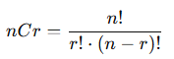

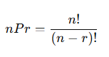
- nPr (Permutation): The number of ways to arrange r objects from n objects where the order matters.

- Problems:
Problem - C - Codeforces, CSES - Creating Strings II

pigeonhole principle

- If there are n+1 pigeons and n pigeonholes, then there is at least one pigeonhole with more than one pigeon in it.
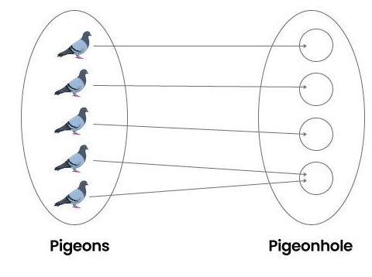

- Pigeonhole Principle | Brilliant Math & Science Wiki

- Problems:
Problem - B - Codeforces

Stars and bars

- n objects, m boxes, then then number of ways to distribute the n objects into the m boxes is
(n + m - 1) C (n) = (n + m - 1) C (m - 1)

- Explanation: n stars, (m - 1) bars to separate between them,
Then the no. of ways = (n + m - 1)! / (n)! * (m - 1)!

- Combination - Wikipedia
- Stars and bars - Algorithms for Competitive Programming

- Problems:
CSES - Distributing Apples

The Inclusion-Exclusion Principle

- The inclusion-exclusion principle is an important combinatorial way to compute the size of a set or the probability of complex events. It relates the sizes of individual sets with their union.

- To compute the size of a union of multiple sets, it is necessary to sum the sizes of these sets separately, and then subtract the sizes of all pairwise intersections of the sets, then add back the size of the intersections of triples of the sets, subtract the size of quadruples of the sets, and so on, up to the intersection of all sets.

- The Inclusion-Exclusion Principle - Algorithms for Competitive Programming

- S(A U B U C) = S(A) + S(B) + S(C)
- S(A ∩ B) - S(A ∩ C) - S(B ∩ C)
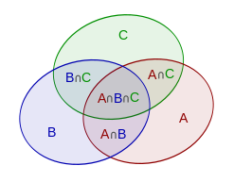
+ S(A ∩ B ∩ C)

(+, -, +, -, …)

odds (+ve), evens(-ve)

- Problems:
Combinatorics - Virtual Judge
Problem - 1750D - Codeforces

Catalan Number
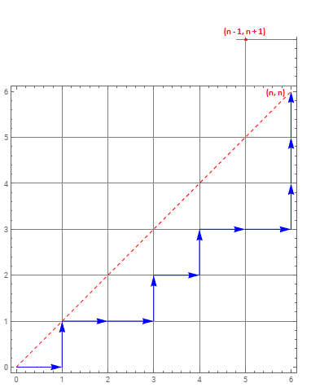
- Dyck Paths:

Dyck paths are lattice paths from (0,0) to
(n, n), that do not pass above the diagonal y=x.
(Moving right or up only)

- When u cross the diagonal, then the remaining cnt_right are greater than cnt_up by 1.
(cnt_right – cnt_up = 1) (n, n)
Invert the remaining sequence
(cnt_up – cnt_right = 1) (n - 1, n + 1)

Then all bad paths will reach (n –1, n + 1), if
invert the remaining bad part.
- no. of good paths =
no. of good paths – no. of bad paths = (2n)C(n) – (2n)C(n + 1) =
(2n!)/ (n! * n!) – (2n!)/ (((n - 1)!) * ((n + 1)!)) =
(2n!)/ (n! * n!) – (2n!)/ (((n!) / n)* (n + 1)*(n!)) =
((2n!) / (n! * n!)) * (1 – (n/(n + 1))) =
((2n!) / (n! * n!)) * (1 – (n/(n + 1))) =
((2n!) / (n! * n!)) * (1/(n + 1)) =
(2n!) / (n! * n! * (n + 1)) =
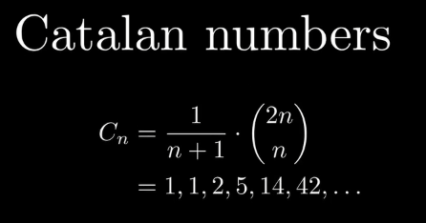
(2n)C(n) / (n + 1)

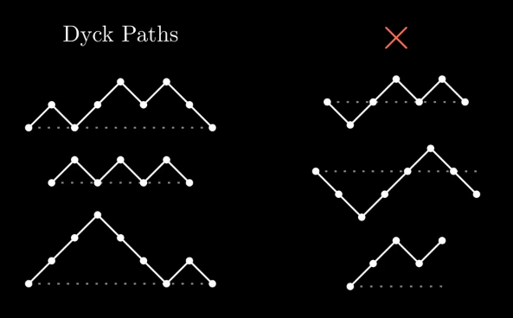

- Catalan Numbers - Algorithms for Competitive Programming
Catalan Numbers - Numberphile
The Most Important Sequence: The Catalan Numbers
Catalan numbers, kind of, and Educational 170 E - Codeforces
[Tutorial] Catalan Numbers and Catalan Convolution - Codeforces
Catalan Numbers Problem - Codeforces

- Problems:

Derangement Generation of an Array

- Derangement of a permutation is another ordering where each and every element of the permutation is not in its original position.

In other words, a derangement is a
permutation that has no fixed points.

- If an element occurs more than 'half the size' number of times in an array then the derangement of that array is not possible.

- Derangement Generation of an Array [Tutorial] - Codeforces

- Problems:
Problem - F1 - Codeforces
Markers and Caps Practice Coding Problem

- The number of different derangements is
D(n) = (n−1) * (D(n−1) + D(n−2))
This formula assumes that all elements are distinct, as it relies on the concept of permutations without fixed points (derangements), which are fundamentally different when duplicates are present.

- Problems:
CSES - Christmas Party

Fermat's Theorem

- a is an integer, p is a prime number

a^{p} % p ≡ a % p a^{p} ≡ a (mod p)

If a not divisible by p (a % p != 0, a < p,
gcd(a, p) = 1), then
a^{p-1} % p = 1 % p = 1 a^{p - 1} ≡ 1 (mod p)

- a^{p-1} % p = 1 % p (* a⁻¹)
a^{p - 2} % p = a⁻¹ % p

a⁻¹ % p = a^{p - 2} % p (Inverse of a number)

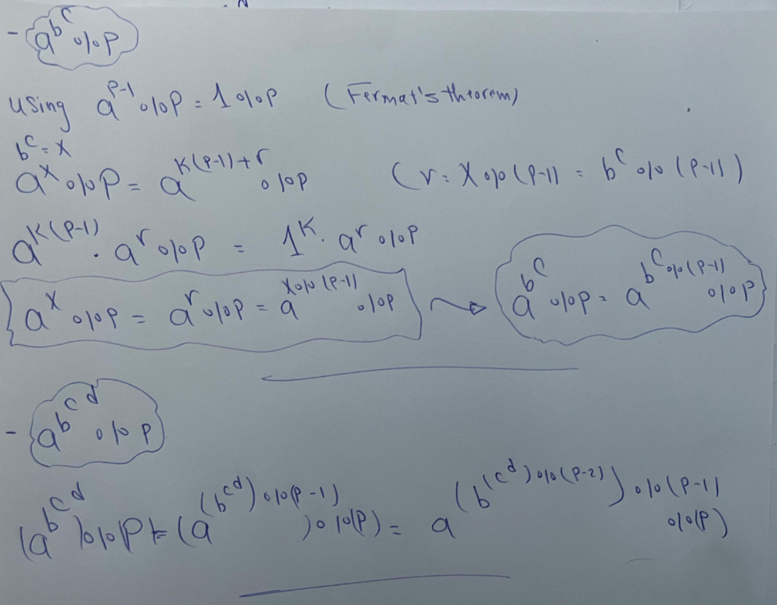
- CSES - Exponentiation II

Burnside's lemma

- Burnside’s lemma sometimes also called Burnside's counting theorem, the Cauchy–Frobenius lemma, or the orbit-counting theorem. (Group theory)

- Burnside's lemma allows us to count the number of equivalence classes in sets, based on internal symmetry.
"Up to Symmetries" means Instead of treating every representation(picture) as unique, we group pictures that can be obtained from one another via symmetries into a single group (called an orbit). Burnside's Lemma counts these groups, not the individual pictures.

- The number of objects equals the average number of symmetrical pictures (taken over all symmetries).

the number of distinct objects =
sum of representations under all symmetries / number of symmetries

- The no. of distinct necklaces of n stones, m colors (available movement is Rotation only) =
sum[i=0->n-1](m^(gcd(i, n))) / n
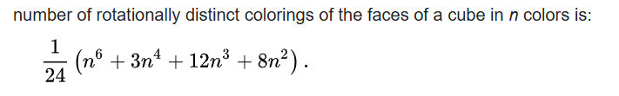

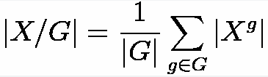

a group is a set with an operation that associates an element of the set to every pair of elements of the set.

Orbits are exactly the classes of objects which we consider equal, because they only differ by some symmetry or other transformation. Our goal is to count the number of orbits. | X / G |

|G| is the number of operations (including identity).

is the set of objects which are not changed by
the operation g.

- Videos:
Burnside's Lemma - An Introduction to Group Theory
Burnside's lemma: counting up to symmetries

- Blogs:
Burnside's lemma / Pólya enumeration theorem - Algorithms for Competitive Programming

- Problems:
CSES - Counting Necklaces
CSES - Counting Grids
Problem - B - Codeforces (extended version of counting necklace)
Problem - E - Codeforces
Burnside Lemma - Codeforces (some problems)

