DP

- Dynamic Programming

- When to think about DP?
Counting --> DP / Combinatorics
Minimize/Maximize --> DP / Greedy / Binary Search
YES/NO

- DP patterns:
Subset style, consecutive range, nested range, general range, masks, counting, probability, exceptions, games.

- Recursion + memo --> Memoization (top-down)
- Iterative --> DP (bottom-up)

- Recursive DP Iterative DP

- Take the code of the recursive dp and put in for loops looping on all the states (take care from forward, or backward), then copy the code inside them, and replace each return with continue, and put the ret the first thing, and remove the check if.

- Building iterative (I think same time & space as recursive unless u are minimizing/maximizing on the output),
But u can make a infinite while loop, and put recursive building code inside it and replace returns with continue except the first one.

- Code example (LCS):
Submission #59295770 - Educational DP Contest

- Building Output

- Minimize/Maximize building output using dp.
Source code - Virtual Judge
Source code - Virtual Judge (iterative building)

Source code - Virtual Judge

DP Iterative

- Any DP Problem when draw its states and connect them --> it’ll form a DAG.

- Recursive DFS topological sorting, or
Iterative BFS topological sorting using degree.
(If top sort size < n after running BFS --> detect cycle)

- Invariants: index, length, value, depth, pop count, …

- 1-Dimensional DP Memory Reduction:

- YwPMhU - Online C++0x Compiler & Debugging Tool - Ideone.com
- P5PI9G - Online C++0x Compiler & Debugging Tool - Ideone.com

- Subset Sum:
- bitset is very fast, often faster than vector<bool> or dynamic structures like unordered_set, because it stores bits in packed form and uses bitwise CPU instructions.
- It performs bitwise operations in O(N/64).

- Good ideas/problems:

- Push parameter to be the return of the slv idea:
Source code - Virtual Judge
Submission #310967941 - Codeforces

Subset Style

- Take or leave - 0/1 Knapsack - Recursion
- Very good optimization for Complete Search
Complete search: O(2^n), 2 --> 0, 1
Subset Style DP: O(no. of states * time of each state)
Usually no. of state = size of memo array,
Time of each state = 1

- Steps: Find states, Create transition, Memorize the states.

- Time complexity of Fibonacci using recursion is O(2^n), while using Recursion DP is O(n).
“2^n because it like binary tree”

- There is similar style, but u can take the each element more than one time!

- Good Problems & Tips:

- Check the range of parameters in the worst case, maybe the range is small, so u can make shifting.
Problem - 506A - Codeforces parameter values may be large, but small different numbers

- To reduce one parameter upper/lower bound.
Problem - D - Codeforces remove a state, then use iterators

- Take care of time complexity of mod_operations.
CSES - Coin Combinations I

DP Ranges

- Consecutive, Nested, General ranges.

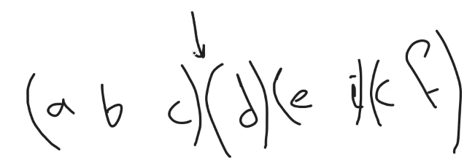
- Consecutive range:

- There are problems where you can’t take some elements.

- If u use an inference(dependent) parameter in the recursion function --> u can not use it in the dp.

- Mostly O(N^2).

- Nested range:
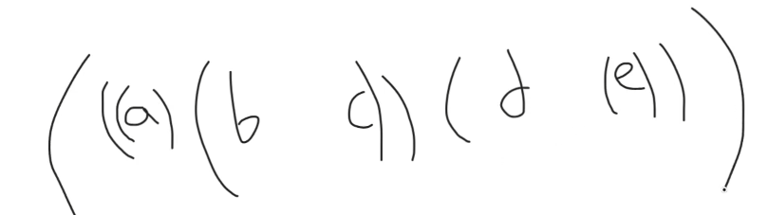

- There are problems where u can don’t take some elements.

- General range:

- Good Problems & Tips:

- Problem - G - Codeforces
- Problem - 607B - Codeforces
- Problem - 1132F - Codeforces
- Problem - E - Codeforces
- Problem - 1337E - Codeforces

- LIS (Longest Increasing Subsequence):

- LIS in O(nlogn) with printing solution | Day 4 Part 1 | Dynamic Programming workshop | Vivek Gupta - YouTube

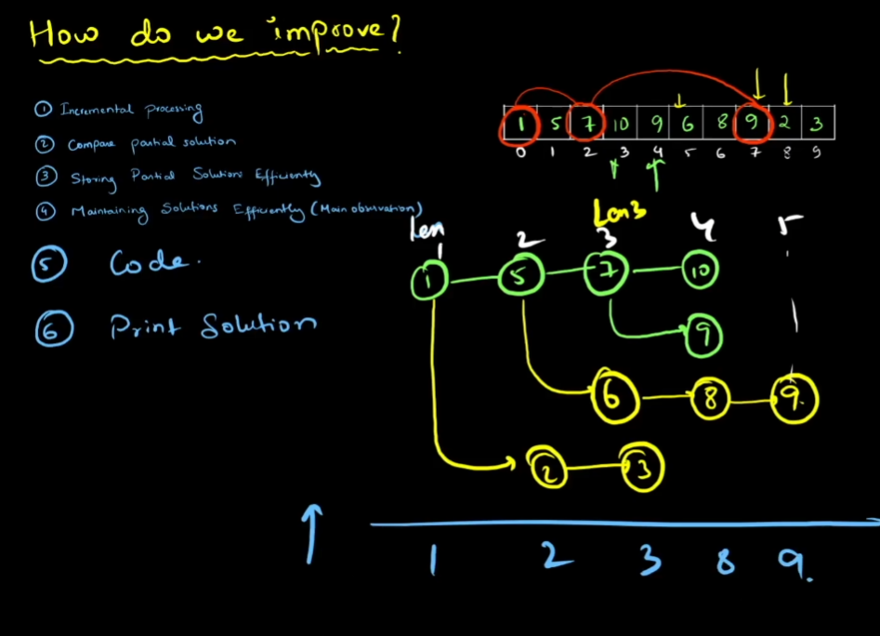

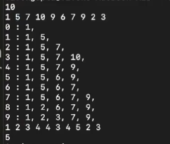

Digits

- Count the number of integers between a and b having specific property! (a, b are up to 10¹⁸)

- Ans = count from (0 to b) – count from (0 to a - 1)
Or Ans = count from (a to b)

- Counting from 0 to X using one state
state = 0 (0 --> 9), state = 1 (0 --> x[l])
dp[l][eqX][…];
state means i still equal to X or not!
CSES - Counting Numbers - Results
CSES - Counting Numbers - Results

- Counting from X to Y using two state
State for X, and the other for Y
dp[l][eqX][eqY][…];
CSES - Counting Numbers - Results
CSES - Counting Numbers - Results

- Take care of case 000… (not started yet)
Or u can create start state or if (last==10 && i == 0)
Because of the padding problem!

- We can DP on digits(binary, decimal, …).

- Binary Search with DP on Digits:
Find the Kth digit to achieve the F(X)!
Problem - N - Codeforces

- Good ideas/problems:

- Problem - 509C - Codeforces --> use build function to get the min number that is greater than the last number.

- Camp 1 | Sheet 2 : DP Digit & Bitmask - Virtual Judge --> Good count problem

- Camp 1 | Sheet 2 : DP Digit & Bitmask - Virtual Judge Overcount problem

- Investigation - LightOJ 1068 - Virtual Judge --> pigeonhole principle

- Problem - E - Codeforces

- Digit Sum Divisible - AtCoder abc336_e - Virtual Judge

Bitmask

- 2^20 = 2e6, 2^25 = 4e7

- Generate all the submasks of a mask in O(2^ones)
submask = (submask - 1) & mask

- Dividing n into some number of groups! Where each must belong to exactly one group, Find The maximum possible total score.
Camp 1 | Sheet 2 : DP Digit & Bitmask - Virtual Judge
Iterating through all masks with their submasks using & trick is O(3^n) , so n <= 16.

- bin packing problem is an optimization problem, in which items of different sizes must be packed into a finite number of bins or containers, each of a fixed given capacity, in a way that minimizes the number of bins used.
CSES - Elevator Rides same problem but n<=20, so we can’t iterate over all submasks of the mask.

- Good trick: slv(l, mask) can be optimized to slv(mask), where l = number of ones in the mask!

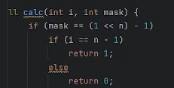
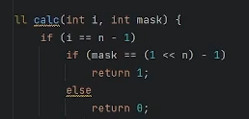

The first image is much faster than the second image.
first if --> n, second if --> 2^n

- Harshad number: An integer number in base 10 which is divisible by the sum of its digits.

- Good ideas/problems:

- Camp 1 | Sheet 2 : DP Digit & Bitmask - Virtual Judge --> pre-process all different mask cost &
submask = (submask - 1) & mask

- Submission #289996859 - Codeforces -->
Create a mask of base 3

- Problem - C - Codeforces --> good combinatorics problem.

- Problem - 8C - Codeforces --> order sometimes doesn’t matter

- Mask of prime numbers Idea:
Sherlock and Coprime Subset | Practice Problems
Problem - B - Codeforces
Sereja and GCD 2 Practice Coding Problem

- Sum state with mask is dependent state,
Like this example, Submission #312512167 - Codeforces
or a nice idea is to pre-process the sum of all possible masks!
Like this example, Source code - Virtual Judge
I don’t know why the first method doesn’t work here!

- Consider 4 points, and we have 2 segments to connect them, there will be always a way to connect these points without intersection of segments and with smaller sum of segments lengths (by Pythagorean theorem).
Hasan and Points Pairing | Practice Problems

SOS (Sum over Subsets) DP

- Iterating through (2^n) masks with their submasks in O(3^n).

- A[x] having K off bits is visited by 2^{K} masks, thus there is repeated recalculation.

Prefix on DP

- When u need to loop on a large length in the slv function --> convert to iterative, then make prefix sum on the pervious dp before starting the new one.

- This idea is good optimization for deleting the large loop, and do pre-processing on the previous dp like sum, min, max, …
Which is not possible in Recursive DP.

- Problems:
M - Candies Submission #59512811 - Educational DP Contest

DP on Graph

- Problems:
Problem - D - Codeforces

Probability

- Infinite geometric series:
1 + p + p*p + …. = 1 / (1 - p), where |p| < 1

- probability = no. of favorable outcomes (success) / total no. of possible outcomes

- P(A∪B) Union means or, at least one, either .. or .., one or more, …
P(A∪B) = P(A) + P(B) − P(A∩B)
= P(A) + P(B) – (P(A) * P(B))
= 1 - P(A∩B) = 1 - P(A) * P(B)

P(A∩B) Intersection means and, both, …
P(A∩B) = P(A) * P(B)

- Problems:

- When there are multiple players dp of each player, then calculate probabilities of the result of the dp of all players (bcos independency between players).
PrimeSoccer - TopCoder 10033 - Virtual Judge
XYm7uD - Online IDE & Debugging Tool - Ideone.com dp with 2 players
fmspNO - Online IDE & Debugging Tool - Ideone.com
pG4yv0 - Online IDE & Debugging Tool - Ideone.com
6Ngs0p - Online C++0x Compiler & Debugging Tool - Ideone.com
3FNKwF - Online C++0x Compiler & Debugging Tool - Ideone.com bitmask
slE8AH - Online C++0x Compiler & Debugging Tool - Ideone.com combinatorics

- Problem - E - Codeforces
In this problem u choose the next player not by probability, so u didn’t multiply by 1.0/rem, and he wants the probability of winning so max on ret.

Expectation

1) Basic Expectation

- E(X) = ∑ xi​.pi​
multiply each possible value of the random variable by its probability and sum them up.

- The expected value doesn't have to be a value the random variable can actually take.

- Recursive Expectation:
Expected value of flipping a coin till get a head
E(head) = 0.5*1 + 0.5*0.5*2 + …. = 2
E(head) = 0.5*1 + 0.5*(1 + E(head)), E(head) = 2

- Problems:

- Problem - 28C - Codeforces

- 2) Recursive Expectation
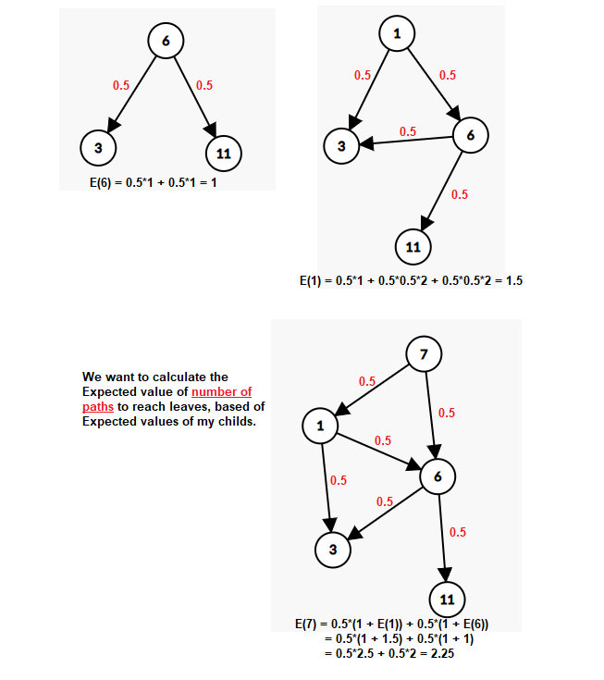
Expectation is calculated based on Expectation of childs! (calculated from them)
- Basic method:
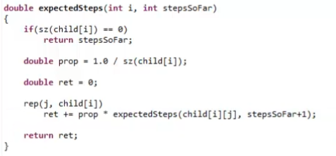

O(n^3) we need to add the parameters of the Expected value here!

- Recursive method:
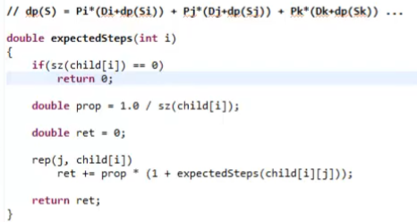
(Di is The cost)

O(n^2) which is much better!
Because we remove the parameters of the expected value(length of path here!)
(u need to get a possible relation to get parent from child)
- Problems:

- BankLottery - TopCoder 10988 - Virtual Judge
dnh7Hj - Online C++0x Compiler & Debugging Tool - Ideone.com basic
RchODl - Online C++0x Compiler & Debugging Tool - Ideone.com recursive

- TableSeating - TopCoder 4616 - Virtual Judge
kOOob5 - Online C++0x Compiler & Debugging Tool - Ideone.com recursive

3) Optimize (Minimize/Maximize) Expectation

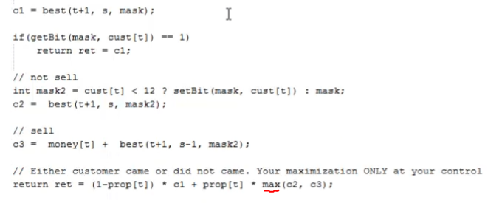
- There are random parts (we have no control on it), and other parts we have control on it (we minimize/maximize it).

- Problems:

- NewItemShop - TopCoder 11508 - Virtual Judge
Dbr13D - Online C++0x Compiler & Debugging Tool - Ideone.com

4) Linearity of Expectation

- E[X] = E[X1​ + X2​ + ⋯ + Xn​] = E[X1​] + E[X2​] + ⋯ + E[Xn​]
This holds true regardless of whether the Xi​'s are independent or not.

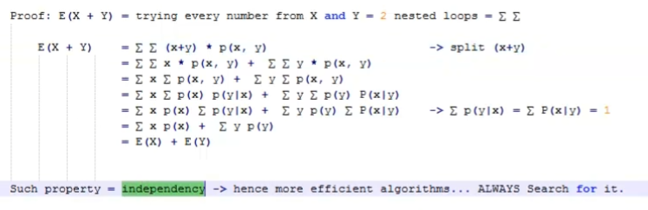

- Problems:

- https://codeforces.com/problemset/problem/601/C

- Problem - 601C - Codeforces

5) Law of Total Expectation

- also known as the law of iterated expectations (or LIE) .

- Problems:

- Problem - 601C - Codeforces

6) Linearity & Total Expectation

DP Games

- Problems:

- PerfectlyFairGame - TopCoder 11530 - Virtual Judge
BfAIUt - Online C++0x Compiler & Debugging Tool - Ideone.com
0cufgm - Online C++0x Compiler & Debugging Tool - Ideone.com
LfZTao - Online C++0x Compiler & Debugging Tool - Ideone.com
RdCd0n - Online C++0x Compiler & Debugging Tool - Ideone.com
max, min or 1 – slv()

- PointsGame - TopCoder 9791 - Virtual Judge

MCM

- Matrix Chain Multiplication (MCM) is a classic optimization problem in dynamic programming. The goal is to determine the most efficient way to multiply a given sequence of matrices, minimizing the total number of scalar multiplications.

- Given a chain of matrices A1, A2, ..., An, where matrix Ai has dimensions p[i-1] x p[i], find the minimum number of scalar multiplications needed to compute the matrix product A1 * A2 * ... * An.

- Note: Matrix multiplication is associative but not commutative, so the order of multiplication matters for efficiency.

- The number of possible combinations is Catalan number but n – 1 is 2(n - 1)C(n - 1) / n.

- Formula:
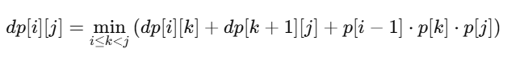

Knuth optimization

- Knuth optimization is applicable if adding elements to the right of the array, will cause the pivot to move to right (old pivot <= new pivot), or vice versa.
opt[l, r - 1] <= opt[l, r] <= opt[l + 1, r]

- Optimal Binary Search Tree - UVA 10304 - Virtual Judge
Source code - Virtual Judge Recursive O(N^3)
Source code - Virtual Judge Iterative O(N^3)
Source code - Virtual Judge Knuth optimization O(N^2)

Monotonic optimization

- Binary Search in recursive slv function:
When we move over a loop inside the slv, but it’s shape is convex, so we can binary search on it to reduce time complexity.

- Sliding Window:
Fixed pointer for the outside loop in iterative dp,
when we iterate over a loop [l, r] for optimal point, but by increasing the outside loop parameter, the optimal point in [l, r] gets more to the right (right to the previous values).

- Balls - HDU 3281 - Virtual Judge
Source code - Virtual Judge Recursive O(B * M^2)
Source code - Virtual Judge Binary search O(B * M * log2(M))
Source code - Virtual Judge Sliding window O(B * M)

D&C

CHT

Li Chao

- Dynamic Li Chao segment tree - Pastebin.com
- qnoAgO - Online C++0x Compiler & Debugging Tool - Ideone.com

