DSU

- Disjoint Set (Union-Find Algorithm)
- Two sets are called disjoint sets if they don’t have any element in common, the intersection of sets is a null set.
- Disjoint Set Union - Algorithms for Competitive Programming (cp-algorithms.com)

- A data structure that stores non overlapping or disjoint subset of elements.

- The disjoint set data structure supports following operations:
- Adding new sets to the disjoint set,
- Merging disjoint sets to a single disjoint set using Union operation,
- Finding representative of a disjoint set using Find operation,
- Check if two sets are disjoint or not.

- Partitioning the individuals into different sets according to the groups in which they fall. This method is known as a Disjoint set Union which maintains a collection of Disjoint sets and each set is represented by one of its members.
- Data Structures used are:
- Parent vector: Stores the parent of the all nodes, the parent of the root of each disjoint set is itself.
Time complexity of union operations is O(n).

- Size vector: Store the number of nodes in each disjoint set. (Size optimization)
We merge th small size into the large size, cause the height of the large size doesn’t change, and the small size increases by 1.
Time complexity of union operations is O(log(n)).

- Rank vector: Store the height of each disjoint set. (Rank optimization)
Time complexity of union operations is O(log(n)).

- Path compression optimization:
This optimization is designed for speeding up find_set.
Time complexity of find operations is O(log(n)).

- if we combine both optimizations - path compression with union by size / rank - we will reach nearly constant time queries. It turns out, that the final amortized time complexity is O(α(n)),
Where α(n) is the inverse Ackermann function, which grows very slowly.
In fact it grows so slowly, that it doesn't exceed
4 for all reasonable n.

- DSU with union by size / rank, but without path compression works in O(logn) time per query.

MST

- Minimum spanning tree - Kruskal's algorithm
- Minimum Spanning Tree - Kruskal - Algorithms for Competitive Programming (cp-algorithms.com)

- Given a weighted undirected graph. We want to find a subtree of this graph which connects all vertices (i.e. it is a spanning tree) and has the least weight (i.e. the sum of weights of all the edges is minimum) of all possible spanning trees. This spanning tree is called a minimum spanning tree.

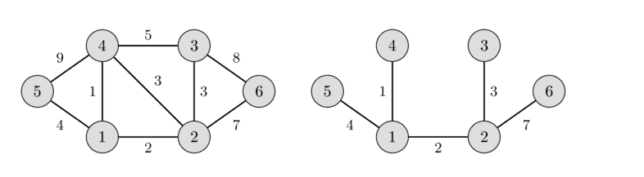

- Steps: Sort edge by weight, merge all pairs.

- Minimum spanning tree of a graph is unique, if the weight of all the edges are distinct. Otherwise, there may be multiple minimum spanning trees.

- Minimum spanning tree is also the tree with minimum product of weights of edges.

- In a minimum spanning tree of a graph, the maximum weight of an edge is the minimum possible from all possible spanning trees of that graph.

- The maximum spanning tree (spanning tree with the sum of weights of edges being maximum) of a graph can be obtained similarly to that of the minimum spanning tree, by changing the signs of the weights of all the edges to their opposite and then applying any of the minimum spanning tree algorithm.

- Kruskal's algorithm: Kruskal's algorithm initially places all the nodes of the original graph isolated from each other, to form a forest of single node trees, and then gradually merges these trees, combining at each iteration any two of all the trees with some edge of the original graph.
Before the execution of the algorithm, all edges are sorted by weight (in non-decreasing order).
Then begins the process of unification: pick all edges from the first to the last (in sorted order), and if the ends of the currently picked edge belong to different subtrees, these subtrees are combined, and the edge is added to the answer. After iterating through all the edges, all the vertices will belong to the same sub-tree, and we will get the answer.

We can use the Disjoint Set Union (DSU) data structure to write a faster implementation of the Kruskal's algorithm with the time complexity of about O(MlogN)

- A spanning tree is a subset of Graph G, such that all the vertices are connected using minimum possible number of edges. n nodes, n – 1 edges
Hence, a spanning tree does not have cycles and a graph may have more than one spanning tree.

- Notes:

- You can detect Cycles in Undirected graph, through merging all pairs, and if there is a pair already found --> Cycle.

