Graph

- Node: object,
Edge: relationship between nodes.

- Edges can be directed or not-directed Directed graph vs Undirected graph
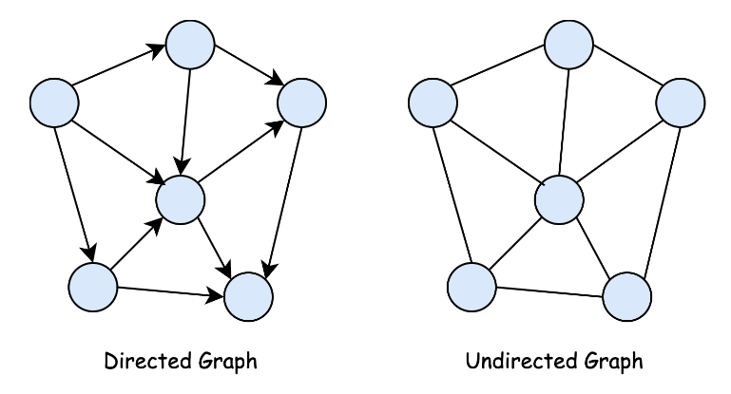

- Edges can be weighted or not-weighted
Weighted graph vs Unweighted graph
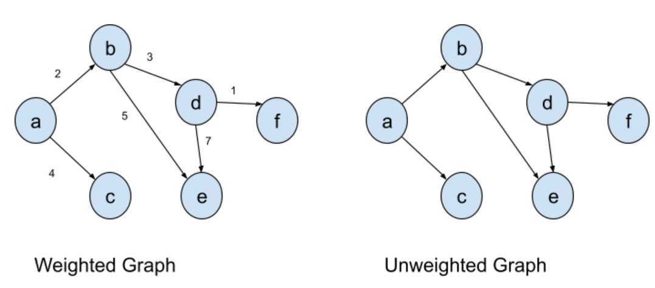

- Graphs can be connected or disconnected
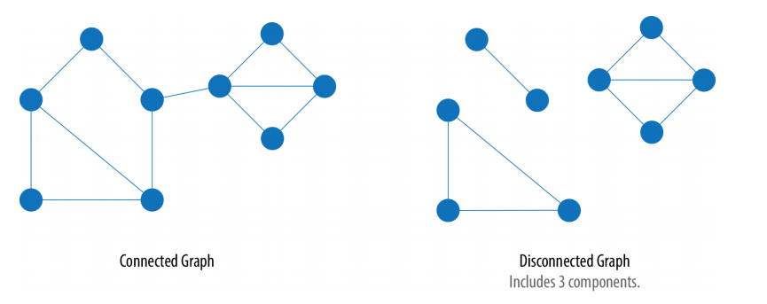
Connected graph vs Disconnected graph
- Graphs can contain cycles or not
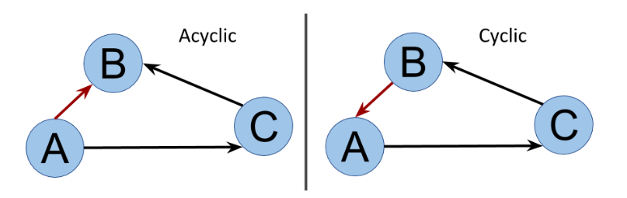
Cyclic graph vs Acyclic graph
Undirected graphs can contain cycles, if there is another path to the same node when u start from it.
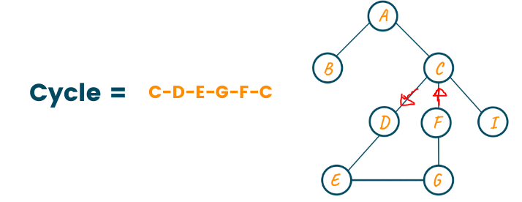

- DAG (Directed Acyclic Graph)
Directed, Acyclic Graph, every node can have multiple different paths to it (have more than one parent).
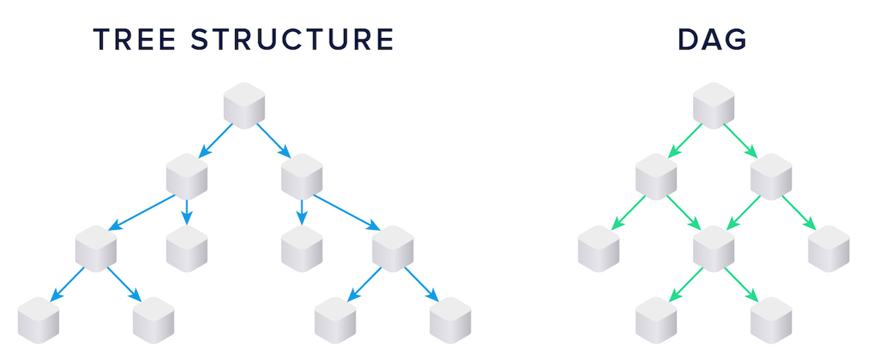
Tree Special type of DAG, but there is only one path to any node (each node has only one parent).
(n nodes, n – 1 edges)

- Complete Graph (Fully Connected Graph) each node is connected to all nodes.
(n*(n - 1) edges if directed graph),
(n*(n - 1)/2 = nC2 edges if not-directed graph)

Regular Graph All nodes are connected with the same number of edges.

Dense Graph v ≈ n^2
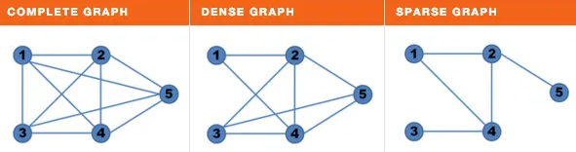
Sparse Graph v ≈ n

Tree v = n - 1

- Node Indegree number of parents,
Node Outdegree number of children

- Graph Representation: n nodes, m edges

1) Adjacency Matrix: square matrix n*n, O(n^2)
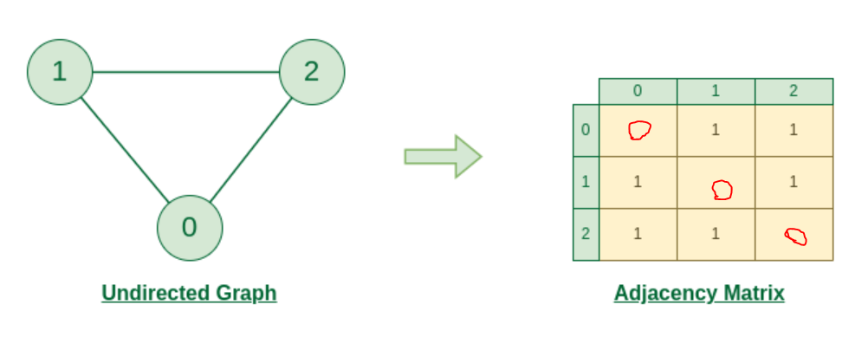

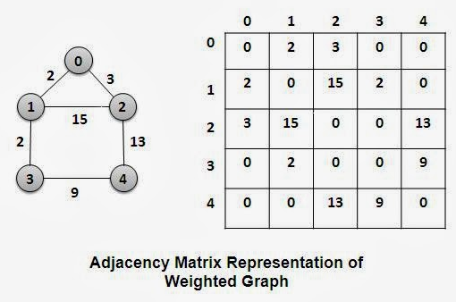

Adjacency matrix in undirected graph is symmetric around the main diagonal.
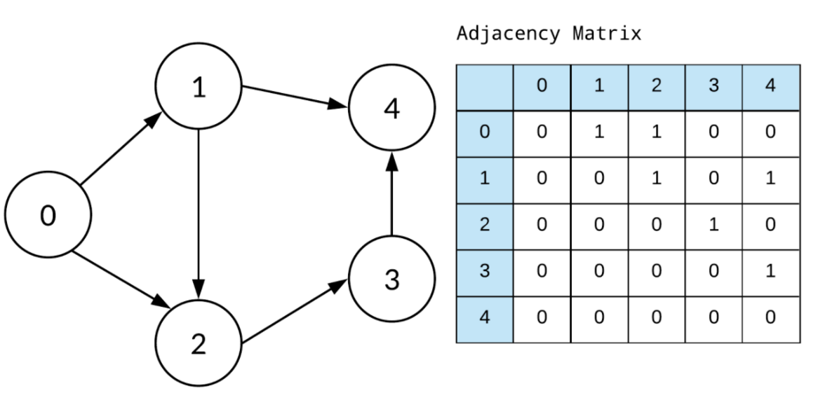

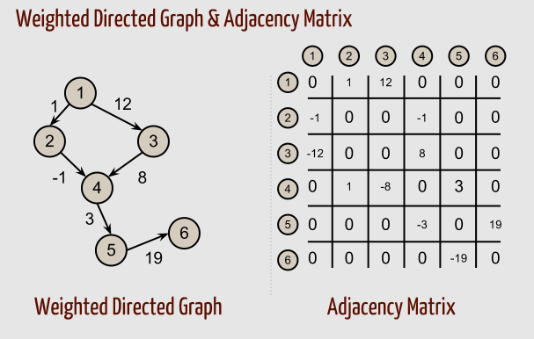
Main diagonal always zero (if !=0 --> self-loop).
2) Adjacency List: O(n + m)
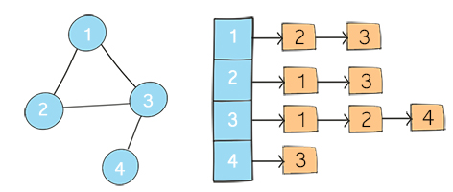

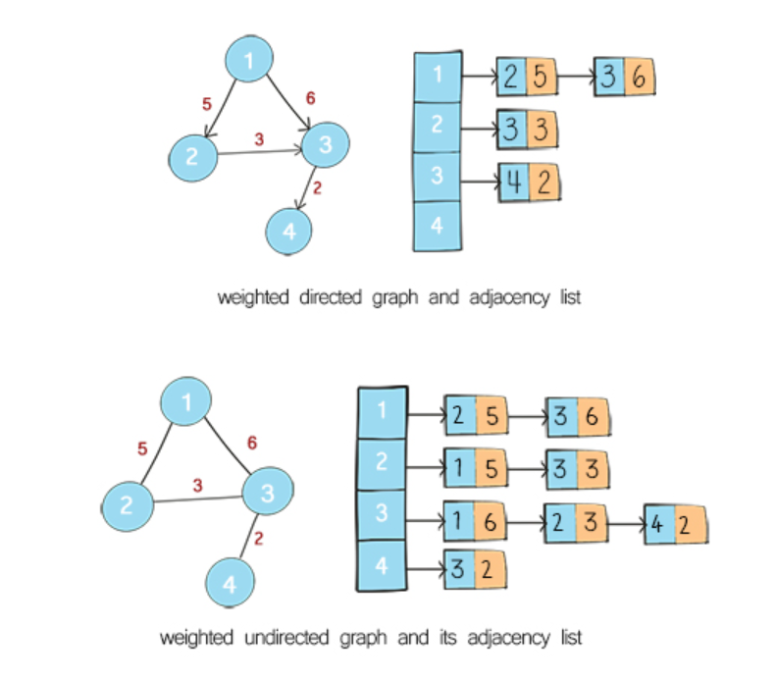
- Adjacency matrix is useful to check if there is a common edge between any two nodes or not
in O(1), but using Adjacency list in O(n).

- Know the neighbors of each node is O(n) in both.

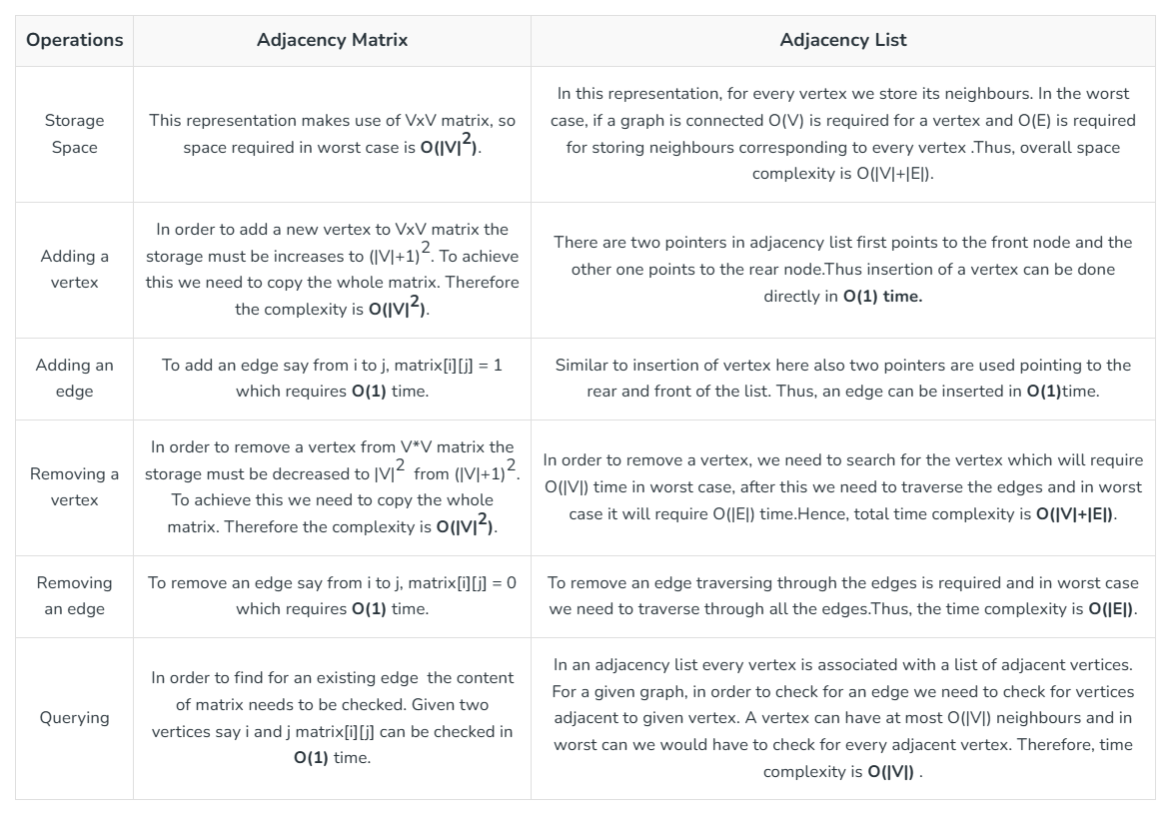

- In Tree there is only one unique path to each node.
Rules: only node has one parent, connected graph, acyclic, edges = nodes – 1.

- The first node of the tree is called the root (node that doesn’t have parents).

- If u can’t visit all nodes then it is Disconnected Graph.

DFS

- Depth-First Search

- DFS explores the graph by going deeper into the graph, while BFS explores the graph by going wider.

- DFS will first explore all the nodes that are directly connected to the source node and then will move on to explore the nodes that are indirectly connected to the source node.
BFS, on the other hand, will first explore all the nodes that are at a distance of one edge away from the source node, and then will move on to explore the nodes that are at a distance of two edges away, and so on.

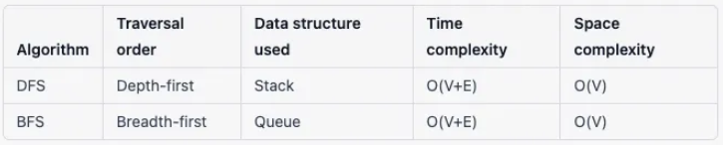
- DFS is better suited for exploring graphs that are deep and narrow, while BFS is better suited for exploring graphs that are wide and shallow.

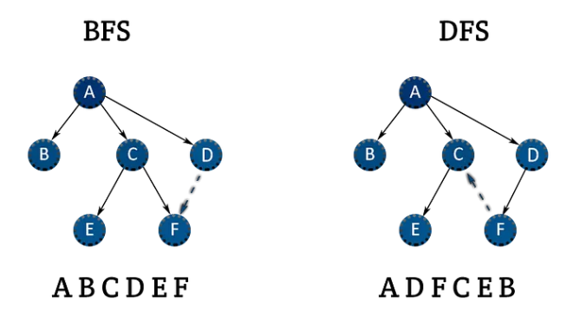

- Detect if there are cycles in a directed graph:
To find cycle in a directed graph we can use DFS.
It is based on the idea that there is a cycle in a graph only if there is a back edge [i.e., a node points to one of its ancestors in a DFS tree] present in the graph.
To detect a back edge, we need to keep track of the nodes visited till now and the nodes that are in the current recursion stack [i.e., the current path that we are visiting].
If during recursion, we reach a node that is already in the recursion stack, there is a cycle present in the graph.

Notes:
- Don’t use return with void
- Using DFS on matrices --> it’s better to work on the input matrix and don’t create a graph to save time and memory.
- Mazes techniques --> Running DFS twice
- Get longest path in unweighted undirected graph --> Run DFS twice.
[Tutorial] Diameter of a tree and its applications - Codeforces

- Graph n * m: {i, j} --> i*m + j

Topological Sort
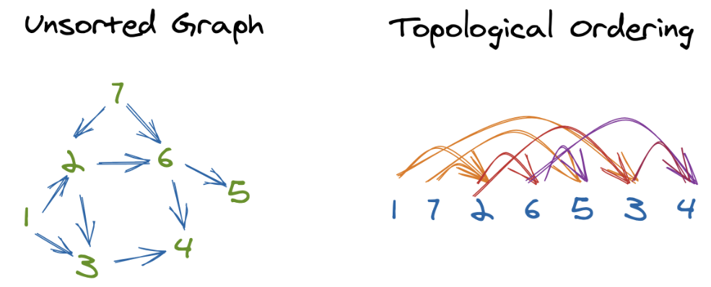

- Topological sorting for Directed Acyclic Graph (DAG) only is a linear ordering of vertices such that for every directed edge u-v, vertex u comes before v in the ordering.
- We also can't topologically sort an undirected graph since each edge in an undirected graph creates a cycle, So topological sorts only apply to directed, acyclic (no cycles) graphs - or DAGs.
- Can be done using DFS or BFS.
- Topological order may not be Unique.
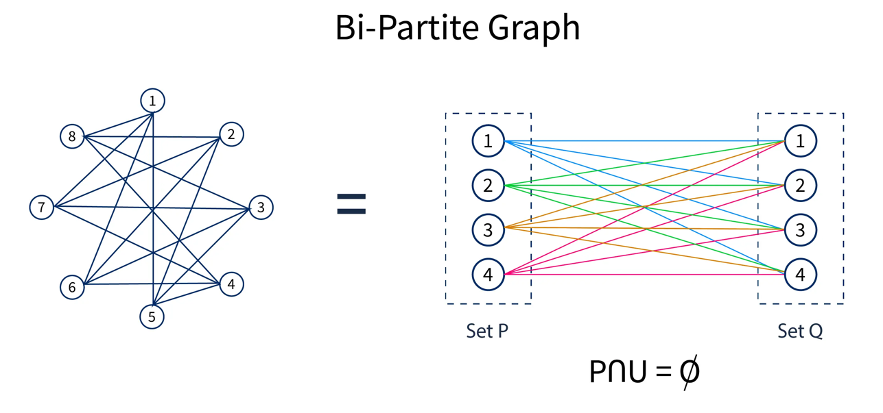
Bipartite Graph
- Is a graph whose vertices (or nodes) can be divided into two disjoint sets X and Y such that every edge connects a vertex in X to one in Y.
- Bipartite graphs cannot contain odd-length cycles.
- Vertices in a bipartite graph can be divided into two disjoint sets, No edges exist between vertices within each set, Every edge in a bipartite graph connects vertices from different sets.
- The maximum degree of a vertex is equal to the size of the smaller set.
- Bipartite graphs can be colored using two colors.
- Can be done using BFS or DFS.
- Tree is always Bipartite.( All acyclic graphs are bipartite!)
BFS

- Breadth-First Search

- Find Shortest Path in unweighted graph in
O(E + V).
If used DFS --> O(2^n) --> Backtracking
- BFS --> Singel Source Shortest path in unweighted graph (positive edges only)
- Dijkstra --> Singel Source Shortest path in weighted graph (positive edges only)
Bellman–Ford --> handle negative edges.
- Floyd Warshall --> find the shortest paths between all pairs of nodes in a weighted graph
(handle positive & negative edges).

- Notes:

- Instead of using Level vector --> use queue of pairs.
- Useful vectors --> vis, level, parent, .…

- Need Path! --> use parent vector

- When running BFS/DFS multiple times (4-5ms):
Use int, not long long !!!
+
FOR BFS , use LEVEL Vector only, don’t use VIS vector !!!

- If(!vis[i]) == If(level[u] + 1 < level[i])
// default level[i] = INT_MAX

- Vectors are better than maps!!

- Good idea: need min distance from every point in group a to every point in group b -->
reverse graph + run 2 BFS

- Multi Source BFS: you start traversing the graph from multiple source nodes simultaneously.
Instead of pushing all the real sources into the queue, you add a fake source, link it to all the real sources, and just push that single fake source into the queue.
The side effect is that the calculated distances are all +1 compared to the actual distances, that's because the fake source and the fake edges increase the distance. So, subtract 1 from all the distances, and you are good to go.

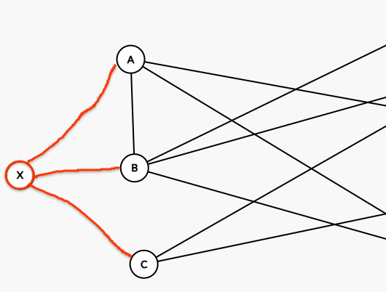

- Vector + Sort: Might be more efficient if you insert all elements first and only need to sort once, especially if the overhead of maintaining a balanced tree isn't worth it for your use case.
Multiset: Useful if you need to maintain a sorted collection dynamically, as it handles insertions in logarithmic time and keeps the collection sorted at all times.

DIJKSTRA

- Singel Source Shortest path in non-negative edge weighted graph. O((V + E) log V)

- PQ add in O(logn), modify in O(n),
Indexed-PQ add in O(n), modify in O(logn)

- Notes:

- Can work with positive edged weighted probability, to get maximum probability, because p1*p2*.. --> decreases (so max porb = min path)

Bellman Ford

- Singel Source Shortest path in negative edge weighted graph. O(EV)

- It states that for the graph having N vertices, all the edges should be relaxed N-1 times to compute the single source shortest path.
- In order to detect whether a negative cycle exists or not, relax all the edge one more time and if the shortest distance for any node reduces then we can say that a negative cycle exists.
- Why Relaxing Edges N-1 times? In the worst-case scenario, a shortest path between two vertices can have at most N-1 edges, where N is the number of vertices.

--------------------------------------------------------------------
Strongly Connected
Components (SCC)

- Let 𝐺=(𝑉,𝐸) be a directed graph with vertices V and edges 𝐸 ⊆ 𝑉×𝑉,
A subset of vertices 𝐶 ⊆ 𝑉 is called a strongly connected component (SSC) if the following conditions hold:
For all 𝑢, 𝑣 ∈ 𝐶 if 𝑢≠𝑣 there exists a path from 𝑢 to 𝑣 and a path from 𝑣 to 𝑢,
𝐶 is maximal, in the sense that no vertex can be added without violating the above condition.

- These strongly connected components do not intersect with each other and cover all vertices in the graph.
Thus, the set SCC(𝐺) is a partition of 𝑉.

- Adding extra node to an SSC to make it contains extra node --> make it not SCC.

- Here we have
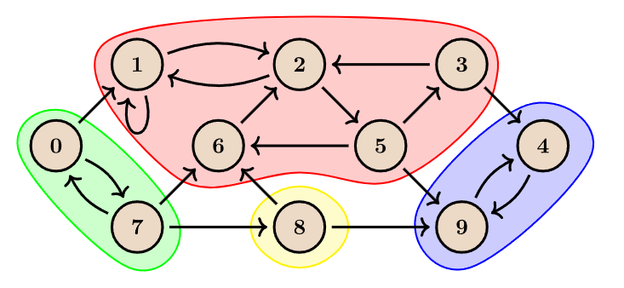
SCC(𝐺example) = { {0,7}, {1,2,3,5,6}, {4,9}, {8} }.

- Two famous algorithms:

- Kosaraju algorithm
Is a linear time algorithm to find the strongly connected components of a directed graph.
(Run 2 DFS)

- Tarjan algorithm
Run 1 DFS only, can compute bridges & articulation points.

Tarjan algorithm

- Time Complexity: O(V + E)

- Tarjan’s Steps:

- Assign dfsn(DFS number) for each node, depending on DFS traversal order.

- When start exploring a node, we put nodes in a stack.

- When node v reaches a node u already in the stack, where dfsn(u) < dfsn(v) --> u is an ancestor of v --> Cycle --> SSC

- When node v reaches a node u not in the stack --> Bridge

- The low-link value of a node is the smallest dfsn reachable from that node when doing a depth-first search (DFS), including itself.
(Initially, dfsn = low link )
- After running the algorithm, each SSC has only one head node for it where dfsn = low link.

- Implementation 3 cases:
- Child not visited: minimize the parent low link with the min. child low link can get to.

Child is visited:
In the current stack (ancestor of me) --> minimize with the low link of my ancestor,
Else --> don’t minimize

- low link = dfsn --> Head of the SSC

- Node of the same SSC may have different low link numbers.

- SSC of a directed graph is the same of its inverse.

- Strongly Connected Components and Condensation Graph - Algorithms for Competitive Programming (cp-algorithms.com)

- Finding bridges in a graph in O(N+M) - Algorithms for Competitive Programming (cp-algorithms.com)

- Notes:

- Good application: What are the min edges to add to graph to make it a whole cycle?
Get SSC using Tarjan, then compress each SSC into exactly one node --> get new component graph, then get
number of nodes have indegree = 0 (Source nodes) &
number of nodes have outdegree = 0 (Destination nodes),
The answer is the max(src nodes, dest nodes).

Bridges

- Time complexity using Tarjan algorithm is O(V + E).

- We are given an undirected graph. A bridge is defined as an edge which, when removed, makes the graph disconnected (or more precisely, increases the number of connected components in the graph). The task is to find all bridges in the given graph.

- Every bridge is not a part of a cycle.

- When a node gets to a visited node --> this node is always ancestor of mine.

Articulation Points

- Time complexity using Tarjan algorithm is O(V + E).

- We are given an undirected graph. An articulation point (or cut vertex) is defined as a vertex which, when removed along with associated edges, makes the graph disconnected (or more precisely, increases the number of connected components in the graph). The task is to find all articulation points in the given graph.

- Biconnected Graph: contain no articulation points. meaning that if any one vertex were to be removed, the graph would remain connected.

- A graph with n articulation points --> splits into
n/n + 1 Biconnected components (BCC).

- Two connected nodes with one edge --> both nodes aren’t considered as articulation points.

- Notes:

- grid (n * m): (i, j) (i*m + j + 1)

--------------------------------------------------------------------
- Strong Orientation:
A strong orientation of an undirected graph is an assignment of a direction to each edge that makes it a strongly connected graph.
Just run DFS on each bridgeless component with the same order.

Strong Orientation - Algorithms for Competitive Programming (cp-algorithms.com)

Tree

- It’s a graph with n nodes, n – 1 edges, where there is no cycles.
There is only one path from each node to another node.

