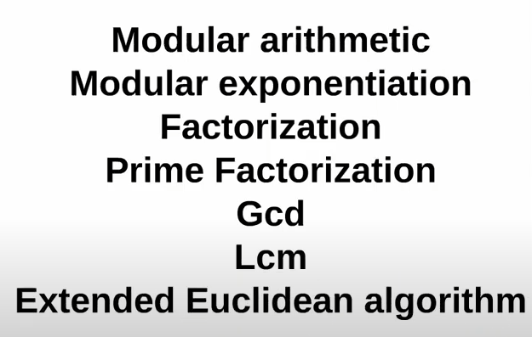


- Modular Arithmetic:
- x % y: Smallest non-negative number m such that make (x – m) is divisible (or multiple) by y.
- math equ.: x % y = m or q * y + m = x
x > y: m > 0, x = y: m = 0
x < y: m = x, x = 0: m = 0
y = 0: error
- Properties:
- Cyclic >> 0123456789 % 5 = 0123401234 [0, y – 1]

- If a & b are large numbers, so their sum or product gonna be so large.
(a + b) % c = ((a % c) + (b % c)) % c
(a * b) % c = ((a % c) * (b % c)) % c
- [0, c-1] each, worst case is 2(c - 1) % c or (c-1)^2 % c

- x < 0: (x + n*y)%y, where n is smallest number that make (x + n*y) +ve. a % c = ((a % c) + n*c) % c

- (a - b) % c = ((a % c) - (b % c) + c) % c
- Worst case that a % c = 0, b % c = c – 1
then the result is – (c-1) so we add c to make it positive.
- (a / b) % c = ((a % c) * (b ^(-1) % c)) % c

- Last digit of a is (a % 10)
- Last digit of multiplication of a and b is (a%10)*(b%10)%10

- x % y = ??, if x < 0 ((x % y) + y) % y is general!

- Modular Exponentiation:
- X^n: X * X * X * …… * X (n times O(n)).
- Fast power (Binary exp.): log2(n)
n is even: X ^ n = (X^2) ^ n/2
n is odd: X^n = (X)*(X)^ n – 1 = (X) * (X^2)^ (n - 1)/2
Code:
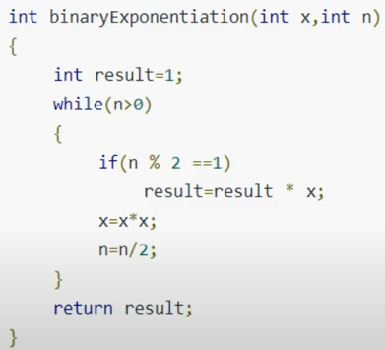

- Mod of high powers
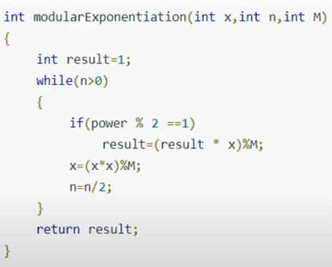

If u use long long, then (x * x) gonna be so large, then use
(x * x) % m =
((x % m) * (x % m)) % m
- Factorization: find factors
- A Factor is a number that divides into another number exactly and without leaving a remainder.
- Any number than achieve m % factor = 0
- i <= sqrt(n) but O(log(n)), so use i * i <= n O(1)
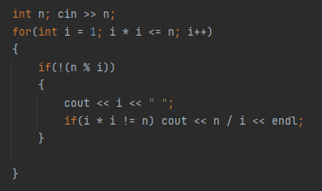
- Code:

- Prime Factorization
- Prime number: a number with two factors only 1 & n.
- 2, 3, 5, 7, 11, …
- Every integer greater than 1 can be written as the product of prime numbers.
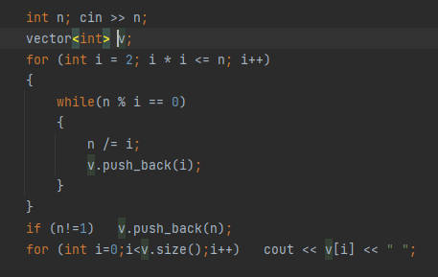
- Prime factorization code:

Greatest common divisor (GCD)
- Greatest common factor of two numbers.
- Simple implementation using for loop: O(min(a, b))
- Another implementation: product of the common prime factors.
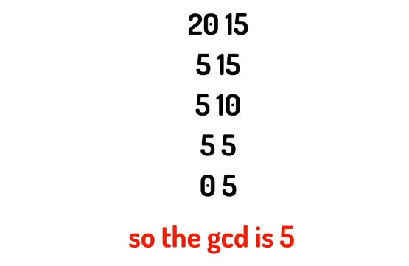
- Euclidean Algorithm:

- GCD(a, b) = GCD(b, a % b) till b = 0 then result is a.
- GCD(a, b, c) = GCD(a, |b – a|, |c – a|)
- GCD(a, 2a) = a

Least Common Multiple (LCM)
- Least number that a & b are two factors of it.
- LCM(a, b) = c, where c % a == 0 & c % b == 0.
- LCM(1260, 7350) = ??
1260 = 2*2*3*3*5*5*7, 7350 = 2*3*5*5*7*7
LCM(1260, 7350) = 2*2 * 3*3 * 5*5 * 7*7 = 44100
- بنضرب ف الأكثر تكرارا لكل رقم
- LCM(a, b) = a * b / GCD(a, b)
- GCD هو ضرب الأقل تكرارا
- a * b = GCD(a, b) * LCM(a, b)
- LCM(a, 2a) = 2a

Sieve of Eratosthenes

- Given a number n, print all primes smaller than or equal to n. It is also given that n is a small number.
- Standard: O(log(log(n)))
- Linear: O(n)
An optimized version of the Standard Sieve Algorithm.
Unlike the Standard Sieve, the Linear Sieve doesn't check for all multiples of every number but only for multiples of primes calculated till some predefined limit.

Segmented Sieve

- segmented sieve and it's optimizations Arabic Animated intuition - باللغة العربية (youtube.com)

NOTES

- Sum of first n numbers: n*(n + 1) / 2
- Sum of first n even numbers: n*(n + 1)
- Sum of first n odd numbers: n^2

- No. of even numbers till n : (int)(n / 2)
- No. of odd numbers till n: (int)((n + 1) / 2)

- MEX(a1, a2, a3, …, an): the smallest non-negative integer that is not present in the set.

- Sum of all numbers between two numbers (inclusive):
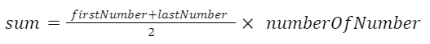

- The k-th positive integer that is not divisible by n:
K + ( (k - 1) / (n – 1) )

- number of integers divisible by both a & b in the range 1 to n: n / lcm(a, b)

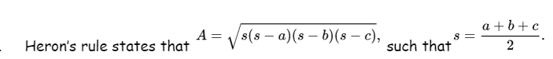
- Area of a triangle:
- How many distinct triangles?
n * (n + 2) * (2*n + 1) / 8
- x + y <= z
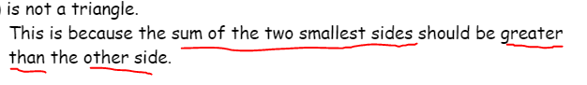
- x + y = z (degenerate triangle)

- number of digits of n is 1 + (ll)log10(n)

- n = 0, n += +-x1 +- x2 +- x3
Minimum change to n is gcd(x1, x2, x3)

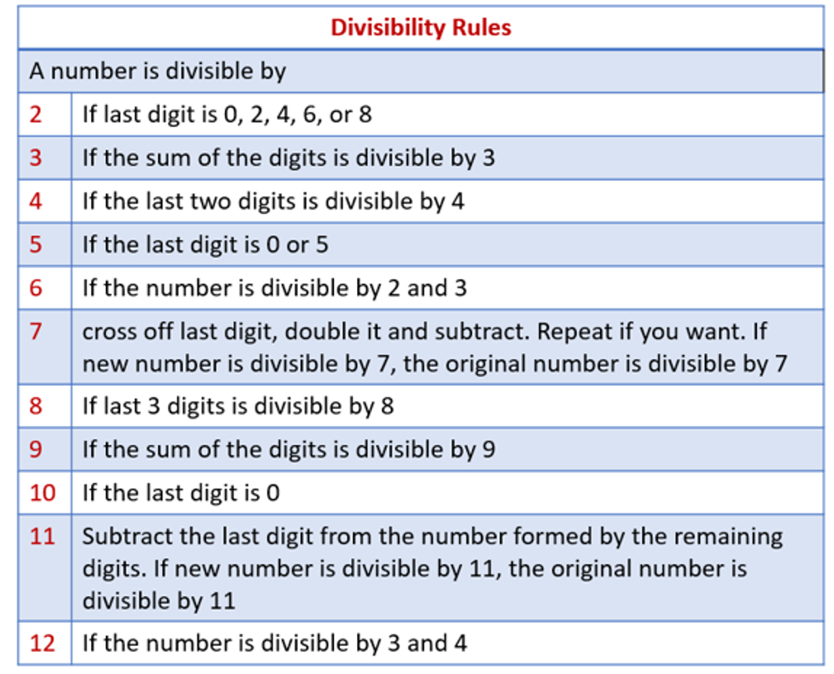
- Chinese remainder theorem, a number is divisible by 60 if and only if it is divisible by 3 and 20.
A number is divisible by 3 if and only if the sum of its digits is divisible by 3.
A number is divisible by 20 if it ends in 20, 40, 60, 80 or 00.

- abs(), fabs():
The difference is that fabs() will always return a floating-point number even if the argument is an integer, whereas abs() will return a floating-point or an integer depending upon the argument.

- y = b^x log_y(b) = log_k(b) / log_k(y) = x

- odd % even always odd

- x ^ (x + 4) = …..00

- __gcd(a, b) not gcd(a, b)

- Get max outside map not in updating loop

- The Goldbach Conjecture is a yet unproven conjecture stating that every even integer greater than two is the sum of two prime numbers.
even = prime + prime
- Any odd number can be expressed as sum of two prime numbers if (n - 2) is prime. odd = 2 + prime
else can be represented by 3 prime numbers
odd = prime + even = prime + prime + prime
// odd = 3 + even = 3 + prime + prime

- Two consecutive integers are Co-Prime, meaning that they do not share any common factor but 1. This means that
GCD(a, a+1) = 1 & LCM(a, a+1) = a * (a + 1)
- LCM(n*(n + 1)*(n + 2)) = (n)*(n + 1)*(n + 2)
If n is odd number
Proof:
n & (n + 1) are coprime because they are consecutive,
n & (n + 2) are coprime because both are two consecutive odd numbers
LCM of three consecutive integers is always their product when two of them are odd numbers!

- All prime numbers are odd, except the number 2.
- GCD(1, x) = 1, LCM(1, x) = x
- n have 4 divisors if n = prime * prime, and so on…
- lcm(d, x/d) = x, if (x/d) % d != 0 (x/d > d)

Probabilities and Expected Values

- The Expected Value (EV, expectation) is the average value of an event/experiment.

- Linearity of EV (super important theorem): E(X + Y) = E(X) + E(Y)
(it works whether the variables are independent or dependent)

- E(X × Y) = E(X) × E(Y)
is true if and only if X and Y are independent random variables, like rolling die twice.
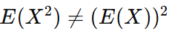

You first square X (each value), then find the average of these squares. “Average of the squares”
You find the mean E(X),then square that number.
“Square of the average.”
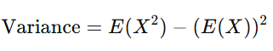

- Ordered Pairs (Super Interpretation of square)

The square of the size of a set is equal to the number of ordered pairs of elements in the set.

So we iterate over pairs and for each we compute the contribution to the answer.

Similarly, the k-th power is equal to the number of sequences (tuples) of length k.

