STL

- Standard Template Library: Libraries contain
Container – Iterator – Algorithm
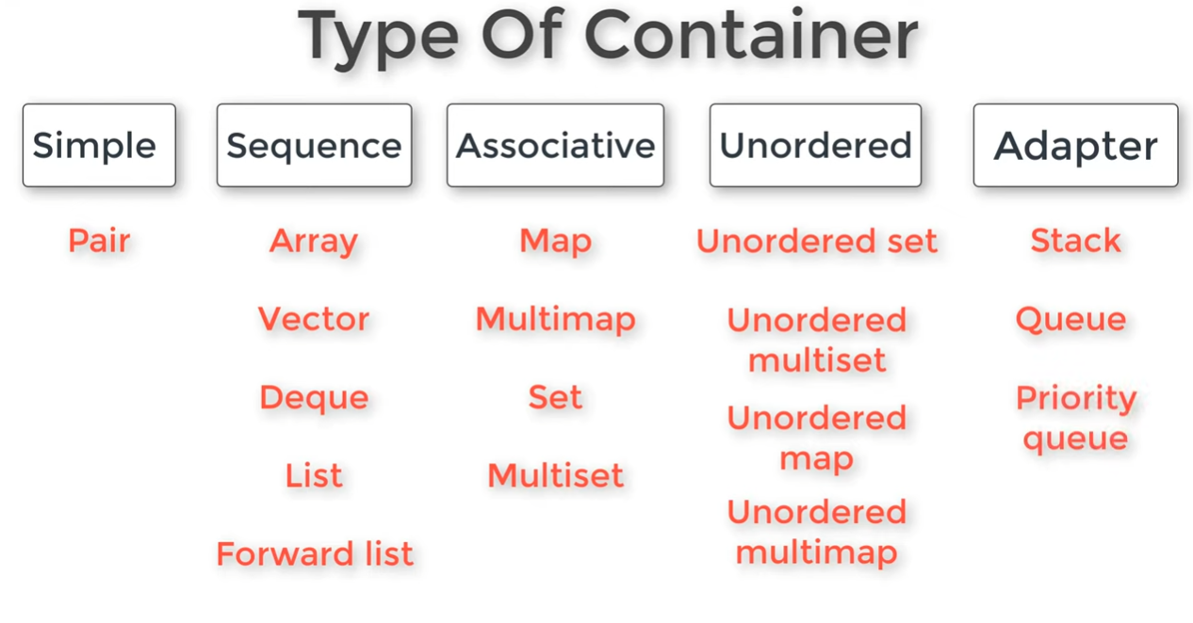

Sequence Containers: implement data structures that can be accessed in a sequential manner.

Associative Containers: implement sorted data structures that can be quickly searched (O(log n) complexity)
Elements in associative containers are referenced by their key and not by their absolute position in the container.

Unordered Associative Containers: implement unordered data structures that can be quickly searched
Container Adaptors: provide a different interface for sequential containers.

- Vector

- Dynamic array, Sequence container.
- #include < vector > - vector < ll > v;
- Insertion/removal of elements at end O(1), else O(n).

- Declaration:
vector < data_type > vector_name;
// use push_back / emplace_back / insert / emplace.

- Initialization:
vector < data_type > vector_name(n);
// initialize n elements with 0 value (default is 0).
vector < data_type > vector_name(n, default_value);
// initialize n elements with default value.

vector < data_type > vector_name = {e1, e2, …};
vector < data_type > vector_name{e1, e2, …};
- Copy:
vector < data_type > v_copy(v); // different container
// make v_copy = v, by passing vector as constructor.

vector < data_type > v_copy(v.begin(), v.end());
vector < data_type > v_copy(arr, arr + n);

vector < data_type > v_copy = v; // same container
// make v_copy = v, by assignment operator.

- Insertion:
v.push_back(element) == v.emplace_back(element)
// push elements into a vector from the back.

v.insert(v.begin + i, element); // or emplace
// Insert an Element at the index i.
v.insert(v.end(), element); // or emplace
// Insert an Element at end.

v.insert(v.begin + index, size, element); // insert only!!
v.insert(v.begin + index, {e1, e2, ……}); // insert only!!
// Insert Multiple Elements at Given Index.
v.insert(v.end(), it1, it2); // insert only!!
// Insert Multiple Elements at Given range.
v.insert(v.end(), v2); // insert only!!
// Append v2 elements at the end of v. must be same container!
- Deletion:
v.pop_back();
// pop or remove last element in the vector.

v.clear();
// remove all the elements of the vector container, thus making it size 0.

v.erase(v.begin() + index);
// remove specific position.

v.erase(v.begin() + start pos, v.begin() + end pos);
// remove a range of elements, (inclusive, exclusive).

- Access:
v[index];
// If the position is not present in the vector, it returns any number.
// when deletion u can access the deleted elements.

v.at(index);
// If the position is not present in the vector, it throws out_of_range exception.

v.front(); == *v.begin()
// return first element.
v.back(); == *(v.end() - 1)
// return last element.

- Swap:
swap(v1[index], v2[index]);
// swap two elements in same or different vectors.

v1.swap(v2); or swap(v1, v2);
// swap the entire contents of one vector with another vector of same type.

- Sorting:
sort(v.begin(), v.end());
// sort elements of the vector Ascending order.

sort(v.rbegin(), v.rend())
sort(v.begin(), v.end(), greater<data_type>());
// sort elements of the vector Descending order.

- Re-Shaping:
v.resize();
// change the size allocated for the vector container.
// if new size < old size, extra elements are demolished (the elements still found by its values but not included in the vector range)
// if new size > old size, new elements are initialized with specified value (zero if not passed). v.resize(size, initial value of new elements)

v.shrink_to_fit();
// reduces the capacity of the container to fit its size and destroys all elements beyond the capacity.
// make (size = capacity)
// function does not accept any parameters and does not return anything.

- Zzz:
v.size();
// Returns the number of elements in vector.
v.capacity();
// not necessarily equal to the size of vector.
// It can be equal or greater than vector size.

v.max_size();
// Returns the maximum number of elements that can be held by the vector container.

v.empty();
// Returns 1 if there are no elements in vector.

v.begin();
// Returns an iterator pointing to the first element in vector.
v.end();
// Returns an iterator pointing to the theoretical element that follows the last element in the vector.
// v.end() – 1 >> Returns an iterator pointing to last element.

void fun(vector < int > &v) { }
// Pass by Reference.
void fun(vector < int > v) { }
// Pass by Value.

vector < vector < int > > v (n, vector < int > (m, 0))
// 2d Vector

- Iterators:
vector < int > v = {0, 1, 2, 3, 4};
vector < int > :: iterator it = v.begin();
// auto it = v.begin

cout << *(it + 1); // 1

auto it2 = v.end();
cout << *(it2 - 1); // 4
- Outputting:

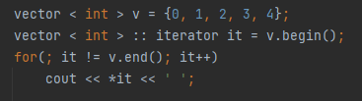
- begin, end

cbegin, cend (const_iterator)
rbegin, rend (reverse_iterator)
crbegin, crend (const_ reverse _iterator)

- auto
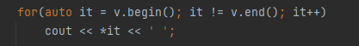

- Efficiency cause using iterators
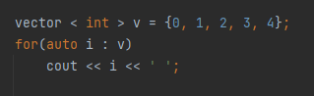

auto i >> copy (can be expensive) (not preferred)
auto &i >> modify (preferred)
const auto &i >> avoid copying (more appropriate)
______________________________________________
fill(v.begin(), v.end(), n);
// Assign the value n to all the elements in the range.

reverse(v.begin(), v.end());
// reverse the vector.

*min_element (v.begin(), v.end());
*max_element (v.begin(), v.end());
// return an iterator pointing to the min & max elements.

find(v.begin(), v.end(), K); O(n)
// return an iterator pointing to the first element equal to K in the vector.
// if not found return v.end().
index = find(v.begin(), v.end(), K) - v.

upper_bound(all(v), element); O(log(n))
// returns an iterator pointing to the first element in the range [first, last) that is greater than the value. If no such an element is found, return end().
// return first element which is > value. If not, return end().
// index = upper_bound(all(v), element) – v.begin();

lower_bound(all(v), element); O(log(n))
// returns an iterator pointing to the first element in the range [first, last) which is greater or equal to the value. If no such an element is found, return end().
// return first element which is ≥ value. If not, return end().
// index = lower_bound(all(v), element) – v.begin();
The sequence must be sorted, else gives undefined behavior!!

Distance()
Binary_seach()

______________________________________________
- Deque

- #include < deque > - deque < ll > dq;
- Insertion / removal of elements at start or end O(1).
- time complexity of deletion is O(1).

- Same methods as Vector, the only difference is
d.push_front(); == d.emplace_front();
d.pop_front();

- next(iterator, +/- n);

______________________________________________
- List

- #include < list > - list < ll > l;
- Doubly Linked List
- Insertion / removal of elements at any place O(1).
- Doesn’t support Random Access, means you can’t just access any item in the list immediately, You have to start at one end and traverse the list towards the item. This makes sorting, searching, and replace slower and takes more steps than a random-access capable container (array, vector, deque).
But supports fast insert and removal of items, because no shifting right of the remaining items need to be done.
- Iterators do not support arithmetic operations like subtraction or addition to access elements by index as you would with arrays or vectors or deque.
- Can’t subtract / add list iterators, use advance().

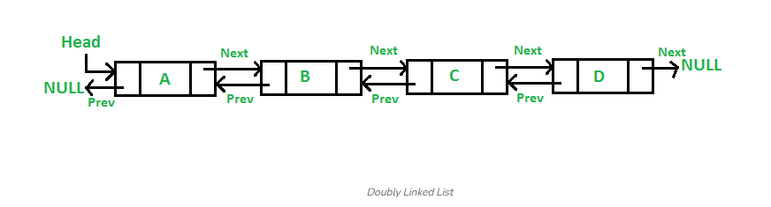

- Same Initialization, Declaration and Copy as vector & deque.
There is an additional method called assign
(can be used for Vector & Deque also)
// Assigns new contents to the container, replacing its current contents, and modifying its size accordingly.

list<int>l; l.assign(cnt, val); == list<int>l(cnt, val);
// Assigns the elements specified in the value parameter cnt number of times starting from the first element in the list till end.
list<int>l2; l2.assign(all(l)); // copy
list<int>l2; l2.assign(arr, arr + n);
list<int>l2; l2.assign({0, 1, 2, 3, …});
- Merge:
l2.merge(l1);
// merge two lists into l2 (l1 is deleted)
// The lists should be sorted in ascending order.

list1.splice(list1.begin(), list2);
// Transfer all the elements of list2 into list1 at some position.
list1.splice(list1.begin(), list2, list2.begin(), list2.begin() + n);
// Transfer range of elements of list2 into list1 at some position.
list1.splice(list1.begin(), list2, list2.begin());
// Transfer an element from list2 into list1 at some position.
// the transferred elements are deleted. (Like insert),
// Between any two containers.
Same Insertion as deque.
push f/b, emplace f/b, emplace, insert.
l.insert(l.begin() + 5, 10); XX WRONG XX No RA

- Same Deletion as Vector & Deque but only for first and last elements only.
pop f/b
l.erase(l.begin() + 5); XXX WRONG XXX No RA

but there is an additional method called remove
l.remove(val); // Very Good method!!
// remove all the elements from the list whose value is equal to val.
l.remove_if(bool_function);
l.remove_if([] (ll n) {return n <= 2});
// remove all the values from the list that correspond true to the predicate or condition given as parameter to the function
# Trying to erase end() results in undefined behavior.

- Access:
v.front(); - v.back();
No random access!! like vector & deque ([], .at()).
// can’t use [] / .at() to access.
also l.begin() + 1 XXX WRONG XXX No RA
instead make iterator
auto it = l.begin();
cout << *(it + 1); XXX WRONG XXX No RA
it++; cout << *it; Right
advance(it, 5); cout << *it; Right

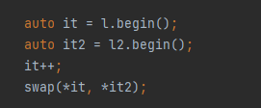
- Swap:

Use advance(it, +/- n)

l.swap(l2);
swap(l, l2);
// Swap two lists

- Sorting:
You can't use sort() to sort a list, because sort() requires iterators to be random access, and list iterators are only bidirectional,
but list has a member function sort:
l.sort(); // Ascending order
l.sort(greater<int>()); // Descending order

- Re-Shaping:
l.resize(new_size);

- Zzz:
l.size() - l.max_size() - l.empty() - l.resize()
l.begin() - l.end() - l.front() - l.back()

advance(it, +/- n); == it += n or it -= n in vector
next(iterator, +/- n);
//move the iterator it +/- (forward / backward) n moves

l.unique(); // Very Good method!!
// removes all duplicate consecutive elements from the list
l.reverse(); // also reverse(all(list));
// reverse the list
Modify an element
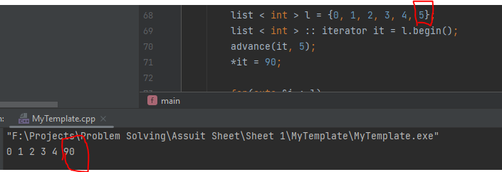

______________________________________________
- Forward List

- #include < forward_list > - forward_list < ll > fl;
- Singly Linked List
- Insertion / removal of elements at any place O(1).
- It is very similar to list, but the list stores both the location of the previous and the next elements of the list while forward_list only stores the location of the next element, thus it saves memory (less memory than list) and more efficient than list.
- Iterators move forward only.
- No random access like list.
- Each element keeps internally only a link to the next element, while List keeps two links per element: one pointing to the next element and one to the preceding one, allowing efficient iteration in both directions, but consuming additional storage per element and with a slight higher time overhead inserting and removing elements.
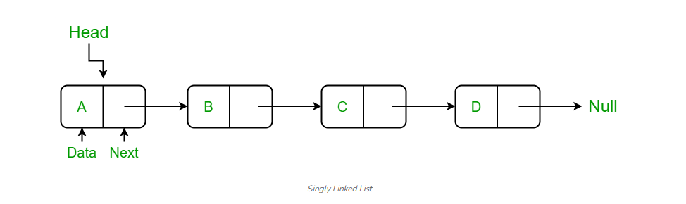

- Same Initialization, Declaration and Copy as list.
- Merge:
l2.merge(l1); // like list

Fl1.splice_after(Fl1.begin(), Fl2);
// Transfer all the elements of Fl2 into Fl1 at some position.
Fl1.splice_after(Fl1.begin(), Fl2, Fl2.begin(), Fl2.begin() + n);
// Transfer range of elements of Fl2 into Fl1 at some position.

Fl1.splice_after(Fl1.begin(), Fl2, Fl2.begin());
// Transfer an element from Fl2 into Fl1 at some position.
// the transferred elements are deleted. (Like insert).
// Between only Forward_lists.

- Insertion
Since Forward_list doesn't have direct access to the last element, it doesn't provide a push_back() function, only push front().
Fl.push_front(); / Fl.emplace_front();

Fl.insert_ after(Fl.begin(), element); // emplace_after
// insert element at iterator l.begin() + 1

Fl.insert_ after(Fl.before_begin(), element);
// insert element at begin of the list.
Fl.insert_ after(Fl.end(), element); XXXX Wrong
Fl.insert_ after(Fl.begin(), {0, 1, 2, ...});

Fl.insert_ after(Fl.begin(), n, element);
// insert n element starting from iterator l.begin() + 1

Fl.insert_ after(Fl.begin(), itr1, itr2); // not same container

Fl.insert_ after(Fl.begin(), Fl2); // must be same container

- Deletion
u can’t pop at end, only at front.
Fl.pop_front();

Fl.erase_after(Fl.begin());
// delete second element in the list
Fl.erase_after(it1, it2);
// delete [*(it1 + 1), *(it2 - 1)]

Fl.clear()
// remove all the elements of the forward list container

Fl.remove(val);
// remove all the elements from the list whose value is equal to val.
Fl.remove_if(bool_function);
// remove all the values from the list that correspond true to the predicate or condition given as parameter to the function
- Access:
Fl.front();
there is no Fl.back() !!
advance(it, +n); // moves forward only.

- Swap:

Use advance(it, + n)

Fl.swap(Fl2);
// Swap two lists

- Sorting:
You can't use sort() to sort a list, because sort() requires iterators to be random access, and list iterators are only bidirectional,
but list has a member function sort:
Fl.sort(); // Ascending order
Fl.sort(greater<int>()); // Descending order

- Re-Shaping:
Fl.resize(new_size);
- Zzz:
Fl.max_size() - Fl.empty() - Fl.begin() - Fl.end() -Fl.front() -

F.before_begin() new !!
//Returns an iterator pointing to the position before the first element in the container.

advance(it, +n); == it += n
//move the iterator it +n moves only.

Fl.unique(); // Very Good method!!
// removes all duplicate consecutive elements from the list

Fl.reverse(); // can’t use reverse(all(list));
// reverse the forward_list.

Modify an element
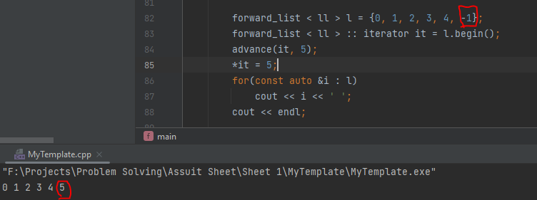
____________________________________________
- Stack LIFO

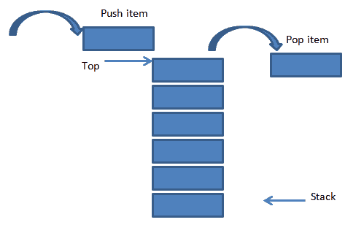

- #include <stack>
- stack < ll > st; // default is deque
- stack < stack, vector < ll > > st; // use vector
- Implemented as container adaptors.
- The time complexity of all member functions is O(1).

- Member functions:

- st.push(val); = st.emplace(val);
// Inserts a new element at the top of the stack.
- st.pop();
// Removes the element on top of the stack.

- st.top();
// Returns a reference to the top element in the stack.

- st.size();
// Returns the number of elements in the stack.

- st.empty ();
// Returns 1 if there is no element in the stack.

- st.swap(st2); = swap(st, st2);
// Swap the elements of two stacks.

- stack < ll > st(deque); // stack initialized to copy of deque.
// the passed container must be the same type as the stack (default >> dequeue).
// stack < ll, list < ll > > st(list); - stack < ll, vector < ll > > st(v);

____________________________________________
- Queue FIFO

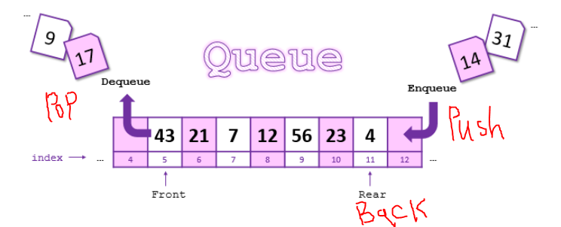

- #include < queue >
- queue < ll > qu; // default is deque
- queue < queue, vector < ll > > st; // use vector
- Implemented as container adaptors.
- The time complexity of all member functions is O(1).

- Member functions:

- qu.push(val); = qu.emplace(val);
// Inserts a new element at the end of the queue, after its current last element
- qu.pop();
// Removes the first element of the queue.

- qu.front();
// Returns the first element in the queue
- qu.back();
// Returns the last element in the queue.

- qu.size();
// Returns the number of elements in the queue.
- qu.empty ();
// Returns 1 if there is no element in the queue.

- qu.swap(qu2); = swap(qu, qu2);
// Swap the elements of two queues.

- queue < ll > qu(deque); // queue initialized to copy of deque.
// the passed container must be the same type as the queue (default >> dequeue).
____________________________________________
- Priority Queue

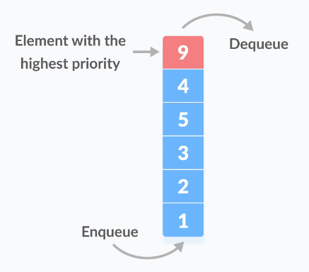

- #include < queue >
- priority_queue < ll > pqu; // default is vector
- priority_queue < queue, list < ll > > st; // use list
- Implemented as container adaptors.
- Are built on the top of the max heap and use an array or vector as an internal structure.
- The top element is always the greatest by default, but we can also change it to the smallest element at the top.
- Designed such that the first element of the queue is either the greatest or the smallest of all elements in the queue, and elements are in non-increasing or non-decreasing order.
- This context is similar to a heap, where elements can be inserted at any moment, and only the max heap element can be retrieved (the one at the top in the priority queue).
- The time complexity of all member functions is O(1), except insertion & deletion are O(log(n)).

- Max Heap:
priority_queue < ll > maxpqu;
priority_queue < ll, vector < ll >, less < ll > > minpqu;
// The element with the highest priority (largest value) is at the top.

- Min Heap:
priority_queue < ll, vector < ll >, greater < ll > > minpqu;
// The element with the lowest priority (smallest value) is at the top.
- Member functions:

- pqu.push(val); = pqu.emplace(val);
// Inserts a new element into the priority queue.

- pqu.pop();
// Removes the top element in the priority queue.

- pqu.top();
// Returns the top element in the priority queue.

- pqu.size();
// Returns the number of elements in the priority queue.
- pqu.empty ();
// Returns 1 if there is no element in the priority queue.

- pqu.swap(pqu2); = swap(pqu, pqu2);
// Swap the elements of two priorities queues.

- Piriority_queue < ll > pqu(all(container));
// Priority queue initialized to copy of a container (iterator ranges).
// The passed container can be an array.
_____________________________________________
- Pair

- #include < utility >
- pair < data_type1, data_type2 > pr;
- Pair is used to combine together two values that may be of different data types.
- The first element is referenced as ‘first’ and the second element as ‘second’ and the order is fixed (first, second).

- Single Pair:

- Initialization:

pair < data_type1, data_type2 > pr;
// initialized with default values (zero for numbers), (Null for string & char).

pair < data_type1, data_type2 > pr (val1, val2);
pair < data_type1, data_type2 > pr {val1, val2};

pair < data_type1, data_type2 > pr = {val1, val2};
pair < data_type1, data_type2 > pr = make_pair(val1, val2);
pair < data_type1, data_type2 > pr = pair < data_type1, data_type2 > (val1, val2);

pair < data_type1, data_type2 > pr;
pr = {val1, val2}; or pr = make_pair(val1, val2);
or pr = pair < d_t1, d_t2 > (val1, val2);

pr.first = val1; pr.second = val2;
or cin >> pr.first >> pr.second;

pair < data_type1, data_type2 > pr (pr2);
// Copy.

- Swap:
Pr.swap(pr2)
// The pairs must be of the same type.

- Vector of Pair:

- Declaration:
vector < pair < data_type1, data_type2 > > pr;

- Initialization:
vector < pair < data_type1, data_type2 > > pr;
pr.push_back({val1, val2});
or pr.push_back(make_pair(val1, val2));
or pr.push_back(pair < d_t1, d_t2 > (val1, val2));

vector < pair < data_type1, data_type2 > > pr(n);
pr.front().first = val - pr.back().second = val
- pr[5].first = val

- Iterators:
vector < pair < data_type1, data_type2 > > pr;
vector < pair < data_type1, data_type2 > > ::iterator it = pr.begin();
it -> first - it -> second

- Sorting:

- Ordered by first:

Ascending Order: sort(all(v));
Descending Order: sort(rall(v));
or sort(all(v), greater < pair < dt1, dt2 > >());

- Ordered by second:

Ascending Order: sort(all(v), SortSecondAscending);
Descending Order: sort(all(v), SortSecondDescending);

- Priority queue of pairs:

- Ordered by first:

- Max Priority queue (Or Max heap) ordered by first element:
priority_queue < pair < d_t1, d_t2 > > mxpq;

- Min Priority queue (Or Min heap) ordered by first element:
priority_queue <
pair < d_t1, d_t2 >,
vector < pair < d_t1, d_t2 > >,
less < pair < d_t1, d_t2 > >
> mnpq;

- Ordered by Second:
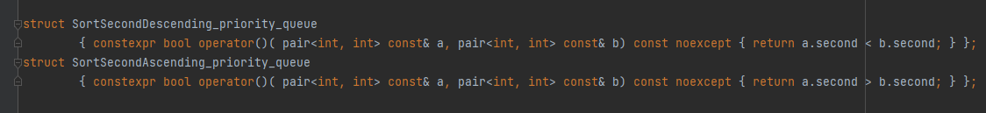

- Max Priority queue (Or Max heap) ordered by first element:

priority_queue <
pair < d_t1, d_t2 >,
vector < pair < d_t1, d_t2 > >,
SortSecondDescending_priority_queue>
> mxpq;

- Min Priority queue (Or Min heap) ordered by first element:

priority_queue <
pair < d_t1, d_t2 >,
vector < pair < d_t1, d_t2 > >,
SortSecondAscending_priority_queue>
> mnpq;
_____________________________________________
- Set

- #include <set>
- set < ll > st;
- Sets are typically implemented as binary search trees.
- Associative Container, in which each element has to be unique because the value of the element identifies it, The values are stored in a specific sorted order i.e. either ascending or descending.
- Set containers are generally slower than Unordered_Set containers to access individual elements by their key, but they allow the direct iteration on subsets based on their order.
- The value of an element is also the key used to identify it.
- No two elements in the container can have equivalent keys.
- No Random Access.
- By default, Set is sorted in ascending order, However, we have the option to change the sorting order (descending order) by using the following syntax.
set < data_type, greater < data_type > > st;

- Declaration:
set < data_type > st;
// empty set.

- Initialization:

set < data_type > st = {e1, e2, e3, ….};
set < data_type > st {e1, e2, e3, ….};
// Initialize a set with given elements.

- Copy:

set < data_type > st = st2;
set < data_type > st (st2);
// the two sets must be the same data type & sorting (typical declaration).

set < data_type > st (stl.begin(), stl.send());
set < data_type > st (arr, arr + n); nlog(size + n)
// copy a STL container or array elements to a Set.

- Insertion:

st.insert(element); O(log N)
st.emplace(element);
// Inserts a new element in the set, if unique.
// Return Value: the function returns a pair of an iterator to the newly inserted element and a Boolean value (1 if successfully inserted, else 0).

st.insert(iterator, element);
st.emplace_hint(iterator, element);
// The iterator points to a position from where the searching operation is to be started for insertion to make the process faster.
// Return Value: an iterator to the equivalent element within the container.

st.insert({e1, e2, e3, ….});
// Insert multiple elements, if unique.

st.insert(it1, it2); st.insert(arr, arr + n);
// Insert a range of STL container.

- Check if found:
auto it = st.insert(e1);
auto it = st. emplace (e1);
// insert / emplace returns a pair of iterators, the first iterator pointing to the element, and the second iterator is a Boolean value if the element was successfully inserted.
// cout << *it.first << endl; print the element e1.
// cout << it.second << endl; print 0, if the set size doesn’t change, else 1.
// auto it == pair < set < data_type > :: iterator, bool > it;

st.find(element); O(log N)
// Return an iterator to the element, if val is found, or st.end() otherwise.

st.count(val); O(log N)
// Return 1 (Frequency) if the container contains an element equivalent to val, or 0 otherwise.

- Deletion: O(log N)

st.erase(element);
// Return a Boolean iterator, 1 if the element is in the set and deleted, else 0.

st.erase(iterator);
// Delete the element the iterator pointing to if found, and return an iterator pointing to the next element to the deleted element
// u can get the iterator using st.find(element), but be sure that the element is in the set.

st.erase(iterator1, iterator2);
// Delete a range of numbers between the two iterators (in, ex).
// u can get the iterator using st.find(element), but be sure that the element is in the set.
// Return Value: iterator pointing to the next element to the deleted element (itertator 2).

st.clear();
// Removes all elements from the set container (which are destroyed), leaving the container with a size of 0.
// No Return Value.

- Searching: O(log N) very fast!
st.find(element);
// Return an iterator pointing to the element, if val is found, or st.end() otherwise

st.lower_bound(element); >=
// Return an iterator pointing to the first element that is not less than element, if found, or st.end() otherwise

st.upper_bound(element); >
// Return an iterator pointing to the first element that is greater than the element, if found, or st.end() otherwise

st.equal_range(element); lower + upper bounds
// Return two iterators, one pointing to the first element that is not less than key (element itself) and another pointing to the first element greater than key.
// Because all elements in a set container are unique, the range returned will contain a single element at most.

- Swap
st.swap(st2);
swap(st, st2);
// Exchanges the content of two Sets (Same Type).

- Zzz:
st.size() - st.max_size() - st.empty() - st.begin() - st.end() -

_____________________________________________

- Multi-Set

- #include <set>
- multiset < ll > st;
- Multi_Sets are typically implemented as binary search trees.
- Associative Container, in which each element has a value identifies it, The values are stored in a specific sorted order i.e. either ascending or descending.
- The value of the elements in a multiset cannot be modified once in the container (the elements are always const), but they can be inserted or removed from the container.
- Multi_Set containers are generally slower than Unordered_Multiset containers to access individual elements by their key, but they allow the direct iteration on subsets based on their order.
- No Random Access.
- By default, Multi_Set is sorted in ascending order, However, we have the option to change the sorting order (descending order) by using the following syntax.
multiset < data_type, greater < data_type > > st;

- Declaration:
multiset < data_type > st;
// empty multi_set.

- Same Declaration & Copy as Set:

- Insertion:

st.insert(element); O(log N)
st.emplace(element);
// Inserts a new element in the multi_set.
// Return Value: An iterator pointing to the newly inserted element in the multiset.

st.insert(iterator, element); More efficient
st.emplace_hint(iterator, element);
// The iterator points to a position from where the searching operation is to be started for insertion to make the process faster.
// Return Value: An iterator pointing to the newly inserted element in the multiset.

st.insert({e1, e2, e3, ….});
// Insert multiple elements.
st.insert(it1, it2); st.insert(arr, arr + n);
// Insert a range of STL container.

- Deletion: O(log N)
st.erase(element);
// Removes elements from the multiset container, if found.
// Returns the number of elements erased.

st.erase(iterator);
// Delete the element the iterator pointing to if found, and return an iterator pointing to the next element to the deleted element .
// u can get the iterator using st.find(element), but be sure that the element is in the set.
// st = {-1, 0, 0, 0, 0, 5} >> st.begin() + 1 is deleted
st.erase(iterator1, iterator2);
// Delete a range of numbers between the two iterators (in, ex).
// u can get the iterator using st.find(element), but be sure that the element is in the set.
// Return Value: iterator pointing to the next element to the deleted element (itertator 2).

st.clear();
// Removes all elements from the set container (which are destroyed), leaving the container with a size of 0. // No Return Value.
- Searching: O(log N)
st.find(element);
// Return an iterator pointing to the element, if val is found, or st.end() otherwise

st.count(val);
// Return (Frequency) of val if the container contains an element equivalent to val, or 0 otherwise.

st.lower_bound(element); >=
// Return an iterator pointing to the first element that is not less than element, if found, or st.end() otherwise

st.upper_bound(element); >
// Return an iterator pointing to the first element that is greater than the element, if found, or st.end() otherwise

st.equal_range(element); lower + upper bounds
// Return two iterators, one pointing to the first element that is not less than key (element itself) and another pointing to the first element greater than key.
// if not found, return two iterators pointing to st.end().

- Swap
st.swap(st2);
swap(st, st2);
// Exchanges the content of two Sets (Same Type).

- Zzz:
st.size() - st.max_size() - st.empty() - st.begin() - st.end() -

_____________________________________________
- Map

- #include <map>
- map < ll, ll > mp;
- Always sorted by key, Unique keys

- mp.count(k) Return 1 if the container contains an element whose key is equivalent to k, or zero otherwise.
- mp.erase(key)

_____________________________________________
- Multi-Map

_____________________________________________
- Unordered-Set

_____________________________________________

