Garments Products Wholesaler Management System



A project submitted in partial fulfillment of the requirements of Varendra University for the degree of BSc Engineering in CSE.

January 2019

Submitted by
ID: 151311056
Department of Computer Science and Engineering
Varendra University
Rajshahi, Bangladesh

Supervised by
Krishna Chandro Ray
Lecturer
Department of Computer Science and Engineering
Varendra University
Rajshahi, Bangladesh

Abstract

This project report on garments products wholesaler management system. During the making/developing of this project explored new ideas and functionality behind the work. This project is the output of my planning, schedule, programming skill and the hard work, and this report reflects my steps taken at various levels of programming skill, planning, schedule. I have learnt a lot during this project and liked the improvement in testing skills and deep concept related to this kinds of projects.
Garments Products Wholesaler Management System. This is a web based application which helps a wholesaler to find and buy latest garments company products with different functionalities on internet. It is useful in a way that it makes an easier way to buy different garments products online.
In this application basically having three modules. The first modules includes the garments company module, second modules includes wholesaler and third modules includes admin.

Acknowledgements

At first I would like to pray our heartiest gratitude to almighty Allah for this divine blessing which made me possible to complete this project wok successfully.
I express my thanks and full-hearted gratitude to my respected teacher, supervisor Krishna Chandro Ray, Department of Computer Science and Engineering, Varendra University, for his full guidance and entire support in completing this project successfully. I am very much thankful to him for the constant encouragement and continuous inspiration that he has given to me.
Finally I convey my real sense of gratitude and thankfulness to all my friends for their unconditional support and encouragement during my project work without which I would hardly be capable of producing this huge work.

Table of Contents Page
Abstract
Acknowledgement

Chapter 1: Introduction
1.1 General Introduction 6
1.2 Proposed System 6
1.3 Purpose of the Project 6-7
1.4 Scope 7

Chapter 2: Requirements Analysis
2.1 Requirements Analysis 8
2.2 Customer Analysis 8
2.3 Process Requirements 9
2.4 Functional Requirements 9
2.5 Software Requirements 9
2.6 Feasibility Study 10
2.7 Technical Feasibility 10
2.8 Economic Feasibility 10
2.9 Operational Feasibility 10
2.10 Use Case Diagram 11-12
2.11 Data Flow Diagram (DFD) 13-14

Chapter 3: Database Table Design
3.1 Company table 15
3.2 wholesaler table 16
3.3 Product table 16
3.4 Order table 17
3.5 Admin table 17

Chapter 4: Implementation
4.1 Implementation 18
4.2 HTML 18
4.3 CSS 19
4.4 Bootstrap 19
4.5 Asp.Net 19
4.6 Testing 20
4.7 Black Box Testing 20
4.8 White Box Testing 21

Chapter 5: Design Specification
5.1 Home Page 22
5.2 Customer login page 23
5.3 Customer Registration Page 23
5.4 Customer product list page 24
5.5 Wholesaler Product details view with Add to Cart option 25
5.6 Wholesaler Shopping Cart before checkout 25
5.7 Wholesaler Order History 26
5.8 Company Login 26
5.9 Company Register 27
5.10 Company Add product 27
5.11 Company Added Product list 28
5.12 Feedback 29
5.13 Admin Login 29
5.14 Admin Manage Users Account 30

Chapter 6: Conclusion and Future Work
6.1 Conclusion 31
6.2 Limitation 31
6.3 Future Scope 32
References 32

Chapter-1 Introduction

1.1 General Introduction

Internet is attracting all type people day by day. As it gets popularity there are many sites offering products online. Online shopping is the process whereby consumers directly buy products and gets services from a seller interactively in real time without an intermediary service over the internet. But here I made an attempt to provide generalized program to suit all the garments company to sell their products to the wholesaler and wholesaler have the choice to buy the product online. This project like a middleware between Garments Company and wholesaler.

1.2 Proposed System:

This general Garments product wholesaler management system site program will help many company who want to sell their product and wholesaler who want to buy garments product online.

1.3 Purpose of the Project:

Shopping in online became a recreational activity of life. The reason of developing web based garments product wholesaler management system is every wholesaler travel company storehouse it has some difficulties, also some wholesaler are so much busy and not able to go out for storehouse. There is another reason that it’s not possible to see all the product of a storehouse, also its hazardous for both. The world of software development there lots of improvement to reduce the complexity of people of life.
Garments product wholesaler management system is a virtual store on Internet where wholesaler can browse the product and select the product of interest. The selected product may be collected in shopping cart. At checkout time the items in the shopping cart will be presented as an order. At that time shipping information and payment method have to select to the customer. Finally by confirming the order have to complete the shopping and the product will deliver to customer via currier, post office or by direct agent of company.
The purpose of designing the Garments Product Wholesaler Management System is to give the Wholesaler, a platform for finding a right and a satisfactory product and service according to their satisfactory prices. It also connects the Wholesaler with the major companies. This site can handle data of Several Companies, wholesaler.

1.4 Scope:

The scope of the Garments Products Wholesaler Management System includes:

- Company Area
    - Online registration: company have to registration to add products.
    - Add and View Products: company can add products images with products details specification and also view their product details.
    - Order: company can view wholesaler products orders.
    - Deliver: company deliver products to wholesaler address.

- Wholesaler Area
    - Online registration: Customer have to register to buy product online.
    - View Product: Customer can view product. Select the items to cart, also can delete from cart before final submission, he can also view product details, shipping information and price that means all in invoice.
    - Payment Method: Customer can select the payment method what is easy for him for payment the cost.

- Administrator’s Control Panel
    - Accounts: admin can manage users account.
    - Product: admin can manage product.

Chapter 2: Requirements and System Analysis

2.1 Requirement Analysis

As the goal of the application is ease of use and to provide an interactive interface, extensive research has been done to gain an insight into the needs and behaviors of various users. The working of the application is made convenient and easy to use for the end user. In this systems there are three party who interact with the system, one of them are company who wants to sell product, another wholesaler who wants to buy products and other the system admin manage the system.

2.2 Customers’ Requirements:

- Product adding option for company and viewing orders details.
- Knowing when an item have to save not save in the shopping cart.
- Returning the different parts of the site after adding an item to the shopping cart.
- Easy scanning and selecting items in the list.
- Simple navigation from home page to information and order links for specific products.
- Obvious shopping links or buttons.
- Consistent layout of product information.
- A well-organized web interface to work as admin so that he can handle all the part of the system properly.

2.3 Process Requirement

To perform any systems have some specific authentication functionality. The following process requirements are identified for the better performance of the system:

- A valid company user id is need to add their products details so that they can advertise their products and also view orders.
- A valid admin user is needed to access the information of the system for the admin.
- A valid wholesaler ID is need to the wholesaler to buy the product.
- Admin login to the system can users and product related information. Also he can update the order information
- Wholesaler can add product to cart only when he is a register user to the system, as well as have to login to the system otherwise not able to add product to cart.

2.4 Functional requirements:
This system must provide following functionalities-

- Keeping records of all users.
- Keeping records of products.
- Storing the feedback given by the users.
- Keeping details about the products orders.

2.5 Software Requirement
- Web Technology : ASP.NET
- Design : HTML, CSS, Bootstrap
- Development Platform : Microsoft Visual Studio 2015
- Database : MS SQL Server 2014

2.6 Feasibility Study:

The feasibility study of a project can be ascertained in terms of technical and economic factors or both. A feasibility study is documented with a report showing all the ramifications of the project.
Five common factors of Feasibility Study:
The acronym TELOS refers to the five areas of feasibility - Technical, Economic, Legal,
Operational, and Scheduling.

2.7 Technical Feasibility:

Technological feasibility is carried out to determine whether the company has the capability, in terms of software, hardware, personnel and expertise, to handle the completion of the project.

2.8 Economic Feasibility:

Economic analysis is the most frequently used method for evaluating the effectiveness of a new system. More commonly known as cost/benefit analysis, the procedure is to determine the benefits and savings that are expected from a candidate system and compare them with costs. If benefits outweigh costs, then the decision is made to design and implement the system. An entrepreneur must accurately weigh the cost versus benefits before taking an action.

2.9 Operational Feasibility:

Operational feasibility is a measure of how well a proposed system solves the problems, and takes advantage of the opportunities identified during scope definition and how it satisfies the requirements identified in the requirements analysis phase of system development.

2.10 Use Case Diagram:

A use case is a methodology used in system analysis to identify, clarify, and organize system requirements. The use case is made up of a set of possible sequences of interactions between systems and users in a particular environment and related to a particular goal. It consists of a group of elements (for example, classes and interfaces) that can be used together in a way that will have an effect larger than the sum of the separate elements combined.
The use case should contain all system activities that have significance to the users. A use case can be thought of as a collection of possible scenarios related to a particular goal, indeed, the use case and goal are sometimes considered to be synonymous.

Use case diagram figure:
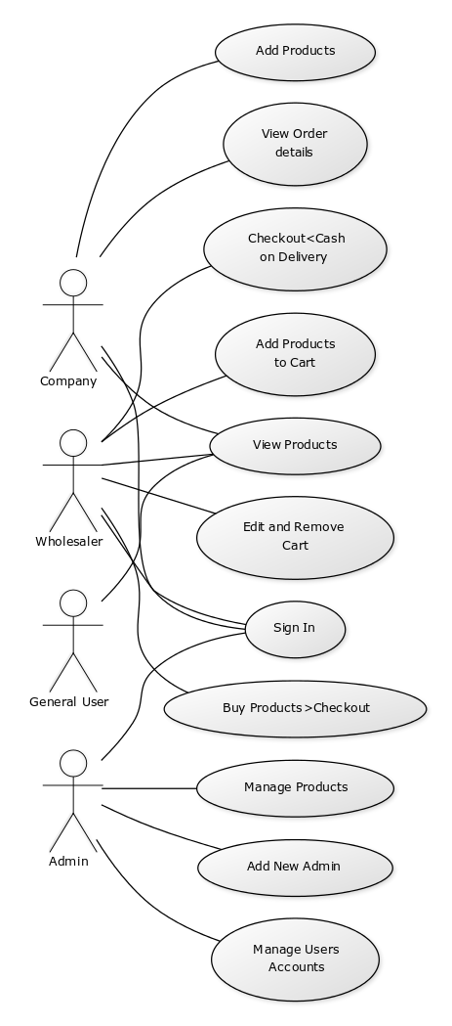

2.11 Data Flow Diagram (DFD):

A data flow diagram (DFD) is a graphical representation of the "flow" of data through an information system, modelling its process aspects. A DFD is often used as a preliminary step to create an overview of the system.

Admin DFD:

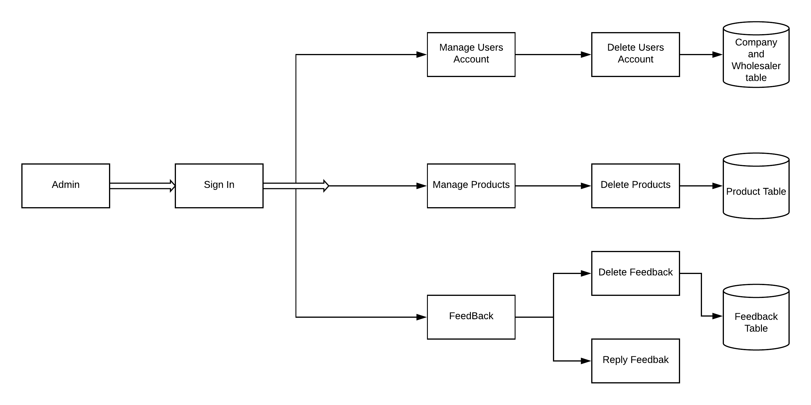

Company DFD:

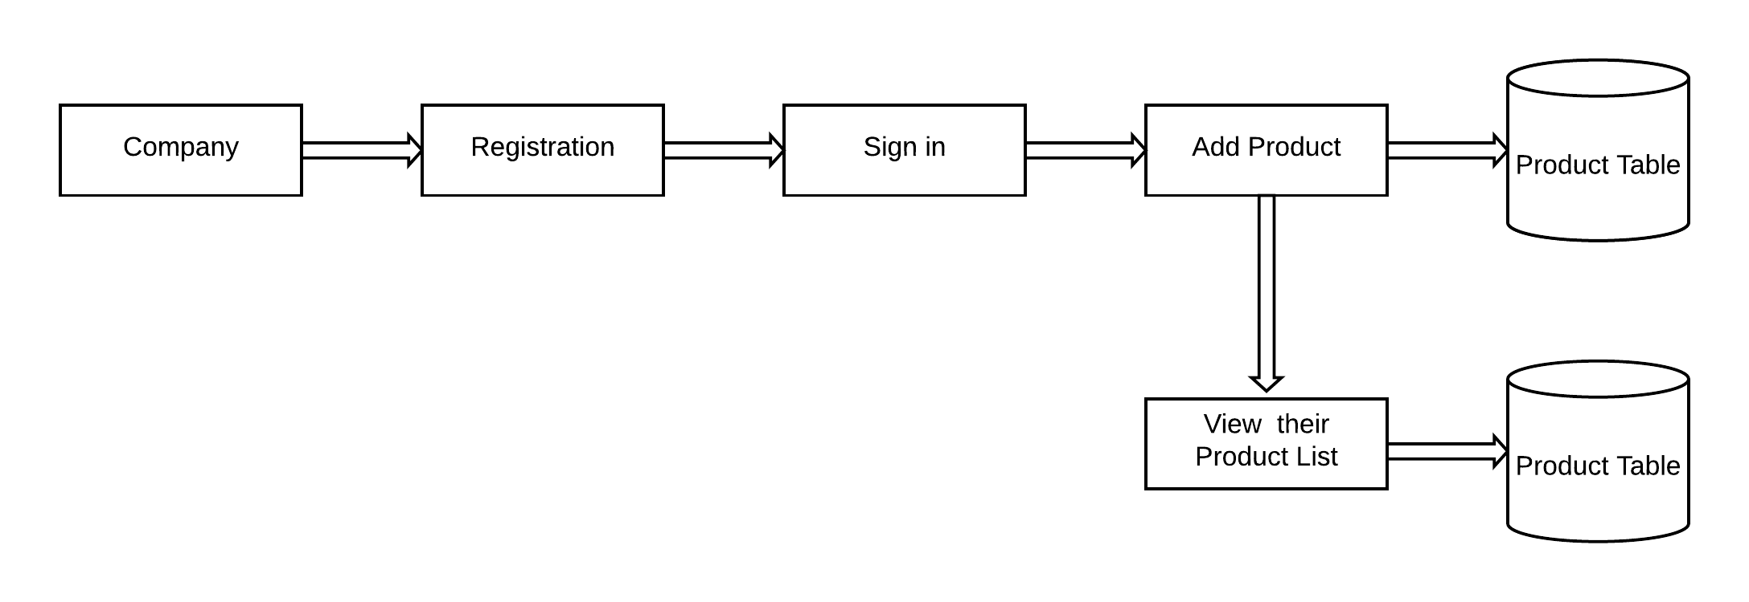

Customer DFD:

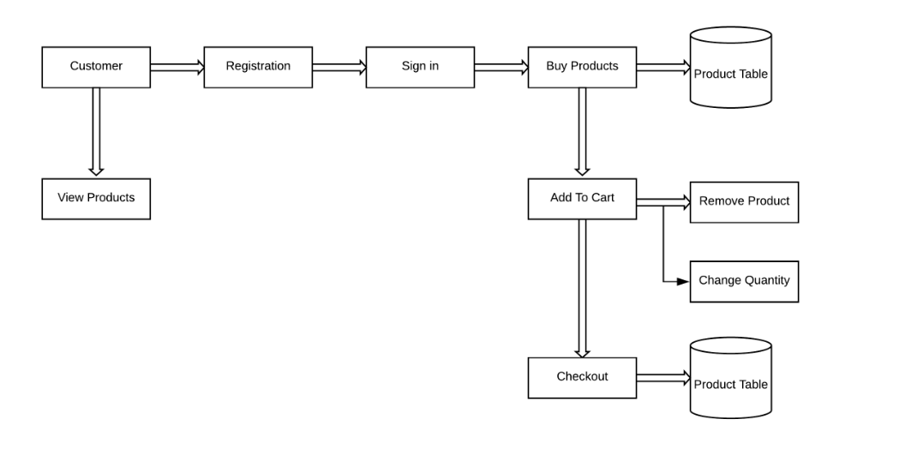

Chapter 3 Database Design

A database design is a collection of stored data organized in such a way that the data requirements are satisfied by the database. The general objective is to make information access easy, quick, inexpensive and flexible for the user. There are also some specific objective like control redundancy from failure, privacy, security and performance.
A collection of relative records make up a table. To design and store data to the needed forms database tables are prepared. Two essential setting for a database are,

Primary key: The field that is unique for all the record occurrences.
Foreign Key: The field use to set relation between tables. Normalization is a technique to avoid redundancy in the tables.
3.1 Company Table

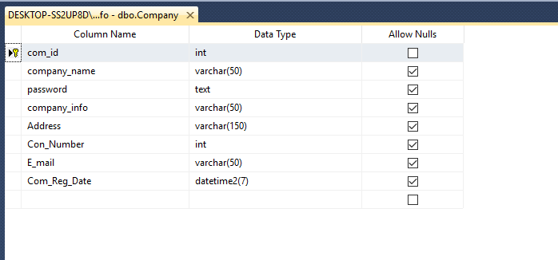

3.2 Wholesaler Table

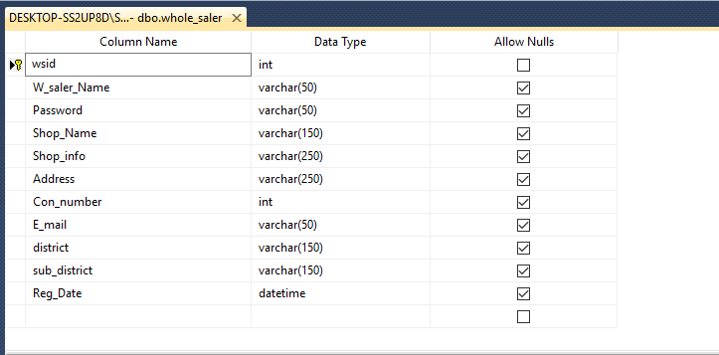

3.3 Product Table

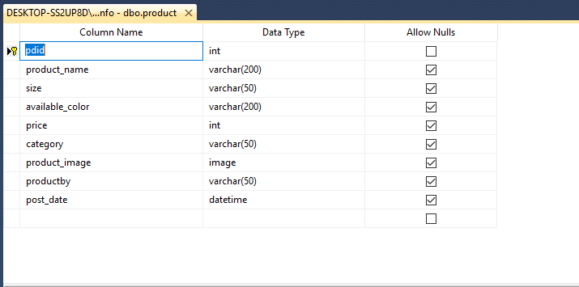

3.4 Order Table

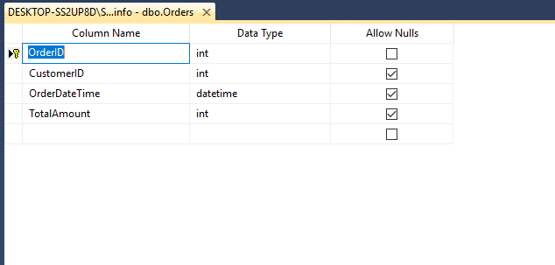

3.5 Admin Table

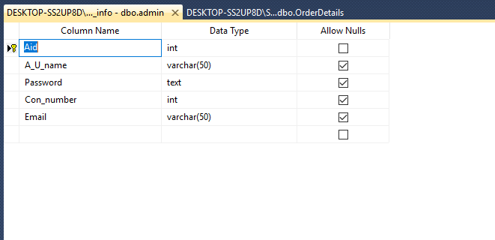

Chapter 4 Implementation

4. 1 Implementation

While there are number of software tools to develop and implement the web based Garments Products Wholesaler Management system, I have chosen those are open source, so that it will reduce the developing cost of the project. For designing the project HTML, CSS, Bootstraps, Asp.net for making the system dynamic. MS SQL as database server. All of the tools are open source.

4.2 HTML
In this project HTML used for design the structure. HTML is a markup language for describing web documents and stands for Hyper Text Markup Language, a markup language is a set of markup tags. HTML documents are described by HTML tags. Each HTML tag describes different document content. HTML used because:
• Easy to learn.
• Easy to use.
• Supported by all browser.
• Cost effective.

4.3 CSS:
CSS stands for Cascading style Sheets is a language for style and manipulate HTML. CSS is a style sheet used for describing the look and formatting of document written in a markup language.

4.4 Bootstrap:
Bootstrap is a free and open-source framework for creating websites and web applications. It's the most popular HTML, CSS, and JS framework for developing responsive, mobile first projects on the web.

4.5 Asp.Net:

ASP.NET is a web development platform, which provides a programming model, a comprehensive software infrastructure and various services required to build up robust web applications for PC as well as mobile devices.
ASP.NET works on top of the HTTP protocol, and uses the HTTP commands and policies to set a browser-to-server bilateral communication and cooperation.
ASP.NET is a part of Microsoft .Net platform. ASP.NET applications are compiled codes, written using the extensible and reusable components or objects present in .Net framework. These codes can use the entire hierarchy of classes in .Net framework.
ASP.NET application codes can be written in any of the following languages:
• C#
• Visual Basic.Net
• Jscript
• J#
ASP.NET is used to produce interactive, data-driven web applications over the internet. It consists of a large number of controls such as text boxes, buttons, and labels for assembling, configuring, and manipulating code to create HTML pages.

4.6 Testing

Exhaustive testing for the project is not possible. Some testing strategies and stage designed manually. For this project Black box and White box testing are chosen. This two type testing applied different part of the project.

4.7 Black Box Testing

Black Box Testing, also known as Behavioral Testing, is a software testing method in which the internal structure/ design/ implementation of the item being tested is not known to the tester. These tests can be functional or non-functional, though usually functional. This method is named so because the

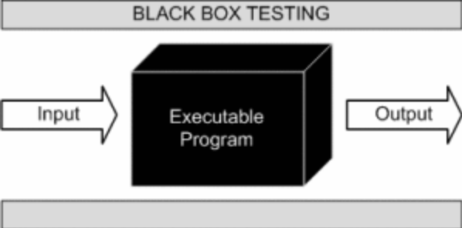

Software program, in the eyes of the tester, is like a black box; inside which one cannot see. This method attempts to find errors in the following categories:
• Incorrect or missing functions
• Interface errors
• Errors in data structures or external database access
• Behavior or performance errors
• Initialization and termination errors

4.8 White Box Testing

White Box Testing also known as Clear Box Testing, Open Box Testing, Glass Box Testing, Transparent Box Testing, Code-Based Testing or Structural Testing is a software testing method in which the internal structure/ design/ implementation of the item being tested is known to the tester. The tester chooses inputs to exercise paths through the code and determines the appropriate outputs. Programming know-how and the implementation knowledge is essential. White box testing is testing beyond the user interface. The white box testing perform normally in this project different part.

Chapter 5 Design Specification

5.1 Home Page:
Home Page view is shown in figure below:

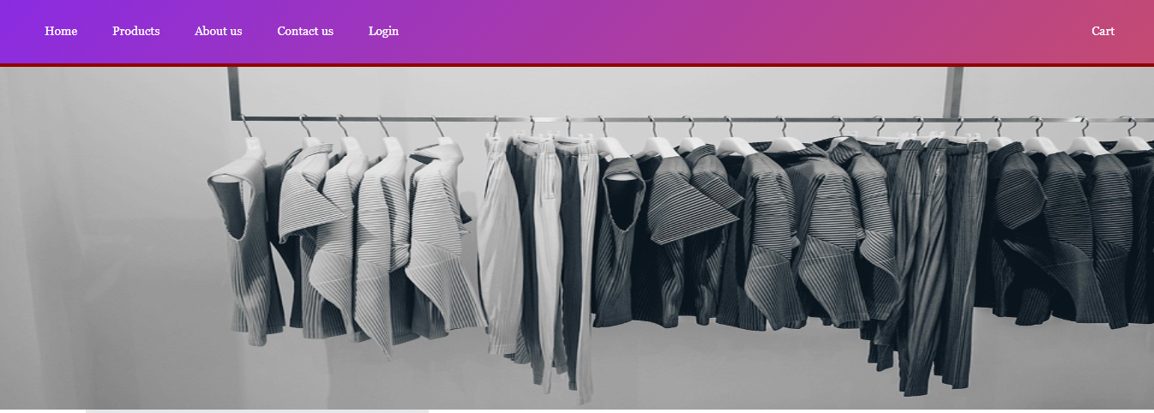
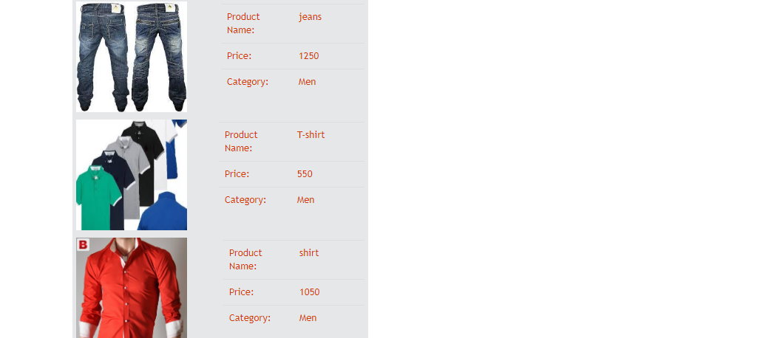

5.2 Customer login page

Wholesaler have to login before adding product in cart. In this page existing wholesaler can login to buy product. Figure of user login page given below:
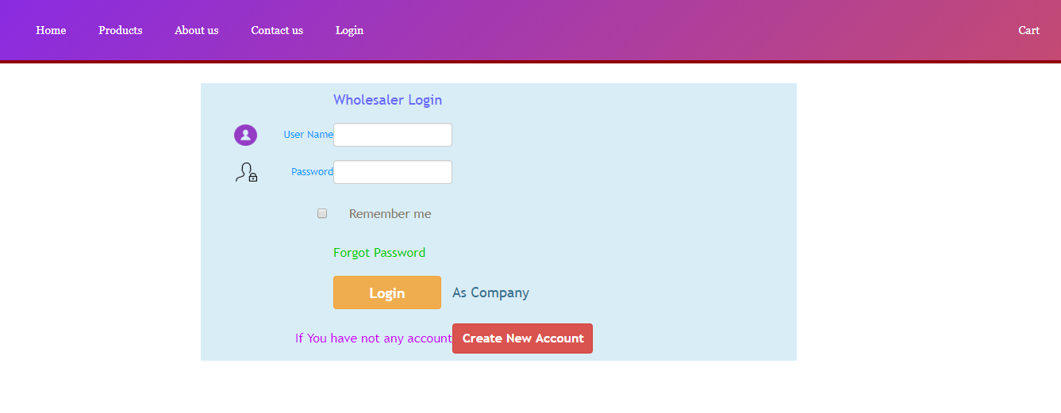

5.3 Customer Registration Page:

A new user can create an account for buying the product. Figure of wholesaler registration page.

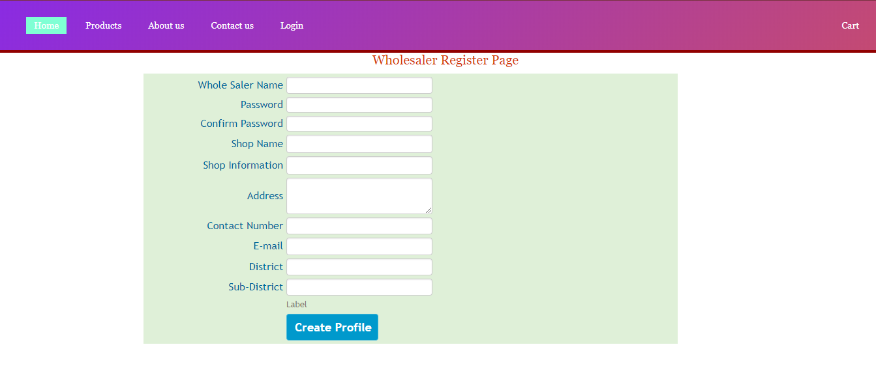

5.4 Customer product list page

In this page wholesaler show all company products. Figure of wholesaler product page.

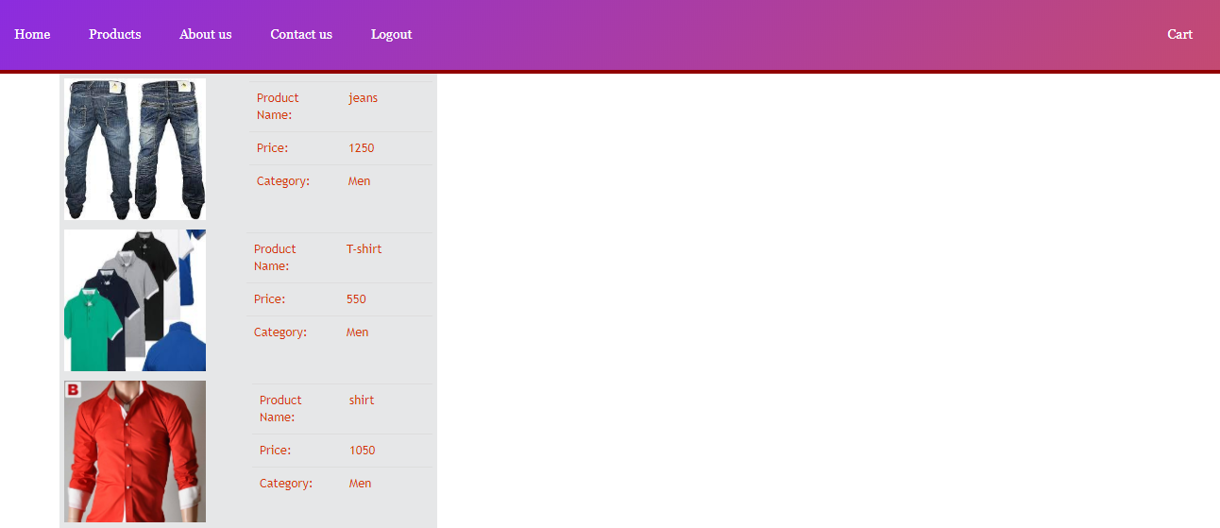
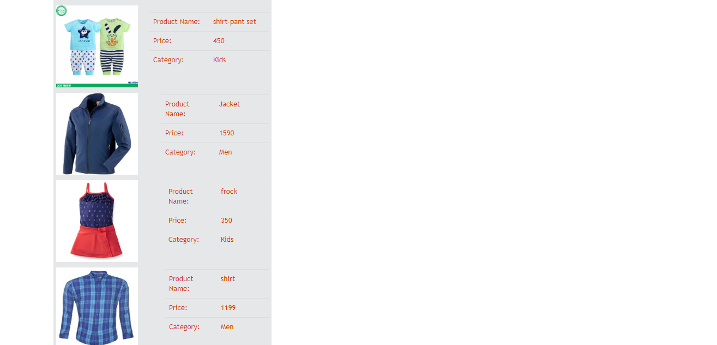

5.5 Wholesaler Product details view with Add to Cart option:

Wholesaler can view product image with product details description and add product to cart. Figure of products details view with add to cart option.

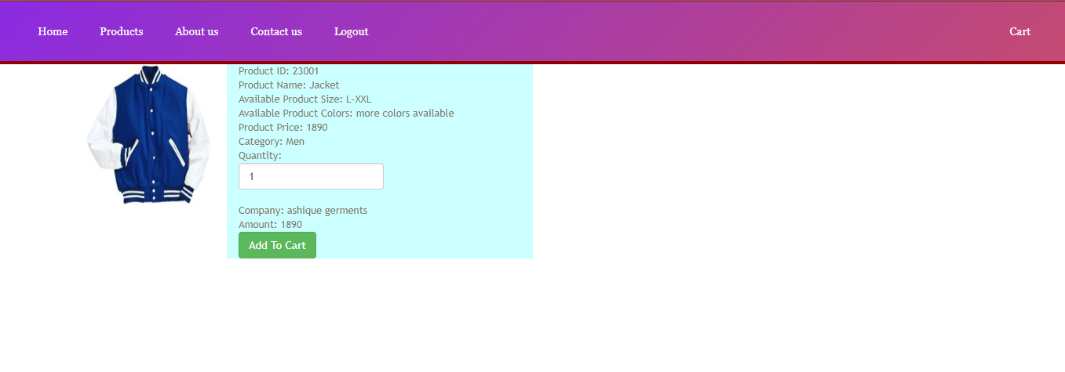

5.6 Wholesaler Shopping Cart before checkout:

The wholesaler can view the product, update number of product, delete product from cart and check out and given figure below:
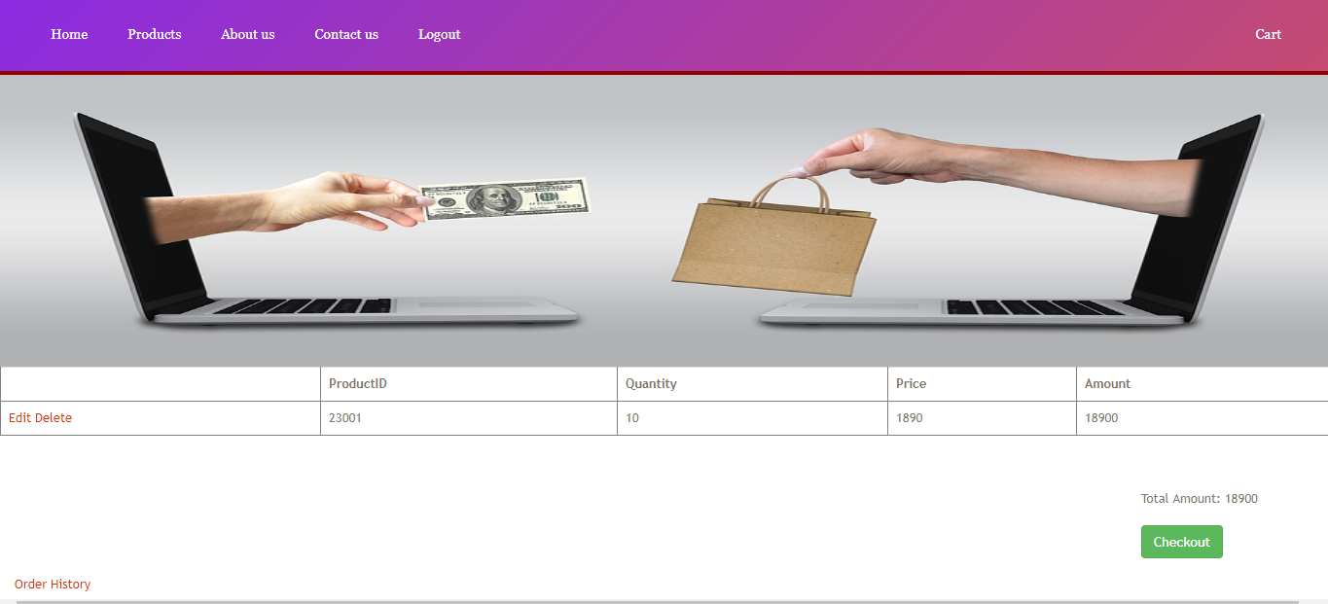

5.7 Wholesaler Order History:

Wholesaler can see his/her order history. Figure of order history given below.
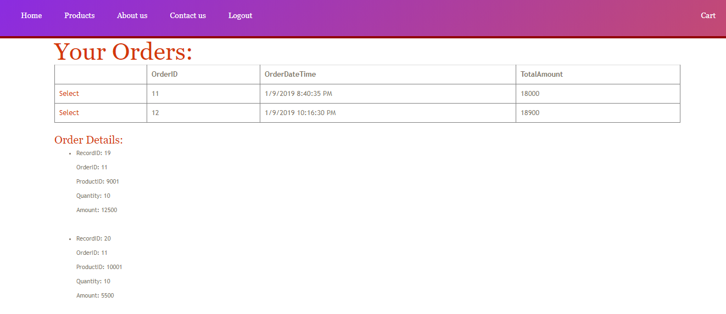

5.8 Company Login:

Company have to login before adding their product for advertise. In this page existing company can login to add product. Figure of company login page given below:

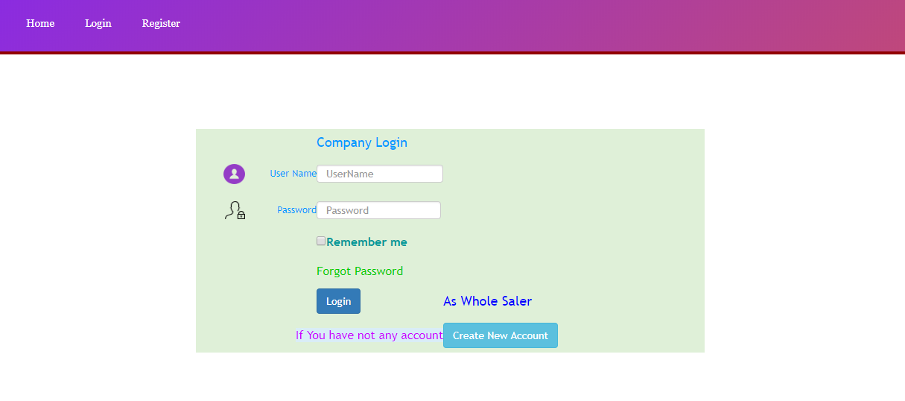

5.9 Company Register:

A new company can create an account for add the product. Figure of company registration page.

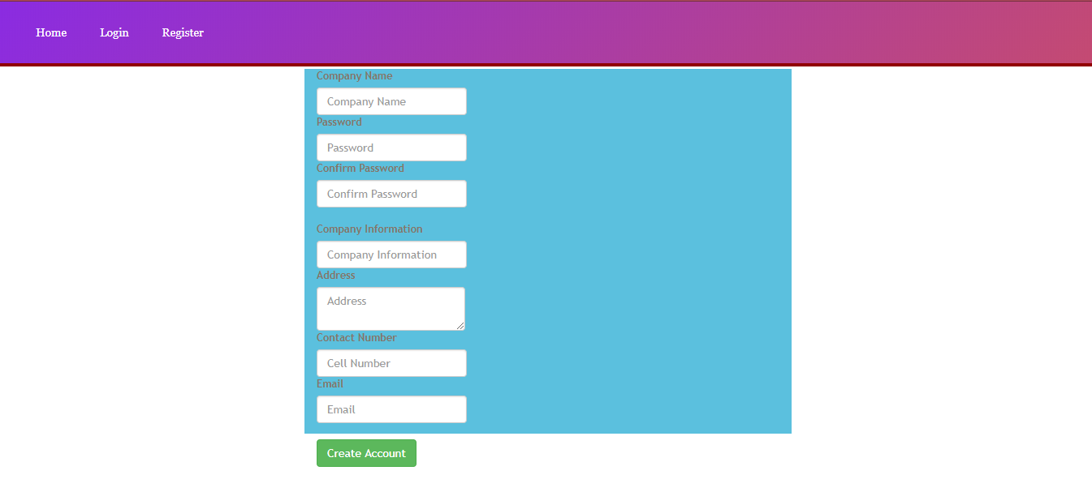

5.10 Company Add product:

Company can add their product image with product details information. Given figure is below.

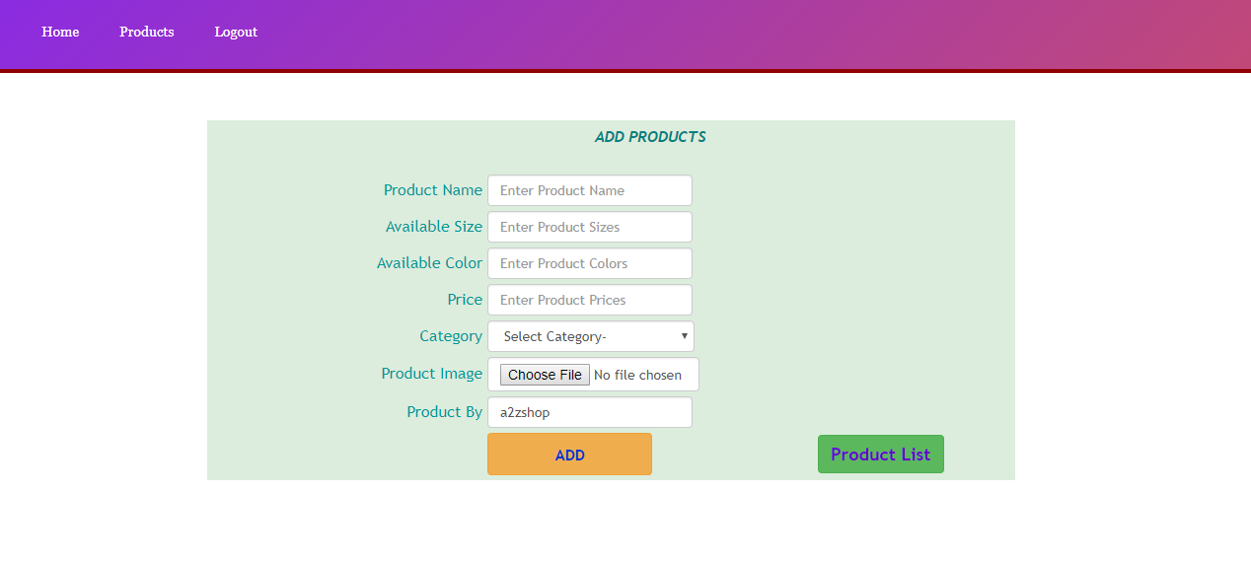

5.11 Company Added Product list:

Company can see all products which added by them. Given figure below.

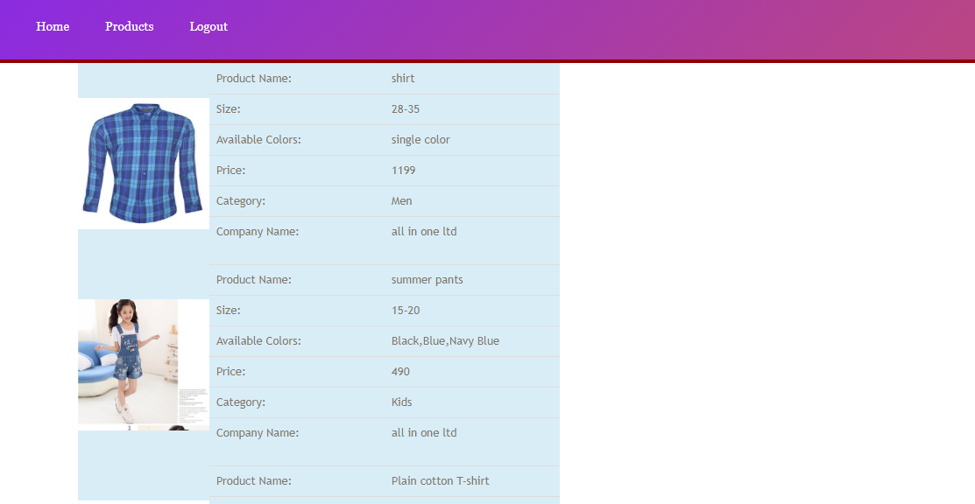
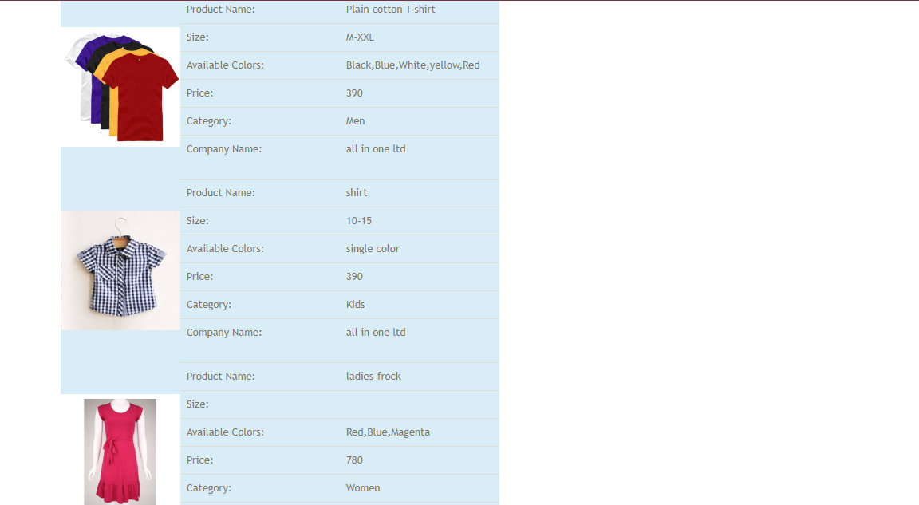

5.12 Feedback:

Users can feedback about our services and problems. Given figure below.

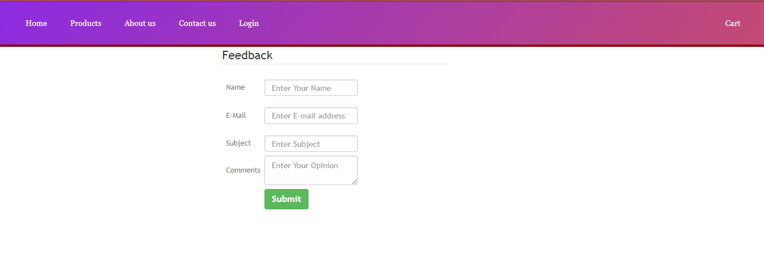

5.13 Admin Login:

An admin must be need login to manage website. Given figure below.

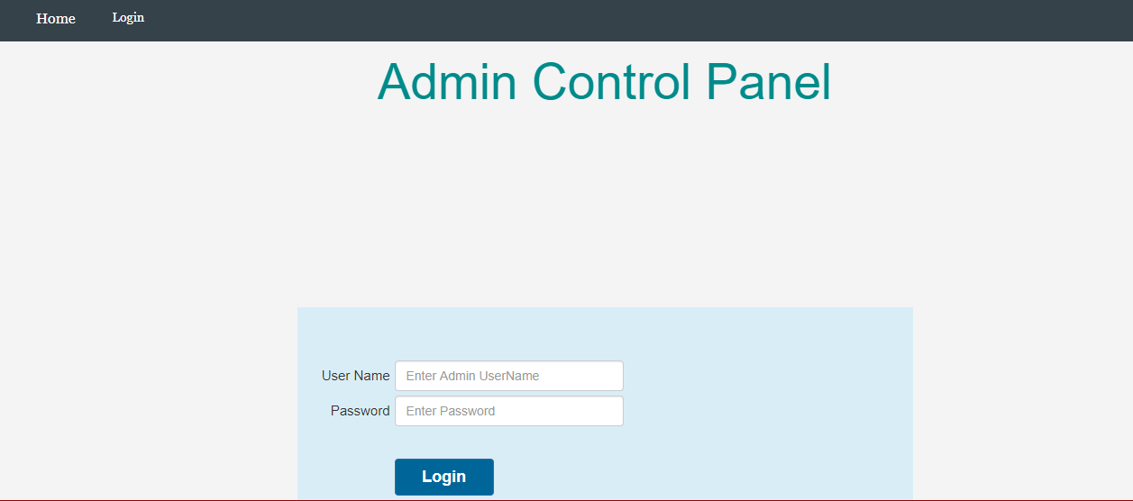

5.14 Admin Manage Users Account:

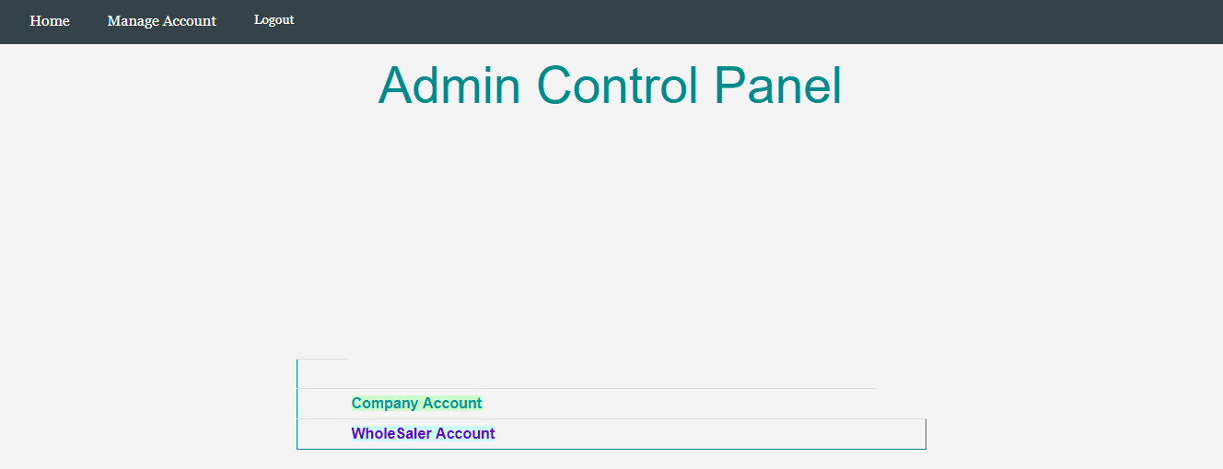

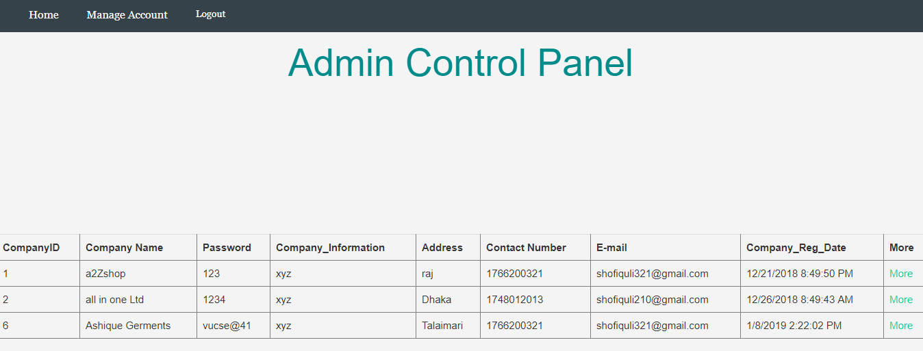
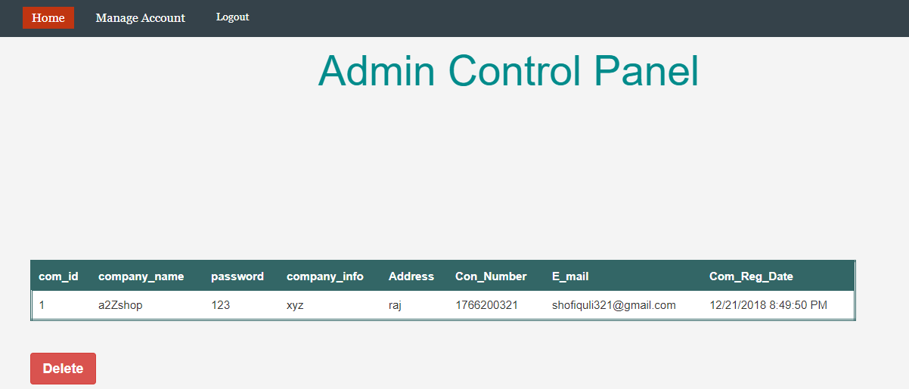

Chapter 6 Conclusion

6.1 Conclusion:

The Internet has become a major resource in modern business, thus online shopping has gained significance not only from the entrepreneur’s but also from the customers point of view. For the entrepreneur, online Garments Product Wholesaler Management System generates a new business opportunities and for the customer, it makes the comparative shopping possible. A god shopping cart design must be accompanied with user-friendly shopping cart application logic. It should be convenient for the customer to view the contents of their cart and to be able to remove or add items to their cart. The shopping cart application described in this project provides a numbers of features that are designed to make the customer more comfortable. This project helps in understanding the creation of an interactive web page and technologies user to implement it. During the course of the project, we have across the wide variety of problems and difficulties. We have learned the appropriate intricate working behind the dynamic website, how tricky data manipulation can be occurred sometimes but we have done everything
Successfully, the system has been designed in response to the system analysis. All possible error in the program have been eliminated. Necessary validation techniques have been used and normal, abnormal and extremely data was used to test the system. However, doing this project has been a good boost to our confidence as the future IT member of our global village.

6.2 Limitation:
The software we have developed have some limitation. We are trying to fulfill all requirements. But some tasks are not done here. Real time services like voice, chatting and video conferencing, products searching, products category are not done here. The system is developed for only cash on delivery as payment method. Bkash, Rocket not added. Upcoming product will display only website but not added messaging service that when any product will come will send message to customer mobile that new product available.

6.3 Future Scope:
If its limitation can be solved then it would be more effective. In future we will try to develop our project so that we able to give these facilities and credit card validation is not done. The administrator of the website can be given more functionality, looking specific customer generate invoice from admin panel of customer till present for taking decision. Adding SMS gateway to confirm that customer order successfully submitted, and also the current stats of order that means any state change of order customer will get a notification from company.

References:
http://www.stackoverflow.com/questions/
https://www.codeproject.com/
https://forums.asp.net/
https://docs.microsoft.com
https://www.c-sharpcorner.com/
https://www.aspsnippets.com/
http://www.dotnetfunda.com/
You tube Video Tutorials

