

**杭州电子科技大学**

**《编译原理课程实践》**

**实验报告**

题 目：nfa转dfa

学 院：计算机

专 业：计算机科学与技术

班 级：21052314

学 号：21051408

姓 名：蔡龙祥

完成日期：2023-11-7

1. **实验目的**

学习nfa转换为dfa的方法并且通过算法得到最小化的dfa

1. **实验内容与实验要求**

NFA向DFA转化及最小化

1. **设计方案与算法描述**

题目2.基于子集法的nfa到dfa转换

1. 以nfa为基础,找到nfa的起始状态做e_cloure操作得到起始状态
2. 以0状态作为起点,使用所有在正则表达式中出现的字符作为连接边,构造新的状态
3. 如果状态从未出现过,就列入dfa中
4. 重复步骤2直到再也没有新状态出现
5. 基于求同法和并查集算法找到等效的状态并消除构造最小dfa
6. **测试结果**

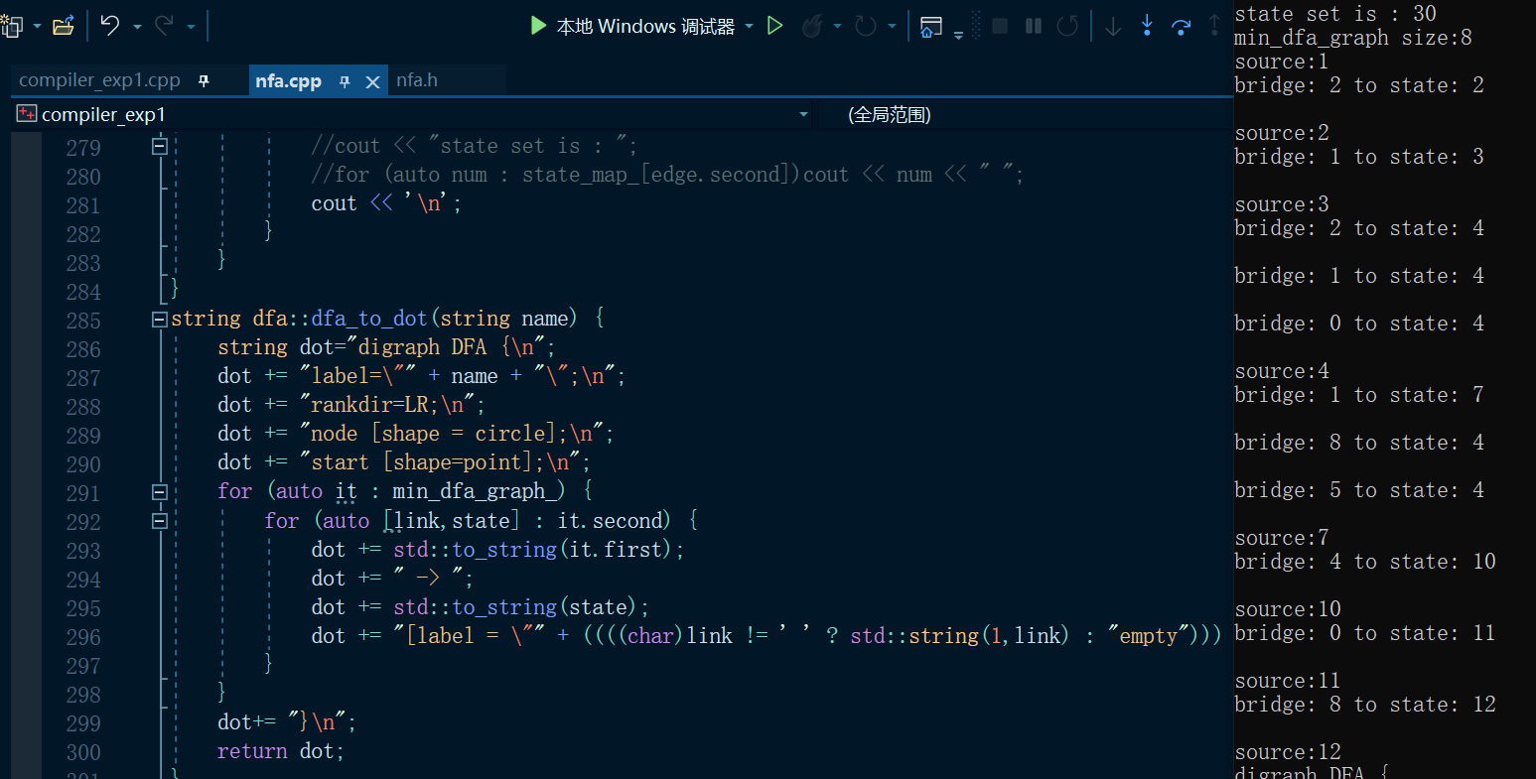

图1.构造dfa

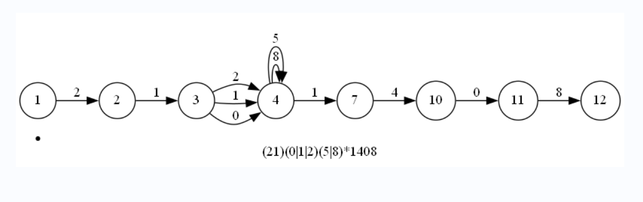

图2. dfa图示

1. **源代码**

Nfa.h

#pragma once

#include <map>

#include <utility>

#include<iostream>

#include<fstream>

#include <string.h>

#include<string>

#include <stack>

#include<iostream>

#include<vector>

#include<algorithm>

#include<queue>

#include<unordered_set>

#include<unordered_map>

using std::cout;

using std::string;

using std::vector;

using std::pair;

using std::make_pair;

#define PII pair<int,int>

#define PCI pair<char,int>

#define VPI vector<PII>

#define VPC vector<PCI>

static vector<VPI>INIT_GRAPH{ {} };

#define DEFINE_ENUMS() \

ENUM(UNDEFINED) \

ENUM(ZERO_ANY_MATCH)\

ENUM(ONE_ANY_MATCH)\

ENUM(ZERO_ONE_MATCH)\

ENUM(ANY_CHAR)\

ENUM(HEAD_MATCH)\

ENUM(BACK_MATCH)\

ENUM(OR)\

ENUM(LBRACE)\

ENUM(RBRACE)\

ENUM(AND)

const char AND_CHAR = '_';

using state = int;

template<typename T>

bool operator==(vector<T>a,vector<T>b) {

if (a.size() != b.size())return false;

int n = a.size();

for (int i = 0; i < n; i++) {

if (a[i] != b[i])return false;

}

return true;

}

struct vector_hash {

std::size_t operator()(std::vector<int> vec) const {

std::size_t seed = vec.size();

for (auto& i : vec) {

seed ^= i + 0x9e3779b9 + (seed << 6) + (seed >> 2);

}

return seed;

}

};

int find(vector<int>& v, int x);

class nfa

{

public:

nfa() = default;

nfa(string name, string regex);

string name_;

string regex_;

string regex_post_;

state start_, end_;

vector<VPI>graph_;

int iterator;

virtual bool build();

virtual int next();

struct char_hash {

std::size_t operator()(char ch) const {

size_t seed = 0;

seed ^= ch + 0x9e3779b9 + (seed << 6) + (seed >> 2);

return seed;

}

};

std::unordered_set<int>chs;

private:

string regex_to_postfix(string regex);

string regex_post() { return regex_post_; }

};

enum class REGEX_OP_TYPE {

UNDEFINED = 'x',

ZERO_ANY_MATCH = '*',

ONE_ANY_MATCH = '+',

ZERO_ONE_MATCH = '?',

ANY_CHAR = '.',

HEAD_MATCH = '^',

BACK_MATCH = '$',

OR = '|',

LBRACE = '(',

RBRACE = ')',

AND = AND_CHAR, ///< '_'

};

enum class REGEX_OP_PRIORITY {

#define PRI(name,pri) name##_PRIORITY=pri ,

PRI(UNDEFINED,-1)

PRI(ZERO_ANY_MATCH,3)\

PRI(ONE_ANY_MATCH,4)\

PRI(ZERO_ONE_MATCH,4)\

PRI(ANY_CHAR,5)\

PRI(HEAD_MATCH,6)\

PRI(BACK_MATCH,7)\

PRI(OR,1)\

PRI(LBRACE,0)\

PRI(RBRACE,0)\

PRI(AND,2)

#undef PRI

};

REGEX_OP_PRIORITY regex_op_priority(char op);

bool priority_lt(char l_op, char r_op);

class dfa :public nfa

{

public:

dfa() = default;

dfa(string name, string regex);

dfa(nfa* nfa);

void print();

bool build();

std::unordered_map<int, VPC>dfa_graph_;

std::unordered_map<int, VPC>min_dfa_graph_;

void dfs_move(int num,char ch, vector<int>& v,vector<bool>&vis);

std::unordered_map<int, VPC> get_min_dfa();

string dfa_to_dot(string name);

void print_dfa(std::unordered_map<int, VPC>&graph);

private:

nfa nfa_;

std::unordered_set<vector<int>,vector_hash>state_set_;

std::unordered_map<int,vector<int>>state_map_;

std::unordered_map<vector<int>,int, vector_hash>state_map_reverse_;

};

Nfa.cpp

#include "nfa.h"

nfa::nfa(string name, string regex)

:name_(name),

regex_(regex),

start_(0),

end_(0),

iterator(0),

regex_post_(regex_to_postfix(regex)),

graph_(INIT_GRAPH)

{}

string nfa::regex_to_postfix(string regex) {

string tmp;

for (int i = 0; i < regex.size() - 1; i++) {

tmp += regex[i];

if (regex[i] != '(' && regex[i+1] != ')'&& regex[i] != '|' && regex[i + 1] != '|'

&& regex[i + 1] != '*') tmp += AND_CHAR;

}

tmp += regex.back();

std::cout << regex_ << std::endl;

std::cout << tmp << std::endl;

std::stack<char>op_stack;

string post_regex;

for (auto c : tmp) {

if (isalnum(c)) {

post_regex += c;

continue;

}

if (REGEX_OP_TYPE(c) == REGEX_OP_TYPE::LBRACE) {

op_stack.push(c);

}

else if (REGEX_OP_TYPE(c) == REGEX_OP_TYPE::ZERO_ANY_MATCH

|| REGEX_OP_TYPE(c) == REGEX_OP_TYPE::AND

|| REGEX_OP_TYPE(c) == REGEX_OP_TYPE::OR){

while (op_stack.size()) {

if (priority_lt(op_stack.top(), c)){

break;

}

else {

post_regex += op_stack.top();

op_stack.pop();

}

}

op_stack.push(c);

}

else if(REGEX_OP_TYPE(c) == REGEX_OP_TYPE::RBRACE) {

while (op_stack.size() && op_stack.top() != char(REGEX_OP_TYPE::LBRACE)) {

post_regex += op_stack.top();

op_stack.pop();

}

op_stack.pop();

}

}

while (op_stack.size()) {

post_regex += op_stack.top();

op_stack.pop();

}

std::cout << post_regex << std::endl;

return post_regex;

}

const char LINK = ' ';

int nfa::next() {

graph_.push_back(VPI{});

return ++iterator;

}

bool nfa::build() {

bool res = true;

std::stack<PII>edges;

int source, destination;

for (auto ch : regex_post_) {

if (REGEX_OP_TYPE(ch) != REGEX_OP_TYPE::ZERO_ANY_MATCH && REGEX_OP_TYPE(ch) != REGEX_OP_TYPE::AND&& REGEX_OP_TYPE(ch) != REGEX_OP_TYPE::OR) {

source = next();

destination = next();

edges.push(PII{ source,destination });

graph_[source].push_back(make_pair(destination, ch));

chs.insert(ch);

continue;

}

switch (REGEX_OP_TYPE(ch)) {

case REGEX_OP_TYPE::ZERO_ANY_MATCH: {

PII edge = edges.top(); edges.pop();

source = next();

destination = next();

edges.push(PII{ source,destination });

graph_[source].push_back(PII{ edge.first,LINK });

graph_[source].push_back(PII{ destination,LINK });

graph_[edge.second].push_back(PII{ edge.first, LINK });

graph_[edge.second].push_back(PII{ destination, LINK });

}break;

case REGEX_OP_TYPE::AND: {

PII right = edges.top(); edges.pop();

PII left = edges.top(); edges.pop();

edges.push(PII{ left.first,right.second });

graph_[left.second].push_back(PII{ right.first,LINK });

}break;

case REGEX_OP_TYPE::OR: {

PII right = edges.top(); edges.pop();

PII left = edges.top(); edges.pop();

source = next();

destination = next();

edges.push(PII{ source,destination });

graph_[source].push_back(PII{left.first, LINK });

graph_[source].push_back(PII{right.first, LINK});

graph_[left.second].push_back(PII{destination,LINK});

graph_[right.second].push_back(PII{ destination,LINK});

}break;

default:break;

}

}

start_ = edges.top().first;

end_ = edges.top().second;

cout << "start from:" << start_ << " end at:" << end_ << "\n";

for (int i = 1; i <= iterator; i++) {

for (auto edge : graph_[i]) {

std::cout << i << "----" << char(edge.second) << "---->" << edge.first << "\n";

}

}

return res;

}

REGEX_OP_PRIORITY regex_op_priority(char op) {

switch (REGEX_OP_TYPE(op)) {

#define ENUM(name) case REGEX_OP_TYPE::name : return REGEX_OP_PRIORITY::##name##_PRIORITY;

DEFINE_ENUMS()

#undef ENUM

default:return REGEX_OP_PRIORITY::UNDEFINED_PRIORITY;

}

}

bool priority_lt(char l_op, char r_op) {

return (regex_op_priority(l_op) < regex_op_priority(r_op));

}

dfa::dfa(string name, string regex) :nfa_(nfa(name, regex)){}

dfa::dfa(nfa* nfa) {

iterator=0;

nfa_ = *nfa;

}

void dfa::print() {

}

bool dfa::build(){

cout << "build dfa\n" ;

//子集构造法

std::queue<vector<int>>q;

vector<int>v;

v.push_back(nfa_.start_);

int n = nfa_.iterator;

vector<bool>vis(n + 1, false);

dfs_move(nfa_.start_, LINK, v, vis);

v.erase(std::unique(v.begin(), v.end()),v.end());

sort(v.begin(), v.end());

cout << "start state:\n";

for (auto it : v)cout << it << " ";

cout << std::endl;

q.push(v);

state_set_.insert(v);

state_map_.insert(make_pair(++iterator, v));

state_map_reverse_.insert(make_pair(v, iterator));

while (q.size()) {

vector<int>vec = q.front(); q.pop();

cout << "get vec:";

for (auto it : vec)cout << it << " "; cout << '\n';

for (auto ch : nfa_.chs) {

vector<int>next;

vis = vector<bool>(n + 1, false);

for (auto num : vec) {

dfs_move(num, ch, next, vis);

}

cout << "use char " << char(ch) << " to state:";

for (auto it : next)cout << it << " ";

cout << "\n";

vis = vector<bool>(n + 1, false);

vector<int>tmp = next;

for (auto num : tmp) {

dfs_move(num, LINK, next, vis);

}

next.erase(std::unique(next.begin(), next.end()), next.end());

sort(next.begin(), next.end());

int source = state_map_reverse_[vec];

if (next.size()&&!state_set_.count(next)) {

++iterator;

cout << "------------------------------------\n";

cout << "get new state:"<<iterator << std::endl;

cout << "------------------------------------\n";

state_set_.insert(next);

state_map_.insert(make_pair(iterator, next));

state_map_reverse_.insert(make_pair(next, iterator));

q.push(next);

}

auto pos = state_map_reverse_.find(next);

if (pos!= state_map_reverse_.end()) {

dfa_graph_[source].push_back({ ch,pos->second});

}

}

}

cout<<"dfa state_size: "<< state_set_.size() << std::endl;

cout << "dfa_graph size: " << dfa_graph_.size() << std::endl;

for (auto it : dfa_graph_) {

cout << "source:" << it.first << '\n';

for (auto edge : it.second) {

cout << "bridge: " << edge.first << " to state: " << edge.second << "\n";

cout << "state set is : ";

for (auto num : state_map_[edge.second])cout << num << " ";

cout << '\n';

}

}

return true;

}

void dfa::dfs_move(int num,char ch, vector<int>& next, vector<bool>& vis) {

if (vis[num])return;

vis[num] = true;

for (auto [a, b] : nfa_.graph_[num]) {

//cout << "num:" << num << "\n" << "graph size:" << nfa_.graph_[num].size() << "\n";

if (ch == char(b)) {

next.push_back(a);

dfs_move(a, ch, next, vis);

}

}

}

int find(vector<int>& v, int x) {

if (x == v[x])return x;

return v[x] = find(v,v[x]);

}

std::unordered_map<int, VPC>dfa::get_min_dfa() {

std::unordered_map<int, VPC >graph=dfa_graph_;

int n = iterator;

vector<VPC>v(n + 1);

vector<int>f(n + 1, 0);

vector<PII>mt;

for (int i = 1; i <= n; i++)f[i] = i;

for (auto node: graph) {

v[node.first] = node.second;

}

for (int i = 1; i <= n; i++) {

for (int j = i + 1; j <= n; j++) {

if (v[i] == v[j]) {

//cout << "node[" << i << "]==node[" << j << "]\n";

mt.push_back({ i,j });

}

}

}

for (auto [a, b] : mt) {

int fa = find(f, a);

int fb = find(f, b);

if (fa != fb) {

if (fa < fb)f[fb] = fa;

else f[fa] = f[fb];

}

}

for (int i = 1; i <= n; i++) {

if (i != f[i]) {

graph.erase(i);

continue;

}

else {

for (auto& [a, b] : graph[i]) {

if (b<=n&&b != f[b]) {

b = f[b];

}

else if(b>n)cout <<"b =="<<b<< " out of range\n";

}

}

}

cout << "min_dfa_graph size:" << graph.size() << std::endl;

print_dfa(graph);

min_dfa_graph_ = graph;

return graph;

}

void dfa::print_dfa(std::unordered_map<int, VPC>&graph) {

for (auto it : graph) {

cout << "source:" << it.first << '\n';

for (auto [link, state] : it.second) {

cout << "bridge: " << ((((char)link != ' ' ? std::string(1, link) : "empty"))) << " to state: " << state << "\n";

//cout << "state set is : ";

//for (auto num : state_map_[edge.second])cout << num << " ";

cout << '\n';

}

}

}

string dfa::dfa_to_dot(string name) {

string dot="digraph DFA {\n";

dot += "label=\"" + name + "\";\n";

dot += "rankdir=LR;\n";

dot += "node [shape = circle];\n";

dot += "start [shape=point];\n";

for (auto it : min_dfa_graph_) {

for (auto [link,state] : it.second) {

dot += std::to_string(it.first);

dot += " -> ";

dot += std::to_string(state);

dot += "[label = \"" + ((((char)link != ' ' ? std::string(1,link) : "empty"))) + "\"]; \n";

}

}

dot+= "}\n";

return dot;

}