PicorderOS Sensor-Data Exchange Interface

Abstract
The scope of this document is to define a multi purpose interface for the exchange of arbitrary sensor data between services as a part of the PicorderOS project. By the use of this interface description, a service is able to query PicorderOS for installed sensors, data transformations, streamed realtime data and sensor time sequences and receive the data in well defined, easy to read and process JSON format.
PicorderOS will act as the communication server part in this scheme and will listen actively on the chosen communication channel.

Data Model
The Data Model representation is the foundation of the JSON interface description as it describes the Object structure represented by JSON. This is a non mandatory suggestion of how a data model might be conceived.
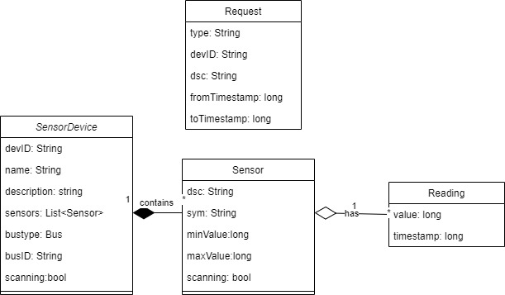

The corresponding Request JSON Schemas look as follows:
{
"$schema": "http://json-schema.org/draft/2019-09/schema",
"id": "https://github.com/directive0/picorderOS/SensorRequest.json",
"title": "SensorRequest",
"type": "object",
"properties":
{
"requestType":
{
"type": "string",
"enum": [ "listSensors","RequestDataSequence", "RequestSensorStream","StartDataCollection", "StopDataCollection" ]
},
"devID": {"type": "string"},
"dsc": {"type": "string"},
"fromTimestamp":{"type": "string"},
"fromTimestamp":{"type": "string"}
}
}

The corresponding Response JSON Schema looks as follows:
"{
"$schema": "http://json-schema.org/draft/2019-09/schema",
"id": "https://github.com/directive0/picorderOS/SensorResponse.json",
"title": "SensorResponse",
"type": "array",
"properties":
{
"SensorDevice":
{ "type": "object",
"properties": {
"devID": {"type": "string"},
"name": {"type": "string"},
"description": {"type": "string"},
"busType": {
"type": "string",
"enum": [ "SPI", "IIC"]
},
"busID": {"type": "string"},
"scanning": {"type": "boolean"},
"sensors": {
"type": "array",
"items": {
"Sensor" : {
"type" : "object",
"properties": {
"dsc": {"type": "string"},
"description": {"type": "string"},
"sym": {"type": "string"},
"symdescription": {"type": "string"},
"minValue": {"type": "number"},
"maxValue": {"type": "number"},
"readings": {
"type": "array",
"items": {
"Reading": {
"type": "object",
"properties": {
"value": {
"type": "numer"},
"timestamp": {"type": "string"}
}
}
},
"default": []
}
}
}
},
"default": []
}
}
}
}
}

Request Types

ListSensors
This request is used by the client to query general meta information about available sensors from PicorderOS. The Server will respond with a JSON representation of the Datamodel above, but will not provide any sensor readings.

Request JSON Example
This JSON request will list all sensors on all sensor boards:
{
"requestType": "listSensors"
}

You may also query for a specific sensor Board:
{
"requestType": "listSensors"
"devID": "BME680"
}

Response JSON Example
[
{"SensorDevice":
{
"devID": "SensorBoard1",
"name": "BME680",
"description" : "Temp, Hum, Pressure and VOC sensor by Bosch",
"busType" : "IIC",
"busID" : "0x77",
"scanning" : "false",
"sensors": [
{
"dsc": "Temp",
"sym": "°C",
"minValue": "-40",
"maxValue": "85"
},
{
"dsc": "Hum",
"sym": "%",
"minValue": "0",
"maxValue": "100"
},
{
"dsc": "Press",
"sym": "hPa",
"minValue": "300",
"maxValue": "1100"
},
{
"dsc": "VOC",
"description": "Volatile Organic Component sensor provides indoor air qualitiy control",
"sym": "IAQ",
"symdescription": "IAQ - Indoor Air Quality Index. Please refer to the BMP680 Datasheet",
"minValue": "0",
"maxValue": "400"
}
]
}
},
{"SensorDevice":
{
"devID": "SensorBoard2",
"name": "MPU6050",
"description" : "6DOF Gyros and Accelerometer",
"busType" : "IIC",
"busID" : "0x68",
"scanning" : "false",
"sensors": [
{
"dsc": "gyroX",
"sym": "°"
},
{
"dsc": "gyroY",
"sym": "°"
},
{
"dsc": "gyroZ",
"sym": "°"
},
{
"dsc": "accX",
"sym": "g"
},
{
"dsc": "accY",
"sym": "g"
},
{
"dsc": "accZ",
"sym": "g"
}
]
}
}



