InvenTrack: A Role-Based Inventory Management System
by
Shohab Sikder

Exam Roll: 25218

&

Ripon Kumar Das

Exam Roll: 25204

A project report submitted to the Institute of Information Technology
Post Graduate Diploma in Information Technology (PGDIT)
Supervisor:

Dr. Risala Tasin Khan

Professor, IIT, JU


Institute of Information Technology
Jahangirnagar University
Savar, Dhaka-1342
Date: September 10, 2026

CERTIFICATE
The project titled "InvenTrack: A Role-Based Inventory Management System" submitted by [Shohab Sikder], ID: [25218], And [Ripon Kumar Das], ID: [25204] Session: [Summer 2025], has been accepted as satisfactory in partial fulfillment of the requirements for the degree of Post Graduate Diploma in Information Technology on
Date of Defense: September 18, 2026.

Dr. Risala Tasin Khan
Professor, IIT, JU
Supervisor
BOARD OF EXAMINERS
Dr. Shamim Al Mamun  Professor, IIT, JU | Coordinator  PGDIT Coordination Committee
Dr. Risala Tasin Khan  Professor, IIT, JU | Member, PGDIT Coordination Committee  & Director, IIT
Dr. Mohammad Shahidul Islam  Professor, IIT, JU | Member, PGDIT Coordination Committee

CANDIDATE'S DECLARATION
I hereby declare that this project work is based on the results found by myself. Materials of work found by other researchers are mentioned by reference. This project, neither in whole nor in part, has previously been submitted for any degree.
Name: Shohab Sikder
ID: 25218
&
Name: Ripon Kumar Das
ID: 25204

DEDICATION
Dedicated to parents.

TABLE OF CONTENTS
Page
CERTIFICATE ii
CANDIDATE'S DECLARATION iii
DEDICATION iii
LIST OF TABLES vi
LIST OF FIGURES vii
ABBREVIATIONS AND SYMBOLS viii
ACKNOWLEDGEMENTS ix
ABSTRACT x
CHAPTER 1 INTRODUCTION AND BACKGROUND 1
1.1 Introduction 1
1.2 Problem Statement 1
1.3 Objectives 2
1.4 Scope 2
1.5 Significance 2
1.6 Report Organization 3
CHAPTER 2 LITERATURE REVIEW AND RELATED CONCEPTS 4
2.1 Inventory Information Systems 4
2.2 Web-Based Business Applications 4
2.3 Role-Based Access Control 4
2.4 Transactional Data Management 4
2.5 Data Recovery and Auditability 5
2.6 Position of the Proposed System 5
CHAPTER 3 SYSTEM ANALYSIS AND DESIGN 6
3.1 Functional Requirements 6
3.2 Non-Functional Requirements 6
3.3 System Architecture 6
3.4 Module Design 7
3.5 Database Design 8
3.6 Authentication and Authorization Design 8
3.7 Data Flow 8
CHAPTER 4 IMPLEMENTATION AND VERIFICATION 9
4.1 Frontend Implementation 9
4.2 Backend Implementation 9
4.3 Inventory Workflow 9
4.4 Invoice Workflow 9
4.5 Administrative Workflow 10
4.6 Verification Approach 10
4.7 Limitations 11
CHAPTER 5 CONCLUSION AND FUTURE WORK 12
5.1 Conclusion 12
5.2 Major Contributions 12
5.3 Future Work 12
BIBLIOGRAPHY 14
APPENDICES 15
Appendix A REST API Summary 15
Appendix B Database Entity Summary 15
Appendix C User Workflow Summary 15
BIOGRAPHY 16
REPORTS ON SIMILARITY INDEX 17

LIST OF TABLES
Table Page
Table 4.1 Acceptance Test Checks 10

LIST OF FIGURES
Figure Page
Figure 3.1 System Architecture 7

ABBREVIATIONS AND SYMBOLS
Abbreviation Equivalence
API | Application Programming Interface
CRUD | Create, Read, Update, Delete
ERP | Enterprise Resource Planning
HTTP | Hypertext Transfer Protocol
IIT | Institute of Information Technology
JU | Jahangirnagar University
JWT | JSON Web Token
KPI | Key Performance Indicator
OTP | One-Time Password
PDF | Portable Document Format
PGDIT | Post Graduate Diploma in Information Technology
REST | Representational State Transfer
RBAC | Role-Based Access Control
SMTP | Simple Mail Transfer Protocol
SQL | Structured Query Language
UI | User Interface

ACKNOWLEDGEMENTS
I express my sincere gratitude to my project supervisor, [Name of Supervisor], for guidance, feedback, and encouragement throughout the development of this project. I am also grateful to the Institute of Information Technology, Jahangirnagar University, for providing the academic environment and resources required to complete the work.
I acknowledge the contribution of the open-source technologies used in this system, including Angular, Node.js, Express, PostgreSQL, Bootstrap, Chart.js, PDFKit, and the supporting npm ecosystem. Finally, I thank my family and well-wishers for their patience and support during the planning, implementation, and documentation of the project.
Name: Shohab Sikder
ID: 25218
&
Ripon Kumar Das
ID: 25204
September 10, 2026

ABSTRACT
Small and medium-sized operations often manage products, suppliers, customers, stock, sales, deliveries, and invoices through disconnected spreadsheets or manual records. These practices make it difficult to maintain accurate stock balances, enforce responsibility, trace changes, and produce timely business reports. This project presents InvenTrack, a full-stack, role-based Inventory Management System designed to centralize these activities in a browser-based application.
The system provides product, category, vendor, customer, warehouse, stock, order, delivery, return, invoice, and reporting workflows. It implements JWT-based authentication, bcrypt password protection, first-login OTP password setup, role-based access control, granular per-module permissions, audit logging, pagination, keyword search, soft deletion, and restore from a Trash view. Stock is adjusted automatically when relevant purchase and delivery operations are saved. The invoice module supports line items, discounts, tax, status tracking, transactional persistence, and server-side A4 PDF generation.
The frontend is implemented with Angular 17.3, Bootstrap 5, FontAwesome, and Chart.js. The backend uses Node.js, Express 4, and REST endpoints. PostgreSQL hosted through Supabase stores the application data, while node-postgres provides database connectivity. The resulting system offers a maintainable foundation for inventory visibility, controlled access, operational traceability, and future analytics.
Keywords: inventory management, role-based access control, Angular, Express, PostgreSQL, stock tracking, invoicing

CHAPTER 1

INTRODUCTION AND BACKGROUND

1.1 Introduction
Inventory is a central operational resource for any organization that purchases, stores, sells, or distributes products. Accurate inventory information is necessary for procurement, customer service, financial control, and management decision-making. When information is maintained manually or across unrelated tools, duplicate entries, delayed updates, missing history, and unauthorized changes become common risks.
InvenTrack addresses this problem with one web-based platform. It gives authorized users a dashboard for current operational information and dedicated modules for the complete inventory lifecycle. The application separates presentation, API, business service, and persistence concerns so that the system can be extended without rewriting the whole product.

1.2 Problem Statement
The project targets the following problems:
1. Product, vendor, customer, warehouse, and stock information may be stored in separate records.
2. Manual stock adjustment can produce inaccurate quantities and weak traceability.
3. Users may receive more access than their responsibilities require.
4. Deleted records may be lost permanently, making recovery and auditing difficult.
5. Invoice preparation and reporting can require repetitive manual work.
6. Managers need summarized information such as latest orders, sales totals, and low-stock conditions.

1.3 Objectives
The main objective is to develop a secure and usable Inventory Management System for small to mid-size operations.
Specific objectives are to:
1. Centralize inventory-related master data and transactions.
2. Provide authenticated access with role and module-level permissions.
3. Track stock changes caused by purchasing, delivery, transfer, and movement operations.
4. Support order, delivery, return, invoice, and payment-related workflows.
5. Generate branded PDF invoices from the server.
6. Preserve deleted business records through soft delete and restore functionality.
7. Provide search, pagination, dashboard KPIs, charts, and operational reports.
8. Establish a maintainable architecture for future forecasting and AI-assisted features.

1.4 Scope
The scope includes the Angular web portal, Node.js and Express REST API, PostgreSQL database, authentication and authorization, master-data management, stock operations, orders, deliveries, returns, invoices, dashboard reporting, audit logs, and administrative permission management.
The system is not intended to replace a full accounting package, warehouse robotics system, or enterprise resource planning suite. Payment settlement, external accounting synchronization, barcode hardware integration, and production-grade predictive model training are outside the current scope.

1.5 Significance
The system improves consistency by keeping operational data in a shared database, improves accountability through permissions and audit records, and reduces recovery risk through soft deletion. It also provides a practical base for organizations that need stronger control than spreadsheets but do not require the cost and complexity of a large ERP platform.

1.6 Report Organization
Chapter 1 introduces the problem, objectives, scope, and significance. Chapter 2 discusses related concepts and existing approaches. Chapter 3 presents requirements, architecture, data design, and security design. Chapter 4 describes implementation, workflows, and verification. Chapter 5 concludes the report and identifies future improvements. The appendices provide an API summary, database entity summary, and user workflow notes.
CHAPTER 2

LITERATURE REVIEW AND RELATED CONCEPTS

2.1 Inventory Information Systems
An inventory information system records the identity, location, quantity, status, and movement history of products. A useful system normally combines master data, transaction processing, reporting, and access control. The design of InvenTrack follows this pattern by separating product and warehouse information from stock movement, order, delivery, and invoice transactions.

2.2 Web-Based Business Applications
Web applications provide centralized access through a browser and reduce the need to install client software on every workstation. A client-server architecture also allows the user interface and backend services to evolve independently. InvenTrack uses Angular for the client portal and Express REST routes for server communication.

2.3 Role-Based Access Control
Role-based access control assigns permissions according to a user's role rather than granting every user unrestricted access. In this project, permissions are stored per role and module with separate view, create, update, and delete capabilities. This is more expressive than a single administrator/user flag and supports operational separation of duties.

2.4 Transactional Data Management
Inventory and invoice operations often update several related records. Partial updates can create inconsistent totals or stock values. InvenTrack uses database transactions for invoice save and update operations, committing the complete operation or rolling it back when an error occurs.

2.5 Data Recovery and Auditability
Permanent deletion is risky in business applications. Soft deletion retains the record and marks it as deleted, allowing the active view to remain clean while authorized administrators can review or restore historical records. Audit logging adds a record of important actions and their actors.

2.6 Position of the Proposed System
The proposed system combines the above concepts in one focused application: centralized inventory workflows, granular authorization, transaction-aware persistence, PDF documentation, and recoverable deletion. Its emphasis is practical usability for small and mid-size operations, while its modular design permits later expansion.
CHAPTER 3

SYSTEM ANALYSIS AND DESIGN

3.1 Functional Requirements
The system shall authenticate users and issue time-limited JWT sessions. It shall support first-login OTP verification and password setup. It shall allow authorized users to create, view, update, search, and delete business records according to their permissions. It shall support products, categories, vendors, customers, warehouses, stocks, orders, deliveries, returns, invoices, statuses, stock movements, and stock transfers. It shall provide dashboard KPIs and charts, PDF invoice export, audit logs, role management, user management, and permission configuration.

3.2 Non-Functional Requirements
The application should be secure, maintainable, responsive, reasonably performant for its target scale, and understandable to operational users. API responses should use consistent HTTP semantics. List endpoints should be paginated with a maximum page size of 100. Data-changing operations should validate input and preserve database consistency. The interface should provide clear feedback for successful and failed operations.

3.3 System Architecture
The system follows a three-layer web architecture:
1. Presentation layer: Angular 17.3 components, reactive forms, lazy routing, Bootstrap 5, FontAwesome, and Chart.js.
2. Application layer: Node.js and Express 4 routes, controllers, middleware, and services exposed through a REST API on port 3001.
3. Data layer: PostgreSQL on Supabase, accessed through the pg connection pool.
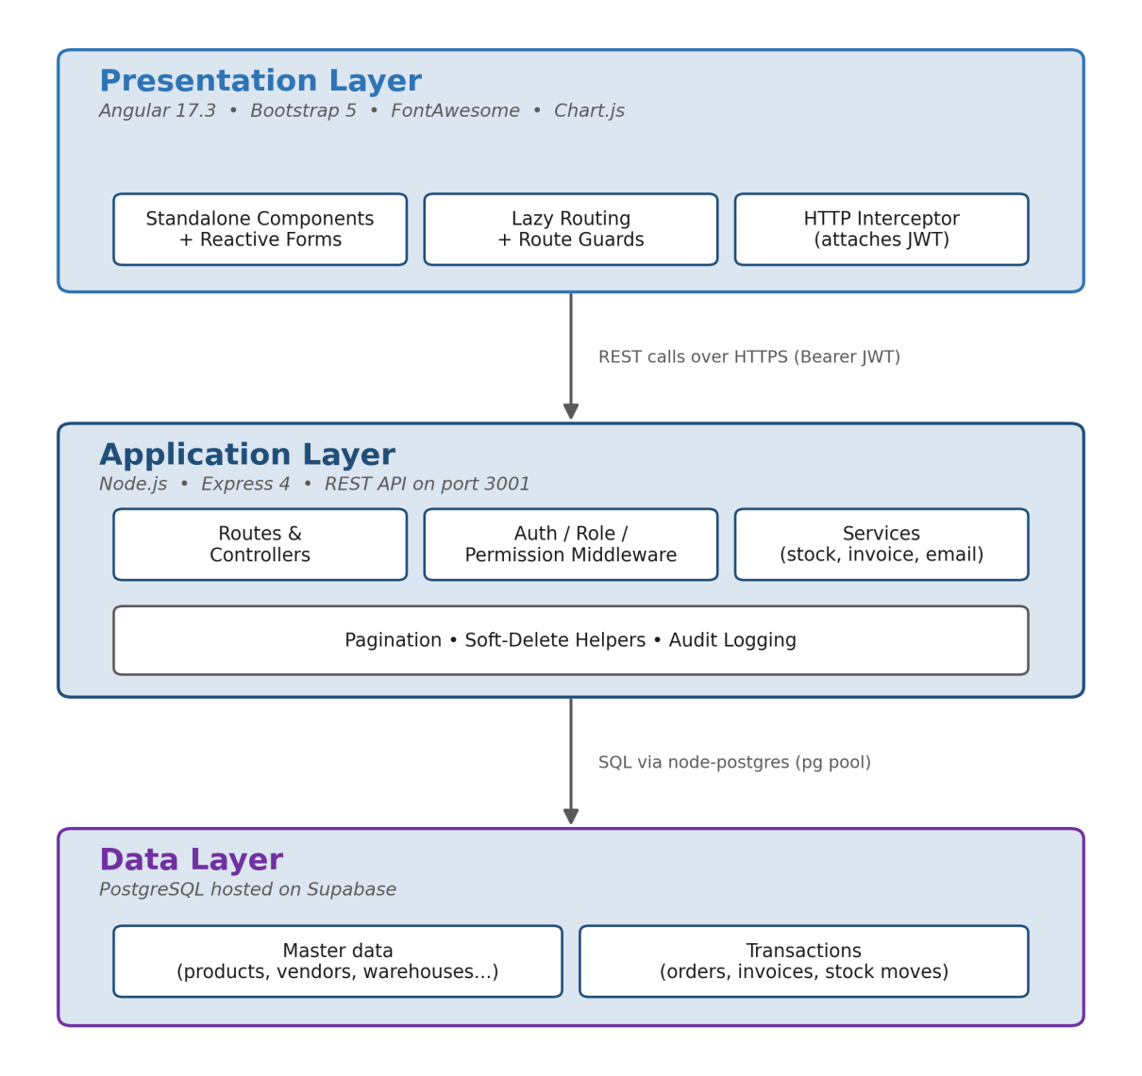
Figure 3.1: System Architecture
The Angular HTTP interceptor attaches the bearer token to outgoing requests. Authentication, role, and permission guards protect portal routes. On the server, token verification and permission middleware protect resource operations.

3.4 Module Design
The main modules are authentication, dashboard, products, categories, vendors, customers, warehouses, stocks, stock movements, stock transfers, orders, deliveries, returns, invoices, reports, activity logs, users, roles, permissions, and the legacy book module. Each major resource has a route file and controller, keeping endpoint responsibilities localized.

3.5 Database Design
The main public entities are users, roles, modules, role_permissions, categories, warehouses, status, products, vendors, customers, stocks, order_details, delivery_details, invoices, invoice_items, payments, returns, stock_movements, stock_transfers, and activity_logs. Relationships connect products to categories, stock to products and warehouses, invoices to invoice items, and users to roles and permissions.
Business tables include soft-delete fields such as is_deleted, deleted_at, and deleted_by. This design allows active and deleted records to be presented separately without discarding the underlying data.

3.6 Authentication and Authorization Design
Passwords are protected with bcryptjs. A successful login produces a JWT with an eight-hour expiry and user identity and role information. New users receive a one-time code through Nodemailer and Gmail SMTP; the code is stored as a bcrypt hash with a ten-minute expiry. Users must complete password setup before normal use.
Permission middleware maps HTTP methods to module permissions: GET to view, POST to create, PATCH to update, and DELETE to delete. A dedicated delete-permission check is used for semantic delete actions such as restore endpoints. Super-admin access bypasses ordinary module checks.

3.7 Data Flow
The user submits a form in the Angular portal. The service sends an authenticated HTTP request to the corresponding Express route. Middleware verifies the token and permission, the controller validates and processes the request, and the database layer reads or changes PostgreSQL records. The controller returns a JSON response, which the portal uses to refresh the view and notify the user.
CHAPTER 4

IMPLEMENTATION AND VERIFICATION

4.1 Frontend Implementation
The portal is an Angular application with standalone components, lazy routing, reactive forms, HTTP services, route guards, and an application layout. List screens support pagination, keyword search, active and Trash views, and CRUD dialogs or forms. The dashboard presents order and sales information through KPI endpoints and Chart.js visualizations.

4.2 Backend Implementation
The backend starts Express on port 3001 and mounts one router per resource. Controllers contain resource operations, middleware handles authentication and authorization, and services contain shared behavior such as email delivery, password setup, stock updating, and forecasting. Pagination utilities limit page size and soft-delete helpers keep deletion behavior consistent.

4.3 Inventory Workflow
Products are associated with categories and can be stored across warehouses. Stock records represent available quantity. Saving a purchase order increases the corresponding stock, while saving a delivery decreases it through the shared stock-update service. Stock movements and transfers provide additional traceability for inventory changes. This centralizes quantity adjustment and reduces the chance that different screens implement conflicting rules.

4.4 Invoice Workflow
An invoice contains customer and status information together with invoice items. Each item includes quantity and unit price; the invoice calculation also supports subtotal, discount, tax percentage, and grand total. Save and update operations run within BEGIN, COMMIT, and ROLLBACK boundaries. The server generates a branded A4 PDF using PDFKit, and the portal exposes the result as a downloadable invoice document.

4.5 Administrative Workflow
Super-admin users can manage roles and users and configure the role-permission matrix. Ordinary users see only modules and actions allowed by their assigned role. The frontend stores the current permission information for route and interface decisions, while the backend remains the authoritative enforcement point.

4.6 Verification Approach
Verification should cover authentication, authorization, validation, CRUD operations, search, pagination, soft deletion and restoration, stock adjustment, invoice calculations, transaction rollback, PDF generation, and responsive portal navigation. The repository provides the implemented source and database dump; environment-specific integration results depend on valid Supabase and SMTP configuration.
The following acceptance checks define the expected behavior:
Table 4.1: Acceptance Test Checks
ID | Check | Expected result
V1 | Login with valid credentials | JWT session is issued and protected routes open
V2 | Login with invalid credentials | Request is rejected without a session
V3 | Access a disallowed module | API and portal block the operation
V4 | Create and search a product | Product is persisted and returned by keyword search
V5 | Delete and restore a record | Record leaves Active, appears in Trash, then returns after restore
V6 | Save an order or delivery | Related stock quantity is adjusted according to workflow
V7 | Save an invoice with items | Totals are persisted atomically
V8 | Download invoice PDF | A readable A4 PDF is generated

4.7 Limitations
The current implementation relies on configured external services for Supabase database access and Gmail SMTP. The report does not claim production-scale load-test measurements because no repeatable benchmark results are included in the project materials. The system also does not yet include barcode scanning, accounting synchronization, multi-currency accounting, or a validated machine-learning forecasting evaluation.
CHAPTER 5

CONCLUSION AND FUTURE WORK

5.1 Conclusion
InvenTrack provides a unified web platform for managing core inventory operations. Its Angular portal, Express REST API, and PostgreSQL data layer create a clear separation of responsibilities. Role-based permissions, OTP-based first login, soft deletion, audit logging, automatic stock adjustment, transactional invoices, and PDF export address important operational and control requirements.
The project demonstrates how a focused full-stack application can replace scattered manual workflows with a consistent, recoverable, and extensible system. The architecture is sufficiently modular to support additional resources and integrations without changing the fundamental user experience.

5.2 Major Contributions
1. A browser-based inventory platform covering master data and transaction workflows.
2. Granular role and module permission management.
3. Recoverable soft-delete and Trash functionality.
4. Automatic stock adjustment for purchasing and delivery operations.
5. Transaction-safe invoice persistence and branded PDF export.
6. Dashboard KPIs, charts, reports, and search-enabled paginated lists.

5.3 Future Work
Future versions may add barcode and QR-code scanning, supplier purchase-order workflows, accounting and payment-gateway integration, multi-warehouse optimization, configurable low-stock notifications, stronger automated test coverage, deployment monitoring, and a validated forecasting model. A mobile-friendly offline workflow could also support warehouse staff working in locations with intermittent connectivity.

BIBLIOGRAPHY
1. Angular Team. “Angular Documentation.” Retrieved August 21, 2026, from https://angular.dev/
2. Bootstrap Team. “Bootstrap Documentation.” Retrieved August 21, 2026, from https://getbootstrap.com/docs/
3. Chart.js Contributors. “Chart.js Documentation.” Retrieved August 21, 2026, from https://www.chartjs.org/docs/
4. Express.js. “Express Web Framework Documentation.” Retrieved August 21, 2026, from https://expressjs.com/
5. Node.js. “Node.js Documentation.” Retrieved August 21, 2026, from https://nodejs.org/docs/latest/api/
6. PostgreSQL Global Development Group. “PostgreSQL Documentation.” Retrieved August 21, 2026, from https://www.postgresql.org/docs/
7. Supabase. “Supabase Documentation.” Retrieved August 21, 2026, from https://supabase.com/docs
8. JSON Web Token. “Introduction to JSON Web Tokens.” Retrieved August 21, 2026, from https://jwt.io/introduction

APPENDICES

Appendix A: REST API Summary
Authentication endpoints include /auth/login, /auth/setup-password, and /auth/me. Resource endpoints follow the pattern /<resource> and /<resource>/:id for CRUD operations. Search uses /<resource>/search?value=...; deleted data is available under /<resource>/trash; restoration uses /<resource>/restore/:id. Administrative endpoints are grouped under /admin/roles, /admin/users, and /admin/permissions. Dashboard endpoints include /orders/latest, /orders/total, /delivery/latest, and /delivery/total. Invoice PDFs are available through /invoices/:id/pdf.

Appendix B: Database Entity Summary
[Insert entity-relationship diagram or table summary of the database schema here.]

Appendix C: User Workflow Summary
1. An administrator creates a user, assigns a role, and grants module permissions.
2. The new user logs in with the issued account and completes OTP-based password setup.
3. Authorized staff maintain products, categories, vendors, customers, and warehouses.
4. Staff record orders, deliveries, stock movements, transfers, returns, and invoices.
5. Managers review dashboard KPIs and reports.
6. Authorized administrators review Trash and restore records when required.

BIOGRAPHY
Shohab Sikder & Ripon Kumar das are students of the Post Graduate Diploma in Information Technology program at the Institute of Information Technology, Jahangirnagar University. The student has an interest in full-stack web development, database systems, software engineering, and practical business information systems.

REPORTS ON SIMILARITY INDEX
[Attach the similarity-index report here after checking the final document.]

