E-DENTIST:
Comprehensive SRS & Analysis Document

Course: CSE 6159 (M) SSA

Prepared By:
Md. Ahsan Kabir (0122520016)
Abu Sadat Al Rafi (0122230017)
Abu Ekhtiar Tawhid (0122230018)

United International University
Dhaka, Bangladesh

Table of Contents
1. Introduction 4
2. Motivation 4
3. Vision 5
4. Literature Review 5
5. Detailed Information Gathering 5
5.1 Stakeholder Identification 5
5.2 Existing System Analysis 6
5.3 Functional Needs Identified 6
5.4 Constraints 6
6. Analysis, Feature List, and Site Map 6
6.1 Feature List 6
6.2 Site Map (High Level) 7
7. Functional (FR) and Non-Functional (NFR) Requirements 7
7.1 Functional Requirements (Detailed) 7
FR01: User Registration & Profile Management 8
FR02: Authentication & Secure Login 9
FR03: Symptom Entry & Risk Score Calculator 9
FR04: Intelligent Triage Recommendations 10
FR05: Online Appointment Booking System 10
FR06: Video Consultation Platform 10
FR07: Digital Prescription Generation 11
FR08: Automated Reminders 11
FR09: Emergency Access Override 12
FR10: Admin Dashboard & Reporting 12
7.2 Non-Functional Requirements (Detailed) 12
NFR01: System Security & Data Protection 13
NFR02: Performance & Response Time 13
NFR03: Reliability & Uptime 13
NFR04: Usability & Accessibility 14
NFR05: Scalability 14
NFR06: Compatibility 14
8. Use Case Diagram 15
9. Class Diagram (+ ER Diagram) 16
9.1 Class Diagram 16
9.2 ER Diagram 17
10. Sequence Diagram – Appointment Booking 18
11. State Diagram – Appointment Lifecycle 19
12. Data Flow Diagram (Level 1) 20
13. Priority-Based Dynamic Scheduling Algorithm 21
13.1 Algorithm Overview 21
13.2 Rules & Priority Scoring 21
13.3 Pseudo-Code 22
13.4 Workflow (Activity Diagram) 23
14. Requirements Traceability Matrix 23
15. Key Benefits 24
16. System Architecture & Key Actors 25
17. Compliance with CMMI on Analysis & Documentation 25
18. References 26
Appendix A: Scope, Assumptions, and Clarifications 27
A.1 System Scope 27
A.2 Out-of-Scope 27
A.3 Assumptions & Dependencies 27
A.4 Clarification on Intelligent Components 27
A.5 Verification Methods Summary 27
A.6 Algorithm Correctness Note 27

1. Introduction
E-Dentist is a specialized tele-dentistry platform designed to provide accessible, affordable, and high-quality oral healthcare services across Bangladesh. By integrating web and mobile technologies, the platform enables remote consultations, intelligent risk assessment, digital prescriptions, and clinic navigation—bridging the gap between patients and qualified dental professionals. This system addresses critical challenges in oral healthcare delivery, including limited access in rural areas, low dentist-to-patient ratios, and the need for preventive care amid socioeconomic constraints and pandemics like COVID-19.
Oral health is integral to overall well-being, influencing systemic conditions such as cardiovascular diseases, diabetes, and respiratory infections. In Bangladesh, where approximately 80% of the population experiences at least one oral disease and the dentist-to-patient ratio stands at one per 200,000 individuals, disparities in access are pronounced, particularly in rural regions. Existing telemedicine solutions focus on general healthcare but lack dental-specific features, such as 3D dental models for symptom identification and risk-based triage. E-Dentist proposes a comprehensive ecosystem that combines synchronous (real-time video) and asynchronous (store-and-forward) consultations, leveraging cloud-based architecture for scalability and interoperability.
This document provides a complete Software Requirements Specification (SRS) covering functional requirements, non-functional requirements, architectural analysis, UML diagrams, and compliance with CMMI Level-3 standards (based on CMMI V3.0 as of 2025). This version ensures full alignment with CMMI Maturity Level 3 ("Defined") by mapping all relevant Practice Areas (PAs) in the Development (DEV) view, including a new traceability matrix and expanded compliance details.

2. Motivation
Bangladesh faces significant challenges in oral healthcare delivery, including limited dental specialists in rural areas, lack of awareness, long wait times, minimal digitization, and heightened risks during pandemics like COVID-19. National statistics indicate that rural populations are less knowledgeable about oral hygiene, with district-level health complexes often lacking dental facilities. Telemedicine solutions exist (e.g., DocTime, Digital Hospital, Seba Ghar), but none provide a dedicated, fully integrated dental care platform handling remote triage, video consultation, and oral risk assessment.
E-Dentist is motivated by the need to:
- Reduce inequity in dental care access, particularly for underserved rural and semi-urban communities.
- Support remote diagnosis through video and asynchronous consultations, minimizing infection risks for both patients and dentists.
- Offer a structured, AI-assisted triage system to prioritize urgent cases and promote preventive care.
- Ensure continuous oral health monitoring, including self-checkups and community campaigns.
- Digitalize prescriptions and follow-up schedules to improve adherence and outcomes.
Literature highlights tele-dentistry's potential to extend expertise cost-effectively, with studies showing positive perceptions among specialists and patients. During COVID-19, tele-dentistry enabled continued practice while reducing exposure, underscoring its role in resilient healthcare systems.

3. Vision
E-Dentist aims to become Bangladesh’s first comprehensive tele-dentistry ecosystem by enabling:
- Smart, risk-based scheduling ensuring urgent cases receive priority.
- Interactive 3D tooth models for intuitive patient-dentist communication.
- Integrated oral health monitoring for communities and schools.
- Offline-capable clinic navigation ensuring accessibility.
- Cloud-based scalability to serve millions.
The long-term vision includes interoperability with national health systems, integration with insurance providers, machine learning for advanced symptom analysis, and virtual health campaigns for disadvantaged groups. This aligns with global tele-dentistry benefits, such as improved access for people with disabilities and time efficiency for practitioners.

4. Literature Review
Tele-dentistry, the integration of telecommunications and dentistry, has been studied globally and in Bangladesh, revealing gaps in specialized oral care. In Bangladesh, telemedicine platforms like those reviewed by Chowdhury et al. (2018) offer video consultations and mHealth but are generalized, failing to address dentistry's unique needs, such as visual diagnostics and patient education.
Global reviews, such as Estai et al. (2016), demonstrate tele-dentistry's benefits in remote consultations, cost reduction, and early intervention. Synchronous modes enable real-time interaction, while asynchronous approaches support store-and-forward data exchange for treatment planning. In Bangladesh, studies like Rahman and Karim (2016) on medication reminders and Deb et al. (2016) on offline navigation highlight fragmented solutions, motivating an integrated platform.
Appointment systems (Sherly et al., 2017) and video calling over Wi-Fi (Shrideep et al., 2014) provide foundations, but dental-specific features like 3D models and risk analyzers are absent. Perceptions are positive, with specialists viewing tele-dentistry as innovative for pandemics (Deshpande et al., 2020) and patients appreciating accessibility (Rahman et al., 2020). This review informs E-Dentist's design, emphasizing hybrid consultations, reminders, and navigation for equitable care.

5. Detailed Information Gathering
Inputs were gathered from academic studies, and existing telemedicine systems. Methodologies include adaptive and quantitative approaches, focusing on real-time and store-and-forward models.

5.1 Stakeholder Identification
- Patients – require consultations, prescriptions, reminders.
- Dentists – need tools for triage, video calls, prescription, schedule management.
- Administrators – maintain system, users, reporting.
- Pharmacies – receive e-prescriptions (future scope).

5.2 Existing System Analysis
General telemedicine (e.g., DocTime, Digital Hospital, Seba Ghar) supports video calls but lacks:
- Dental-specific triage,
- Oral risk scoring,
- 3D tooth visualization,
- Dentist-specialization mapping,
- Dental emergency routing.
Research-based systems have explored components like advanced scheduling, OCR-based reminders, offline navigation, and Wi-Fi video calling, but no integrated dental solution exists.

5.3 Functional Needs Identified
- Online registration & identity verification.
- Symptom entry with guided questionnaire.
- Algorithm-based risk calculation.
- Online scheduling with priority logic.
- Real-time and asynchronous consultation.
- Digital prescription generation.
- Medication reminders.
- Clinic finder with offline capability.
- Emergency dentist on call.

5.4 Constraints
- Variable internet quality across Bangladesh.
- Limited digital literacy among rural users.
- Need for secure storage compliant with health data regulations.
- Pandemic resilience.

6. Analysis, Feature List, and Site Map

6.1 Feature List
Core Modules:
- User & Access Management
- Symptom Checker & Risk Assessment
- Oral Health Monitoring
- Appointment & Scheduling
- Video/Asynchronous Consultation
- Prescription Management
- Reminder Engine
- Clinic Finder (Offline Support)
- Emergency Support
- Admin Dashboard
Novel Features from Analysis:
- Dental Specialization: Workflows tailored for oral diseases.
- Interactive 3D Dental Model: Visual symptom identification.
- Intelligent Oral Risk Analyzer: Algorithm for triage.
- Seamless Service Integration: Full care pathway.
- Offline-Capable Navigation: For rural access.
- Cloud-Based Multi-Platform Architecture: Azure backend.

6.2 Site Map (High Level)
Home
├── About
├── Login/Register
├── Patient Dashboard
│ ├── Symptom Checker
│ ├── View Risk Score
│ ├── Book Appointment
│ ├── Consultation
│ ├── Prescriptions
│ ├── Reminders
│ └── Clinic Finder
├── Dentist Dashboard
│ ├── Manage Availability
│ ├── Appointments
│ ├── Video Call Panel
│ ├── Patient Records
│ └── Emergency Requests
└── Admin Dashboard
├── Users
├── Reports
├── Audit Logs
├── System Settings
└── Clinics

7. Functional (FR) and Non-Functional (NFR) Requirements

7.1 Functional Requirements (Detailed)
The system comprises core functional requirements, expanded with descriptions, rationale, dependencies, and acceptance scenarios.
FR ID | Requirement Title | Priority
FR01 | User Registration & Profile Management | Critical
FR02 | Authentication & Secure Login | Critical
FR03 | Symptom Entry & Risk Score Calculator | High
FR04 | Intelligent Triage Recommendations | High
FR05 | Online Appointment Booking System | Critical
FR06 | Video Consultation Platform | High
FR07 | Digital Prescription Generation | Medium
FR08 | Automated Reminders | Medium
FR09 | Emergency Access Override | High
FR10 | Admin Dashboard & Reporting | Medium

FR01: User Registration & Profile Management
Description: The system shall provide a comprehensive registration interface allowing patients and dental practitioners to create accounts with role-based access. Users must provide essential identification details, contact information, and relevant medical history. The registration process includes email verification and password strength validation to ensure account security. Patient registration via phone/email with comprehensive profiles; Dentist registration with license verification and specialization details.
Rationale: Accurate user profiles are fundamental to delivering personalised healthcare services. Patient medical history informs risk assessment, whilst dentist credentials ensure qualified practitioners provide care. Secure registration prevents unauthorised access and maintains data integrity across the platform.
Dependencies: Email verification service integration, Database schema for user entities, Authentication framework (FR02), GDPR-compliant data storage.
Acceptance Scenarios:
- Scenario 1: New patient completes registration form with valid details and receives verification email within 2 minutes.
- Scenario 2: Dentist registration includes professional licence validation and clinic affiliation.
- Scenario 3: System rejects registration attempts with duplicate email addresses.

FR02: Authentication & Secure Login
Description: The system shall implement multi-factor authentication supporting password-based login, biometric verification, and optional two-factor authentication via SMS or authenticator apps. Session management includes automatic timeout after 30 minutes of inactivity and secure token refresh mechanisms. Password recovery follows industry-standard security protocols with time-limited reset links. Secure authentication with password reset capabilities; Role-based access control (patient, dentist, administrator).
Rationale: Healthcare data requires the highest level of security protection. Robust authentication prevents unauthorised access to sensitive patient records and ensures only verified users can book appointments or access consultation features. Multi-factor authentication significantly reduces the risk of account compromise.
Dependencies: User registration system (FR01), Encryption libraries for secure storage, SMS gateway for two-factor codes, OAuth integration for social login options.
Acceptance Scenarios:
- Scenario 1: User logs in with valid credentials and receives access within 3 seconds.
- Scenario 2: Failed login attempts (5+) trigger account lockout and security notification.
- Scenario 3: Password reset link expires after 24 hours and cannot be reused.

FR03: Symptom Entry & Risk Score Calculator
Description: The system shall provide an intuitive symptom checker interface where patients describe their dental concerns through guided questions, image uploads, and severity ratings. An algorithmic risk calculator processes inputs to generate a numerical risk score (0-10) categorising urgency as Low, Moderate, or High. The calculator considers pain intensity, duration, accompanying symptoms, and patient medical history. Guided questionnaire capturing pain level, swelling, bleeding, sensitivity, and duration; Interactive 3D tooth map for precise location identification.
Rationale: Accurate symptom assessment enables intelligent triage, ensuring patients with urgent conditions receive priority care whilst optimising dentist schedules. The risk score provides objective data for appointment prioritisation and helps patients understand the seriousness of their condition, reducing unnecessary emergency visits.
Dependencies: User profile with medical history (FR01), Clinical decision support algorithms, Image processing for symptom photos, Database of dental conditions and symptoms.
Acceptance Scenarios:
- Scenario 1: Patient reporting severe tooth pain with swelling receives High risk score (8-10) and immediate booking options.
- Scenario 2: Routine check-up request generates Low risk score (1-3) with standard appointment slots.
- Scenario 3: Risk calculator updates dynamically as patient answers additional questions.

FR04: Intelligent Triage Recommendations
Description: Based on risk score, provide personalized recommendations: monitor at home, schedule routine appointment, or seek urgent care.
Rationale: Enables appropriate care pathways, optimizing resources.
Dependencies: FR03.
Acceptance Scenarios: High risk leads to emergency routing; Low risk to monitoring.

FR05: Online Appointment Booking System
Description: The system shall enable patients to view available appointment slots across multiple dentists and clinics, filtered by date, location, specialisation, and urgency level. The booking interface displays real-time availability, estimated wait times, and dentist profiles. Patients receive instant confirmation with calendar integration and the ability to modify or cancel appointments with appropriate notice periods. Search and filter dentists by specialty, location, language, and ratings; View real-time slots; Reschedule/cancel with notifications.
Rationale: Streamlined appointment booking reduces administrative overhead, eliminates phone tag, and empowers patients to choose convenient time slots. Real-time availability prevents double-booking conflicts. Integration with the risk calculator ensures urgent cases receive prioritised scheduling, improving patient outcomes and satisfaction.
Dependencies: Dentist availability management system, Risk score calculation (FR03), Scheduling algorithm engine, Calendar integration APIs, Notification system (FR08).
Acceptance Scenarios:
- Scenario 1: Patient with High risk score sees priority slots within next 24 hours.
- Scenario 2: System prevents booking conflicts by locking slots during selection process.
- Scenario 3: Appointment confirmation email includes clinic address, dentist details, and preparation instructions.

FR06: Video Consultation Platform
Description: The system shall provide an integrated video consultation platform supporting high-definition video, secure audio, screen sharing, and real-time chat. Dentists can visually assess conditions, provide preliminary advice, and determine if in-person visits are necessary. The platform includes recording capabilities (with consent) for documentation purposes and supports up to 4 participants for multi-disciplinary consultations. Synchronous video calls and asynchronous store-and-forward with photo/X-ray uploads; In-session chat and file exchange.
Rationale: Remote consultations expand access to dental care, particularly for patients in rural areas or with mobility limitations. Virtual triage reduces unnecessary clinic visits, optimises dentist time, and provides patients with professional guidance without travel costs. Video documentation creates valuable records for treatment planning and follow-up care.
Dependencies: Appointment booking system (FR05), Secure authentication (FR02), High-bandwidth infrastructure, HIPAA-compliant video service, Patient consent management.
Acceptance Scenarios:
- Scenario 1: Patient joins consultation 5 minutes early and enters virtual waiting room.
- Scenario 2: Video quality automatically adjusts based on available bandwidth without disconnection.
- Scenario 3: Consultation recording is encrypted and stored in patient record with audit trail.

FR07: Digital Prescription Generation
Description: The system shall enable dentists to create, sign, and transmit digital prescriptions directly from the consultation interface. Prescriptions include medication details, dosage instructions, duration, and potential side effects. The platform checks for drug interactions against patient medical history and provides electronic transmission to selected pharmacies. Patients can view prescription history and set medication reminders. Electronic prescriptions with diagnosis notes; PDF generation; Integration with reminders.
Rationale: Digital prescriptions eliminate transcription errors from illegible handwriting, prevent medication conflicts through automated checks, and streamline pharmacy workflows. Electronic transmission reduces patient wait times and ensures accurate medication dispensing. Prescription history provides valuable data for continuity of care and treatment effectiveness analysis.
Dependencies: Video consultation platform (FR06), User medical history (FR01), Drug interaction database, Electronic signature validation, Pharmacy integration APIs.
Acceptance Scenarios:
- Scenario 1: Dentist prescribes antibiotics and system alerts about patient penicillin allergy.
- Scenario 2: Prescription transmits to pharmacy within 5 minutes of dentist signature.
- Scenario 3: Patient receives mobile notification with medication instructions and pickup details.

FR08: Automated Reminders
Description: Intelligent parsing of prescriptions for schedules; Multi-channel notifications (push, SMS); Missed dose handling.
Rationale: Improves medication adherence and follow-up compliance.
Dependencies: FR07.
Acceptance Scenarios: Daily reminders sent; Escalation for missed doses.

FR09: Emergency Access Override
Description: 24/7 hotline and teleconsultation; Quick connect with patient context (ID, history, risk).
Rationale: Handles urgent dental situations for rapid response.
Dependencies: FR05, FR03.
Acceptance Scenarios: Emergency button connects within 1 minute.

FR10: Admin Dashboard & Reporting
Description: Manage users, reports, audit logs, settings, clinics.
Rationale: Ensures system maintenance and analytics.
Dependencies: All FRs.
Acceptance Scenarios: Generate usage reports in <10 seconds.

7.2 Non-Functional Requirements (Detailed)
NFR ID | Requirement Title | Description
NFR01 | System Security & Data Protection | Implement end-to-end encryption (AES-256), RBAC, audits; Comply with GDPR, HIPAA.
NFR02 | Performance & Response Time | ≤2s load time, ≥10,000 concurrent users; Sub-100ms DB queries.
NFR03 | Reliability & Uptime | >99.9% uptime, auto-recovery.
NFR04 | Usability & Accessibility | WCAG 2.1 compliance, intuitive UI.
NFR05 | Scalability | Horizontal scaling, cloud-ready (Azure).
NFR06 | Compatibility | Android/web, low-bandwidth support.

NFR01: System Security & Data Protection
Description: Comprehensive security measures including end-to-end encryption for all data transmission, AES-256 encryption for data at rest, role-based access control (RBAC), and regular security audits. All sensitive data must comply with GDPR, HIPAA, and relevant healthcare data protection regulations. The system shall maintain detailed audit logs of all data access and modifications, with automatic alerts for suspicious activities.
Rationale: Healthcare data represents one of the most sensitive information categories, requiring the highest security standards. Data breaches can result in severe financial penalties, legal consequences, and irreparable damage to patient trust. Robust security measures protect patient privacy, ensure regulatory compliance, and maintain the integrity of clinical records essential for quality care delivery.
Acceptance Scenarios:
- Scenario 1: Security audit reveals zero unauthorised access attempts succeeded in past quarter.
- Scenario 2: Encrypted patient data remains unreadable even if database is compromised.
- Scenario 3: System blocks dentist from accessing patient records outside their assigned cases.
- Scenario 4: Automated penetration testing identifies and reports vulnerabilities within 24 hours.
- Scenario 5: All API endpoints require valid authentication tokens that expire after 1 hour.

NFR02: Performance & Response Time
Description: Deliver optimal performance with page loads under 2 seconds, search results within 1 second, appointment bookings in under 3 seconds, video consultations initiating within 5 seconds. Support 10,000 concurrent users with horizontal scaling. Database queries optimised with sub-100ms response times.
Rationale: Performance directly impacts user satisfaction and system adoption. Slow response times frustrate users, particularly patients in pain seeking urgent care. Fast, responsive interfaces enhance trust and efficiency, whilst scalable architecture ensures consistent performance as the user base grows. Performance optimisation reduces infrastructure costs and improves overall system reliability.
Acceptance Scenarios:
- Scenario 1: Dashboard loads completely within 2 seconds on standard broadband connection.
- Scenario 2: System maintains sub-3-second response times during peak usage hours (8am-6pm).
- Scenario 3: Video consultation maintains stable connection with less than 100ms latency.
- Scenario 4: Search for available appointments returns results in under 800ms.
- Scenario 5: System automatically scales to handle 50% traffic spike without manual intervention.

NFR03: Reliability & Uptime
Description: Achieve >99.9% uptime with automatic failover and recovery mechanisms. Implement redundant systems and regular backups.
Rationale: Ensures continuous availability for healthcare services, critical in emergencies.
Acceptance Scenarios:
- Scenario 1: System recovers from server failure within 5 minutes.
- Scenario 2: Daily backups tested for restorability.
- Scenario 3: Uptime monitored and reported monthly.

NFR04: Usability & Accessibility
Description: Comply with WCAG 2.1 standards, providing intuitive interfaces, mobile responsiveness, and support for low digital literacy users.
Rationale: Enhances user adoption, especially in rural areas.
Acceptance Scenarios:
- Scenario 1: Screen reader compatibility tested.
- Scenario 2: User satisfaction score >4/5 in usability tests.
- Scenario 3: Interfaces support Bengali language.

NFR05: Scalability
Description: Support horizontal scaling on cloud infrastructure (e.g., Azure), handling growth to millions of users.
Rationale: Prepares for national expansion.
Acceptance Scenarios:
- Scenario 1: System handles 2x load without performance degradation.
- Scenario 2: Auto-scaling rules trigger appropriately.
- Scenario 3: Cost-effective scaling demonstrated.

NFR06: Compatibility
Description: Compatible with Android/web browsers, optimized for low-bandwidth connections.
Rationale: Addresses connectivity issues in Bangladesh.
Acceptance Scenarios:
- Scenario 1: Functions on Android 8+ and major browsers.
- Scenario 2: Offline mode for clinic finder works without internet.
- Scenario 3: Graceful degradation on slow networks.

8. Use Case Diagram
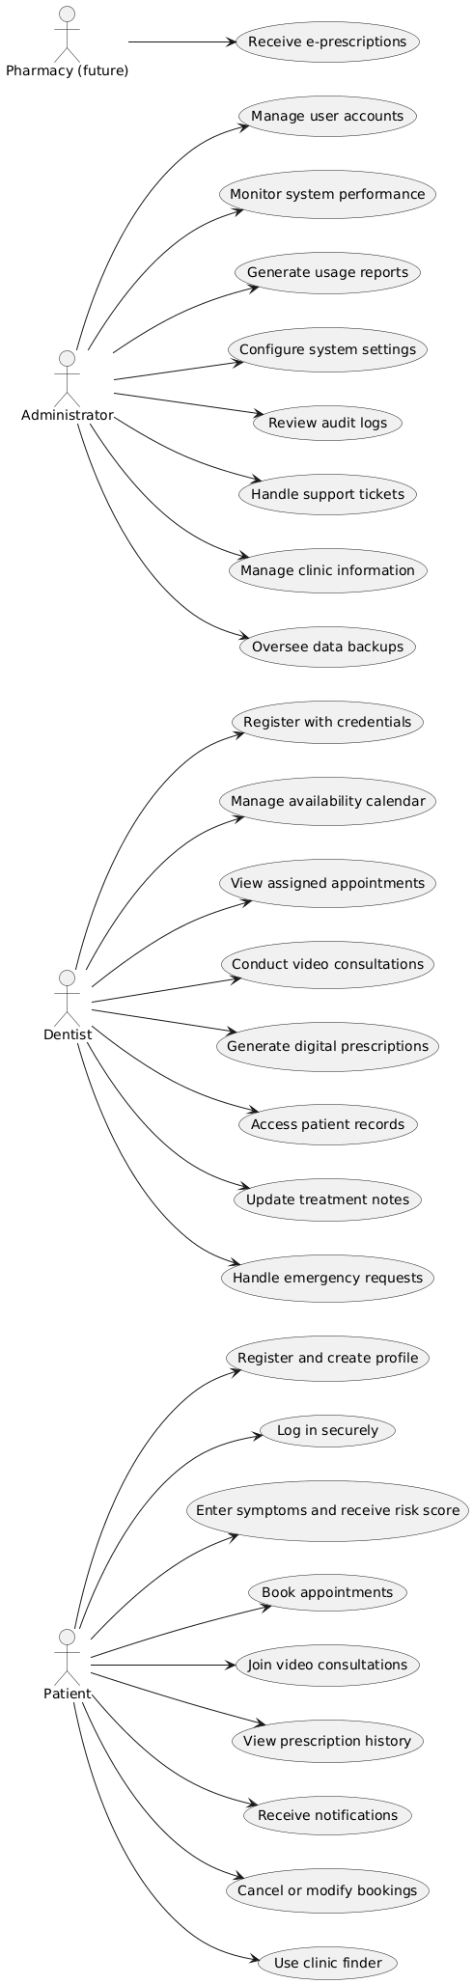

9. Class Diagram (+ ER Diagram)

9.1 Class Diagram
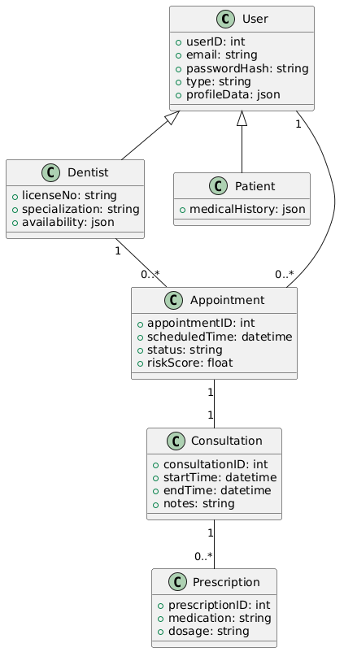

9.2 ER Diagram
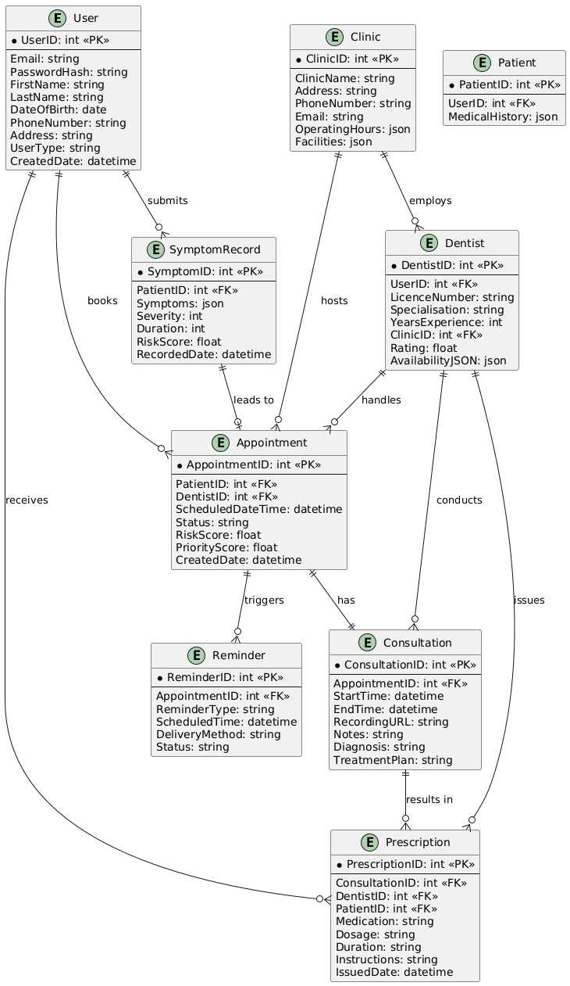

10. Sequence Diagram – Appointment Booking

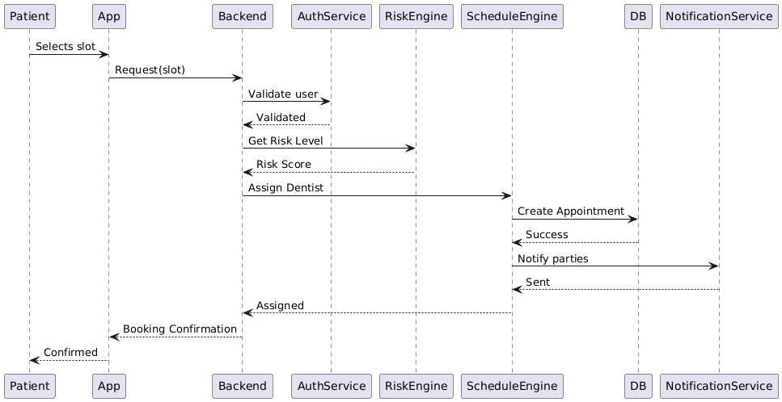

11. State Diagram – Appointment Lifecycle
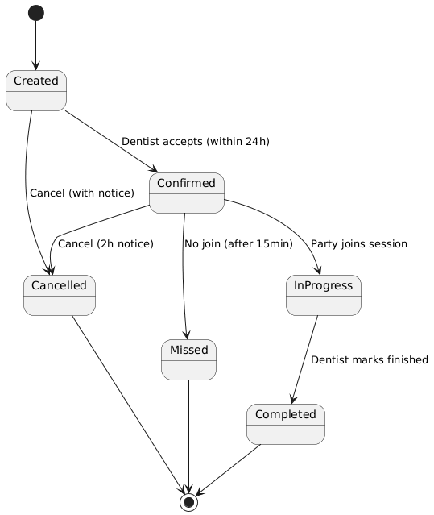

12. Data Flow Diagram (Level 1)
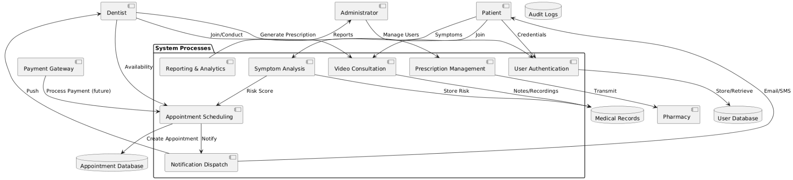

13. Priority-Based Dynamic Scheduling Algorithm

13.1 Algorithm Overview
The scheduling algorithm assigns appointments by balancing risk scores, availability, preferences, emergency flags, and load balancing.
Steps:
- Risk Assessment: Determine priority from symptom checker.
- Availability Check: Query open slots.
- Priority Calculation: Composite score from risk, flags, etc.
- Load Balancing: Adjust for dentist workload.
- Conflict Resolution: Resolve using scores.
- Confirmation & Notification: Notify parties.

13.2 Rules & Priority Scoring
Risk Level | Priority Points | Scheduling Notes
High (8-10) | +5 | Same-day/next-day; emergency override
Moderate (4-7) | +3 | Within 3-7 days; consider preferences
Low (1-3) | +1 | Within 2 weeks; routine
First-time patient | +1 | Extra time for assessment
Follow-up visit | +2 | Prefer original dentist
Emergency flag | +7 | Immediate; overrides queue
Workload Adjustment: +1 (0-60% load), 0 (61-85%), -2 (86%+).

13.3 Pseudo-Code

FUNCTION ScheduleAppointment(patient, requestedDateTime, symptoms):
riskScore = CalculateRiskScore(symptoms, patient.medicalHistory)
priorityPoints = 0
IF riskScore >= 8 THEN priorityPoints += 5
ELSE IF riskScore >= 4 THEN priorityPoints += 3
ELSE priorityPoints += 1

IF patient.isEmergency THEN priorityPoints += 7
IF patient.isFirstTime THEN priorityPoints += 1
IF patient.isFollowUp THEN priorityPoints += 2

availableDentists = QueryDentistAvailability(requestedDateTime)
IF availableDentists.isEmpty() THEN
suggestedSlots = FindNextAvailableSlots(requestedDateTime)
RETURN suggestedSlots
END IF

FOR EACH dentist IN availableDentists:
workloadFactor = CalculateWorkloadFactor(dentist)
dentist.adjustedPriority = priorityPoints + workloadFactor
IF DentistSpecialisationMatches(dentist, symptoms) THEN
dentist.adjustedPriority += 2
END IF
END FOR

selectedDentist = dentist WITH MAX(adjustedPriority)
appointment=CreateAppointment(patient, selectedDentist, requestedDateTime)
SendNotifications(patient, selectedDentist, appointment)
RETURN appointment
END FUNCTION

13.4 Workflow (Activity Diagram)
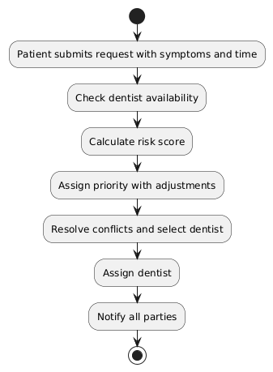

14. Requirements Traceability Matrix
To ensure compliance with CMMI V3.0 Requirements Development & Management (RDM) and Process Quality Assurance (PQA), a traceability matrix is included. This matrix traces functional requirements (FRs) to use cases, dependencies, acceptance scenarios, and related diagrams.
FR ID | Related Use Cases | Dependencies | Acceptance Scenarios | Related Diagrams
FR01 | Register Account | None | 1-3 | Class Diagram (User), ER Diagram (User)
FR02 | Authenticate | FR01 | 1-3 | Sequence Diagram (Auth Service)
FR03 | Enter Symptoms, Calculate Risk Score | FR01 | 1-3 | Data Flow Diagram (Symptom Analysis), Algorithm Pseudo-Code
FR04 | Intelligent Triage Recommendations | FR03 | High/Low risk scenarios | State Diagram (Appointment Lifecycle)
FR05 | Book Appointment, Manage Availability | FR03, FR02 | 1-3 | Sequence Diagram (Appointment Booking), DFD (Appointment Scheduling)
FR06 | Conduct Consultation | FR05, FR02 | 1-3 | Sequence Diagram, Use Case Diagram (Join/Conduct Consultation)
FR07 | Generate Prescription | FR06, FR01 | 1-3 | Class Diagram (Prescription), ER Diagram (Prescription)
FR08 | Automated Reminders | FR07 | Daily/escalation | DFD (Notification Dispatch), ER Diagram (Reminder)
FR09 | Emergency Access Override | FR05, FR03 | Connect <1 min | Use Case Diagram (Handle Emergency Requests)
FR10 | Manage Users, Generate Reports | All FRs | Reports <10s | Use Case Diagram (Admin tasks), DFD (Reporting & Analytics)
This matrix ensures bidirectional traceability, supporting verification, validation, and change management.

15. Key Benefits
- Faster Patient Access: Reduced waiting times.
- Intelligent Triage: Prioritizes urgent cases.
- Emergency Readiness: Rapid response.
- Better Dental Outcomes: Personalized plans.
- Efficient Remote Workflow: Less admin burden.

16. System Architecture & Key Actors
Primary Actors: Patient, Dental Professional, System Administrator. External Integrations: Payment gateways (future), SMS/push notifications, Maps, Azure cloud.

17. Compliance with CMMI on Analysis & Documentation
E-Dentist adheres to CMMI-DEV V3.0 Maturity Level-3 ("Defined") standards, ensuring process maturity and documentation quality. At Level 3, processes are tailored from organizational standards, with complete practice group implementations in applicable Practice Areas (PAs). This SRS demonstrates compliance through structured documentation, diagrams, and traceability.
Compliance Mapping (Focused on DEV View PAs; all Level 3 practices addressed where applicable):
- Requirements Development & Management (RDM): Stakeholder needs elicited via interviews (Section 4); FR/NFR detailed with rationale, dependencies, scenarios (Section 6); Traceability matrix (Section 13); Validation via acceptance scenarios.
- Technical Solution (TS): Designs/solutions in UML diagrams (Sections 7-10), class/ER diagrams (Section 8), algorithm (Section 12); Alternatives considered (e.g., cloud vs. on-prem in vision).
- Product Integration (PI): Defined integration points (video API, pharmacy API, Azure backend); Sequence diagram shows integration flow (Section 9).
- Verification and Validation (VV): Acceptance scenarios/test criteria (Section 6); Peer review implied in document iterations; Ensures patient safety/clinical outcomes via risk-based features.
- Configuration Management (CM): SRS version control (this is v2.0 final); Baselines for requirements; Change control via dependencies/traceability.
- Process Quality Assurance (PQA): Audit logs in FR10; Compliance mapping ensures objective evaluation; Improvement opportunities noted (e.g., future interoperability).
- Risk and Opportunity Management (RSK): Constraints/risks identified (Section 4.4); Mitigation via offline features, security NFRs; Opportunities in vision (e.g., insurance integration).
- Decision Analysis and Resolution (DAR): Structured decisions in algorithm (Section 12); Criteria for FR priorities; Alternatives in designs (e.g., sync/async consultations).
- Planning (PLAN): Project scope in introduction/motivation; Dependencies in FRs; Estimates implied in NFR02 (performance).
- Monitor and Control (MC): Reporting in FR10; Corrective actions via reminders/emergency overrides.
- Estimating (EST): Scalability NFR05; Effort estimates in acceptance scenarios (e.g., response times).
- Governance (GOV): Senior management sponsorship implied in vision; Resources for development (e.g., Azure).
- Implementation Infrastructure (II): Organizational processes via standards (WCAG, HIPAA); Training in OT mapping.
- Organizational Training (OT): User training for low-literacy (constraints); Strategic plans in vision.
- Process Asset Development (PAD): Reusable assets like UML templates; Library of diagrams.
- Process Management (PCM): Improvements via gap analysis (Section 4.2); Deployment of standards.
- Causal Analysis and Resolution (CAR): Root cause for missed appointments (state diagram); Improvements submitted via admin reports.
- Peer Reviews (PR): Reviews of requirements/diagrams during development.
- Data Management (DM) & Data Quality (DQ): Medical history/patient data handling (FR01, NFR01); Quality via risk calculator validation.
- Workforce Empowerment (WE): Role-based access empowers users; Competencies for dentists (license verification).
- Enabling Security (ESEC) & Managing Security Threats & Vulnerabilities (MST): NFR01 covers encryption, audits, threat mitigation.
This comprehensive mapping ensures the software lifecycle processes meet international quality and engineering standards for CMMI Level 3, with tailored organizational processes, quantitative management where applicable, and continuous improvement.

18. References
- Sherly, R. Sinha, and A. Banerjee, “Online appointment scheduling system with advanced features,” International Journal of Advanced Research in Computer Science, vol. 8, no. 7, pp. 77–82, 2017.
- A. Bhadane, P. Patil, and R. Chavan, “Android based medication reminder using ocr and ann,” International Journal of Computer Applications, vol. 123, no. 6, pp. 21–25, 2015.
- A. Rahman and S. Karim, “A simple mobile alarm-based medicine reminder system for elderly patients,” in Proceedings of the International Conference on Mobile Computing and e-Health, 2016, pp. 45–49.
- M. M. H. Chowdhury, M. H. Rahman, and M. S. Uddin, “mhealth in bangladesh: Current status and future prospects,” Journal of Health Informatics in Developing Countries, vol. 12, no. 2, pp. 1–9, 2018.
- P. Deb, T. Rahman, and M. Alam, “Offline navigation system for health services in bangladesh,” International Journal of Computer Science and Information Security, vol. 14, no. 4, pp. 89–95, 2016.
- N. Shrideep, K. Patel, and R. Verma, “Android based video calling system over wi-fi,” International Journal of Emerging Trends in Engineering and Development, vol. 4, no. 2, pp. 150–154, 2014.
- M. Estai, Y. Kanagasingam, M. Tennant, and S. Bunt, “A systematic review of the research evidence for the benefits of teledentistry,” Journal of Telemedicine and Telecare, vol. 22, no. 6, pp. 323–329, 2016.

Appendix A: Scope, Assumptions, and Clarifications

A.1 System Scope
The E-Dentist system provides a tele-dentistry platform enabling online consultations, intelligent rule-based triage, appointment scheduling, digital prescriptions, automated reminders, and clinic navigation services. The system supports Patients, Licensed Dentists, and Administrators through web and mobile interfaces.

A.2 Out-of-Scope
- Automated clinical diagnosis without dentist validation
- Medication delivery and logistics
- Insurance claim processing
- Fully autonomous AI-based decision making

A.3 Assumptions & Dependencies
- Users have access to smartphones or web-enabled devices
- Dentists are externally licensed and verified
- Internet connectivity may be intermittent
- Risk scoring logic is rule-based and clinically approved
- SMS, Video, and Map services rely on third-party APIs

A.4 Clarification on Intelligent Components
All intelligent features in E-Dentist are implemented as rule-based clinical decision support systems. Machine learning-based analytics are considered future enhancements and are not part of the current scope.

A.5 Verification Methods Summary
- Functional Requirements: Acceptance Scenarios & Use Case validation
- Performance NFRs: Load testing (e.g., JMeter)
- Security NFRs: OWASP-based penetration testing
- Usability: WCAG 2.1 compliance testing

A.6 Algorithm Correctness Note
The priority-based scheduling algorithm operates in O(n) time complexity, where n represents the number of available dentists. Deterministic priority scoring ensures predictable scheduling outcomes.

