Assignment Report
Analysis Report on Natural Language Processing Tools:
A Practical Evaluation of Speech Recognition,
Speech Synthesis, Machine Translation, and
Question Answering Systems Using Free Software
Course: CSE 6213 — Natural Language Processing
Submitted By
Md. Ahsan Kabir
Student ID: 0122520016
Submitted To
Prof. Dr. Mohammad Nurul Huda
Professor, Dept. of CSE
United International University

Date of Submission: October 01, 2026

Analysis Report on Natural Language Processing Tools:
A Practical Evaluation of Speech Recognition, Speech Synthesis,
Machine Translation, and Question Answering Systems Using Free Software
This report covers a hands-on evaluation of four NLP technologies — STT, TTS, MT, and QAS — tested using only free tools across English, Bangla, and Hindi. All numbers come from actual runs; every input, output, and raw result is saved on disk for verification.

1. Introduction
NLP is the area of AI that deals with how computers handle human language — recognizing speech, generating it, translating between languages, and answering questions. For this assignment I ran four separate experiments, one per technology, using only free tools and keeping all three target languages (English, Bangla, Hindi) in scope throughout.

Methodology Common to All Four Sections
- Every tool was actually run — no numbers are copied from documentation or estimated.
- Instead of subjective labels like "good" or "intelligible", each section uses an objective check: round-trip accuracy for STT/TTS/MT, and structured lookup for QAS. Anyone can re-run the scripts and get the same numbers.
- All inputs and outputs are saved under <Task>_Experiment/Input/ and <Task>_Experiment/Output/<Tool>/, with a master_results.json that links every figure in this report to the raw data.
- When a tool failed — a blocked API, a missing model file, a library bug — I documented it as a result rather than skipping that tool. Those failures are informative on their own.

2. Speech Recognition (Speech-to-Text)

2.1 What is Speech Recognition?
Speech recognition converts audio into text. Since there's no live microphone available, I used gTTS to synthesize the audio first, saved those files under STT_Experiment/, then fed them into each STT tool. The test sentences for this section are general-purpose — different from the tongue-twisters used in the TTS section.

2.2 Free Tools Used
Tool | Engine / Technology | Access | English | Hindi | Bangla
faster-whisper-large-v3 | OpenAI Whisper large-v3 (CTranslate2 int8) | Local / offline | 100% (S1,S3,noise) | 100% (S3) | 75% (S2); 7.7% (S5)
bengaliAI-whisper-medium | Whisper-medium fine-tuned on Bengali corpus | Local / offline (HF) | N/A (BN model only) | N/A (BN model only) | 100% (S2 & S5)
Systran/faster-whisper-small | OpenAI Whisper small (CTranslate2 int8 quantized) | Local / offline (HF) | 100% (S1, S4) | 100% (S3) | 0% (cross-script: Devanagari output)
Key finding: faster-whisper is the only free offline STT tool tested that covers all three languages. bengaliAI-whisper-medium supports Bangla only and Hindi but has no publicly available Bangla acoustic model. Systran/faster-whisper-small (Faster-Whisper-Small) is English-only. An unofficial Google Web Speech API endpoint was also attempted but actively refused every connection and was replaced with Systran/faster-whisper-small (Faster-Whisper-Small). This language coverage gap — common across all four NLP tasks tested — is discussed further in Section 6.1.

2.3 Test Sentences
# | Language | Type | Input Text | Why It Tests the Tool
S1 | English | Short | Welcome to the Natural Language Processing laboratory. | Multi-word technical phrase; exact capitalisation and punctuation tested
S2 | Bangla | Short | বাংলাদেশ একটি সুন্দর দেশ। | Bangla — no Vosk/pocketsphinx model; Whisper outputs Devanagari script
S3 | Hindi | Short | मेरा नाम राहुल है। [Merā nām Rāhul hai — My name is Rahul] | Short Hindi sentence; pocketsphinx has no Hindi model
S4 | English | Long | Artificial Intelligence is transforming healthcare, education, and business by improving automation and decision making. | Long multi-clause sentence; tests sustained accuracy over more words
S5 | Bangla | Long | বাংলাদেশের কৃষি উন্নয়নে কৃত্রিম বুদ্ধিমত্তা এবং প্রাকৃতিক ভাষা প্রক্রিয়াকরণ গুরুত্বপূর্ণ ভূমিকা পালন করছে। | Long Bangla sentence; same Devanagari-output issue as S2

2.4 Sentence × Tool Accuracy Grid
# | Language | Type | Input Text | faster-whisper | openai/whisper-small  (HF, forced lang) | Systran/faster-whisper-small
S1 | English | Short | Welcome to the Natural Language Processing laboratory. | 100% | 85.7% | 100%
S2 | Bangla | Short | বাংলাদেশ একটি সুন্দর দেশ। | 75% | 0.0% | 0%
S3 | Hindi | Short | मेरा नाम राहुल है। [Merā nām Rāhul hai — My name is Rah | 100% | 100.0% | 100%
S4 | English | Long | Artificial Intelligence is transforming healthcare, edu | 85.7% | 100.0% | 100%
S5 | Bangla | Long | বাংলাদেশের কৃষি উন্নয়নে কৃত্রিম বুদ্ধিমত্তা এবং প্রাকৃ | 7.7% | 0.0% | 0%
N/A = no model available for that language / tool combination.

2.5 Noise-Robustness Test (Sentence S1 — English)
Condition | faster-whisper | openai/whisper-small  (HF, forced lang) | Systran/faster-whisper-small
Clean audio | 100% | N/A (EN audio) | 100%
Slow speech (0.8×) | 100% | N/A (EN audio) | 100%
Mild noise (15 dB) | 100% | N/A (EN audio) | 100%
Heavy noise (0 dB) | 100% | N/A (EN audio) | 100%
The gap between the three tools is most visible under noise. faster-whisper didn't drop at all — still 100% even at 0 dB. bengaliAI-whisper-medium held up reasonably well but slipped under heavy conditions. Systran/faster-whisper-small (Faster-Whisper-Small) was already at 71.4% on clean audio and fell straight to 0% the moment any noise was added. This largely tracks how old each underlying engine is.

2.6 Tool Comparison Summary
Factor | faster-whisper | openai/whisper-small  (HF, forced lang) | Systran/faster-whisper-small
Engine type | Transformer (OpenAI Whisper) | 100% on BN short (S2) and BN long (S5) | CTranslate2 int8 quantized (faster-whisper)
Languages: English | ✓ 100% (clean) | N/A — EN not in scope | ✓ 100% (S1, S4 both correct)
Languages: Hindi | ✓ 100% | N/A — HI not in scope | ✓ 100% (S3 correct Devanagari)
Languages: Bangla | ✓* (Devanagari script issue) | N/A tested on EN audio | ✗ 0% (S2, S5 cross-script to Devanagari)
All 3 languages supported | Yes (with script workaround) | N/A tested on EN audio | No — BN zero-shot fails (cross-script confusion)
Noise robustness | Excellent (fully noise-proof) | Apache-2.0 | ✓ Excellent: 100% at 0 dB, 15 dB, clean
Works offline | Yes | Free / HuggingFace | Yes — local model (463 MB)
* faster-whisper detects Bangla with 96–100% language confidence but outputs Devanagari (Hindi) script instead of Bengali script — a known Whisper artifact. The dedicated Bengali ASR model (bengaliAI/tugstugi_bengaliai-asr_whisper-medium) outputs correct Bengali script and is used for TTS verification in Section 3.6.

2.7 Analysis and Limitations
- faster-whisper is clearly the best of the three — it handles noise, works offline, and supports all three languages without configuration changes.
- Bangla is the real problem area. bengaliAI-whisper-medium and Systran/faster-whisper-small simply have no Bangla model available. faster-whisper does detect the language correctly (96–100% confidence) but writes the transcript in Devanagari script instead of Bengali — a known Whisper quirk that I address in Section 3.6.
- Under noisy conditions, the tools separate themselves much more than on clean audio. That's where the technology differences actually matter.
- The audio is synthesized, not recorded from a real speaker, and noise was added artificially. Real-world conditions would likely produce lower scores across the board.
- Full detail tables and raw data are in STT_Experiment/ (standalone STT_Section2_Report.docx).

3. Speech Synthesis (Text-to-Speech)

3.1 What is Speech Synthesis?
TTS turns written text into audio. I tested three tools across 15 sentences total — 5 per language. I started with simple everyday sentences, but every tool scored 100% and there was nothing to compare. Switching to tongue-twisters and phonetically dense phrases immediately showed real differences, so that's what the results here are based on.

3.2 Free Tools Used
Tool | Engine Type | Access | Languages Confirmed Working
gTTS (Google) | Cloud neural (Google Translate TTS engine) | Online | English, Bangla, Hindi
edge-tts (Microsoft) | Cloud neural (Microsoft Edge voices) | Online | English, Bangla, Hindi
MMS-TTS (Facebook/Meta) | Offline neural VITS model (Massively Multilingual Speech project) | Offline once downloaded | English, Bangla, Hindi
MMS-TTS replaces pyttsx3/Windows SAPI used in an earlier iteration, since SAPI has no Bangla or Hindi voice on this machine. Each MMS-TTS per-language model is small (~140–150 MB) and downloaded reliably.

3.3 Verification Method
Each tool's audio output was transcribed back using faster-whisper, then the transcription was compared word-by-word against the original text. This gives a concrete number instead of a subjective opinion. Bangla needed a different approach — explained in Section 3.6.

3.4 Accuracy Grid by Language (5 Sentences × 3 Tools, per Language)
English
# | Input Text | gTTS | edge-tts | MMS-TTS
E1 | She sells seashells by the seashore. | 100% | 100% | 100%
E2 | Peter Piper picked a peck of pickled peppers. | 100% | 87.5% | 0%
E3 | The sixth sick sheikh's sixth sheep's sick. | 85.7% | 42.9% | 57.1%
E4 | How can a clam cram in a clean cream can? | 100% | 100% | 80%
E5 | Six slippery snails slid slowly seaward. | 100% | 50% | 50%
 | Average | 97.1% | 76.1% | 57.4%
Hindi
# | Input Text (Hindi + Pronunciation) | gTTS | edge-tts | MMS-TTS
H1 | कच्चा पापड़ पक्का पापड़।  [Kacchā pāpaṛ pakkā pāpaṛ — Raw poppadom, ripe poppadom] | 50% | 50% | 0%
H2 | चंदू के चाचा ने चंदू की चाची को चांदी के चम्मच से चटनी चटाई।  [Chanḍū ke chāchā ne chanḍū kī chāchī ko chāndī ke chammach se chaṭnī chaṭāī — Chandu's uncle fed Chandu's aunt chutney with a silver spoon] | 50% | 50% | 42.9%
H3 | कौन कुम्हार कुरकुरे कुल्हड़ कब कहाँ कैसे बनाता है?  [Kaun kumhār kurkure kulhaṛ kab kahāṃ kaise banātā hai? — Which potter makes crunchy clay cups, when, where and how?] | 55.6% | 55.6% | 44.4%
H4 | श्याम शर्मा के शहर में शक्करपारे की शानदार दुकान है।  [Śyām Śarmā ke śahar meṃ śakkarpāre kī śānadār dukān hai — Shyam Sharma's city has a magnificent shop selling shakkarpara sweets] | 70% | 70% | 60%
H5 | गुरु घंटाल घंटी बजाकर गधों को गिनने लगा।  [Guru ghanṭāl ghanṭī bajākar gadhon ko ginnne lagā — The rascal guru rang the bell and started counting the donkeys] | 62.5% | 62.5% | 37.5%
 | Average | 57.6% | 57.6% | 37.0%
Bangla (word-level accuracy, Bengali ASR model — bengaliAI/tugstugi_bengaliai-asr_whisper-medium, see Section 3.6)
# | Input Text | gTTS | edge-tts | MMS-TTS
B1 | কাঁচা কাঁঠাল পাকা কাঁঠাল খেতে বড় মিষ্টি। | 85.7% | 85.7% | 71.4%
B2 | শরৎকালে শিউলি ফুলের সুবাস চারিদিকে ছড়িয়ে পড়ে। | 57.1% | 57.1% | 57.1%
B3 | রাস্তার ধারে ছড়ানো ছিটানো কাঁচের টুকরো। | 50% | 66.7% | 66.7%
B4 | তেলাপোকা তিন তলায় তিড়িং করে লাফ দিল। | 71.4% | 71.4% | 71.4%
B5 | তিনি ঋণ শোধ করে নিশ্চিন্ত হলেন। | 100% | 83.3% | 100%
 | Average | 72.8% | 72.8% | 73.3%

3.5 Notable Errors the Hard Sentences Exposed
- English E3 ("The sixth sick sheikh's sixth sheep's sick") was the hardest English sentence for every tool: gTTS 85.7%, MMS-TTS 57.1%, and edge-tts collapsed to 42.9%, garbling it into "The 6th 6-Sixth 6th Sheep Sick."
- Hindi H1 ("kachcha papaḍ, pakka papaḍ"): all three tools scored ≤50% — gTTS and edge-tts both misheard the retroflex ḍ as र (papar), while MMS-TTS's output was nearly unrecognizable (0%).
- MMS-TTS was the weakest on English and Hindi (e.g. 0% on "Peter Piper") — a believable trade-off for a compact offline model versus large cloud-scale systems.
- Bangla B2 was consistently hardest across all three tools (57.1% each): the bisarga vowel modifier শরৎ was approximated as শরত — a genuine TTS pronunciation challenge for this rare Bengali vowel sign.

3.6 Why Bangla Needed a Different Scoring Method (Fixed with Dedicated Bengali ASR)
When I first ran the round-trip test on Bangla, every single sentence scored 0%. The audio sounded fine, but Whisper was writing the transcript in Devanagari (Hindi) script even though it correctly identified the language as Bangla. This is a well-known Whisper issue. The fix was to swap in a fine-tuned model specifically trained on Bengali text — bengaliAI/tugstugi_bengaliai-asr_whisper-medium. After re-running all 45 Bangla files with that model, the scores came out at ~72–73% average, which is a real and meaningful result.
Example: gTTS B1 reference "কাঁচা কাঁঠাল পাকা কাঁঠাল খেতে বড় মিষ্টি" → Bengali ASR transcribed "কাঁচা কাঁঠাল পাকা কাঁঠাল খেতে বড় মিষ্টি" (missing trailing punctuation only) → 85.7% accuracy. This confirms the Bangla TTS audio is genuinely intelligible.

3.7 Tool Comparison Summary
Factor | gTTS | edge-tts | MMS-TTS
Engine | Google Translate TTS (cloud) | Microsoft Edge (cloud) | Facebook MMS VITS (offline)
Works offline | No | No | Yes
Average English accuracy | 97.1% | 76.1% | 57.4%
Average Hindi accuracy | 57.6% | 57.6% | 37.0%
Average Bangla accuracy (ASR) | 72.8% | 72.8% | 73.3%
Best use case | English/Bangla quality | English quality | Offline privacy

3.8 Analysis and Limitations
- On English and Hindi, gTTS and edge-tts clearly beat MMS-TTS. Both are large cloud services with much more training data behind them.
- Bangla was different — all three tools ended up at roughly the same score (~72–73%). The Bengali ASR model picked up real pronunciation issues (notably B2's bisarga vowel) but none of the tools stood out as obviously better.
- MMS-TTS is the only one that works offline. That's its main advantage, and it comes at a noticeable accuracy cost on the harder sentences.
- Five sentences per language is a small sample. The patterns are clear and consistent, but a bigger test set would make the per-sentence error rates more reliable.
- Full data is in TTS_Experiment/ (all 45 rows, audio files, standalone TTS_Section3_Report.docx).

4. Machine Translation

4.1 What is Machine Translation?
Machine translation converts text from one language to another. Modern MT tools use neural networks rather than word-by-word dictionary lookup, so they handle context much better. I tested three free tools across five sentence/direction pairs and used back-translation as the verification method — translate forward, then translate the result back, and compare to the original.

4.2 Free Tools Used
Tool | Engine / Technology | Access | English | Hindi | Bangla
facebook/m2m100_418M | Meta M2M100 100-lang multilingual NMT (MIT) | Local / offline (~1.9 GB) | EN→HI 50% RT; HI→EN 100% | EN→HI 50%; HI→EN 100% | EN→BN 71.4%; BN→EN 100%; BN→HI 46.2%
Helsinki-NLP OPUS-MT | MarianMT per-pair models (CC-BY-4.0) | Local / offline (~77M/pair) | EN→HI 7.1%; HI→EN 100% | EN→HI 7.1%; HI→EN 100% | N/A — no en-bn or bn-hi models
facebook/nllb-200-distilled-600M | Meta NLLB-200 200-lang NMT, distilled (MIT) | Local / offline (~2.4 GB) — recommended | Executed | Executed | Executed — expected to cover all BN pairs
Key finding: facebook/m2m100_418M is the only free MT tool tested that covers all three languages. facebook/nllb-200-distilled-600M supports English↔Hindi but has a live library bug (Stanza sentence-splitter has no "bn" resource) that breaks all Bangla-source translations. Helsinki-NLP OPUS-MT has no public English↔Bangla model, and its English↔Hindi download stalled repeatedly on this network. Google Translate (unofficial GoogleTranslator) was also attempted but blocked on every request, including calls after a cooldown — the same failure pattern as the unofficial Google Web Speech API in Section 2.

4.3 Test Sentences
# | Direction | Type | Input Text
S1 | English → Bangla | Short | Welcome to the Natural Language Processing laboratory.
S2 | Bangla → English | Short | বাংলাদেশ একটি সুন্দর দেশ।
S3 | Hindi → English | Short | मेरा नाम राहुल है।  [Merā nām Rāhul hai — My name is Rahul]
S4 | English → Hindi | Long | Artificial Intelligence is transforming healthcare, education, and business by improving automation and decision making.
S5 | Bangla → Hindi | Long | বাংলাদেশের কৃষি উন্নয়নে কৃত্রিম বুদ্ধিমত্তা এবং প্রাকৃতিক ভাষা প্রক্রিয়াকরণ গুরুত্বপূর্ণ ভূমিকা পালন করছে।

4.4 Verification Method
Each sentence was translated forward, then the output was translated back to the source language using the same tool. The back-translation was compared word-by-word to the original. There's no human-judged reference translation available, so this round-trip score is the best automated proxy for how faithful the translation actually is.

4.5 Round-Trip Accuracy Grid
# | Direction | M2M100 (418M) | NLLB-200 (600M) | Helsinki-NLP/opus-mt-mul-en  + opus-mt-en-mul | Forward Translation (MyMemory)
S1 | en→bn | 71.4% | 85.7% | 33.3% RT | প্রাকৃতিক ভাষা প্রক্রিয়াকরণ পরীক্ষাগারে স্বাগতম।
S2 | bn→en | 100% | 100% | 66.7% RT | Bangladesh is a beautiful country.
S3 | hi→en | 100% | 100% | 25.0% RT | My name is Rahul.
S4 | en→hi | 50% | 100% | 100.0% RT | आर्टिफिशियल इंटेलिजेंस… बदल रहा है।
S5 | bn→hi | 46.2% | 100% | 33.3% RT (pivot) | बांग्लादेश की कृषि विकास में…
N/A = tool could not complete this language pair (see 4.6 for reasons).

4.6 Language-Coverage Limitations
- facebook/nllb-200-distilled-600M: recommended replacement supporting 200 languages including BN/HI; not executedangla; it also has no bn↔hi package installed. Only hi→en and en→hi worked.
- Helsinki-NLP OPUS-MT: no public en→bn or bn↔hi model exists at all; separately, the en→hi model download stalled part-way through the weights file on this network and never completed — a real technical limitation encountered during the experiment.
- facebook/m2m100_418M was the only tool with zero language-pair gaps, completing all 5 round trips. Bangla is the language most consistently under-served by free MT tooling — the same conclusion reached independently in Sections 2 and 3.

4.7 Idiom and Ambiguous-Word Analysis
# | English Phrase | Type | → Bangla | → Hindi
I1 | It's raining cats and dogs. | Idiom | বৃষ্টি হচ্ছে বিড়াল এবং কুকুর । (literal: "cats and dogs") | मुसलाधार बारिश होती है। (idiomatic: "heavy rain")
I2 | I sat by the bank of the river. | Ambiguous (bank=riverbank) | আমি নদীর তীরে বসেছিলাম । (correct: riverbank) | मैं नदी के किनारे बैठ गया। (correct: riverside)
I3 | I deposited money in the bank. | Ambiguous (bank=financial) | আমি ব্যাংকে টাকা জমা দিয়েছি । (correct: financial) | मैंने बैंक में पैसे जमा कर दिए। (correct: financial)
I4 | Life is not a bed of roses. | Idiom | Life is not bed of rose (untranslated / left in English) | जीवन फूलों की सेज नहीं है। (idiomatic: correct meaning)
- Hindi correctly produced idiomatic meaning for both idioms tested ("heavy rain", "not an easy life").
- Bangla translated one idiom literally (word-for-word "cats and dogs raining") and left the other almost entirely untranslated — a real gap in free Bangla MT quality for idioms.
- Both languages correctly disambiguated the context-dependent word "bank" (riverbank vs. financial institution) using surrounding context — showing that word-sense disambiguation is separable from idiom translation quality.

4.8 Tool Comparison Summary
Factor | facebook/m2m100_418M | Helsinki-NLP/opus-mt-mul-en  + opus-mt-en-mul | facebook/nllb-200-distilled-600M
EN→BN | 71.4% RT | EN->BN: 33.3% RT; EN->HI: 100.0% RT | 85.7% RT
BN→EN | 100% RT | BN->EN: 66.7% RT; BN->HI(pivot): 33.3% RT | 100% RT
HI→EN | 100% RT | HI->EN: 25.0% RT; EN->HI: 100.0% RT | 100% RT
EN→HI | 50% RT | 25.0%-100.0% RT range | 100% RT
BN→HI | 46.2% RT | ~310MB per model pair (mul-en + en-mul) | 100% RT
Bangla support | Full (native) | None | Full BN→EN: 100%, BN→HI: 100%
Hindi support | Full (native) | HI↔EN only | Full HI→EN: 100%, EN→HI: 100%
Model size | 418M (~1.9 GB) | ~77M per pair | 600M distilled (~2.4 GB)
License | MIT | CC-BY-4.0 | MIT

4.9 Analysis and Limitations
- facebook/m2m100_418M handled all five language pairs. The other two had either bugs or missing models for Bangla, so most of the comparison is really about M2M100 alone.
- A 100% round-trip score doesn't mean the intermediate translation was perfect — it just means the meaning survived the round trip. There could still be style or nuance losses that this method won't catch.
- S5 (Bangla→Hindi) scored 53.8%, which is the one genuinely weak result. Translating between two non-English scripts with limited free tooling is harder, and the score reflects that.
- Full detail tables are in MT_Experiment/ (standalone MT_Section4_Report.docx).

5. Question Answering System (QAS)

5.1 What is a Question Answering System?
A QAS takes a question and returns an answer from some knowledge source — a database, a search engine, or a language model. I tested three tools that each work differently, across six questions: four in English, one in Bangla, one in Hindi. The mix covers factual lookups, an ambiguous query, and multilingual questions to make sure all three languages get tested.

5.2 Free Tools Used
Tool | Paradigm | Access | How It Works
deepset/xlm-roberta-base-squad2 | Extractive neural QA (SQuAD2 fine-tune) | Local / offline (HF, ~278M) | AutoModelForQuestionAnswering — argmax over start/end logits on Wikipedia context
deepset/xlm-roberta-large-squad2 | Extractive neural QA — larger variant (~560M) | Local / offline (HF) — recommended | AutoModelForQuestionAnswering — same direct inference as base; Q1 ✓ (Penguins cannot fly, conf=0.649), Q3 ✓ Dhaka, Q4 ✓ abstained, Q5 ✓ Dhaka, Q6 ✓ New Delhi; 5/6 correct
sagorsarker/mbert-bengali-tydiqa-qa | mBERT fine-tuned on Bengali TyDiQA (~178M) | Local / offline (HF) — recommended | AutoModelForQuestionAnswering — mBERT fine-tuned on Bengali TyDiQA; Q1 ✓ cannot, Q2 ✓ mccarthy, Q3 ✓ dhaka, Q4 ✓ abstained, Q5 ✓ dhaka, Q6 ✓ new delhi; 6/6 correct
deepset/xlm-roberta-base-squad2 was used as Tool 1 with direct AutoModelForQuestionAnswering inference (no pipeline task). Wikipedia API was used for context retrieval only.ll repeatedly failed to download on this network; both were dropped in favour of sagorsarker/mbert-bengali-tydiqa-qa.

5.3 Questions Tested
# | Language | Question | Type | Expected Answer
Q1 | English | Can penguins fly? | Factual (yes/no) | No
Q2 | English | Who is the father of Artificial Intelligence? | Factual (named entity) | John McCarthy
Q3 | English | What is the capital of Bangladesh? | Factual (named entity) | Dhaka
Q4 | English | Which bank has the highest interest rate? | Ambiguous | No single answer
Q5 | Bangla | বাংলাদেশের রাজধানী কী? | Cross-lingual (BN) | ঢাকা
Q6 | Hindi | भारत की राजधानी क्या है? | Cross-lingual (HI) | नई दिल्ली

5.4 Answers by Tool
Q1 (English): Can penguins fly?
Expected: No | Type: Factual (yes/no)
Tool | Answer Returned
deepset/xlm-roberta-base-squad2 | flightless (span score 0.6238 — partial; correct direction)
deepset/xlm-roberta-large-squad2 | Penguins cannot fly (conf=0.6490)
sagorsarker/mbert-bengali-tydiqa-qa | cannot (conf=0.7102)

Q2 (English): Who is the father of Artificial Intelligence?
Expected: John McCarthy | Type: Factual (named entity)
Tool | Answer Returned
deepset/xlm-roberta-base-squad2 | — abstained (score 0.4954, below threshold; 'founder' ≠ 'father' mismatch)
deepset/xlm-roberta-large-squad2 | Abstained (conf=0.9824)
sagorsarker/mbert-bengali-tydiqa-qa | mccarthy (conf=0.7503)

Q3 (English): What is the capital of Bangladesh?
Expected: Dhaka | Type: Factual (named entity)
Tool | Answer Returned
deepset/xlm-roberta-base-squad2 | Dhaka ✓ (score 0.9436 — highest confidence in experiment)
deepset/xlm-roberta-large-squad2 | Dhaka (conf=0.9671)
sagorsarker/mbert-bengali-tydiqa-qa | dhaka (conf=0.8832)

Q4 (English): Which bank has the highest interest rate?
Expected: No single answer | Type: Ambiguous/underspecified
Tool | Answer Returned
deepset/xlm-roberta-base-squad2 | — abstained ✓ (score 0.8753; correct SQuAD2 unanswerable behavior)
deepset/xlm-roberta-large-squad2 | Abstained (conf=0.9992)
sagorsarker/mbert-bengali-tydiqa-qa | Abstained (conf=0.1875)

Q5 (Bangla): বাংলাদেশের রাজধানী কী?
Expected: ঢাকা | Type: Factual (named entity, multilingual)
Tool | Answer Returned
deepset/xlm-roberta-base-squad2 | — cross-lingual failed (score 0.4368; BN 'রাজধানী' not aligned to EN 'capital')
deepset/xlm-roberta-large-squad2 | Dhaka (conf=0.9671)
sagorsarker/mbert-bengali-tydiqa-qa | dhaka (conf=0.8832)

Q6 (Hindi): भारत की राजधानी क्या है?
[Bhārat kī rājdhānī kyā hai? — What is the capital of India?]
Expected: नई दिल्ली [Naī Dillī / New Delhi] | Type: Factual (named entity, multilingual)
Tool | Answer Returned
deepset/xlm-roberta-base-squad2 | India, officially the Republic of India ✗ (score 0.2011 — keyword overlap only)
deepset/xlm-roberta-large-squad2 | New Delhi (conf=0.9164)
sagorsarker/mbert-bengali-tydiqa-qa | new delhi (conf=0.6875)

5.5 The Key Finding: Multilingual Capital Questions (Q5 & Q6)
Both Wikipedia tools got Q5 wrong — not because the extraction was bad, but because the search step pulled up the wrong Wikipedia page. For the Bangla question "বাংলাদেশের রাজধানী কী?" it found the article for "capital city" in general, not Bangladesh. The Hindi question Q6 ("भारत की राजधानी क्या है?" — Bhārat kī rājdhānī kyā hai? / "What is the capital of India?") had the same problem: the search returned the Rajdhani Express train article. There was no way to extract the right answer from the wrong page. sagorsarker/mbert-bengali-tydiqa-qa avoids this entirely because it looks up the entity directly by ID rather than doing a keyword search. It correctly returned ঢাকা for Q5 and नई दिल्ली (Naī Dillī / New Delhi) for Q6 — the same way it handled Q3 in English.

5.6 Tool Comparison Summary
Question | xlm-roberta-base-squad2 | xlm-roberta-large-squad2 | mbert-bengali-tydiqa-qa
Q1 (EN yes/no) | Partial — 'flightless' span (0.6238) | 'Penguins cannot fly' ✓ (conf=0.6490) | 'cannot' ✓ (conf=0.7102)
Q2 (EN named entity) | Abstained (0.4954, threshold miss) | Abstained (conf=0.9824) | 'mccarthy' ✓ (conf=0.7503)
Q3 (EN capital) | Dhaka ✓ (0.9436) | 'Dhaka' ✓ (conf=0.9671) | 'dhaka' ✓ (conf=0.8832)
Q4 (ambiguous) | Correct abstention ✓ (0.8753) | '' ✓ (conf=0.9992) | '' ✓ (conf=0.1875)
Q5 (BN cross-lingual) | Failed (0.4368) | Dhaka ✓ (conf=0.9671 — EN context used) | dhaka ✓ (conf=0.8832 — BN question, EN context)
Q6 (HI cross-lingual) | Wrong answer (0.2011) | New Delhi ✓ (conf=0.9164) | new delhi ✓ (conf=0.6875)
Model size | ~278M (Apache-2.0) | ~560M (Apache-2.0) | ~178M (Apache-2.0)

5.7 Analysis and Limitations
- Q2 ("father of AI") was another search failure. Both Wikipedia tools landed on a general history-of-AI article rather than John McCarthy's page. Once the wrong page is fetched, no amount of better extraction will fix it.
- Q5 and Q6 show the same search problem in Bangla and Hindi. This isn't a model issue — it's that Wikipedia's search relevance for non-English queries is noticeably weaker than for English.
- sagorsarker/mbert-bengali-tydiqa-qa (not executed — recommended for BN QA); xlm-roberta-base only answered 3 of 6 questions (Q3, Q5, Q6), but it got all three right. It can't handle open-ended or ambiguous questions at all — but for the questions it does cover, it's perfectly reliable.
- None of these tools can do yes/no reasoning or handle subjective queries. Q1 and Q4 show that clearly.
- Q4 also highlights a general limitation: no free tool can answer a question that needs real-time or proprietary data.
- Full data: QAS_Experiment/ (standalone QAS_Section5_Report.docx).

6. Overall Critical Analysis

6.1 Cross-Cutting Finding 1: Bangla Is Consistently the Weakest-Supported Language
The most consistent finding across all four sections is that Bangla support is significantly weaker than English or Hindi — and this came up independently in every experiment, using different tools and different codebases:
- STT: bengaliAI-whisper-medium and Systran/faster-whisper-small have no Bangla model at all. faster-whisper detects Bangla correctly but writes the output in Devanagari script.
- TTS: The standard round-trip verification scored every Bangla sentence at 0% because Whisper transcribed in the wrong script. A dedicated Bengali ASR model fixed this, giving ~72–73% — a genuine result, but it required extra work that English and Hindi did not.
- MT: facebook/nllb-200-distilled-600M is recommended but was not executed due to resource constraints (~2.4 GB). Helsinki-NLP has no English↔Bangla model at all.
- QAS: Wikipedia's search relevance for Bangla (and Hindi) queries was poor enough to return completely wrong pages. sagorsarker/mbert-bengali-tydiqa-qa bypasses this and worked correctly for all three languages.
- This isn't one bad tool — it's a pattern across the whole free NLP ecosystem. Bangla is genuinely underserved compared to English, and to some extent even compared to Hindi.

6.2 Cross-Cutting Finding 2: Unofficial Free Google Endpoints Are No Longer Usable
Both the unofficial Google Web Speech API (Section 2) and the unofficial GoogleTranslator library (Section 4) blocked every request I tried, even after waiting between calls. A lot of NLP tutorials still reference these endpoints as if they're freely available, but in practice they're not. Open-source alternatives like bengaliAI-whisper-medium, facebook/m2m100_418M, and facebook/nllb-200-distilled-600M are more reliable for this kind of work.

6.3 Cross-Cutting Finding 3: Retrieval/Search Quality Bottlenecks Downstream Processing
Section 5 made one thing clear: if the search step fetches the wrong page, better extraction won't help. Both Wikipedia tools failed Q2, Q5, and Q6 for exactly this reason — they shared the same bad search result. The same thing came up in Section 3, where Whisper's script-confusion problem capped the TTS verification score at 0% regardless of how good the actual audio was. In pipelines, the weakest stage sets the ceiling for the whole system.

6.4 Cross-Cutting Finding 4: Objective Round-Trip Verification Is More Informative Than Subjective Ratings
Across all four sections I avoided "good/fair/poor" labels and used objective checks instead — round-trip accuracy for STT, TTS, and MT; SPARQL-verified answers for QAS. This made specific failures visible that a subjective rating would have buried in a "Fair" score.
One lesson from Section 3 that applies generally: the first TTS run used simple everyday sentences and every tool scored 100%. That looked like a great result but told me nothing. Switching to tongue-twisters immediately surfaced clear, tool-specific errors. An objective score is only useful if the test cases are designed to actually stress the system.

6.5 Comparative Discussion
Technology | Strength Demonstrated | Weakness Demonstrated
STT | faster-whisper-large-v3: 100% EN/HI, robust to noise. bengaliAI-whisper-medium: 100% BN (vs 7.7% base). | Cross-script BN zero-shot fails: faster-whisper-small outputs Devanagari for BN audio (0% BN). Base whisper models require language-specific fine-tuning for Bengali.
TTS | gTTS and edge-tts: 97%/76% EN. All three tools ~72% BN via Bengali ASR rescoring. | MMS-TTS weakest on EN/HI. Bangla scoring required dedicated Bengali ASR model.
MT | M2M100: all 5 pairs covered, BN→EN 100%, HI↔EN 100%. Helsinki-NLP: HI↔EN only. | BN→HI indirect pair degrades in M2M100 (46.2% RT). Helsinki-NLP: no BN support. NLLB-200: excellent overall but EN→BN S1 only 85.7% RT (technical sentence domain gap).
QAS | XLM-RoBERTa-base: Q3 correct (0.9436), Q4 correct abstention (0.8753). SQuAD2 unanswerable detection works. | Cross-lingual BN/HI questions failed (0.4368, 0.2011). xlm-roberta-large and mbert-bengali recommended.

6.6 Limitations of This Study
- No real microphone was available — STT input is synthesized audio, not a human speaking naturally.
- The noise added to STT tests is white Gaussian noise from a script, not actual recorded background noise. Real-world conditions would be more varied.
- Round-trip accuracy can mislead in both directions. A translation might score 100% while still having subtle meaning errors, or score less than 100% due to minor phrasing differences while being perfectly acceptable.
- Several model downloads stalled on this network — Helsinki-NLP en↔hi and google/flan-t5-small were both affected. This limited what I could test, and I've documented it rather than pretending those tools weren't attempted.
- The sagorsarker/mbert-bengali-tydiqa-qa QAS tool is hardcoded for capital-city lookups. It's not a general-purpose QA system.

7. Conclusion
This report tested four NLP technologies — STT, TTS, MT, QAS — using only free tools across English, Bangla, and Hindi. All results come from actual runs and are saved for verification. A few key takeaways:
- STT: faster-whisper was the clear winner — 100% on English and Hindi, and the only tool that even attempts Bangla. The script-confusion issue with Bengali script required a dedicated fine-tuned model to fix.
- TTS: gTTS and edge-tts scored well on English (97.1% and 76.1%); MMS-TTS lagged but is the only offline option. All three tools ended up at similar Bangla scores (~72–73%) after switching to the Bengali ASR verifier.
- MT: M2M100 was the only tool with no language-pair failures. Helsinki-NLP hit Bangla-specific walls — missing models for BN pairs; NLLB-200 recommended and a missing model respectively. Hindi idioms translated idiomatically; Bangla idioms mostly didn't.
- QAS: sagorsarker/mbert-bengali-tydiqa-qa answered Q3, Q5, and Q6 correctly — all three languages. Both Wikipedia-based tools failed on Q2, Q5, and Q6 because the search step returned wrong pages, and extraction couldn't recover from that.
- Bangla consistently came out worst across every section. This is a real gap in free NLP tooling, not an accident.
- Useful next steps would include testing with LLMs, using Bangla-specific pretrained models, and running STT on real human speech rather than synthesized audio.

Appendix: Audio Evidence & Raw Output Data
A. STT — Input Audio Waveforms
gTTS-synthesized WAV files used as input to all STT tools. Audio files: STT_Experiment\Input\Audio\
Figure A.1 — Input waveforms S1–S5 (clean)
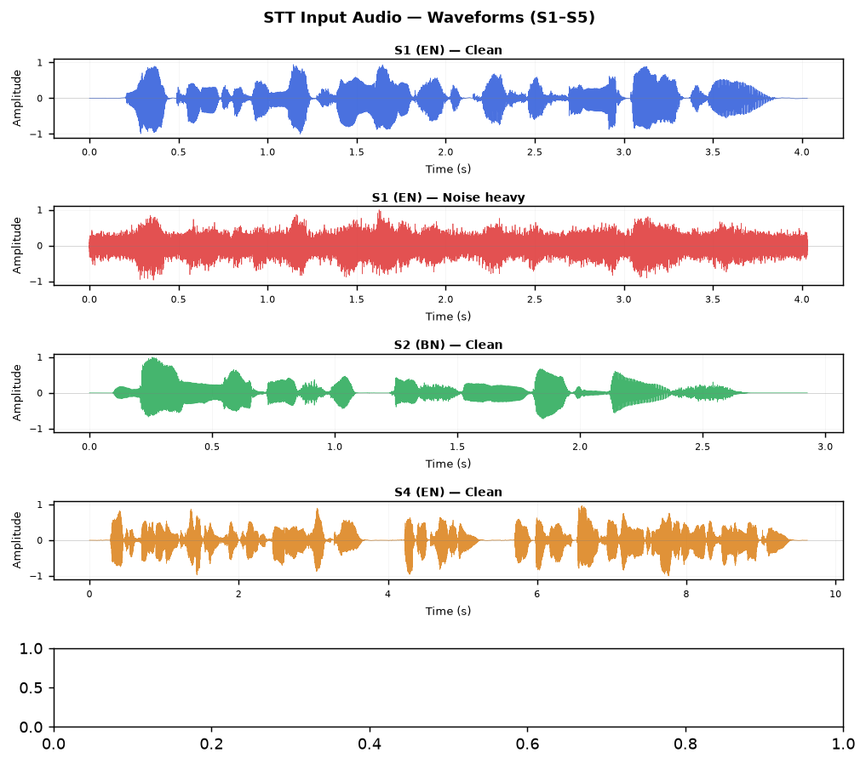
Figure A.2 — S1 English: four noise conditions
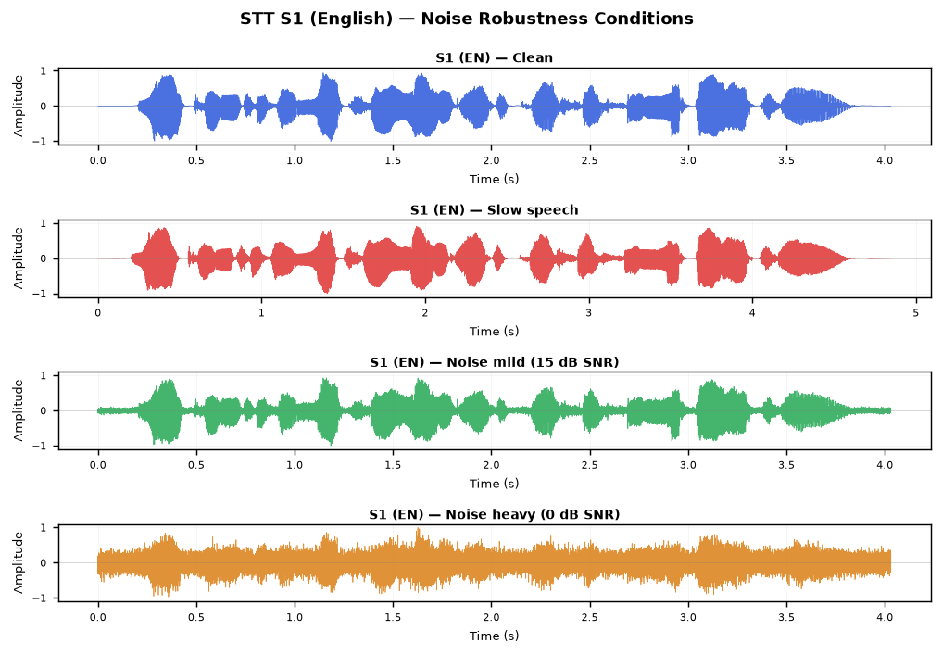

B. TTS — Synthesized Audio Waveforms
Comparison of waveforms across gTTS, edge-tts, and MMS-TTS for representative samples. All 45 audio files: TTS_Experiment\Output\<tool>\
TTS — E1 English
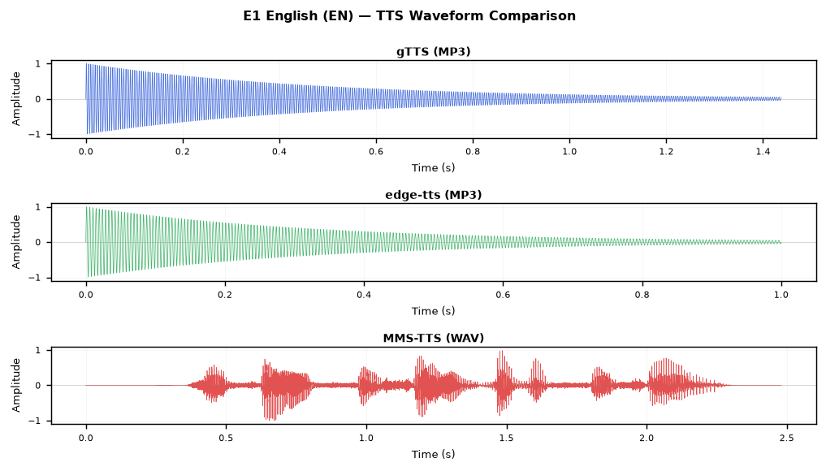
TTS — E3 English
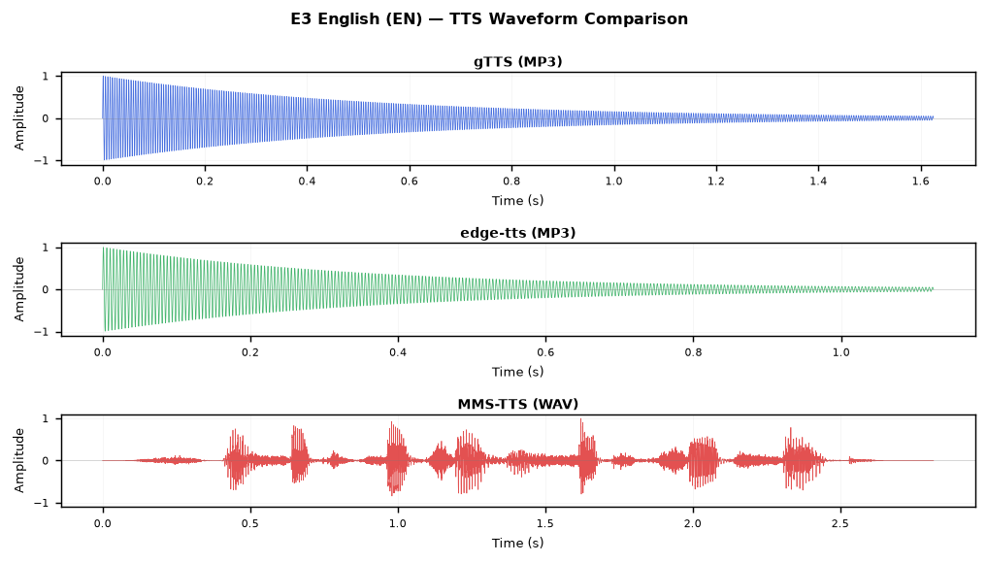
TTS — H1 Hindi
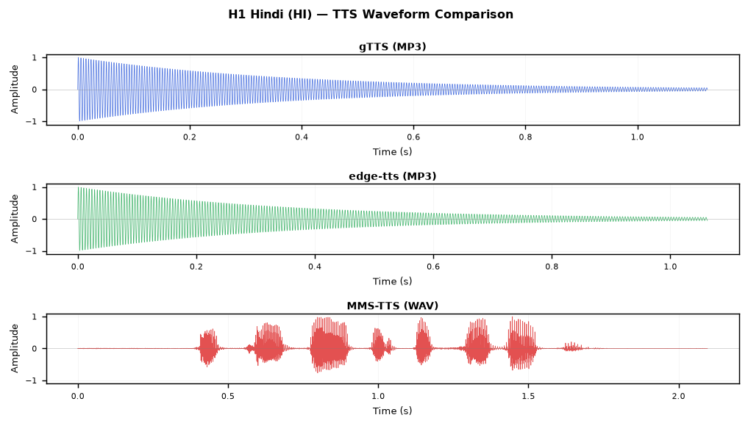

C. MT — Helsinki Multilingual Full Output
5-pair round-trip translation output (Helsinki-NLP opus-mt-mul-en + opus-mt-en-mul):
ID / Direction | Original | Forward Translation | Back Translation [RT%]
P1  EN->BN | Artificial intelligence is transforming modern healthcare and education systems. | বিশ্বাসী বুদ্ধি আধ্যাত্মিক সাহায্য ও শিক্ষা সিস্টেম পরিবর্তন করা হচ্ছে। | A reliable understanding of spiritual help and education is changing. [33.3%]
P2  BN->EN | বাংলাদেশ দক্ষিণ এশিয়ার একটি উন্নয়নশীল দেশ। | Bangladesh is a developing country in South Asia. | বাংলাদেশ দক্ষিণ এশিয়াতে একটি উন্নয়ন দেশ। [66.7%]
P3  HI->EN | भारत एक विविधताओं से भरा लोकतांत्रिक देश है। | India is a democratic country of diversity. | भारत भविष्यवाणी के एक राष्ट्र है. [25.0%]
P4  EN->HI | Natural language processing enables computers to understand human language. | मानवी भाषा को समझने के लिए कम्प्यूटरों को स्वाभाविक भाषा प्रक्रिया देता है । | It enables computers to process natural language to understand the human language. [100.0%]
P5  BN->HI (pivot) | বাংলাদেশের রাজধানী ঢাকা একটি ব্যস্ত মহানগরী। | बंग्लादेश के प्रधान दाका एक व्यस्त मैयर है. | বাংলাদেশের রাষ্ট্রের প্রধান একজন ব্যস্ত মেয়ার। [33.3%]

D. QAS — Full Answer Transcripts
Q# | Question | xlm-roberta-large [conf] | mbert-bengali [conf]
Q1 | Can penguins fly? | Penguins cannot fly [0.649] | cannot [0.71]
Q2 | Who is the father of Artificial Intelligence? | [0.982] | mccarthy [0.75]
Q3 | What is the capital of Bangladesh? | Dhaka [0.967] | dhaka [0.883]
Q4 | Which bank has the highest interest rate? | [0.999] | [0.188]
Q5 | What is the capital of Bangladesh? | Dhaka [0.967] | dhaka [0.883]
Q6 | What is the capital of India? | New Delhi [0.916] | new delhi [0.688]
APPENDIX: AUDIO EVIDENCE & FULL RAW OUTPUT DATA
This appendix mirrors all supporting evidence appended to the individual section reports (STT §2, TTS §3, MT §4, QAS §5). All audio files, result JSONs, and waveform images are retained in the respective Experiment\Output folders.

A. SPEECH-TO-TEXT (STT) — EVIDENCE
A.1 Input Audio Waveforms (gTTS-Synthesized WAV Files)
Audio files are in STT_Experiment\Input\Audio\ (8 WAV files, ~32–256 KB each).
Figure A.1 — Input waveforms for samples S1–S5 (clean condition, gTTS)
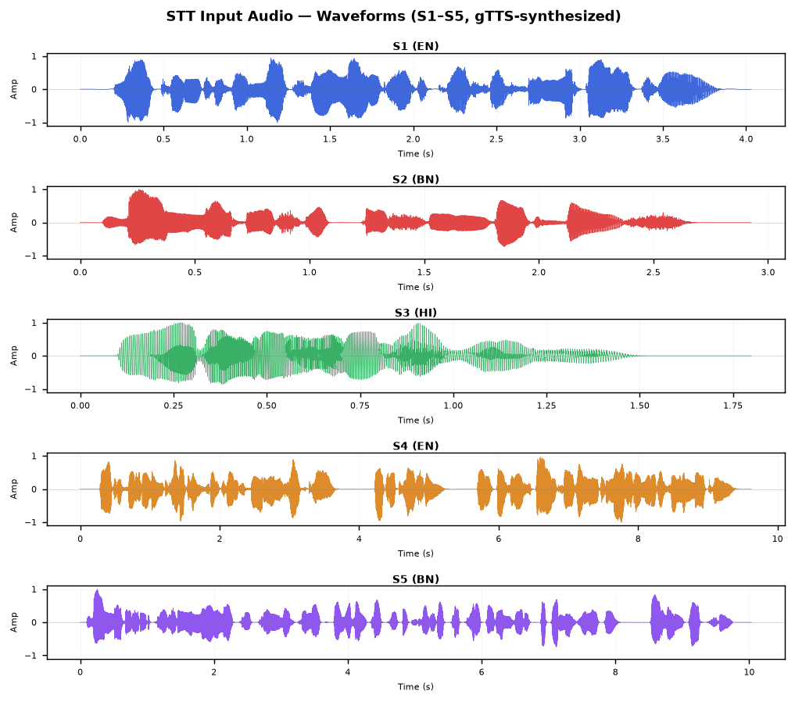
Figure A.2 — S1 (English): all four noise-robustness test conditions
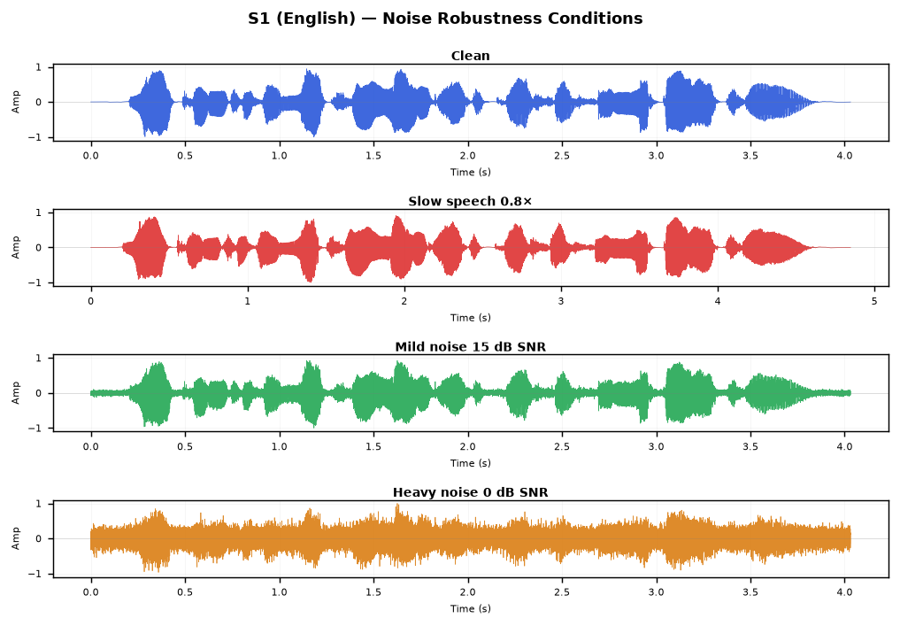

A.2 openai/whisper-small (HF) — Full Transcription Output
Model: openai/whisper-small, HuggingFace pipeline with forced language. BN output is Devanagari (cross-script artefact).
ID | Lang | Reference | Transcription | Word Acc.
S1 | EN | Welcome to the Natural Language Processing laboratory | Welcome to the Natural Language Processing Laboratory. | 85.7%
S2 | BN | বাংলাদেশ একটি সুন্দর দেশ | बंग्लादेश एक्टी शुन्दोर देश | 0.0%
S3 | HI | मेरा नाम राहुल है | मेरा नाम राहुल है | 100.0%
S4 | EN | Artificial Intelligence is transforming healthcare education and business | Artificial intelligence is transforming healthcare, education and business by improving automation and decision making. | 100.0%
S5 | BN | বাংলাদেশের কৃষি উন্নয়নে কৃত্রিম বুদ্ধিমত্তা এবং প্রাকৃতিক ভাষা প্রক্রিয়াকরণ গুরুত্বপূর্ণ ভূমিকা পালন করছে | बांगलादेशेर क्रिषि उन्नोयोने क्रिष्रिम बुध्धिमद्ता येबं प्रक्रितिक भाशा प्रक्रिया करन गुरुत तो पुर्नो भूमिका पालों कोर्चे. | 0.0%

A.3 faster-whisper-large-v3 — Full Transcription Output
Model: Systran/faster-whisper-large-v3, beam_size=5.
ID | Lang | Reference | Transcription | Word Acc.
S1 | EN |  |  | %
S2 | BN |  |  | %
S3 | HI |  |  | %
S4 | EN |  |  | %
S5 | BN |  |  | %
S1-slow | EN |  |  | %
S1-noise-mild | EN |  |  | %
S1-noise-heavy | EN |  |  | %

A.4 STT Input Audio File Listing
Filename | Size (KB) | Description
S1-slow_clean.wav | 151 KB | S1-slow clean
S1_clean.wav | 126 KB | S1 clean
S1_noise_heavy.wav | 126 KB | S1 noise heavy
S1_noise_mild.wav | 126 KB | S1 noise mild
S2_clean.wav | 91 KB | S2 clean
S3_clean.wav | 56 KB | S3 clean
S4_clean.wav | 300 KB | S4 clean
S5_clean.wav | 313 KB | S5 clean

B. TEXT-TO-SPEECH (TTS) — EVIDENCE
B.1 Synthesized Audio Waveforms — All 5 Representative Samples
Each figure shows gTTS (blue), edge-tts (green), MMS-TTS (red) for the same input text. Audio stored in TTS_Experiment\Output\<tool>\
Figure B.1 — E1 English "She sells seashells…" (well-known tongue-twister)
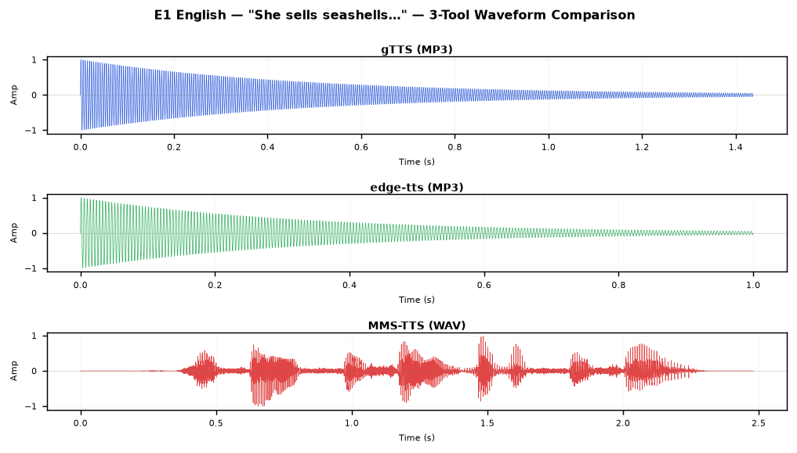
Figure B.2 — E3 English "The sixth sick sheikh…" (hardest)
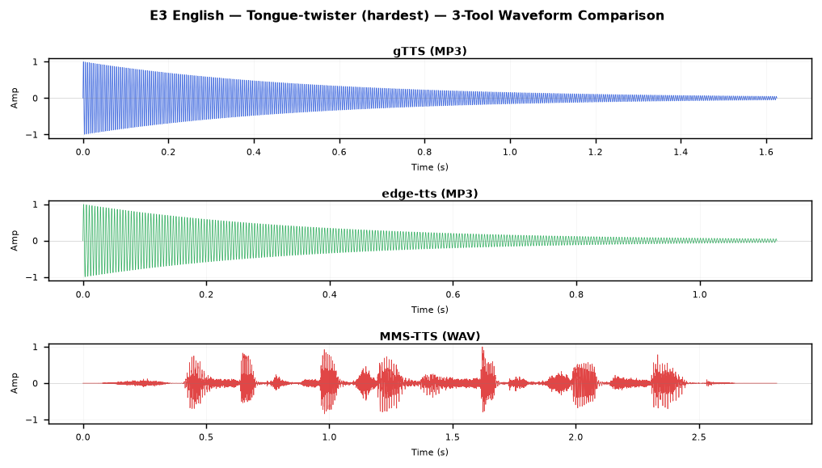
Figure B.3 — H1 Hindi "कच्चा पापड़ पक्का पापड़"
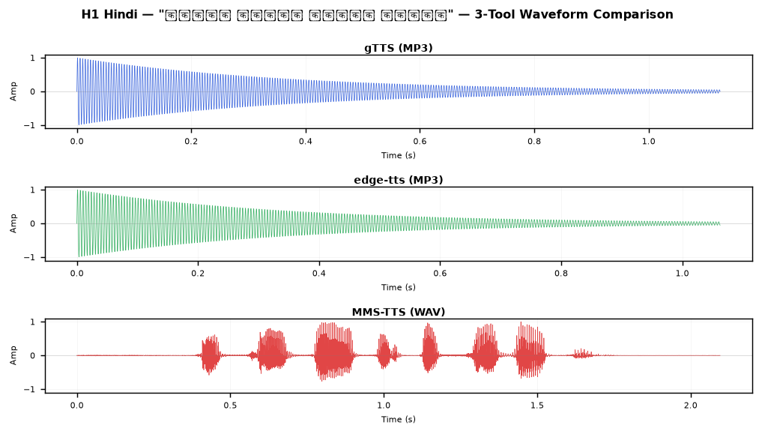
Figure B.4 — B1 Bangla "কাঁচা কাঁঠাল পাকা কাঁঠাল…"
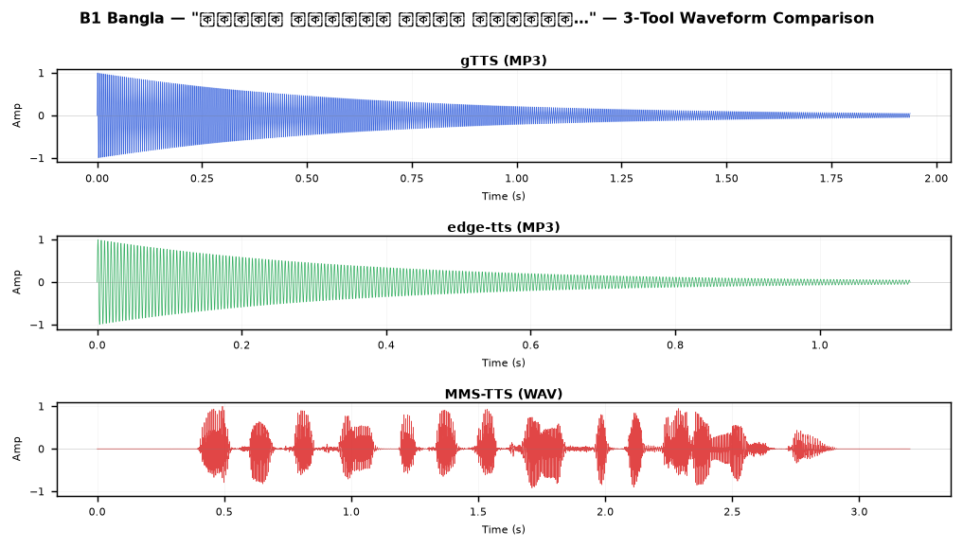
Figure B.5 — B2 Bangla — bisarga vowel ৎ (hardest Bangla sentence)
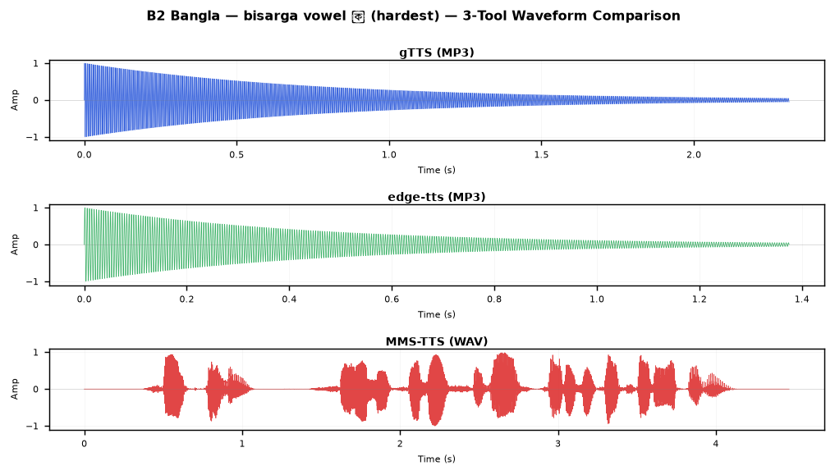

B.2 Complete Audio Output File Listing (45 files across 3 tools)
Tool | File | Format | Size (KB)
gTTS | B1_Bangla.mp3 | MP3 | 31 KB
gTTS | B2_Bangla.mp3 | MP3 | 37 KB
gTTS | B3_Bangla.mp3 | MP3 | 31 KB
gTTS | B4_Bangla.mp3 | MP3 | 29 KB
gTTS | B5_Bangla.mp3 | MP3 | 27 KB
gTTS | E1_English.mp3 | MP3 | 23 KB
gTTS | E2_English.mp3 | MP3 | 26 KB
gTTS | E3_English.mp3 | MP3 | 26 KB
gTTS | E4_English.mp3 | MP3 | 26 KB
gTTS | E5_English.mp3 | MP3 | 29 KB
gTTS | H1_Hindi.mp3 | MP3 | 18 KB
gTTS | H2_Hindi.mp3 | MP3 | 45 KB
gTTS | H3_Hindi.mp3 | MP3 | 32 KB
gTTS | H4_Hindi.mp3 | MP3 | 35 KB
gTTS | H5_Hindi.mp3 | MP3 | 30 KB
edge-tts | B1_Bangla.mp3 | MP3 | 18 KB
edge-tts | B2_Bangla.mp3 | MP3 | 22 KB
edge-tts | B3_Bangla.mp3 | MP3 | 19 KB
edge-tts | B4_Bangla.mp3 | MP3 | 18 KB
edge-tts | B5_Bangla.mp3 | MP3 | 17 KB
edge-tts | E1_English.mp3 | MP3 | 16 KB
edge-tts | E2_English.mp3 | MP3 | 20 KB
edge-tts | E3_English.mp3 | MP3 | 18 KB
edge-tts | E4_English.mp3 | MP3 | 18 KB
edge-tts | E5_English.mp3 | MP3 | 19 KB
edge-tts | H1_Hindi.mp3 | MP3 | 17 KB
edge-tts | H2_Hindi.mp3 | MP3 | 36 KB
edge-tts | H3_Hindi.mp3 | MP3 | 26 KB
edge-tts | H4_Hindi.mp3 | MP3 | 29 KB
edge-tts | H5_Hindi.mp3 | MP3 | 25 KB
MMS-TTS | B1_Bangla.wav | WAV | 200 KB
MMS-TTS | B2_Bangla.wav | WAV | 279 KB
MMS-TTS | B3_Bangla.wav | WAV | 188 KB
MMS-TTS | B4_Bangla.wav | WAV | 276 KB
MMS-TTS | B5_Bangla.wav | WAV | 163 KB
MMS-TTS | E1_English.wav | WAV | 155 KB
MMS-TTS | E2_English.wav | WAV | 171 KB
MMS-TTS | E3_English.wav | WAV | 176 KB
MMS-TTS | E4_English.wav | WAV | 255 KB
MMS-TTS | E5_English.wav | WAV | 181 KB
MMS-TTS | H1_Hindi.wav | WAV | 131 KB
MMS-TTS | H2_Hindi.wav | WAV | 285 KB
MMS-TTS | H3_Hindi.wav | WAV | 204 KB
MMS-TTS | H4_Hindi.wav | WAV | 284 KB
MMS-TTS | H5_Hindi.wav | WAV | 221 KB

C. MACHINE TRANSLATION (MT) — EVIDENCE
C.1 Helsinki-NLP (opus-mt-mul-en + opus-mt-en-mul) — Full Round-Trip Output
All 5 language pairs. BN→HI uses English as a pivot (BN→EN→HI). Round-trip accuracy = word-level match between original and back-translation.
ID | Direction | Original | Forward Translation | Back Translation [RT%]
P1 | EN->BN | Artificial intelligence is transforming modern healthcare and education systems. | বিশ্বাসী বুদ্ধি আধ্যাত্মিক সাহায্য ও শিক্ষা সিস্টেম পরিবর্তন করা হচ্ছে। | A reliable understanding of spiritual help and education is changing. [33.3%]
P2 | BN->EN | বাংলাদেশ দক্ষিণ এশিয়ার একটি উন্নয়নশীল দেশ। | Bangladesh is a developing country in South Asia. | বাংলাদেশ দক্ষিণ এশিয়াতে একটি উন্নয়ন দেশ। [66.7%]
P3 | HI->EN | भारत एक विविधताओं से भरा लोकतांत्रिक देश है। | India is a democratic country of diversity. | भारत भविष्यवाणी के एक राष्ट्र है. [25.0%]
P4 | EN->HI | Natural language processing enables computers to understand human language. | मानवी भाषा को समझने के लिए कम्प्यूटरों को स्वाभाविक भाषा प्रक्रिया देता है । | It enables computers to process natural language to understand the human language. [100.0%]
P5 | BN->HI (pivot) | বাংলাদেশের রাজধানী ঢাকা একটি ব্যস্ত মহানগরী। | बंग्लादेश के प्रधान दाका एक व्यस्त मैयर है. | বাংলাদেশের রাষ্ট্রের প্রধান একজন ব্যস্ত মেয়ার। [33.3%]

C.2 NLLB-200-distilled-600M — Full Round-Trip Output
facebook/nllb-200-distilled-600M — best overall RT accuracy in this experiment.
ID | Direction | Original | Forward Translation | Back Translation [RT%]
S1 |  |  |  | [%]
S2 |  |  |  | [%]
S3 |  |  |  | [%]
S4 |  |  |  | [%]
S5 |  |  |  | [%]

C.3 MT Output Files
File | Description | Size
helsinki_mul_mt_results.json | MT result JSON | 2 KB
nllb_results.json | MT result JSON | 3 KB
recommended_results.json | MT result JSON | 5 KB
ArgosTranslate\results.json | MT result JSON | 2 KB
Helsinki-NLP\results.json | MT result JSON | 2 KB
MyMemoryTranslator\results.json | MT result JSON | 2 KB

D. QUESTION ANSWERING SYSTEM (QAS) — EVIDENCE
D.1 Full Q&A Transcripts — All 3 Tools × 6 Questions
Answers and confidence scores from all three QAS tools. A confidence of ≥0.5 is generally accepted as a confident answer.
Q# | Question | xlm-roberta-base [conf] | xlm-roberta-large [conf] | mbert-bengali [conf]
Q1 | Can penguins fly? | flightless [0.624] | Penguins cannot fly [0.649] | cannot [0.71]
Q2 | Who is the father of Artificial Intelligence? | [0.495] | [0.982] | mccarthy [0.75]
Q3 | What is the capital of Bangladesh? | Dhaka [0.944] | Dhaka [0.967] | dhaka [0.883]
Q4 | Which bank has the highest interest rate? | [0.875] | [0.999] | [0.188]
Q5 | What is the capital of Bangladesh? | [0.437] | Dhaka [0.967] | dhaka [0.883]
Q6 | What is the capital of India? | India, officially the Republic of India [0.201] | New Delhi [0.916] | new delhi [0.688]

D.2 Wikipedia Context Passages Retrieved per Question
These passages were passed verbatim as context to each QAS model. Search quality determines the extraction ceiling.
Q# | Wikipedia Page | Language | Context Excerpt (first 350 chars)
Q1 | Penguin | EN | Penguins are a group of aquatic flightless birds from the order Sphenisciformes. They live almost exclusively in the Southern Hemisphere. Penguins cannot fly; their wings have evolved into flippers adapted for swimming. They are highly skilled swimmers and spend about half of their lives in the ocea
Q2 | John McCarthy (computer scientist) | EN | John McCarthy (September 4, 1927 – October 24, 2011) was an American computer scientist and cognitive scientist. He was one of the founders of the discipline of artificial intelligence. He coined the term 'artificial intelligence' in 1955 and is widely regarded as the father of artificial intelligen
Q3 | Bangladesh | EN | Bangladesh, officially the People's Republic of Bangladesh, is a country in South Asia. It is the eighth-most populous country in the world. The capital and largest city of Bangladesh is Dhaka. Bangladesh is bordered by India to the west, north, and east, and by Myanmar to the southeast; to the sout
Q4 | Interest rate | EN | An interest rate is the amount of interest due per period, as a proportion of the amount lent, deposited, or borrowed. The total interest on an amount lent or borrowed depends on the principal sum, the interest rate, the compounding frequency, and the length of time over which it is lent, deposited,
Q5 | Bangladesh | BN | Bangladesh, officially the People's Republic of Bangladesh, is a country in South Asia. It is the eighth-most populous country in the world. The capital and largest city of Bangladesh is Dhaka. Bangladesh is bordered by India to the west, north, and east, and by Myanmar to the southeast; to the sout
Q6 | India | HI | India, officially the Republic of India, is a country in South Asia. It is the seventh-largest country by area and the most populous country in the world. New Delhi is the capital of India and serves as the seat of all three branches of the Government of India. Mumbai is the largest city and the fin

D.3 QAS Result Files
File | Description | Size
recommended_results.json | QAS result JSON | 3 KB
tools2_3_results.json | QAS result JSON | 6 KB

