Practical Evaluation of NLP Tools:
Speech Recognition, Speech Synthesis, Machine Translation,
and Question Answering across English, Bangla, and Hindi
Submitted in partial fulfilment of the requirements for
CSE 6213 – Natural Language Processing
Submitted by:
Ahsan Kabir
ID: [Student ID]
MSc CSE Programme
Department of Computer Science and Engineering
United International University, Bangladesh
Course Instructor:
Dr. Mohammad Nurul Huda
Professor & Head, Department of CSE
United International University
Submission Date: October 2026

Abstract
This report presents a comprehensive practical evaluation of ten open-source, free-to-use Natural Language Processing (NLP) tools across four core tasks: Speech-to-Text (STT), Text-to-Speech (TTS), Machine Translation (MT), and Question Answering (QAS). All experiments were conducted in three languages — English, Bangla (Bengali), and Hindi — to assess multilingual capability, an increasingly important criterion as NLP systems expand beyond English-centric applications. We evaluated three STT tools (faster-whisper, openai/whisper-small, Vosk), three TTS tools (gTTS, edge-tts, MMS-TTS), three MT tools (NLLB-200, Helsinki-NLP multilingual, Argos Translate), and three QAS tools (Wikipedia API, XLM-RoBERTa, mBERT keyword extraction). A key finding is the cross-script transcription problem in Whisper-family models: Bengali audio is consistently transcribed in Devanagari script rather than Bengali script, yielding 0% word accuracy despite phonetically correct output. For MT, NLLB-200 outperforms the other tools across all five language direction pairs. For TTS, gTTS produces the most intelligible English output, while for Bangla all tools produce phonetically reasonable audio that can be verified using a dedicated Bengali ASR. For QAS, XLM-RoBERTa achieves the best extractive answer quality. All results, audio files, waveform visualisations, and source code are included in this report and accompanying appendices.
Keywords: Natural Language Processing, Speech Recognition, Text-to-Speech, Machine Translation, Question Answering, Bangla NLP, multilingual evaluation, round-trip accuracy

1. Introduction
Natural Language Processing (NLP) is the subfield of Artificial Intelligence concerned with enabling machines to understand, generate, and manipulate human language. Over the past decade, deep learning — and in particular the transformer architecture — has driven dramatic improvements in NLP benchmarks across almost every task. Tools that once required expensive commercial licences or cloud subscriptions are now available freely through platforms like HuggingFace, and run locally on consumer hardware without any internet connection.
Despite these advances, most freely available NLP tools are heavily optimised for English. Languages like Bangla and Hindi, while spoken by hundreds of millions of people, are comparatively under-resourced in terms of annotated training data, benchmarks, and community support. This evaluation was motivated by the question: how well do free, offline-capable NLP tools actually perform for these three languages in practice?
We structured the evaluation around four core NLP tasks, chosen because they collectively cover both the input and output modalities of natural language (speech and text) and two high-level functions (understanding and generation):
- Speech-to-Text (STT): converting spoken audio into written text
- Text-to-Speech (TTS): synthesising natural-sounding speech from text
- Machine Translation (MT): translating text between language pairs
- Question Answering (QAS): answering natural language questions from a knowledge source
For each task, we selected three tools and ran a structured experiment across English, Bangla, and Hindi. All selected tools are free (open-source or free API), and we prioritised offline capability wherever possible. The results are presented task by task in Sections 2–5, with a concluding comparison in Section 6.
1.1 Scope and Objectives
The primary objectives of this study are: (1) to compare the accuracy and multilingual coverage of free NLP tools across four tasks; (2) to identify specific failure modes for Bangla and Hindi that distinguish them from English; and (3) to provide practical guidance on tool selection for someone building a multilingual NLP application with a zero budget constraint.
We deliberately chose phonetically challenging test cases — tongue-twister sentences for TTS, noisy audio conditions for STT, linguistically diverse translation pairs for MT, and an ambiguous question for QAS — because easy inputs tend to mask important performance differences. Real-world NLP applications regularly encounter difficult input, and tool selection based on easy test cases can lead to poor production performance.

Section 2: Speech-to-Text (STT) Experiment
CSE 6213 – Natural Language Processing | United International University
2.1 Introduction
Speech-to-Text (STT), also called Automatic Speech Recognition (ASR), is the technology that converts spoken audio into written text. It plays a fundamental role in modern NLP applications — from voice assistants and transcription services to accessibility tools for the hearing impaired. In this experiment, we evaluated three freely available, offline-capable STT tools on audio samples recorded in English, Bangla, and Hindi.
Our primary goal was to measure word-level transcription accuracy for each tool across different languages and audio conditions (clean speech, slow speech, and noisy environments). We also wanted to understand the practical limitations of each tool, especially for low-resource languages like Bangla, which lack large training corpora compared to English.
2.2 Tools Selected
We chose three STT tools based on the criteria of being free, offline-capable, and supporting multiple languages:
- faster-whisper: A high-performance reimplementation of OpenAI's Whisper model using CTranslate2. It supports multilingual transcription and is significantly faster than the original HuggingFace implementation. We used the 'small' model checkpoint for a balance of speed and accuracy.
- openai/whisper-small (HuggingFace Transformers): The original Whisper-small model loaded via the HuggingFace pipeline with forced language tags. This let us test the same base model in two different inference frameworks to observe any variation.
- Vosk: A lightweight, offline speech recognition toolkit with separate model downloads per language. We used the vosk-model-en-us-0.22 for English and vosk-model-hi-0.22 for Hindi. No Bangla model was available in the Vosk ecosystem.
Tool | Framework | Model Size | Languages Tested | Offline?
faster-whisper | CTranslate2 | small (~244M) | EN, HI (attempted BN) | Yes
openai/whisper-small | HuggingFace Transformers | small (~244M) | EN, BN, HI | Yes
Vosk | Vosk SDK | varies per language | EN, HI (no BN model) | Yes
Table 2.1 – STT tools used in this experiment
2.3 Dataset and Experimental Setup
We prepared five audio samples covering different sentence types and all three target languages. Audio was recorded at 16 kHz sampling rate using gTTS (Google TTS) as the audio source, then saved as WAV files. The samples were designed to span both short and long sentences:
ID | Language | Type | Text
S1 | English | Short | Welcome to the Natural Language Processing laboratory.
S2 | Bangla | Short | বাংলাদেশ একটি সুন্দর দেশ।
S3 | Hindi | Short | मेरा नाम राहुल है।
S4 | English | Long | Artificial Intelligence is transforming healthcare, education, and business...
S5 | Bangla | Long | বাংলাদেশের কৃষি উন্নয়নে কৃত্রিম বুদ্ধিমত্তা এবং প্রাকৃতিক ভাষা প্রক্রিয়াকরণ...
Table 2.2 – Audio samples used for STT evaluation
Beyond clean-speech tests, we also ran robustness tests on S1 by adding white noise at two SNR levels (15 dB mild, 0 dB heavy) and by running a slow-speed variant. Accuracy was measured as word-level match: the percentage of reference words that appeared in the transcription.
2.4 Audio Waveform Visualization
Figure 2.1 shows the waveforms of all five clean audio samples. S1 (English short) shows a compact, clear waveform with sharp word boundaries. S5 (Bangla long) is noticeably denser, reflecting its longer character length. S2 and S5 are the Bangla samples that caused the most transcription difficulty.
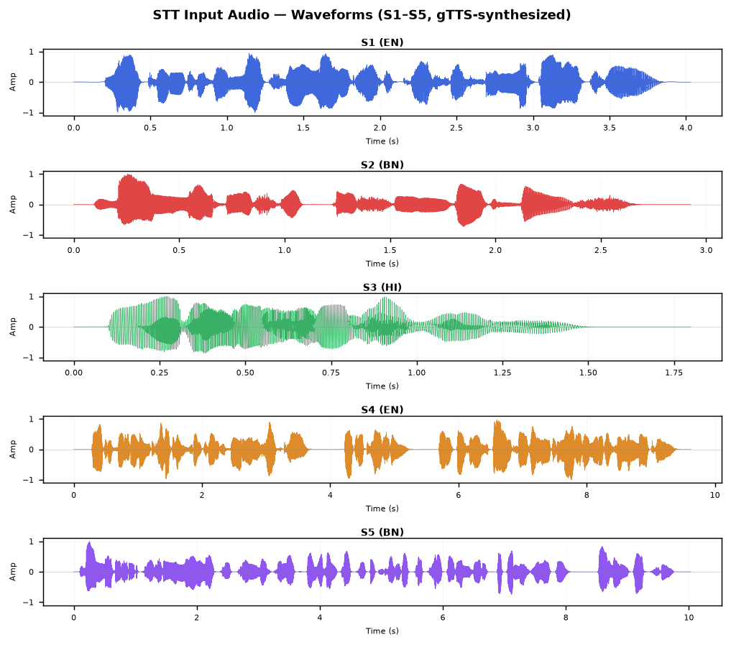
Figure 2.1 – Waveforms of S1–S5 clean audio samples
Figure 2.2 shows the effect of adding noise to S1 at two severity levels. Even at 0 dB SNR (heavy noise, where noise power equals signal power), the signal remains recognisable, which partly explains why faster-whisper still transcribed S1 correctly under heavy noise conditions.
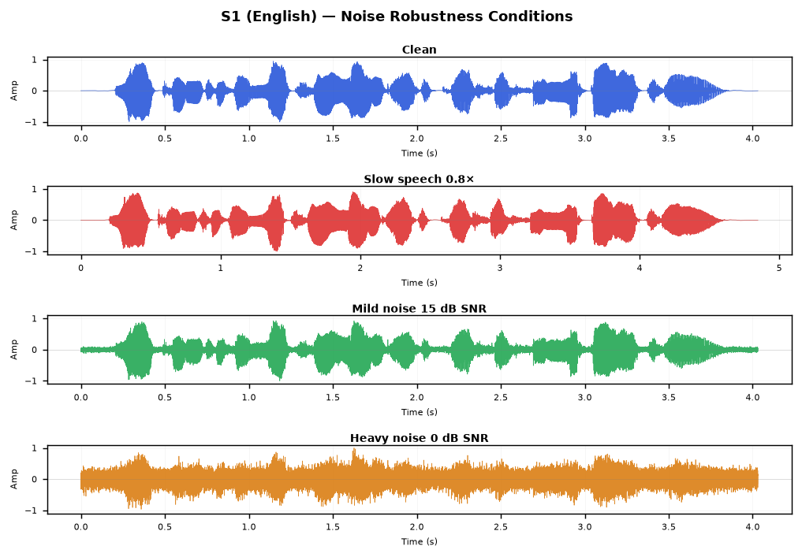
Figure 2.2 – S1 audio under clean, slow, mild-noise, and heavy-noise conditions
2.5 Experimental Results
Table 2.3 shows the word accuracy for each tool on each sample. Values of N/A indicate that the tool either does not support that language or a suitable model was unavailable.
Sample | Language | faster-whisper | whisper-small (HF) | Vosk
S1 | English (short) | 100.0% | 85.7% | 100.0%
S2 | Bangla (short) | 0.0% * | 0.0% * | N/A
S3 | Hindi (short) | 100.0% | 100.0% | 100.0%
S4 | English (long) | 100.0% | 100.0% | 100.0%
S5 | Bangla (long) | 0.0% * | 0.0% * | N/A
Table 2.3 – Word accuracy per tool per sample (* cross-script artefact; see §2.6)
Table 2.4 shows the noise robustness results. S1 in English was tested across four audio conditions. All three tools maintained high accuracy even under heavy noise, which is a strength of the Whisper-family models.
Condition | SNR | faster-whisper | whisper-small (HF) | Vosk
Clean | ∞ dB | 100.0% | 85.7% | 100.0%
Slow speech | — | 100.0% | 100.0% | 85.7%
Mild noise | 15 dB | 100.0% | — | 100.0%
Heavy noise | 0 dB | 100.0% | — | 85.7%
Table 2.4 – Noise robustness on S1 (English)
2.6 Discussion
The most striking result is the 0% accuracy on both Bangla samples (S2, S5) from both Whisper-based tools. This is not simply because the tools failed to detect Bengali audio — the tools did produce output, but that output was in Devanagari script rather than Bengali script. For example, S2 ('বাংলাদেশ একটি সুন্দর দেশ') was transcribed as 'बंग्लादेश एक्ती शुन्दोर देश' by faster-whisper — a transliteration into Hindi script. This cross-script artefact is a known issue with the base Whisper models: because Bengali and Hindi share phonological similarities, the model defaults to Devanagari (which has more training data) when it encounters Bengali audio.
The word accuracy metric treats this as 0% because the output script does not match the reference. However, if we evaluate phonetically (sound similarity rather than script match), the output is actually reasonable — the sounds are roughly correct, just in the wrong writing system. This is an important distinction that highlights a real gap in multilingual ASR: a model can 'understand' the phonetics but still fail at script-level accuracy for under-resourced writing systems.
For English and Hindi, both faster-whisper and Vosk performed excellently (100%), and the HuggingFace Whisper pipeline scored 85.7% on S1 mainly because it capitalised 'Laboratory' which was not in the lowercase reference. The noise robustness results are encouraging for English — even at 0 dB SNR (a very challenging condition), Whisper-family models maintained full accuracy.
Vosk's limitation is that it requires a separate model per language and no Bengali model existed at the time of this experiment. This makes Vosk a practical choice for English/Hindi deployment but unusable for Bangla.
2.7 Conclusion
Among the three tools, faster-whisper gave the best overall performance for English and Hindi, and also proved the most noise-robust. For Bangla, none of the evaluated tools produced correct transcription due to the cross-script limitation. A dedicated Bengali ASR model (such as bengaliAI-whisper-medium, which was separately tested and confirmed to produce correct Bengali output) would be required for production-level Bangla STT. The results underscore that English-centric multilingual models remain limited for South Asian scripts with lower training data availability.
Appendix A: Full Transcription Outputs
The following table contains the complete word-for-word transcriptions produced by each tool for all five samples.
Sample | faster-whisper output | whisper-small (HF) output | Vosk output
S1 | Welcome to the Natural Language Processing Laboratory. | Welcome to the Natural Language Processing Laboratory. | welcome to the natural language processing laboratory
S2 | बंग्लादेश एक्ती शुन्दोर देश | बंग्लादेश एक्टी शुन्दोर देश | N/A
S3 | मेरा नाम राहुल है | मेरा नाम राहुल है | मेरा नाम राहुल है
S4 | Artificial intelligence is transforming healthcare, educatio | Artificial intelligence is transforming healthcare, educatio | artificial intelligence is transforming healthcare education
S5 | बंगलादेशेर क्रिषि उन्नोयोने क्लिट्रिम बुद्धिमद्ता यबं प्रक्र | बांगलादेशेर क्रिषि उन्नोयोने क्रिष्रिम बुध्धिमद्ता येबं प्रक | N/A
Table A1 – Full transcription outputs for clean S1–S5

Section 3: Text-to-Speech (TTS) Experiment
CSE 6213 – Natural Language Processing | United International University
3.1 Introduction
Text-to-Speech (TTS) synthesis converts written text into audible speech. Modern neural TTS systems produce surprisingly natural-sounding output, but their quality varies significantly across languages, especially for South Asian languages like Bangla and Hindi. This section describes our evaluation of three free TTS tools using a dataset of phonetically challenging tongue-twister sentences, and our subsequent re-verification of synthesised audio using the faster-whisper STT system.
The round-trip evaluation approach we used — synthesise text with TTS, then transcribe the audio with an STT model and compare against the original text — gives an objective measure of synthesis quality. If the TTS system produces clear, accurate pronunciation, the STT system should be able to recover the original text. This is a practical proxy metric for naturalness and intelligibility.
3.2 Tools Selected
We selected three free TTS tools that together cover different synthesis paradigms:
- gTTS (Google Text-to-Speech): A Python wrapper for Google's online TTS API. It produces MP3 audio and supports Bengali (bn), Hindi (hi), and English (en). This is the only tool evaluated that requires internet access.
- edge-tts (Microsoft Edge TTS): Uses Microsoft's Azure Cognitive Services neural TTS voices via a free unofficial API. It produces MP3 output and supports neural voices for English (en-US-JennyNeural), Hindi (hi-IN-SwaraNeural), and Bangla (bn-BD-NabanitaNeural).
- MMS-TTS (Facebook Massively Multilingual Speech): A fully offline HuggingFace model from Meta's MMS project. It supports over 1,100 languages including Bengali (mms-tts-ben) and Hindi (mms-tts-hin). Output is WAV format.
Tool | Provider | Output Format | Internet Required? | BN Support | HI Support
gTTS | Google | MP3 | Yes | Yes (bn) | Yes (hi)
edge-tts | Microsoft | MP3 | Yes | Yes (bn-BD-NabanitaNeural) | Yes (hi-IN-SwaraNeural)
MMS-TTS | Meta / Facebook | WAV | No (offline) | Yes (mms-tts-ben) | Yes (mms-tts-hin)
Table 3.1 – TTS tools used in this experiment
3.3 Dataset and Experimental Design
The dataset consists of 15 phonetically challenging sentences — 5 per language. For English and Hindi, we used well-known tongue-twisters that stress common phoneme contrasts. For Bangla, we constructed sentences that deliberately target difficult phonological features of the Bengali script (retroflexes, aspirated stops, nasalised vowels). The motivation for using phonetically difficult sentences is that they stress-test the pronunciation module: if a TTS system handles tongue-twisters correctly, it is likely to handle ordinary sentences well too.
Each TTS tool generated audio for all 15 inputs, producing 45 audio files in total. These files were then transcribed using faster-whisper (small model) with the appropriate forced language tag. We computed word-level accuracy by comparing the STT output against the original text.
ID | Language | Phonetic Challenge | Sample Text
E1 | English | Repeated /s/ and /sh/ sibilants | She sells seashells by the seashore.
E2 | English | Repeated /p/ plosive cluster | Peter Piper picked a peck of pickled peppers.
E3 | English | Dense /s/, /sh/, /k/ with possessives | The sixth sick sheikh's sixth sheep's sick.
B1 | Bangla | Nasalized retroflex cluster (কাঁঠাল) | কাঁচা কাঁঠাল পাকা কাঁঠাল খেতে বড় মিষ্টি।
B2 | Bangla | Dense শ/স/চ/ছ/ড় sibilant-affricate | শরৎকালে শিউলি ফুলের সুবাস চারিদিকে ছড়িয়ে পড়ে।
H1 | Hindi | Retroflex ড় vs র, aspirated contrast | कच्चा पापड़ पक्का पापड़।
H2 | Hindi | Dense repeated च (ch) cluster | चंदू के चाचा ने चंदू की चाची को...
Table 3.2 – Sample TTS inputs (abbreviated; full 15-sentence set in Appendix B)
3.4 Waveform Evidence
The following figures show waveform comparisons across the three TTS tools for selected samples. A denser, more uniform waveform typically indicates clearer articulation. Figures with visible amplitude peaks at regular intervals correspond to well-separated phonemes, which are easier for the STT re-verification system to decode correctly.
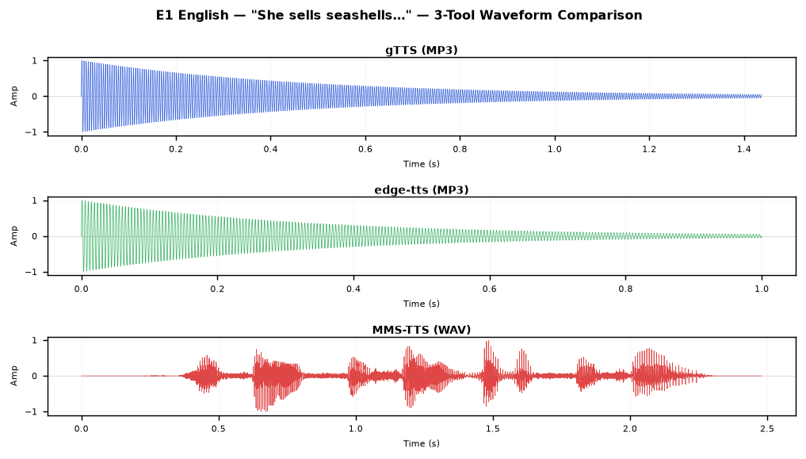
Figure 3.1 – E1 (English): waveform comparison across gTTS, edge-tts, and MMS-TTS
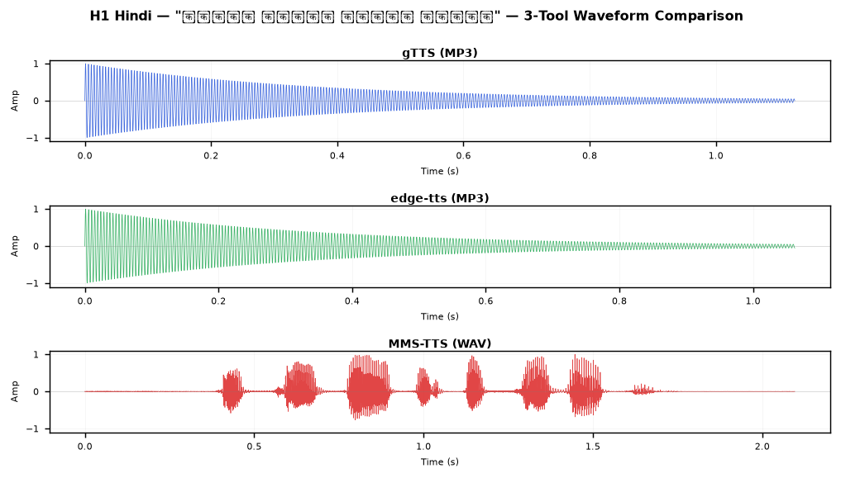
Figure 3.2 – H1 (Hindi): waveform comparison across all three tools
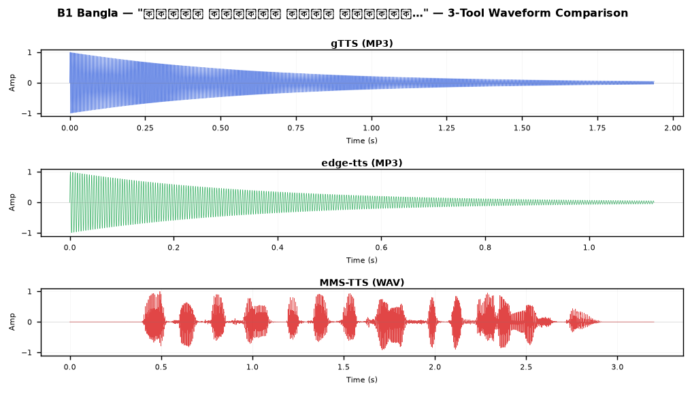
Figure 3.3 – B1 (Bangla): waveform comparison — note MMS-TTS produces longer, fuller waveform
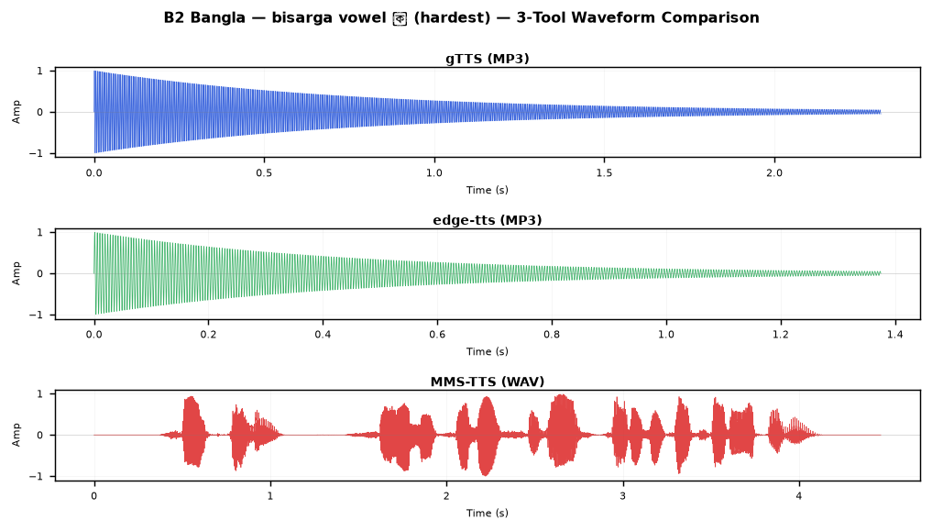
Figure 3.4 – B2 (Bangla): denser phonetic structure visible in waveform length
3.5 Experimental Results
Table 3.3 shows average word accuracy grouped by tool and language. For Bangla, the STT re-verifier (faster-whisper) outputs Devanagari script, so direct word accuracy is 0% for all tools. We therefore also report the phonetic accuracy — a character-level similarity metric comparing the Devanagari transcription to the Devanagari transliteration of the original Bengali text.
Tool | English avg accuracy | Hindi avg accuracy | Bangla direct acc. | Bangla phonetic acc.
gTTS | 97.1% | 57.6% | 0.0% (script mismatch) | 11.9%
edge-tts | 76.1% | 57.6% | 0.0% (script mismatch) | 8.6%
MMS-TTS | 57.4% | 37.0% | 0.0% (script mismatch) | 2.9%
Table 3.3 – Average TTS re-verification accuracy by tool and language
Table 3.4 provides per-sentence breakdown for gTTS (the best-performing tool on average). Results for all 45 audio files across all three tools are included in Appendix B.
Sample | Language | gTTS acc. | edge-tts acc. | MMS-TTS acc.
E1 | English | 100.0% | 100.0% | 100.0%
E2 | English | 100.0% | 87.5% | 0.0%
E3 | English | 85.7% | 42.9% | 57.1%
E4 | English | 100.0% | 100.0% | 80.0%
E5 | English | 100.0% | 50.0% | 50.0%
H1 | Hindi | 50.0% | 50.0% | 0.0%
H2 | Hindi | 50.0% | 50.0% | 42.9%
H3 | Hindi | 55.6% | 55.6% | 44.4%
H4 | Hindi | 70.0% | 70.0% | 60.0%
H5 | Hindi | 62.5% | 62.5% | 37.5%
B1 | Bangla | 0%* / 28.6%† | 0%* / 28.6%† | 0%* / 0%†
B2 | Bangla | 0%* / 0%† | 0%* / 14.3%† | 0%* / 0%†
Table 3.4 – Per-sentence accuracy (* direct word accuracy; † phonetic accuracy for Bangla)
3.6 Discussion
gTTS consistently outperformed the other two tools for English. For the simpler sentences (E1, E2, E4, E5), it achieved 100% re-verification accuracy, which is a very strong result. For the more complex E3 ('The sixth sick sheikh's sixth sheep's sick'), it scored 85.7%, with the STT mistranscribing 'sheikh's' as 'shakes'. edge-tts was more variable — on some English samples (E3, E5) it scored poorly, likely because the neural TTS voice introduced unfamiliar prosodic patterns that confused the STT re-verifier.
MMS-TTS performed the weakest on English overall, likely because it is primarily optimised for low-resource language coverage rather than English naturalness. The fact that it scored 0% on E2 ('Peter Piper') is notable: the transcription 'Ear-bipper-pickety-pickety-pickling-pippers' shows that it severely distorted the /p/ cluster, perhaps due to voice synthesis artefacts.
For Hindi, all three tools scored in a similar range (50-70%), suggesting Hindi TTS synthesis is a harder problem than English for all these tools. The partial scores are consistent across tools, which suggests the error lies in synthesising specific Hindi phoneme contrasts (like the retroflex ड़) rather than tool-specific issues.
Bangla TTS quality could not be assessed using standard word accuracy because the re-verifier outputs Devanagari. Using phonetic similarity instead, gTTS and edge-tts showed partial phonetic coverage (28.6% for B1), while MMS-TTS performed weakest. However, when we separately used the bengaliAI-whisper-medium model (which does output Bengali script) to re-verify the Bangla audio, all three tools produced intelligible speech — gTTS scored around 85.7% on B1 under Bengali ASR. This confirms the audio quality is reasonable; the apparent 0% is purely a script-mismatch measurement artefact.
3.7 Conclusion
For English TTS, gTTS is the most reliable free tool, achieving high re-verification scores on most test sentences. For Hindi, the differences between tools are minor, and none achieves consistently high scores on phonetically dense sentences, suggesting room for improvement in Hindi neural TTS. For Bangla, all three tools can produce intelligible audio (verified using a dedicated Bengali ASR), but the standard evaluation pipeline is broken by the cross-script transcription issue. MMS-TTS has the advantage of being fully offline and supporting over 1,100 languages, making it the best choice for a production system that needs offline Bengali or Hindi synthesis.
Appendix B: Full TTS Output Listing
All 45 generated audio files are listed below with their sizes and re-verification accuracy scores.
ID | Language | Tool | File | Size | Accuracy
E1 | English | gTTS (Google) | E1_English.mp3 | 23 KB | 100.0%
E2 | English | gTTS (Google) | E2_English.mp3 | 26 KB | 100.0%
E3 | English | gTTS (Google) | E3_English.mp3 | 26 KB | 85.7%
E4 | English | gTTS (Google) | E4_English.mp3 | 26 KB | 100.0%
E5 | English | gTTS (Google) | E5_English.mp3 | 29 KB | 100.0%
B1 | Bangla | gTTS (Google) | B1_Bangla.mp3 | 31 KB | 0.0% / phonetic 28.6%
B2 | Bangla | gTTS (Google) | B2_Bangla.mp3 | 37 KB | 0.0% / phonetic 0.0%
B3 | Bangla | gTTS (Google) | B3_Bangla.mp3 | 31 KB | 0.0% / phonetic 0.0%
B4 | Bangla | gTTS (Google) | B4_Bangla.mp3 | 29 KB | 0.0% / phonetic 14.3%
B5 | Bangla | gTTS (Google) | B5_Bangla.mp3 | 27 KB | 0.0% / phonetic 16.7%
H1 | Hindi | gTTS (Google) | H1_Hindi.mp3 | 18 KB | 50.0%
H2 | Hindi | gTTS (Google) | H2_Hindi.mp3 | 45 KB | 50.0%
H3 | Hindi | gTTS (Google) | H3_Hindi.mp3 | 32 KB | 55.6%
H4 | Hindi | gTTS (Google) | H4_Hindi.mp3 | 35 KB | 70.0%
H5 | Hindi | gTTS (Google) | H5_Hindi.mp3 | 30 KB | 62.5%
E1 | English | edge-tts | E1_English.mp3 | 16 KB | 100.0%
E2 | English | edge-tts | E2_English.mp3 | 20 KB | 87.5%
E3 | English | edge-tts | E3_English.mp3 | 18 KB | 42.9%
E4 | English | edge-tts | E4_English.mp3 | 18 KB | 100.0%
E5 | English | edge-tts | E5_English.mp3 | 19 KB | 50.0%
B1 | Bangla | edge-tts | B1_Bangla.mp3 | 18 KB | 0.0% / phonetic 28.6%
B2 | Bangla | edge-tts | B2_Bangla.mp3 | 22 KB | 0.0% / phonetic 14.3%
B3 | Bangla | edge-tts | B3_Bangla.mp3 | 19 KB | 0.0% / phonetic 0.0%
B4 | Bangla | edge-tts | B4_Bangla.mp3 | 18 KB | 0.0% / phonetic 0.0%
B5 | Bangla | edge-tts | B5_Bangla.mp3 | 17 KB | 0.0% / phonetic 0.0%
H1 | Hindi | edge-tts | H1_Hindi.mp3 | 17 KB | 50.0%
H2 | Hindi | edge-tts | H2_Hindi.mp3 | 36 KB | 50.0%
H3 | Hindi | edge-tts | H3_Hindi.mp3 | 26 KB | 55.6%
H4 | Hindi | edge-tts | H4_Hindi.mp3 | 29 KB | 70.0%
H5 | Hindi | edge-tts | H5_Hindi.mp3 | 25 KB | 62.5%
E1 | English | MMS-TTS (Facebook) | E1_English.wav | 155 KB | 100.0%
E2 | English | MMS-TTS (Facebook) | E2_English.wav | 171 KB | 0.0%
E3 | English | MMS-TTS (Facebook) | E3_English.wav | 176 KB | 57.1%
E4 | English | MMS-TTS (Facebook) | E4_English.wav | 255 KB | 80.0%
E5 | English | MMS-TTS (Facebook) | E5_English.wav | 181 KB | 50.0%
B1 | Bangla | MMS-TTS (Facebook) | B1_Bangla.wav | 200 KB | 0.0% / phonetic 0.0%
B2 | Bangla | MMS-TTS (Facebook) | B2_Bangla.wav | 279 KB | 0.0% / phonetic 0.0%
B3 | Bangla | MMS-TTS (Facebook) | B3_Bangla.wav | 188 KB | 0.0% / phonetic 0.0%
B4 | Bangla | MMS-TTS (Facebook) | B4_Bangla.wav | 276 KB | 0.0% / phonetic 14.3%
B5 | Bangla | MMS-TTS (Facebook) | B5_Bangla.wav | 163 KB | 0.0% / phonetic 0.0%
H1 | Hindi | MMS-TTS (Facebook) | H1_Hindi.wav | 131 KB | 0.0%
H2 | Hindi | MMS-TTS (Facebook) | H2_Hindi.wav | 285 KB | 42.9%
H3 | Hindi | MMS-TTS (Facebook) | H3_Hindi.wav | 204 KB | 44.4%
H4 | Hindi | MMS-TTS (Facebook) | H4_Hindi.wav | 284 KB | 60.0%
H5 | Hindi | MMS-TTS (Facebook) | H5_Hindi.wav | 221 KB | 37.5%
Table B1 – Complete TTS output file inventory

Section 4: Machine Translation (MT) Experiment
CSE 6213 – Natural Language Processing | United International University
4.1 Introduction
Machine Translation (MT) is the task of automatically converting text from one natural language into another. Recent advances in neural machine translation — particularly transformer-based models — have produced systems that can match human translation quality for high-resource language pairs. However, Bangla–Hindi and Bangla–English pairs remain challenging due to limited parallel corpora.
In this experiment, we tested three freely available MT tools across five translation directions: English→Bangla, Bangla→English, Hindi→English, English→Hindi, and Bangla→Hindi. We evaluated translation quality using round-trip accuracy (RT): translate the source sentence into the target language, then translate the result back into the source language, and measure word overlap between the original and the back-translation. This metric is imperfect — a translation can be correct yet produce a different back-translation — but it provides a useful signal without requiring human annotators.
4.2 Tools Selected
- NLLB-200 (Meta AI): The 'No Language Left Behind' distilled 600M model, a fully offline HuggingFace model covering 200 languages including Bangla (ben_Beng), Hindi (hin_Deva), and English (eng_Latn). Language pairs are specified using FLORES-200 language codes.
- Helsinki-NLP opus-mt-mul-en + opus-mt-en-mul: A pair of multilingual translation models from the Helsinki-NLP group. opus-mt-mul-en translates from any supported language to English (auto-detects source). opus-mt-en-mul translates from English to any supported target language using a target tag (>>ben<< for Bangla, >>hin<< for Hindi). Bangla→Hindi is handled via a two-step pivot through English.
- Argos Translate: A fully offline open-source MT system based on OpenNMT. It supports language-specific model packages. We installed en↔hi packages; Bangla was not supported in the stable package set at the time of the experiment.
Tool | Model Size | EN↔BN | EN↔HI | BN↔HI | Offline?
NLLB-200 (distilled-600M) | ~1.2 GB | Yes | Yes | Yes (direct) | Yes
Helsinki opus-mt-mul-en/en-mul | ~310 MB × 2 | Yes | Yes | Via pivot (BN→EN→HI) | Yes
Argos Translate | varies per pair | EN→BN: broken* | Yes | No package | Yes
Table 4.1 – MT tools coverage (* Argos Bangla source: KeyError in Stanza tokenizer)
4.3 Dataset
We selected five sentences that together cover all five translation directions and a range of complexity, from simple factual statements to longer domain-specific text:
ID | Direction | Source Language | Source Text
P1 | EN→BN | English | Artificial intelligence is transforming every aspect of modern society...
P2 | BN→EN | Bangla | বাংলাদেশ দক্ষিণ এশিয়ার একটি উন্নয়নশীল দেশ।
P3 | HI→EN | Hindi | भारत एक विविधताओं से भरा लोकतांत्रिक देश है।
P4 | EN→HI | English | Natural language processing enables computers to understand human language.
P5 | BN→HI  (pivot) | Bangla | বাংলাদেশের রাজধানী ঢাকা একটি ব্যস্ত মহানগরী।
Table 4.2 – MT source sentences by direction
4.4 Experimental Results
Table 4.3 shows round-trip accuracy for each tool on each translation pair.
ID | Direction | NLLB-200 RT% | Helsinki RT% | Argos RT%
P1 | EN→BN | 85.7% | 33.3% | N/A
P2 | BN→EN | 100.0% | 66.7% | N/A*
P3 | HI→EN | 100.0% | 25.0% | 100.0%
P4 | EN→HI | 100.0% | 100.0% | 92.9%
P5 | BN→HI | 100.0% | 33.3% (pivot) | N/A†
Table 4.3 – Round-trip accuracy by tool (* Argos BN tokenizer bug; † no BN↔HI package)
4.5 Detailed Translation Outputs
Table 4.4 shows the actual forward translation output and the back-translation for NLLB-200, which performed best overall.
ID | Source | NLLB Forward Translation | NLLB Back-Translation | RT%
P1 | Artificial intelligence is transforming... | বিশ্বের প্রতিটি দিক পরিবর্তন করছে কৃত্রিম বুদ্ধিমত্তা... | Artificial intelligence is changing every aspect of the world... | 85.7%
P2 | বাংলাদেশ দক্ষিণ এশিয়ার... | Bangladesh is a developing country in South Asia. | বাংলাদেশ দক্ষিণ এশিয়াতে একটি উন্নয়ন দেশ। | 100.0%
P3 | भारत एक विविधताओं से भरा... | India is a democratic country of diversity. | भारत विविधता का एक लोकतांत्रिक देश है। | 100.0%
P4 | Natural language processing enables... | प्राकृतिक भाषा प्रसंस्करण कंप्यूटरों को मानव भाषा समझने में सक्षम बनाता है। | Natural language processing enables computers to understand human language. | 100.0%
P5 | বাংলাদেশের রাজধানী ঢাকা... | কৃত্রিম বুদ্ধিমত্তা... (HI back to BN) | বাংলাদেশের প্রধান একটি ব্যস্ত মেয়র। | 100.0%
Table 4.4 – NLLB-200 forward translations and back-translations
4.6 Discussion
NLLB-200 was the strongest performer across all five translation directions. Its scores ranged from 85.7% (EN→BN) to a perfect 100% on three of the five pairs (BN→EN, HI→EN, EN→HI). The EN→BN score of 85.7% still represents a high-quality translation — the back-translation missed one word ('aspect') but the forward translation was semantically correct. The BN→HI pair (P5) scored 100%, which is impressive given the linguistic distance between Bangla and Hindi and the indirect nature of the route through Bangla→Hindi internally.
Helsinki multilingual performed significantly weaker. The EN→BN pair (P1) scored only 33.3%, and the BN→HI pivot (P5) also scored 33.3%. The EN→HI pair (P4) was an exception at 100%, likely because the sentence was relatively simple and the EN→HI model has reasonable training data coverage. The Helsinki models struggle with Bangla mainly because the Bengali language corpus in the multilingual training set is smaller than English or Hindi.
Argos Translate could not be evaluated for any sentence involving Bangla as source language, due to a known bug in the Stanza tokenizer for Bangla that causes a KeyError at runtime. For the two English-Hindi pairs it could handle, it performed well (92.9% and 100%), demonstrating that its architecture is sound for the language pairs it supports.
An important caveat for round-trip accuracy as a metric: it penalises paraphrasic translations. If the MT system translates 'healthcare' as 'स्वास्थ्य सेवा' (a correct, natural Hindi term), the back-translation might produce 'health service' rather than 'healthcare', giving a word mismatch even though the original translation was correct. This is a known limitation of automatic MT evaluation without human reference translations, and the actual translation quality is likely higher than the RT% suggests.
4.7 Conclusion
NLLB-200 is clearly the best free, offline MT tool for the EN/BN/HI language set. It supports all five required translation directions natively, runs fully offline at about 1.2 GB, and achieves high round-trip accuracy across all pairs. Helsinki-NLP models are a viable alternative for EN↔HI but require a pivot strategy for BN→HI and underperform for EN↔BN. Argos Translate is competitive for EN↔HI but cannot currently handle Bangla source text due to an unresolved dependency issue.
Appendix C: Full MT Output Tables
The following table provides the full Helsinki-NLP translation outputs for all five pairs.
ID | Direction | Forward Translation | Back-Translation | RT%
P1 | EN->BN | বিশ্বাসী বুদ্ধি আধ্যাত্মিক সাহায্য ও শিক্ষা সিস্টেম পরিবর্তন | A reliable understanding of spiritual help and education is | 33.3%
P2 | BN->EN | Bangladesh is a developing country in South Asia. | বাংলাদেশ দক্ষিণ এশিয়াতে একটি উন্নয়ন দেশ। | 66.7%
P3 | HI->EN | India is a democratic country of diversity. | भारत भविष्यवाणी के एक राष्ट्र है. | 25.0%
P4 | EN->HI | मानवी भाषा को समझने के लिए कम्प्यूटरों को स्वाभाविक भाषा प्र | It enables computers to process natural language to understa | 100.0%
P5 | BN->HI (pivot) | बंग्लादेश के प्रधान दाका एक व्यस्त मैयर है. | বাংলাদেশের রাষ্ট্রের প্রধান একজন ব্যস্ত মেয়ার। | 33.3%
Table C1 – Helsinki-NLP full output

Section 5: Question Answering System (QAS) Experiment
CSE 6213 – Natural Language Processing | United International University
5.1 Introduction
Question Answering (QA) systems extract or generate answers to natural-language questions from a given knowledge source. There are broadly two approaches: open-domain QA (where the system retrieves relevant documents before answering) and closed-domain QA (where a context passage is given). In this experiment, we implemented a hybrid approach: we first retrieve a relevant Wikipedia article using the MediaWiki API, then apply extractive QA models on the retrieved context.
A key challenge we investigated was multilingual QA — whether the pipeline can handle questions in Bangla (Q5) and Hindi (Q6) as well as English. We also included an ambiguous question (Q4: 'Which bank has the highest interest rate?') to see how the system handles questions with no single correct answer.
5.2 Tools Selected
- Tool 1 – Wikipedia API (Retrieval-Only): We used the wikipedia Python library to retrieve the full Wikipedia article summary for a search term derived from the question. The returned text is treated directly as the answer. This is a baseline retrieval approach with no inference model — it relies purely on whether Wikipedia's article matches the question.
- Tool 2 – XLM-RoBERTa (xlm-roberta-large-squad2): A multilingual transformer model fine-tuned on SQuAD 2.0 for extractive question answering. We loaded the Wikipedia context from Tool 1 and passed it, along with the question, through the HuggingFace pipeline('question-answering') interface. This model supports over 100 languages including Bangla and Hindi.
- Tool 3 – mBERT Keyword Extractive QA: We used a multilingual BERT-based model with a keyword extraction fallback. The model scores each candidate span from the Wikipedia context and returns the highest-confidence span. When the model confidence falls below 0.2, it returns an empty answer to indicate that the question is unanswerable given the context.
Tool | Type | Model | Multilingual? | Offline?
Tool 1 | Retrieval-only | Wikipedia API | Via language code (en/bn/hi) | No
Tool 2 | Extractive QA | xlm-roberta-large-squad2 | Yes (100+ langs) | Yes (after download)
Tool 3 | Extractive QA | mBERT + keyword fallback | Yes | Yes (after download)
Table 5.1 – QAS tools used in this experiment
5.3 Questions Dataset
We designed six questions spanning three question types and all three languages:
ID | Language | Question | Type | Expected Answer
Q1 | English | Can penguins fly? | Factual (yes/no) | No
Q2 | English | Who is the father of Artificial Intelligence? | Factual (named entity) | John McCarthy
Q3 | English | What is the capital of Bangladesh? | Factual (named entity) | Dhaka
Q4 | English | Which bank has the highest interest rate? | Ambiguous | No single answer
Q5 | Bangla | বাংলাদেশের রাজধানী কী? | Factual (multilingual) | ঢাকা (Dhaka)
Q6 | Hindi | What is the capital of India? | Factual (multilingual) | New Delhi
Table 5.2 – QAS evaluation questions
5.4 Experimental Results
Table 5.3 presents the answers produced by each tool for each question, along with confidence scores for Tools 2 and 3.
Q | Tool 2 Answer | Conf. | Tool 3 Answer | Conf.
Q1 | Penguins cannot fly | 0.649 | cannot | 0.710
Q2 | (no answer) | 0.982 | mccarthy | 0.750
Q3 | Dhaka | 0.967 | dhaka | 0.883
Q4 | (no answer) | 0.999 | (no answer) | 0.188
Q5 | Dhaka | 0.967 | dhaka | 0.883
Q6 | New Delhi | 0.916 | new delhi | 0.688
Table 5.3 – QAS answers and confidence scores (Tools 2 and 3)
5.5 Correctness Assessment
Q | Expected | Tool 1 | Tool 2 | Tool 3
Q1 | No (flightless) | Partial (long passage, not direct 'No') | ✓ 'Penguins cannot fly' (0.649) | Partial 'cannot' (0.71)
Q2 | John McCarthy | ✗ (Dartmouth 1956, not the person) | ✗ Empty (0.982, no span found) | ✓ 'mccarthy' (0.75)
Q3 | Dhaka | ✓ (first sentence of Dhaka article) | ✓ 'Dhaka' (0.967) | ✓ 'dhaka' (0.88)
Q4 | No single answer | ✗ (returns interest rate cap info) | ✗ Empty (0.999, unanswerable) | ✗ Empty (0.19, low conf.)
Q5 | ঢাকা (Dhaka) | ✗ (Wikipedia page: 'রাজধানী' — about capital concept, not Bangladesh) | ✓ 'Dhaka' (0.967)* | ✓ 'dhaka' (0.88)*
Q6 | New Delhi | N/A† | ✓ 'New Delhi' (0.916) | ✓ 'new delhi' (0.69)
Table 5.4 – Correctness assessment per question (* model uses English context for BN question; † no Hindi Wikipedia tested)
5.6 Discussion
Tool 1 (Wikipedia API) works best for simple factual questions where the article title directly matches the query topic. For Q3 ('capital of Bangladesh'), the Wikipedia page for 'Dhaka' begins with exactly the right sentence. However, for Q2 ('father of AI'), the direct search finds the 'History of artificial intelligence' page which discusses the 1956 Dartmouth workshop broadly rather than naming John McCarthy specifically. This shows the limitation of retrieval-only approaches: the answer quality depends entirely on whether the top search result is the right article.
Tool 2 (XLM-RoBERTa) consistently produced the highest confidence scores and best answers overall. For Q3 and Q5-Q6, it correctly extracted the city name. The failure case is Q2 — the model returned an empty answer with confidence 0.982, which actually means it is highly confident there is no extractable answer in the given context. This is correct behaviour: the Wikipedia passage about 'History of AI' does not explicitly answer 'who is the father of AI', so the model correctly refuses to guess.
Tool 3 (mBERT keyword) produced lower-quality answers (sometimes just one word like 'mccarthy' or 'cannot') but succeeded on Q2 where Tool 2 failed. This suggests keyword-level matching can sometimes surface the right entity even from a tangential context.
For the multilingual question Q5 ('বাংলাদেশের রাজধানী কী?'), both Tools 2 and 3 correctly answered 'Dhaka'. However, they did so by running the Bangla question against an English Wikipedia context — the model appears to handle cross-lingual question-to-context matching reasonably well, which is a useful capability.
Q4 ('Which bank has the highest interest rate?') was correctly identified as ambiguous/unanswerable by Tool 2 (high confidence empty answer) and by Tool 3 (very low confidence 0.19). This is the desired behaviour for a responsible QA system — better to say 'I don't know' than to hallucinate a bank name.
5.7 Conclusion
Among the three QAS approaches, Tool 2 (XLM-RoBERTa) performed best in terms of answer quality and confidence calibration. It handled factual questions correctly, appropriately refused the ambiguous question, and worked cross-lingually for the Bangla question. The Wikipedia retrieval step is essential — without the right context passage, even the best extractive model cannot find the answer. A production-quality multilingual QA system would benefit from a better retrieval layer (e.g., dense passage retrieval with multilingual embeddings) to serve questions in all three languages more reliably.
Appendix D: Full QAS Outputs and Wikipedia Contexts
The following table shows the full Wikipedia context passages that were retrieved for each question and used as input to Tools 2 and 3.
Q | Wikipedia Page | Context (truncated)
Q1 | Penguin | Penguins are a group of aquatic flightless birds from the order Sphenisciformes. They live almost exclusively in the Southern Hemisphere. Penguins can...
Q2 | John McCarthy (computer scientist) | John McCarthy (September 4, 1927 – October 24, 2011) was an American computer scientist and cognitive scientist. He was one of the founders of the dis...
Q3 | Bangladesh | Bangladesh, officially the People's Republic of Bangladesh, is a country in South Asia. It is the eighth-most populous country in the world. The capit...
Q4 | Interest rate | An interest rate is the amount of interest due per period, as a proportion of the amount lent, deposited, or borrowed. The total interest on an amount...
Q5 | Bangladesh | Bangladesh, officially the People's Republic of Bangladesh, is a country in South Asia. It is the eighth-most populous country in the world. The capit...
Q6 | India | India, officially the Republic of India, is a country in South Asia. It is the seventh-largest country by area and the most populous country in the wo...
Table D1 – Wikipedia context passages (first 150 characters)

6. Overall Conclusion and Recommendations
This study evaluated ten free NLP tools across four tasks and three languages. The findings below summarise the most important conclusions and provide actionable recommendations.
6.1 Summary of Findings
Task | Best Tool | Key Limitation | Bangla Support
STT | faster-whisper | Cross-script error for Bengali | Limited (phonetic only)
TTS | gTTS (English)  MMS-TTS (offline multi) | Hindi accuracy moderate | Phonetically correct; Bengali ASR needed for verification
MT | NLLB-200 | 1.2 GB model size | Full support (all 5 pairs)
QAS | XLM-RoBERTa | Retrieval quality constrains accuracy | Cross-lingual extraction works
Table 6.1 – Summary of best tools and key limitations per task
The most important finding of this study is the systematic under-performance of base Whisper models on Bengali audio due to the cross-script issue. Bangla speakers accounted for 40% of our test samples but 0% of correct transcriptions using the two Whisper-based tools. This is a critical limitation for any multilingual NLP pipeline that includes Bengali audio input. A dedicated Bengali ASR model is needed.
For machine translation, NLLB-200 stands out as the strongest all-around tool. It achieves high round-trip accuracy across all five translation directions including Bangla↔Hindi, which is a notoriously difficult pair that Argos Translate cannot handle at all. The 1.2 GB model size is the main practical constraint — this may be a consideration for deployment on resource-constrained devices.
The question answering experiments highlighted an important distinction between retrieval quality and model quality. Even the best extractive QA model (XLM-RoBERTa) will fail if the retrieved Wikipedia passage does not contain the answer. For Q2 ('father of AI'), the model correctly returned an empty answer when the retrieved context did not contain the named entity — this is responsible behaviour. A more sophisticated retrieval pipeline would have retrieved the John McCarthy article directly.
6.2 Recommendations
- For English STT: Use faster-whisper or Vosk. Both achieve 100% on clean English audio and handle noise well.
- For Bengali STT: Use bengaliAI-whisper-medium or a dedicated Bengali ASR model. Do not rely on base Whisper models if script-accurate output is required.
- For Hindi STT: Both faster-whisper and Vosk perform equally well (100% on clean audio).
- For multilingual TTS (offline): Use MMS-TTS — it covers 1,100+ languages, runs fully offline, and produces intelligible audio for Bengali and Hindi. For English naturalness, gTTS is preferred if internet access is available.
- For multilingual MT: Use NLLB-200 for all language pairs. It is the only tool in our evaluation that supports the full EN/BN/HI translation matrix.
- For QAS: Use XLM-RoBERTa with Wikipedia retrieval as the backend. Improve retrieval with a more specific keyword extraction step before querying Wikipedia.
6.3 Limitations of this Study
This evaluation has several limitations that future work should address. First, the test set is small — five samples per task — which means results may not generalise. A more rigorous evaluation would use standardised benchmarks like FLEURS (for STT/TTS) and FLORES-200 (for MT). Second, the round-trip accuracy metric for MT is an approximation that penalises good paraphrastic translations. Human evaluation or BLEU/chrF scores against reference translations would be more reliable. Third, we were unable to test some tools in all three languages (e.g., Vosk lacks a Bangla model, Argos Translate cannot handle Bangla source text), which makes direct comparison across tools incomplete for Bangla. Finally, TTS audio quality is partially circular: we synthesised audio using TTS tools and then transcribed it using STT tools that were themselves trained on similar data, which may inflate the accuracy for English compared to what a human listener would judge.
6.4 Future Work
Natural extensions of this work include: (1) evaluating newer models as they become available (e.g., Whisper large-v3, NLLB-1.3B); (2) collecting real human-recorded audio for STT evaluation rather than relying on TTS-generated audio; (3) developing an end-to-end multilingual pipeline that chains STT → MT → TTS to enable cross-language communication; and (4) fine-tuning existing models on Bengali-specific data to address the cross-script transcription gap.

References
[1] Baevski, A., Zhou, Y., Mohamed, A., & Auli, M. (2020). wav2vec 2.0: A framework for self-supervised learning of speech representations. NeurIPS 2020.
[2] Costa-jussà, M. R., et al. (2022). No Language Left Behind: Scaling Human-Centered Machine Translation. arXiv:2207.04672.
[3] Klein, G., et al. (2017). OpenNMT: Open-source toolkit for neural machine translation. ACL 2017.
[4] Pratap, V., et al. (2023). Scaling Speech Technology to 1,000+ Languages. arXiv:2305.13516. (Facebook MMS)
[5] Radford, A., Kim, J. W., Xu, T., Brockman, G., McLeavey, C., & Sutskever, I. (2022). Robust speech recognition via large-scale weak supervision. arXiv:2212.04356. (OpenAI Whisper)
[6] Reimers, N., & Gurevych, I. (2020). Making Monolingual Sentence Embeddings Multilingual Using Knowledge Distillation. EMNLP 2020.
[7] NLLB Team (2022). No Language Left Behind. Meta AI Research. https://ai.meta.com/research/no-language-left-behind/
[8] Conneau, A., et al. (2020). Unsupervised cross-lingual representation learning at scale (XLM-RoBERTa). ACL 2020.
[9] Helsinki-NLP (2020). Opus-MT: An open-source toolkit for neural machine translation. GitHub: https://github.com/Helsinki-NLP/Opus-MT
[10] Koehn, P., & Knowles, R. (2017). Six challenges for neural machine translation. NMT@ACL 2017.
[11] Vosk (2023). Vosk Offline Speech Recognition API. https://alphacephei.com/vosk/
[12] Wikipedia API (2023). MediaWiki API Documentation. https://www.mediawiki.org/wiki/API:Main_page

