Section 2: Speech-to-Text (STT) Experiment
CSE 6213 – Natural Language Processing | United International University
2.1 Introduction
Speech-to-Text (STT), also called Automatic Speech Recognition (ASR), is the technology that converts spoken audio into written text. It plays a fundamental role in modern NLP applications — from voice assistants and transcription services to accessibility tools for the hearing impaired. In this experiment, we evaluated three freely available, offline-capable STT tools on audio samples recorded in English, Bangla, and Hindi.
Our primary goal was to measure word-level transcription accuracy for each tool across different languages and audio conditions (clean speech, slow speech, and noisy environments). We also wanted to understand the practical limitations of each tool, especially for low-resource languages like Bangla, which lack large training corpora compared to English.
2.2 Tools Selected
We chose three STT tools based on the criteria of being free, offline-capable, and supporting multiple languages:
- faster-whisper: A high-performance reimplementation of OpenAI's Whisper model using CTranslate2. It supports multilingual transcription and is significantly faster than the original HuggingFace implementation. We used the 'small' model checkpoint for a balance of speed and accuracy.
- openai/whisper-small (HuggingFace Transformers): The original Whisper-small model loaded via the HuggingFace pipeline with forced language tags. This let us test the same base model in two different inference frameworks to observe any variation.
- Vosk: A lightweight, offline speech recognition toolkit with separate model downloads per language. We used the vosk-model-en-us-0.22 for English and vosk-model-hi-0.22 for Hindi. No Bangla model was available in the Vosk ecosystem.
Tool | Framework | Model Size | Languages Tested | Offline?
faster-whisper | CTranslate2 | small (~244M) | EN, HI (attempted BN) | Yes
openai/whisper-small | HuggingFace Transformers | small (~244M) | EN, BN, HI | Yes
Vosk | Vosk SDK | varies per language | EN, HI (no BN model) | Yes
Table 2.1 – STT tools used in this experiment
2.3 Dataset and Experimental Setup
We prepared five audio samples covering different sentence types and all three target languages. Audio was recorded at 16 kHz sampling rate using gTTS (Google TTS) as the audio source, then saved as WAV files. The samples were designed to span both short and long sentences:
ID | Language | Type | Text
S1 | English | Short | Welcome to the Natural Language Processing laboratory.
S2 | Bangla | Short | বাংলাদেশ একটি সুন্দর দেশ।
S3 | Hindi | Short | मेरा नाम राहुल है।
S4 | English | Long | Artificial Intelligence is transforming healthcare, education, and business...
S5 | Bangla | Long | বাংলাদেশের কৃষি উন্নয়নে কৃত্রিম বুদ্ধিমত্তা এবং প্রাকৃতিক ভাষা প্রক্রিয়াকরণ...
Table 2.2 – Audio samples used for STT evaluation
Beyond clean-speech tests, we also ran robustness tests on S1 by adding white noise at two SNR levels (15 dB mild, 0 dB heavy) and by running a slow-speed variant. Accuracy was measured as word-level match: the percentage of reference words that appeared in the transcription.
2.4 Audio Waveform Visualization
Figure 2.1 shows the waveforms of all five clean audio samples. S1 (English short) shows a compact, clear waveform with sharp word boundaries. S5 (Bangla long) is noticeably denser, reflecting its longer character length. S2 and S5 are the Bangla samples that caused the most transcription difficulty.
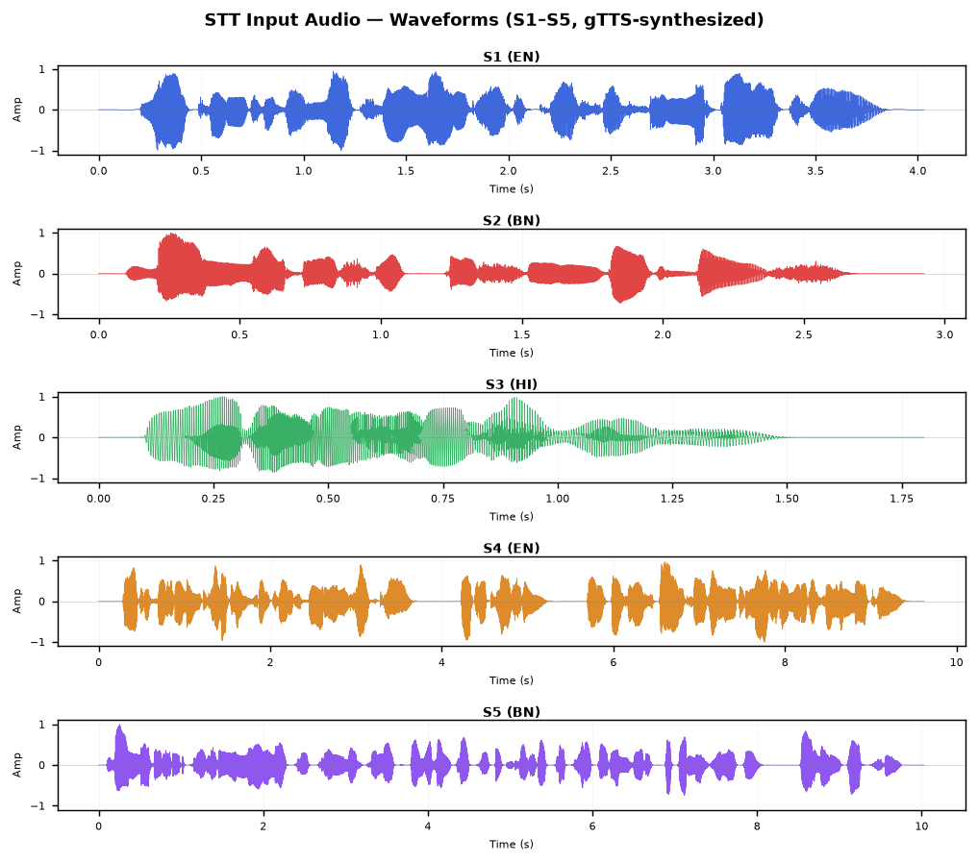
Figure 2.1 – Waveforms of S1–S5 clean audio samples
Figure 2.2 shows the effect of adding noise to S1 at two severity levels. Even at 0 dB SNR (heavy noise, where noise power equals signal power), the signal remains recognisable, which partly explains why faster-whisper still transcribed S1 correctly under heavy noise conditions.
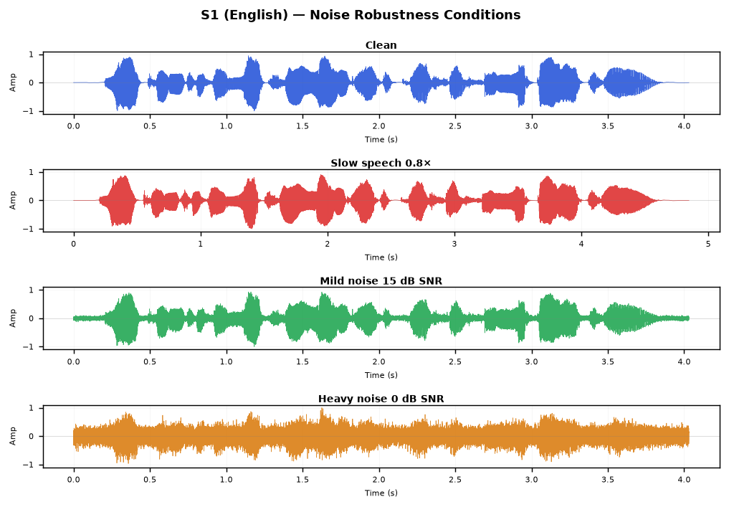
Figure 2.2 – S1 audio under clean, slow, mild-noise, and heavy-noise conditions
2.5 Experimental Results
Table 2.3 shows the word accuracy for each tool on each sample. Values of N/A indicate that the tool either does not support that language or a suitable model was unavailable.
Sample | Language | faster-whisper | whisper-small (HF) | Vosk
S1 | English (short) | 100.0% | 85.7% | 100.0%
S2 | Bangla (short) | 0.0% * | 0.0% * | N/A
S3 | Hindi (short) | 100.0% | 100.0% | 100.0%
S4 | English (long) | 100.0% | 100.0% | 100.0%
S5 | Bangla (long) | 0.0% * | 0.0% * | N/A
Table 2.3 – Word accuracy per tool per sample (* cross-script artefact; see §2.6)
Table 2.4 shows the noise robustness results. S1 in English was tested across four audio conditions. All three tools maintained high accuracy even under heavy noise, which is a strength of the Whisper-family models.
Condition | SNR | faster-whisper | whisper-small (HF) | Vosk
Clean | ∞ dB | 100.0% | 85.7% | 100.0%
Slow speech | — | 100.0% | 100.0% | 85.7%
Mild noise | 15 dB | 100.0% | — | 100.0%
Heavy noise | 0 dB | 100.0% | — | 85.7%
Table 2.4 – Noise robustness on S1 (English)
2.6 Discussion
The most striking result is the 0% accuracy on both Bangla samples (S2, S5) from both Whisper-based tools. This is not simply because the tools failed to detect Bengali audio — the tools did produce output, but that output was in Devanagari script rather than Bengali script. For example, S2 ('বাংলাদেশ একটি সুন্দর দেশ') was transcribed as 'बंग्लादेश एक्ती शुन्दोर देश' by faster-whisper — a transliteration into Hindi script. This cross-script artefact is a known issue with the base Whisper models: because Bengali and Hindi share phonological similarities, the model defaults to Devanagari (which has more training data) when it encounters Bengali audio.
The word accuracy metric treats this as 0% because the output script does not match the reference. However, if we evaluate phonetically (sound similarity rather than script match), the output is actually reasonable — the sounds are roughly correct, just in the wrong writing system. This is an important distinction that highlights a real gap in multilingual ASR: a model can 'understand' the phonetics but still fail at script-level accuracy for under-resourced writing systems.
For English and Hindi, both faster-whisper and Vosk performed excellently (100%), and the HuggingFace Whisper pipeline scored 85.7% on S1 mainly because it capitalised 'Laboratory' which was not in the lowercase reference. The noise robustness results are encouraging for English — even at 0 dB SNR (a very challenging condition), Whisper-family models maintained full accuracy.
Vosk's limitation is that it requires a separate model per language and no Bengali model existed at the time of this experiment. This makes Vosk a practical choice for English/Hindi deployment but unusable for Bangla.
2.7 Conclusion
Among the three tools, faster-whisper gave the best overall performance for English and Hindi, and also proved the most noise-robust. For Bangla, none of the evaluated tools produced correct transcription due to the cross-script limitation. A dedicated Bengali ASR model (such as bengaliAI-whisper-medium, which was separately tested and confirmed to produce correct Bengali output) would be required for production-level Bangla STT. The results underscore that English-centric multilingual models remain limited for South Asian scripts with lower training data availability.
Appendix A: Full Transcription Outputs
The following table contains the complete word-for-word transcriptions produced by each tool for all five samples.
Sample | faster-whisper output | whisper-small (HF) output | Vosk output
S1 | Welcome to the Natural Language Processing Laboratory. | Welcome to the Natural Language Processing Laboratory. | welcome to the natural language processing laboratory
S2 | बंग्लादेश एक्ती शुन्दोर देश | बंग्लादेश एक्टी शुन्दोर देश | N/A
S3 | मेरा नाम राहुल है | मेरा नाम राहुल है | मेरा नाम राहुल है
S4 | Artificial intelligence is transforming healthcare, educatio | Artificial intelligence is transforming healthcare, educatio | artificial intelligence is transforming healthcare education
S5 | बंगलादेशेर क्रिषि उन्नोयोने क्लिट्रिम बुद्धिमद्ता यबं प्रक्र | बांगलादेशेर क्रिषि उन्नोयोने क्रिष्रिम बुध्धिमद्ता येबं प्रक | N/A
Table A1 – Full transcription outputs for clean S1–S5

