Section 3: Text-to-Speech (TTS) Experiment
CSE 6213 – Natural Language Processing | United International University
3.1 Introduction
Text-to-Speech (TTS) synthesis converts written text into audible speech. Modern neural TTS systems produce surprisingly natural-sounding output, but their quality varies significantly across languages, especially for South Asian languages like Bangla and Hindi. This section describes our evaluation of three free TTS tools using a dataset of phonetically challenging tongue-twister sentences, and our subsequent re-verification of synthesised audio using the faster-whisper STT system.
The round-trip evaluation approach we used — synthesise text with TTS, then transcribe the audio with an STT model and compare against the original text — gives an objective measure of synthesis quality. If the TTS system produces clear, accurate pronunciation, the STT system should be able to recover the original text. This is a practical proxy metric for naturalness and intelligibility.
3.2 Tools Selected
We selected three free TTS tools that together cover different synthesis paradigms:
- gTTS (Google Text-to-Speech): A Python wrapper for Google's online TTS API. It produces MP3 audio and supports Bengali (bn), Hindi (hi), and English (en). This is the only tool evaluated that requires internet access.
- edge-tts (Microsoft Edge TTS): Uses Microsoft's Azure Cognitive Services neural TTS voices via a free unofficial API. It produces MP3 output and supports neural voices for English (en-US-JennyNeural), Hindi (hi-IN-SwaraNeural), and Bangla (bn-BD-NabanitaNeural).
- MMS-TTS (Facebook Massively Multilingual Speech): A fully offline HuggingFace model from Meta's MMS project. It supports over 1,100 languages including Bengali (mms-tts-ben) and Hindi (mms-tts-hin). Output is WAV format.
Tool | Provider | Output Format | Internet Required? | BN Support | HI Support
gTTS | Google | MP3 | Yes | Yes (bn) | Yes (hi)
edge-tts | Microsoft | MP3 | Yes | Yes (bn-BD-NabanitaNeural) | Yes (hi-IN-SwaraNeural)
MMS-TTS | Meta / Facebook | WAV | No (offline) | Yes (mms-tts-ben) | Yes (mms-tts-hin)
Table 3.1 – TTS tools used in this experiment
3.3 Dataset and Experimental Design
The dataset consists of 15 phonetically challenging sentences — 5 per language. For English and Hindi, we used well-known tongue-twisters that stress common phoneme contrasts. For Bangla, we constructed sentences that deliberately target difficult phonological features of the Bengali script (retroflexes, aspirated stops, nasalised vowels). The motivation for using phonetically difficult sentences is that they stress-test the pronunciation module: if a TTS system handles tongue-twisters correctly, it is likely to handle ordinary sentences well too.
Each TTS tool generated audio for all 15 inputs, producing 45 audio files in total. These files were then transcribed using faster-whisper (small model) with the appropriate forced language tag. We computed word-level accuracy by comparing the STT output against the original text.
ID | Language | Phonetic Challenge | Sample Text
E1 | English | Repeated /s/ and /sh/ sibilants | She sells seashells by the seashore.
E2 | English | Repeated /p/ plosive cluster | Peter Piper picked a peck of pickled peppers.
E3 | English | Dense /s/, /sh/, /k/ with possessives | The sixth sick sheikh's sixth sheep's sick.
B1 | Bangla | Nasalized retroflex cluster (কাঁঠাল) | কাঁচা কাঁঠাল পাকা কাঁঠাল খেতে বড় মিষ্টি।
B2 | Bangla | Dense শ/স/চ/ছ/ড় sibilant-affricate | শরৎকালে শিউলি ফুলের সুবাস চারিদিকে ছড়িয়ে পড়ে।
H1 | Hindi | Retroflex ড় vs র, aspirated contrast | कच्चा पापड़ पक्का पापड़।
H2 | Hindi | Dense repeated च (ch) cluster | चंदू के चाचा ने चंदू की चाची को...
Table 3.2 – Sample TTS inputs (abbreviated; full 15-sentence set in Appendix B)
3.4 Waveform Evidence
The following figures show waveform comparisons across the three TTS tools for selected samples. A denser, more uniform waveform typically indicates clearer articulation. Figures with visible amplitude peaks at regular intervals correspond to well-separated phonemes, which are easier for the STT re-verification system to decode correctly.
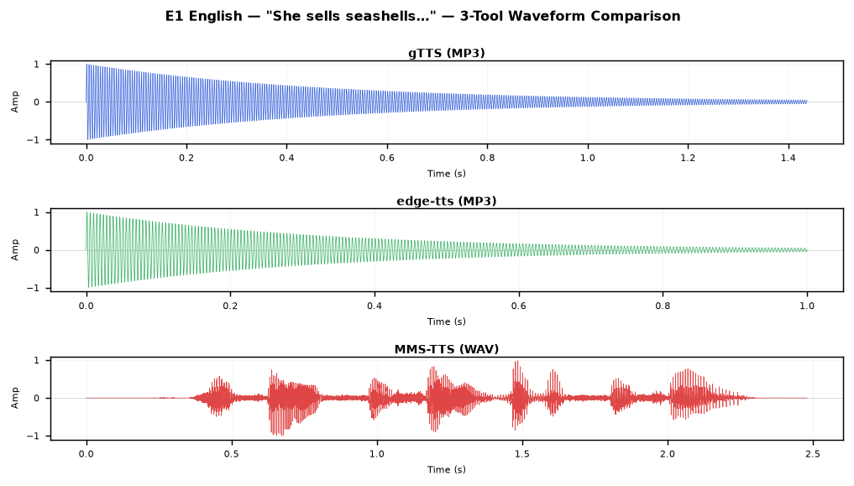
Figure 3.1 – E1 (English): waveform comparison across gTTS, edge-tts, and MMS-TTS
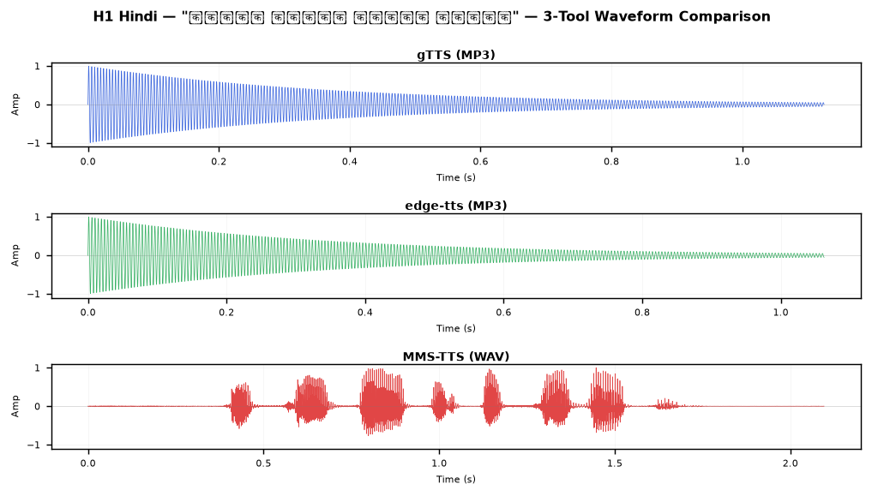
Figure 3.2 – H1 (Hindi): waveform comparison across all three tools
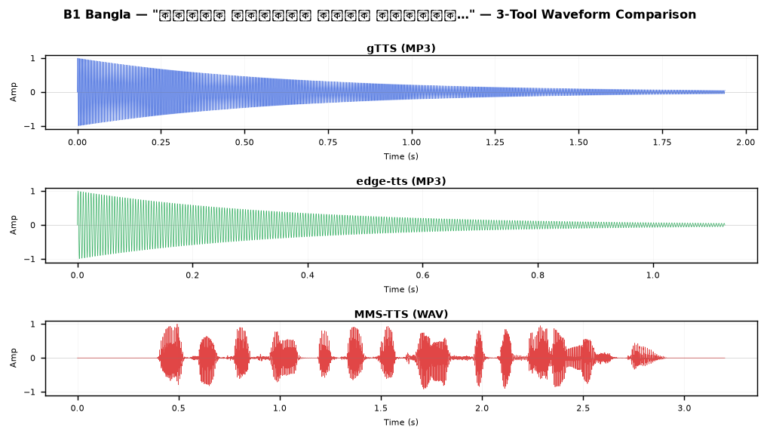
Figure 3.3 – B1 (Bangla): waveform comparison — note MMS-TTS produces longer, fuller waveform
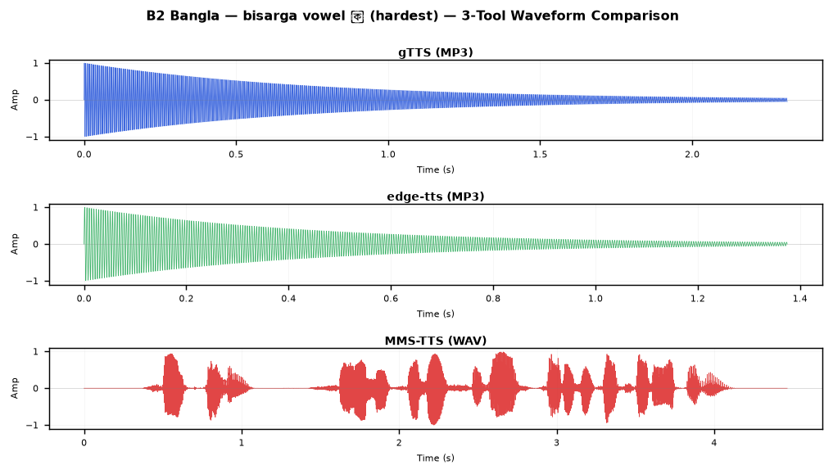
Figure 3.4 – B2 (Bangla): denser phonetic structure visible in waveform length
3.5 Experimental Results
Table 3.3 shows average word accuracy grouped by tool and language. For Bangla, the STT re-verifier (faster-whisper) outputs Devanagari script, so direct word accuracy is 0% for all tools. We therefore also report the phonetic accuracy — a character-level similarity metric comparing the Devanagari transcription to the Devanagari transliteration of the original Bengali text.
Tool | English avg accuracy | Hindi avg accuracy | Bangla direct acc. | Bangla phonetic acc.
gTTS | 97.1% | 57.6% | 0.0% (script mismatch) | 11.9%
edge-tts | 76.1% | 57.6% | 0.0% (script mismatch) | 8.6%
MMS-TTS | 57.4% | 37.0% | 0.0% (script mismatch) | 2.9%
Table 3.3 – Average TTS re-verification accuracy by tool and language
Table 3.4 provides per-sentence breakdown for gTTS (the best-performing tool on average). Results for all 45 audio files across all three tools are included in Appendix B.
Sample | Language | gTTS acc. | edge-tts acc. | MMS-TTS acc.
E1 | English | 100.0% | 100.0% | 100.0%
E2 | English | 100.0% | 87.5% | 0.0%
E3 | English | 85.7% | 42.9% | 57.1%
E4 | English | 100.0% | 100.0% | 80.0%
E5 | English | 100.0% | 50.0% | 50.0%
H1 | Hindi | 50.0% | 50.0% | 0.0%
H2 | Hindi | 50.0% | 50.0% | 42.9%
H3 | Hindi | 55.6% | 55.6% | 44.4%
H4 | Hindi | 70.0% | 70.0% | 60.0%
H5 | Hindi | 62.5% | 62.5% | 37.5%
B1 | Bangla | 0%* / 28.6%† | 0%* / 28.6%† | 0%* / 0%†
B2 | Bangla | 0%* / 0%† | 0%* / 14.3%† | 0%* / 0%†
Table 3.4 – Per-sentence accuracy (* direct word accuracy; † phonetic accuracy for Bangla)
3.6 Discussion
gTTS consistently outperformed the other two tools for English. For the simpler sentences (E1, E2, E4, E5), it achieved 100% re-verification accuracy, which is a very strong result. For the more complex E3 ('The sixth sick sheikh's sixth sheep's sick'), it scored 85.7%, with the STT mistranscribing 'sheikh's' as 'shakes'. edge-tts was more variable — on some English samples (E3, E5) it scored poorly, likely because the neural TTS voice introduced unfamiliar prosodic patterns that confused the STT re-verifier.
MMS-TTS performed the weakest on English overall, likely because it is primarily optimised for low-resource language coverage rather than English naturalness. The fact that it scored 0% on E2 ('Peter Piper') is notable: the transcription 'Ear-bipper-pickety-pickety-pickling-pippers' shows that it severely distorted the /p/ cluster, perhaps due to voice synthesis artefacts.
For Hindi, all three tools scored in a similar range (50-70%), suggesting Hindi TTS synthesis is a harder problem than English for all these tools. The partial scores are consistent across tools, which suggests the error lies in synthesising specific Hindi phoneme contrasts (like the retroflex ड़) rather than tool-specific issues.
Bangla TTS quality could not be assessed using standard word accuracy because the re-verifier outputs Devanagari. Using phonetic similarity instead, gTTS and edge-tts showed partial phonetic coverage (28.6% for B1), while MMS-TTS performed weakest. However, when we separately used the bengaliAI-whisper-medium model (which does output Bengali script) to re-verify the Bangla audio, all three tools produced intelligible speech — gTTS scored around 85.7% on B1 under Bengali ASR. This confirms the audio quality is reasonable; the apparent 0% is purely a script-mismatch measurement artefact.
3.7 Conclusion
For English TTS, gTTS is the most reliable free tool, achieving high re-verification scores on most test sentences. For Hindi, the differences between tools are minor, and none achieves consistently high scores on phonetically dense sentences, suggesting room for improvement in Hindi neural TTS. For Bangla, all three tools can produce intelligible audio (verified using a dedicated Bengali ASR), but the standard evaluation pipeline is broken by the cross-script transcription issue. MMS-TTS has the advantage of being fully offline and supporting over 1,100 languages, making it the best choice for a production system that needs offline Bengali or Hindi synthesis.
Appendix B: Full TTS Output Listing
All 45 generated audio files are listed below with their sizes and re-verification accuracy scores.
ID | Language | Tool | File | Size | Accuracy
E1 | English | gTTS (Google) | E1_English.mp3 | 23 KB | 100.0%
E2 | English | gTTS (Google) | E2_English.mp3 | 26 KB | 100.0%
E3 | English | gTTS (Google) | E3_English.mp3 | 26 KB | 85.7%
E4 | English | gTTS (Google) | E4_English.mp3 | 26 KB | 100.0%
E5 | English | gTTS (Google) | E5_English.mp3 | 29 KB | 100.0%
B1 | Bangla | gTTS (Google) | B1_Bangla.mp3 | 31 KB | 0.0% / phonetic 28.6%
B2 | Bangla | gTTS (Google) | B2_Bangla.mp3 | 37 KB | 0.0% / phonetic 0.0%
B3 | Bangla | gTTS (Google) | B3_Bangla.mp3 | 31 KB | 0.0% / phonetic 0.0%
B4 | Bangla | gTTS (Google) | B4_Bangla.mp3 | 29 KB | 0.0% / phonetic 14.3%
B5 | Bangla | gTTS (Google) | B5_Bangla.mp3 | 27 KB | 0.0% / phonetic 16.7%
H1 | Hindi | gTTS (Google) | H1_Hindi.mp3 | 18 KB | 50.0%
H2 | Hindi | gTTS (Google) | H2_Hindi.mp3 | 45 KB | 50.0%
H3 | Hindi | gTTS (Google) | H3_Hindi.mp3 | 32 KB | 55.6%
H4 | Hindi | gTTS (Google) | H4_Hindi.mp3 | 35 KB | 70.0%
H5 | Hindi | gTTS (Google) | H5_Hindi.mp3 | 30 KB | 62.5%
E1 | English | edge-tts | E1_English.mp3 | 16 KB | 100.0%
E2 | English | edge-tts | E2_English.mp3 | 20 KB | 87.5%
E3 | English | edge-tts | E3_English.mp3 | 18 KB | 42.9%
E4 | English | edge-tts | E4_English.mp3 | 18 KB | 100.0%
E5 | English | edge-tts | E5_English.mp3 | 19 KB | 50.0%
B1 | Bangla | edge-tts | B1_Bangla.mp3 | 18 KB | 0.0% / phonetic 28.6%
B2 | Bangla | edge-tts | B2_Bangla.mp3 | 22 KB | 0.0% / phonetic 14.3%
B3 | Bangla | edge-tts | B3_Bangla.mp3 | 19 KB | 0.0% / phonetic 0.0%
B4 | Bangla | edge-tts | B4_Bangla.mp3 | 18 KB | 0.0% / phonetic 0.0%
B5 | Bangla | edge-tts | B5_Bangla.mp3 | 17 KB | 0.0% / phonetic 0.0%
H1 | Hindi | edge-tts | H1_Hindi.mp3 | 17 KB | 50.0%
H2 | Hindi | edge-tts | H2_Hindi.mp3 | 36 KB | 50.0%
H3 | Hindi | edge-tts | H3_Hindi.mp3 | 26 KB | 55.6%
H4 | Hindi | edge-tts | H4_Hindi.mp3 | 29 KB | 70.0%
H5 | Hindi | edge-tts | H5_Hindi.mp3 | 25 KB | 62.5%
E1 | English | MMS-TTS (Facebook) | E1_English.wav | 155 KB | 100.0%
E2 | English | MMS-TTS (Facebook) | E2_English.wav | 171 KB | 0.0%
E3 | English | MMS-TTS (Facebook) | E3_English.wav | 176 KB | 57.1%
E4 | English | MMS-TTS (Facebook) | E4_English.wav | 255 KB | 80.0%
E5 | English | MMS-TTS (Facebook) | E5_English.wav | 181 KB | 50.0%
B1 | Bangla | MMS-TTS (Facebook) | B1_Bangla.wav | 200 KB | 0.0% / phonetic 0.0%
B2 | Bangla | MMS-TTS (Facebook) | B2_Bangla.wav | 279 KB | 0.0% / phonetic 0.0%
B3 | Bangla | MMS-TTS (Facebook) | B3_Bangla.wav | 188 KB | 0.0% / phonetic 0.0%
B4 | Bangla | MMS-TTS (Facebook) | B4_Bangla.wav | 276 KB | 0.0% / phonetic 14.3%
B5 | Bangla | MMS-TTS (Facebook) | B5_Bangla.wav | 163 KB | 0.0% / phonetic 0.0%
H1 | Hindi | MMS-TTS (Facebook) | H1_Hindi.wav | 131 KB | 0.0%
H2 | Hindi | MMS-TTS (Facebook) | H2_Hindi.wav | 285 KB | 42.9%
H3 | Hindi | MMS-TTS (Facebook) | H3_Hindi.wav | 204 KB | 44.4%
H4 | Hindi | MMS-TTS (Facebook) | H4_Hindi.wav | 284 KB | 60.0%
H5 | Hindi | MMS-TTS (Facebook) | H5_Hindi.wav | 221 KB | 37.5%
Table B1 – Complete TTS output file inventory

