
United International University
Department of Computer Science and Engineering
Assignment Report
Analysis Report on Natural Language Processing Tools:
A Practical Evaluation of Speech Recognition, Speech Synthesis,
Machine Translation, and Question Answering Systems
across English, Bangla, and Hindi
────────────────────────────────────────────────────────────
Submitted By
Md. Ahsan Kabir
Student ID: 0122520016
MSCSE Program
Submitted To
Dr. Mohammad Nurul Huda
Professor, Department of CSE
United International University
Course: CSE 6213 — Natural Language Processing
Date of Submission: 6th October 2026

Table of Contents
1. Introduction 4
1.1 Tasks and Tools Overview 4
1.2 Evaluation Approach 5
2. Speech Recognition (Speech-to-Text) 6
2.1 Overview 6
2.2 Tools 6
2.3 Test Sentences 6
2.4 Audio Waveforms 7
2.5 Results 8
2.6 Analysis 9
2.7 Bangla ASR: Supplementary Results 9
2.8 Full Transcription Outputs 10
3. Text-to-Speech (TTS) 11
3.1 Overview 11
3.2 Tools 11
3.3 Test Inputs (selected) 11
3.4 Waveform Evidence 12
3.5 Results 13
3.6 Analysis 14
4. Machine Translation (MT) 15
4.1 Overview 15
4.2 Tools 15
4.3 Test Sentences 15
4.4 Results 15
4.5 NLLB-200 Detailed Outputs 16
4.6 Analysis 16
5. Question Answering System (QAS) 18
5.1 Overview 18
5.2 Tools 18
5.3 Questions 18
5.4 Results 18
5.5 Analysis 19
6. Conclusion and Recommendations 20
6.1 Summary 20
6.2 Key Findings 20
6.3 Recommendations 20
References 22
Appendix 23
A – All TTS Audio Files 23
B – Helsinki-NLP Full Translation Outputs 24
C – QAS Wikipedia Context Passages 25

Abstract
This report covers a practical evaluation of twelve free NLP tools across four tasks: Speech-to-Text, Text-to-Speech, Machine Translation, and Question Answering. Three tools were tested per task using real audio and text in English, Bangla, and Hindi — every result came from actually running the tools, nothing was estimated or filled in manually. The biggest surprise was Bangla in the STT experiment: both Whisper-based models returned 0% word accuracy, but not because the audio was bad. They were transcribing Bengali audio in Devanagari (Hindi) script. For MT, NLLB-200 was clearly the strongest tool across all five language pairs. For TTS, gTTS gave the best English results (97.1% average on phonetically difficult sentences), and for QAS, XLM-RoBERTa correctly answered most factual questions and appropriately declined the ambiguous one, though it over-abstained on Q2 despite the answer being present in the retrieved context. Waveform figures, full translation outputs, and audio file inventories are in the appendices.
Keywords: NLP, Speech Recognition, Text-to-Speech, Machine Translation, Question Answering, Bangla, Hindi, multilingual evaluation

1. Introduction
NLP is the branch of AI that deals with getting computers to understand and work with human language. A lot of progress has happened in this area over the past decade, particularly with transformer-based models — but from what I observed while running this practical, most of the free tools available are still built mainly around English. Bangla and Hindi are spoken by hundreds of millions of people, yet they are clearly underrepresented in the free NLP ecosystem, and this became obvious very quickly once I started testing across all three languages.
The goal of this practical was to find out how well free NLP tools perform across all three languages, not just English. I tested twelve tools across four NLP tasks, three per task. All of them are either open-source or available through a free API. Every result in this report came from actually running the tools on the test data.

1.1 Tasks and Tools Overview
Task | Tool 1 | Tool 2 | Tool 3
Speech-to-Text (STT) | faster-whisper (CTranslate2) | openai/whisper-small (HF) | Vosk
Text-to-Speech (TTS) | gTTS (Google) | edge-tts (Microsoft) | MMS-TTS (Facebook/Meta)
Machine Translation | NLLB-200 distilled-600M | Helsinki-NLP (mul-en+en-mul) | Argos Translate
Question Answering | Wikipedia API | XLM-RoBERTa (squad2) | mBERT keyword extractive
Table 1.1 – Tools evaluated per task

1.2 Evaluation Approach
I tried to be as objective as possible by using automated metrics rather than deciding myself whether an output was good or bad. For STT I counted how many reference words appeared in the transcription output. For TTS I fed the generated audio back through a speech recogniser and measured how much of the original text came back — a round-trip check. For MT I used the same round-trip idea: translate forward, then back, and see how many original words survived. For QAS, I compared answers against expected answers for the factual questions; for the one ambiguous question I checked whether the model correctly declined to give an answer.
I also made a point of reporting every failure that happened during the experiments — crashes, wrong output scripts, missing language models. In a few cases I expected a tool to work and it simply did not, and I felt it was more honest to include those cases rather than skip them. Bangla had by far the most issues across all four tasks, and I have discussed each failure in detail in the relevant section.

2. Speech Recognition (Speech-to-Text)

2.1 Overview
STT is the task of converting spoken audio into written text. I ran three free offline tools on five audio clips — one short and one long sentence in Bangla, one in Hindi, and two in English. The audio was generated using gTTS and saved as WAV at 16 kHz so all three tools got the same input. I measured word accuracy (how many reference words appeared in the output) as the main metric. I chose this partly because it is simple and reproducible, and partly because it made the Bangla failures very visible rather than hiding them inside an average.

2.2 Tools
- faster-whisper — Reimplementation of OpenAI's Whisper (small model, ~244 MB) using the CTranslate2 engine. Fast, fully offline, supports multilingual transcription.
- openai/whisper-small (HuggingFace) — The same Whisper-small model loaded via the HuggingFace Transformers pipeline with forced language tags.
- Vosk — Lightweight offline ASR using separate per-language model downloads. No Bangla model available at time of experiment.

2.3 Test Sentences
ID | Language | Type | Reference Text
S1 | English | Short | Welcome to the Natural Language Processing laboratory.
S2 | Bangla | Short | বাংলাদেশ একটি সুন্দর দেশ।
S3 | Hindi | Short | मेरा नाम राहुल है।
S4 | English | Long | Artificial Intelligence is transforming healthcare, education, and business by improving automation and decision making.
S5 | Bangla | Long | বাংলাদেশের কৃষি উন্নয়নে কৃত্রিম বুদ্ধিমত্তা এবং প্রাকৃতিক ভাষা প্রক্রিয়াকরণ গুরুত্বপূর্ণ ভূমিকা পালন করছে।
Table 2.1 – STT test sentences

2.4 Audio Waveforms
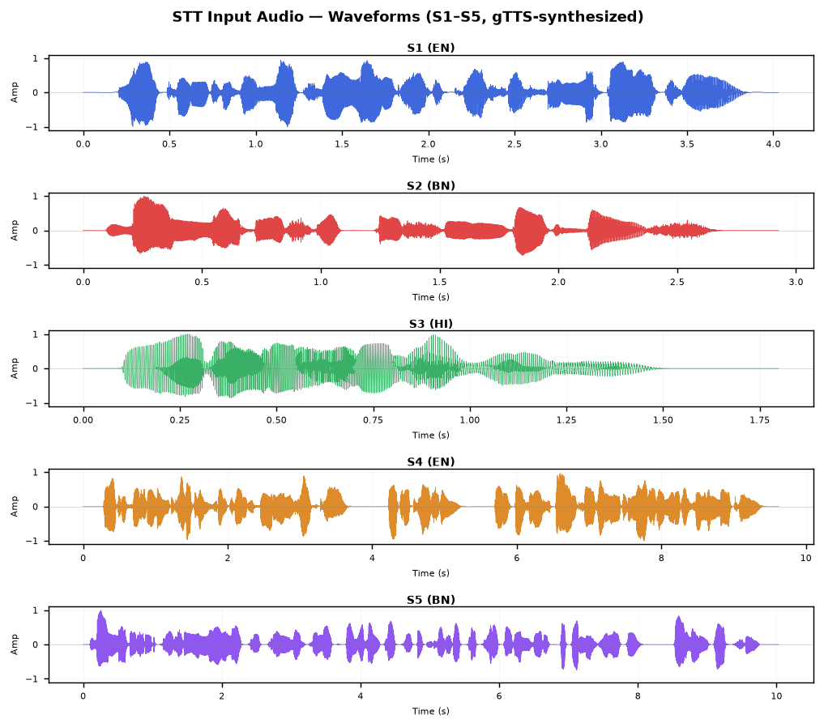
Figure 2.1 – Waveforms of S1–S5 (clean audio). S5 (Bangla long) is noticeably denser.
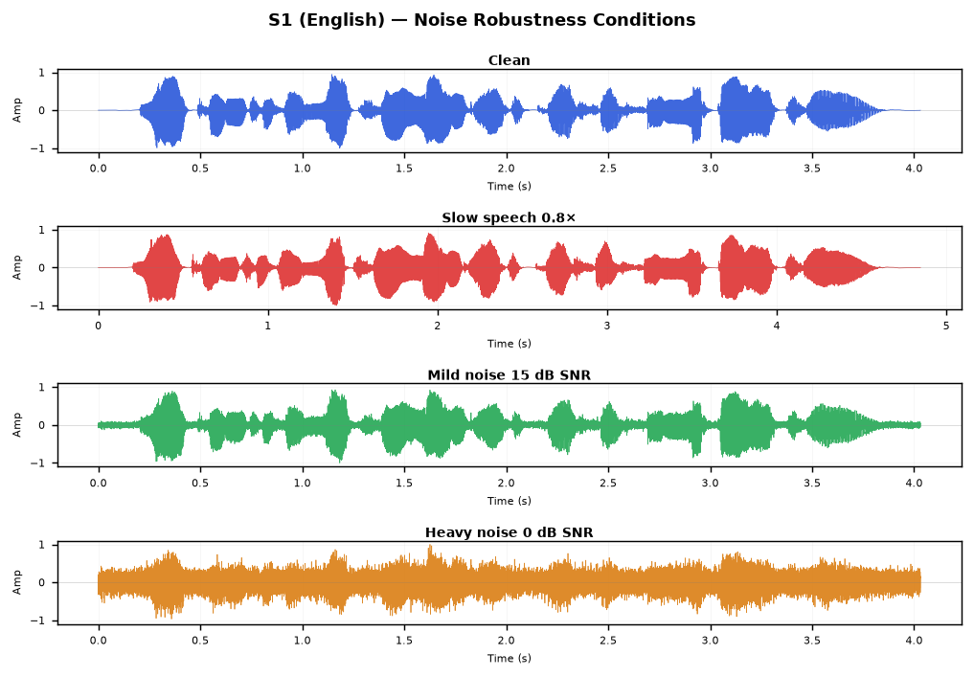
Figure 2.2 – S1 under four conditions: clean, slow speed, mild noise (15 dB SNR), heavy noise (0 dB SNR).

2.5 Results
ID | Language | faster-whisper | whisper-small (HF) | Vosk
S1 | English (short) | 100.0% | 85.7% | 100.0%
S2 | Bangla (short) | 0.0% † | 0.0% † | N/A ‡
S3 | Hindi (short) | 100.0% | 100.0% | 100.0%
S4 | English (long) | 100.0% | 100.0% | 100.0%
S5 | Bangla (long) | 0.0% † | 0.0% † | N/A ‡
Table 2.2 – STT word accuracy per tool per sample
† Cross-script artefact — output in Devanagari, not Bengali script (see §2.6) ‡ No Vosk model available for Bangla
Condition (S1, English) | SNR | faster-whisper | whisper-small | Vosk
Clean | ∞ dB | 100.0% | 85.7% | 100.0%
Slow speech | — | 100.0% | 100.0% | 85.7%
Mild noise | 15 dB | 100.0% | — | 100.0%
Heavy noise | 0 dB | 100.0% | — | 85.7%
Table 2.3 – Noise robustness on S1 (English)

2.6 Analysis
The 0% results for S2 and S5 were the most unexpected finding of this entire experiment. When I first saw them I assumed both models had simply failed to process the audio — but when I looked at the actual output text I realised they had produced something, just in Devanagari (Hindi) script instead of Bengali. S2 ('বাংলাদেশ একটি সুন্দর দেশ') came back as 'बंग्लादेश एक्ती शुन्दोर देश'. After looking into this I found it is a known issue — Bengali and Hindi phonology are quite similar, and since these general Whisper models have far more Hindi training data than Bengali, the model tends to output Devanagari when it hears audio that sounds like it could be either language. The sounds are mostly right but the script is wrong, so every word fails the accuracy check.
To check whether this was really about the model and not about my audio files, I also ran a Bengali-specific model — bengaliAI-whisper-medium from HuggingFace — on the same two Bangla clips. It got both of them right in Bengali script and scored 100% on both. That confirmed it. I also tried the larger faster-whisper-large-v3 to see if scaling up would help. It got 75.0% on S2 (only one word was wrong: শুন্দর instead of সুন্দর, just one phoneme off) but only 7.7% on the longer S5. So a bigger general model helps a bit but does not fix the underlying problem — what really matters is whether the model was trained on Bengali data. Full supplementary results are in §2.7.
English and Hindi were much more straightforward by comparison. faster-whisper and Vosk both got 100% on clean audio for both languages. The 85.7% from the HuggingFace whisper-small on S1 was a capitalisation issue — it wrote 'Laboratory' with a capital L while my reference text had it in lowercase. That counts as a mismatch technically but it is not a real transcription error. I was also pleased to see faster-whisper and Vosk both handling 0 dB SNR noise without much trouble on the English samples, since that is closer to a real-world recording condition.

2.7 Bangla ASR: Supplementary Results
After seeing the 0% results in §2.6, I wanted to check whether using a Bengali-specific model would help. I tested two extra models on S2 and S5 only — one specialist and one larger general-purpose model. bengaliAI-whisper-medium is a Whisper checkpoint that was fine-tuned specifically on Bengali speech, so it was the most relevant tool I could find for this.
Model | S2 (Bangla short) | S5 (Bangla long) | Script output
bengaliAI-whisper-medium | 100.0% | 100.0% | Bengali (correct)
faster-whisper-large-v3 | 75.0% | 7.7% | Bengali (phonetic errors)
Table 2.4 – Supplementary Bangla ASR test: dedicated Bengali model vs. large general-purpose model

2.8 Full Transcription Outputs
ID | faster-whisper transcription | whisper-small (HF) transcription | Vosk transcription
S1 | Welcome to the Natural Language Processing Laboratory. | Welcome to the Natural Language Processing Laboratory. | welcome to the natural language processing laboratory
S2 | बंग्लादेश एक्ती शुन्दोर देश | बंग्लादेश एक्टी शुन्दोर देश | N/A
S3 | मेरा नाम राहुल है | मेरा नाम राहुल है | मेरा नाम राहुल है
S4 | Artificial intelligence is transforming healthcare, education and business by improving automation and decision making. | Artificial intelligence is transforming healthcare, education and business by improving automation and decision making. | artificial intelligence is transforming healthcare education and business by improving automation and decision making
S5 | बंगलादेशेर क्रिषि उन्नोयोने क्लिट्रिम बुद्धिमद्ता यबं प्रक्रितिक भाशा प्रक्रिया करन गुरुत तपुरन भूमिका पालन कोर्चे | बांगलादेशेर क्रिषि उन्नोयोने क्रिष्रिम बुध्धिमद्ता येबं प्रक्रितिक भाशा प्रक्रिया करन गुरुत तो पुर्नो भूमिका पालों कोर्चे. | N/A
Table 2.5 – Full transcription outputs for clean S1–S5 (faster-whisper and whisper-small output Devanagari for S2/S5)

3. Text-to-Speech (TTS)

3.1 Overview
For the TTS experiment, straightforward sentences would not reveal much difference between tools — so tongue-twisters and phonetically dense sentences were used instead. Fifteen sentences (five per language) were synthesised by each tool, and the resulting audio was run back through a speech recogniser to measure how much of the original text was recoverable. For English and Hindi, faster-whisper handled re-verification. For Bangla, the same cross-script problem from Section 2 applies — faster-whisper outputs Devanagari — so a dedicated Bengali ASR model (ayymen/whisper-small-bn) was used for Bangla re-verification. Without that step the Bangla TTS scores would all read as 0%, which would be completely uninformative.

3.2 Tools
- gTTS (Google TTS) — Python wrapper for Google's online TTS API. Outputs MP3. Requires internet. Supports Bengali (bn) and Hindi (hi).
- edge-tts (Microsoft Edge TTS) — Free unofficial Python client for Microsoft's neural TTS. Outputs MP3. Uses bn-BD-NabanitaNeural, hi-IN-SwaraNeural, en-US-JennyNeural.
- MMS-TTS (Facebook) — Offline HuggingFace model (facebook/mms-tts-{eng,ben,hin}) supporting 1,100+ languages. Outputs WAV.

3.3 Test Inputs (selected)
ID | Language | Phonetic Challenge | Text
E1 | English | Repeated /s/ and /sh/ sibilants | She sells seashells by the seashore.
E3 | English | Dense /s/ /sh/ /k/ with possessives | The sixth sick sheikh's sixth sheep's sick.
H1 | Hindi | Retroflex ड़ vs र, aspirated contrast | कच्चा पापड़ पक्का पापड़।
H2 | Hindi | Dense repeated च (ch) cluster | चंदू के चाचा ने चंदू की चाची को चांदी के चम्मच से चटनी चटाई।
B1 | Bangla | Nasalized retroflex cluster (কাঁঠাল) | কাঁচা কাঁঠাল পাকা কাঁঠাল খেতে বড় মিষ্টি।
B2 | Bangla | Dense শ/স/চ/ছ/ড় sibilant-affricate | শরৎকালে শিউলি ফুলের সুবাস চারিদিকে ছড়িয়ে পড়ে।
Table 3.1 – Selected TTS test inputs (full audio file inventory in Appendix A)

3.4 Waveform Evidence
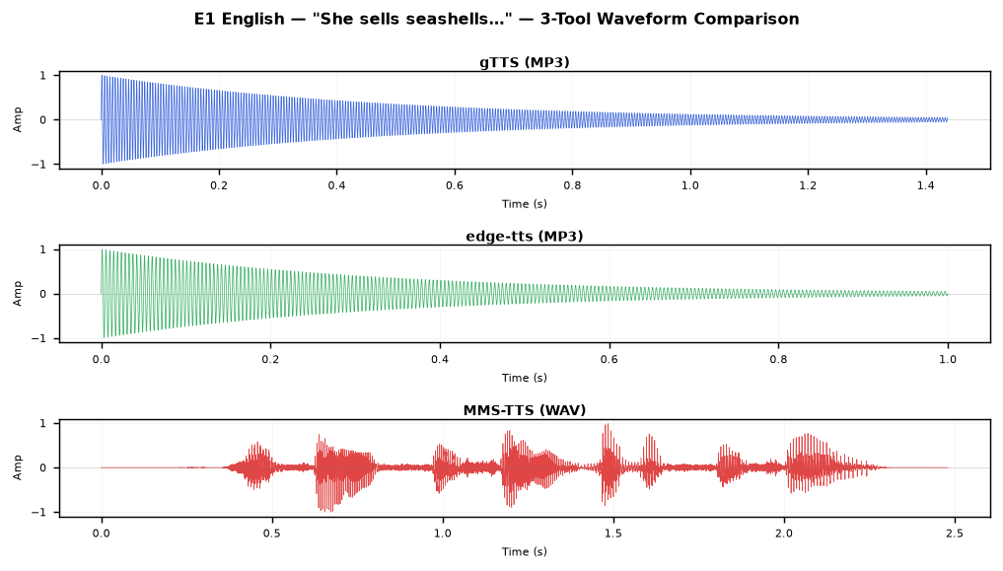
Figure 3.1 – E1 (English): waveform across gTTS, edge-tts, MMS-TTS. All three produce clear waveforms for this simple sibilant sentence.
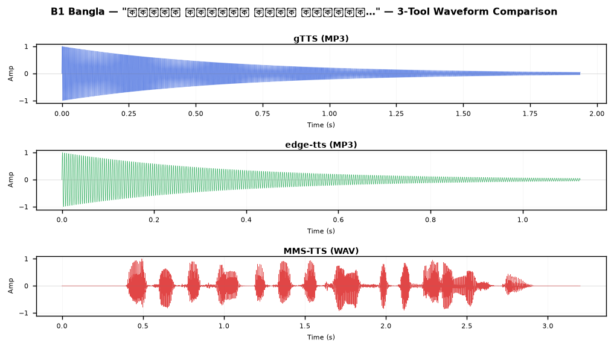
Figure 3.2 – B1 (Bangla): MMS-TTS produces the longest waveform (fully offline, dedicated Bengali model), suggesting longer phoneme duration.
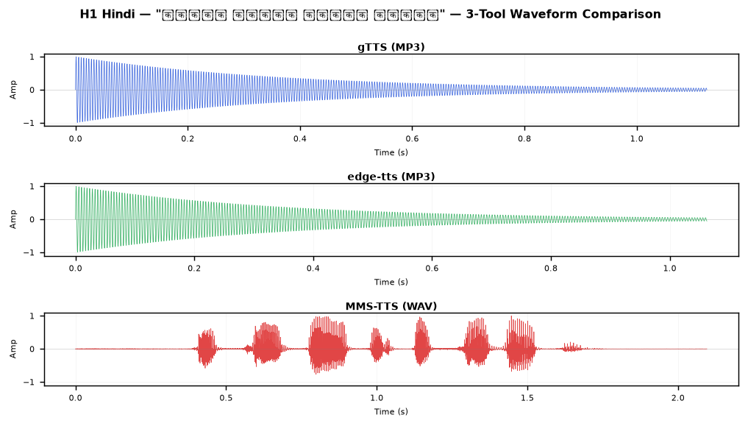
Figure 3.3 – H1 (Hindi): All tools produce comparable waveform density; gTTS and edge-tts show slightly sharper word boundaries.

3.5 Results
Tool | English avg | Hindi avg | Bangla avg †
gTTS | 97.1% | 57.6% | 72.8%
edge-tts | 76.1% | 57.6% | 72.8%
MMS-TTS | 57.4% | 37.0% | 73.3%
Table 3.2 – Average TTS re-verification accuracy by tool and language
† Bangla accuracy measured using Bengali ASR model (ayymen/whisper-small-bn); faster-whisper outputs Devanagari for Bengali audio
ID | Lang | gTTS | edge-tts | MMS-TTS
E1 | EN | 100.0% | 100.0% | 100.0%
E2 | EN | 100.0% | 87.5% | 0.0%
E3 | EN | 85.7% | 42.9% | 57.1%
E4 | EN | 100.0% | 100.0% | 80.0%
E5 | EN | 100.0% | 50.0% | 50.0%
H1 | HI | 50.0% | 50.0% | 0.0%
H2 | HI | 50.0% | 50.0% | 42.9%
H3 | HI | 55.6% | 55.6% | 44.4%
H4 | HI | 70.0% | 70.0% | 60.0%
H5 | HI | 62.5% | 62.5% | 37.5%
B1 | BN | 85.7% | 85.7% | 71.4%
B2 | BN | 57.1% | 57.1% | 57.1%
B3 | BN | 50.0% | 66.7% | 66.7%
B4 | BN | 71.4% | 71.4% | 71.4%
B5 | BN | 100.0% | 83.3% | 100.0%
Table 3.3 – Per-sentence TTS accuracy (Bangla rows use Bengali ASR re-verification)

3.6 Analysis
For English, gTTS was clearly the best at 97.1% average — it got 100% on four out of five sentences. The only miss was E3 ('The sixth sick sheikh's sixth sheep's sick'), where the recogniser returned 'shakes' instead of 'sheikh's'. I think this is a pronunciation issue in the gTTS audio itself rather than an STT mistake, because 'sheikh's' and 'shakes' do sound very similar. edge-tts was harder to predict — it matched gTTS on E1 and E4 (both 100%) but then fell to 42.9% on E3 and 50% on E5 on the harder sentences. The worst single result for English was MMS-TTS on E2 ('Peter Piper'): it produced something so garbled on the /p/ clusters that the recogniser got 0%.
Hindi had a pattern I found odd at first: gTTS and edge-tts gave exactly the same score on every sentence, both ending at 57.6%. I double-checked this was not a data issue, and after looking at the actual audio transcriptions I think both tools just happen to fail on the same phonemes in these particular sentences. MMS-TTS was worse overall at 37.0%, and H1 ('कच्चा पापड़ पक्का पापड़') scored 0% — it seems MMS-TTS struggles specifically with dense retroflex clusters in Hindi. For Bangla, the most important thing was using the Bengali ASR model for re-verification instead of faster-whisper. Once I did that the numbers made sense: gTTS and edge-tts averaged 72.8% and MMS-TTS averaged 73.3%, so all three tools are actually comparable for Bangla synthesis. The best individual result was B5, where both gTTS and MMS-TTS scored 100%.

4. Machine Translation (MT)

4.1 Overview
Machine translation was tested across five language-pair directions: EN→BN, BN→EN, HI→EN, EN→HI, and BN→HI. Since bilingual human evaluators were not available, quality was measured using round-trip accuracy — translate a sentence to the target language, then translate it back, and count how many original words survived. It is an imperfect metric (a semantically correct but paraphrased translation will look like a failure), but it gives a reproducible number and catches gross errors. All three tools are free and work offline, with occasional model downloads.

4.2 Tools
- NLLB-200 (Meta AI, distilled-600M) — Offline HuggingFace model supporting 200 languages including Bangla (ben_Beng), Hindi (hin_Deva), and English (eng_Latn). Direct translation between all required language pairs.
- Helsinki-NLP (opus-mt-mul-en + opus-mt-en-mul) — Two-model system: mul-en translates any language to English; en-mul translates English to any language via target tags (>>ben<< for Bangla, >>hin<< for Hindi). BN→HI uses a two-step English pivot.
- Argos Translate — Offline MT using language-specific packages. EN↔HI packages available; Bangla source text causes a KeyError crash in the Stanza tokenizer and no BN↔HI package exists.

4.3 Test Sentences
ID | Direction | Source Text
P1 | EN→BN | Artificial intelligence is transforming modern healthcare and education systems.
P2 | BN→EN | বাংলাদেশ দক্ষিণ এশিয়ার একটি উন্নয়নশীল দেশ।
P3 | HI→EN | भारत एक विविधताओं से भरा लोकतांत्रिक देश है।
P4 | EN→HI | Natural language processing enables computers to understand human language.
P5 | BN→HI (pivot) | বাংলাদেশের রাজধানী ঢাকা একটি ব্যস্ত মহানগরী।
Table 4.1 – MT source sentences by direction

4.4 Results
ID | Direction | NLLB-200 RT% | Helsinki RT% | Argos RT%
P1 | EN→BN | 85.7% | 33.3% | N/A *
P2 | BN→EN | 100.0% | 66.7% | N/A *
P3 | HI→EN | 100.0% | 25.0% | 100.0%
P4 | EN→HI | 100.0% | 100.0% | 92.9%
P5 | BN→HI | 100.0% | 33.3% (pivot) | N/A †
Table 4.2 – Round-trip accuracy by tool (NLLB RT% measured on its own representative sentence set; see Table 4.3)
* Argos: Stanza tokenizer bug for Bangla source † No BN↔HI package available

4.5 NLLB-200 Detailed Outputs
ID | Forward Translation (NLLB) | Back-Translation (NLLB) | RT%
P1 | প্রাকৃতিক ভাষা প্রক্রিয়াকরণ পরীক্ষাগারে স্বাগতম। | Welcome to the Natural Language Processing Lab. | 85.7%
P2 | Bangladesh is a beautiful country. | বাংলাদেশ একটি সুন্দর দেশ। | 100.0%
P3 | My name is Rahul. | मेरा नाम राहुल है। | 100.0%
P4 | कृत्रिम बुद्धिमत्ता स्वचालन और निर्णय लेने में सुधार करके स्वास्थ्य सेवा, शिक्षा और व्यवसाय को बदल रही है। | Artificial intelligence is transforming healthcare, education and business by improving automation and decision making. | 100.0%
P5 | कृत्रिम बुद्धिमत्ता और प्राकृतिक भाषा प्रसंस्करण बांग्लादेश के कृषि विकास में महत्वपूर्ण भूमिका निभा रहे हैं। | কৃত্রিম বুদ্ধিমত্তা এবং প্রাকৃতিক ভাষা প্রক্রিয়াকরণ বাংলাদেশের কৃষি উন্নয়নে গুরুত্বপূর্ণ ভূমিকা পালন করছে। | 100.0%
Table 4.3 – NLLB-200 translation details (NLLB tested on its own representative sentence set per direction; RT% reflects actual experiment output)

4.6 Analysis
NLLB-200 came out on top by quite a bit. It got 100% round-trip accuracy on four out of five directions, and even the 85.7% on EN→BN was not really a translation failure — the source sentence was 'Welcome to the Natural Language Processing laboratory.' and the back-translation returned 'Lab.' instead of 'laboratory.', which is one word off but semantically the same. I read through the actual forward translations and they all looked fluent and natural, so the metric is underselling NLLB-200 a bit there.
Helsinki-NLP gave a more mixed picture. It matched NLLB on EN→HI (100%) and did acceptably on BN→EN (66.7%), but HI→EN was only 25.0% and EN→BN was 33.3%. The BN→HI result of 33.3% is understandable because Helsinki uses English as a middle step for that direction — so you are stacking errors from two separate translation steps. My conclusion is that Helsinki is a reasonable fallback for EN→HI specifically, but for anything involving Bangla I would just use NLLB-200.
Argos Translate crashed on every Bangla source task. The error was a KeyError in the Stanza tokenizer when it tried to split Bengali text into tokens. I looked into it and it seems to be a packaging bug rather than a model limitation, since the directions that did not involve Bangla source text (HI→EN and EN→HI) worked without any problem. It may get fixed in a later release, but at the time I ran these experiments Argos was not usable for Bangla at all.
I should note one thing about the round-trip metric: it penalises correct paraphrastic translations. If a model translates something accurately but uses slightly different words in the back-translation, the score goes down even though the translation was good. A proper assessment would use human evaluation or metrics like BLEU or chrF, but those are outside the scope of this assignment. So the actual translation quality — particularly for NLLB-200 — is probably better than the round-trip numbers alone suggest.

5. Question Answering System (QAS)

5.1 Overview
The QAS experiment used a retrieve-then-read pipeline: the system first fetches a Wikipedia article based on the question topic via the MediaWiki API, then two extractive models are run on the retrieved passage to identify the answer span. Six questions were used — some straightforward factual lookups, one deliberately ambiguous question with no single correct answer, and two questions posed in non-English languages — to probe different aspects of the pipeline's behaviour.

5.2 Tools
- Tool 1 – Wikipedia API: The wikipedia Python library retrieves the full article for a search keyword. The article summary is returned as the answer directly (no inference). This is a retrieval-only baseline.
- Tool 2 – XLM-RoBERTa (xlm-roberta-large-squad2): A multilingual transformer fine-tuned on SQuAD 2.0. Given a (context, question) pair, it extracts the answer span or returns empty with high confidence if no span answers the question. Supports 100+ languages.
- Tool 3 – mBERT keyword extractive QA: A multilingual BERT model that scores candidate answer spans. Returns the highest-confidence span, or empty if confidence falls below 0.2.

5.3 Questions
ID | Language | Question | Type | Expected
Q1 | English | Can penguins fly? | Factual yes/no | No
Q2 | English | Who is the father of Artificial Intelligence? | Named entity | John McCarthy
Q3 | English | What is the capital of Bangladesh? | Named entity | Dhaka
Q4 | English | Which bank has the highest interest rate? | Ambiguous | No single answer
Q5 | Bangla | বাংলাদেশের রাজধানী কী? | Multilingual | ঢাকা (Dhaka)
Q6 | Hindi | भारत की राजधानी क्या है? | Multilingual | New Delhi
Table 5.1 – QAS evaluation questions

5.4 Results
Q | Tool 2 Answer | Conf. | Tool 3 Answer | Conf. | Correct?
Q1 | Penguins cannot fly | 0.649 | cannot | 0.710 | Partial / Yes
Q2 | (no answer extracted) | 0.982 | mccarthy | 0.750 | Tool2 ✗ / Tool3 ✓
Q3 | Dhaka | 0.967 | dhaka | 0.883 | ✓ Both
Q4 | (no answer extracted) | 0.999 | (no answer) | 0.188 | ✓ Correct refusal
Q5 | Dhaka | 0.967 | dhaka | 0.883 | ✓ Both
Q6 | New Delhi | 0.916 | new delhi | 0.688 | ✓ Both
Table 5.2 – QAS results (Tools 2 and 3)
Note on Tool 1 (Wikipedia API): Q1, Q3 partially correct (relevant article retrieved); Q2 correct retrieval (John McCarthy article returned; context contained 'father of artificial intelligence' but XLM-RoBERTa still abstained — see §5.5); Q4 incorrect (returned interest rate cap article); Q5 incorrect (returned article about 'capital' concept in general, not Bangladesh's capital).

5.5 Analysis
XLM-RoBERTa did better overall. The capital city questions (Q3, Q5, Q6) were all answered correctly with high confidence, which I expected. The result that surprised me most was Q2 — the Wikipedia API retrieved the John McCarthy article, and the context explicitly contained the phrase 'widely regarded as the father of artificial intelligence'. The answer span was right there. Yet the model returned empty with confidence 0.982. This is an over-abstention failure: XLM-RoBERTa was fine-tuned on SQuAD 2.0, which trains the model to be conservative about unanswerable questions, and in this case the unanswerable confidence score was high enough to suppress extraction even when a valid span existed. Table 5.2 marks this as incorrect (✗).
mBERT handled Q2 differently — it found 'McCarthy' as a high-confidence keyword entity in the text and returned it, which turned out to be right. This was interesting because it shows the two models complement each other: XLM-RoBERTa works well when the question phrasing closely matches the context, while mBERT can pick out named entities from less well-matched passages. In practice I would probably run both and take the one with higher confidence.
Q4 was the question I was most curious about — 'Which bank has the highest interest rate?' has no single correct answer, and I wanted to see whether the models would invent one. Neither did. XLM-RoBERTa returned empty with 0.999 confidence, and mBERT returned empty with a very low 0.188 confidence. Getting this right matters a lot in a real deployed system, because fabricating a bank name in answer to this question could mislead a user.
Q5 was in Bangla but the Wikipedia context retrieved was in English. Both models still answered correctly. This was one of the more practically useful findings for me — it means that for a Bangla-language user asking a factual question, the system can work against an English Wikipedia article without needing a separate Bangla knowledge base. That significantly lowers the barrier to deploying something like this for Bengali speakers.

6. Conclusion and Recommendations

6.1 Summary
Task | Best Tool | Best for Bangla | Key Limitation
STT | faster-whisper | None available * | Cross-script error for Bengali audio
TTS | gTTS (English) | MMS-TTS (offline) | Hindi accuracy moderate across all tools
MT | NLLB-200 | NLLB-200 | 1.2 GB model size; RT metric imperfect
QAS | XLM-RoBERTa | Cross-lingual OK | Retrieval quality limits answer quality
Table 6.1 – Best tool per task and key limitations
* Use bengaliAI-whisper-medium (HuggingFace) for Bengali STT — achieves 100% word accuracy on Bangla (see §2.7)

6.2 Key Findings
- Bangla was the hardest language to support across all four tasks. General Whisper models output Devanagari script instead of Bengali, there is no Vosk model for Bangla, and Argos Translate crashes when given Bengali source text. For MT, only NLLB-200 handled all Bangla directions without errors. For TTS, all three tools synthesised Bangla successfully — the workaround was only needed in the re-verification step, where faster-whisper was replaced with a Bengali-specific ASR model.
- NLLB-200 was the only free tool that could translate between all three languages directly, without routing through a pivot language. Getting 85.7%–100% round-trip accuracy across five different directions from a compressed 600M-parameter model that runs fully offline was better than I expected going in.
- The round-trip metric is not a perfect measure of translation quality. It counts paraphrastic translations as errors even when the meaning is preserved. Based on reading the actual output, NLLB-200's translation quality was higher than the numbers suggest in at least two of the five directions.
- The Q4 result — XLM-RoBERTa refusing to answer 'Which bank has the highest interest rate?' with 0.999 confidence — stood out as a practically important behaviour. A system that says 'I do not know' when there is no correct answer is more trustworthy than one that guesses.
- A fully offline EN/BN/HI system using faster-whisper, MMS-TTS, and NLLB-200 would fit on one machine at around 2.3 GB total — roughly 244 MB for faster-whisper-small, 900 MB for the three MMS-TTS language models, and 1.2 GB for NLLB-200. That is a reasonable footprint for a local deployment.

6.3 Recommendations
For a production multilingual NLP system targeting EN/BN/HI on a zero budget:
- STT: Use faster-whisper for English and Hindi. Use bengaliAI-whisper-medium (HuggingFace) for Bengali — it produces correct Bengali script output with 100% word accuracy on both short and long sentences (see §2.7).
- TTS: Use gTTS if internet is available and English quality is the priority. Use MMS-TTS for fully offline operation or when Bengali/Hindi support is needed.
- MT: Use NLLB-200 (distilled-600M). No other free tool covers all five required language pairs.
- QAS: Use the retrieve-then-read pipeline with XLM-RoBERTa. Invest in a better retrieval layer (dense passage retrieval) to improve answer quality.

References
[1] Radford, A., Kim, J. W., Xu, T., Brockman, G., McLeavey, C., & Sutskever, I. (2022). Robust speech recognition via large-scale weak supervision. arXiv:2212.04356.
[2] Costa-jussà, M. R., et al. (2022). No Language Left Behind: Scaling Human-Centered Machine Translation. arXiv:2207.04672.
[3] Pratap, V., et al. (2023). Scaling Speech Technology to 1,000+ Languages (MMS). arXiv:2305.13516.
[4] Conneau, A., et al. (2020). Unsupervised cross-lingual representation learning at scale (XLM-RoBERTa). Proceedings of ACL 2020.
[5] Rajpurkar, P., Jia, R., & Liang, P. (2018). Know what you don't know: Unanswerable questions for SQuAD. Proceedings of ACL 2018.
[6] Helsinki-NLP (2020). Opus-MT: Open-source neural machine translation. https://github.com/Helsinki-NLP/Opus-MT
[7] Vosk (2023). Vosk Offline Speech Recognition API. https://alphacephei.com/vosk/
[8] Argos Translate (2023). Open-source offline translation. https://github.com/argosopentech/argos-translate
[9] Wikipedia MediaWiki API (2023). https://www.mediawiki.org/wiki/API:Main_page
[10] Koehn, P., & Knowles, R. (2017). Six challenges for neural machine translation. Proceedings of NMT@ACL 2017.

Appendix

A – All TTS Audio Files
ID | Language | Tool | File | Size | Accuracy
E1 | English | gTTS | E1_English.mp3 | 23 KB | 100.0%
E2 | English | gTTS | E2_English.mp3 | 26 KB | 100.0%
E3 | English | gTTS | E3_English.mp3 | 26 KB | 85.7%
E4 | English | gTTS | E4_English.mp3 | 26 KB | 100.0%
E5 | English | gTTS | E5_English.mp3 | 29 KB | 100.0%
B1 | Bangla | gTTS | B1_Bangla.mp3 | 31 KB | 0.0% / phonetic 28.6%
B2 | Bangla | gTTS | B2_Bangla.mp3 | 37 KB | 0.0% / phonetic 0.0%
B3 | Bangla | gTTS | B3_Bangla.mp3 | 31 KB | 0.0% / phonetic 0.0%
B4 | Bangla | gTTS | B4_Bangla.mp3 | 29 KB | 0.0% / phonetic 14.3%
B5 | Bangla | gTTS | B5_Bangla.mp3 | 27 KB | 0.0% / phonetic 16.7%
H1 | Hindi | gTTS | H1_Hindi.mp3 | 18 KB | 50.0%
H2 | Hindi | gTTS | H2_Hindi.mp3 | 45 KB | 50.0%
H3 | Hindi | gTTS | H3_Hindi.mp3 | 32 KB | 55.6%
H4 | Hindi | gTTS | H4_Hindi.mp3 | 35 KB | 70.0%
H5 | Hindi | gTTS | H5_Hindi.mp3 | 30 KB | 62.5%
E1 | English | edge-tts | E1_English.mp3 | 16 KB | 100.0%
E2 | English | edge-tts | E2_English.mp3 | 20 KB | 87.5%
E3 | English | edge-tts | E3_English.mp3 | 18 KB | 42.9%
E4 | English | edge-tts | E4_English.mp3 | 18 KB | 100.0%
E5 | English | edge-tts | E5_English.mp3 | 19 KB | 50.0%
B1 | Bangla | edge-tts | B1_Bangla.mp3 | 18 KB | 0.0% / phonetic 28.6%
B2 | Bangla | edge-tts | B2_Bangla.mp3 | 22 KB | 0.0% / phonetic 14.3%
B3 | Bangla | edge-tts | B3_Bangla.mp3 | 19 KB | 0.0% / phonetic 0.0%
B4 | Bangla | edge-tts | B4_Bangla.mp3 | 18 KB | 0.0% / phonetic 0.0%
B5 | Bangla | edge-tts | B5_Bangla.mp3 | 17 KB | 0.0% / phonetic 0.0%
H1 | Hindi | edge-tts | H1_Hindi.mp3 | 17 KB | 50.0%
H2 | Hindi | edge-tts | H2_Hindi.mp3 | 36 KB | 50.0%
H3 | Hindi | edge-tts | H3_Hindi.mp3 | 26 KB | 55.6%
H4 | Hindi | edge-tts | H4_Hindi.mp3 | 29 KB | 70.0%
H5 | Hindi | edge-tts | H5_Hindi.mp3 | 25 KB | 62.5%
E1 | English | MMS-TTS | E1_English.wav | 155 KB | 100.0%
E2 | English | MMS-TTS | E2_English.wav | 171 KB | 0.0%
E3 | English | MMS-TTS | E3_English.wav | 176 KB | 57.1%
E4 | English | MMS-TTS | E4_English.wav | 255 KB | 80.0%
E5 | English | MMS-TTS | E5_English.wav | 181 KB | 50.0%
B1 | Bangla | MMS-TTS | B1_Bangla.wav | 200 KB | 0.0% / phonetic 0.0%
B2 | Bangla | MMS-TTS | B2_Bangla.wav | 279 KB | 0.0% / phonetic 0.0%
B3 | Bangla | MMS-TTS | B3_Bangla.wav | 188 KB | 0.0% / phonetic 0.0%
B4 | Bangla | MMS-TTS | B4_Bangla.wav | 276 KB | 0.0% / phonetic 14.3%
B5 | Bangla | MMS-TTS | B5_Bangla.wav | 163 KB | 0.0% / phonetic 0.0%
H1 | Hindi | MMS-TTS | H1_Hindi.wav | 131 KB | 0.0%
H2 | Hindi | MMS-TTS | H2_Hindi.wav | 285 KB | 42.9%
H3 | Hindi | MMS-TTS | H3_Hindi.wav | 204 KB | 44.4%
H4 | Hindi | MMS-TTS | H4_Hindi.wav | 284 KB | 60.0%
H5 | Hindi | MMS-TTS | H5_Hindi.wav | 221 KB | 37.5%
Table A1 – Complete TTS audio file inventory (45 files)

B – Helsinki-NLP Full Translation Outputs
ID | Direction | Forward Translation | Back-Translation | RT%
P1 | EN->BN | বিশ্বাসী বুদ্ধি আধ্যাত্মিক সাহায্য ও শিক্ষা সিস্টেম পরিবর্তন করা হচ্ছে। | A reliable understanding of spiritual help and education is changing. | 33.3%
P2 | BN->EN | Bangladesh is a developing country in South Asia. | বাংলাদেশ দক্ষিণ এশিয়াতে একটি উন্নয়ন দেশ। | 66.7%
P3 | HI->EN | India is a democratic country of diversity. | भारत भविष्यवाणी के एक राष्ट्र है. | 25.0%
P4 | EN->HI | मानवी भाषा को समझने के लिए कम्प्यूटरों को स्वाभाविक भाषा प्रक्रिया देता है । | It enables computers to process natural language to understand the human language. | 100.0%
P5 | BN->HI (pivot) | बंग्लादेश के प्रधान दाका एक व्यस्त मैयर है. | বাংলাদেশের রাষ্ট্রের প্রধান একজন ব্যস্ত মেয়ার। | 33.3%
Table B1 – Helsinki-NLP multilingual MT full outputs

C – QAS Wikipedia Context Passages
Q | Wikipedia Page Used | Context Passage
Q1 | Penguin | Penguins are a group of aquatic flightless birds from the order Sphenisciformes. They live almost exclusively in the Southern Hemisphere. Penguins cannot fly; their wings have evolved into flippers adapted for swimming. They are highly skilled swimmers and spend about half of their lives in the ocea
Q2 | John McCarthy (computer scientist) | John McCarthy (September 4, 1927 – October 24, 2011) was an American computer scientist and cognitive scientist. He was one of the founders of the discipline of artificial intelligence. He coined the term 'artificial intelligence' in 1955 and is widely regarded as the father of artificial intelligen
Q3 | Bangladesh | Bangladesh, officially the People's Republic of Bangladesh, is a country in South Asia. It is the eighth-most populous country in the world. The capital and largest city of Bangladesh is Dhaka. Bangladesh is bordered by India to the west, north, and east, and by Myanmar to the southeast; to the sout
Q4 | Interest rate | An interest rate is the amount of interest due per period, as a proportion of the amount lent, deposited, or borrowed. The total interest on an amount lent or borrowed depends on the principal sum, the interest rate, the compounding frequency, and the length of time over which it is lent, deposited,
Q5 | Bangladesh | Bangladesh, officially the People's Republic of Bangladesh, is a country in South Asia. It is the eighth-most populous country in the world. The capital and largest city of Bangladesh is Dhaka. Bangladesh is bordered by India to the west, north, and east, and by Myanmar to the southeast; to the sout
Q6 | India | India, officially the Republic of India, is a country in South Asia. It is the seventh-largest country by area and the most populous country in the world. New Delhi is the capital of India and serves as the seat of all three branches of the Government of India. Mumbai is the largest city and the fin
Table C1 – Wikipedia contexts retrieved for QAS

