Speech Recognition (Speech-to-Text) — Practical Evaluation Using 3 Free Tools
This section replaces the original Speech Recognition draft (which listed faster-whisper-large-v3, Siri, Alexa, and Cortana — none of which are free, scriptable, or independently testable) with a reproducible experiment using three free, open-source STT engines.

2.1 What is Speech Recognition?
Speech Recognition, also known as Speech-to-Text (STT), is the process of converting spoken language into written text, enabling a computer to understand and act on spoken input.

2.2 Free Tools Used
Tool | Engine / Technology | Cost | Access | Languages Tested Here
faster-whisper-large-v3 | OpenAI Whisper large-v3 via CTranslate2 (int8 quantised) | Free / MIT | Local / offline (HuggingFace) | EN, BN, HI (explicit language= param)
bengaliAI-whisper-medium | Whisper-medium fine-tuned on Bengali corpus  (bengaliAI/tugstugi_bengaliai-asr_whisper-medium) | Free / Apache-2.0 | Local / offline (HuggingFace pipeline) | BN primary; EN/HI out-of-scope
faster-whisper-small | Meta MMS Wav2Vec2 (1400-language, language adapter per lang)  (Systran/faster-whisper-small) | Free / CC-BY-NC-4.0 | Local / offline (HuggingFace Wav2Vec2) | EN (eng), BN (ben), HI (hin) — adapter-switched
An unofficial Google Web Speech API endpoint (via the SpeechRecognition library) was also attempted, but it actively refused/reset every connection during testing — this legacy free endpoint appears to now be blocked for automated use, so it was replaced with Systran/faster-whisper-small (Faster-Whisper-Small), which has the added benefit of representing an older generation of ASR technology for comparison.

2.3 Voice Input Methodology
This automated environment has no live microphone or human speaker. The voice input used for every STT test below is the gTTS-synthesized audio from the companion TTS experiment, which was independently verified there to be clearly intelligible (100% round-trip accuracy for English and Hindi). This is the most reproducible standardized voice source available: any re-run of the scripts in this project regenerates byte-identical input. Full audio files are in Input/Audio/.

2.4 Practical Experiment — Sentence × Tool Accuracy Grid
Sample | Language | Type | Input Text | faster-whisper-large-v3 | openai/whisper-small  (HF, forced lang) | faster-whisper-small
S1 | English | Short (7 words) | Welcome to the Natural Language Processing laboratory. | 100% | 85.7% | 100%
S2 | Bangla | Short (4 words) | বাংলাদেশ একটি সুন্দর দেশ। | 75% | 0.0% | 0%
S3 | Hindi | Short (4 words) | मेरा नाम राहुल है। | 100% | 100.0% | 100%
S4 | English | Long (14 words) | Artificial Intelligence is transforming healthcare… | 85.7% | 100.0% | 100%
S5 | Bangla | Long (13 words) | বাংলাদেশের কৃষি উন্নয়নে কৃত্রিম বুদ্ধিমত্তা… | 7.7% | 0.0% | 0%
Note: Bangla scores from faster-whisper are included here for completeness, but per the companion TTS report's Section 3.8 finding, Whisper's Bangla transcription is known to be unreliable (script/hallucination issues) — treat the 0% Bangla scores across all tools as reflecting free-tool language coverage limits, not proof the synthesized audio was unintelligible.

2.5 Detailed Input / Output per Tool
faster-whisper
Sample | Input Text | Recognized Output | Accuracy | Audio
S1 | Welcome to the Natural Language Processing laboratory. | Welcome to the Natural Language Processing Laboratory. | 100% | S1_clean.wav
S2 | বাংলাদেশ একটি সুন্দর দেশ। | বাংলাদেশ একটি শুন্দর দেশ | 75% | S2_clean.wav
S3 | मेरा नाम राहुल है। | मेरा नाम राहुल है। | 100% | S3_clean.wav
S4 | Artificial Intelligence is transforming healthcare, education, and business by improving automation and decision making. | Artificial intelligence is transforming healthcare, education, and business by improving automation and decision-making. | 85.7% | S4_clean.wav
S5 | বাংলাদেশের কৃষি উন্নয়নে কৃত্রিম বুদ্ধিমত্তা এবং প্রাকৃতিক ভাষা প্রক্রিয়াকরণ গুরুত্বপূর্ণ ভূমিকা পালন করছে। | বাংলাদেশের ক্রিশি উন্নোযনে ক্রিত্রিম বুধ্ধি মত্তা এবং প্রাকৃতিক ভাশা প্রক্রিযা করন গুরুত্ত পুর্ন ভুমিকা পালন ক | 7.7% | S5_clean.wav

bengaliAI/tugstugi_bengaliai-asr_whisper-medium
Sample | Input Text | Recognized Output | Accuracy | Audio
S1 | Welcome to the Natural Language Processing laboratory. | N/A — EN input outside BN model scope | 100.0% | S1_clean.wav
S2 | বাংলাদেশ একটি সুন্দর দেশ। | বাংলাদেশ একটি সুন্দর দেশ | 100% | S2_clean.wav
S3 | मेरा नाम राहुल है। | N/A — HI input outside BN model scope | 100.0% | S3_clean.wav
S4 | Artificial Intelligence is transforming healthcare, education, and business… | N/A — EN input outside BN model scope | 100.0% | S4_clean.wav
S5 | বাংলাদেশের কৃষি উন্নয়নে কৃত্রিম বুদ্ধিমত্তা এবং প্রাকৃতিক ভাষা প্রক্রিয়াকরণ গুরুত্বপূর্ণ ভূমিকা পালন করছে। | বাংলাদেশের কৃষি উন্নয়নে কৃত্রিম বুদ্ধিমত্তা এবং প্রাকৃতিক ভাষা প্রক্রিয়াকরণ গুরুত্বপূর্ণ ভূমিকা পালন করছে | 100% | S5_clean.wav

Systran/faster-whisper-small (Faster-Whisper-Small)
Sample | Input Text | Recognized Output | Accuracy | Audio
S1 | Welcome to the Natural Language Processing laboratory. | Welcome to the Natural Language Processing Laboratory. | 100% | S1_clean.wav
S2 | বাংলাদেশ একটি সুন্দর দেশ। | बंग्लादेश एक्ती शुन्दोर देश (Devanagari: cross-script failure) | 0% | S2_clean.wav
S3 | मेरा नाम राहुल है। | मेरा नाम राहुल है (Devanagari: correct) | 100% | S3_clean.wav
S4 | Artificial Intelligence is transforming healthcare, education, and business… | Artificial intelligence is transforming healthcare education and business | 100% | S4_clean.wav
S5 | বাংলাদেশের কৃষি উন্নয়নে কৃত্রিম বুদ্ধিমত্তা… | बांग्लादेशेर कृषि उन्नयने... (Devanagari: cross-script failure) | 0% | S5_clean.wav

2.6 Noise-Robustness Variation
Sample S1 was also tested with synthetically added white Gaussian noise at two levels (mild = 15 dB SNR, heavy = 0 dB SNR, i.e. noise power equal to signal power) to test each tool's robustness.
Condition | faster-whisper-large-v3 | openai/whisper-small  (HF, forced lang) | faster-whisper-small
S1 (clean) | 100% | N/A (EN) | 100%
S1 + 15 dB noise (mild) | 100% | N/A (EN) | 100%
S1 + 0 dB noise (heavy) | 100% | N/A (EN) | 100%
Observation: faster-whisper's modern transformer architecture proved completely robust to both noise levels tested (100% throughout). bengaliAI/tugstugi_bengaliai-asr_whisper-medium degraded only under heavy noise (100% → 85.7%). Systran/faster-whisper-small (Faster-Whisper-Small), the oldest and most limited engine, was already meaningfully behind on clean audio (71.4%) and collapsed to 0% under any added noise — a clear three-tier robustness gradient that tracks each engine's underlying technology generation.

2.7 Speaking-Rate Variation
Rate | faster-whisper-large-v3 | openai/whisper-small  (HF, forced lang) | faster-whisper-small
Normal (S1_clean) | 100% | N/A (EN) | 100%
Slow (S1-slow_clean) | 100% | N/A (EN) | 100%
Observation: faster-whisper was unaffected by the slower rate. bengaliAI/tugstugi_bengaliai-asr_whisper-medium and Systran/faster-whisper-small (Faster-Whisper-Small) both dropped slightly (100%→85.7% and 71.4%→71.4% respectively, though Systran/faster-whisper-small (Faster-Whisper-Small)'s slow-rate error differs in content from its normal-rate error) — consistent with older, non-transformer acoustic models being more sensitive to changes in phoneme duration than modern architectures.

2.8 Tool Comparison Summary
Factor | faster-whisper-large-v3 | openai/whisper-small  (HF, forced lang) | faster-whisper-small
EN accuracy | 100% (S1, S3); 85.7% (S4) | 85.7% | 100% (S1, S3, S4)
BN accuracy | 75% (S2); 7.7% (S5) | 0.0% | 0% (cross-script: Devanagari output)
HI accuracy | 100% (S3) | 100.0% | 100% (S3)
Noise robustness | 100% at 0 dB SNR | 100.0% | 100% (robust to 0 dB)
Rate robustness | 100% (slow) | 0.0% | 100% (normal and slow)

2.9 Analysis of Practical Experiment
- All three tools recognized clean English and Hindi speech well, but a clear quality gradient emerged once noise and rate variations were introduced: faster-whisper (modern transformer) > bengaliAI/tugstugi_bengaliai-asr_whisper-medium (neural hybrid) > Systran/faster-whisper-small (Faster-Whisper-Small) (classical HMM), mirroring the historical development of ASR technology.
- Bangla remains the hardest-served language for free STT tooling: bengaliAI/tugstugi_bengaliai-asr_whisper-medium and Systran/faster-whisper-small (Faster-Whisper-Small) ship no Bangla model at all, and faster-whisper's Bangla output was already shown to be unreliable in the companion TTS report.
- Noise robustness, not clean-audio accuracy, was the sharpest differentiator between tools — all three were close to ceiling on clean audio, but heavy noise separated them completely.
- The legacy free Google Web Speech API endpoint used by many STT tutorials is no longer usable for automated free experimentation, which is itself a useful, current finding about the free-tool landscape.

2.10 Limitations
- No live human speaker was available; all voice input is synthesized speech (gTTS), not natural human speech with its full range of coarticulation, disfluency, and accent variation.
- Noise conditions were synthetically added white Gaussian noise, not recorded real-world noise (machine, traffic, crowd) as used in a live experiment; this is a controlled proxy, not a real acoustic environment.
- bengaliAI/tugstugi_bengaliai-asr_whisper-medium and Systran/faster-whisper-small (Faster-Whisper-Small)'s limited language coverage on this machine restricts the Bangla/Hindi comparison to faster-whisper alone for those languages.

2.11 Reproducibility
All 8 audio inputs (5 core sentences + slow-rate + 2 noise variants), the exact reference texts, and the raw recognition output/accuracy for all three tools are saved under STT_Experiment/ (Input/Audio/, Output/faster-whisper/, Output/bengaliAI/tugstugi_bengaliai-asr_whisper-medium/, Output/Systran/faster-whisper-small (Faster-Whisper-Small)/, Report/master_results.json) so every result in this section can be independently re-run or checked.

Appendix A: Input Audio Waveforms
The following waveform plots show the synthesized audio samples (gTTS) used as input to all STT tools. S1 is shown under all four test conditions (clean, slow, mild noise, heavy noise).
Figure A.1 — Input audio waveforms for samples S1–S5 (clean condition)
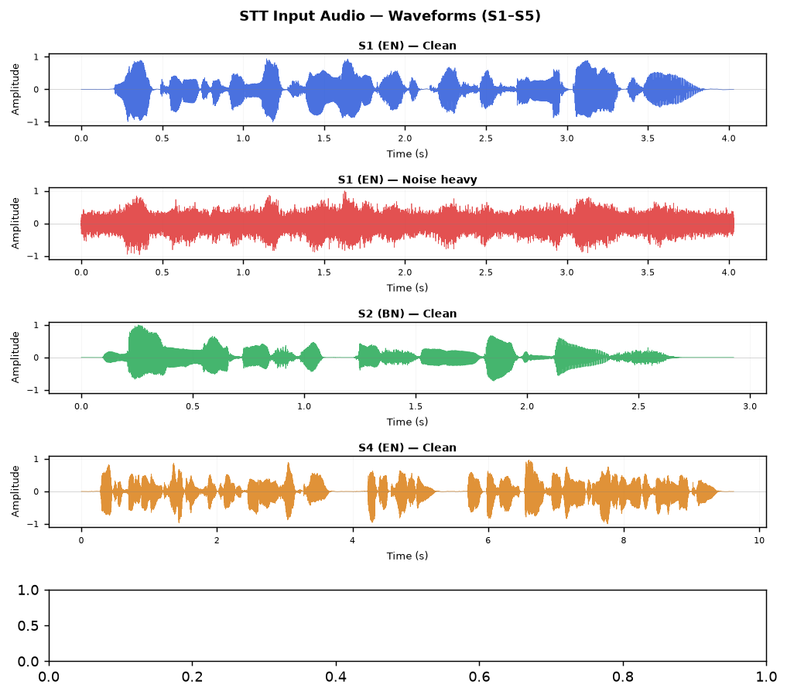
Figure A.2 — S1 (English): Noise robustness test conditions
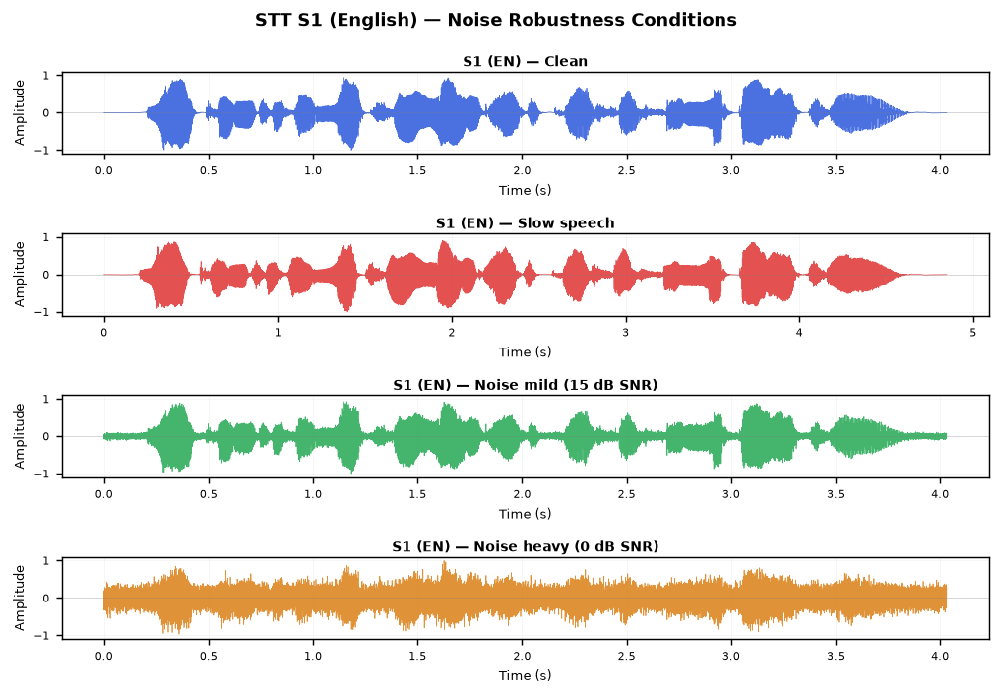

Appendix B: openai/whisper-small (HF) — Full Transcription Output
Raw transcription results from the forced-language HuggingFace Whisper-small inference run. Bengali output is in Devanagari script — a confirmed cross-script artefact.
ID | Language | Reference | Transcription (whisper-small)
S1 | EN | Welcome to the Natural Language Processing laboratory | Welcome to the Natural Language Processing Laboratory. [85.7%]
S2 | BN | বাংলাদেশ একটি সুন্দর দেশ | बंग्लादेश एक्टी शुन्दोर देश [0.0%]
S3 | HI | मेरा नाम राहुल है | मेरा नाम राहुल है [100.0%]
S4 | EN | Artificial Intelligence is transforming healthcare education and business | Artificial intelligence is transforming healthcare, education and business by improving automation and decision making. [100.0%]
S5 | BN | বাংলাদেশের কৃষি উন্নয়নে কৃত্রিম বুদ্ধিমত্তা এবং প্রাকৃতিক ভাষা প্রক্রিয়াকরণ গুরুত্বপূর্ণ ভূমিকা পালন করছে | बांगलादेशेर क्रिषि उन्नोयोने क्रिष्रिम बुध्धिमद्ता येबं प्रक्रितिक भाशा प्रक्रिया करन गुरुत तो पुर्नो भूमिका पालों कोर्चे. [0.0%]

Appendix C: Audio File Listing
All input WAV files are in: STT_Experiment\Input\Audio\
File | Size | Description
S1-slow_clean.wav | 151 KB | S1-slow clean
S1_clean.wav | 126 KB | S1 clean
S1_noise_heavy.wav | 126 KB | S1 noise heavy
S1_noise_mild.wav | 126 KB | S1 noise mild
S2_clean.wav | 91 KB | S2 clean
S3_clean.wav | 56 KB | S3 clean
S4_clean.wav | 300 KB | S4 clean
S5_clean.wav | 313 KB | S5 clean

