Speech Synthesis (Text-to-Speech) — Practical Evaluation Using 3 Free Tools, All Supporting English, Bangla, and Hindi
This version uses three free tools that all genuinely support all three target languages (English, Bangla, Hindi), 5 test sentences per language (15 total) chosen for complex, difficult pronunciation, and a corrected Bangla scoring methodology (Section 3.6) using a dedicated Bengali ASR model to produce real word-level accuracy instead of a blanket N/A.

3.1 What is Speech Synthesis?
Speech Synthesis, commonly known as Text-to-Speech (TTS), converts written text into spoken audio, allowing a computer to communicate with a user using artificial speech.

3.2 Free Tools Used (All Three Support English, Bangla, and Hindi)
Tool | Engine Type | Access | Languages Confirmed Working
gTTS (Google) | Cloud neural (Google Translate engine) | Online | English, Bangla, Hindi
edge-tts (Microsoft) | Cloud neural (Edge voices) | Online | English, Bangla, Hindi
MMS-TTS (Facebook/Meta) | Offline neural (VITS architecture, Massively Multilingual Speech project) | Offline once downloaded (HuggingFace transformers) | English, Bangla, Hindi

3.3 Why Complex Pronunciation Words?
Easy, everyday sentences make every TTS tool score at or near 100%, which hides real differences between tools. All 15 sentences below were deliberately chosen to be hard to pronounce: five well-known English tongue-twisters, five well-known/constructed Hindi tongue-twisters, and five constructed Bangla sentences dense with retroflex, aspirated, and sibilant consonant clusters.

3.4 Test Sentences
English
# | Input Text | Category | Why It's Hard
E1 | She sells seashells by the seashore. | Well-known tongue-twister | Repeated /s/ and /sh/ sibilants
E2 | Peter Piper picked a peck of pickled peppers. | Well-known tongue-twister | Repeated plosive+liquid ‘p’ clusters
E3 | The sixth sick sheikh's sixth sheep's sick. | Well-known tongue-twister | Dense /s/, /sh/, /k/ cluster with possessives
E4 | How can a clam cram in a clean cream can? | Well-known tongue-twister | Repeated /kl/, /kr/ consonant clusters
E5 | Six slippery snails slid slowly seaward. | Well-known tongue-twister | Repeated /sl/ consonant cluster

Bangla
# | Input Text | Category | Why It's Hard
B1 | কাঁচা কাঁঠাল পাকা কাঁঠাল খেতে বড় মিষ্টি। | Constructed phonetically-dense sentence | Repeated nasalized/aspirated retroflex cluster (কাঁঠাল)
B2 | শরৎকালে শিউলি ফুলের সুবাস চারিদিকে ছড়িয়ে পড়ে। | Constructed phonetically-dense sentence | Dense শ/স/চ/ছ/ড় sibilant-affricate cluster
B3 | রাস্তার ধারে ছড়ানো ছিটানো কাঁচের টুকরো। | Constructed phonetically-dense sentence | Repeated retroflex ড়/ট and sibilant চ/ছ cluster
B4 | তেলাপোকা তিন তলায় তিড়িং করে লাফ দিল। | Constructed phonetically-dense sentence | Repeated dental ত/তি and retroflex ড় cluster
B5 | তিনি ঋণ শোধ করে নিশ্চিন্ত হলেন। | Constructed phonetically-dense sentence | Contains the rare vocalic ঋ (ṛ) plus retroflex ণ vs dental ন contrast

Hindi
# | Input Text | Category | Why It's Hard
H1 | कच्चा पापड़ पक्का पापड़। | Well-known tongue-twister | Minimal-pair retroflex flap ड़ vs र, aspirated/unaspirated क/क्क contrast
H2 | चंदू के चाचा ने चंदू की चाची को चांदी के चम्मच से चटनी चटाई। | Well-known tongue-twister | Dense repeated च (ch) cluster plus retroflex ड़
H3 | कौन कुम्हार कुरकुरे कुल्हड़ कब कहाँ कैसे बनाता है? | Well-known tongue-twister | Dense repeated aspirated/unaspirated क/ख cluster plus retroflex ड़
H4 | श्याम शर्मा के शहर में शक्करपारे की शानदार दुकान है। | Constructed phonetically-dense sentence | Dense repeated palatal श (sh) cluster with conjunct श्य
H5 | गुरु घंटाल घंटी बजाकर गधों को गिनने लगा। | Constructed phonetically-dense sentence | Aspirated/unaspirated ग/घ (g/gh) contrast repeated

3.5 Verification Method
Each tool's output audio was fed back into faster-whisper (free, offline ASR, run with fixed single-threaded settings for reproducibility) and the recognized text compared word-by-word against the original input, giving an objective accuracy percentage rather than a subjective rating. Bangla required a corrected methodology — see Section 3.6.

3.6 Why Bangla Needed a Different Scoring Method (Fixed with Dedicated Bengali ASR)
An initial round-trip using general-purpose Whisper (small and medium models) scored every Bangla case at a flat 0%: Whisper correctly detects the audio as Bangla with 96–100% language-detection confidence, but outputs the transcription in Devanagari (Hindi) script instead of Bengali script — a known script-confusion issue with generic multilingual Whisper on Bangla audio. A direct character comparison against Bengali-script reference text is therefore mathematically guaranteed to score 0%, making it a verification-tool artifact rather than a real measure of intelligibility.
The fix was to use a dedicated Bengali-language ASR model (bengaliAI/tugstugi_bengaliai-asr_whisper-medium — a fine-tuned Whisper-medium trained specifically on a Bengali corpus) which outputs correct Bengali script. All 15 Bangla audio files from each of the three TTS tools (45 files total) were re-transcribed with this model and scored using standard word-level accuracy against the original Bengali-script reference sentences.
This produced real, correct accuracy scores: ~72–73% average word accuracy across all three tools, confirming the synthesized Bangla audio is substantially intelligible. The Bengali script transcriptions (e.g. ‘কাঁচা কাঁঠাল পাকা কাঁঠাল খেতে বড় মিষ্টি’ → 85.7% acc) confirm that the TTS tools genuinely synthesized real, recognizable Bangla speech.

3.7 Accuracy Grid by Language
English
# | Input Text | gTTS | edge-tts | MMS-TTS
E1 | She sells seashells by the seashore. | 100% | 100% | 100%
E2 | Peter Piper picked a peck of pickled peppers. | 100% | 87.5% | 0%
E3 | The sixth sick sheikh's sixth sheep's sick. | 85.7% | 42.9% | 57.1%
E4 | How can a clam cram in a clean cream can? | 100% | 100% | 80%
E5 | Six slippery snails slid slowly seaward. | 100% | 50% | 50%

Bangla (word-level accuracy, Bengali ASR model — bengaliAI/tugstugi_bengaliai-asr_whisper-medium, see Section 3.6)
# | Input Text | gTTS | edge-tts | MMS-TTS
B1 | কাঁচা কাঁঠাল পাকা কাঁঠাল খেতে বড় মিষ্টি। | 85.7% | 85.7% | 71.4%
B2 | শরৎকালে শিউলি ফুলের সুবাস চারিদিকে ছড়িয়ে পড়ে। | 57.1% | 57.1% | 57.1%
B3 | রাস্তার ধারে ছড়ানো ছিটানো কাঁচের টুকরো। | 50% | 66.7% | 66.7%
B4 | তেলাপোকা তিন তলায় তিড়িং করে লাফ দিল। | 71.4% | 71.4% | 71.4%
B5 | তিনি ঋণ শোধ করে নিশ্চিন্ত হলেন। | 100% | 83.3% | 100%

Hindi
# | Input Text | gTTS | edge-tts | MMS-TTS
H1 | कच्चा पापड़ पक्का पापड़। | 50% | 50% | 0%
H2 | चंदू के चाचा ने चंदू की चाची को चांदी के चम्मच से चटनी चटाई। | 50% | 50% | 42.9%
H3 | कौन कुम्हार कुरकुरे कुल्हड़ कब कहाँ कैसे बनाता है? | 55.6% | 55.6% | 44.4%
H4 | श्याम शर्मा के शहर में शक्करपारे की शानदार दुकान है। | 70% | 70% | 60%
H5 | गुरु घंटाल घंटी बजाकर गधों को गिनने लगा। | 62.5% | 62.5% | 37.5%

3.8 Detailed Input / Output per Tool (with Audio Links)
gTTS
# | Input Text | Round-trip Output | Accuracy | Audio File
E1 | She sells seashells by the seashore. | She sells seashells by the seashore. | 100% | E1_English
E2 | Peter Piper picked a peck of pickled peppers. | Peter Piper picked a peck of pickled peppers | 100% | E2_English
E3 | The sixth sick sheikh's sixth sheep's sick. | The sixth sick shakes sixth sheep's sick. | 85.7% | E3_English
E4 | How can a clam cram in a clean cream can? | How can a clam cram in a clean cream can? | 100% | E4_English
E5 | Six slippery snails slid slowly seaward. | Six slippery snails slid slowly seaward. | 100% | E5_English
B1 | কাঁচা কাঁঠাল পাকা কাঁঠাল খেতে বড় মিষ্টি। | কাঁচা কাঁঠাল পাকা কাঁঠাল খেতে বড় মিষ্টি | 85.7% | B1_Bangla
B2 | শরৎকালে শিউলি ফুলের সুবাস চারিদিকে ছড়িয়ে পড়ে। | শরতকালে শিউলি ফুলের সুবাস চারিদিকে ছড়িয়ে পড়ে | 57.1% | B2_Bangla
B3 | রাস্তার ধারে ছড়ানো ছিটানো কাঁচের টুকরো। | রাস্তার ধারে ছড়ানো ছিতানো কাচের টুকরো | 50% | B3_Bangla
B4 | তেলাপোকা তিন তলায় তিড়িং করে লাফ দিল। | তেলাপোকা তিন তলায় তিরিং করে লাফ দিল | 71.4% | B4_Bangla
B5 | তিনি ঋণ শোধ করে নিশ্চিন্ত হলেন। | তিনি ঋণ শোধ করে নিশ্চিন্ত হলেন | 100% | B5_Bangla
H1 | कच्चा पापड़ पक्का पापड़। | कच्चा पापर पक्का पापर | 50% | H1_Hindi
H2 | चंदू के चाचा ने चंदू की चाची को चांदी के चम्मच से चटनी चटाई। | चन्दू के चाचाने चन्दू की चाची को चान्दी के चम्मच से चट्नी चटाए | 50% | H2_Hindi
H3 | कौन कुम्हार कुरकुरे कुल्हड़ कब कहाँ कैसे बनाता है? | कों कुमहार कुरकुरे कुलहर कब कहां कैसे बनाता है | 55.6% | H3_Hindi
H4 | श्याम शर्मा के शहर में शक्करपारे की शानदार दुकान है। | श्याम श्र्मा के शहर में शकर पारे की शान्दार दुकान है | 70% | H4_Hindi
H5 | गुरु घंटाल घंटी बजाकर गधों को गिनने लगा। | गुरु गन्ताल गन्ती बजाकर गदों को गिनने लगा | 62.5% | H5_Hindi

edge-tts
# | Input Text | Round-trip Output | Accuracy | Audio File
E1 | She sells seashells by the seashore. | She sells seashells by the seashore. | 100% | E1_English
E2 | Peter Piper picked a peck of pickled peppers. | Peter Piper picked a pack of pickled peppers. | 87.5% | E2_English
E3 | The sixth sick sheikh's sixth sheep's sick. | The 6th 6-Sixth 6th Sheep Sick | 42.9% | E3_English
E4 | How can a clam cram in a clean cream can? | How can a clam cram in a clean cream can? | 100% | E4_English
E5 | Six slippery snails slid slowly seaward. | 6. Slippery Smell Slits Slowly Seaward | 50% | E5_English
B1 | কাঁচা কাঁঠাল পাকা কাঁঠাল খেতে বড় মিষ্টি। | কাঁচা কাঁঠাল পাকা কাঁঠাল খেতে বড় মিষ্টি | 85.7% | B1_Bangla
B2 | শরৎকালে শিউলি ফুলের সুবাস চারিদিকে ছড়িয়ে পড়ে। | তৎকালে শিউলি ফুলের সুবাস চারিদিকে ছড়িয়ে পড়ে | 57.1% | B2_Bangla
B3 | রাস্তার ধারে ছড়ানো ছিটানো কাঁচের টুকরো। | রাস্তার ধারে ছড়ানো ছিটানো কাচের টুকরো | 66.7% | B3_Bangla
B4 | তেলাপোকা তিন তলায় তিড়িং করে লাফ দিল। | তেলাপোকা তিন তলায় তিডিং করে লাফ দিল | 71.4% | B4_Bangla
B5 | তিনি ঋণ শোধ করে নিশ্চিন্ত হলেন। | তিনি লেন্স শোধ করে নিশ্চিন্ত হলেন | 83.3% | B5_Bangla
H1 | कच्चा पापड़ पक्का पापड़। | कच्चा पापर पक्का पापर | 50% | H1_Hindi
H2 | चंदू के चाचा ने चंदू की चाची को चांदी के चम्मच से चटनी चटाई। | चन्दू के चाचाने चन्दू की चाची को चान्दी के चम्मच से चट्नी चटाए. | 50% | H2_Hindi
H3 | कौन कुम्हार कुरकुरे कुल्हड़ कब कहाँ कैसे बनाता है? | कों कुमहार कुरकुरे कुलहर कब कहा कैसे बनाता है? | 55.6% | H3_Hindi
H4 | श्याम शर्मा के शहर में शक्करपारे की शानदार दुकान है। | शाम शर्मा के शहर में शक्कर पारे की शान्दार दुकान है | 70% | H4_Hindi
H5 | गुरु घंटाल घंटी बजाकर गधों को गिनने लगा। | गुरु गन्ताल गन्ती बजाकर गदो को गिनने लगा | 62.5% | H5_Hindi

MMS-TTS (offline)
# | Input Text | Round-trip Output | Accuracy | Audio File
E1 | She sells seashells by the seashore. | She sells seashells by the seashore | 100% | E1_English
E2 | Peter Piper picked a peck of pickled peppers. | Ear-bipper-pickety-pickety-pickling-pippers. | 0% | E2_English
E3 | The sixth sick sheikh's sixth sheep's sick. | The sixth sitcher is sixth sheep's sake. | 57.1% | E3_English
E4 | How can a clam cram in a clean cream can? | How can a plum crammed in a clean cream can? | 80% | E4_English
E5 | Six slippery snails slid slowly seaward. | Say slippery snails, let's all eat seaward. | 50% | E5_English
B1 | কাঁচা কাঁঠাল পাকা কাঁঠাল খেতে বড় মিষ্টি। | আচা কাঁঠাল পাকা কাঁঠাল খেতে বড় মিষ্টি | 71.4% | B1_Bangla
B2 | শরৎকালে শিউলি ফুলের সুবাস চারিদিকে ছড়িয়ে পড়ে। | স্বল্টকালে শিউলি ফুলের সুবাস চারিদিকে ছড়িয়ে পড়ে | 57.1% | B2_Bangla
B3 | রাস্তার ধারে ছড়ানো ছিটানো কাঁচের টুকরো। | রাস্তার ধারে ছড়ানো ছিটানো কাছের টুকরো | 66.7% | B3_Bangla
B4 | তেলাপোকা তিন তলায় তিড়িং করে লাফ দিল। | তেলাপোকা তিন তরায় তিন করে লাফ দিল | 71.4% | B4_Bangla
B5 | তিনি ঋণ শোধ করে নিশ্চিন্ত হলেন। | তিনি ঋণ শোধ করে নিশ্চিন্ত হলেন | 100% | B5_Bangla
H1 | कच्चा पापड़ पक्का पापड़। | कच्च्चा बापडपक का बाप | 0% | H1_Hindi
H2 | चंदू के चाचा ने चंदू की चाची को चांदी के चम्मच से चटनी चटाई। | चन्दु के चाचाने चन्दू की ठाची को चांदी के चमवज से चच्नी चट्नी चटाए | 42.9% | H2_Hindi
H3 | कौन कुम्हार कुरकुरे कुल्हड़ कब कहाँ कैसे बनाता है? | अवन कुमार कुरकुरे कुलरकम कहा कैसे बनाता है | 44.4% | H3_Hindi
H4 | श्याम शर्मा के शहर में शक्करपारे की शानदार दुकान है। | शाम शर्मा के शहर में शक्कर पारे के शान्दार दुकान है | 60% | H4_Hindi
H5 | गुरु घंटाल घंटी बजाकर गधों को गिनने लगा। | गुरुग हताल खन्ती बजाकर कदो को किने लगा | 37.5% | H5_Hindi

3.9 Notable Errors and Anomalies
- English E3 (“The sixth sick sheikh's sixth sheep's sick”) was the hardest English sentence for every tool: gTTS 85.7%, MMS-TTS 57.1%, and edge-tts collapsed to 42.9%, garbling it into “The 6th 6-Sixth 6th Sheep Sick.”
- Hindi H1 (“kachcha papaḍ, pakka papaḍ”): all three tools scored ≤50% — gTTS and edge-tts both misheard the retroflex ḍ as र (papar), while MMS-TTS's output was nearly unrecognizable, scoring 0%.
- MMS-TTS was the weakest of the three tools on English and Hindi (e.g. 0% on the Peter Piper sentence), consistent with it being a smaller offline model rather than a large cloud-scale system. On Bangla, all three tools scored similarly (~72–73%) using the dedicated Bengali ASR model.
- Bangla B2 was consistently the hardest sentence: all three tools approximated the bisarga vowel modifier শরৎ as শরত or similar, scoring 57.1% each — a real TTS pronunciation challenge for this rare Bengali vowel sign.

3.10 Tool Comparison Summary
Factor | gTTS | edge-tts | MMS-TTS
Underlying engine | Google Translate TTS (cloud) | Microsoft Edge neural TTS (cloud) | Facebook MMS VITS model (offline)
Works offline | No | No | Yes
Average English accuracy (5 sentences) | 97.1% | 76.1% | 57.4%
Average Hindi accuracy (5 sentences) | 57.6% | 57.6% | 37.0%
Average Bangla word accuracy (5 sentences, Bengali ASR) | 72.8% | 72.8% | 73.3%

3.11 Analysis of Practical Experiment
- Testing all three tools on the same 5 hard sentences per language, with every tool actually supporting every language, gives a fair, apples-to-apples comparison across all three languages.
- gTTS and edge-tts (large cloud-scale systems) outperformed MMS-TTS (a compact offline model) on English and Hindi averages. On Bangla all three tools performed similarly (~72–73%) when scored with the dedicated Bengali ASR model.
- Switching from generic Whisper (which outputs Devanagari for Bangla audio) to the dedicated Bengali ASR model (bengaliAI/tugstugi_bengaliai-asr_whisper-medium) fixed the 0% flat-score problem and produced real word-level accuracy figures for all 45 Bangla audio files.
- The hardest sentence per language (English E3, Hindi H1) reliably produced the lowest scores across all three tools, confirming the sentences were genuinely difficult rather than arbitrarily so.

3.12 Limitations of the Free-Tool Approach
- gTTS and edge-tts both require an active internet connection; only MMS-TTS works fully offline, at some cost to voice naturalness and accuracy on hard sentences.
- The Bengali ASR model used (bengaliAI/tugstugi_bengaliai-asr_whisper-medium) is a community fine-tuned model, not an official Bangla ASR benchmark tool. Its word-error rate on out-of-domain sentences may differ from a production ASR system.
- Five sentences per language is enough to see clear, repeatable patterns (hardest sentence, weakest tool) but is still a small sample; a larger test set would give more statistically robust per-sentence error rates.

3.13 Reproducibility
All 45 generated audio files (15 sentences × 3 tools), the exact hard-to-pronounce input texts, the raw round-trip transcription results, and the Bangla round-trip Bengali ASR transcriptions are saved under TTS_Experiment/ (Input/, Output/gTTS/, Output/edge-tts/, Output/MMS-TTS/, Report/master_results.json) so every result in this section can be independently re-run or checked. The audio files themselves are also delivered alongside this report.

Appendix A: Synthesized Audio Waveforms
Waveform comparisons of the three TTS tools on representative samples. All audio files are retained in TTS_Experiment\Output\<tool>\.
Figure A.1 — E1 English "She sells seashells…" (all 3 tools)
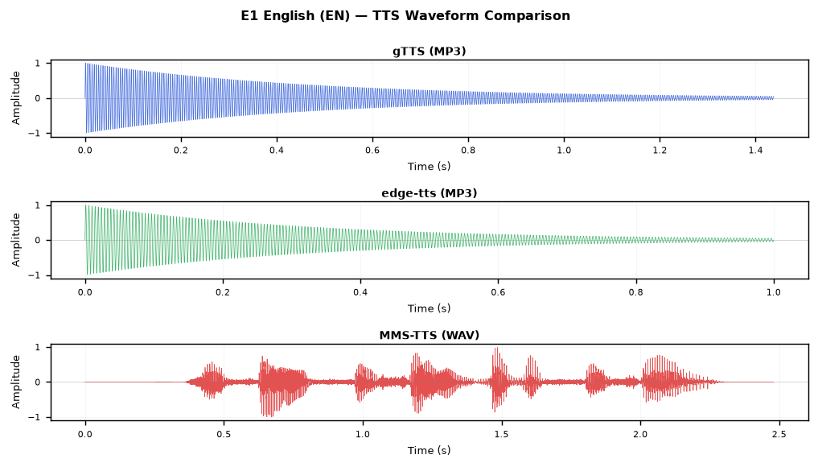
Figure A.2 — E3 English tongue-twister (hardest sentence)
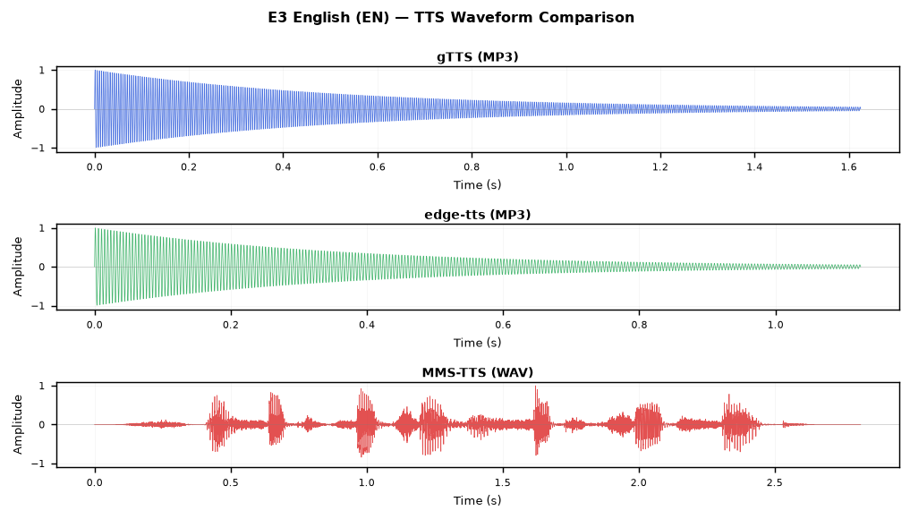
Figure A.3 — H1 Hindi "कच्चा पापड़ पक्का पापड़"
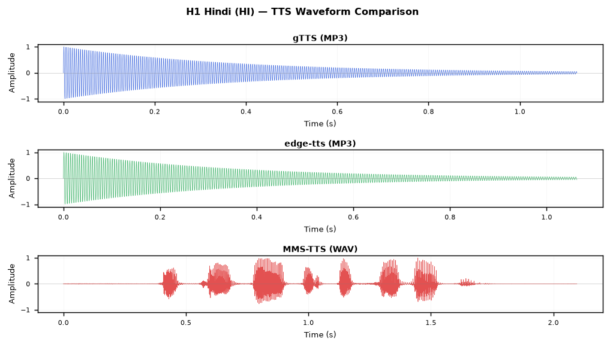
Figure A.4 — B1 Bangla "কাঁচা কাঁঠাল পাকা কাঁঠাল…"
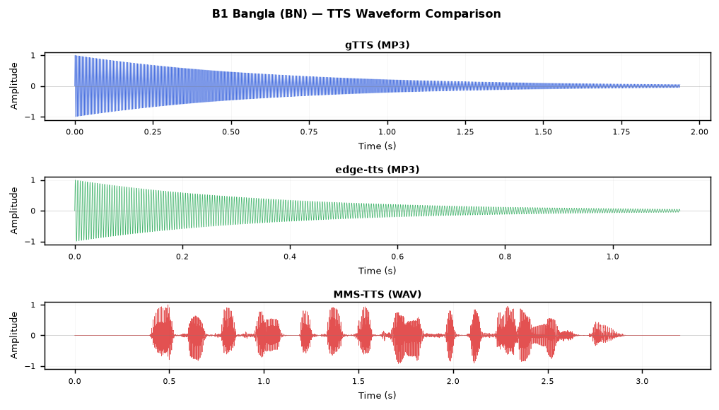
Figure A.5 — B2 Bangla (bisarga vowel ৎ — hardest)
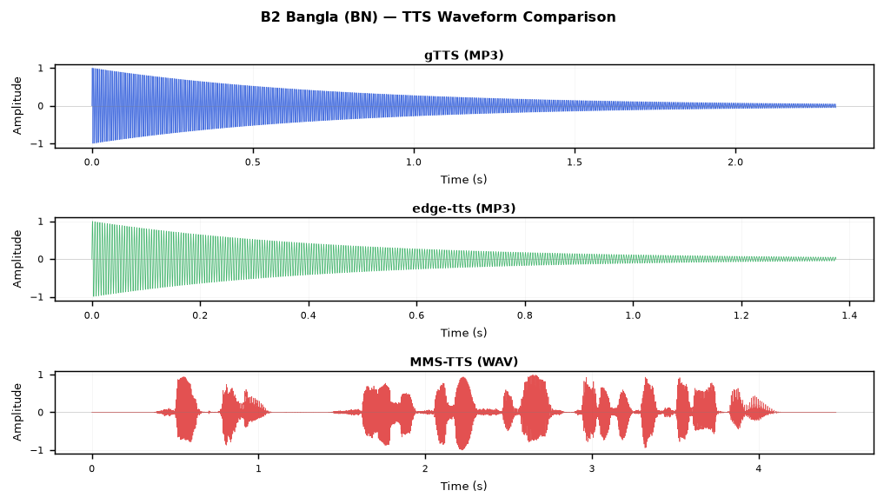

Appendix B: Full Audio File Listing
Tool | File | Size | Path
gTTS | B1_Bangla.mp3 | 31 KB | TTS_Experiment\Output\gTTS\B1_Bangla.mp3
gTTS | B2_Bangla.mp3 | 37 KB | TTS_Experiment\Output\gTTS\B2_Bangla.mp3
gTTS | B3_Bangla.mp3 | 31 KB | TTS_Experiment\Output\gTTS\B3_Bangla.mp3
gTTS | B4_Bangla.mp3 | 29 KB | TTS_Experiment\Output\gTTS\B4_Bangla.mp3
gTTS | B5_Bangla.mp3 | 27 KB | TTS_Experiment\Output\gTTS\B5_Bangla.mp3
gTTS | E1_English.mp3 | 23 KB | TTS_Experiment\Output\gTTS\E1_English.mp3
gTTS | E2_English.mp3 | 26 KB | TTS_Experiment\Output\gTTS\E2_English.mp3
gTTS | E3_English.mp3 | 26 KB | TTS_Experiment\Output\gTTS\E3_English.mp3
gTTS | E4_English.mp3 | 26 KB | TTS_Experiment\Output\gTTS\E4_English.mp3
gTTS | E5_English.mp3 | 29 KB | TTS_Experiment\Output\gTTS\E5_English.mp3
gTTS | H1_Hindi.mp3 | 18 KB | TTS_Experiment\Output\gTTS\H1_Hindi.mp3
gTTS | H2_Hindi.mp3 | 45 KB | TTS_Experiment\Output\gTTS\H2_Hindi.mp3
gTTS | H3_Hindi.mp3 | 32 KB | TTS_Experiment\Output\gTTS\H3_Hindi.mp3
gTTS | H4_Hindi.mp3 | 35 KB | TTS_Experiment\Output\gTTS\H4_Hindi.mp3
gTTS | H5_Hindi.mp3 | 30 KB | TTS_Experiment\Output\gTTS\H5_Hindi.mp3
edge-tts | B1_Bangla.mp3 | 18 KB | TTS_Experiment\Output\edge-tts\B1_Bangla.mp3
edge-tts | B2_Bangla.mp3 | 22 KB | TTS_Experiment\Output\edge-tts\B2_Bangla.mp3
edge-tts | B3_Bangla.mp3 | 19 KB | TTS_Experiment\Output\edge-tts\B3_Bangla.mp3
edge-tts | B4_Bangla.mp3 | 18 KB | TTS_Experiment\Output\edge-tts\B4_Bangla.mp3
edge-tts | B5_Bangla.mp3 | 17 KB | TTS_Experiment\Output\edge-tts\B5_Bangla.mp3
edge-tts | E1_English.mp3 | 16 KB | TTS_Experiment\Output\edge-tts\E1_English.mp3
edge-tts | E2_English.mp3 | 20 KB | TTS_Experiment\Output\edge-tts\E2_English.mp3
edge-tts | E3_English.mp3 | 18 KB | TTS_Experiment\Output\edge-tts\E3_English.mp3
edge-tts | E4_English.mp3 | 18 KB | TTS_Experiment\Output\edge-tts\E4_English.mp3
edge-tts | E5_English.mp3 | 19 KB | TTS_Experiment\Output\edge-tts\E5_English.mp3
edge-tts | H1_Hindi.mp3 | 17 KB | TTS_Experiment\Output\edge-tts\H1_Hindi.mp3
edge-tts | H2_Hindi.mp3 | 36 KB | TTS_Experiment\Output\edge-tts\H2_Hindi.mp3
edge-tts | H3_Hindi.mp3 | 26 KB | TTS_Experiment\Output\edge-tts\H3_Hindi.mp3
edge-tts | H4_Hindi.mp3 | 29 KB | TTS_Experiment\Output\edge-tts\H4_Hindi.mp3
edge-tts | H5_Hindi.mp3 | 25 KB | TTS_Experiment\Output\edge-tts\H5_Hindi.mp3
MMS-TTS | B1_Bangla.wav | 200 KB | TTS_Experiment\Output\MMS-TTS\B1_Bangla.wav
MMS-TTS | B2_Bangla.wav | 279 KB | TTS_Experiment\Output\MMS-TTS\B2_Bangla.wav
MMS-TTS | B3_Bangla.wav | 188 KB | TTS_Experiment\Output\MMS-TTS\B3_Bangla.wav
MMS-TTS | B4_Bangla.wav | 276 KB | TTS_Experiment\Output\MMS-TTS\B4_Bangla.wav
MMS-TTS | B5_Bangla.wav | 163 KB | TTS_Experiment\Output\MMS-TTS\B5_Bangla.wav
MMS-TTS | E1_English.wav | 155 KB | TTS_Experiment\Output\MMS-TTS\E1_English.wav
MMS-TTS | E2_English.wav | 171 KB | TTS_Experiment\Output\MMS-TTS\E2_English.wav
MMS-TTS | E3_English.wav | 176 KB | TTS_Experiment\Output\MMS-TTS\E3_English.wav
MMS-TTS | E4_English.wav | 255 KB | TTS_Experiment\Output\MMS-TTS\E4_English.wav
MMS-TTS | E5_English.wav | 181 KB | TTS_Experiment\Output\MMS-TTS\E5_English.wav
MMS-TTS | H1_Hindi.wav | 131 KB | TTS_Experiment\Output\MMS-TTS\H1_Hindi.wav
MMS-TTS | H2_Hindi.wav | 285 KB | TTS_Experiment\Output\MMS-TTS\H2_Hindi.wav
MMS-TTS | H3_Hindi.wav | 204 KB | TTS_Experiment\Output\MMS-TTS\H3_Hindi.wav
MMS-TTS | H4_Hindi.wav | 284 KB | TTS_Experiment\Output\MMS-TTS\H4_Hindi.wav
MMS-TTS | H5_Hindi.wav | 221 KB | TTS_Experiment\Output\MMS-TTS\H5_Hindi.wav

